Motivations for Global Expansion

- Economic, technological and competitive forces have combined to push companies from a domestic to a global focus.
  - Economies of scale
  - Economies of scope
  - Low-cost production factors.

- Economies of scale:
  - Benefit sought during the industrial revolution
  - New technology and production methods
  - Get production costs down while increasing output

- Economies of Scope:
  - The number and variety of products/services a company offers
  - The number and variety of regions, countries and markets
  - More countries create
    - More marketing power
    - More opportunities for synergy

- Low cost production factors:
  - Obtaining raw materials and resources at a low prices
  - Overcoming scarcity in home country
  - Looking for less expensive labour

Stages of International Evolution:

- Domestic

- International
  - Ace Bakery (i.e.) available in Canada, Us and Bahamas distributed internationally

- Multinational
  - E.g. Wal-Mart
    - Internationals ales up 11.5%
    - US sales up 0.6%
    - Company on the edge of global
    - Having some push back from some countries

- Global
  - E.g. Nestle
    - 130 years old
    - 2000+ brands
    - Operates in 86 countries

Global strategies:

Two main global strategies:

- Globalization strategy:
  - Product design, manufacturing and marketing are standardized around the world

- Multi-domestic strategy:
  - Completion in each country is handled independently of competition in other countries.

Global expansion through international strategic alliances:

3 ways to develop international expertise:
- Licensing
- Joint Ventures
- Consortia

Cross License
- E.g. cross-license the newest drugs
  - Support industry wide innovation
  - Offset high fixed costs of research and distribution

Joint Venture
- Separate entity
- Created with two or more active firms
- Why?
  - Way to share development and production costs
  - Move into new markets
  - Take advantage of partner’s local knowledge
  - Achieve economies of scale
  - Share complementary tech expertise
  - Share distribution channels
- May be with customers or competitors
- E.g., Nestle and L’Oreal
  - Joined to create and develop Inneov a skincare product.

Consortia
- Groups of companies (suppliers, customers, competitors) join together
- Share: skills, resources, costs, access to each other’s markets
- E.g. Keiretsu (family of corporations in Japan)

Stateless Corporation
- These firms have no one country to which they owe more loyalty than any other
- Its operations are evenly distributed among nations.
- Do stateless multinationals compete away standards in a race to the bottom?
  - It is true that multinationals shop around for low tax rates
- But globally integrated companies need a single culture
  - Often one of the highest ethics
  - Anything less tends to corrode the culture
- Globally integrated firm cannot allow corrupt practices by employees in some countries and not others
  - Thus it outlaw them everywhere
- It cannot enforce religious practices and holidays, or different ways of life in different locations
  - Therefore it must preach tolerance
- Challenge is the size of these organizations and the power they wield over governments.

Standardization vs. National Responsiveness:

- Global standardization: Managers must decide whether they want each affiliate to act autonomously or whether activities should be standardized across countries.

- National Responsiveness: Each country is handled independently of competition in other countries.

Designing structure to fit Global Strategy:
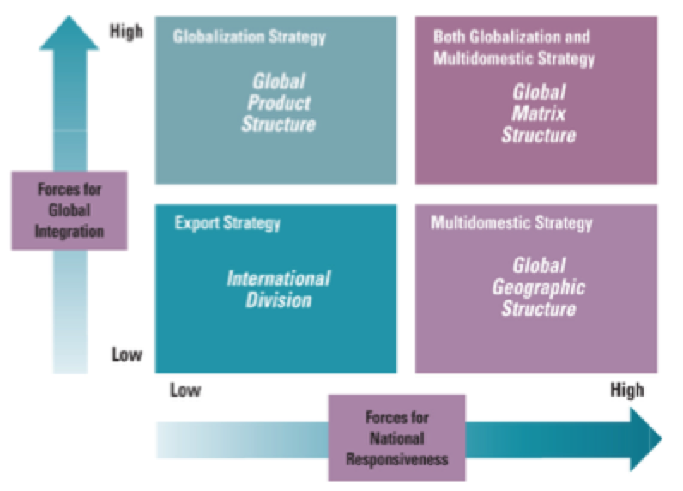
4 quadrants:

- International Strategy (Export Strategy):
  - Forces for global integration low
  - Forces for national responsiveness low
  - There is an export department that grows into an international division
  - Usually a domestic structure with an appropriate way to handle international business
- Globalization Product Structure (globalization strategy):
  - Forces for Global integration high
  - Forces for national responsiveness low
  - Product design, manufacturing and marketing strategy are standardized throughout the world
  - Many companies moving away from strict globalization
    - Global for local feel
    - Responding to backlash against large corporations
  - E.g. Coca Cola
    - Product is the same or nearly the same
    - Only advertising and marketing are tailored to the regions
  - E.g. Wal-Mart
    - Fails in some locations at globalization
    - E.g. Indonesia – customers did not like:
      - Brightly lit store
      - Organized store
      - No option for bargaining – thus thought price too high
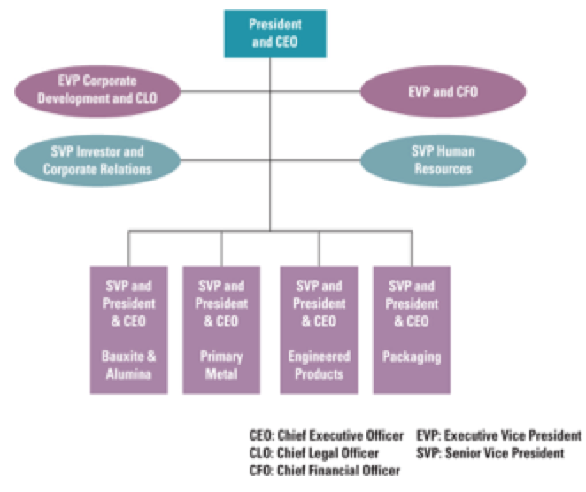
- Global geographic structure (Multi-domestic strategy):
  - Forces for global integration low
  - Forces for national responsiveness high
  - Product design, assembly and marketing tailored to the specific needs of the country
  - More common for services – cultural influences
  - E.g. proctor and gamble standardizing diaper design (Italian mothers want the navel of baby covered)
  - E.g. Ikea – initially all European sizes
  - E.g. Canadians use babies in adds, illegal in France

- Global Matrix Structure globalization and Multi Domestic Strategy:
  - Forces for global integration high
  - Forces for national responsiveness high
    - Similar to the domestic matrix
    - Greater geographical distances
    - Coordination is even more complex
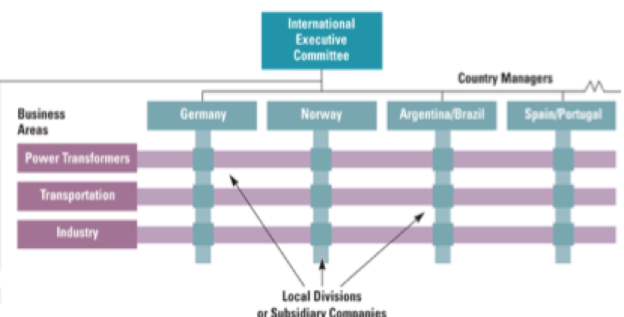

Building Global Capabilities:

- The global organizational challenge
  - Increased complexity and differentiation
  - Need for integration
  - Knowledge transfer

- Global Coordination Mechanisms
  - Global teams
  - Headquarters planning
  - Expanding coordination roles

Work Values across cultures:
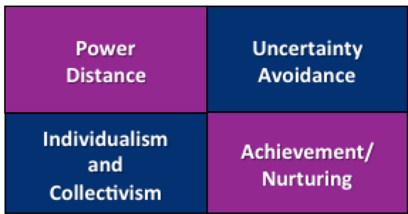

How do national values systems make a difference?
- Traditional values in Mexico support high power distance and a low tolerance for uncertainty
- What would you predict about a company that opens a division in Mexico and tries to implement global teams characterized by shared power and authority with the lack of formal guidelines, rules and structure.

Cultural difference in coordination and control:

- National approaches to coordination and control
  - Centralized coordination
  - Decentralized approach
  - Coordination and control through formalization

Transnational Model of Organizations (a type of stateless organization):

- - Assets and resources are dispersed worldwide
  - Highly specialized operations
  - Linked together through interdependent relationships
- Structures are flexible and ever-changing
- Subsidiary managers initiate strategies and innovations
  - Become strategy for the corporation as a whole
- Unification and coordination are achieved
  - Through corporate culture, shared visions and values, and management style
- Assets and resources are dispersed worldwide into highly specialized operations and linked together through interdependent relationships
- Structures are flexible and ever-changing
- Subsidiary managers initiate strategies and innovations that become strategy for the corporation as a whole
- Unification and coordination are achieved primarily through corporate culture, shared visions and values, and management style
- Subsidiary managers initiate strategies and innovations that become strategy for the corporation as a whole
- Unification and coordination are achieved primarily through corporate culture, shared visions and values, and management style rather than through formal structures and systems

