BUSI 2101 GUIDE
  - (40/60 or 35/65 split on Course material before and after midterm)

1st Half of course:

Chapter 1: Psychological contract and commitment
A psychological contract is an individual’s beliefs, shaped by the organization, regarding the terms and conditions of a reciprocal exchange agreement between individuals and organizations. Basically, it is an unwritten rule of what is and isn’t’ appropriate in a workplace setting.
Social exchange theory: Where the economic and social obligations play a role in the relationships, and balanced exchange is valued.
Self-fulfilling prophecy: When the performer performs at the rater’s expectations. Eg. School children who are told they are gifted perform better than their peers, despite no other differences
Pinch model: The day to day negotiations and communications between employee and employer. Eventually, there will be a strain in it, or pinch. While small, this problem can fester into a crunch point, where it has become too big to ignore, and
- Return to normal
- Renegotiate the terms
- Resentful termination (fired)

If you break a psychological contract:
Willing + Able  You commit an inadvertent | Unwilling + Able  You commit a Breach
Willing + Unable

You commit a disruption

Reponses to breaking psychological contract:
Silence (Say nothing)
Voice (Say something)
Neglect (Do you job worse than before)
Exit (Quit or leave)

Motivation:

Motivation is the thing that determines the direction of people’s behaviour, level or effort, persistence and direction.
Need-based theories:
Focuses on WHAT motivates employees, such as Maslow’s hierarchy (physiological, safety, social, esteem, self-actualization). Believes that people have internal tension which they are motivated to eliminate.
Process-based Theories:
Focuses on HOW motivation is evoked. Finds out how leaders and corporations can evoke motivation. Examples of this are goal-setting theory.
Cognitive Evaluation Theory: Offering extrinsic rewards for work that was previously rewarding intrinsically, will decrease the person’s motivation and in turn his/her performance
- Reduces sense of control/autonomy
- Changes perceived explanation for one’s behaviour/ “cheapens” the experience

McClelland’s Theory of Need
- Socialized Power
- Seek to make things better for others
- User power to empower others
Personalized Power
- Impulsive
- Personal Dominance
- Dictator-like

- Affiliation: Desire for friendly/close interrelationships
Affiliative interest: Concern for relationships, but not at expense of goals. Can still give native feedback or make tough decisions
Affiliative Assurance: Seeking approval at all costs. Avoids issues or conflicts that threaten relationships
- Achievement
Need to accomplish goals, excel and strive continually to do things better
- Taking calculated risks
- Task-oriented
- Personal success/failure

Hackman + Oldman Job characteristics theory
A different approach focusing on internal work motivation
Performing well on the job results in the individual feeling a sense of accomplishment if the individual feeling unhappy.
- Skill variety (different variety of skills)
- Task Identity (where their task is in the grand scheme of organization)
- Task significance (how important their test is)
- Autonomy (how much freedom they have on the task)
- Job feedback: Individual differences (knowledge and skill, growth, satisfaction).
Goal-setting Theory:
Setting clear goals, and letting everyone know what is expected of them to achieve this goal.
Equity Theory:
Employees look at what they received from the job (salary, shares, bonuses, compensation packages) versus what they put in (time, skills, effort). Usually compare it with other works, or with the difficulty of current work.

Reinforcement theory:
Positive Reinforcement: give people good for doing good
Negative Reinforcement: taking away bad when bad stops
Extinction: take away something good until the bad stops
Punishment: give people bad for doing bad
External motivation vs internal motivation:
External is a means to an end.
Internal is an end in itself.

Chapter 4: Personality

Trait model
Traits are a relatively stable set of characteristics or dimensions, and determine how one interacts with his environment. There are two popular types of tests, the Big 5 (OCEAN) and the MBIT (Myers Briggs Type).
Openness to experience: The extent in which people seek new experiences, and the extent in which they are aware of their thoughts and feelings.
Conscientiousness: People who are conscientious are dependable and trustworthy, and conform to social norms. This is the best indicator of a good employee.
Extroversion: Refers to how outgoing, sociable and assertive people are. They are normally energetic and active.
Agreeableness: This dimension captures the extent to people are likeable, cooperative and considerate
Neuroticism: Calling emotional stability, goes to tendency to experience chronic negative emotions, such as worry, insecurity, self-pity, poor self-Image.
Dealing with difficult people
- Create a rich picture of the problem person
- Reframe your goals
- Stage the encounter
- Follow up
Myer-Briggs measure 4 things:
- Extraverted/introverted
- Sensing/Intuiting
- Think/Feeling
- Judging/Perceiving (controlled decision making vs flexible and open)
Machiavellianism is how much means justify the ends
Self-esteem is the degree of regard people have for themselves
Locus of control: People with inner locust feel they are in control, external locust being that things are due to luck

Interactionist model:
Conditional Reasoning Approach: People interpret what happens in their social environment based on their individual dispositions. Individuals differ in this by how they frame the world.
Cognitive Affective Processing: Behaviour is best predicted from a comprehensive understanding of the person, the situation and the interaction between the two. Individuals react according to the if the relations depend of their interpretation of the situation

Chapter 3: Organized Learning
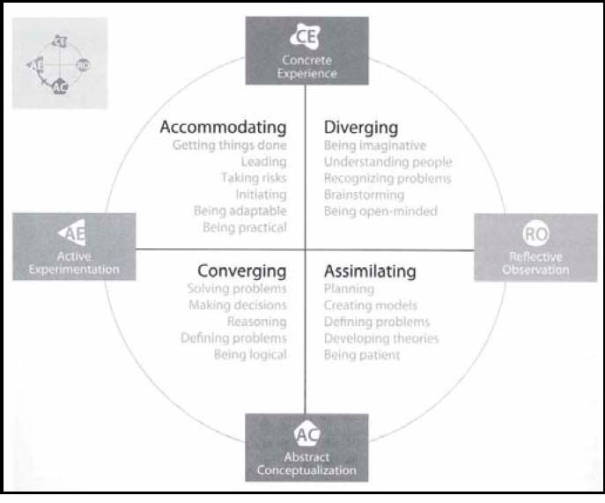

Kolb’s individual learning styles
Everyone learns by going through a 4-step process
Individuals put greater emphasis on some of the stages (we have stronger and weaker stages and preferences)
There are individual differences in learning.
Concrete Experience – activist – prefers doing and experiencing
Reflective observation – reflector – observes and reflects
Abstract Conceptualization – Theorist – wants to understand underlying reasons, concepts, and relationships
Active experimentation – pragmatist – likes to try things to see if they work.

Argyris and Schon (1978): Levels of organizational learning
Single – loop learning: adaptive learning – coping
- Changing according to existing procedures and strategies
- “Inside the box”
Double-loop learning: Generative Learning – creating
- Questioning and possibly altering the governing assumptions, policies, procedures and strategies and developing a new one.
- “Outside the box”
Triple-loop or Deutero learning: learning to learn

3 types of learning
Cognitive- reading the information from a book
Affective –emotions, like fear and happiness
Psychomotor – Physically doing something

Organizational Learning:
It is a process, in which an organization’s capacity to acquire, process, exploit/apply and disseminate knowledge in order to ensure its success. Basically the concept of individual learning applied to the organization as a whole as opposed to just individuals.
For example, teaching someone else in the organization is a net game of 0. You could hire someone who knows different things, and have a net change in knowledge. You can lose knowledge by someone leaving.

2 Types of Organizational Learning
Exploration:
- Search for and experiment with new kinds or forms of organizational activities and procedures
Exploitation:
- Learn ways to refine and improve existing organizational activities and procedures

Chapter 10: Teamwork

Groups are a two or more people with a common relationship. They are good for ambiguous and segmented projects.
Teams are needed it the goal is clear and there is a need for common purpose.

Tuckman’s Group development:
Forming: In this stage, members focus on accepting each other and learning more about the group and purpose.
Storming: Members confront each other about their own individuality, and who leads the group. The group subdivides into cliques.
Norming: Members shared expectations on the group’s roles and norms. This part if when greater cohesion and commitment for the group occurs. Group thinking is when members seek consensus on a certain idea without actually debating the alternatives.
Performing: At this point, it is about the group being productive and doing when the original intent of the team is for.
Adjourning: Group disbands and seeks closure (what’s next?)

Role Theory:

Role Conflict: Obligations from one role may conflict with another
Role Ambiguity: Person is unclear of what their role is, or what it entails
Role Overload: When a person is overwhelmed at the amount of tasks they have.

Punctuated Equilibrium:
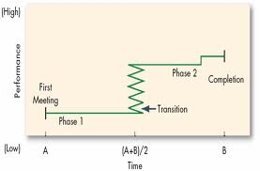

Task orientation
Initiating: starting the group project
Seeking information or opinions: Efficient flow of information
Giving information or opinions: Give your own information or seek initiative in finding it.
Clarifying and elaborating: Communicates listening and collaboration.
Summarizing: Useful to summarize the group’s discussions into something coherent.
Consensus testing: Seeing if everyone agrees on the same points
Reality testing: Seeing if ideas hold up in the real world.
Orienting: Putting the group in the right direction to their goal.

Maintenance roles for groups:
Gatekeeping: Allowing everyone to speak
Encouraging: Helps people who don’t participate help more
Compromising and harmonising: Having each side yield a bit
Standard setting and testing: Testing to see if the group work is what they intended it to be.
Using humour

Emotional Behaviour to reduce tension
Friendly Helper – Someone who is set on keeping the group friendly and accepts what is similar and dissimilar
Tough Battler – Only find satisfaction in the unification of thoughts.
Logical Thinker – No emotions, just logic and thinking

Chapter 13: Conflict and Negotiation:
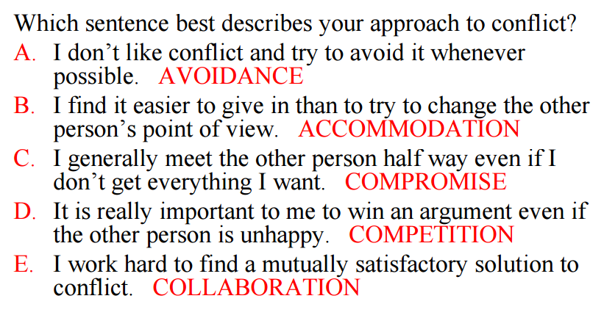

Principled Negotiation:
Fisher + Ury
Based on integration (win win)
Focus is on merits of specific rather than what each side says they will or will not do.
4 key principles:
- Separate people from the problem
- Focus on interests not positions
- Invent options for mutual gain
- Insist on objective criteria

BATNA: Best alternative to a negotiating agreement
Reservation Point: point beyond which you will not accept a deal and will turn to your BATNA (minimum willing to accept). An example is you wouldn’t accept a price higher than 7000 for a car since you know it’s a ripoff.
Bargaining Zone: The range between one party’s high and the other party’s low.

Retaliatory Cycle
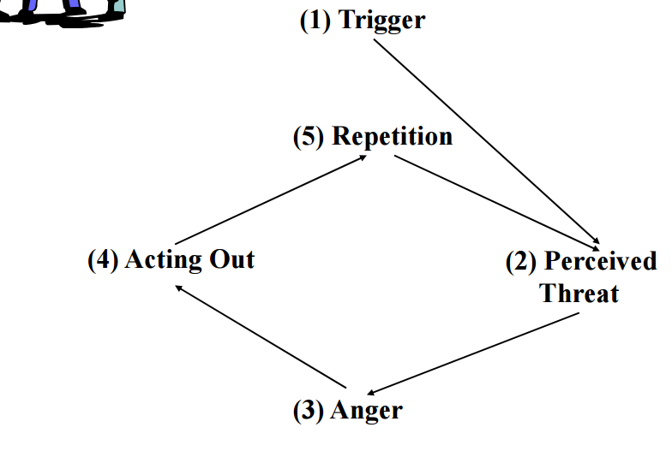

Types of negotiation:
Distributive is win-lose
Integrative is win-win.

Chapter 8&9 Communication and Attribution:

Perception is the process by which we select, organize and evaluate the stimuli in our environment to make it meaningful for ourselves.
Attribution Theory: When people observe behaviour, they attempt to determine whether it is internally or externally caused.
People look for information about consensus, consistency, and distinctiveness to decide on causation.
Transactional method of communication: A model when both the speaker and listener send message to each other, which changes how each respond. Model includes a field of experience (experiences both listener and speaker have had) as well as noise (things that distort the meaning of the listening), via physiological, emotional or environmental means.

Arc of distortion: What person A says, and what person B actually hears.

Barriers to communication:
- Poor Relationships
- Lack of Clarity
- Individual differences in encoding and decoding
- Gender (women are more concerned with seeking and giving confirmation and support, rather than dominate the conversation).
- Perception (in communication, people only wish to hear what they want to hear)
- Culture
- High context vs low context (some languages need explicit verbal messages to convey meaning)
- Silence (perceived differently in different cultures)
- Direct vs Indirect communication (which refers to the language and tone of voice reveals the speaker’s intent)

Perceptual process:
Selection (picks what stimuli we focus on)
Organization (construct a mental image of what the stimuli is)
Interpretation (what does it mean)

Stereotyping:
When we base our image of the person based on the group of people they come from.

Perceptual distortions:
Halo effect: We evaluate someone based on only one of their traits (eg. We find someone is great only because they are smart)
Primacy effect: First impression is everything
Recency effect: Last impression is everything
Central Tendency: This is when you see everything as average, and don’t lean to extremes
Projection: Projects the feelings of one’s own attitudes onto another person, therefore relieving ones guilt.
Perceptual: Lets through what we want to see, and not what we don’t

Johari Window

Arena: Known by self and others
Façade: Known by self but not others
Blind spot: Not known by self, but by others
Unknown: No one knows
Self-Serving bias: If I do well, it’s all me. If I do badly, it’s due to external factors. This is strongly associated to mental health, especially those who look at the world as it is.
Men never grow out of this. Women are less likely to display self-serving bias as they age, marked in adolescence.
Magnitude of self-serving bias is different for cultures (Americans are very much like this, Eastern Asia not so much).
Fundamental attribution error: Tendency to underestimate the influence of external factors for others, but go easy on ourselves.

Chapter 17: Decision Making

Models of Decision Making
Rational Decision Making
- Recognize and define the problem
- Identify the objective of the decision and decision criteria
- Allocate weights to criteria
- List and develop alternatives
- Evaluate the alternatives
- Select the best alternative
- Implement the decision
- Evaluate the decision

Bounded Rationality:
Assumed that people normally make decisions with limited information, engage in limited information searches and often find less than optimal solutions. This assume that managers often select the first alternative that is minimally acceptable, have incomplete information, and are confident in using heuristics and not considering alternatives.

Garbage can model:
Says that decision making is purely chaotic and random, and only happens when problems, participants, solutions and choice opportunities collide together to form a decision.

Leadership-Participation Model
This model reveals whether or not a decisions should be:
Decide: The leader alone decides
Consult Individually: Consult each team member individually before making a decision
Consult Group: Consult everyone at once before making a decision.
Facilitate: The leader gives the group the problem, and gives the boundaries of it
Delegate: Allows group to make decision thought limits

The result of this affect 4 part of the decision-making process:
Decision quality (was the decision well thought out?)
Decision implementation (how close is implementation to the decision)
Cost of Decision making (time and energy)
Development (employees learn about problem solving)
The chart is based off the time driven model of:
Decision Significance (how significant is the decision of the success of project or organization)
Importance of Commitment (how much does the commitment of the group to the decision mean)
Leader Experience (leader has expertise in area of decision)
Likelihood of Commitment (if you choose the decision yourself, would you commit to it)
Group support of Objective (how much does the team support the organizations objectives)
Group expertise (what knowledge the group has)
Team competence (do members have the ability to work together)

Avoiding groupthink (EAABL)
- Encourage members to express doubts
- Assign a devil’s advocate to challenge assumptions and arguments
- Adopt the perspectives of others with a stake in the decision
- Bring in qualified outsiders to discuss the issue
- Let’s sleep on it

Chapter 18: Power and Influence
Power – the capacity to influence the behaviour of others
A has power over B to the extent that A can get B to do something that B would not otherwise do
Influence: People who can persuade others to do their bidding or have the same thoughts.
Authority – power granted to an employee recognized as legitimate (person has an obligation to comply, such as with law enforcement).

Influencing Styles:
Assertive Persuasion: We push others with our intellect. We use facts logic and rational arguments to get our point across. This is emotionally neutral.
Reward and Punishment: Pushing style with bargaining incentives, pressure and demanding certain behaviour from others. Can also have compliance and punishment. Eg. If you do X, I’ll do Y. If you don’t you X, you’ll be punished with Y.
Participation and Trust: Active listening and being involved with others. Uses participation and trust to influence their partners. This is a pull strategy.
Common vision: Identifies a common vision for the future and to strengthen the group members beliefs that through hard work, the vision can become a reality.

Sources of Power (CCER)
- Coercive Power (by force by threatening with power)
- Charismatic Power (Power to be well liked, attracts others).
- Expertise
- Right place-right time (control over resources or access to information; context like MLK during the racism era, Winston Churchill in WW2).

Influence tactics (RICIPECP)
Rational persuasion (using cold hard facts)
Inspirational appeals (trying to appeal to the target’s values, ideals and aspirations)
Consultation (shows how the proposal will address the targets concerns)
Ingratiation (flattery, friendly behaviour, helpful behaviour to get them in a good mood)
Personal appeals (feelings of loyalty and friendship)
Exchange (I rub your back, you rub mines)
Coalition Tactics (Since I support him, you should too)
Legitimating tactics (Having the authority or right to make the request)
Pressure (Threats and demands, frequent checking)

Influence Strategies (RSC SEL)
Reciprocity (people repay in kind0
Social proof (people follow the lead of similar others)
Consistency (clearly aligned with a public commitment)
Scarcity (people want more of a scarce resource)
Expertise and Authority (relevant to experiences)
Liking (charismatic and pleasant)

Power distance:
How accepting are people of the disparity of power

Chapter 6: Ethics
Ethics: Moral duties arising from ones interpretation of right and wrong.
Nonethical values: Things that we personally find important, such as riches, fame, pleasure, being liked.

Five ways to encourage ethics:
- Set expectations of ethical guidelines to employees
- Hire top executives which also follow these guidelines
- Rewards good ethics, punish bad ethics
- Teach employees basic ethical decision making
- Encourage discussion of ethics
Values: Core beliefs that motivate actions and attitudes
Value congruence: The shared system of values between two entities.
Terminal values are desirable end states of existence or the goal that a person would like to achieve in his or her lifetime, such as personal values (freedom, happiness, salvation) and social values (world peace, equality, national security)
Instrumental values are modes of behaviour to achieve ones terminal values. They two types of moral values and competence values. Moral values are being cheerful, courageous, helpful and honest, and when violated, make up have pangs of guilt. Competence values are being ambitious, capable, intellectual etc. Failing in these makes up be

Kohlberg’s Moral reasoning
Self-centered level (Preconventional)
Stage 1: Obedience and punishment Orientation: Physical consequences of an action determined its goodness or badness. An avoidance of [punishment and unquestioning deference to power are valued but no because they believe in morals.
Stage 2: Instrumental Relativist Orientation: Interest to satisfy one’s own needs. Reciprocity is just a matter of you scratch my back and I scratch yours as an action rather than friendship.
Conformity (conventional)
Stage 3: Interpersonal Accord, conformity and mutual expectation: Good behaviour is what others and selves find appropriate. Do unto others as you would want to yourself.
Stage 4: Law and Order: Takes accord with the expectations of society. Finds the consistent set of codes and procedures, and applies them impartially to society. Doing one’s duties to society is what this level is.
Principled Level (Postconventional)
Stage 5: Social contract and Individual Rights: Individual agrees to contracts, the rights of others, and general good. Awareness of the values of others, and holding up the rights no matter what opposition.
Stage 6: Universal Ethics: Abstract and ethical values such as justice, equality and the respect and dignity of human beings.

Ethical Frameworks JUICE
- Utilitarianism: Moral acts produces the greatest good for the greatest number of people
- Individual Right Principle: Peoples rights to privacy, free speech and due process. This is a legalistic approach that focuses on legal and human rights of individuals.
- Justice Principle: Guided on fairness, equity and impartiality.
- Caring Principle: The well-being of others, and the arenas for the needs and feelings of others, and responding to that need.
- Environmentalism: Human kind and the sustainability of the earth. Make it so people have an obligation to protect the earth.

Sources of Power
- Coercive Power (by force by threatening with power)
- Charismatic Power (Power to be well liked, attracts others).
- Expertise
- Right place-right time (control over resources or access to information; context like MLK during the racism era, Winston Churchill in WW2).

Chapter 16: Culture

Schein’s three level of cultures (AEA):
- Artifacts that are visible or tangible (buildings, rituals and ceremonies, stories, language)
- Espoused values, such as strategies, goals and philosophies (company mission)
- Assumptions, which are taken for grant beliefs, perceptions, thoughts and feelings

Organizational Justice (DPI):
- Distributive justice: How fair are the compensations for workers?
- Procedural justice: The fairness in deciding how resources are distributed.
- Interactional justice: Treatment of employees by power figures.

Transmitting culture: SSSJRS
- Socialization: How to introduce a new member into their culture
- Stories: Folklore and stories that are repeated to the newcomers
- Symbols: For example, pink Cadillac’s to the best sales women, banners in the hockey arena dedicated to its best and most storied players.
- Jargon and language: Colloquialisms or slang used by the organization
- Rituals and ceremonies: Programmed routines of daily life that reflect values of corporate culture. Example of Casual dress code and beer on Fridays.
- Statement of principles: Organization’s list of values and basic assumptions. These can be posted on walls.

