Final Exam Review 2
The following questions are adapted from Financial Accounting: Tools for Business Decision-Making, by Kimmel, Weygandt, Kieso, Trenholm, & Irvine, 5th Canadian Edition. NOTE that: all rights reserved. No part of this publication may be reproduced, distributed, or transmitted in any form or by any means, including photocopying, recording, or other electronic or mechanical methods, except for educational purposes (<10%), as that is for noncommercial uses permitted by copyright law.
Disclaimer:
These questions are for review purposes only. These questions do not, in any way, indicate the type, content, or style of questions that will be on the final exam. This package is for additional practice so students can determine what they know…and what they do not know.
NOTE that these questions do not include concepts prior to Chapter 6. The final exam WILL be cumulative (include all chapters from 1 to 9). For a review of the first 5 chapters see the Midterm Review Package.

Solutions to these questions will be posted in a separate document.

FER2-1

On January 6, Compton Limited sold merchandise on account to Singh Inc. for $24,000, terms 2/10, n/30. The merchandise originally cost Compton $16,000. On January 15, Singh paid the amount due. Both Compton and Singh use a perpetual inventory system.
Instructions
(a) | Record the business activities on Compton Limited's accounting equation using account names to record the sale and related collection.

(b) | Record the business activities on Singh Inc.'s accounting equation using account names to record the purchase and related payment.

FER2-2

Hohnberger Enterprises purchased equipment on March 15, 2012, for $75,000. The company also paid the following amounts: $1,000 for delivery charges; $200 for insurance while the equipment was in transit; $1,800 for a one-year insurance policy; $2,100 to train employees to use the new equipment; and $2,800 for testing and installation. The equipment was ready for use on April 1, 2012, but the company did not start using it until May 1, 2012.
Hohnberger has estimated the equipment will have a 10-year useful life with no residual value. The company has a December 31 year end.
Instructions
(a) | Calculate the cost of the equipment.
(b) | When should the company begin depreciating the equipment: March 15, April 1, or May 1? Why?
(c) | Using straight line depreciation calculate the depreciation expense on the equipment for 2012 and 2013.
Year | Depr. Expense | Accumulated Depr. | Book value

FER2-3

Zerbe Consulting Inc.'s gross salaries for all their employees for the biweekly (2 weeks) period ended August 22 was $15,000. Deductions included $743 for CPP, $267 for EI, and $6,258 for income tax. The employer's payroll costs were $743 for CPP and $374 for EI. Record the entries in the expanded accounting equations using account names for (a) the payment of salaries on August 22, and (b) the employer payroll costs on August 22, assuming they will not be paid to the government until September, and (c) the payment of the employee benefits to the government on September 8.

Date | Assets | Liabilities |  |  | Equity
Date | Assets |  |  |  | Owner's Capital | Retained Earnings
 |  |  |  |  |  | Revenue | Expenses
Date | Cash | CPP Payable | EI Payable | Employee  Income Taxes  Payable |  |  | Salary Expense | Employee  Benefits  Expense

FER2-4
Condensed data from the comparative statement of financial position of Dressaire Inc. follow:
 | 2012 | 2011
Current assets | $120,000 | $ 80,000
Non-current assets | 400,000 | 350,000
Current liabilities | 70,000 | 90,000
Non-current liabilities | 165,000 | 105,000
Common shares | 150,000 | 115,000
Retained earnings | 135,000 | 120,000

Instructions
(a) | Perform a horizontal analysis.
(b) | Analyze the outcome of your horizontal analysis. What can you say about the business between 2012 and 2011?

FER2-5

An important part of accounts receivable is to recognize that businesses owe many customers. Those customer’s invoices can then be aged. The aging categorizes all invoices by how long they are outstanding.
The following question will help you to recognize and create an accounts receivable sub-ledger while, at the same time, testing your understanding Chapter 4, merchandising businesses.
NOTE: no information is available regarding the cost of the inventory sold. This question focuses on Accounts Receivable only, which is why inventory is ignored for purposes of this quesiton.
The transactions that follow were for Discovery Sports Ltd. with its customers during the company's first month of business:
Feb. 2 | Sold $1,140 of merchandise to Andrew Noren on account, terms n/30.
4 | Andrew Noren returned $140 of the merchandise purchased on February 2.
5 | Sold $760 of merchandise to Dong Corporation on account, terms 2/10, n/30.
8 | Sold $842 of merchandise to Michael Collins for cash.
10 | Sold $920 of merchandise to Rafik Kurji, who paid cash.
14 | Dong Corporation paid.
17 | Andrew Noren purchased an additional $696 of merchandise on account, terms n/30.
22 | Sold $1,738 of merchandise to Batstone Corporation, terms 2/10, n/30.
28 | Andrew Noren paid $1,000 from his outstanding accounts receivable.

Instructions
Record the business activities into the accounting equation using account names. Round your answers to the nearest dollar.
SEE THE CHART ON THE LAST PAGE OF THIS PACKAGE!!!

FER2-6
Condensed data from the comparative statement of financial position of Dressaire Inc. follow:
 | 2015 | 2014
Current assets | $ 80,000 | $100,000
Non-current assets | 350,000 | 300,000
Current liabilities | 90,000 | 65,000
Non-current liabilities | 105,000 | 150,000
Common shares | 115,000 | 100,000
Retained earnings | 120,000 | 85,000

Instructions
(a) | Perform a horizontal analysis.
(b) | Analyze the outcome of your horizontal analysis. What can you say about the business between 2014 and 2015?

FER2-7

Romez Limited borrowed $60,000 from the bank on July 1 for three months; 5% interest is payable the first of each month, starting August 1. Romez's year end is August 31. Prepare journal entries to record (a) the receipt of the bank loan on July 1; (b) (1) the accrual of interest on July 31, (2) the payment of interest on August 1, (3) the accrual of interest on August 31, (4) the payment of interest on September 1.
Date | Assets | Liabilities |  |  | Equity
Date | Assets |  |  |  | Owner's capital | Retained earnings
 |  |  |  |  |  |  | Profit
 |  |  |  |  |  |  | Revenue
Date | Cash | Accounts payable | Note Payable | Interest Payable | Owner's capital | Retained Earnings | Sales Revenue | Interest Expense

FER2-8

Spector Limited purchased a truck on January 1, 2010, for 62,000. The truck had a residual value of $6,000, and an estimated 4 year useful life. On January 1, 2012, Spector sold the delivery truck for $10,000. Spector uses straight-line depreciation and had a December 31 yearend.
Create a chart which shows the depreciation expense, accumulated depreciation, and book value (also called carrying value) for 2010, 2011, and 2012. Record the depreciation expense for December 31, 2010, December 31, 2011. For 2012 record all the necessary entries, including the sale of the truck.

Year | Depr. Expense | Accumulated Depr. | Book value

Calculations of the gain or loss on sale:

FER2-9
Chinook Limited's general ledger reports a balance in Accounts Receivable of $360,000 at the end of December.
Instructions
(a) | Assuming that Allowance for Doubtful Accounts has a balance of $-4,400 and that uncollectible accounts are estimated to be $36,000 by aging the accounts, record the entry at December 31.
(b) | Assuming the same information as in (a) except that uncollectible accounts are expected to be 9% of the accounts receivable, record the entry at December 31.
(c) | Assuming the same information as in (a) except that the Allowance for Doubtful Accounts has a balance of $+2,400, record the entry at December 31.  Part (a):

Charts for Part (b) and (c) are on the next page.

+300000*.07/12Part (b):

Part (c):

FER2-10

Eyre Inc. borrows a 10-year, 7%, $300,000 mortgage on November 1, 2015, to buy a new building. The mortgage interest is paid on the first day of every month, starting December 1, 2015. Prepare the entry at November 1, when you took out the loan. Record the following interest entries: November 30 when you accrue the interest, December 1 when you pay the interest, and December 31, when you accrue the interest at the end of the year.

Date | Assets | Liabilities |  |  | Equity
Date | Assets |  |  |  | Owner's capital | Retained earnings
 |  |  |  |  |  |  | Profit
 |  |  |  |  |  |  | Revenue
Date | Cash | Accounts payable | Note Payable | Interest Payable | Owner's capital | Retained Earnings | Sales Revenue | Interest Expense

FER2-11

Jintao's gross payroll for the month of August was $40,500 for all employees. The company deducted $2,005 for CPP, $721 for EI, $3,200 for pension, and $8,010 for income tax from the employees' pay. Jintao's payroll costs for the month were $2,005 for CPP and $1,009 for EI.
Required:
Record the payment of salaries on August 31, 2015 and the accrual of the company employee benefits on the same date. Record the payment of the employee benefits to the government on September 8, 2015.

Date | Assets | Liabilities |  |  | Equity
Date | Assets |  |  |  | Owner's Capital | Retained Earnings
 |  |  |  |  |  | Revenue | Expenses
Date | Cash | CPP Payable | EI Payable | Employee  Income Taxes  Payable |  |  | Salary Expense | Employee  Benefits  Expense

FER2-12

Spector Limited purchased a computer on January 1, 2010, for $10,980. The computer had no residual value and a useful life of three (3) years. On September 1, 2012, Spector sold the computer for $1,500 cash. Spector uses straight-line depreciation and had a December 31 yearend.
Create a chart which shows the depreciation expense, accumulated depreciation, and book value (also called carrying value) for 2010, 2011, and 2012. Record the depreciation expense for December 31, 2010, December 31, 2011. For 2012 record all the necessary entries, including the sale of the computer.
Year | Depr. Expense | Accumulated Depr. | Book value

Calculations of the gain or loss on sale:

FER2-13

Gemini Ltd. has accounts receivable of $370,000 at March 31, 2012. An analysis of the accounts shows these amounts:
Month of Sale | 2012
March | $260,000
February | 50,400
January | 34,000
October-December | 25,600
 | $370,000

At March 31, 2012, there is an $-8,800 balance in the allowance for doubtful account. The company estimates its uncollectible accounts as follows:
Number of Days Outstanding | Estimated Percentage Uncollectible
0-30 | 2%
31-60 | 10%
61-90 | 30%
Over 90 | 50%

Instructions
(a) | Prepare an aging schedule to determine the total estimated uncollectible accounts receivable at March 31, 2012.
(b) | Record the entry that the business would have to make at March 31, 2012, to record bad debts expense estimate that you just calculated. Make the entry into the accounting equation using account names.

FER2-14
Condensed data from the income statement for Fleetwood Corporation follow:
 | 2012 | 2011
Net sales | $800,000 | $600,000
Cost of goods sold | 550,000 | 375,000
Gross profit | 250,000 | 225,000
Operating expenses | 175,000 | 125,000
Profit before income tax | 75,000 | 100,000
Income tax expense | 15,000 | 20,000
Profit | $ 60,000 | $ 80,000

Instructions
- Prepare a vertical analysis for each year.
- Analyze the outcome of your vertical analysis. What can you say about this business between 2011 and 2012?

FER2-15

On December 31, 2015, when its Allowance for Doubtful Accounts had a balance of $+2,000, Ceja Corp. estimated that $16,800 of its accounts receivable would become uncollectible, and it recorded the bad debts estimate in the accounting equation using account names. On May 11, 2016, the following year, Ceja determined that Robert Worthy's account was uncollectible (bad) and wrote off his account, a total of $1,900. On November 12, 2016, Robert Worthy paid $1,000 of the amount that was previously written off.
Instructions
Prepare all the entries for both 2015 and 2016 using the accounting equation and account names. ADD additional rows as required to the chart!

FER2-16
Spector Limited purchased equipment on January 1, 2010, for $150,000. The equipment had no residual value and a useful life of ten (10) years. On December 1, 2013, Spector sold the equipment for $80,000 cash. Spector uses straight-line depreciation and had a December 31 yearend.
Create a chart which shows the depreciation expense, accumulated depreciation, and book value (also called carrying value) for 2010, 2011, 2012, and 2013. Record the depreciation expense for December 31, 2010, December 31, 2011, and December 31, 2012. For 2013 record all the necessary entries, including the sale of the equipment.

Year | Depr. Expense | Accumulated Depr. | Book value

Calculations of the gain or loss on sale:

Date | Assets |  |  | Liabilities | Equity
Date |  |  |  | Liabilities | Owner's Capital | Retained Earnings
Date |  |  |  | Liabilities |  | Profit
 |  |  |  |  |  | Revenue |  | Expense
Date | Cash | Equipment | Accumulated Depr. | Accounts payable | Owner's Capital | Revenue | Gain on Sale | Loss on Sale | Depr. Expense

FER2-17

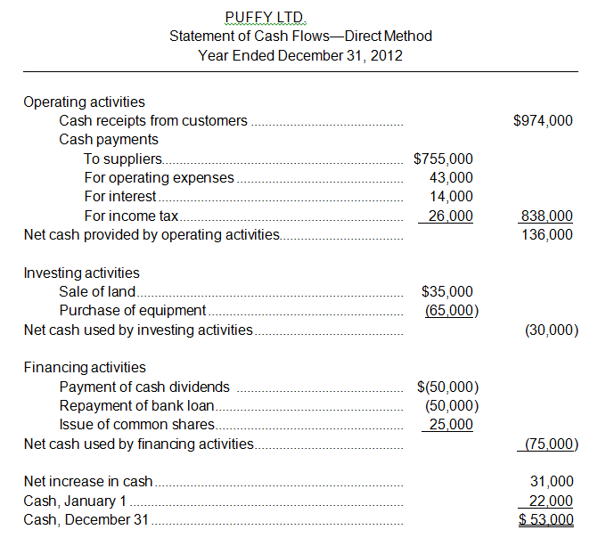
Required:
Analyze the cash flow statement. Do you feel the business is doing well? Support your position using information from the cash flow statement!

FER2-18
During its first year of operations, which ended on December 31, 2014, Fort Nelson Resources Ltd. determined that customers owing the company $12,000 would not be able to pay and wrote off these accounts. By the end of the year, the company had $1,700,000 of accounts receivable and estimated that 10% of these were doubtful of collection. In 2015, the company wrote off accounts receivable amounting to $14,000. By December 31, 2015, the company had accounts receivable of $2,100,000 and estimated doubtful accounts at 10% of outstanding accounts receivable.
Instructions
(a) | Prepare the entries that Fort Nelson Resources would record in 2014.
(b) | Prepare the entries that Fort Nelson Resources would record in 2015.
(c) | Assess whether the company's policy of estimating doubtful accounts at 10% of outstanding receivables is appropriate.  ADD additional rows as required!!!

FER2-19

The following expenditures are made for a forklift:
1. | Rebuilding of the diesel engine, $10,000
2. | New tires, $4,000
3. | New safety cab, $5,000
4. | Replacement of the windshield, $800
5. | Training a new operator, $1,600
6. | New paint job after the company changed its logo and colours, $2,000
7. | One-year accident insurance policy, $1,110
8. | Payment to an operator to reorganize where items were stored in the warehouse to increase efficiency, $2,400.

Instructions
For each of the above amounts indicate if the amount would be capitalized (included in the cost of the forklift) or expensed OR recorded in some other way. Briefly explain your reasoning. Record all the entries into the accounting equation using account names assuming it was all paid in cash.
Cost: | Explanation!

FER2-20

At January 1, 2012, Bordeaux Inc. reported the following information on its statement of financial position:
Accounts receivable | $480,000
Allowance for doubtful accounts | -35,000

During 2012, the company had the following summary transactions for receivables:
1. | Sales on account, $1,600,000
2. | Sales returns and allowances, $250,000
3. | Collections of accounts receivable, $1,500,000
4. | Write-offs of accounts receivable deemed uncollectible, $45,000
5. | Customers who were previously written off sent in a cheque for $10,500

Instructions
(a) | Prepare all the entries required using the accounting equation with account names for the year.
(b) | Prepare the entry to record bad debts expense at December 31, assuming that aging the accounts receivable indicates that the amount for estimated uncollectible accounts is $55,000.
(c) | The balance sheet at December 31 would show what?
(d) | The income statement at December 31 would show what?
Answers to (c)and (d):

FER2-21
The statement of cash flows for Cutting Edge Grooming Company is provided, below. Analyze the statement and indicate what you think about how the company did for this year. Do you think that the business should have paid dividends to the owner? Why or why not? Be sure to support your answer with information from the cash flow, both when you answer these specific questions but also when you analyze the statement!
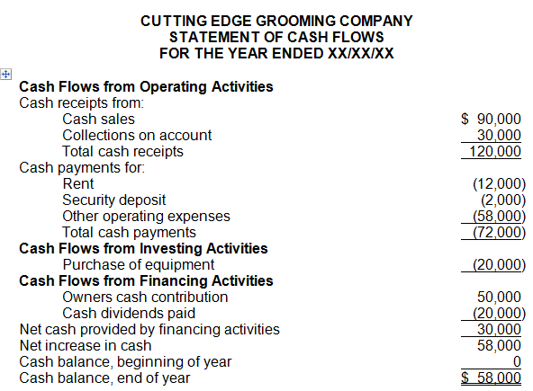

FER2-22
If you were investing in a business what would you LIKE to see on the statement of cash flows for:
- Operating activities.
- Investing activities.
- Financing activities.
Be sure to explain WHY you would want to see those things.

FER2-5 Chart:

