Lecture 1
- Macroeconomics – Concerned with the whole economy, subdivisions, and aggregates
- Microecon – individual units (households, firms, and decision making)
- Production Possibilities Curve
  - Assumes
    - Fixed employment and production efficiency
    - Fixed resources
    - Fixed technology
  - Points inside curve represent underemployment or unemployment
  - Points outside are unattainable
  - Points on the curve are attainable at best Most OPTIMAL
- Law of increasing opportunity costs
  - The more of a produced is produced, the greater is its marginal opportunity cost
    - Slope becomes steeper on the PPC
- Economic Rationale
  - Economic resources are not completely adaptable to alternative uses
  - If you want to increase pizza, there may not be enough workers that are readily available to transfer from making robots to pizza.
- Direct Relationship = As X increases Y increases, the variables are proportional
  - Downward sloping
- Inverse Relationship = As X increases Y decreases, the variables are inversely proportional
  - Upward sloping

Lecture 2
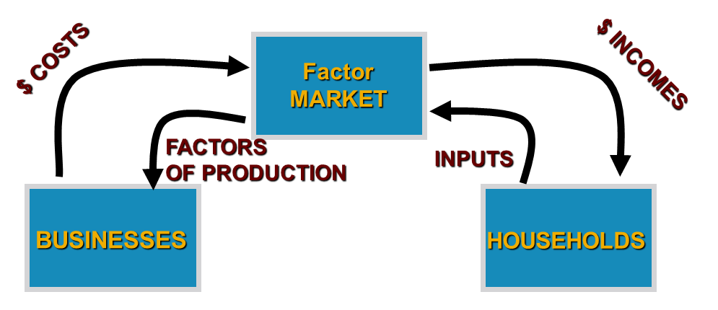
- 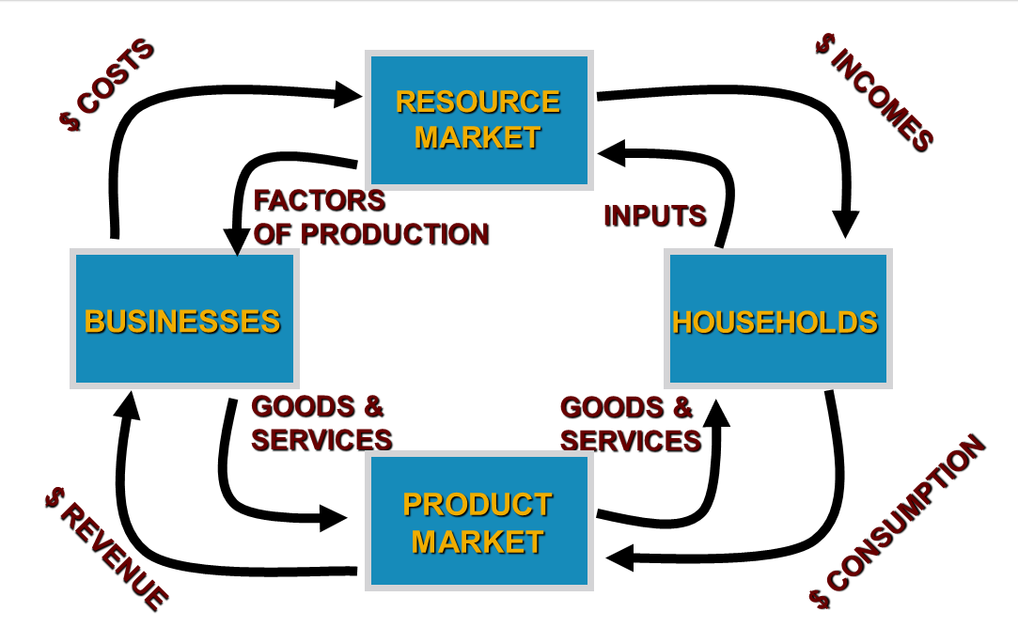
- Gross Domestic Product = Monetary measure of the total market value of all the final goods and services produced within a country in one year
  - Only includes final goods and services by eliminating intermediate goods used in production of these final goods or services
  - What was being produced in the economy, not what was being sold
  - Expenditures Approach: GDP = C + I + G + NX
    - NX = Exports – Imports
  - Income Approach: Adds up all the expenditures that are allocated as income to those producing the output
- Nominal GDP = GDP based on prices when output was produced
- Real GDP = GDP based on prices in some reference/base year = Quantity of year X * price in year 0
  - Real GDP = (Nominal GDP/Price index) * 100
- Price Index = (Price Basket In Y2) / (Price Basket In Base Year)
- GDP Deflator = (Nominal GDP / Real GDP) * 100

Lecture 3
- Economists measure the health of the economy by analyzing the
  - Real GDP Growth
  - Unemployment
  - Inflation
- Rate of growth of GDP = (GDP of Y2 – GDP of Y1) / GDP of Year 1
- Inflation Rate = [(CPI of Y2 – CPI of Y1) / CPI of Y1] x 100%
  - CPI = Consumer price index
- Unemployment Rate = [Labour Force – Employed]/ Labour Force
  - Aged 15 or older employed full time/part-time/self-employed
- Real GDP per capita = Real GDP / Population
  - Can only grow if the following increases
    - Worker productivity
      - Human capital
      - Physical capital
      - Resources – Land/other natural resources
      - Technology
      - Entrepreneurship
      - Political and legal environment
    - Average working hours per worker
    - The fraction of population employed
- Rule of 72
  - Divide 72 by the growth rate by the growth rate to find out how many years it takes a magnitude to double
- GDP per person = Total Real Output / Total Population

Lecture 4
- Four Business Cycles
  - Prosperity
    - Expansion of output, income, employment, prices, and higher standard of living
  - Recession
    - Economic activities slow down. Steady decline in output, income, employment, etc
  - Depression
    - Continuous Decrease of output, income and employment
  - Recovery
    - Rise in economic activities. Steady rise in output, income, employment etc.
- Characteristics of fluctuations in the economy
  - Goods are more sensitive to income and interest rate fluctuations
    - Cars, houses, capital equipment
  - Services and goods that are necessary are much less sensitive to fluctuations
    - Food, hospitals, schools.
- Y* = Potential output
- Output gap = Y – Y*
  - If Y* > Y then there is a recessionary gap
  - Expansionary gap Y* < Y

- Measuring Unemployment
  - Ages 15 or older are either
    - Doing paid work = Employed
    - Looking for work = Unemployed
    - Not looking for work = Not in work force
- Types of unemployment
  - Frictional Searching for jobs or waiting to take jobs soon
  - Structural Skills become obsolete
  - Cyclical “Demand-Deficient unemployment”, caused by recession
  - Seasonal Due to change in weather (jobs only available for 1-2 seasons)
- Full employment = All available labor resources are being used in the most economically efficient way.
  - Highest amount of skilled and unskilled labor that could be employed within an economy.
  - Remaining unemployment is frictional
- Cyclical Unemployment U = Actual unemployment rate | U* = Natural rate of unemployment
  - U > U* = Recession
  - U < U* = Expansion/Prosperity
- Okun’s Law
  - Every extra % of cyclical is associated with a 2 point increase change in output
  - (Y*- Y)/Y* = 2(U - U*)
- Real Quantity = Nominal Quantity/Price Index * 100
- Real interest rate = Nominal Interest rate – Inflation rate
- Unanticipated Inflation = When inflation turns out to be higher or lower than expected
  - Debtors win when inflation > expected, loans that are paid have less purchasing power than expected
  - Debtors lose when inflation < expected, loans that are paid have more purchasing power than expected
- Fisher Effect = nominal interest rates are high when inflation is high
  - Low when inflation is low
- Types of inflation
  - Demand Pull Inflation
    - Excess demand
  - Cost-push inflation
    - Per unit produced
    - Supply shocks
  - Complexities
Lecture 5
- AE = C + I + G + NX
- AE = C + I in a private economy, no government and trade
- Marginal Propensity to Consume = Change in Consumption/ Change in Output
- MPC + MPS = 1

Lecture 5 and Lecture 6 (up to slide #18)
Lecture 5 and 6 are very important, it explains the basic aggregate expenditure model, please review all of the slides and examples, you must understand:
- AE = Y derive the short-run equilibrium level of output
  - AE = C + I (in the private, closed economy)
  - Y is measure by real GDP
  - It is the point where the 45 degree line intercepts AE Function.
- The Consumption Function C = C0 + cY, which is a relationship between aggregate consumption spending and real income (measure by real GDP) and C0 is the autonomous expenditure, c is the marginal propensity to consume.
- The Saving function S = Y – C and S = S0 + sY, s is the marginal propensity to save and c + s = 1.
- The Investment function I = I_{g}, gross investment spending is not a function of real GDP, it is determined by investment demand. Investment demand and real interest rate is negatively related.

Note: Review Lyryx Lab 5

- AE = C + I = C0 + cY + Ig = (C0 + Ig) + cY, note that, AE function is also a linear function, it relates the aggregate spending with real output (measured by real GDP), the intercept of the AE function is given by (C0 + Ig), which is also called autonomous expenditure; the slope of the AE function is given by c, the marginal propensity to consume.
- The equilibrium output is that output which creates total spending just sufficient to produce that output (Y = AE)
- Saving equals planned investment (S = I)
- No unplanned changes in inventories
- AE = Y, Ye = (C0 + Ig)/(1-c); equilibrium output is equal to autonomous expenditure divided by (1 – MPC)
- The Multiplier
  - Multiplier = 1/(1-MPC) = 1/MPS
  - Multiplier = change in equilibrium output/change in autonomous expenditure
  - Multiplier = ΔY_{e}/ΔAE
Note: Review questions on Slide 17 and 18. Lyryx lab 6 Question 1 and 2. Additional MC questions posted on blackboard under Connect quizzes.

