Chapter 5

Module A
“What is Consciousness?”

Definition of Consciousness: awareness of internal and external stimuli
Awareness of:
- External events
- Internal events (hunger)
- Awareness of yourself (awake, excited)
- Awareness of thoughts about events (reflections on our thoughts of the weather)
-Continuously changes due to time of day, sleep, meditation, hypnosis, attention, drugs

Historical Movements:

- William James (1890): stream of consciousness influenced by attention (leaf in the river, the leaves we pay attention to is brought to our conscious)
- Freud (1900) behavior driven by unconscious (needs, wishes, conflicts) and conscious thought
Controlled and automatic processes (page 187)
- Skinner (1950): conscious cannot be observed therefore ignore.
- 1960’s: Widespread awareness of conscious-altering drugs, behavior

Variations in awareness and control

- Mind-wandering: refers to peoples experience of task-unrelated thoughts (15-50% of time mind wandering)

Operational Definition:
Physiological Index of Conscious

- Electroencephalograph (EEG) most common (consciousness): - Amplitude (height)
- Frequency (cycles per second)
EEG: is a device that monitors the electrical activity of the brain over time by means of recording electrodes attached to the surface of the scalp?
- Electromyograph (EMG): muscles tension and movement (jaw) (Sleep)
- Electrooculograph (EOG): eyes movement (sleep)

EEG Wave Patterns (based on frequency of brain waves)

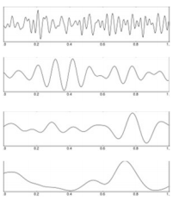
Beta: Awake, alert activity, 13-24 cps (problem solving)

Alpha: Awake, very relaxed, 8-12 cps

Theta: light sleep 4-7 cps

Delta: deep sleep (dreamless) <4 cps

DO NOT know whether mental state changes cause brain wave changes or vice versa. Maybe a third factor? (signals from subcortical structures)

Thinking Unconsciously?

Dijksterhuis, A. (2004). The merits of unconscious thought in preference development and decision making. Journal of Personality & Social Psychology, Vol. 87 (5), 586-598.

- Hypothesis: in some instances, thinking unconsciously leads to better decisions.
- if distracted from “conscious deliberation” some decisions may be enhanced

- Method:
N= 94 subjects (80 females, 14 males)

Pick a roommate:
- Bad profile: 4 positive, 8 negative attributes
- Medium profile: 6 positive, 6 negative attributes
- Good profile: 8 positive, 4 negative attributes

Roommate Attributes
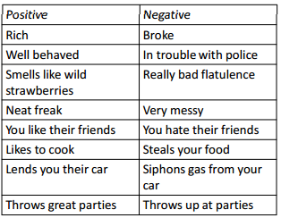

Subject Decision Making

- After reading about 3 potential roommates, subjects divided into 3 groups”
1) Decide immediately
2) Think for 4 minutes (conscious decision)
3) Play video game distractor for 4 min then decide (unconscious decision)

Results
Operational Definition: biggest difference between most/least liked represents best decision
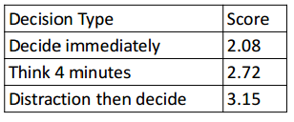
Rating of most attractive minus less attractive

Conclusion
- Thought and due consideration generally do lead to best decisions.
- But, in some circumstances unconscious consideration may lead to better decisions

Module B
Daily Changes

Biological Rhythms: periodic fluctuations in physiological functioning (189)

Circadian Rhythms: 24 hour biological cycles found in humans and many other species (chart page 190)

100’s bodily functions fluctuate in 24 hr cycles – persist even when external cues are eliminated
- Blood pressure
- Temperature (peak in afternoon, low point in the middle of the night), fall asleep at drop and awaken when rises.
- Heart Rate
- Appetite
- Mood
- Hormones
- Learning

Carcadian Rhythms is controlled by suprachiasmatic nucleus (SNC) in hypothalamus.

Light – retina – SNC – Pineal Gland – secretes hormone melatonin
- Regulates sleep and other body functions
(Melatonin supplements a regulated substance, dosage timing critical)

Control of Circadian Rhythms

- Bright light, especially sunlight
-Pineal gland secretes melatonin in darkness
- If no sunlight, lengthens to 24.2-25 hour cycle
- Daily fluctuation of body temp [best sleep when body temp lowest (36.1)]

Disruptions in Circadian Rhythms: Sleep debt: must be paid back with extra sleep

Jet Lag:
- Frequent flyers and airline employees – heart disease and autoimmune disorders
- Less jetlag going west
- a day recovery for each time zone crossed east
-2/3 of a day recovery for each time zone west
- 3 hours or more in time zone shifts take days to adjust

Delayed Sleep Phase Syndrome (DSPS):
- Difficulty falling asleep, caused by hormonal changes, late hours
- Adolescents, young adults

Advanced Sleep Phase Syndrome (ASPS):
- Fall asleep at very early times
- Treatment opposite of DSPS

Disrupted Circadian Rhythms due to Work

30% of Canadians work shifts (191)
- Biological clock – “go to sleep”
- Energy, efficiency, reaction time poorest.
- Daylight savings time in spring: 6.5% increase in accidental deaths
- Move work schedules forward from days to evenings to nights makes adjustment easier
- Rotate shifts every 3 weeks lessens effects

Melatonin: regulate human biological clock. (timing of dose is crucial)

For shift workers: progressively later starting times than progressive earlier starting times are beneficial

Module C
Sleep & dreams

Major Change in consciousness

Spend approx. 1/3 or about 25 years asleep
Dots = frequency of dreams
) Symbol = eye movement
- Men get less sleep than women,
- Working full time and stress = less sleep
- Higher income= less sleep
- Married couples = less sleep
- have children = less sleep
1/7 report sleep difficulties

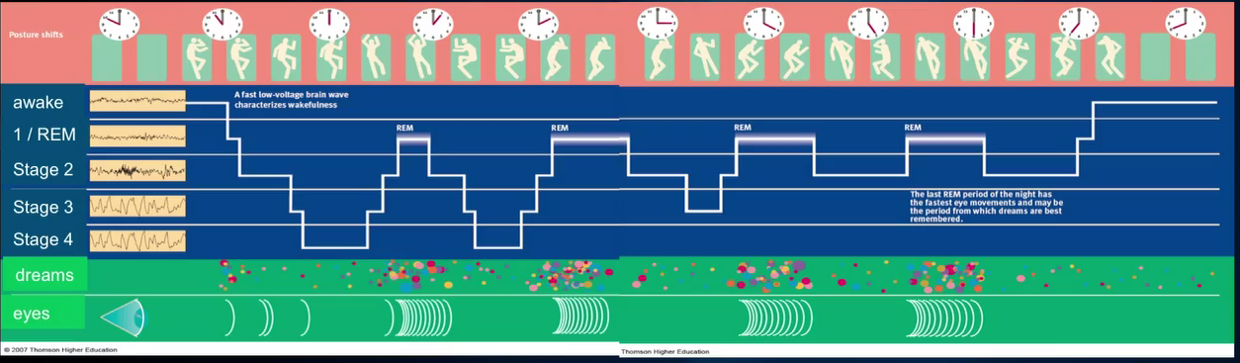
EEG of sleep cycles

Sleep Cycles

90 min cycle; 5 or 6 cycles per night

Stage 1/REM:
- Wake to sleep transition
- 1-7 minutes, more theta than alpha waves, hypnic jerks (muscular reaction jerk)

Stage 2:
- 10-25 min, more deeply asleep
- Sleep spindles: Brief, intense activity (high brief EEG signals)

Stage 3:
- 30 min, slow wave sleep: high amplitude, low frequency delta waves begin
- Delta waves reach 20%

Stage 4:
- Delta waves nearly 100%
- Growth hormone secreted primarily in stages 3 & 4

Rapid Eye Movement (REM): William dement
- EEG = awake, vivid dreaming, (Rem periods get progressively longer throughout the night)
- Muscles very relaxed (don’t really move), most dreams occur.
- High frequency, low amplitude
- get progressively longer (40-60 min)

NREM: Non-REM sleep consists of sleep from stages 1-4, absences of eye movement, little dreaming, varied EEG (tend to get shorter throughout sleep)

Age and Sleep:

15-24 = best sleep
35-44 = least sleep (time stress, family and work)

Babies after birth: 2 cycles, REM and NREM (more time in REM than adults)
- Elderly: may just need less sleep (1.5 hours less than young adults) (jet lag does effect them more though)

Culture and Sleep:

Psychological and physiological process of sleep does not differ between cultures
- Sleeping arrangements and napping customs are different
co-sleeping: discouraged in western culture, encouraged in Japanese
Mid-day napes: close shops in tropical areas of world (avoid working in hottest part of day)

Neural Bases of Sleep

Brain Structures:
- Most important structure for sleep and awakens is the reticular formation
- Ascending reticular activating system or (ARAS): consists of afferent fibers running through the reticular formation that influence physiological arousal if severed = constant sleep
- Pons,- medulla, thalamus, hypothalamus,- (midbrain) limbic system

Neurotransmitters:
- GABA, serotonin, others

Lifespan Sleep Decreases

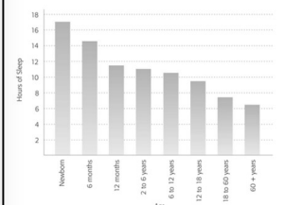
Infants and young children:
- Longest sleep time (16+)
- Highest REM and slow wave sleep

6-puberty:
- 10+ hours
- Most consistent sleepers and wakers

Adolescents:
- Sleep patterns influenced by schedules
- Poor sleep, poor school performance

Why Sleep?

Hypothesis 1: conserve organisms’ energy ( strongest hypothesis)

Hypothesis 2: Adaptive because it reduces danger (in an enclosed space)

Hypothesis 3: Restore energy, other resources

Higginson & Peters (2010)

Group 1
- At 9:00 AM, played Guitar Hero until 61%
- 12 hours later at 9:00pm played again

Group 2:
- At 9:00 PM, played Guitar Hero until 61%
- 12 hours later at 9:00 AM (1 sleep) played again

Results: 2nd Play Performance?
- Group 1: 63%
- Group 2: 68%

Conclusion?
- Sleep allowed Group 2 to consolidate learning & perform better

Dreams

REM dream:
- Almost always from first person perspective
- REM sleep
- Story-like qualities (beginning, middle, end)
- More vivid, visual, emotional than NREM dreams

NREM dreams:
- Less frequent
- Less memorable

Lucid dreams:
- Individual is aware of dreaming
- Often able to influence content

Try Lucid Dreaming

1. Relax
2. Close eyes, focus on imaginary spot
3. Intend to have a lucid dream
4. Tell yourself you’re going to dream about whatever you want.
5. Imagine yourself in a dream of type you want to have
6. Repeat until you fall asleep

Content and Significance of Dreams
- Content is usually familiar
- Common themes
- Waking life spill-over into dream – day residue (freud)
- Western (curiosity) dream = imaginary vs. Non-Western interpretations (alternate reality), spiritual, about the future, info about self

Dream Theories (Freud, Cartwright, Hobsor & McCarley)
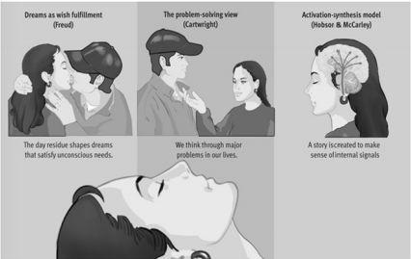

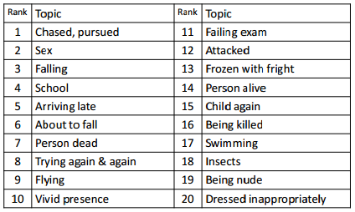
Typical Dreams (Neilsen et al 2003)

Interpreting Dreams

Freud: unconscious sexual, aggressive desires must be disguised. Wish fulfillment

Manifest Content: plot of dream at surface level
- Content as recalled by dreamer
- Sticks, trees, guns (penis) VS. caves, cupboard, boxes (vagina)

Latent content: hidden or disguised meaning
- Underlying meaning of dream
- Male, female, sexual organs

Cartwright: cognitive problem-solving: opportunity to work through everyday problems

Hobson & McCarly: dreams are by product of burst of activity emanating from subcortical areas

Activation-synthesis:
- Brain’s attempt to makes sense of random firing of cells
- People impose meaning on random mental activity

Module D
Sleep Disorders

Sleep Deprivation:

Complete deprivation: 3-4 days max

Partial deprivation or sleep restriction: make due with substantially less sleep than normal
- Impaired attention, reaction times, coordination, decision making
-Accidents: Chernobyl, Exxon Valdez (oil spill)

Selective Deprivation: (awaken during REM sleep)
- not a lot of daily functioning consequences, led to interesting sleep cycles (shift spontaneously into REM more frequenty) CHART page 199
-REM and Slow-wave sleep: rebound effect: spend extra time in REM sleep
NEED REM FOR memory consolidation and creativity

Sound sleep habits facilitate learning

Neurogenesis: formation of new neurons (happens during REM)

Sleep Loss and Health (page 200)

Sleep restriction = hormonal changes that increase hunger
= impaired immune system function

Sleep Problems:
- Insomnia
- Narcolepsy
- Sleep Apnea
- Nightmares
- Night terrors
- Somnambulism
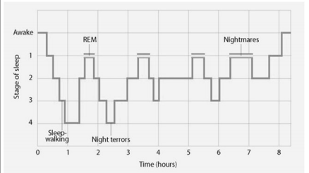
Sleep Problems & sleep Cycle

Major Sleep Disorders:

Narcolepsy:
- 1/2000 people, incurable
- Uncontrollable attacks of REM sleep (10-20 min)
- Could be triggered by fear, or excitement, (emotional triggers, Cataplexy)

Sleep Apnea:
- Breathing stops during sleep (min 10 sec)
- Must awaken in order to breathe
- 2% women, 4% men (30-60 yrs)

Insomnia:
- Difficulty falling or staying asleep; wakes too early
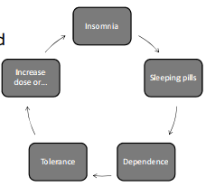
- Light, restless, or poor quality sleep
- 13% of Canadians
- Most common
- caused by anxiety, tension, depression, work stress, cocaine amphetamines
- People with hyperarousal are more prone (page 202)

Insomnia and Sleeping pills
- With continued use and constant dose, effects are diminished

Insomnia Treatment:
- Benzodiazepine sedatives
- drugs short term, behavioral intervention = long term (70-80% from CBT (cog-behav therapy)

Sleep Disorders: Parasomnias

Somnambulism (sleepwalking): Genetic predisposing
- During partial arousal from stage 4 sleep, first 1-2 hours of sleep
- Usually a shuffle or standing still (15 sec-30min)
- Ken parks: murdered inlaws while sleepwalking
- no underlying emotional or psych problems
- safe to awaken sleep walker

Night Terror:
- Stage 4 of sleep(NREM), starts with piercing scream
- 5-15 minutes
6% of childen 3-8yrs

Nightmares:
- Frightening dream during REM sleep, towards morning
- Associated with high anxiety, stress
- 5% adults
-10-50% children

Somniloquy (sleeptalking):
- Occurs during any sleep stage
- More frequent with children

REM sleep behavior Disorder (RBD):
- Troublesome dream enactments during REM period
- Talk yell gesture and flail during REM dreams
- Chased or attacked
- 50-60 men

Module E
Altered States

Hypnotic Susceptibility: a systematic procedure that typically produces a heightened state of suggestibility
80-95% of people hypnotizable to some degree
- 5% can reach deepest levels
- Highly hypnotizable include those prone to fantasy and high expectations of hypnosis

Hypnosis
Power of suggestion can include change in:
- thoughts
-feelings
-sensations
-perceptions
-behaviour

Medical hypnosis
- Control of pain in cancer, surgery, dentistry
- High blood pressure, bleeding, psoriasis, morning sickness, chemotherapy, burns
- Severe asthma, insomnia, phobias, multiple personality disorder
- Warts nightmares, sexual dysfunction
NOT USEFUL FOR: obesity, drugs, alcohol abuse, and smoking

Hypnotic Phenomena
1) Anesthesia: withstand a lot of pain (surgery)
2) sensory distortion/hallucination:
Positive Hallucinations: things not present
Negative Hallucination: fail to experience things
3) Disinhibition: - do stuff they normally wouldn’t do
4) Posthypnotic suggestions and amnesia: influence later bahaviour ( remember nothing that happened)

Theories of Hypnosis:

Sociocognitive (role playing)
- Expectations about how to behave – not a trance just expectaiton

(Altered state of consciousness) Dissociation theory: split or dissociation, between 2 streams of consciousness (driving while talking, [don’t remember driving 100 km because of deep conversation])

- Imaginative suggestibility: susceptible to suggestion when not hypnotized.

Mediation: a family of practices that train attention to heighten awareness and bring mental processes under greater voluntary control

Focus on: object, word, breathing, and body movements
-Block distractions, heighten awareness, mental processes under greater voluntary control

yoga, zen, transcendental meditation (NORTH AMERICAN)

Focused Attention: attention is focused on specific object, image, sound, body senstaiotn (meant to clear mind)

Open Monitoring: contents of ones moment to moment experience in a non judgmental or nonreactive way. (detached observer of ones own sensations, thoughts)

Mindfulness meditation = open monitoring, zen
TM: attention approach, Hinduism

Can help with physical & psychological probs (alpha and theta waves = more prominent, activity in prefrontal cortex)
- lower blood pressure and rumination
- control emotions, memory, focus
-blood flow to cerebral cortex increases
- Lower stress hormones
-enhance immune response
- reduce anxiety and drug abuse
- increased creativity and intelligence

Culture & altered States

All cultures find ways to induce altered states of consciousness
- trance rituals
-spiritual procession
- Religious rites
-tribal ceremonies
-Flooding senses with: repeating chants, whirling in circles, pungent incents

Psychoactive Drugs: chemical substances that modify mental, emotional or behavioural functioning (stats 215)

1) Narcotics: drugs derived from opium that are capable of relieving pain

- Morphine, codein, heroin, (opium poppy), oxycodone
- Mimic endorphins, produced by pituitary & hypothalamus
- Pain relief, calming effects (common in cough medicine, pain relievers)

Withdrawal symptoms:
- Begin 6-24 hours
- Nausea, diarrhea, depression, stomach cramps, insomnia, increase in pain common

2) Sedatives: are sleep-inducing drugs that tend to decrease central nervous system activation and behavioural activity

- Act on GABA receptors
- similar to alcohol feeling, relaxed pleasant)

Barbiturates:
- Depress CNS
- Sedative or sleeping pill effect depending on dose
- Drowsy, confused
- Thinking, judgment suffer
-Coordination, reflexes affected
- Fatal if overdosed (3X regular dose) particularly with alcohol.

Minor Tranquilizers:
- Benzodiazepines (Valium, Librium, Dalmane, Xanax)
- Abuse: temporary & permanent impairment of memory, other cognitive functions

3) Alcohol 79%:

Depresses CNS:

- Slurred speech
- Poor coordination, staggering
- Impaired depth perception
- Men tend to become aggressive, sexually aroused but less able to preform
- Decreases ability to form new memories
- Drinker’s expectations contribute to effect

4) Stimulants: drugs that increase CNS activation and behavioural activity

- Mimic neurotransmitter epinephrine
- Amphetamines, Cocaine, Caffeine, Nicotine
- Speeds up CNS
-Increase blood pressure, pulse rate, respiration
-Reduce cerebral blood flow, appetite

-Feel more awake
- High dose make people feel more:
- Nervous
- Jittery, restless
- Shaky, or trembling
-Unable to sleep

Caffeine:
Coffee, tea, cola, chocolate, 100s prescriptions & over the counter drugs

Withdrawal from moderate and heavy use induces:
- Nervousness
- Instability
- Headaches, drowsiness
- Decreased alertness

EEG’s confirm withdrawal effects on brain
- Increase blood pressure & velocity of blood flow in all 4 cerebral arteries
- Slower brain waves, decreased alertness and drowsiness

Nicotine:

- Increases alertness
- Suppresses appetite in some way
- Highly addictive
- Hypnosis treatments largely ineffective
- Nicotine patches help 1 in 5 smokers

Cocaine: briefer high than amphetamines
From coca leaves:
- Sniffed, injected, or smoked as crack
- Euphoria followed by crash characterized by:
- Depression
- Anxiety
- Agitation
- Powerful craving for more
Stimulate reward pathways in brain that fail with continued use
freebasing: chemical treatment used to extract nearly pure cocaine from street coke

Withdrawal (primarily psychological):
- Inability to feel pleasure
- Strong desire for more

Amphetamines: made in labs (powder = crank)
- Increase arousal
- Relieve fatigue
- Improve alertness
- Suppress appetite
- Rush of energy
- Release dopamine in frontal cortex improving attention concentration
- Can cause confused and disorganized behavior:
- Extreme fear/suspicion
- Delusions, Hallucinations
- Aggressive, antisocial behavior
- Manic behavior/paranoia

POSITIVE EFFECTS
- Amphetamines (Ritalin) affect parts of brain that control attention and concentration

5) Hallucinogens (psychedelics): diverse group of drugs that have powerful effects on mental and emotional functioning, marked most prominently by distortions in sensory and perceptual experience

Alter; distort perceptions of time, space, mood, feelings of unreality, hallucinations.

Marijuana (THC [tetrahydrocannabinol]): 14%
- Remains in body for days or weeks
- Impairs attention, coordination
- Slows reaction time even after high passed
- Interferes with concentration, logical thinking, and ability to form new memories
- Fragmented thought, confusion over recent occurrences
- Chronic use: loss of motivation, general apathy, decline in school/work performance
- Benefits: treatment for glaucoma, nausea in cancer patients, improves appetite; stops weight loss in AIDS, pain.

LSD (acid [Lysergic Acid Diethylamide]):
- Lasts 10-12 hours
-Extreme perceptual and emotional changes
- Visual hallucinations
- Feelings of panic
- Bad trips associated with
- Accidents, death, or suicide
- Flashbacks or ‘hallucinogen persisting disorder’

Designer Drugs:
- Mimic pleasurable effects of other drugs
- STP (Ecstasy (MDMA))
- Feeling of ‘connectedness’
- Derived from amphetamines
- Hallucinogenic, stimulant effect
- Can destroy serotonin releasing neurons; impair memory, verbal reasoning

MDMA (ecstacy): compound drug related to both amphetamines and hallucinogens (a few hours)
- friendly
-euphoric
-insightful
-empathetic
- increased blood pressure, muscle tension, blurred vision, insomnia, anxiety

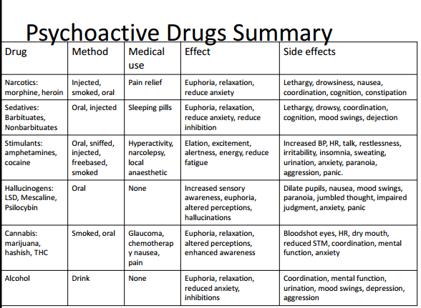

Module G:
Drugs and Behaviour

“Psychedelic”
- Coined in 1957 by Humphry Osmond (Saskatoon)
- Osmond was attempting to replicate hallucinations associated with schizophrenia using LSD

“Phanerothymic”
- Competing term by Aldous Huxley
INTOXICATION
ABUSE
USE
Use/Intoxication/Abuse (table on page 219)
- Fuzzy distinction
-Abuse: interferes with life (work, school, social)

Physical Drug Dependence

Drug tolerance: progressive decrease in a persons responsiveness to a drug
- Progressively less affected by drug
- Increasingly larger doses to get same effect

Physical Dependence:
- Drug tolerance
- Unpleasant physical withdrawal symptoms when drug discontinued

Psychological Drug Dependence:
Craving for pleasurable effects
- Harder to fight than physical dependence
- Drugs not physically addictive may still cause psychological dependence
- Learning processes important
Withdrawal: symptoms when drugs discontinued
- Exact opposite of effects produced by drugs
- Symptoms terminate when drug is taken again

REM Rebound: increase REM sleep after REM deprivation

Alcohol, amphetamines, cocaine, LSD = suppress REM
Withdrawal results in REM rebounds
Intensity of REM sleep increases
Often with unpleasant dreams/nightmares

Drugs and the Brain

Pleasure has neurological basis:

- Increase of dopamine in limbic system (nerves in the brain)
- Acts as reward, with motivational effects
- Produced by psychoactive drugs

-Effects cascade down, involving entire neurotransmitter system

Amphetamines: increase realease of neurotransmitters in Dopamine and NE (norepinephrine) synapses
- Interfere with reuptake of neurotransmitter molecules at DA and NE synapses
_INCREASE LEVELS OF DA AND NE

Cocaine: interfers with reuptake of DA, NE and serotonin

Two types of receptors in brain for THC:
Cannabinoid receptor: active chemical ingredient in THC
Endocannabinoid: activate receptors and influence GABA

DA (dopamine) system & Frontal Cortex
- DA system connected to frontal cortex
- Can shut down frontal lobes
- Irrational decision-making of addicts?

All drugs increase activity in: mesobolic dopamine pathway (reward pathway)

Causes that Increase DA activity
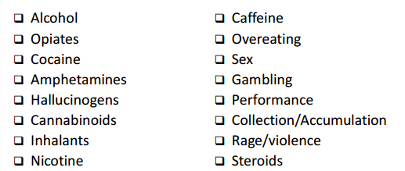

DA & Reward Systems

2 ingredients:

Liking: Experience or memory of pleasure in presence of reward
+
Wanting/Anticipation: willingness to work for reward

DA plays role in ‘wanting’
- explains why addicts continue to crave even after no longer pleasurable & physiological withdrawal complete.
- marshmallow experiment

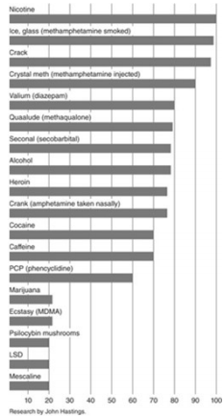
Addictive Potential of Drugs
- How quickly effects are felt
- How pleasurable effects are
- How long pleasurable effects last.
- How much discomfort when discontinued
- Price and availability

MOST ADDICTIVE = ease of obtaining + difficulty stopping
Gateway: alcohol/nicotine

Probability of Addiction/Abuse

Psychological & Social Risks: (increase risk)
- Impulsivity
- Stress
- Family Violence
- Early Start, more likely use heavier drugs

Protective Factors/Risk-reducing: (reduce risk)
- Parental support
- Coping skills
- Academic & social competence
- Cohorts with higher academic & social competence
- Cultural variables
- Increased time with family

Why youth experiment with drugs
1) Curiosity
2) Readily available and inexpensive
3) To express opposition to authority
4) Symbol of developmental transition

Drugs and Health

Overdose: (tables on page 219)
Greatest risk = sedatives, narcotics, alcohol (CNS depressents)
-heart attack, stroke, seizure

Direct Effects:
-direct tissue damage (snorting coke = damage nasal membranes)
- cardiovascular system
- smoking = repiratory problems

Indirect Effects:
- Attitudes, intentions behaviors
Stimulants = not eat or sleep properly
Alcohol = risky sex behavior
Impair driving = accidents
Alcohol = most diverse physical negative effects

Weed controversy:
High use = probably reparatory problems
Increases risk of car accidents
Link between schizophrenia and Weed

Reduces immune response (but infectious disease isn’t more common)
link between chronic use and negative cognitive functioning (may disappear after not smoking for a month)

New findings with Ecstasy:
4th most used drug amoung 15-24 year olds
- not addictive
-heat stroke, heart attack, seizures, liver damage
-often contains contaminants
-subtle long term effects on cognitive behavior

Nominal fallacy: is a false belief that a phenomenon is understood if its named or labeled

