- What is International Business?
  - International business consists of business transactions between parties from more than one country.
  - Foreign Direct Investment (FDI): direct investment in business operations in a foreign country.
  - Domestics businesses work within the boundaries of your country.
  - Differences between the two include:
    - Boundaries
    - Currencies
    - Cultures
    - Legal Systems
    - Availability of Resources (Natural & Human Resources)
    - Skills & Knowledge

- International Business Activities
  - Exporting & Importing
  - International Investments
  - International Licensing
  - International Franchising
  - International Management Contract

Going Global: Phases of Development
  - Domestic phase
  - Multidomestic phase
  - Multinational phase
  - Global phase

Globalization: What is it?
  - Globalzation is the shift toward a more integrated and interdependent world economy.
  - Globalization has several different facets including
    - Globalization of Markets
      - Globalization of Markets: moving away from an economic system in which national markets are distinct entities, isolated by trade barriers and barriers of distance, time, and culture, and toward a system in which national markets are merging into one global market.
    - Globalization of Production
      - Globalization of Production: the trend by individual firms to disperse parts of their productive processes to different locations around the globe to take advantage of differences in cost and quality of factors of production.
    - Globalization of Consumers

- Global Institutions
  - As markets globalize business activities and transcend national borders, institutions need to help manage and regulate the global marketplace.
    - Including the following organizations:
      - United Nations (1945)
      - General Agreement on Tariffs and Trade (GATT)
      - World Trade Organization (WTO)
      - International Monetary Fund
      - World Bank

- United Nations
  - An international organization made up of representatives from 193 countries.
  - It is headquarted in New York City and was formed in 1945.
    - They have four purposes:
      - Maintain international peace and security
      - Develop friendly relations among nations
      - Cooperate in solving international problems
      - Promote respect for human rights and be a centre for harmonizing the actions of nations

- General Agreement on Tariffs and Trade (GATT)
  - International treaty that committed signatories to lowering barriers to the free flow of goods across national borders and led to the WTO.

- World Trade Organization (WTO)
  - The World Trade Organization is mainly responsible for policing the world trading system and making sure nation-states adhere to the rules laid down in trade treaties signed by WTO member states.
  - The WTO is essentially a world trade referee for countries wanting to grieve that parties to trade agreements have broken the agreements.

International Monetary Fund
  - The IMF and the World Bank were both created in 1944.
  - The IMF loans come with strings attached.
  - In return for loans, the IMF requires countries to adopt specific policies aimed at returning their troubled economics to stability and growth.
  - These “strings” have generated the most debate.
  - Some critics charge that the IMF’s policy recommendations are often inappropriate.

- The World Bank
  - Not one single entity but rather a group comprised of the following:
    - IBRD – The International Bank for Reconstruction and Development
    - IDA – International Development Association
    - IFC – International Finance Corporation
    - MIGA – Multilateral Investment Guarantee Agency
    - ICSID – International Centre for Settlement of Investment Disputes

- Drivers of Globalization

1. Decline in barriers to the free flow of goods, services, and capital, since the end of World War II.

2. Technological change in communication, information processing, and transportation.

Contemporary Causes of Globalization: Strategic Imperatives
  - Leveraging a firm’s core competencies
  - Acquiring resources at low cost
  - Expanding into new markets
  - Competing with industry rivals

- Contemporary Causes of Globalization: Environmental Causes
  - Changes in the Political Environment
    - Reduction of trade and investment barriers
    - The collapse of European Communism
    - The ideological and policy changes undertaken by China and India
  - Changes in the Technological Environment
    - Advances in transportation
    - Improvements in information processing
    - Changes in communications technology

- Globalization: Good or Bad?
- Arguments for Globalization:
  - Increases economic growth rate, prosperity and opportunity for all participants
  - Technical innovation
  - Increases civil liberties and reduces inequalities
  - Leads to lower, higher employment in developing countries and better standards of living
  - Facilitates the transfer of technology, capital, intellectual property and skilled labour
  - Rising standard of living in developing countries
  - Limits on international behaviour

- Arguments Against Globalization:
  - Increases the wealth of giant corporations and leaves developing countries poorer
  - Harms the environment
  - Neuters government’s ability to govern and results in conspiracies between corporations and governments
  - Increases unemployment in developed countries
  - Reduces standards (manufacturing, health, quality, environmental)
  - Periodic financial crises are caused, disrupting the economies of many countries
  - Intellectual property is not respected
  - Homogenizes cultures
  - Fuels income inequality between nations; increases the gap between haves and have-nots
  - Globalization institutions run by developed countries

- Global Challenges: Managing Security
  - Physical Security: Examine company vulnerability and create a disaster recovery plan.
  - Digital Security: Guard proprietary information and confidential communications.
  - Reputational Risk: Require ethical and lawful behaviour from all employees and business partners.

- Global Manager’s Briefcase: Keys to Global Success
  - Communicate effectively
  - Know the customer
  - Emphasize global awareness
  - Market effectively
  - Monitor business environments

- Fundamentals of International Business – Country Differences in Political Economy

- Country Differences
  - This chapter focuses on how the political, economic, and legal systems of countries differ.
  - Collectively we refer to these systems as constituting the political economy of a country.

- Political Systems
  - Individualism
  - Collectivism
  - Democracy
  - Totalitarianism

Economic Systems
  - Market Economy
  - Command Economy
  - Mixed Economy

Legislation in Canada
  - Charter of Rights and Freedoms (1982)
  - The Canadian Human Rights Act (1977;1998)
  - Employment Standards Legislation (1970s)
  - Employment Equity Act (1986)
  - Pay Equity Act (1978)
  - Official Languages Act (1988)
  - Personal Information Protection and Electronic Documents Act (PIPEDA) (2004)

- How Canada Promotes Workplace diversity
  - Four Protected Groups
    - Women
    - Aboriginals
    - People with disabilities
    - Visible minorities

- Employer’s Role
  - Bona fide Occupational Requirement
  - Duty to Accommodate
  - Preventing Harassment
  - Valuing diversity

- Legal Systems
  - Legal systems refers to the rules or laws that regulate people’s behaviour and business practices.
  - Types of legal systems:
    - Common Law
    - Civil Law
    - Theocratic Law

- Contrats
  - Contract Law
  - International Trade and Contract Disputes

- Property Rights
  - Resources Include:
    - Land & real estate
    - Equipment
    - Capital
    - Mineral rights
    - Businesses
    - Intellectual Property
  - Actions against Property Rights
    - Private action
    - Public action and Corruption

- Corruption
  - Canada’s Bill S-21
    - Otherwise known as the Corruption of Foreign Public Officials Act that entered into force in 1999.
  - It has long been illegal to bribe officials in Canada.
  - Now it is illegal for Canadian officials to bribe officials in another country.

- The Protection of Intellectual Property
  - Intellectual Property: refers to property that is the product of intellectual activity such as computer software, music, formulas, etc.
  - Ownership rights are established through:
    - Patents
    - Copyrights
    - Trademarks
    - Trade Related Aspects of Intellectual Property Rights (TRIPS)

- Product Safety and Product Liability
  - Product Safety Laws set safety standards to which products must adhere, where it is going to be commercialized.
  - Product Liability involves holding a firm and its officers responsible when a product causes injury, death, or damage.

- Human Development Index (HDI)
  - Human Development Index (HDI) measures the quality of human life in different countries in terms of:
    - Life expectancy
    - Education attainment
    - Average incomes

- The Spread of Market-Based Systems
  - Paralleling the spread of democracy since the 19080s has been the transformation from centrally planned command economies to market-based economies.
  - More than 30 countries that were in the former Soviet Union or the Eastern European communist bloc are now changing their economic systems.
  - The overall attractiveness of a country as a market and/or investment site depends on balancing the likely long-term benefits of doing business in that country against the likely costs and risks.
  - Consider the determinants of
    - Benefits, costs, and risks.

- Organizational vs. National Culture
  - Definitions according to:
    - Edward Taylor: “that complex whole which includes knowledge, belief, art, law, custom, and other capabilities acquired by man as a member of society.
    - Geert Hofstede: “the collective programming of the mind which distinguishes the members of one human group from another…culture, includes systems of ralmes”

- Determinants of Culture
  - Norms and Value Systems
  - Religion
  - Political Philosophy
  - Economic Philosophy
  - Education
  - Language
  - Social Structure

- Social System
  - Individual
    - Definition: In Western societies, the individual is the basic building block of social organization.
    - Ex: In the United States and Canada, the emphasis on individual performance finds expression in an admiration of “rugged individualism” and entrepreneurship.
  - Group
    - Definition: Group is the association of two or more individuals who have a shared sense of identity and who interact with each other in structured ways on the basis of a common set of expectations about each other’s behaviour.
    - Ex: One central value of some Asian cultures is the importance attached to group membership.

- Language
  - Chinese is the “mother tongue” of the largest number of people followed by:
    - Spanish
    - English
      - However, the most widely spoken language in the world is English.

- Culture and the Workplace
  - How a society’s culture affects the values in the workplace is of considerable importance to an international business with operations in different countries.
  - Hofstede isolated five dimensions that he claimed summarized different cultures.
    - 1. Power distance
    - 2. Individualism vs. Collectivism
    - 3. Uncertainty avoidance
    - 4. Masculinity vs. Femininity
    - 5. Long-term vs. Short-term orientation

- Trompenars: The Seven Dimensions of Cross-Cultural Management:
  - Three Universally Shared Social Problems Addressed by Seven Fundamental Dimensions of Culture:
  - Relationship with other people
    - Universalism vs. Particularism
    - Collectivism vs. Individualism
    - Neutral vs. Affective
    - Diffuse vs. Specific
    - Achievement vs. Ascription
  - Relationship to Time
    - Monochronic vs. Polychronic
  - Relationship with Nature
    - Inner vs. Outer-directed

Cultural Change
  - Culture is not a constant; it evolves over time.
    - Several studies have suggested that economics may be an important factor in societal change.
    - The cultures of societies may also change as they become richer because economic progress affects a number of other factors, which in turn influence culture.

- Cross-Cultural Literacy
  - Doing business in different cultures requires adaptation to conform with the value systems and norms of that culture.
  - Adaptation embraces all aspects of an international firm’s operatios in a foreign country, including:
    - The way deals are negotiated.
    - The appropriate incentive and pay systems for salespeople.
    - The structure of the organization.
    - The name of the product.
    - The tenor of relations between management and the workforce.
    - The manner in which the product is promoted.

- Ethics in International Business

- More specifically, why do cultures differ in Ethical Response?
  - Because they differ in their underling, Moral Philosophies (related to the Ethical Conduct of Business, - which isn’t entirely distinguished by religious indoctrination)
  - Teleology/Utilitarianism (theory of consequences)
  - Deontology (theory of moral duty)
  - Justice (theory of “fair rules”)
  - Ethical Relativism

- What is a “Code of Ethics” and how can it help in international business?
  - A code of ethics is a formal statement of an organization’s primary values and the ethical rules it expects its employees to follow.
  - Codes of ethics are designed to perform one or more of the following four functions:
    - Increase public confidence
    - Decrease government regulation
    - Improve internal operations by providing consistent standards of both ethical and legal conduct.
    - Assist managers in responding to issues arising from unethical or illegal behaviour.

- Ethics and the Environment
  - The circumstances that affect ethical considerations
    - Political environment
    - Social-cultural environment
    - Technological environment
    - Economic environment
    - The need for corporations to remain economically competitive
    - The competitive environment

- Ethics – Influences
  - The effect of advances in communication technology and the competitiveness of global news media.

- Ethical – Terminology
  - The term ethics refers to the accepted principles of right or wrong that govern the conduct of a person, the members of a profession, or the actions of an organization.
    - Business ethics are the accepted principles of right or wrong that govern the conduct of business people.
    - An ethical strategy is a strategy or course of action that does not violate these accepted principles.

- What are some Common Ethical Dilemmas in International Business?
  - Employment Practices
  - Gender Equality/Human Rights
    - Differences in the way women & minorities are treated in the workforce.
  - Environmental and Ecological Concerns
    - The ecological impact of business operations.
  - False Information
    - Falsifying reports, abusing expense accounts
  - Dealing with Competitors
    - Industrial espionage
  - Bribery & Extortion
  - Social Responsibility
    - Organization’s obligation to conduct business in such a way that safeguards the welfare of society (much of above categories could fall within this category).

- Determinants of Ethical Behaviour
  - Personal Ethics
  - Decision Making Processes
  - Leadership
  - Unrealistic Performance Goals
  - Organization Culture

- Philosophical Approaches to Ethics
  - Fredman’s Doctrine
  - Cultural Relativism
  - The Righteous Moralist
  - The Naïve Immoralist
  - Utilitarian Ethics and Kantian Ethics

- 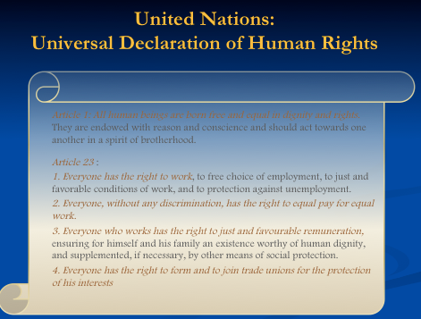

- Ethical Decision Making
  - There are five things that international business managers can do to make sure ethical issues are considered in business decisions:
    - 1. Favour the hiring and promoting of people with a well-grounded sense of personal ethics.
    - 2. Build an organizational culture that places a high value on ethical behaviour.
    - 3. Make sure that leaders within the business not only articulate the rhetoric of ethical behaviour, but also act in a manner that is consistent with that rhetoric.
    - 4. Put decision-making processes in place that require people to consider the ethical dimension of business decisions.
    - 5. Develop moral courage.

- 5-Step Process to Solve Ethical Problems

1. Identify which stakeholders a decision would affect and in what way.

2. Judge the ethics of the proposed strategic decision.

3. Establish moral intent.

4. Engage in ethical behaviour.

5. Audit the decisions reviewing them to make sure they are consistent with ethical principles.

What is Corporate Social Responsibility?
  - The degree of moral obligation that may be ascribed to the corporations beyond simple obedience to the laws of state.
  - An organization’s obligation to maximize its positive impact and minimize its negative effects in being a contributing member to society, with concerns for society’s long run needs and wants. CSR means being a good steward of society’s economic and human resources.
  - The intelligent and objective concern for the welfare of society that restrains individual and corporate behaviour from ultimately destructive activities, no matter how immediately profitable, and leads in the direction of positive contributions to human betterment, variously as the latter may be defined.

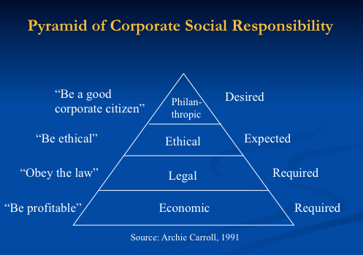

Contemporary Corporate Social Responsibility Concepts

1. Corporate Sustainability
  - Corporate activities demonstrating the inclusion of social and environmental as well as economic responsibilities in business operations as they impact all stakeholders.
  - Five levels
    - Compliance driven – a minimalist approach
    - Profit driven – a tactical approach
    - Caring – an accommodating approach
    - Synergetic – collaborative
    - Holistic – visionary

- 2. Reputational Management
  - Any effort to enhance the corporation’s image and good name.
    - Focus has moved away from media, public relations and crisis management to developing relations with all stakeholders.

- 3. Social Impact Management
  - Defined by the Aspen Institute as “the field of inquiry at the intersection of business needs and wider social concerns that reflects and respects the complex interdependency of the law”
  - Social Impact Management evaluates three aspects of business:
    - Its purpose (in societal and business terms)
    - Social context (are stakeholders concerned?)
    - Metrics (how is performance and profitability measured?)

- Corporate Citizenship
  - The demonstration by a corporation that it takes into account its complete impact on society and the environment as well as its economic influence.

- Natural Environmental Issues
  - Ozone depletion
  - Global warming
  - Solid and hazardous wastes
  - Freshwater quantity and quality
  - Degradation of the marine environment
  - Deforestation
  - Land degradation
  - Endangerment of biological diversity

- CERES Principles:
  - Protection of the biosphere
  - Sustainable use of natural resources
  - Reduction and disposal of waste
  - Energy conservation
  - Risk reduction
  - Safe products and services
  - Environmental restoration
  - Informing the public
  - Management commitment
  - Audits and reports

- International Trade Theories

- An Overview of Trade Theory
  - Adam Smith’s theory of absolute advantage
  - A country has an Absolute Advantage in the production of a product when it is more efficient than any other country in producing it.

- Benefits of Trade
  - The gains of trade arise because international trade allows a country to specialize in the manufacture and export of products that can be produced most efficiently in that country, while importing products that can be produced more efficiently in other countries.

- Heckscher-Ohlin Theory
  - The Heckscher-Ohlin theory predicts that countries will export those goods that make intensive use of factors that are locally abundant, while importing goods that make extensive use of factors that are locally scarce.
  - Like Ricardo’s theory, the Heckscher-Ohlin theory argues that free trade is beneficial.

- The Pattern of International Trade
  - The theories of Smith, Ricardo, and Heckscher-Ohlin
    - Some aspects of the pattern are difficult to understand.
  - Leading to the New Trade Theory
    - New Trade Theory stresses that, in some cases, countries specialize in the production and export of particular products not because of underlying differences in factor endowments, but because in certain industries the world market can support only a limited number of firms.
    - Mercantilism
    - Comparative Advantage
    - The Product Life-Cycle Theory

- Determinants of National Competitive Advantage: Porter’s Diamond
- 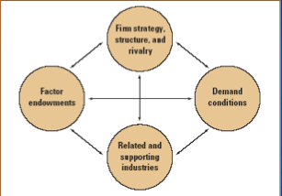

- Implications for International Businesses
  - Location Implications
  - First-mover Implications
  - Policy Implications

- The Political Economy of International Trade

- Free Trade
  - Refers to a situation where a government does not attempt to restrict what its citizens can buy from another country or what they can sell to another country.

- When governments intervene they use what we call “Instruments of Trade Policy”
  - Tariffs
    - Ad valorem tariffs
    - Specific tariffs
  - Subsidies
  - Import quotas and voluntary export restraints
  - Local content requirements
  - Administrative policies
  - Antidumping policies

- The Case for Government Intervention
  - Political Arguments for Intervention

1. Protecting jobs and industries

2. National security

3. Retaliation

4. Protecting consumers

5. Furthering foreign policy objectives

6. Protecting human rights

  - Economic Arguments for Intervention

1. The infant industry argument

2. Strategic trade policy

- The World Trade Organization
  - The WTO acts as an umbrella organization that encompasses the following bodies:

1. GATT

2. GATs (General Agreement on Trade in Services)

3. TRIPs (Trade Related Aspects of Intellectual Property Rights)
  - The WTO has taken the responsibility for arbitrating trade disputes and monitoring the trade policies of member countries.

- The Future of the WTO: The Doha Round
  - In 2001, at Doha, Qatar, member states agreed to launch a new round of talks and staked out an agenda.
  - The agenda agreed upon at Doha includes:

1. Cutting tariffs on industrial goods and services.

2. Phasing out subsidies to agricultural producers.

3. Reducing barriers for cross-border investment (FDI)

4. Limiting the use of antidumping laws.
  - Negotiations are still in progress.

- Foreign Direct Investment

- Foreign Direct Investment in the World Economy
  - Outflows of FDI refers to the flow of FDI OUT of a country.
    - This would mean Canadian companies buying property and/or setting up operations in another country.
  - Inflows of FDI refers to the flow of FDI INTO a country.

- United Nations Conference on Trade and Development (UNCTAD)
  - Many people talking about FDI quote information from UNCTAD.
  - UNCTAD, a United Nations entity, is the most authoritative and reliable source of information about global FDI by country and by activity and its statistics and diagrams are quoted by the right and left wings.

- The Direction and Source of FDI
  - Since World War II, the United States has been the largest source country for FDI.
  - A position it retained during the late 1990s, and throughout the 2000s.
    - Meaning American companies are going to other countries and buying up other companies and resources.
  - Other important source countries include the United Kingdom, France, and Japan.

- Forms of FDI:
  - Acquisitions and Mergers
  - Green Field Investment

- Canada – U.S.
  - In the field of international trade, until 2007, Canada and the United States shared the largest bilateral flow of goods, services, people, capital, and investments between any two countries in the world.
  - In 2008, China nudged passed Canada as top exporter to the United States.
    - It should be noted a large part of Chinese exports are from American companies in China like Nike exporting to Nike USA and subsidiary companies of Walmart exporting to Walmart USA.

- Why Foreign Direct Investment?
  - Because limitations of exporting and licensing are means for capitalizing on foreign market opportunities.
- 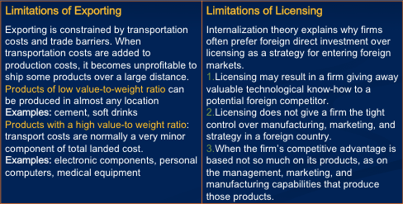

- The “Political Environment” and FDI

How Political Ideology effects FDI
  - Government policy toward FDI has typically been driven by political ideology.
  - Historically, ideology toward FDI has ranged from a radical stance that is hostile to all, to the non-interventionist principle of free market economics.

- Benefits of FDI to the Nation State
- 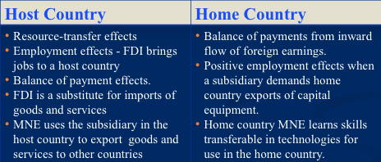

- Costs of FDI to the Nation State
- 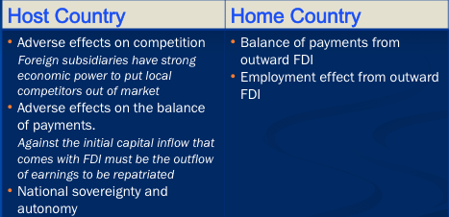

- Regional Economic Integration

- BRIC Countries
  - BRICS (also called the golden BRICS or the Big Four and now South Africa) refers to
    - Brazil
    - Russia
    - India
    - China
    - South Africa
  - They are the five largest economies outside of the OECD.

- The Case for and Impediments to Regional Integration
  - Economic Case for Integration
  - Political Case for Integration
  - European Economic Integration

- Political Structure of the European Union
  - The five main institutions in this structure are:

1. The European Council

2. The Council of Ministers

3. The European Commission

4. The European Parliament

5. The Court of Justice

The Euro
  - By January 1, 1999, the European Union adopted the Euro as a common currency in the Union.
- 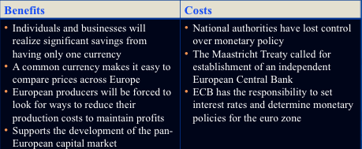

Canada and the European Union
  - Now there is a free trade agreement between the two.
  - Less tariffs, more access to European products and services and vice versa.
  - Now finalized.

- Mercosur
  - Originated in 1988 as a free trade pact between Brazil and Argentina.
  - The pact was expanded in March 1990 to include Paraguay and Uruguay.
  - The four countries of Mercosur have a combined population of 200 million.

- Caricom
  - A customs union was to have been created in 1991 between the English speaking Caribbean countries under the auspices of the Caribbean Community. Referred to as Caricom, established in 1973. However, it repeatedly failed to progress toward economic integration.
  - In early 2006, six Caricom members established the Caribbean Single Market and Economy (CSME), modeled on the EU’s single market, the goal of CSME is to lower trade barriers.

- ASEAN – Association of South East Asian Nations
  - ASEAN members are countries that do not include the big economies of China, Japan, South Korea.

