International Business Lecture 3
There is a written report due and a presentation for both products. Written report is due on Oct 9th regardless of when you present. Need to have 2 Multiple Choice questions. Page limit 10 pages max double spaced.
MC from groups will be on the midterm exam. Midterm is all multiple choice.
Business Ethics
The Cultural Environment-
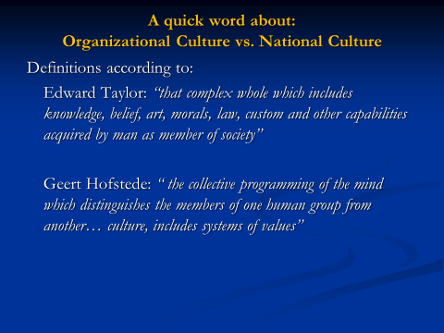
Only thing to compare with Canada will be the cultural models.
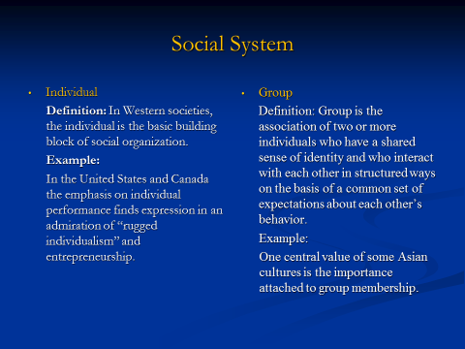
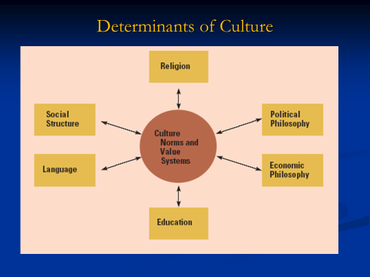
Education level, economics beliefs. Language. English is international
People in individualistic society view themselves as autonomies.
Individualistic society is more a “doing” society. What you can do is similar to your worth.
Collective = social strata.
Culture and workplace
- Power Distance – A lot of layers of management. These societies will have patience for that. A lot of eastern societies.
High example: India. Fathers, mothers are considered high figures at home.
Lower power distance society – ex. Canada, Europeans. People want more democracy. Cannot dictate to people.
- Individualism versus Collectivism
Person is the basis, you decide what you think is good for yourself. vs. People think as “we” view themselves as a father, brother. Based on how many groups the person is from.
Collectivism you care about every association you have.
- Uncertainty avoidance
Tolerance people have towards ambiguity. Ex. Canada has lots of tolerance for uncertainty. People going by the book vs. trial and error. Tolerance for mistakes.
- Masculinity versus femininity
Gender stereotypical assumptions. Material possessions. In feminine societies, focuses more on the person, more forgiving, more trusting. Collectivist society, Middle Eastern very high on masculine scale.
Ex. In masculine society, certain roles are frowned upon, social norms deciding what is acceptable or unacceptable.
- Long-term versus short-term orientation
Anything drastically different from traditions, wont change quickly. Ex. French are very past oriented because traditions very important to them
Canada, China, USA is more present-oriented. Not focused on the past, view future.
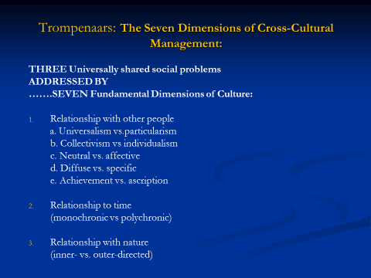
When preparing slide to compare Canada, can compare these five dimensions between countries!

a. Rules or Exceptions. Ex. Charter of Rights and Freedoms, universalism- applies to everyone.
Particularism- obligation. Loyalties, do not apply same rules vs those who you don’t know
C. Neutral- reason or logic. Looking at evidences and rationalize to deal with issues. Don’t show emotions in public.
Affective- emotion based societies, not just applying logic, feeling conscience or gut feeling.
D. Diffuse vs. specific
Diffuse- Swiss and Germans, need to gain lots of trust. Distinction between public/ private life.
Specific- Canada and USA, more open to share things such as politics. People talk on airplanes.
E. Achievement vs. ascription
Achievement – What can you do. More doing culture. Wouldn’t see a pure. What school do you go to?
Ascription- Age, gender, family, education etc. define you as a person. Most societies are ascribed. Would see a pure.
Relationship to time
Monochronic- linear society. People think time is money, one thing at a time. People like to be organized. Timelines.
Polychronic- societies are more flexible, not obsessed with timelines. Common when people are late. People are not obsessed with timelines.
Relationship with nature
Inner- believe they can control their nature. Human domination.
Outer directed- believe in going in harmony with nature. People believe in harmony, god, destiny. Belief that they cannot impose their will.
Global mindset- better ability to work with people with a diverse mindset. Different but not superior or inferior. Cross-Cultural Literacy.
Canada- likes to have contracts written down. Vs. Morocco where people believe they are friends and don’t need contracts.
Ethics in International Business & International Trade Theories
Ethical triangle
1. Am I doing right thing?
2. Intentions
3. Respecting other people/ world?
Teleology/Utilitarianism – evaluate and then make decisions. Americans are Utilitarian- they believe in consequences. Teleology believes in right and wrong way of doing things- ethics.
Deontology- morality.
Justice- fair rules, dos and don’ts. If someone disobeys, legal grounds.
Ethical Relativism- Australians very high, - different cultures, have to take the local approach, cannot take home country values and impose.
Pyramid of Corporate Social Responsibility on Exam.


