Chapter 1

Business Sectors:
Primary Sector:
- Direct use of natural resources
- Ex. Mining, Fishing, Forestry
Secondary Sector:
- Acquires the natural resources from the primary sector and turns them into a finished product
- Ex. Companies that make clothing, refine oil, car manufacturers
Tertiary Sectors:
- Provides services to consumers and companies
- Ex. Fido, Rogers, Bell

What is our Focus?
Retailer:
- Earns profit by reselling goods or services to consumers in order to satisfy their wants needs
Wholesaler:
- Buys large quantities of goods from manufacturers, warehouses them, and then resells them to retailers.
- Wholesalers do not sell to consumers

Who cares about the business and why?
Stakeholders:
- Individuals or groups who either affect the business or affected by actions of the business
- Stakeholders have an object, something they want from their relationship with the business
- Can either be external or internal
Internal Stakeholders:
- Work for the business
- General objectives are:
  - Ability to keep their jobs
  - Do their jobs more efficiently
  - Get promoted
  - Get paid for their work
External Stakeholders:
- Outside of the business
- General objectives are:
  - Decisions that relate to making money
  - How the business can affect them, either positively or negatively

Internal stakeholders and what they want:
- General employee
  - Earn high wages and keep their jobs
- Marketing manager:
  - Impact of advertising (marketing campaigns
- Company lawyer :
  - Ensures laws are followed
- Tax manager:
  - Ensures taxes are minimized and tax laws are followed
- Owners(sole proprietor):
  - Maximize profit, grow/expand the business
External stakeholders and what they want:
- Shareholders (of a corporation)
  - Decide to invest or not invest, earn income from their investment
- Governments:
  - Ensures business pay taxes
  - employ more people
  - follow laws
- Customers:
  - Buy quality products at low prices,
  - get the best warranties on products or services
- Suppliers:
  - Sell products/services to the business
  - get paid on time and in full
- Creditors(banks):
  - Decide whether to lend money and how much
  - ensures business repays loan plus interest on time
- Society/community
  - Employ people from the community
  - Improve the standard of living
  - Run their business in an ethical manner
  - Reduce any negative environmental effects of their business practices
  - Support local charities

Why is it important to know about stakeholders and their objectives?
It is important to know because:
- Financial information a business provides is often the key information that external stakeholders use to make decisions
- By better understanding the stakeholders and their objectives we can better understand the need for financial information and how important it is that stakeholders can depend on that information for their decision making

What information do stakeholders use to answer their questions and make decisions?
- Accounting system:
  - This is where companies record their business transactions
  - Information system that collects, groups, and communicates a business’s financial position, including its financial health and profitability
  - Without an accounting system, stakeholders would not be able to make many of the decisions that help them meet their objectives
- Financial Statements:
  - Used by external stakeholders
  - Tells a business’s, what they do and how well they do it
  - Provide business’s financial performance, its current financial position and its cash flows
  - Used by external stakeholders to analyze a business and answer questions, which allows them to make decisions and meet their objective

What qualities must financial information have to make it useful for decision making?
- Qualitative characteristics:
  - Qualities that stakeholders want financial information to have so they can use the information for decision making
Quality: | Description:
Faithful | Truthful, meaning it is complete, free of error, and neutral (unbiased).
Relevant | Applicable or pertinent to your decision making, helps you predict the future and/or confirm decisions you made in the past.
Comparable | Can compare the same business from year to year OR between two different businesses in the same industry.
Verifiable | Anyone looking at the information would determine similar amounts.
Timely | Information is provided quickly (as old information is less useful).
Understandable | Group and present information so it is clear and concise.

Why is this important?
- It is important to know how trustworthy it is
- If information does not have these qualitative characteristics then it may mislead the stakeholders, causing them to make wrong decisions

How are qualitative characteristics used to produce useful information?
- It is sometimes difficult to apply qualitative characteristics to the recording of financial transactions
- As a result, qualitative characteristics are used to develop assumptions that qualitative that specify how accountants must record, measure and report information.
Assumption | Description:
Separate Entity | Only the activities of the business are included in the business’s financial information.
Unit-of-Measure | All transactions must be reported using the monetary unit of the country the business's head office is located in, even if the business has offices in many countries.
Going Concern | Businesses will continue their operations well into the future.
Historic Cost | All purchases will be recorded at the amount that was paid for them.
Time Period (Periodicity) | Information will be provided quickly, when it is still relevant to the stakeholders (has the capacity to affect their decisions).
Full Disclosure | If something will affect the decisions of the external stakeholders, it must be reported.

Why is this important?
This is important because:
- Is impossible to make an informed decision unless the information provided can be trusted
- When preparers use both qualitative characteristics and assumptions to
  - Record
  - Measure
  - Report financial information
- External stakeholders gain assurance that the information provided is useful for decision making

GAAP
- Qualitative characteristics and underlying assumptions are part of generally accepted accounting principles, called GAAP
- Preparers of accounting information use GAAP as a guideline when preparing financial accounting information
- Overall objective is to provide financial information about a business that is useful to external stakeholders for decision making

Similarity
Qualitative Characteristics
- Faithful
  - Separate Entity
  - Full Disclosure
- Relevant
  - Separate Entity
  - Going Concern
  - Time period
- Comparable
  - Unit – of – Measure
- Verifiable
  - History Cost
- Timely
  - Time Period
- Understandable
  - Ties to all

Chapter 2

What are the financial reporting elements according to GAAP?
Purpose of financial reporting elements:
- To produce financial statements that is used for external stake holders
Five financial reporting elements
- Asset
  - Owned
    - Ownership has transferred
  - Benefit the company in the future
    - Used to generate revenue
  - Happened in the past
    - Transfer was a past event
- Liabilities
  - Owed to third parties
    - Obligation
  - Repaid in the future
    - Give up cash, goods, or services
  - Happened in the past
    - Due to past event
- Equity
  - Wealth due to owners
  - Owners Capital
  - Profit Retained
- Expenses
  - Used, consumed or incurred to help generate
  - Ex. Gas for lawn mower
- Revenue
  - Income Earned – has done their job
  - Service already providED
  - Good already deliverED

What is the interrelationship between the financial reporting elements?
Revenues - Expenses = Profit

How does profit tie into equity?
Retained Earnings = Profit – Dividends
Equity = Owner’s Capital + Retained Earnings

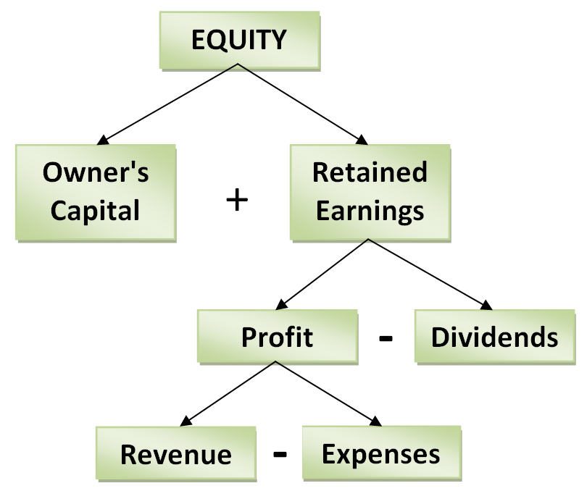
Equity = Owner’s Capital + Revenue – Expenses – Dividends

How do assets and liabilities tie into equity?
Assets – Liabilities = Equity

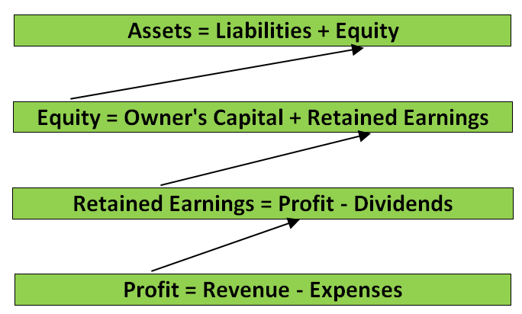

Chapter 3
How to name your business?
- Ask for expert help
  - Downside is cost – 80,000 dollars
  - Same money in the long run
- Reinforce key elements of the business
  - Less effort to explain
- Do not use numbers, or geographic area
- Choose comforting names, appeal to customers that you are trying to attract
- Do not pick names that are
  - Long
  - Confusing
  - Personal puns
- Consider coining a name
  - Can be more meaningful than existing words
- New forms of name, do trademark search
- Final decision:
  - Best fit
  - Best description
- Plan to spend a few weeks on picking a name

What are 6 keys to a memorable company name?
- Can I keep the name under 6-7 characters
- Is it easy to spell
- Easy to pronounce
- Alliterate
  - Memorable
- Animal/color
  - Ex. Firefox
- Abstract is ok, do not get caught up if they do not make sense
  - Some industries cannot use abstract ideas.

Are other important considerations when naming a business?
- To able to use the business name as your domain name in the internet
- Once decided on a domain name, check out domain name registration companies
- If you are selling yourself, use your name as the business and domain name.

Is every business activity recorded in the accounting system?
- An event is
  - a business activity of importance to a business
- transaction
  - an event that is measurable and realized

Can you describe the four financial statements and what they are used for?
- Balance sheet
  - Shows a business their financial position, details of assets, the liabilities, and the equity
  - Used to assess the business’s financial position
  - Balance sheet is used to answer the following
    - Breakdown of the assets?
    - Are the assets liquid enough so that liabilities can be paid when they come due
    - Is there enough liquid to pay off the debts
    - Breakdown of liabilities?
    - when are debts owed and how much debt is there in relation to the assets
    - how much of the business is funded through debt (liabilities) and how much is funded through owner’s contribution
- Retained earning
  - Shows how much of the profit is kept in the business
  - How much is paid out to the owners
  - Answers questions such as
    - Did the business pay dividends to the owners?
    - Given the profit were the dividend payments high enough? Or they too high?
    - How much of the profit was retained (kept) in the business for future growth and expansion?
    - Could the business pay out additional dividends in the future
- Income statement
  - Shows business profitability
  - Whether the revenues are higher than the expenses and by how much
  - Answers the following
    - Are there enough profit to pay dividends
    - Was the profit high enough in comparison to the revenues earned
    - If the business has loans or wants to borrow money from the banks is there enough profit to repay the loan, plus interest, both now and in the future
    - Is the business generating enough profit to repay all the debts as they come due
- Statement of Cash flows
  - Shows the cash inflows and outflows over the period
  - Shows the cash position at the end of the period
  - Answers basic questions such as
    - Where did the business get and spend their cash?

What are the activities that a business is involved in?
- Financing
  - Raise (or repay ) capital
  - Personal capital
  - Borrow money (debt financing)
  - Sell shares (equity financing)

- Investing
  - Purchase of property plant and equipment
  - Purchasing assets used in a business over a long term
- Operating
  - Earn revenues
  - Incur expenses
- Financing:
  - Taking out and repaying debt
- Investing
  - Buying and selling long lived assets
- Operating
  - Revenues and expenses of the business

Chapter 4

What is the difference between service and merchandising businesses?
- Service businesses
  - They do not deal with complexity of inventory
  - Provide services, may sell products
  - Ex. Accounting firms, Banks, Fed Ex
- Merchandising
  - Both and sell inventory
  - Take into account change in inventory
  - Prepare multiple income statements
- GDP
  - Measure how fast the economy is growing
  - GDP growth is driven by personal consumption
  - Retail sales is the number 1 personal consumption

What is the difference between profit and gross profit?
- Profit
  - Revenue less all expenses that were used to generate revenue
  - Includes the cost of the inventory that was sold to generate the revenues as well as advertising expense, rent expense, utilities expense
- General and administrative expenses
  - Advertising, rent and utilities, expenses that are incurred to allow the business to run
- Gross profit
  - Ignores all of the general and administrative expenses and is calculated as revenue less cost of the inventory that the business sold.
  - Gross profit divide it by sales revenue then multiply by 100, you get gross profit margin
  - This is a better measure because it allows one to compare different size companies in the same industry so you can make decisions

What is one of the main concerns for merchandising businesses?
- Selling products is very competitive because the merchandisers are trying to meet the wants and needs of their customers
- If inventory is not able, then customer might go to another seller
- Recording and tracking inventory is therefore a key success factor for merchandising businesses.

What are the two inventory tracking systems that merchandise can use to track inventory?
- Perpetual inventory system
  - Records every purchase and sale of inventory when it happens
  - Computerized
  - Business know what inventory is sold and how much inventory is left for the next day
  - Also analyze what customers want

- Periodic inventory system
  - Records the cost of inventory when it’s purchased; however, when inventory is sold, the selling price is recorded but the cost is not removed from the inventory account.

What are the two different types of shipping terms?
- F.O.B. shipping point
  - The buyer pays the shipping costs
  - Buyer owns the goods while the good are in transit
  - If anything is to happen to the goods while in transit, the buyer will be responsible for it
- F.O.B destination point
  - The seller pays for the shipping costs
  - Seller owns the goods while they are in transit
  - The seller will be responsible for the goods while they are on transit

What would credit terms with a discount look like?
- Would look like 2/10, n/30
  - n/30 means that you have to pay the full amount in 30 days
  - 2/10 means that if you are a buyer, you can receive 2% discount if you pay within 10 days from the date of delivery.
  - If you don’t pay within 10 days, then the seller will want you to pay the full amount within the 30 days of delivery

Chapter 5

What are the three inventory costing methods?
- 1. Specific identification
- Average cost
- First-in, first out (FIFO)

Specific identification:
- Cost of every single item of inventory is calculated and the item is tagged with the cost
- Cost of every single item of inventory can be determined
- When an item is sold the cost of that specific item is moved from the inventory account (an asset decreases) to cost of goods sold (an expense because it was used to generate revenue)
- Method is expensive and time consuming because the accountant is required to keep detailed records.
- Used by business that carry unique products, luxury cars etc.

Average cost:
- Calculated like an average

First-in, first out:
- Assumes that the oldest inventory is always sold first and the newest inventory is still in inventory

So, we’re finished with inventory, right?
- Shrinkage
  - Both employees and customer steal inventory
- Human error
  - When employees accept new shipments from suppliers
  - When they put out the inventory
  - Or when they scan the inventory through the cash register during a sale, they can make mistakes
- Damages
  - Inventory is sometimes damaged
  - This should be reported but employees might not do so
- Obsolescence
  - Inventory might be obsolete and have no future value because no one will buy it

What has to be done when a business does a physical inventory count?
- First
  - Employees will be asked to help count every single item of the inventory
  - Each employee will be given a count sheet
  - The count will be compared to the inventory records after the count is finished
- Second
  - Count has to be adjusted for inventory in transitDexter Inc. recorded net sales of $58,000 during the period, and its cost of goods sold amounted to $32,480. Compute the company's gross profit ratio.

