Two different approaches of bookkeeping: -
- Cash Basis – Usually for small businesses. Involves cash transactions ONLY. Revenue is only recorded when cash is exchanged and when expenses are actually paid (with cash)

- Accrual Basis – Usually for large corporations. Revenues are recorded when earned and expenses are recorded when incurred.
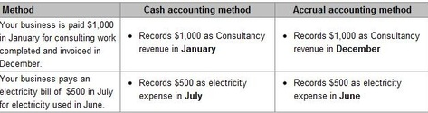

- Contributed Capital – Given to the company by shareholders in exchange for shares.

- Retained Earnings – Generated by company though profitable operation

Unadjusted Trial Balance - is created before any adjustments are made in the ledger accounts. Debits ALWAYS have to equal credits
Adjusted trial balance adjustments ensure that revenues and expenses are up to date so that the adjusted net income number will tell us whether the company was profitable during the period or not.
Net income is not the amount of cash generated during that period!

The order of accounts placed on a trial balance are: -
- Assets
- Liabilities
- Shareholder’s equity
- Revenue
- Expenses

Net profit margin = Net Income
Total Revenue
- Indicates how much profit is earned from each dollar of revenue
- A higher ratio = better performance

Ending Retained Earnings = Beginning retained earnings + net income – dividends

Debt-to-Asset ratio = Total Liabilities
Total Assets
- A higher ratio = sooner pay liabilities

