- Income statement (statement of operations)
- Statement of retained earnings
- Balance sheet (statement of financial position)
- Statements of cash flows

- Net income from the income statement is reported on the statement of retained earnings
- Ending retained earnings from statement of retained earnings is reported on the balance sheet under shareholder’s equity
- Cash on balance sheet = ending cash on the statement of cash flows (pg#14)

Owners cannot lose more than their investment in the corporation. Divides up the ownership into shares which could be sold.

Net income is not how much cash you made. Net income is not necessarily equal to cash because on the income statement revenues are reported when earned and expenses when incurred regardless of when cash is received or paid

Managerial Accounting Reports –updated reports which include detailed financial plans about the operating performance of the company.

Separate entity assumption – requires that a business’s financial reports include only the activities of the business and not those of its shareholders

Unit of measure assumption – Results of business activities should be reported in an appropriate monetary unit, which in Canada is the Canadian dollar.

Financial accounting for external users (creditors, investors etc.)
Managerial accounting for Internal users (managers, supervisors etc.)

Calendar year is a 12-month period ending on December 31st
Fiscal year can be a 12-month period ending on any day other than December 31st

Operating = buying supplies, renting a building, repairing
Investing = land, equipment, purchasing investments, lending loans
Financing = borrowing or paying bank, receiving contributions, paying dividends

Auditors report whether the financial statements fairly present the transactions and comply with GAAP

Companies hire auditors that examine their financial records.
CPAB conducts inspections of audit firms

Two primary external users:

- Creditors – anyone to whom money is owed

- Banks use financial statements to assess whether a person will be able to repay the money he has borrowed from the company. They use financial statements to keep an eye on how a business is doing and interfere if it seems like the business will have trouble repaying.

- Suppliers want to be sure a business can pay them for the services they provide. They usually look at the business’s credit standing.
Creditors are mainly interested if the company is generating enough cash to make payments on its loans. Does the company have enough assets to cover its liabilities?

- Investors

- Shareholders rely on the financial statements to evaluate whether the business is financially secure and likely to be a profitable investment
Investors are mainly interested on the return on their contributions to a company

Private Enterprise - whose shares are not traded on a public stock exchange can choose to follow either IFRS or ASPE

Publicity accountable profit-oriented enterprise - whose shares are traded on a public market. Required to use IFRS
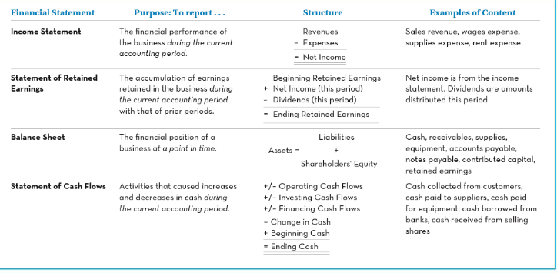
Income Statement
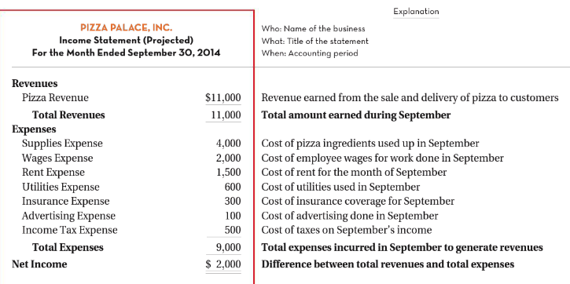

Statement of Retained Earnings

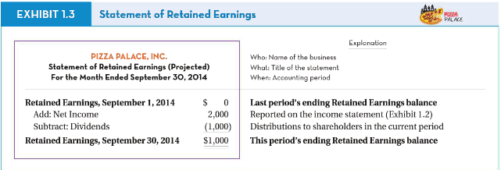

Balance Sheet
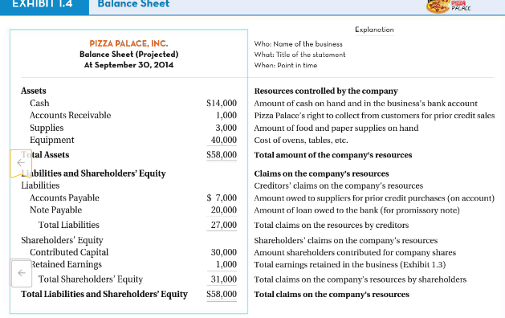

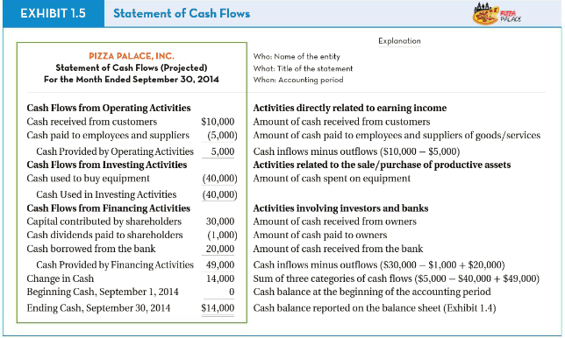
Statement of Cash Flows
Sole Proprietorship
Advantages
- Low cost to start your business
- You keep all the profit
Disadvantages
- Unlimited liability
- You are personally liable for all debts and actions of the company

Partnership
Advantages
- more capital is available for the business
- you’ll have greater borrowing capacity
Disadvantages
- there is a risk of disagreements and friction among partners and management
- shared profits

Corporations
Advantages
- Limited Liability
- Ownership is transferrable (sell shares)
Disadvantages
- Establishing a corporation is a complex process

