ECOR 1010 – Introduction to Engineering

Assignment #6
Assignment Title: BIVARIATE DATA, REGRESSION AND CORRELATION
TO Marking TA:
Name: SAUMITRA GOKHALE
Email:

Lab Section: [Email]
Room: ME2556 – Carleton University

FROM:
Email: [Email]
Student Number: [Email]

Number of Figures and Tables (Including handwritten ones): 7
Last Date and Time of Revision: 20 November 2014

Introduction
The main aim of performance of the bivariate data analysis lab is to determine the prediction of the two strengths of the two alloys with two different carbon content, one with 0.33% and the other with 1.0%. The prediction was made by three model equations those were; linear equation model, polynomial three model and the polynomial six model. All the three equations gave different coefficients of determination and hence different predicted values by the three models. However the polynomial three model was the one which provided relatively more accurate predictions and that was used to predict the strength of the two unknown metal alloys.

Materials and Methods
The used materials in the lab were; calculator, computer and Microsoft Excel program. The methods followed in this lab were as follows; the data were copied and pasted on the Excel sheet, the carbon content and their respective strengths. With the help of excel the mean and standard deviations of the two data inputs were calculated. The square of data deviations from the mean were calculated for both inputs. Then, the product of x variations and y variations were calculated for every observation and then their summation was found. Finally with the help of the equations, the correlation coefficient and coefficient of determination were calculated as shown in the FIGURE 1 in step by step form. To check the accuracy of the equation results, the excel tool for regression was used to provide the full data analysis.

results
The equations for the best fit line was found to be (y=326.823x + 278.609) and hence the slope was found to 326.823 and the intercept was 278.609. The correlation coefficient was found to be 0.935 and the coefficient of determination was found to be 0.874. The same statistics were calculated with the excel for regression, every statistic was the same except for the gradient of the linear graph which was considered with the confidence of 95% and found to be 326.823 +- 110.694 and the y-intercept was found to be 278.609 +- 54.497. The two strength for the linear model was 386.462 for 0.33% and 605.433 for 1.00% carbon content. The predicted strength for the polynomial 3 was 378.187 for 0.33% and 502.878 for 1.00%. The predicted strength for the polynomial 6 were 13830.264 for 0.33% and the 1135743.4 for 1.00% carbon content as seen in the FIGURE 4

discussions
From the results obtained by the three models of equations it is seen that even though the coefficient of determination value of the polynomial 6 was the highest with 0.99 it cannot be used to predict because it varies greatly with the other measured values and the linear equation with 0.93 also had a large variation to the corresponding measured value relative to the third polynomial. The predictions of the third polynomial however was very close to the corresponding measured value with the coefficient of determination 0.96 and thus that was the model with the best predictions.

Conclusions
The predictions on the strengths of the metal alloys were 569 for the 0.33% carbon content and the prediction on the strength of the metal alloy with carbon content of 1.0% was 502.878.

APPENDIces- Figures and Tables
TABLE 2 PICTURE WITH THE ANALYSIS OUTPUT
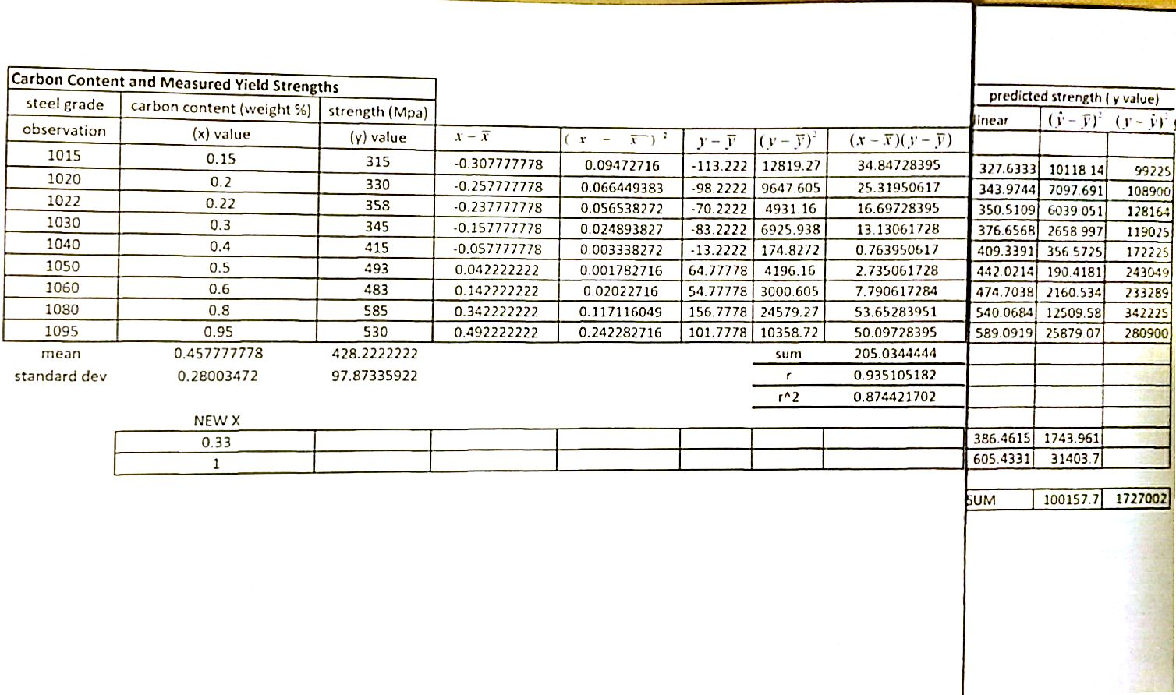
FIGURE 1: THE TABLE THE ANALYSIS DATA BY EQUATION

THE FIGURE FOR THE RESULTS (TABLE)
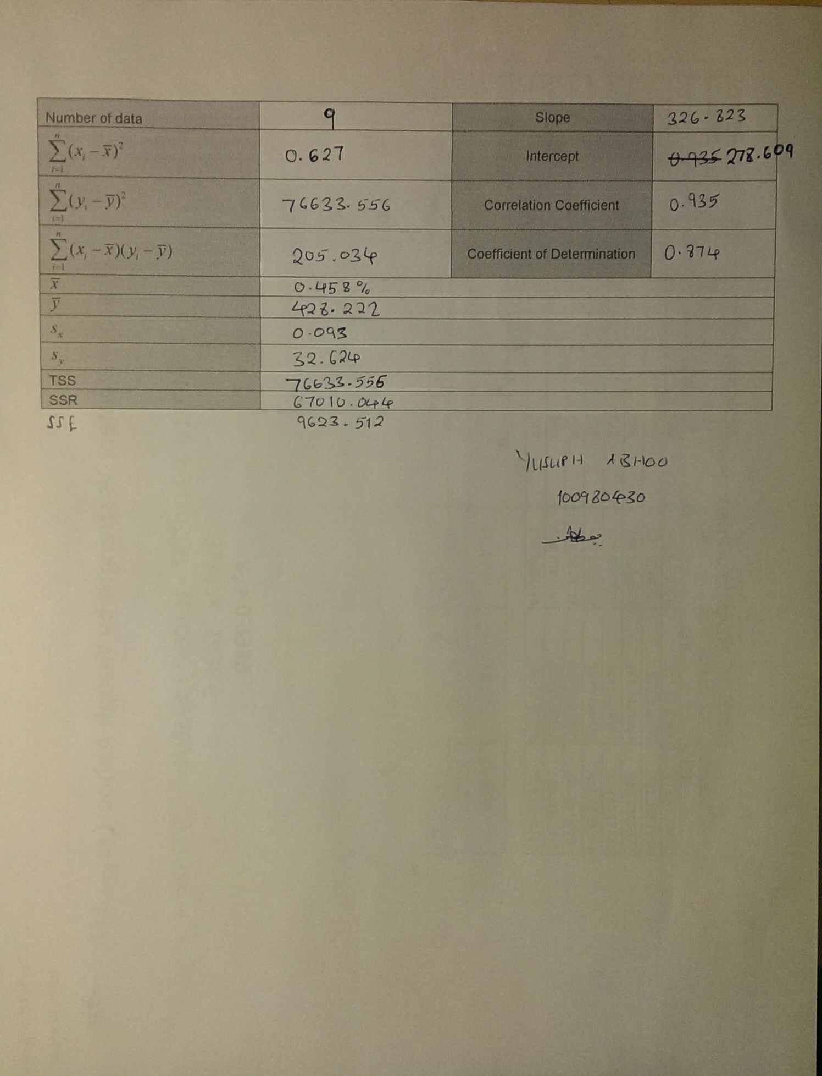
FIGURE 2: THE PICTURE SHOWING THE RESULTS OF THE ANALYSED DATA

THE PICTURE SHOWING THE RESULTS OBTAINED BY MICROSOFT EXCEL
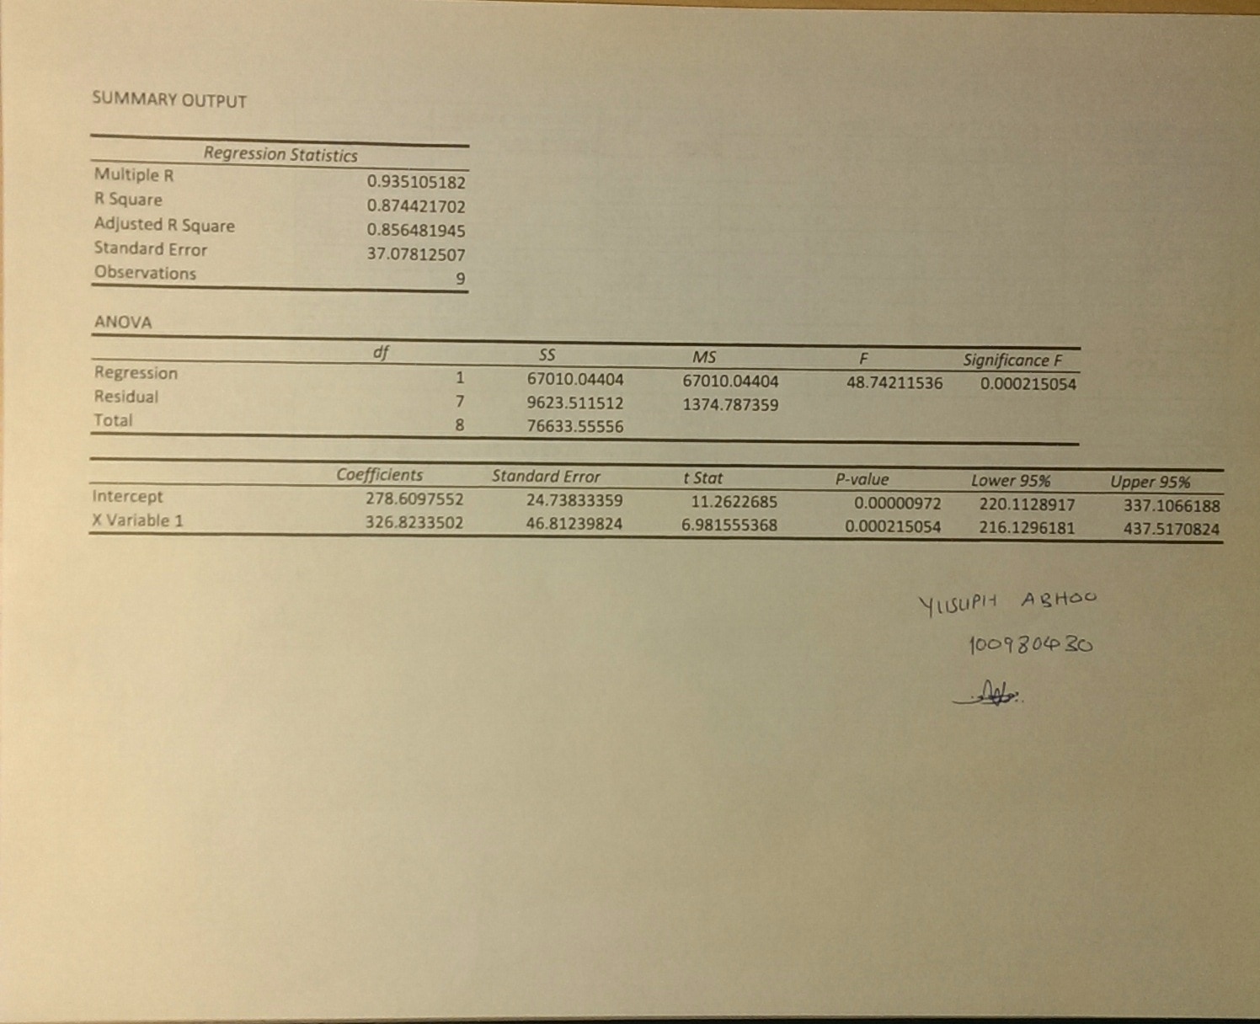
FIGURE 3: THE PICTURE SHOWING THE RESULTS BY THE EQUATIONS

THE PPREDICTED VALUES FOR THE METAL ALLOYS WITH THE THREE MODELS
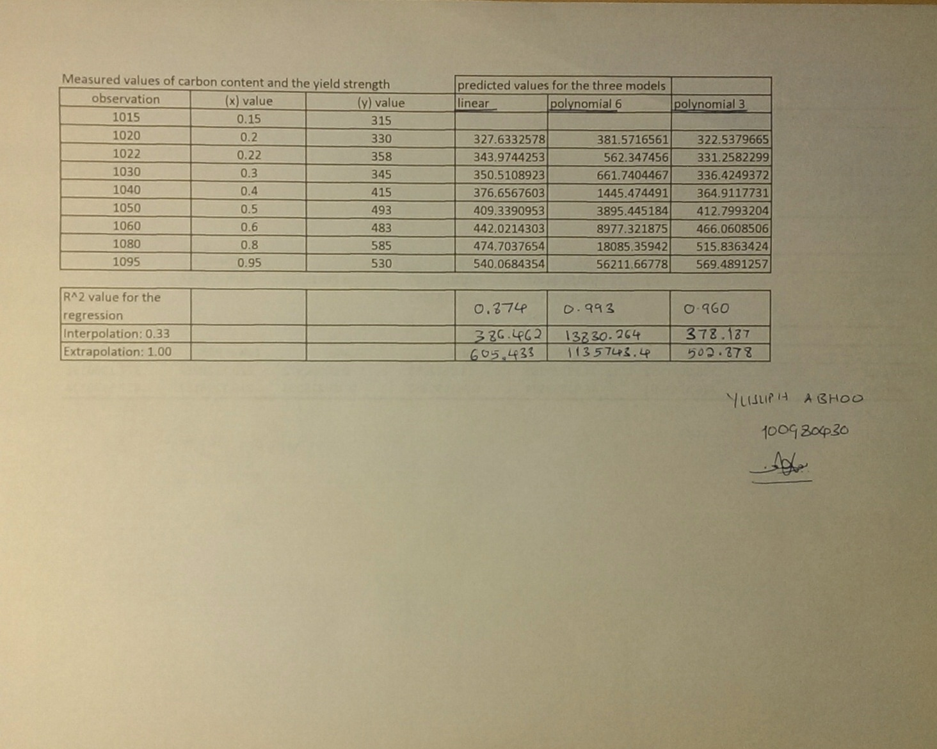
FIGURE 4: THE PICTURE SHOWING THE PREDICTED STRENGTHS

THE GRAPH OF THE LNEAR MODEL
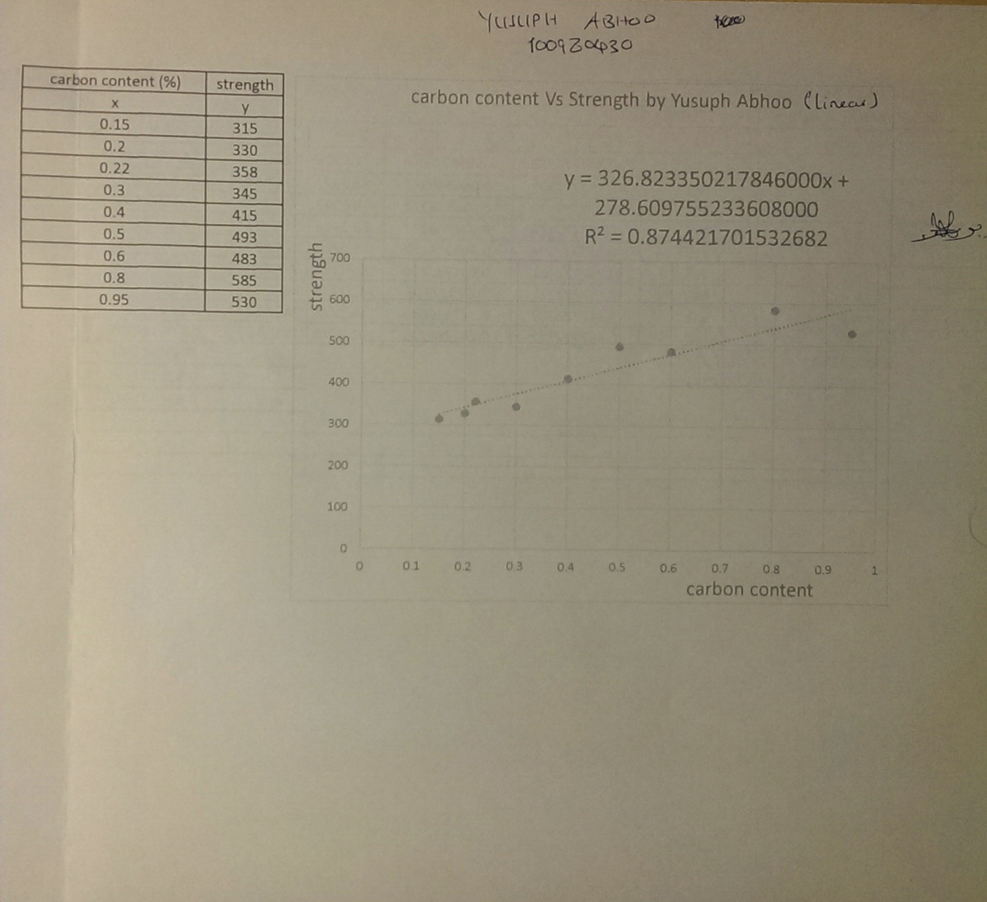
FIGURE 5: THE PICTURE SHOWING THE LINER MODEL GRAPH

THE GRAPH OF THE POLYNOMIAL 3 MODEL
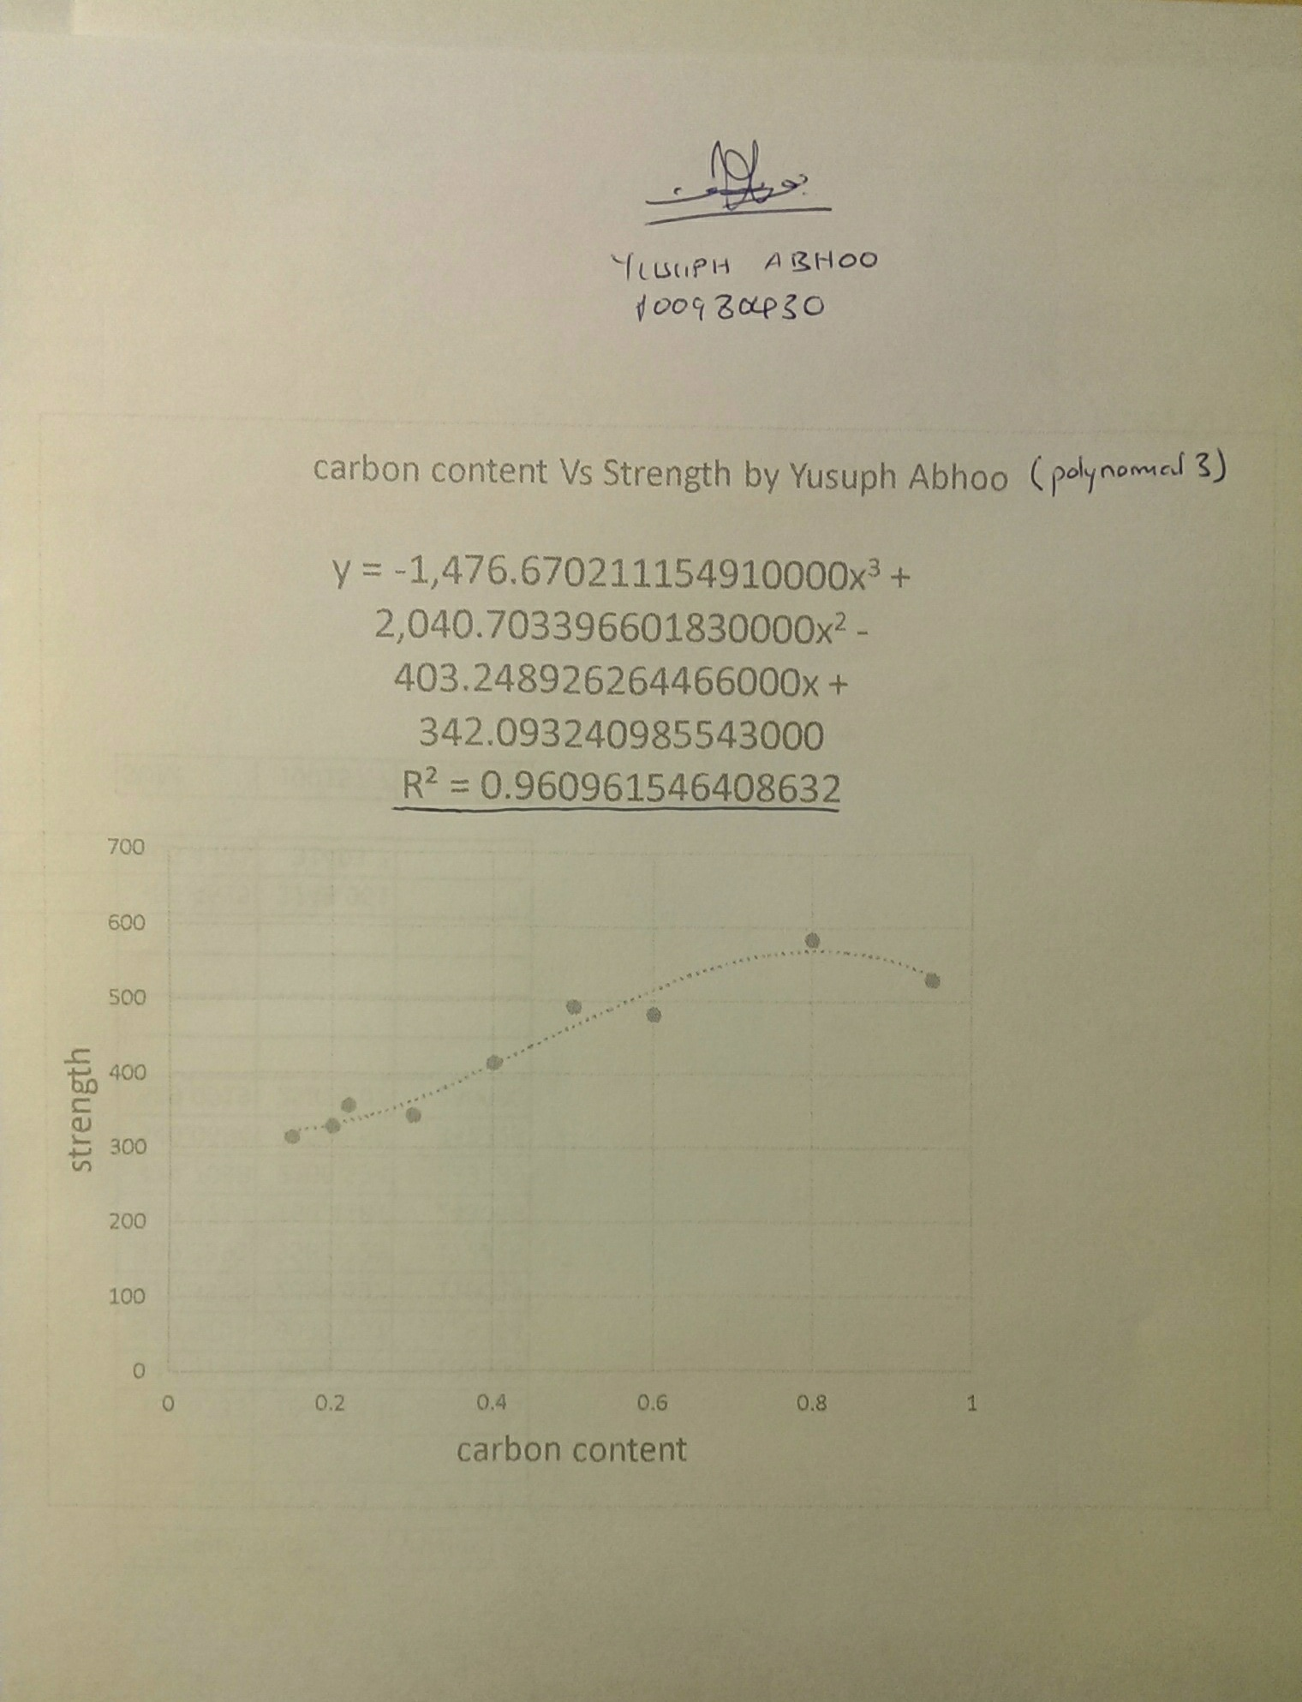
FIGURE 6: THE PICTURE SHOWING THE GRAPH OF THE POLYNOMIAL 3 MODEL

THE GRAPH OF THE POLYNOMIAL 6 MODEL
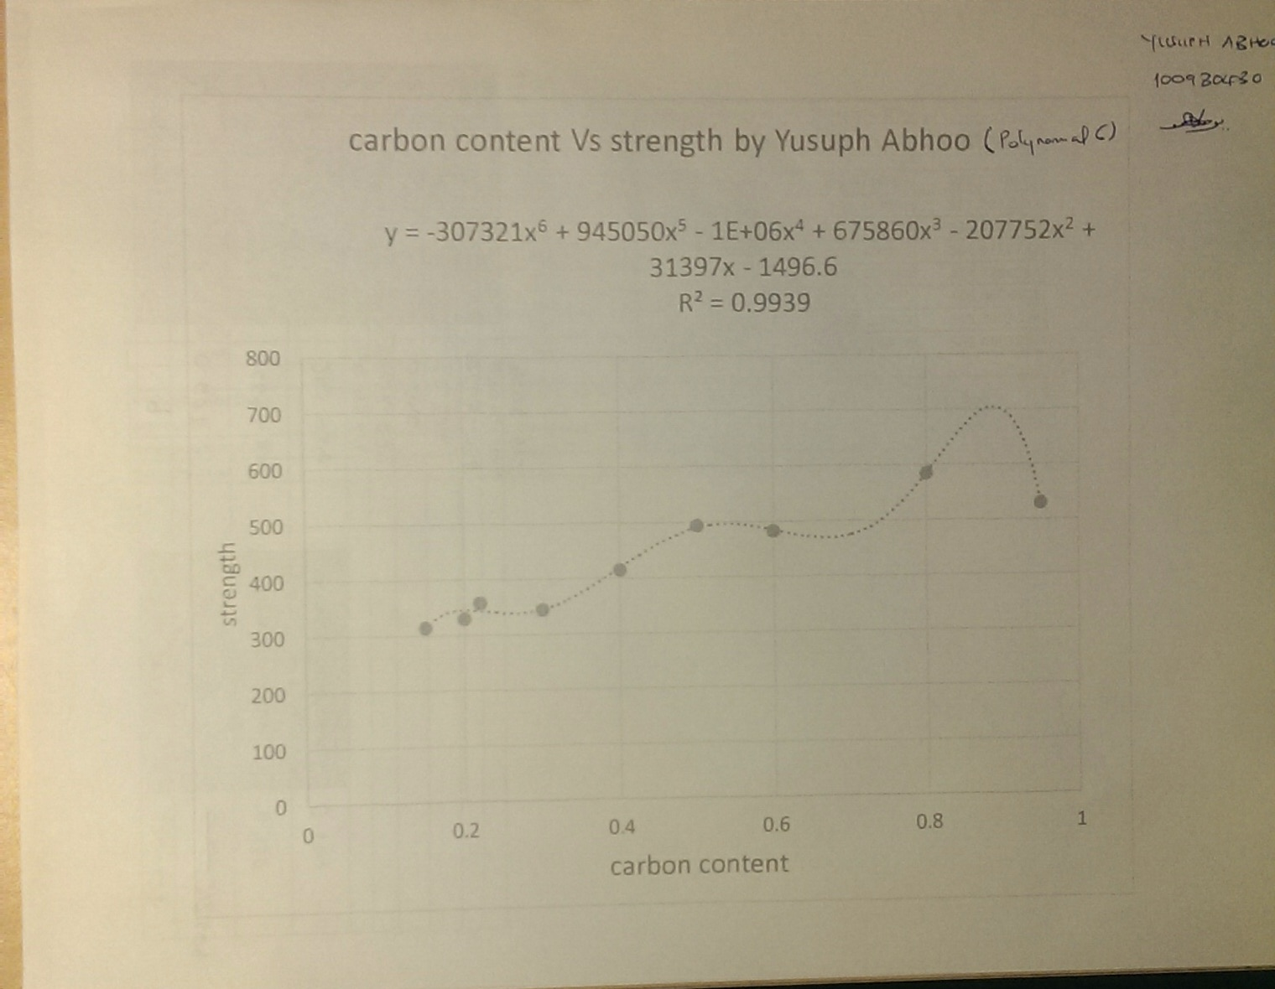
FIGURE 7: THE PICTURE SHOWING THE GRAPH OF POLYNOMIAL 6 MODEL

