ECOR 1010 – Introduction to Engineering

Jacob Zachariah
Assignment #1
Assignment Title: Fuel Consumption Analysis
TO Marking TA:
Name: Michael Gutland
Email: michael.gutland@carleton.ca

Lab Section: L3
Room: 4301CB – Carleton University

FROM:
Email: jacobzachariah@cmail.carleton.ca
Student Number: 101010004

Number of Figures and Tables (Including handwritten ones): 6
Last Date and Time of Revision: 19 September 2015

Introduction
The purpose of this report is to determine fuel consumption of three different types of mode of transportation to find out which one is the most efficient. The conclusion will be determined by technical information of these modes of transportation such as fuel capacity, fuel price, etc. The three different modes of transportation will be a 4-passenger sedan, 7-passenger minivan, and a BlueSky model E-1010 aircraft.

Materials and Methods
By using the information already provided in the tables, the data was assessed and the final answer for the fuel consumption and the CO2 emissions of the three different modes of transportations were made. Sig Figs rules were followed for the measured values. Sig Figs had no effect on the exact values, like the money or amount of people since those values were defined.

Results
The calculations for the report proved that the cars are more fuel efficient than the aircraft while also having the least harmful effect on the environment by producing the least CO2. The minivan produces the least amount of CO2/person and it takes in the least amount of fuel/person. The results determined that the 4-seater car uses 1.15 L/100km/person and the minivan uses 1.51L/100km/person, while the E-1010 aircraft uses 116L/100km/person. The 4-seater car emits 206kgCO2/person, the minivan produces 157kgCO2/person and the plane produces 367kgCO2/person

Discussion
In the report we proved that the minivan used 1.15 L/100km/person while the plane used 3.12L/100km/person. Which proved that the minivan is definitely more fuel efficient than the aircraft since it consumed about ½ as much fuel as the airplane. People can say that it’s easier/faster and more efficient to fly rather than driving, rather than driving all the way there. If you compare the fuel consumption of litres/100km then the car/minivan would use half as much more fuel than the plane. The 3rd table also says that the CO2 emissions of the aircraft was the most compared to the car and the minivan had the least amount of CO2 emitted. One anomalies that was encountered was that the aircraft data was all presented based on the fact that it’s not going to use its reserve fuel which is used in case of emergencies or traffic at the airport. If that number was accounted then the calculations would be different even though the final conclusions would have still remained the same.

Conclusions
Therefore the report to calculate the fuel used and the CO2 emitted of different types of vehicles and the claims of the manufacturers were solved. According to the calculations and the report the Minivan had used up the least fuel per person, while on the other hand the plane used the most. The vehicles that had the lowest effect on the environment. Out of all three vehicles the minivan had the lowest effect on the environment since it produced the least CO2 per person, and it was the most fuel efficient per person.

APPENDIces- Figures and Tables

Table 1: “BlueSky” model E-1010 airplane specifications.
Aircraft model | Max. no. of seats | Max. range* | Max. takeoff weight | Max fuel capacity** | Cruise speed @ 35,000 feet ***
E-1010 | 250 | (Km) | (Kg) | (kg) | (Km/h)
E-1010 | 250 | 4 655 | 67 775 | 32 389 | 894

Table 2: Useful Information
Automobile fuel price | 1.24 | $/L
Fuel density (aircraft and automobile) | 0.80 | kg/L
Aircraft reserve fuel | 10.40 | %
Automobile average speed | 84.00 | km/hr
Aircraft fuel price | 0.80 | $/L
Automobile CO2 emission | 2.35 | kg/L
Airplane CO2 emission | 3.16 | kg CO2/kg Fuel
Halifax to Vancouver distance by car | 5 811 | km
CO2 fixed by the average tree per year | 50.0 | lb CO2/tree/year

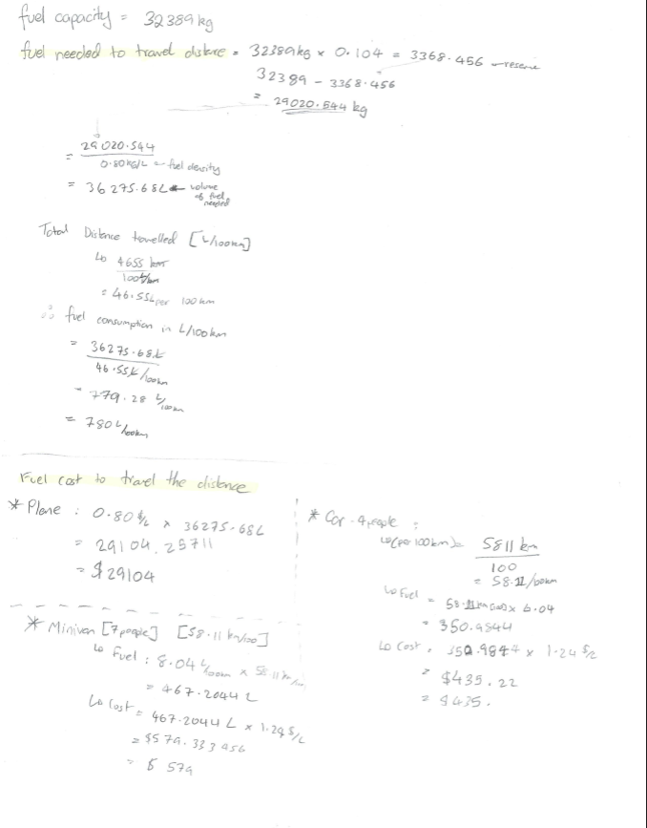

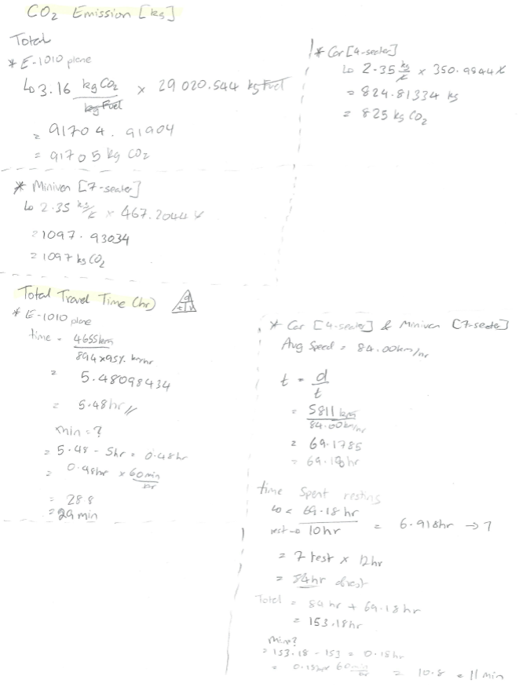

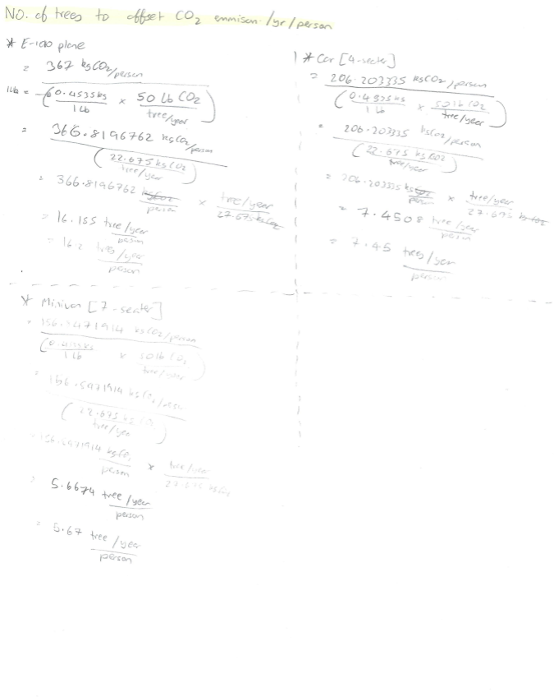

Table 3: Calculation Summary Table

 | Fuel Consumption L/100 km | Fuel Cost for the vehicle to travel the distance ($) | Fuel Consumption per person: 100% occupied seats L/100 km | Fuel Cost per person: 100% occupied seats ($) | CO2 Emission (kg) |  | Total Travel Time (hr) | Total Travel Time |  | No. of trees to offset CO2 emission /yr/person
 |  |  |  |  | Total | per person: 100% occupied seats | Total Travel Time (hr) | hr | min | No. of trees to offset CO2 emission /yr/person
E-1010  250 passengers | 780 | 29100 | 3.12 | 116 | 91700 | 367 | 5.48 | 5 | 29 | 16.2
Car– Sedan 4 passengers | 6.04 | 435 | 1.51 | 109 | 825 | 206 | 153.18 | 153 | 11 | 7.45
Minivan 7 passengers | 8.04 | 579 | 1.15 | 83 | 1097 | 157 | 153.18 | 153 | 11 | 5.67
CO2 Emission per person = Total CO2 Emitted / passengers
Fuel Cost per person = Fuel Cost / passengers
Fuel Consumption per person = Fuel Consumption / passengers

