ANIMAL ENERGETICS pt. 2 Midterm
Bioenergetics: Mechanical work and Chemical work, the main focus of this

Way energy is used by changing into diff forms of energy to do things that are useful for the cell.
Relationship b/w chemical and mechanical work, and similarities in how work are done in converstion of charges.

Review:
- Metabolic rate: last unit was focused on the biochemical method of animals extracting food and turning it into something useful
- Maintenance of appropriate cell structure (imp to fxn)
- Structure was exemplified by the way proteins are organized in the inner mitochondrial mem and electron transport chain

Energy production- summary:

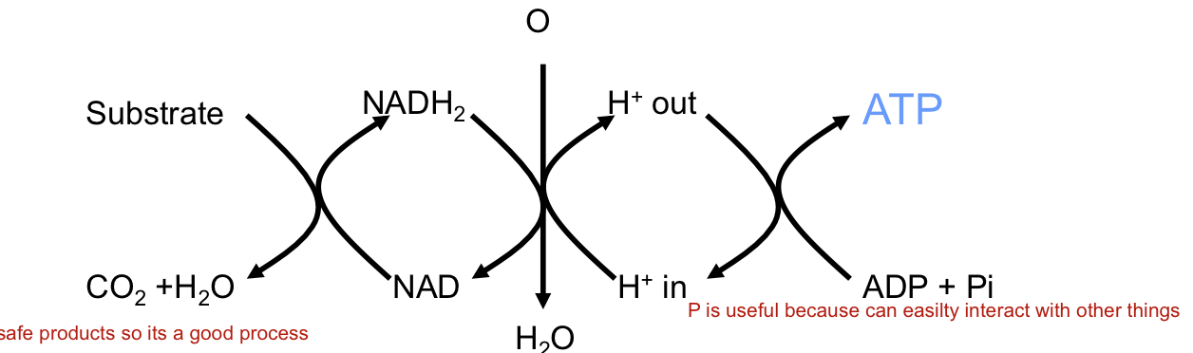
- transfer of energy from one form to another
- aerobic metabolism is a good b/c extract a lot of energy and produce safe anatomics..
- in the process of sending electrons from NADH to water, the energy in the charge is used to do some chem work interacting with proteins in the inner mitocoondiran mem, changing their conformation in such a way theat they take on a hydrogen atom and pump them outside.
- This creates a PH gradient, acidic outside of mitochondria creating pressure that tries to push the H back in.
- It is designed in a controlled way trough channels that are connected to an enzyme.
- H interact with the protein and cause it to rotate which interacts with a catalytic component, catalysis happens when ADP + Pi is changed to ATP

Energy consumption- mitochondrial uncoupling
There are certain processes in the body that construe large portions of the met rate, one of them are represented by mitochondrial uncoupling.
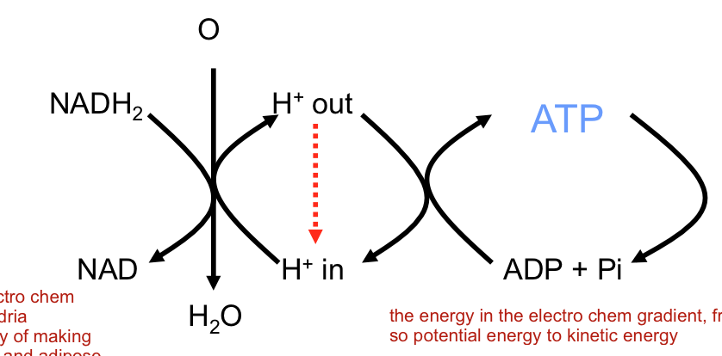
- Electrons go through a electron transport chain and pump H out
- other channels are there that are not directly linked to ATP that allow H to flow down their gradient- key for uncoupling.
- Advantages: regulates electro chemical gradient across mito, and can also be used as a way to produce heat (hibernating animals and adipose tissue)
- Mitochondrial – proton leak (uncoupling protein, UCP)
- Proton leak accounts for about 20% of total BMR in mammals.
- Uncoupling: oxygen is also consumed in high rates, if a lot of uncoupling going on.
- Produce more heat more used to the cold

fig. 8.4: principles of oxidative phosphorylation and uncoupling: review

Energy consumption- biosynthesis
- only briefly mentioned
- very imp b/c involved manufacturing of complex materials (building blocks) used for growth and repair and overall maintenance.
- we have a cycle: 2nd law of thermodynamics in action.
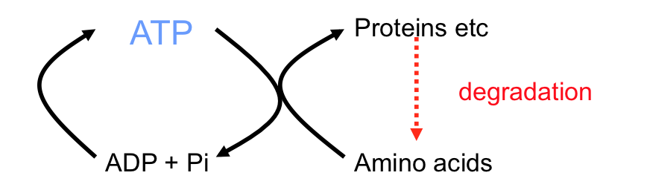
We have a sys that controls the degredation of protein to make sure it happens in a orderly way.

This ensures that we have a constant need for manufacturing of proteins thus need energy that is derived from ATP.

Total basal met rate about 20% (basal means doing min work, so no exercise) as soon as you start doing stud the % ovb will go way up.
Protein synthesis accounts for about 20% of total BMR in adult mammals.

Energy consumption- chemical work (primary active transport)

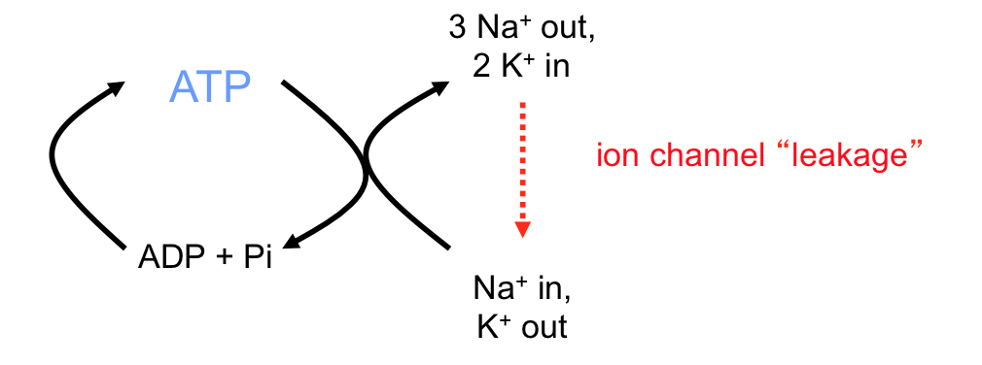
- Na/ K ATPase accounts for about 20% of total BMR in mammals, and about 50% or more in brain and kidney.
- we tend to maintain high levels of K inside and Na outside
- the cell maintains this gradient to set up a charge difference to do things like nerve cells and muscle cells (use to send info)
- the gradient is important and this is what we call chemical work; the generation of electro chemical gradient, using ATP to force ions to move against its gradient.
- Na/ K ATPase pumps 3 Na out at the time time as 2 K in.
- this is found everywhere but more important in cells involved in transport of stuff across the membrane like the brain, the kidney.
- Muscle uses Na/K ATPase a lot.
- the exetent of leakage from high to low conc is controlled.

fig. 5.10: summary of active and passive ion transport in a typical animal cell.

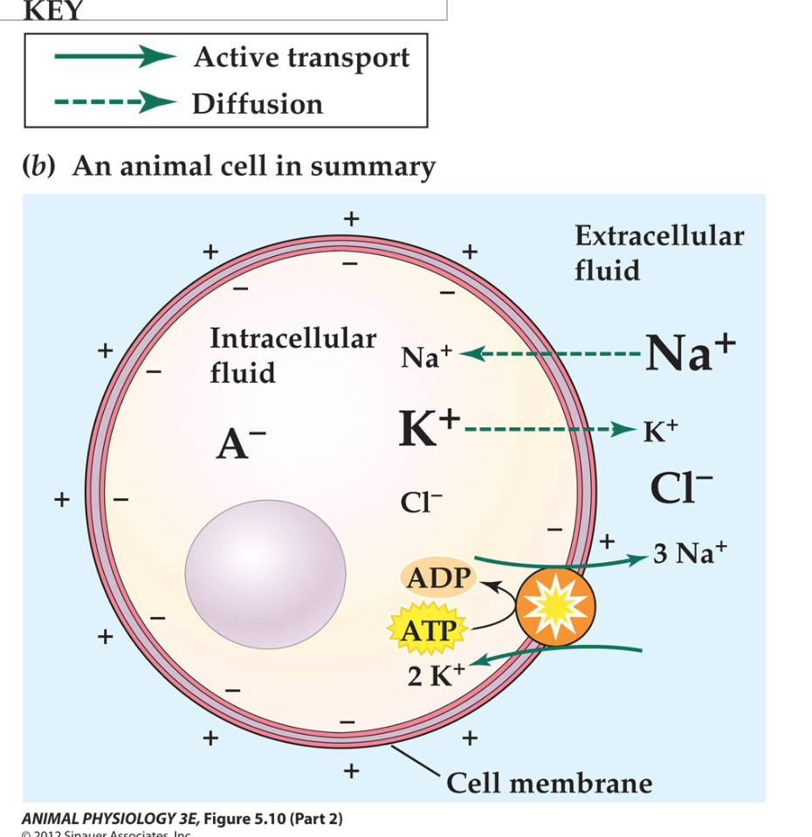
- K high inside, Na high outside
- high anion (in form of protein) in cell contribute to net negative charge for sys. useful fo things like buffering.
- Cl is passively distributed aswell as bicarbonate
- Have Na/K ATPase embedded in mem to maintain a gradient.
- generation of gradient is primary active transport. (it’s the protein that generates gradient and does work)
- secondary active transport when this gradient is used somewhere else in the cell.

fig 5.11: Na/K ATPase transduces ATP-bond energy into ion motive energy.
slide 9 – textbook.

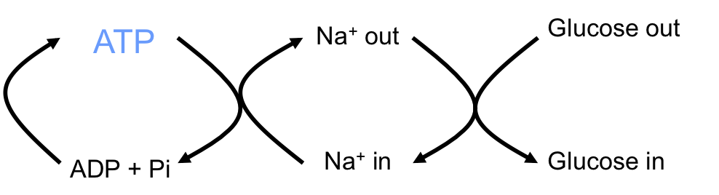
Energy consumption- chemical work (secondary active transport)

- electrochem gradient is used in order to do something else.
- ex. is Glucose across the membrane
- Energy in ATP is used to produce Na gradient, which then drives the uptake of glucose up the membrane.
- Glu too big to diffuse through mem so need work, you are moving Glu against its gradient.
- usually more Glucose found inside cell than outside
- The Na-glucose cotransporter in the apical membrane; transports glucose into the cell.
- In mammals we have Na/K pump on the basolateral side (side of blood) doing work producing low Na inside of cell.
- The glu-Na co transporter is on apical side, uses the force of Na that wants to go down its gradient
- Na charges bind to proetein channel, as it goes down it changes the shape of it allowing glu to flow down with it.
- So ATP is used to form the elctrochem gradient of Na, which in turn is used as a secondary active transport for movement of glucose against its gradient.
- as Na moves down its conc. gradient glucose is moved against its gradient into the cell.
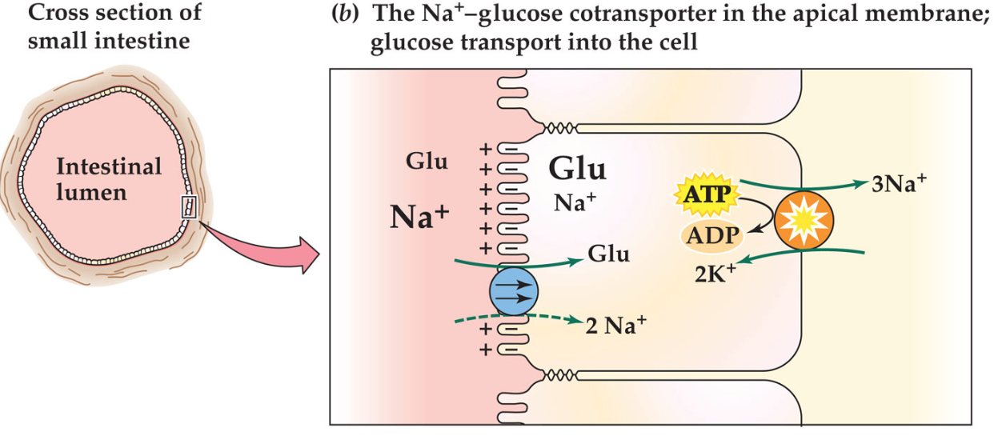

Energy consumption: mechanical work (“molecular motors”)

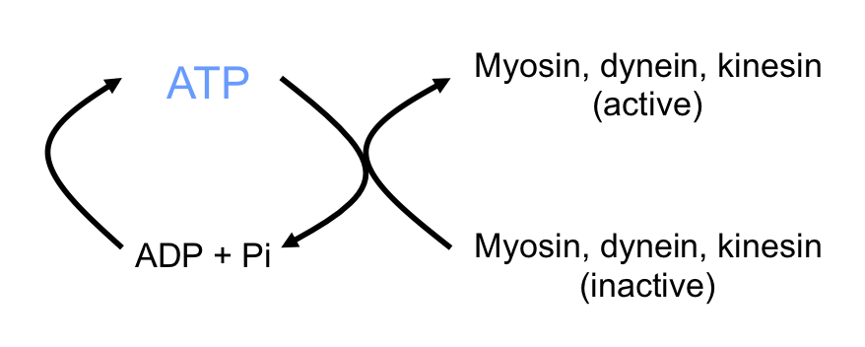
- Essentially the same basic process.
- Within cells we don’t only transport ions, but move around other things as well.
- In many cases materials may be too large to be moved around easily so need to be directed.
- mechanical forces aid in maintaining cell shape, or to move extracellular elements of the animal around.
- done by using proteins: mech is same as converting energy in charge (ATP) to do movement so force to move it over a distance.
- proteins are called motor proteins
- myosin present in the muscle, but aswell as other cells along with various other motor proteins such as dyenien and kinesin
- dynein and kinesin aid in transport in cells and swimming in microscopic organisms.
- emphasis is on similarity of them to myosin general them to how they operate.
- nerve cells are physically quite large, take awhile for the molecules to travel that great of a distance, so we need something to carry it.
- we have a cytoskeleton that forms a structure through which molecules can move along, attach themselves and carry other things with them.

DYNEIN:
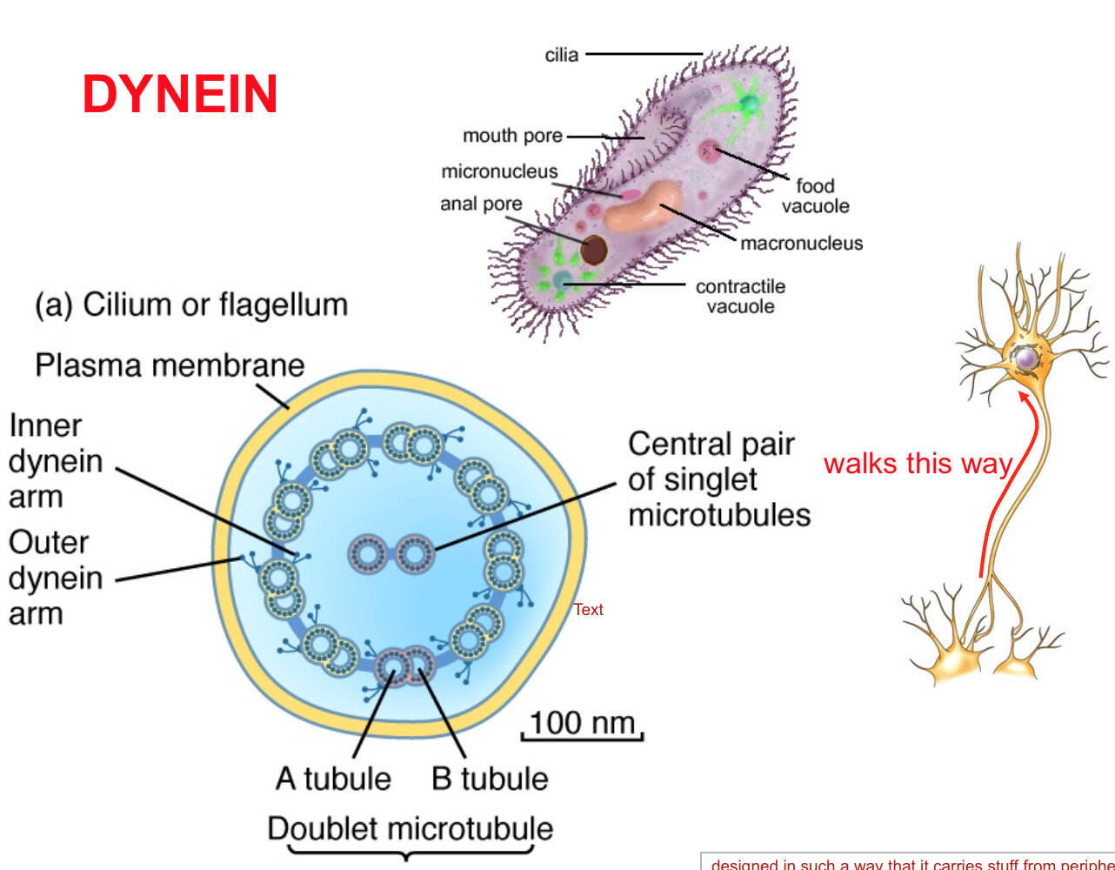
- Designed in such a way that it carries from the periphery of neuron to the center of the cell.
- only walk in that directon, both serve similar fxn in nerve cells.
- dynein also in cell motility, in unicellular organism like cilium or flagellum
- Similar sort of thing in lung to drive mucous through the respiratory tract.

- How do cilia beat? cytoskeletal proteins: microtubules that are arranged in specific orientation with a specific structure that has to be closely maintained.

- the skeletal elements are organized in ring like structure. the motor proteins are the dots (dynein molecule) that interact with ATP to change, and combine to microtubule proxy.

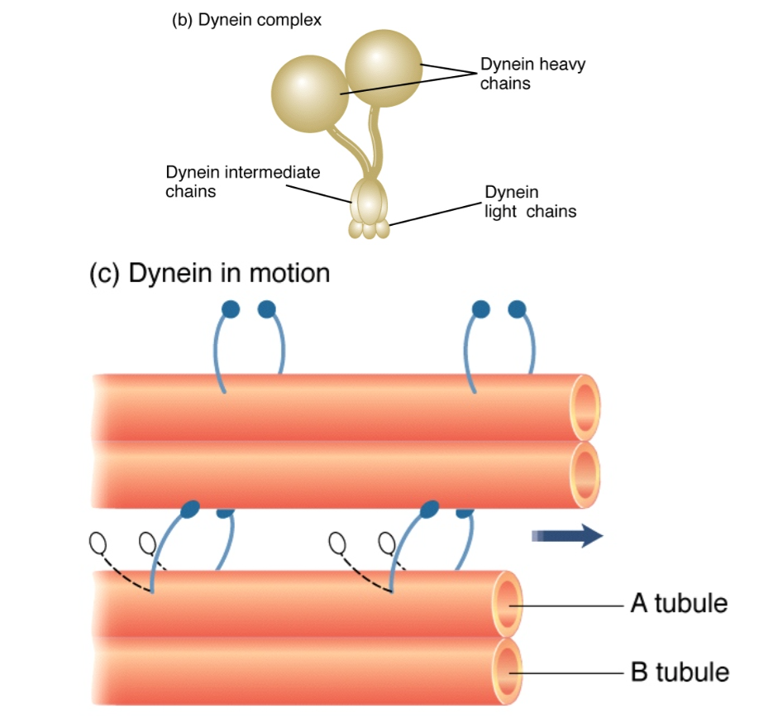
- the change in the shape generates a force and if its bound to the other molecule it will essentially pull.

- in the right order you get a wave of attachement and pulling of the microtube, essentially getting a whip.
- if generate enough force and momentum make the whole animal move.

- chain of tubulin molecules attached to dynein molecule, have flexible biding and catalytic units (hydrolyze with atp when it wants to)

- ATP energy change shape in protein thus causing movement.

- all motor proteins have generally the same structure: they all have a heavy chain, binding sites (connecting to other proteins) and they all have a catalytic unit (ATP conversion), a flexible helical structure that bend easily, a charge changes its shape thus causing movement, the anchor bids to microtubules.
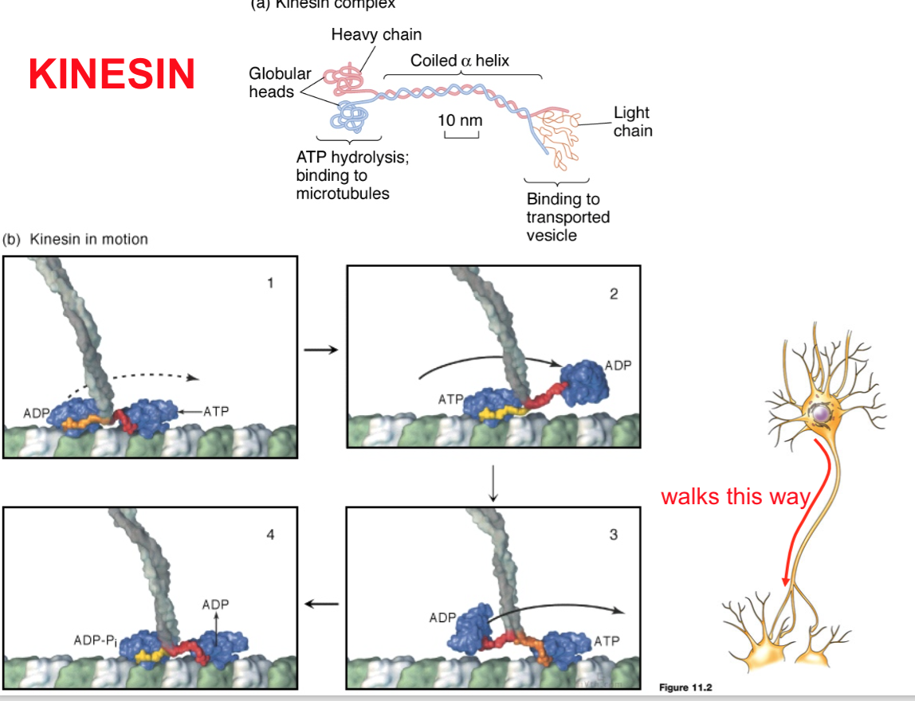
- kinesin anchor on the other hand binds to what ever it is that it is transporting.

- heavy chain: enzymatic activity, flexible component and an anchor component that carries things.

- the ATP charge changes the shape of the protein that allows kinesin to essentially walk along side the microtubules (tubular component) ** essentially the same thing that happens in muscles with actin and myosin

- performs a specific function: to carry things within the cell, in this case cell bodry from nerve out to terminal

MYOSIN:

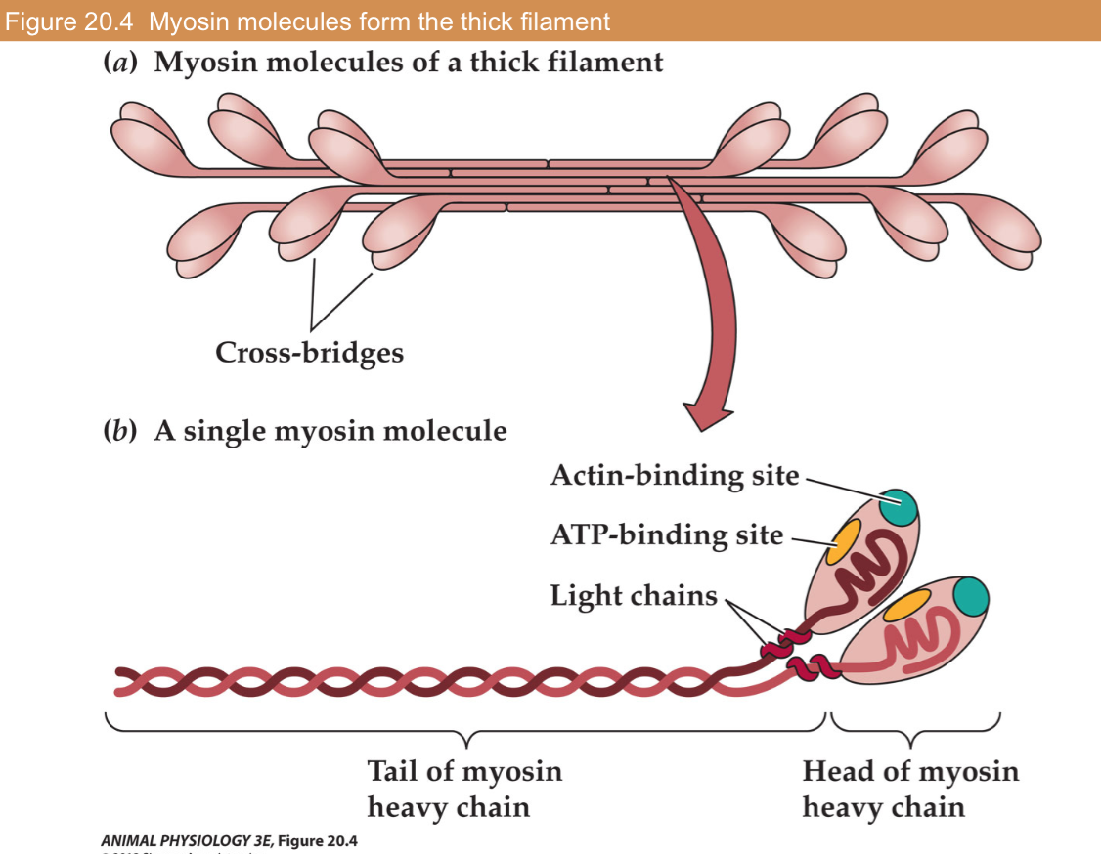
- myosin imp b/c specialed for use in muscle, and for doing microscopic work that allows animals to be active
- myosin: motor protein
- consists of several proteins all in one head structure that contains a catalytic cycle: atp hydrolysis, another site that binds to cytoskeletal elements (in this case actin that it generates its force agains)
- light chain (no focus), flexible chain that allows It to move, and change in structure that allows it to propel the muscle.
- the tail of mysoin forms an anchor structure, instead of attaching to other things, attached to other myosins forming a filament of myosin molecules.
- the motor proteins are arranged in a way that they are facing opposite ways, but all work the same way.
- when they move, they have a structure that generates force that pulls towards the center, so when head is attached to actin they pull actin towards itself and generate tension.

Overall:
- All three different types have a general structure.
- Myosin has various types of different forms to generate different freq. and amount of power.
- Associated with motor proteins are a set of biochemical support sys that provide ATP and signals that tell when to apply force or not.
- Therefore basic principle is that is that chemical work is done as a form of information transfer that directs the mechanical work of a motor protein.

Vertebrate muscle:
Subdivide the similar kind of system into 3 basic types:
- Cardiac muscle
- Skeletal muscle
- Smooth muscle
- skeletal and cardiac are both striated: diff is cardiac have intercelated dics
- striation is due to the arrangement of myofibrils and actin filaments.
- non-straited are smooth muscle b/c have diff charactericts b/w arrangement of motor proteins and is not organized in the same way, these perform diff type of work witin the organism: reduce work at low grade of power so don’t need the same internal organization.

CARDIAC MUSCLE:
- striated because motor proteins are arranged in a specific pattern, the key difference b/w skeletal muscle relate to properties that surround the cells.
- cardiac contract and make their own action potential and causes the cell to depolarize. skeletal muscles don’t contract unless ordered to do so, so we have to direct it. once it contracts we want the whole thing to contract and work as a unit to generate the pressure needed to pump through it.
- In cardiac, the muscle itself is electrically coupled, so when you stimulate only one or two cells, it will be transmitted through the entire organ.
- there are areas where there are connections b/w the cardiac muscle fiber called intercalated disc.
- the transmission of an AP is SA dependent, so you need a massive SA to make efficient.
- SA is key!!!
- ions across cell mem via intercalated dics due to the presence of gap junctions making a greater SA, so gap junctions connect both cells so AP in one cell goes to another.
- in skeletal its diff, AP need to be generated through the entire thing.

SKELETAL MUSCLE:

The organization of a skeletal muscle:
- the way skeletal muscle contracts is controlled.
- uses about 1/3 of energy muscle uses to contract, so fast muscle has large expenditure of energy controlling that.
- the basic structure of a muscle is set up as an individual contractile unit, that is insulated by the surrounding.
- the muscle itself generates a tension in a organized way that motor protein are parallel to one another.
- when you get tension it does work to move.
- they are subdivide, we need connective tissue to provide stability (need nerves, and blood vessels)
- too much CT impede the fxn of the muscle.
- muscle is subdivided into decreasing units ended up in unit of muscle cell called muscle fiber.
- within the fibers are bundles of motor proteins, and b/w the proteins are the other things that the cell quires to control the contraction and supply them with the energy.

Muscle fiber cell:
- composed of bundles of motor protions, myosin and action that are arranged in a specific orientation to each other
- each myosin has 6 actin surrounding it, to maximize its efficiency.
- need mitochondria for ATP and also sarcoplasmic reticulum (CA pump location) beause need Ca for means of control (secondary messenger).
- Ca is used for information transfer, since it is small and charged ion, the energy of the charged ion can tell the axon what to do.
- Ca ion that is released in the vicinity of the motor protein tells it when to contract, so to relax we need removal of Ca.
- Ca is stored in the sarcoplasmic reticulum and since its going from low to high conc area a pump is required to remove the Ca from the cell.

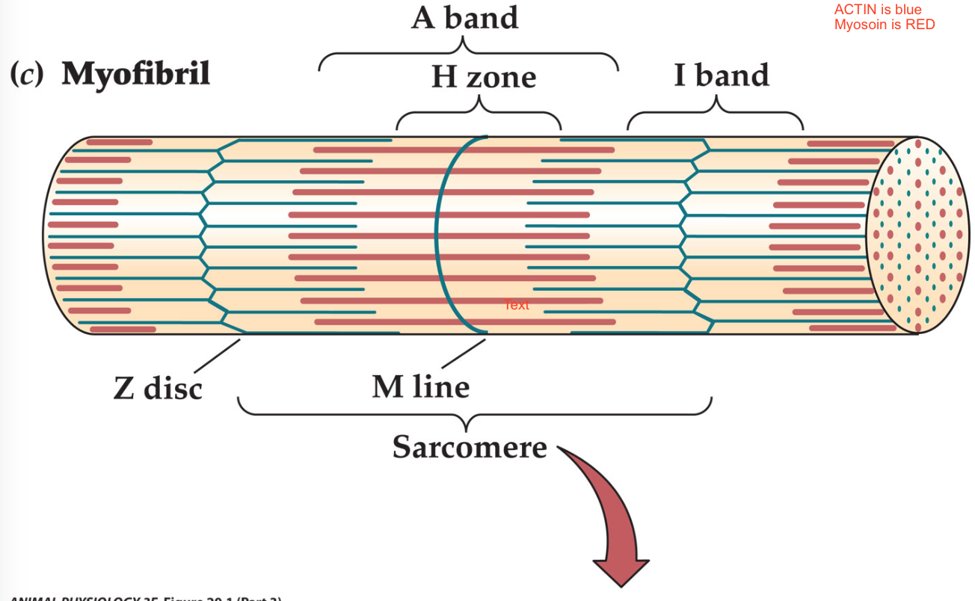
- BLUE is actin filament: made up of globular proteins that have regions with high affitiny for myosin head

- RED is myosin filament

- myosin molecules pull on actin molecules, so string of actin essentially cytoskeletal, so actin is a fixed structure

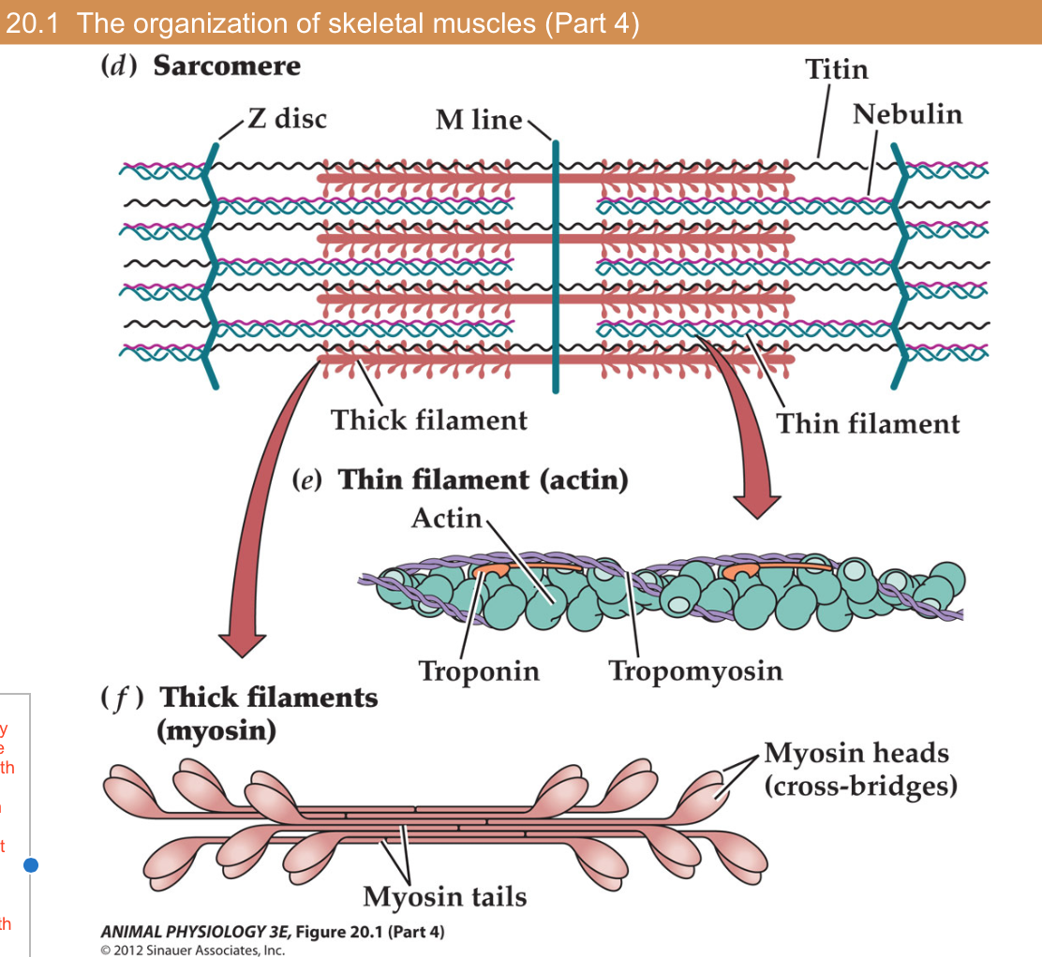
- myosin head interacts with the actin and through changes of conformation apply a force that pulls on the actin.

- when trillions work together, the force is significant, pulling actin towards center.

- dead corpse goes stiff b/c no energy present to undo myosin head from actin so remains contracted

- myosin head is essentially walking along the actin.

- arranged then in specific geometrical organization: 6 actin around 1 myosin, 3 myosin around 1 actin.

- H zone: think filament only: actin

- I band: thin filaments only: myosin

- A band flanking H zone: thick and thin filaments overlap.

Fig 20.6: Ca2+ ions, Troponin (TN) and tropomyosin regulate contraction.

- Tropomyosin is attached to troponin
- Troponin binds to calcium: part that Ca can use to move tropomyosin away.
- Tropomyosin is a protein that runs along the groove of a actin: in relaxed condition sits ontop of the myosin binding site.
- In active condition, Ca is released and it binds to troponin which changes conformation and moves topomyosin out of the way so myosin binding site is exposed.
- Myosin is then able to bind to actin, and allow the head to move tausing tension.
- Taking away Ca reversed the process, removal of Ca causes troponin to back to other configuration and cause tropomyosin to move and sit ontop of the binding site.
- No Ca2+ ions present in the cytoplasm: tropomyosin sits on top of the myosin binding site on the actin
- Ca2+ ions released from sarcoplasmic reticulum: binds to troponin, cause change in configuration and thus moves tropomyosin out of the way exposing myosin binding site.

Fig 20.5: Molecular interaction that underlie muscle contraction:

- Rigor is a transient state: Actin bound to myosin
- ATP binding dissociates myosin from actin. The cross-bridge can now go through the cycle on a new G-actin molecule.
- Myosin ATPase hydrolyzes ATP to ADP and Pi. Energy from the reaction is transferred to the cross-bridge. ADP and Pi remain unbound to myosin.
- The myosin head moves to the cocked position and binds to a G-actin molecule.
- Myosin attachment to actin triggers Pi release and the power strong. The actin filament is moved about 10 nm towards the center of the sarcomere.
- The myosin head unbinds ADP and remains tightly bound to action (rigor)

Energy itself in ATP is not hydrolyzed in the pulling part of myosin head but in the recovery part of the myosin head that puts it back to starting position (removal of head from actin)
In the absence of ATP the two things come together and stay together.
in the presence of ATP, the binding site changes conformation of protein, thus they are no longer attracted to each other thus life away.
When ATP is hydrolyzed and P is released, the P release releases a charge thus charging the charge distribution. kinda of like pulling a trigger which allows for the flexible part of the protein to reform to original shape, which is what causes the pull.

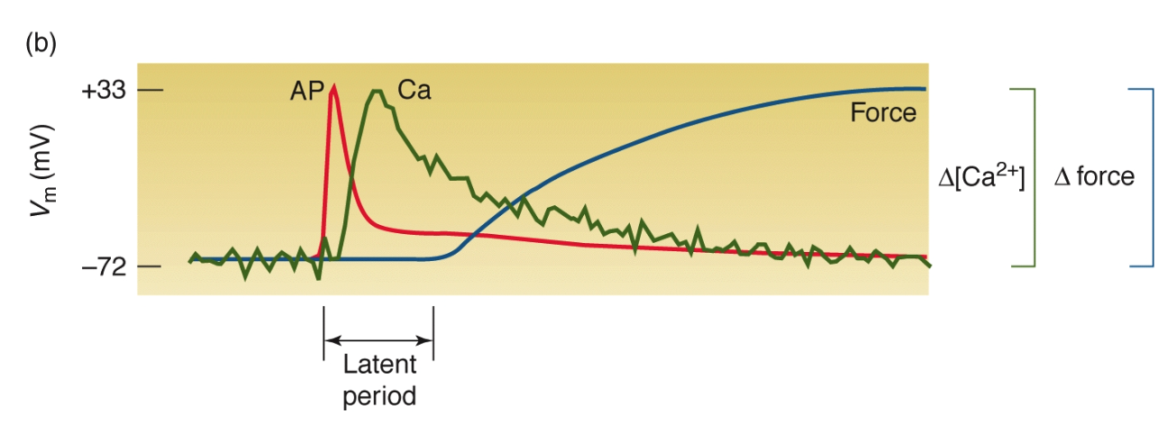

- muscle cell level to whole animal level (exercise) how everything comes together.
- information is transferred to the muscle to direct it.
- important temporal component exist for initiation and conduction of muscle contraction.
- info comes to muscle as AP through nerves across the synape, and goes to muscle mem, thus depolarizing the muscle membrane.
- the pulse is then transferred from mem of muscle to interior of the cell where contractile proteins are located through a secondary messenger, in this case its Ca2+.
- Ca2+ ions are released from the sarcoplasmic reticulum, due to its small size it diffuses rapidly and the strong charge allows it to interact with molecules and force it to do things.
- The strong charge also sets up diffusion, so we get a pulse of Calcium into the cell, carries info from mem to working protein and triggers them to go through the myosin cycle causing myosin actin interaction and generating a force.
- Ca binds to troponin causing change in shape to move tropomyosin out of the way revealing the actin myosin binding site.
- in the muscle it is not just a contractile protein, it consists of various other elements that surround it that helps it do work, like sarcoplasmic reticulu (dense network of liquid mem sac). the whole muscle is tighly packed with various elements in addition to contractile proteins.

Figure 13.9 Summary of events in chemical synaptic transmission at the vertebrate neuromuscular junction:

Figure 20.7: Excitation-contraction coupling is accomplished by the interactions of the transverse tubules (t-tubules) and the sarcoplasmic reticulum (SR).
- in skeletal muscle, the CNS sends a signal to the motor neuron that depolarizes and sends AP down the nerve.
- AP reaches termal, and NT is released into terminals, NT is released from vesicles. (Ach) acetyl choline in case of muscle, down its electro chem gradient towards the sybaptic cleft.
- Ach makes contact with transmembrane proteins that are present in membrane of the muscle – Ach receptors, they bind change shape and act like ion channels mainly for Na.
- Na flow down its electro chem gradient, creating a pulse of charge.
- DHPR is a protein that changes conformation, and works in conjuction with RyR working at a plug at the end of the channel for the sarcoplasmic reticulum. if the AP that reaches the muscle is strong enough, it opens the channel and cause Ca 2+ to rush out, and cause it to bind to troponin moving tropomyosin out of the way and allowing for actin to bind to myonsin and cause a force to contract.
- if damage to DHPR, cause Ca to flow out and cause all sorts of damage to the cell.
- When ATP binds to the myosin head, it releases the actin allowing it to “walk across the actin”.
- Hydrolyzation of ATP causes the head to moved to the cocked position and bind to g-actin molecule., this biding releases Pi and the power stroke of the head. actin moved about 10nm forward twd center of sarcomere.
- To get Ca out of the cell so the cell can relax we need Ca pumps in the sarcoplasmic reticulum to move the Ca up its conc gradient from low to high, thus this pump requires ATP and need to do it rapidly, so lots of pump, lots of energy
- rougly 1/3 of energy consumed during muscle contraction is used up by calcium pump. about 2/3 is being expended by contractile proteins. so a lot of energy used just for the pump to remove Ca out of the cell.

- Energy comes from substrates, proteins and fats that contain large # of electrons that can be used to generate ATP.
- in mitochondria several mechanisms by which energy can be generated by muscle; the aerobic oxidating phosphorylation method is the most efficient in terms of extracting the max amt of enery out of the substrate.
- Carbohydrates is used in absence of oxygen via. substrate level phosphorylation via the glycolytic pathway, but relatively inefficient b/c only some energy of glucose are stored as ATP the remainding as lactate and unused. However if oxygen is present lactate can be further used as energy.
Have 4 stages:
- Diffusive stage, go across barrier from one place to another into blood. ex. O2 in lung alveoli by diffusion.
- Level of ventilation is maintained to keep a partial pressure gradient that force O2 down gradient.
- heart expends a lot of energy to pump blood around circulation and carries with it a lot of diff things such as oxygen, fat and carbs, aswell as other signallikng molecules like adrenaline from the andrenal glands and various other things involved in facilitatinon muscle performance.
- in multicellular organisms such as ourselves, it is imp to have a delivery sys that is highly effective and closely regulated, such that the rate of delivery match the rate of deman.
- **** Rate of delivery match rate of demand****
- ourselves we rely of diffusive and convective mechanisms, essentially pumps to deliver long distances, with reservoirs and buffers of carious components that we use in energy to muscle. There are a number of diff mechanisms involved in this process.
- delivery of substance in gut as talked about before, Large Sa in gut for delivery of things such as sugars and fat, so large distance can’t depend solely on diffusion, so need other convective mechanism to deliver by flow. more expensive b/c need to pump the delivery mech around in this case blood circulation.
Uptake from the outside:

Uptake from the blood into muscle (limited)

Central stores

Blood circulation takes time.

also stored in muscles b/w exercise bouts

The concept of oxygen deficit and excess post exercise oxygen consumption:

ATP consumption must match ATP production, however due to the cardiorespiratory sys it lags behind at both start and end.
cardiovascular sys takes time to get oxygen to the muscle.
At the begging the rate of oxygen demand exceeds the production thus results in oxygen deficit, however it is compensated for towards the end as it takes time to stop aswell, so it replenishes the mech of anerobic.
During this lag period, aneorobic mechanisms of the cell kicks in

the oxygen not being delivered fast enough is reduced by internal stores of O2 in myoglobin. it is small so can diffuse through cytoplasm. it has a heme group that binds to oxygen and releases it under certain conditions.

Anerobic processes:
During onset of exercise: supply of ATP becomes a problem, blood and oxygen inadequate at first so we supply ATP using 2 principle anerobic mechanisms:
- Creatine phosphate: molecule acts as storage of ATP, very rapid but temporary.
- Anerobic glycolysis: substrate level phosphorylation produce net gain in ATP when glucose to lactic acid, ATP formed can be used by muscle to do work
Disadvantage: lactate still contains most of the energy, so you are loosing that to blood so only small % of AtP.
Advantage.: enzyme is rapid so catalyze quickly thus quick flow of AtP through the glycolytic pathway, produce lots of ATP inefficiently but very rapidly.

Oxidative phosphorylation on the other hand is effective in extracting ATP, but produce it relatively slow. limited by rate of delivery of O2 so relatively low power production sys.
Creatine is high power but temporary b/c small amt in cell.

Creatine phosphate: important phosphagen and its reactions:
- Converted rapidly to ATP = high power output
- limited quantities = short duration (regulated with low creatine phosphate so you have as much inorganic phosphate poisonous end product)
- Acts as a BUFFER for ATP
- Acts as a buffer for PH
- Facilitates TRANSPORT of ATP equivalents in the cell.
- During hydrolysis of ATP produce inorganic phosphate as an end product, you can’t have this hanging around b/c not good, thus can’t have too much creatine phosphate in the cell thus tightly regulated.
- so regulate

Anaerobic glycolysis:
-system of substrate level phosphorylation: use a bit of AtP at the beginning to active substrates as they go through ultimately some ATP is returned. put 2 in get 4 so net gain of 2 ATP.

The electorns that come out can be recycled given overt the pyruvic acid to produce lactic acid.

Net gain of 2 ATP for every glucose, and end up with pyruvic acid and eventually lactic acid via lactate dehydrogenase.

carbon chains from lactic acid may be used to rebuild stores of carbohydrats or they may be oxidized.
Phosphofructokinase, an allosterically modulated enzyme is a key regulatory enzyme of glycolysis:

allosterically modulated enzyme, key regulatory enzyme for glycolysis.

When citrate combines according to mass action with its regulatory site, it decreases the catalytic activity of phosphofructokinase.

in contract, AMP potently increases the catalytic activity of phosphofructokinase when it comes with its regulatory site.

The production and the use of ATP:

- Creatine phosphate is consumed for short term, supplemented ontop of that is ATP from glycolysis and substrate level phosphorylation. glusoe for that is from internal muscle stores or it can be delivered from the blood. The rate at which delivery can occur is limited so tend to use up glycogen in muscle, but eventually you run out and you hit the so called w

Use of phosphogon: crea

basically diff types of exercise last for diff duration dep. on itensity. low intensity produced maily by aerobic then sustain for long period of time.

if exersise high intensity with high contraction and large amt of phosphogen and glycogen then duration is dep. on amt of phosphogen or build up of end products like lactic acid that are incompatible with the cell machinery.

Muscle fiber:
type 1- aerobic
Type IIa
Type IIb- aneorobic

what we have in most muscles is a mixed fiber type profile.
muscles that rely more heavily on aerobic are much larger
type IIb are primed for anerobic met,

we have grouped muscle fiber into 3 basic types:
- slow oxidative (red fibers), - contract slowly but use oxidative so long period of time. Endurance exercise in low power (spine and neck)
- light muscle fast glycolytic (contract rapidly), white in color b/c not much myoglovin and blood suplly. has fast production of ATP through glycolysis and phosphocreatine, producing large amount of power in short period of time.
- intermediate: is relatively more aerobic so looks red, has characterisc of both, so slow and fast dpen on the catalytic capacity of the type of myosin it has.

Muscle types:

high proportion of RED fibres: (ENDURANCE) (type I)
- small fibres
- high blood supply
- high myoglobin
- aerobic
- low power
- stustained activity

high proportion of WHITE muscle fibres: (POWER) (type IIb)
- large fibres
- low blood supply
- low myoglobin
- anerobic
- higher power
- fatigue quickly
even in the presence of oxygen can use lactic acid.
lactate dehydrogenase always makes lactate in type 2. some will go through glycolysis (pyruvate) but mojst goes to lactic so need to go somewhere.

Lactate shuttle:
- Diffusion from one cell fiber to another.
- one cell always making it, another always consuming it, so intramuscular part of lactate shuttle.
- FG fiber type IIb makes the lactate, and SO fiber Type I consumes it for glycolysis.
- fig.2: the postulated “lactate shuttle”. Lactate is formed in pale, type IIb, fast glycolytic (FG) fibers when they are recruited.
- Lactate released by FG fibers is consumed and combusted by pigmented type I, slow oxidative fibers.

Lactate is made and used even under aerobic conditons:

- how a contracting muscle could simultaneously release, consume and oxidize lactate as part of the postulated “lactate shuttle”.
- Some lactate molecules released from type IIb fibers could be combusted in type I fibers without leaving the tissue.
- Other lactate molecules which escape from the tissue could be consumed on recirculation to the tissue.
- ** some of the lactate are consumed by blood and carried around in circulation eventually finding way back towards the muscle, diffuse in and gets consumed by type I musle fiber, aswell as other muscle like heart for supply of energy (a lot actually) and finally in the brain aswel.
- we tend to think of brain as consuming glucose but in fact most of the glucose consumed by neurons goes indirectly by lactate. the glucose goes in and consumed by flial cells surround the neuron and gets converted to lactate that goes to neuron and undergoes anerobic condition.
- so lactate shufttle where lactate can be used as a source of energy rather than an end product.

Cost of locomotion: Slope of graph of Rate of O2 consumption, and running speed (energy/ distance)

Terrestial species: have linear relationship with energy consumed and velcosity travel
met rate increases as a liner fxn of speed (speed or exercise intensity same thing)

VO2 max: point where max O2 is transferred to muscle and levels off and reaches maximum.
energy demand reach max capacity of transport due to limitation of heart and lung.

Biomechanics and energetics of locomotion:
- scale and mode of locomotion: cost of transport relationship to body size
- Major forces involved:
- Running swimming and fying birds
- Humming birds.

- Minimal weight specific cost of transport in relation to body weight for running glying and swimming animals:

- swimming < Flying < terrestrial of all same mass

- smaller animals higher cost of transport than larger animals

Terrestial animals: straight forward linear relationship with slope, not same for others

- small animal higher cost of transport because

- increased stride frequency: increased work opposing gravity due to reduced elastic energy storage per slide
- Increased rate of contraction: higher cost of myosin cross bridge cycling, high cost of Ca2+ pump activity.
Fish: swimming is an exponential relationship rather than linear
not linear due to drag with water for any shape animal increases as square of velocity.
mianly drag force associated with it.
cost of locomotion is not the same for different speeds.
can calc the minimal cost of locomotion (by identifiying when the clpe of the line is minimal, with line starts at 0. min cost of transport at a certain speed, is the optimal speed for them to swim at for long distances.

Bird: Flight:
- INDUCED DRAG: drag develoved by part of body weight to generate lift, drag with direction (upward) that can be used to pull the bird up off the ground and keep it there. (drag to generate life (oppose body weight))
- FORM DRAG: drag of body through air and the friction associated with air across the surface. same as that on fish, you have SA that slows down so amout of drag increase as a square of vel: increases exponentially (drag due to body friction, pressure (body (parasite drag) + wing (profile drag))

the wing is designed in such a way to create pressure differential with the two surfaces of the wing
- the cross section of the shape of the wing is stream like. have unequal surface area from front to back, with large SA at top than bottom.
- so when wing moves through the air, air molecuels go above and below, with the top having to travel a greater surface area, thus travel further and faster.
- This creates a pressure differential b/c molecules at top separate thus decreased pressure incomparison to the one below.
- creating a suction between, and the difference between the two forces.
- the negative pressure helps hold the animal in the air, and as it speeds up, extra suction happens on its own the the force required by the bird to keep ieself up in the air decreases and the bird has to do less work.
- speed is dictated by mass and amount of drag.

Two functional parts to the structure of the wing: - primary: propellors that can rotate the axis dependednt on whethere wing is up or down.

Two ways to view the energetics of flapping flight by budergigars .

