ECOR 1010 – Introduction to Engineering

Joshua Fredricton
Assignment #1
Assignment Title: Lab 1
TO Marking TA:
Name:
Email:

Lab Section: [Email]
Room: 4301CB – Carleton University

FROM:
Email: joshfred@cmail.carleton.ca
Student Number: 101004369

Number of Figures and Tables (Including handwritten ones): 4
Last Date and Time of Revision: 21 September 2015

Introduction
This laboratory was used to help individuals recognize and pay close attention to units and how to switch units from the imperial system to the metric system. This was done in the last column of the chart when there were 2 given values, one giving in pounds and one given in kilograms. Another reason this lab was affective was because it is our first lab and taught us how to properly write a formal engineering report due to the fact many have us have never done so. This lab introduced us to the proper formatting that we must use when writing engineering reports and what kind of formatting is expected when we get into our professional engineering lives.

Materials and Methods
The first thing that we needed to do was to simply get the proper format for our engineering lab that many of us have not done before. The next thing was that we read the information given in both “Table 1” and “Table 2” and also read the assumptions that were already made for us when starting this laboratory. The next thing we did was take the information we had from the tables given and plug those values into the final table shown at the end of my laboratory. With these given values it gave us the opportunity to calculate other crucial values used to directly compare the three modes of transportation (aircraft, car and minivan). Next compare the calculated values to each other to find which mode is more efficient and environmentally friendly.

RESULTS AND Discussion
The tables on the next page are very important in this laboratory because it makes it a lot easier to compare important results to one another due to the fact they are right above/below each other. The results above are the calculations that we made from our given information to come up with enough information to be able to proceed in making conclusions based upon them. These calculations were used for comparison to specify which way of transportation is the best and in which categories there is room for improvement in.

Conclusions
There are many things that we can say about the tables below and the calculations that we have made. The main reason for all this information is to compare and contrast the numbers to one another and to realize exactly what those numbers mean. To start you can look at the fuel consumption per person, as you can probably hypothesis already, the aircraft uses about twice as much fuel as an automobile. In this case the mode of transportation that seems to be the most efficient is being in the minivan which only consumes approximately 1.196 L/100km per person. Another category that was calculated and compared was fuel cost per person, once again the minivan is the cheapest due to the fact there is less fuel consumption. Another calculation made was the amount of CO2 emissions in kg per person, this was very interesting, and again the minivan is the most efficient and gives off the least about of CO2 emissions, giving off only about 163.28 kg per person. Another calculation and a huge factor towards the travel is the amount of time it takes. In this given case our trip was from Ottawa to Vancouver, this is a total distance of about 5 811 km. As expected the automobiles take a lot longer to get from point A to point B, so if time is a major factor than the aircraft is best for you. When taking an aircraft it will only take you about 5 hours and 27 minutes but when taking an automobile it will take you 146 hours and 54 minutes. The final calculation was very interesting and it was to see about how many trees it would take to offset the CO2 emissions per year per person. Using the aircraft there would have to be about 16.12 trees to offset its emissions. For the car, 9.59 trees, and finally for the minivan only about 7.2 trees are needed to offset its emissions per person.

APPENDIces- Figures and Tables

Table 1: “BlueSky” model E-1010 airplane specifications.
Aircraft model | Max. no. of seats | Max. range* | Max. takeoff weight | Max fuel capacity** | Cruise speed @ 35,000 feet ***
E-1010 | 250 | (Km) | (Kg) | (kg) | (Km/h)
E-1010 | 250 | 4 655 | 67 775 | 32 389 | 897

Table 2: Useful Information
Automobile fuel price | 1.27 | $/L
Fuel density (aircraft and automobile) | 0.80 | kg/L
Aircraft reserve fuel | 10.70 | %
Automobile average speed | 87.00 | km/hr
Aircraft fuel price | 0.80 | $/L
Automobile CO2 emission | 2.35 | kg/L
Airplane CO2 emission | 3.16 | kg CO2/kg Fuel
Halifax to Vancouver distance by car | 5 811 | km
CO2 fixed by the average tree per year | 50.0 | lb CO2/tree/year

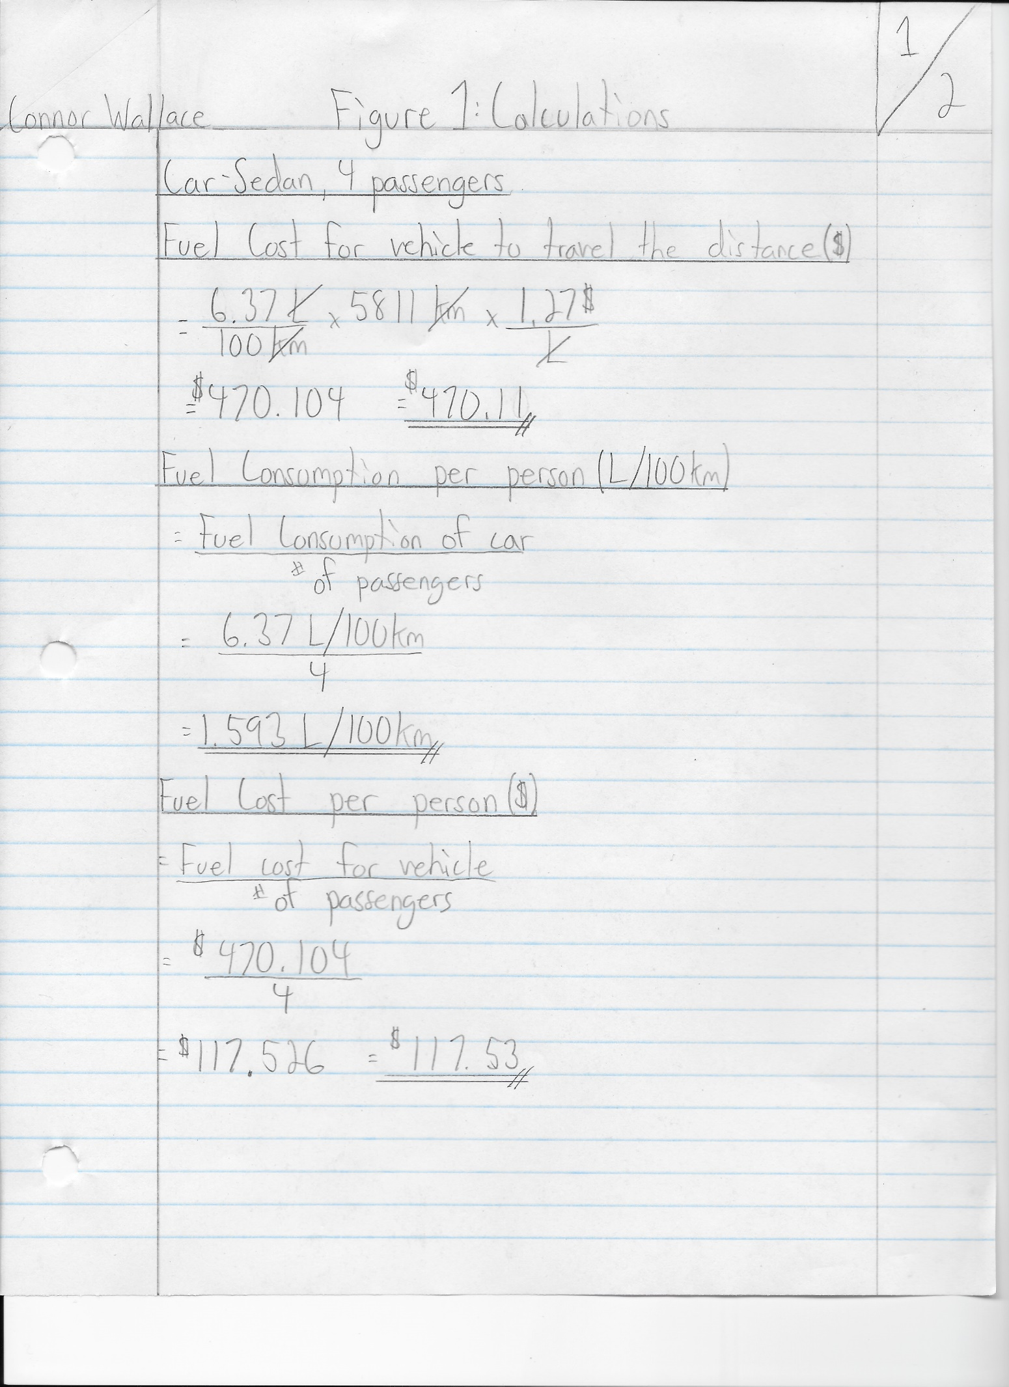

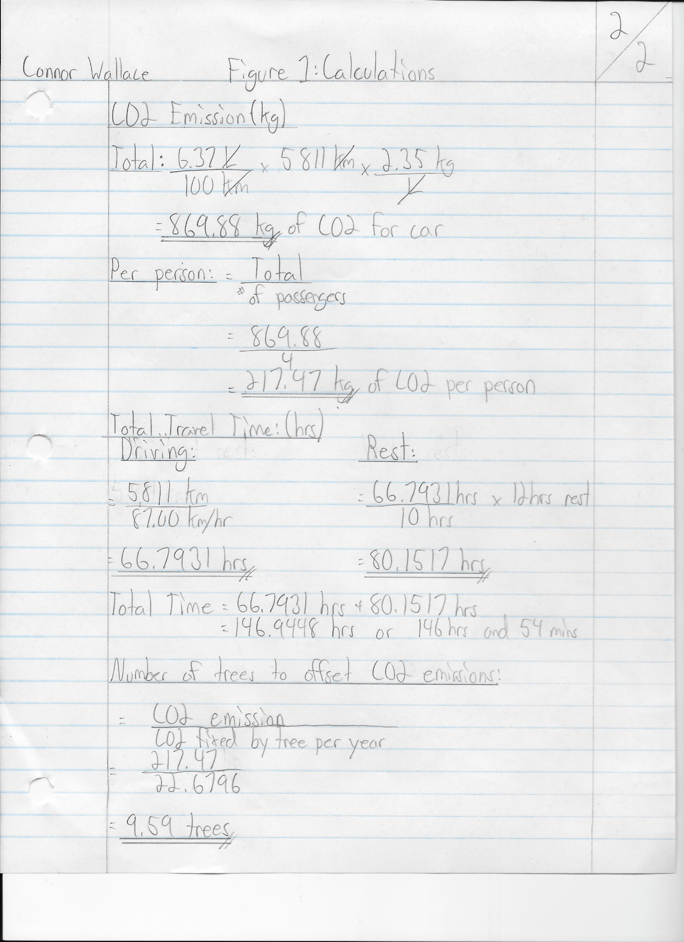

Table 3: Calculation Summary Table

 | Fuel Consumption L/100 km | Fuel Cost for the vehicle to travel the distance ($) | Fuel Consumption per person: 100% occupied seats L/100 km | Fuel Cost per person: 100% occupied seats ($) | CO2 Emission (kg) |  | Total Travel Time (hr) | Total Travel Time |  | No. of trees to offset CO2 emission /yr/person
 |  |  |  |  | Total | per person: 100% occupied seats | Total Travel Time (hr) | hr | min | No. of trees to offset CO2 emission /yr/person
E-1010  250 passengers | 776.67 | 28923.38 | 3.107 | 115.69 | 91397.87 | 365.59 | 5.46 | 5 | 27.6 | 16.12
Car– Sedan 4 passengers | 6.37 | 470.104 | 1.593 | 117.526 | 869.88 | 217.47 | 146.9 | 146 | 54 | 9.59
Minivan 7 passengers | 8.37 | 617.7035 | 1.196 | 88.2434 | 1,142.99 | 163.28 | 146.9 | 146 | 54 | 7.20

