ECOR 1010 – Introduction to Engineering

tarek Massarani
Assignment 100997762
Assignment Title: Univariate Data
TO Marking TA:
Name: Brian Goodman
Email: briangoodman@cmail.carleton.ca

Lab Section: L-12
Room: 4301CB – Carleton University

FROM:
Email: tarekmassarani@cmail.ca
Student Number: 100997762

Number of Figures and Tables (Including handwritten ones): 4
Last Date and Time of Revision: 08 November 2015

Introduction
The purpose of this laboratory is to determine the possess efficiency of producing a plastic knob for an electrical device to ensure the accommodation of the acceptable size of the knob which is (0.140±0.003) inches. This objective is achieved by sampling the production and applying data management techniques.

Materials and Methods
The results of the production of one day are recorded in a production record sheet as a production sample. Different samples of the production are examined separately. The relative frequency histogram and the table are setup using Excel. To calculate the standard deviation, mean, standard error, variance, and the 90% confidence interval of the production Excel spreadsheet is used. Eventually, the value of the proportion of the acceptable knobs was determined.

Results
Tables, histograms, and calculations are provided in the appendances. The mean of production was calculated to be 139.6 thou, the standard deviation was 3.57 thou, and the standard error was 0.532 thou.

Discussion
A bell-shaped frequency histogram resulted from the relative frequency table. The mean gives the average of the knob sizes. The standard deviation is the variation from the mean. Variance is how far each number is from the mean. Standard error is the standard deviation of the distribution the confidence gives the reliability of an estimate of 90% level of confidence.

Conclusions
The objective of this laboratory is successfully achieved by using data management techniques. The average of the production is within the accepted range. The ration of accepted products is about 82% which is reasonable (refer to the appendances for calculations). The overall production is efficient

APPENDIces- Figures and Tables
Figure 1
Bin | Frequency | Relative Frequency
133 | 1 | 0.022222
135 | 3 | 0.066667
137 | 9 | 0.2
139 | 12 | 0.266667
141 | 8 | 0.177778
143 | 5 | 0.111111
145 | 4 | 0.088889
147 | 2 | 0.044444
149 | 1 | 0.022222
Figure 1
Mean |  | 139.7111111
Standard Error |  | 0.529553101
Median |  | 139
Mode |  | 139
Standard Deviation |  | 3.552350197
Sample Variance |  | 12.61919192
Kurtosis |  | -0.12153011
Skewness |  | 0.506853421
Range |  | 15
Minimum |  | 133
Maximum |  | 148
Sum |  | 6287
Count |  | 45
Confidence Level(90.0%) |  | 0.889770995

Figure 2: Random distribution using the last three digits of my student number.

Bin | Frequency | relative frequency
133 | 1 | 0.022222
135 | 2 | 0.044444
137 | 7 | 0.155556
139 | 3 | 0.066667
141 | 6 | 0.133333
143 | 11 | 0.244444
145 | 8 | 0.177778
147 | 5 | 0.111111
149 | 2 | 0.044444
Figure 2
Mean |  | 141.0248074
Standard Error |  | 0.569078088
Median |  | 141.2880956
Mode |  | #N/A
Standard Deviation |  | 3.817491869
Sample Variance |  | 14.57324417
Kurtosis |  | -0.739612069
Skewness |  | -0.247551654
Range |  | 15.16662132
Minimum |  | 132.8826837
Maximum |  | 148.0493051
Sum |  | 6346.116332
Count |  | 45
Confidence Level(90.0%) |  | 0.956182063

Summary Table
Sample Statistic | Result via equations | Result via MS Excel | Random Normal Distribution using Excel with seed =762
Mean | 129 | 139 | 141
Sample Variance | 12.8 | 12.6 | 14.6
Sample Standard Deviation | 3.56 | 3.55 | 3.82
Standard Error | 0.538 | 0.529 | 0.569
Population Mean with 90% Confidence Interval | 0.879 | 0.889 | 0.956

Figure 3: production recorded sheet: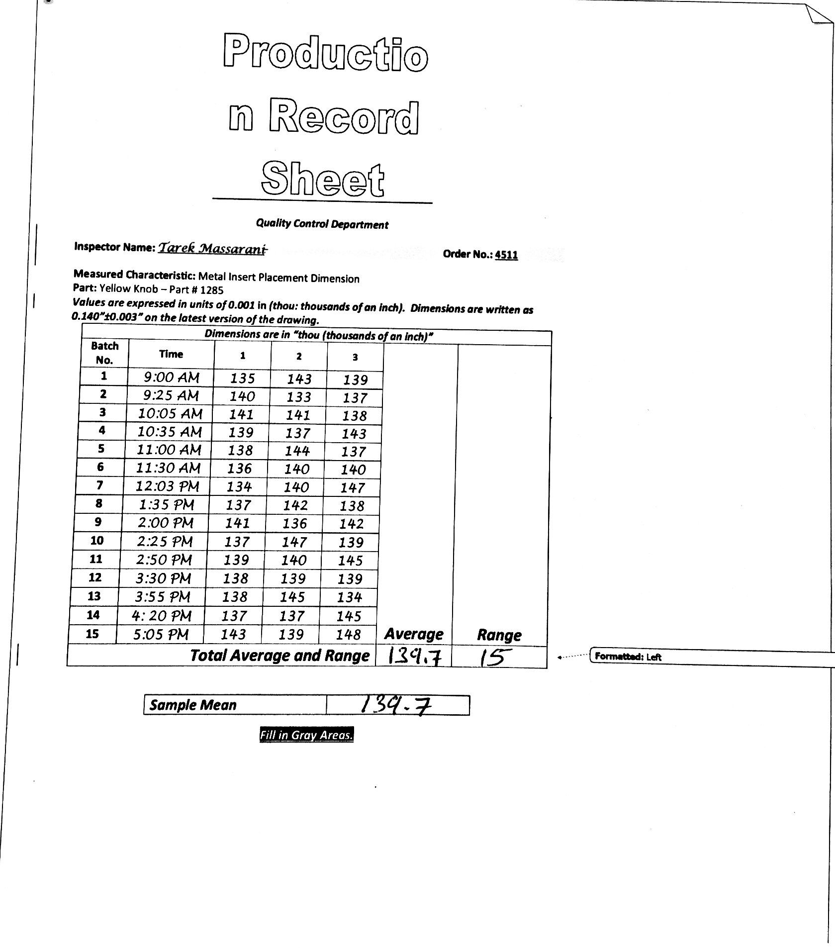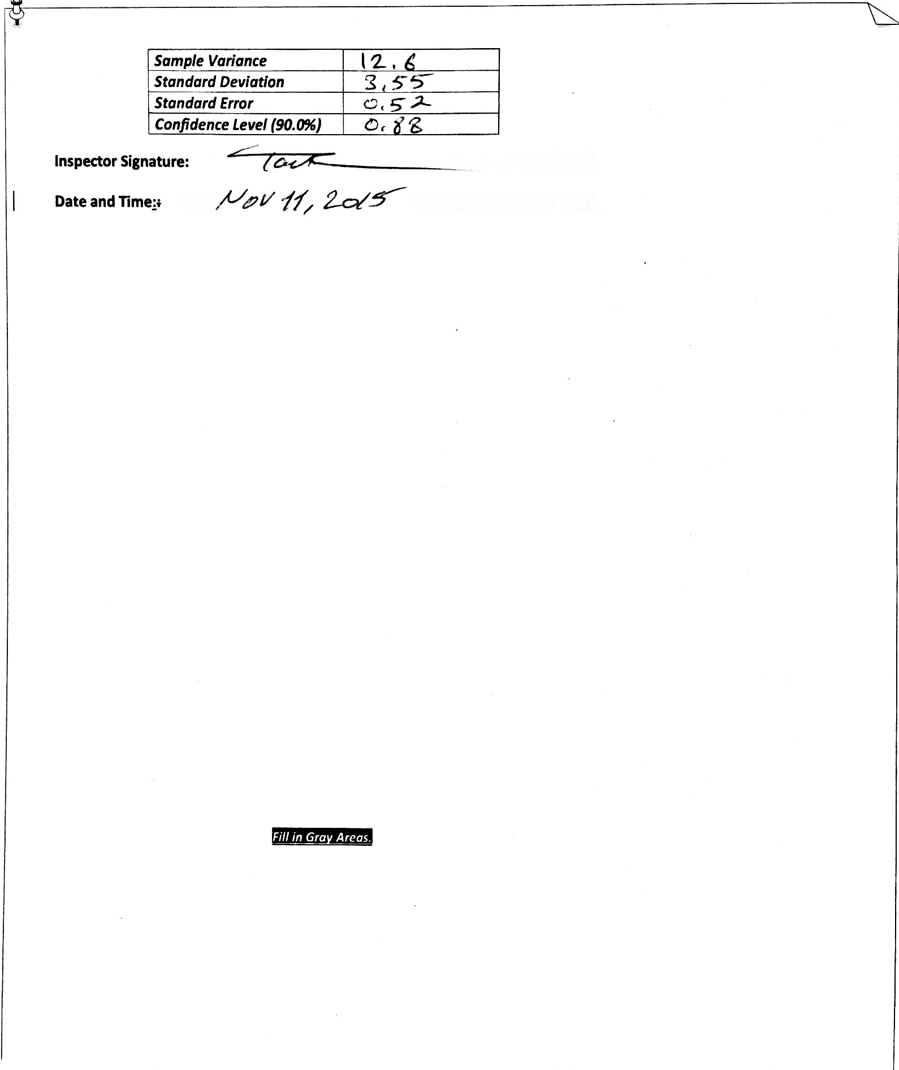

Figure 4: calculations. 

