Chapter 21 Lecture Notes
The Theory of Consumer Choice
The Budget Constraint
Budget constraint: the limit on the consumption bundles that a consumer can afford
-slope of the budget constraint equals the relative price of the two goods (price of good 1 vs. price of good 2)
Ex. using formula: Income= P (pepsi) * Q (pepsi) + P (pizza) * Q (pizza)
1000= 2*Q(pepsi) + 10 *Q (pizza)
Using the following formula we can see the trade off happening with pepsi/pizza
Income=I/P(pepsi) – P(pizza)/P(pepsi) * Q(pizza)
Representing Preferences with Indifference Curves
-Indifference curve: a curve that shows consumption bundles that give the consumer the same level of satisfaction (or utility)
Ex.
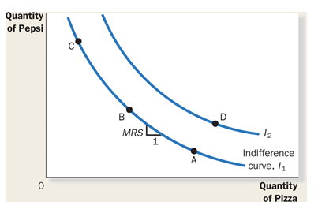
Marginal rate of substitution: the rate at which a consumer is willing to trade one good for another
*slope of the indifference curve
4 Properties of Indifference Curves
- Higher I.C. are preferred
- I.C. are downward sloping
- Two I.C. do not cross
- I.C. are bowed inward
Extreme Examples of Indifference Curves
Perfect Substitutes: two goods with straight-line I.C.
Perfect Complements: two goods with right angle I.C.
Impact of Changes in Income on Consumer Choices
-income increase>budget constraint shifts outward
-normal good: a good for which other things equal, an increase in income leads to an increase in demand
-inferior good: a good for which, other things equal, an increase in income leads to a decrease in demand
Impact of Change in Prices on Consumer Choices
-vertical intercept and slope change
Income and Substitution Effect
- Income effect- the change in consumption that results when a price change moves the consumer to a higher or lower I.C.
- Substitution effect- the change in consumption that results when a price change moves the consumer along a given I.C. to a point with a new marginal rate of substitution
Three Applications
- Giffen good: a good for which an increase in the price raises the quantity demanded
(violation of the law of demand)

