JRE 420 – Exam Study Notes

What do Employers look for in Employees?

% Employers seeking on candidate’s resume
- Ability to work in a team 79.8%
- Leadership 77.2%
- Communication skills (written) 75.6%
- Problem-solving skill 74.1%
- Strong work ethic 73.1%
- Analytical/quantitative skills 72.0%
- Communication skills (verbal) 67.4%
- Initiative 65.3%
- Technical skills 61.1%
- Detail-oriented 57.5%
- Computer skills 55.4%
- Interpersonal skills (relates well to others) 54.9%
- Entrepreneurial skills/risk-taker 21.8%

- Employers satisfied with the level of ‘hard skills’, but not satisfied with the level of ‘soft skills’ of college graduates (NACE, 2010).
- More managers are fired for lack of soft skills than for lacking technical skills.
- Most managers fail because
  - they have “bad judgment,
  - can’t build teams,
  - have troubled relationships,
  - Can’t manage themselves
  - Learn from their mistakes.

Employers Rating of Candidate’s Skills
- Ability to work in a team structure 4.60
- Ability to verbally communicate 4.59
- Ability to make decisions and solve problems 4.49
- Ability to obtain and process information 4.46
- Ability to plan, organize and prioritize work 4.45
- Ability to analyze quantitative data 4.23
- Technical knowledge related to the job 4.23
- Proficiency with computer software programs 4.04
- Ability to create and/or edit written reports 3.65
- Ability to sell or influence others 3.51

Personality
- The relatively stable set of psychological characteristics that influences the way an individual interacts with his or her environment.
Genetics + Environment = Personality
Personality = who I am/ Attitude = depends on who you’re talking to.

Reasons for studying personality
- Employee selection
  - Job Performance
  - Career Success
  - Fit with job/organization
- Leadership development
  - Self and other awareness (next class)

5 Factor Model on Personality
- Most prominent model of personality in organizational behavior
- Five broad traits that can be used to describe people’s personality
- Broad traits called dimensions, each dimension has several small traits
- Dimension is a continuum, ranging from low to high
- Every person has some level of each of these five dimensions
- People cannot be both high and low on a dimension.

Conscientiousness | High: careful, dependable, responsible, organized, persistent, high need for achievement  Low: disorganized, distracted, careless, unreliable, lower need for achievement  Relates positively to job performance, attendance, motivation; relates negatively to counterproductive behaviors  Predicts career success
Emotional Stability | High: poised, secure, calm, self-confident  Low: neurotic, anxious, indecisive, mood swings, depression  Predicts career success
Openness to Experience | High: Curious about world, fascinated by novelty, open to new experiences, enjoy experiences with different cultures, creative, artistic  Low: Resist change, fixed in their ways, conventional, comfortable in familiar settings
Agreeableness | High: Courteous, empathetic, good natured, friendly, easy to get along with  Low: uncooperative, irritable, antagonistic, difficult to get along with  Predicts career success
Extraversion | High: outgoing, talkative, like to socialize, assertive  Low: introverted, shy, quiet, prefer to be alone over groups

More on Extraversion
Facets: Warmth, gregariousness, assertiveness, activity level, excitement seeking, positive emotions -> effective interpersonal interaction
A study shows that extraversion is positively correlated to absenteeism, i.e. extroverted people tend to be absent in more occasions than introverts
It predicts managerial and sales performance

Behavior vs Personality
Behavior
- Can be observed/measured all the time (E.g., Talkativeness in social situations is extraversion vs. talkativeness in non social situations is not)
- Is influenced by personality & other factors (E.g., Talking in class is determined by personality and reinforcement for class participation (e.g., class participation marks) whereas talking across different social situations is determined by personality)

More on Conscientiousness
Facets: Sense of Competence, orderliness, sense of responsibility, achievement striving, self-discipline, deliberateness -> motivation, goal setting, attendance, discipline, achievement oriented -> higher job performance

Intelligence vs Personality
General Mental Ability (IQ) is 59% more accurate than conscientiousness in predicting job success

 | Occupational Level | Income
GMA | .51 | .53
Conscientiousness | .49 | .41

However, conscientiousness is the biggest predictor of job success.

More on Agreeableness
Facets: trust in others, sincerity, altruism, compliance, modesty, sympathy -> cooperative, helpful and nurturing others -> Better interaction and teamwork
Agreeableness predicts job performance in jobs that require working in teams

More on Emotional Stability (Neuroticism)
Facets: anxiety, angry hostility, moodiness/contentment, self-consciousness, self-indulgence, sensitivity to stress -> calm and secure -> effective interaction and teamwork

More on Openness to Experience
Facets: imagination, artistic interests, depth of emotions, willingness to experiment, intellectual curiosity, tolerance for diversity -> Creative, intellectual, curious and broad interests -> creative and effective learning

Why Study Personality?

Research shows Big Five Personality Dimensions are related to
- Job performance and organizational citizenship behaviours
- Work motivation, job satisfaction, and life satisfaction
- Job search and career success

FOR EXAM
- What is personality
  - Compare and contrast to behavior, IQ, attitudes
- Why is personality related to job performance
  - Compare to IQ
- What is the difference between Openness to Experience and Intelligence (IQ)?
- Can a person score high in both neuroticism and extraversion?
- Which personality trait is the best predictor of career success? Why?

Career Interests

What are Interests?
Realist | Working with gadgets/Validity of interests
Investigative | Scientific, mathematics (ex. economics, mathematics, physics, chemistry, biology, engineering)  Relates to openness to experience
Artistic | Creative expression in art (ex. drama, art, music, English, architecture)  Relates to openness to experience
Social | Helping professions, team work (ex. history, political science, sociology, nursing, social work, education)  Relates to extraversion, agreeableness
Enterprising | Leadership, entrepreneur (ex. business management, public administration, marketing and sales)  Relates to extraversion
Conventional | Structured work environment

Interests describe work environment (ex. Hospital, school). So choose work environment based on interests.

Why are interests valid?
Your job satisfaction and performance may depend on the fit between your interest profile and the profile of your workplace
Match between interests of employees and those satisfied by the job predicts higher satisfaction and performance

Sample Good Career Goal
To work as a Chartered Accountant in a firm with great people... find a career that I feel excited about doing every day. My ideal position within a company is somewhere that I am challenged to learn new things every day and in which I get to interact with many different people.
To work as a manager in the next 5 years and then transition into advisory. I would like to move into advisory in a firm and eventually hold a board position(s). My ideal position within a company is as a business consultant with a focus on sustainability and corporate social responsibility.
To work as a certified CPA accountant at an environmentally conscience organization… My ideal position within a company is CFO. I am striving towards my goal of working for the following company/companies: entrepreneurial start up/ new technology (i.e. TESLA ) , renewable energy company. Accounting firm, government

Self-Awareness and Skills

Leadership Skills

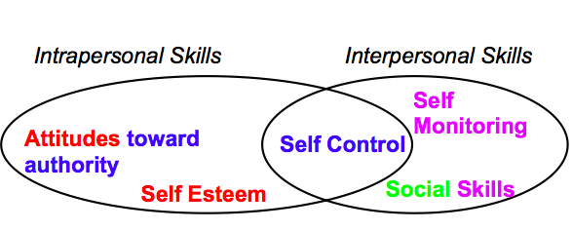
Developing Leadership Skills via Self-Awareness – Assignment 1
- Observe one’s own thoughts, behaviors, skills, using reliable, valid, & structured questionnaires
  - How to know if the questionnaires are reliable and valid?
- Compare own observations to an external source
      - A known other in a professional context
      - Intimate context
      - A complete stranger in this class context (professional)
  - Validity of these perspectives in a LEADERSHIP context
- Incorporate analysis of comparison to change skill
  - Leaders who are self aware are better performers

How does feedback help??
Acceptance and differential use of feedback also can be influenced by self-perception accuracy. Ashford (1989) suggested that individuals with the most accurate self-ratings will be most likely to use information about their abilities and performance and can alter their behavior accordingly.
Likewise, Fahr and Dobbins (1989a, 1989b) noted that self-perceptions and accuracy of self-ratings can be altered by the provision of social comparison information that is used differently by various individuals.
Atwater et al. (1992) found that feedback from subordinates’ ratings subsequently altered self-evaluations of leadership. Specifically, those with inflated self-perceptions (self-ratings higher than follower ratings) significantly reduced their self-evaluations and significantly improved their leadership performance. Those with deflated self-perception significantly increased their self-evaluations, while their performance remained high, but unchanged. (These conclusions reflect mean differences; not all individuals responded in this manner.) In other words, feedback about others’ perceptions can change both self-evaluations and, for over-estimators, subsequent performance

Why Become Self-Aware?
From HRM 1993 Yammarino & Atwater
According to Bass and Yammarino (1991), individuals with inflated or deflated self-assessments (typically over-estimators and under-estimators, respectively) will misdiagnose their strengths and weaknesses. These inaccurate evaluations can adversely affect job relevant decisions. Accurate self-perceivers, in contrast, tend to make more effective job-relevant decisions.
Bandura’s (1982) work on aspiration level also provides some insight. Individuals who under-estimate their abilities and skills will tend to set low aspiration levels and will underachieve. Those with accurate self assessments will develop favorable efficacy expectations and commensurate achievement.

Those who are more aware of how they are perceived by others are rated as more ‘transformational’ by their subordinates and are better performers. Self-aware individuals use information they received about their leadership to improve their performance.
Better managers are better at assessing the level of their own behaviors and the impact these behaviors have on others. (Church, 97)
Van velsor stud: those who had overrated their abilities to build good relationships and to deal effectively with people were provided with feedback, some changed their view (58%). There was a positive relation between change in performance and change in self-view 6 months after feedback.

Skill vs Personality
Skill | Personality
Changeable/malleable | Relatively stable across time and situation
Learned | Relatively genetic
More concrete (lower level) | More abstract (higher level)
Self-esteem is part of emotional stability | Emotional Stability

More on Self-Esteem
Self Esteem is the view of oneself positively; approval of oneself, judging oneself as significant, capable, worthy, believe that one has desirable traits
  - E.g., I am filled with doubts about my competence
Concerns composure, optimism, and stable moods.

Relation to Leadership
Leaders that have high self-esteem:
- Handle pressure well
- Not take criticism personally
- Expect to succeed
- Be hard to coach
- Overlook their mistakes

Leadership Implications
Compared to other leaders, your scores suggest that you usually maintain a positive attitude, remain patient with staff errors and mistakes, and persist in the face of challenges, frustration, and reversals. On the other hand, you may be reluctant to listen to negative feedback.

Competency Analysis
- COMPOSURE: You are perceived as confident and self-assured,
- LISTENING: You are so confident in your judgments that you may sometimes seem not to take others’ views seriously. As a result, others may see you as arrogant, regardless of the merit of your views.
- LEARNING AND PERSONAL COACHABILITY: You are open to and may even solicit feedback. At the same time, because you are so self-confident, you may tend to focus on the positive and ignore the negative. This can make you hard to coach.
- STRESS MANAGEMENT: You seem to deal comfortably with frustrations, delays, and the pressures of deadlines and heavy workloads. In fact, you appear to thrive under pressure, perhaps taking on more than you should. Others admire and count on your resilience.

Self esteem is a better predictor of job performance (.26) than is emotional stability (.19)

Research on Self Esteem:
- People with high self-esteem have favourable self-images.
- People with low self-esteem have unfavourable self-images.
- People with low self-esteem react badly to negative feedback – it lowers subsequent performance.
- People with high self-esteem make more fulfilling career decisions and have higher job satisfaction and job performance.
- People with high self-esteem are more resilient to the strains of everyday work-life, leads to better job performance
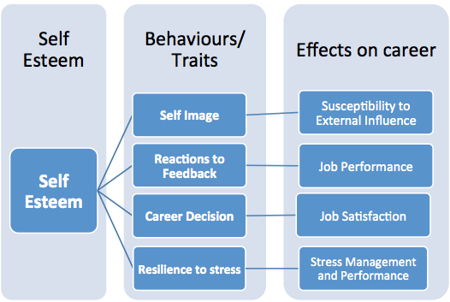

More on Social Skills
- Ability to read others accurately
- Make favourable first impressions
- Adapt to a wide range of social situations
- Be persuasive

Social skills = Some Extraversion traits + Some Agreeableness traits
Concerns seeming talkative, socially bold, and entertaining.

Behavioral Implications
Leaders with similar scores tend to
- Seem approachable, not distant
- Be comfortable either working alone or with others
- Prefer formal rather than casual meetings
- Provide staff relevant feedback
- Balance listening with talking

Leadership Implications
Compared to other leaders, your scores suggest that you are flexible with your time, and don't mind working either alone or as part of a team. You meet the public well, but you don't need to be the center of attention or constantly on stage.

Competency Analysis
- INITIATING INTERACTIONS: You are able to initiate and build good relations with others in your organization, including people you don't already know.
- ENERGY: Others see you as having appropriate energy and enthusiasm for new people and projects.
- APPROACHABILITY: Your ability to initiate interactions with new people is an important skill for leaders. Continue developing contacts in the organization, and include your staff in the interactions.
- INTERPERSONAL NETWORK: Your networking skills are sufficient to keep you in touch with the organization.
- TEAM ORIENTATION: Others see you as participating appropriately in team tasks.

More on Self-Monitoring
The extent to which people observe and regulate how they appear and behave in social settings and relationships.
High self-monitors
    - Take great care to observe and control the images that they project
    - Show concern for socially appropriate emotions and behaviours
    - Tune into social and interpersonal cues
    - Regulate their behaviour and self-presentation according to these cues
- Gravitate to jobs that require role playing
- Gravitate to jobs that require the use of their self presentation skills
- More involved with their jobs and perform better
- More likely to emerge as leaders
- Experience more role stress and show less commitment to their organizations
- Are more likely to change employers and locations, and to receive more promotions
- Are not comfortable in ambiguous social settings, where it might be hard to determine what behaviours are socially appropriate
- Might stress while dealing with unfamiliar cultures

More on Self-Control
Features of self control:
- Impulse control: Delay gratification
- Persistence
- Low risk seeking (for self and other)
- Low self centeredness
- Ability to Control emotions
- Social and personal
- Note differences of self control in interpersonal and intrapersonal context

Self control involves the ability to restrain one's impulses, curb one's appetites, stay focused, maintain schedules, and follow routines. Persons with good self-control are self-disciplined, buttoned down, and abstemious. Persons with poor self control are impulsive, self-indulgent, and undisciplined.
Impulse control = Ability to delay gratification vs. have a ‘here and now” orientation
Lack of Persistence= Lacking diligence, tenacity or persistence in the course of action. In the managerial context it is the ability stay focused on task or on others’ expectations of you
Risk seeking = being adventuresome rather than cautious – agreeing with item: I sometimes find it exciting to do things for which I might get in trouble
Self centeredness=being indifferent or insensitive to the suffering and needs of others
Low ability to control temper = having a minimal tolerance for frustration
Facet of conscientiousness
Validity: Related to career outcomes

Interpersonal Skills
Social Skills
- Put oneself in the place of another person and try to understand what the person expects in an interaction
- Social skills are a combination of empathy & extraversion
Self-monitoring
- Incorporate information about other person’s expectations in one’s subsequent behaviour e.g., Regulating oneself when interacting with supervisor
Self Control
- Stay focused on the other person’s expectation e.g., supervisor’s expectation of being treated with respect
Interpersonal skills is a combination of Extraversion, Conscientiousness and Agreeableness

More on Attitudes toward Authority
- Tendency to act in an obedient manner in situations where it is socially expected of one to follow an overt/implied command
- Tendency to follow rules, respect procedures, behave in socially appropriate manner, be conforming, be compliant (E.g., in traffic; in a church, in certain offices, with people holding certain roles)
- Persons with positive attitudes toward authority follow rules and respect procedures; they are compliant, conforming, socially appropriate, and easy to supervise. Persons with negative attitudes toward authority ignore rules and violate procedures; they are rebellious, refractory, and hard to supervise.
- The predisposition to act in an obedient and respectful manner in situations in which there is a socially sanctioned expectation that an overt or implied command or request will be followed. Situations include those in which there is a legal obligation to confirm (e.g., traffic regulations), institutions such as churches, offices (e.g., manager) roles (parents) or symbols that are seen as exerting socially sanctioned pressure to exact some degree of obedience and respect.
Leadership Implications
- You are concerned about rules, procedures, and task clarity.
- RULE ORIENTATION: You respect the rules of the organization, you follow them carefully, and you expect others to do so as well.

Attitudes toward Authority is a combination of Emotional Stability, Conscientiousness and Agreeableness
Related to career outcomes, supervisor’s satisfaction w/employee

Sample Exam Questions
- What skills should a leader possess? How should a leader develop these skills
- What is self awareness? How should you make the self-awareness process valid?
- Why may there be such discrepancies between your own vs. another’s view of your leadership skills
- Describe a concrete behavioral example that illustrates the difference and similarity between
- Self-control and self monitoring
- Social skills and self control
- Self monitoring and self-control
- Self-control in the intra-personal vs. inter-personal context
- Social skills and inter-personal skills

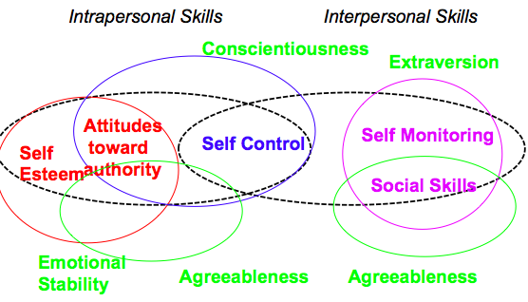

Theory of Motivation
- What is motivating? (aka Process Theories)
  - Expectancy Theory
  - Equity Theory
  - Goal Setting Theory Most Valid
2. What motivates you (aka Need theories)
  - Maslow’s Hierarchy of Needs
  - Aldefer’s ERG Theory
  - McClelland’s Theory of Needs Most Valid, covered in a different session

Goal Setting Theory
Why do goals improve performance?
- Personal examples
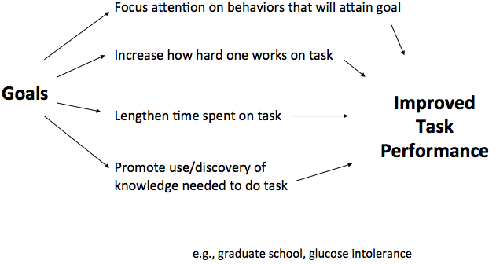

Example of glucose intolerance
- Focus on eating/drinking behaviors that increase glucose
- Read labels of products containing glucose, learn about what products release glucose faster/slower, learn about what ways to reduce glucose intolerance- e.g., exercise
- Spend more time exercising
- Exercise harder– ignore distractions to lowering glucose

What makes goals more effective in improving performance?
- Personal examples, research studies

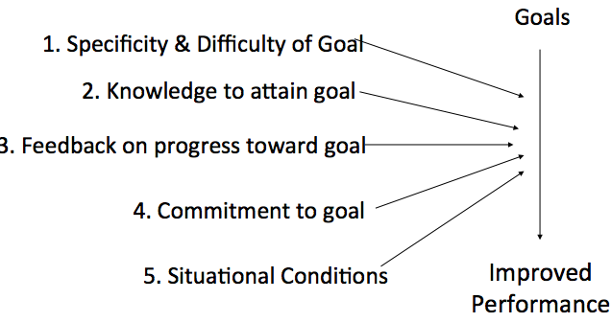
More on 1) Specificity & Difficulty of Goal
- Research - Research shows that Specific and Difficult goals improve performance as opposed to more ambiguous “do your best” goals
- Why do specific & difficult goals result in better performance than ‘do your best’ goals?
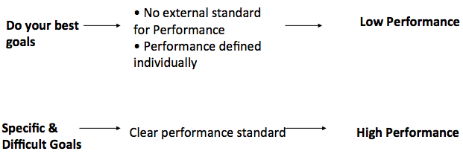
More on 2) Knowledge to Attain Goal
Increasing knowledge:

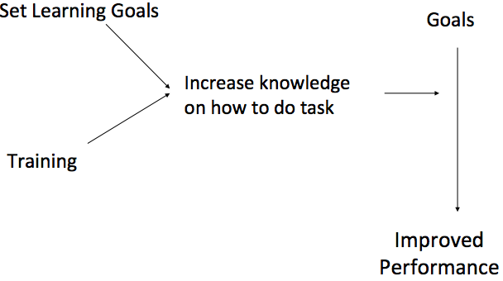
- Learning goal is one that is specific about the number of strategies to be discovered to learn how to perform a task
- Subgoals give markers of progress– recast the big goal into smaller attainable ones, helps get feedback to evaluate whether strategies to attain larger goal are successful.

Learning goals
  - Examples: learn to network; master specific subject matter
Performance goals
  - Example: attain specific GPA at end of semester
Why do learning goals lead to performance?
- Learning goals
  - facilitate planning
  - focus on understanding the task
  - Monitor & evaluate progress toward goal attainment
  - Such behaviors are especially needed in unstructured environments

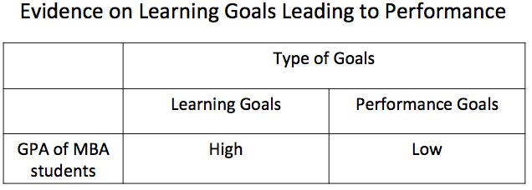

- Based on the research reviewed so far, consider…
  - Is your career goal specific and difficult?
  - Do you “know” what you need to Know to attain your career goal?
    - What are your learning goals
    - What training to you need?
      - Besides specific subject matter

More on 3) Feedback on Performance toward Goal
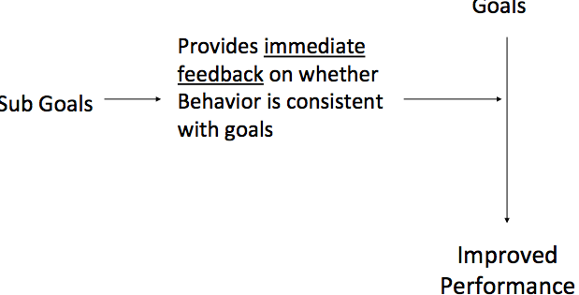
- Based on the research reviewed so far, consider…
  - What are your sub-goals that will give you feedback on whether you are progressing toward your career goals

More on 4) Commitment to Goal

- How will you ensure commitment to your career goals?
  - What rewards?
  - Can you make it public?
  - Does it convey confidence in your own ability to achieve it?
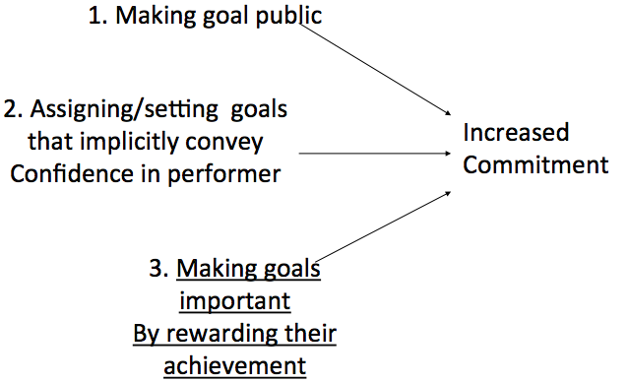

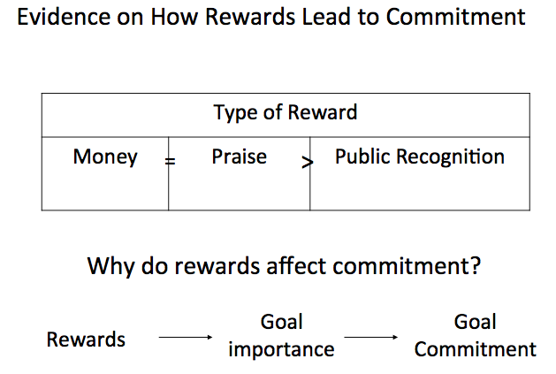
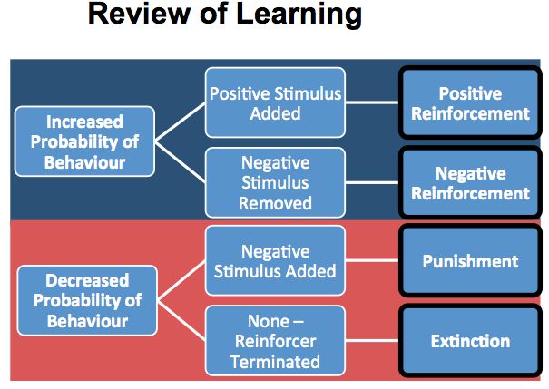

More on 5) Role of Situational Conditions on Goal Attainment

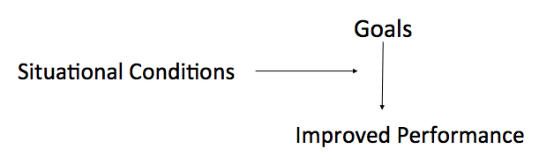

- Example: High Role Overload having excess work without resources to accomplish task
- Goals positively affect performance only when overload was low

Application of Goal Setting Theory to Career Goals (Exam)
- Are your career goals specific and difficult?
- What are the mechanisms by which you will increase knowledge to accomplish goals (i.e., training or research)?
- What learning goals will you have?
- What are potential sub-goals that will enable you to get feedback on how you are progressing toward your goals
- How would you ensure commitment after completing each sub-goal?
- What are the situational obstacles adversities that may stand in the way from achieving your goals and how will you overcome them?

Summary of Goals
- Why goals improve performance
  - Focus attention
  - Promote use of knowledge
  - Increase amount of time on task
  - Increase amount of effort on task
- What makes goals more effective in improving performance
  - 1. Specificity & difficulty of goals
  - 2. Knowledge of how to attain goals
  - 3. Feedback on progress toward goals
  - 4. Commitment to goals
  - 5. Situational constraints

Application of Goal Setting to Leader Role (aka Management by Objectives)
- Manager & employee meet to develop objectives and timeframe to achieve
- Goal setting role play
- Feedback sessions for monitoring purposes
    - Performance feedback role play

- Elaborate, systematic, ongoing program designed to facilitate goal establishment, goal accomplishment and employee development
- Developed by Peter Drucker
- Objectives follow rules of goal setting, specific challenging etc.
  - Include job performance & career development
  - Prioritized
- Feedback sessions to monitor objectives, reprioritize, modify etc.
- Top management develops objectives for whole organization and these are moved down through the organization through MBO process. So org goals are translated into behavioral objectives for specific members
- Research shows productivity gains for implementing MBO programs but many programs fail because top management fails to commit therefore goals set by lower levels of management are confused and are not based on clear goals for the company. Thus, goals can’t be achieved, feedback is unavailable from top management and nothing is accomplished
- Difficult to implement because some types of goals are inherently more difficult to specify and set, measure, and give feedback on.
- Excessive meetings can also be a problem for achieving objectives because employees may feel constantly being reminded of failure to achieve objectives.

Role Play Exam Questions
In your role-play, how did you …
- Make your goals specific and difficult?
- Increase knowledge to accomplish goals?
Set learning & training goals, set sub-goals, enable feedback toward progress
- Increase commitment to goals
- Overcome situational obstacles

More Debriefing Questions
- How do you place the organizational goal and your own goal as a supervisor in the context of your subordinate’s goals
- Goal setting vs. Micro managing
- Does goal setting emphasize short-term results at the expense of long-term effectiveness?
- How does goal setting deal with employees who have multiple goals, some of which are conflicting?
- What barriers in an organization can you identify that might limit the effectiveness of a goal-setting program? How can these barriers be overcome?
- On which of the key learning behaviours relevant to goal-setting skills were you best? Weakest? How would you improve these skills?
- Debriefed by talking about the difference between the overall performance standard / objective, versus goals to help employees achieve the standard. Also, we talked about the difference between goal setting and micro managing. Finally, how tough it is to do it well and then also incorporate a particpative model to the meeting and goal setting process. Overall, it allowed students to see that although you have a performance objective to set, the process of motivating people to achieve that target is done through goal setting, i.e., the meeting they are conducting is part of the process of getting an employee to do what the organization needs

Performance Feedback

Does feedback improve performance?
- <50% of time, feedback improved performance
- 33% of time feedback decreased performance

Feedback Operation
- Attention to self – how do I compare to others (as student/sales person)
- Attention to task – what can I do to improve sales/grades? What is the optimal behavior
- Feedback can elicit attention to self or task goal

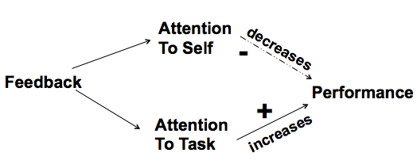
Effects of Attending to Self
Concern about defending self image interferes with ability to focus on task (takes away cognitive resources) and improve performance. Strong feelings of despair, disappointment or happiness can also interfere with task performance– focusing on self diverts attention away from the task to questions of who we really are.

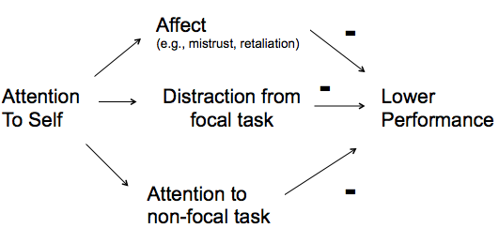
Feedback and Attention to Task
Attending to Task Motivation and/or Learning
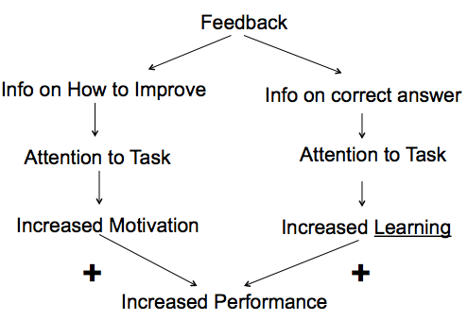

Example of motivation: increased Effort to reduce gap between actual & ideal performance

Reflect on Feedback from Class/Group/Job
- Was the negative feedback
  - Relative to others? Trait based? OR
  - Task based?
- If task based feedback was not provided, how can you seek it?
  - Where will you find information on how to improve
  - Where can you find Information on what is the correct/optimal behavior/answer
    - When you find information on optimal behaviors/answers, set learning goals

Generating Learning Goals
- Example learning goals for a professor
  - Finding specific ways to explain complex material in memorable ways
  - Showing the relevance of the subject matter to the students' lives outside the classroom
- For a golfer
  - Mastering the proper grip of the club
  - Master proper placement of the feet
  - Learning when to use what club
  - Understanding the distribution of weight from one foot to the other when swinging the club
- Generate learning goals for yourself in your course/task/job
  - Xxx

6-Step Agenda for Performance Feedback (for leaders)
1. Enquire about progress (self-appraisal)
2. Give feedback with evidence & behaviors: Positive and Negative
3. Ask subordinate to respond to feedback with reasons for own behavior
4. Ask subordinate for suggestions to improve/change behavior
5. Give feedback on subordinate’s suggestions (if needed)
6. Set goal for behavioral change & make plan to meet again

Behavioural Application of 6-Step Agenda
S – Decreases attention to self
T – Increases attention to task

1. (S) Show respect for subordinate & prevent embarrassment (ex. Invite sub to private setting)
2. (T) Give subordinate an opportunity to self appraise (ex. Set scene for personal review by inquiring about progress on project)
3. (T) Maintain motivation and cooperation (ex. Put the feedback in context by initially acknowledging the positive aspects of performance)
4. (T&S) Maintain standard of work & preserve relationship (ex. Raise issue of concern in sub’s behavior without blame or criticism)
5. (S) Prevent subordinate from getting upset/feeling hurt (ex. Invite sub’s reaction to your feedback)
6. (T) Maintain your credibility & give evidence to justify your concerns (ex. Specify examples of the behavior & the negative consequences for the project)
7. (T) Show subordinate that you are fair-minded & involve subordinate (ex. Invite sub to respond to your feedback and give his/her understanding of the situation)
8. (T) Build ownership & commitment for improvement (ex. Invite sub to give ideas on how to improve performance or situation)
9. (T&S) Show you value the subordinate (ex. Comment on subordinate’s ideas)
10. (T) Try to improve subordinate’s performance (ex. Give your ideas on improving sub’s performance or situation)
11. (T&S) Get best outcome for project & subordinate (ex. Spend time discussing both sets of ideas)
12. (T) Ensure subordinate’s performance changes (ex. Agree with the subordinate on a plan of action & how to monitor progress)
Script increases attention to task
Script decreases the negative effect that attention to self can have on performance

Example

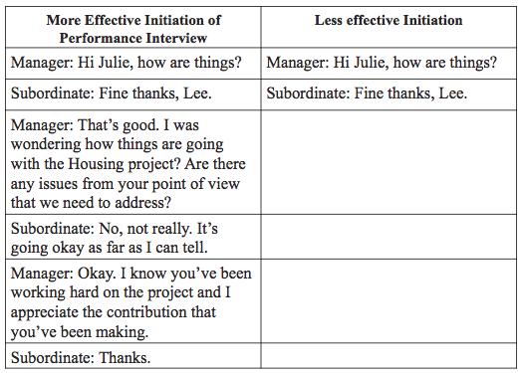
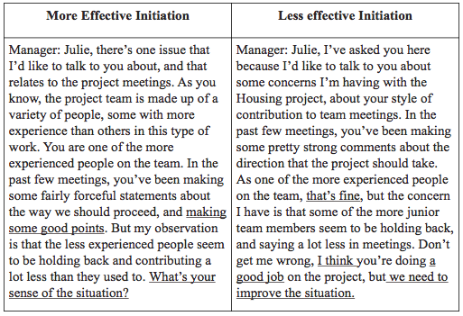
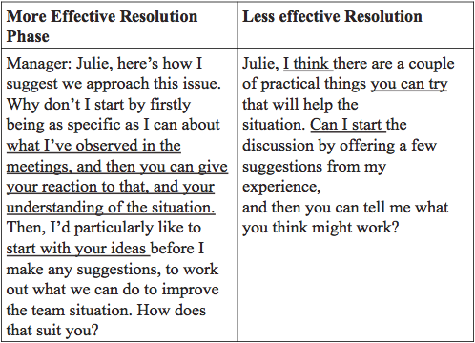
Final Exam Questions
In the performance appraisal interview
- What one piece of concrete evidence of negative performance will you give to your subordinate?
- What one good reason should you anticipate from your subordinate for his/her poor performance?
- When your subordinate is asked for suggestions for improvement give one unreasonable suggestion you should anticipate, and one reasonable one you can accept given yours and your organization’s goals.
How does each element of your agenda and your reaction to you subordinate’s behavior take into account the research on feedback (i.e., that it sometimes has positive, negative or no effect) so that the session will have positive impact on your subordinate’s future performance

Team Effectiveness

Factors affecting Team Functioning
- Shared Mental Models
- Closed-Loop Communication
- Mutual Trust

More on Shared Mental Model
  - Team members have clear and common goals and performance standards
- E.g. What is your Hypothesis? Does it meet the assignment requirement?
- Also you guys came up with team name and logo as a group

  - Team members train and practice together
    - E.g., generate hypothesis that meets the assignment requirements
- An organizing knowledge structure of the relationships among the tasks that the team is engaged in
- About how the team members will interact
  - E.g., How do we make decisions? – who does what in which assignment (across courses, in this course)
- Anticipating and predicting each other’s needs.
- Identify changes in the team, task, or teammates and implicitly adjusting strategies as needed.

More on Closed-Loop Communications
- Exchange of information between a sender and a receiver irrespective of the medium & minimal “links” in communication
  - Team developed a page/platform (e.g., dropbox, blackboard) to exchange information
  - Exchanged contact Information
    - Email addresses, phone numbers, virtual media addresses (e.g.,Skype/ Google hangout)
- E.g., Sign off on agreements on charter!
- E.g., How do we deal with members are too quiet or don’t communicate or are too shy?
Behaviors Displaying Closed-Loop Communication
- Following up with team members to ensure message was received.
- Acknowledging that a message was received.
- Clarifying with the sender of the message that the message received is the same as the intended message.
  - Face-face meetings are crucial
  - Regular meetings are crucial

Mutual Trust
Trust
- Confident positive expectations of another’s behavior
Types of Trust
- Based on Similarity
Perceived compatibility of values, common goals and positive emotional attachment – understanding & learning
    - Positive emotional attachment comes from doing leisure/study activities together
      - e.g., generating hypotheses together
      - E.g., generating team name and logo

- Based on Familiarity
- Based on Social networks
- Implicit trust
- Instant attitudes
- Mere exposure: “He grew on me”
- Schmoozing: “Let’s have lunch sometime”
- Mirroring people
- Flattery
- Face-to-face contact
- Incentive-based(or calculated trust)
- Reward for being trusting and acting trustworthy
- Punishment for violating trust
- Shared belief that team members will perform their roles and protect the interests of their teammates
- Behaviors displaying Mutual Trust
- Information sharing via exchange of contact information
- Willingness to admit mistakes and accept feedback.

Team Contracts
- Ground rules of how the team operates while tackling the problems presented to the team
- Developed via an open, frank and comprehensive discussion about
  - Norms,
  - Behaviors
  - Expectations
  - Responsibilities for which they will hold themselves and other team members accountable
- We will encourage open discussion and be willing to try new ideas.
- Learn from each other.
- Attend all group meetings on time. If unable to attend, the team member shall notify the group of the intended absence and make necessary arrangements
- Come to each meeting with the our assigned tasks completed
Benefits
- “The team charter kept us on track with specific goals and a way to go about attaining them”
- “It sets boundaries. It outlined our expectations and gave us a base to work from”
- “The team charter provided expectations and goals up front so everyone knew what was expected of them”
- Enable each team to develop and understand the rules of conduct expected of each team member
- To have an unambiguous set of standards and expectations for each team member
- To enhance team functioning as per the Salas et al model
Shared Mental Model
- An organizing knowledge structure about how the team members will interact
    - E.g., How do we make decisions? Vote? Unanimous? Majority?
- A shared understanding of the relationships among the tasks that the team is engaged in
    - E.g., after finding evidence for and against hypothesis..
      - Find reasons for evidence and against hypothesis
      - Find research on definitions of variables
Closed-Loop Communication
- Exchange of information between a sender and a receiver irrespective of the medium & with minimal “links” in communication
  - Things to include in your contract - How should we communicate?
    - E.g., every email is acknowledged?
    - E.g., Social media vs. email used for sharing articles?
    - E.g., Meetings virtually vs. telephone vs in person?
    - E.g., How should we encourage members who are too don’t communicate (too shy? Too busy?)
Mutual Trust
- Confident positive expectations of another’s behavior based on
  - Familiarity, similarity, social networks, implicit, incentive-based
  - Engendered by behaviors like information sharing, willingness to admit mistakes and accept feedback
  - E.g. Include things in your team contract to build trust by increasing familiarity
    - e.g., more face-face meetings initially to share information

More characteristics to consider to develop a team contract

Mutual Performance Monitoring
- Develop common understandings of the team environment
- Apply appropriate task strategies to accurately monitor teammate performance.
  - E.g. How will our team do research on the hypothesis (e.g., make notes to share? Share search strategies?)
  - E.g., How should we deal with a group member that misses a meeting?
- Behaviors
  - Identifying mistakes and lapses in other team members’ actions.
  - Providing feedback regarding team member actions to facilitate self-correction.
Back-Up Behavior
- Ability to anticipate other team members’ needs through accurate knowledge about their responsibilities.
- Ability to shift workload among members to achieve balance during high periods of workload or pressure.
  - E.g. How will we maintain a fair and equal workload among all team members? (e.g., in one task vs. all tasks)
  - What should we do to redistribute the workload when it is unbalanced?
- Behaviors
  - Recognize that there is a workload distribution problem in team
  - Shift work responsibilities to underutilized team members.
  - Complete whole task or parts of tasks by other team members

Adaptability
- Ability to adjust strategies based on information gathered from the environment via backup behavior and reallocation of intra team resources.
- Alter a course of action or team repertoire in response to changing conditions (internal or external).
  - E.g. What steps will our team take to effectively and efficiently resolve any conflicts?
- How to display adaptability
- Identify cues that a change has occurred, assign meaning to that change, and develop a new plan to deal with the changes.
- Identify opportunities for improvement and innovation for habitual or routine practices.
- Remain vigilant to changes in the internal and external environment of the team.

Team Orientation
- Propensity to take other’s behavior into account during group interaction
- Belief in the importance of team goal’s over individual members’ goals.
  - E.g. What does it mean to “commit” to a meeting?; What decisions must be agreed to by all?
- Behaviors
- Take into account alternative solutions provided by teammates,
- Appraise team input to determine what is most correct.
- Increased
  - Task involvement,
  - Information sharing,
  - Strategizing,
  - Participatory goal setting.

Team Leadership
- Direct and coordinate the activities of other team members, assign tasks, plan and organize,
- Motivate team members
- Establish a positive atmosphere
- Develop team knowledge, skills, and abilities to make them involved in the challenging task
- Cognitive Ability, Technical Knowledge, Interpersonal Skills, Decision-making, problem-solving
- E.g. How will we ensure that group members take turns being the “spokesperson”?; How do we encourage participation?
- How to display Team Leadership (Learn about members’ experiences & skills)
- What experiences can you draw from each others?
- What is each individual’s experience with research assignments? with presentation?
- What is your experience with teams
- What successes and failures have you had during the team project?
- What are some similarities and differences between the team members? Common weaknesses & strengths
- Behaviors
- Facilitate team problem solving.
- Provide performance expectations and acceptable interaction patterns.
- Synchronize and combine individual team member contributions.
- Seek and evaluate information that affects team functioning.
- Clarify team member roles.
- Engage in preparatory meetings and feedback sessions with the team.

Sample List of Items to Address
- Norms
- Decision Making Process
- Participation
- Method of Dealing with Conflict
- Methods of dealing with violations of Contract
- Goals
  - Learning Goals
  - Performance Goals

Criteria for Goals
- Goals should focus on the longer-term as well as short term
    - E.g., What will you get out of the experience once the grades are submitted?
    - How will the assignment and team experience link to and support your individual goals?
- Goals should be performance and learning goals

What are Learning Goals
- Focus your attention on
  - Understanding, knowing and mastering tasks
  - Important skills and concepts needed to develop proficiency in the task
  - Discovering deep principles and strategies embodied in the task
  - Learning how concepts & strategies are related in the context in which the task is performed
  - Implementing task-relevant procedures/processes, make errors, and learn from those errors.
- Individuals' attention on discovering strategies and mastering a task rather than performing well
- Facilitate planning,
- Focus on understanding the task
- Focused on skills needed to develop proficiency and on the deep principles and strategies embodied in the task
- And its performance context
- Learning goals focused trainee attention on learning important skills and concepts
- Learning goal shifts attention to the discovery and implementation of task-relevant strategies or procedures
- Mastery goals prime trainees to explore complex relations in the task, make errors, and learn from those errors. Development a consistent organization of key task concepts (i.e., coherent knowledge structure)
- Sequence goals to orient attention to basic task features before shifting to more complex principles, such as task strategies and priorities.
- Using learning goals to guide learning, practice, and skill development.
- Think about your marks score as feedback that could help them to learn about the game
- When setting learning goals
- Sequence your learning from basic to complex strategies
- Learning frame
- Work on challenging tasks because they provide you with the opportunity to develop your competency.
- Focus on ways to master tasks so as to develop your competence, acquire new skills, and learn from experience
- Practice makes perfect, practice helps you improve
- Errors are perceived as a natural, instructive part of the process. You should expect to make mistakes- errors help you improve/ the more errors you make, the more you learn
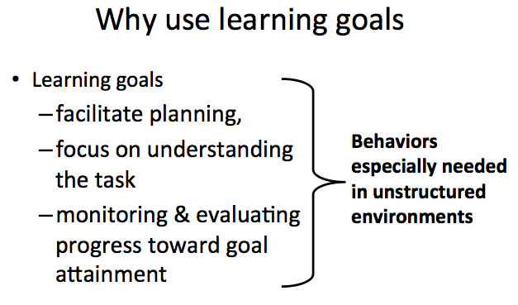

Setting Learning Goals
- Avoid setting only performance goals
  - E.g., “Get A+ grade”
- Focus on goals to gain knowledge about how to achieve the goal (learning goal) or to learn the tasks to do perform it (training goal).
  - E.g., I will get A+ by learning how to research for articles, reading the articles, learning how to summarize articles etc.
- Identify task-relevant strategies that your team will focus on for doing the assignment
- Set specific and difficult learning goals for these “task relevant” behaviors
  - E.g., Identify 4 strategies your team can use to exhibit these behaviors

Team contracts should be cohesive
  - Reinforce the overarching approach or strategy to how you as a team approach the work
  - Team effectiveness model is a guide to explaining the why behind rules
  - Helps team members understand the purpose of each rule

Adaptable Leadership

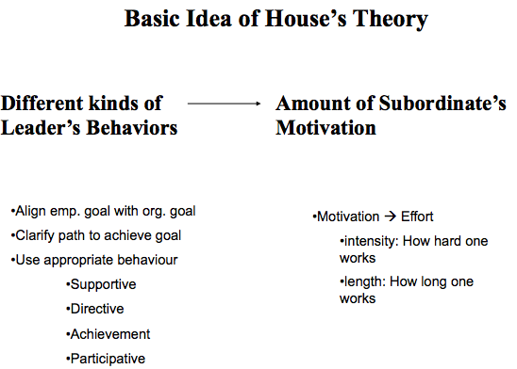

Directive
Sets specific goals and delineates how to achieve them

Supportive
Show concern for welfare
Create a friendly and supportive environment

Participative
Encouraging subordinates to influence how decisions are made, how work is done

Achievement Oriented
Set challenging goals
Look for improvement
Focus on excellent performance
Demonstrate that you are confident that subordinates can achieve the high standards of performance you set

Why subordinates may not be motivated?
- Role Ambiguity=Lack of clarity on
  - what is expected
  - How one’s performance will be evaluated
  - Criteria for evaluation
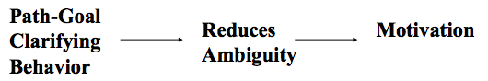

More on Directive Behaviours (Clarifying behavior)

- Clarify what the performance goals are
- Instructs how to effectively carry out tasks to accomplish goals
- Identify what standards will be used to judge performance
- Schedule & coordinate work
- Clarify rules, procedures, policies
- Allocate reward & punishments based on performance

Effectiveness Contingencies
- Novel Roles
- Subordinates with low ability

Novel Roles

Path goal behaviors may only effective in increasing motivation for (new) subordinates who perceive their roles are ambiguous

Low Ability
- When subordinate are low in ability they may perceive their role as being ambiguous and path goal behaviors may only be effective for those low ability subordinates

What if the role is not ambiguous?
Non ambiguous roles imply subordinates are clear on
- what is expected
- How one’s performance will be evaluated
- Criteria for evaluation
- e.g., new vs. old employees may perceive their roles as more or less ambiguous

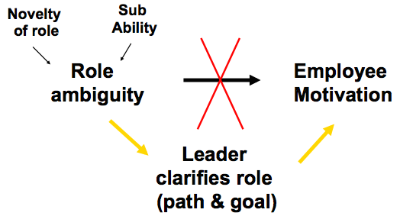
More on Supportive Behaviors
Effect on Subordinates
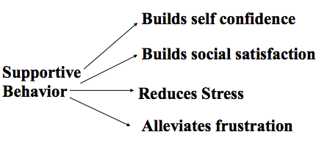

More on Achievement Oriented Behaviours
Effect on Subordinates
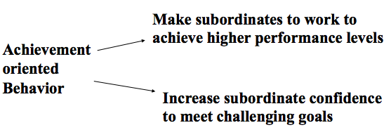
More on Participative Behavior
Effect on employees
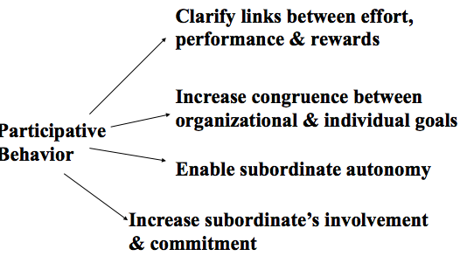
Sample Exam Question
Think of instructors in your university career/ supervisors in your job/any other person with a leadership role toward you…
  - Illustrate how one/more display EACH type of leadership behaviors
    - Path goal, achievement oriented, supportive, participative
  - Illustrate with an example with the above one similarities and one difference between
    - path goal clarifying behavior vs. achievement oriented
    - Achievement oriented vs. participative
    - Path goal clarifying vs. supportive
    - Supportive vs. participative
    - What leadership style (s) should be most effective for each of the subordinates? Why?
- How easy/difficult was it for supervisors to change behavior w/different subordinates?
- For those NOT in Pat Howard Role
  - What differences did you observe in the behavior of the different supervisors? What made some supervisors more effective than others?
- How does each inter-personal skill influence the degree to which one can change their behavior with different subordinates. Explain how
- Social skills,
- Self monitoring
- Self control

Implications
Difficulty being flexible w/different subordinates while not appearing to be inconsistent, fake, or unfair
· Leader’s style changes w/the same subordinate over time (e.g., Chris McBride)
· To be effective leaders, one needs to tailor one’s behavior to specific situational factors

Supervisors roles need to control own preferences for leader behavior (based on the needs & abilities of the three different subordinates)

Were each of the supervisors who met w/you equally effective? What made some supervisors more or less effective than others? What differences did you observe in the behavior of the different supervisors? What was effective? What was ineffective?
- Providing positive & sincerely felt feedback (also giving compliments)
- Providing detailed information to subordinates about how the supervisor will be resolving the various issues raised in the conversations (step by step information rather than saying ‘I’ll take care of it’) to gain credibility in the eyes of subordinates
- Keep the broader organizational goals in mind while taking the subordinates’ concerns into account
- When one could tell all one’s problems to supervisor, and the supervisor gave feedback re: how they could help them directly or indirectly
- Those who displayed styles based on subordinates’ needs (high vs. low confidence, locus of control, need for autonomy) abilities (high vs. low task experience) and the task/situation were more effective (as opposed to those managers who adopted the style that the managers themselves would have liked when they were in a subordinate role). E.g., use a hybrid/mix of styles
- One’s understanding of what the subordinate’ needed may be influenced by one’s previous experiences as a subordinate (a preconceived notion/stereotype) and therefore this could have clouded one’s understanding of what the current experience of one’s actual subordinate was. This was ineffective (can also be regarded as a disadvantage of switching roles or of role-playing in general)
- Those who were more structured in tackling problems or in guiding the discussion were more effective. Those who said ‘come and see me when this happens etc’ (e.g., who were too supportive) were not as effective.

Compare the leadership style you think you used with the one 1) you should have used given subordinates’ characteristics and 2) your subordinate’s feedback. Did you vary your behavior w/different subordinates? Did some behaviors appear to be more effective with one person than with another?
- One student used a directive style (based on role information) of leadership but the subordinate replied in terms of participative/achievement-oriented style (e.g., I think we should do X and I would like to do Y etc.)
- One student set an agenda w/goals for the meeting/relationship at the outset so that the subordinate had a clear understanding of what to expect in the meeting and what to do later on after the meeting
- One student was directive with all subordinates and this was sometimes effective and sometimes not (e.g., the high performer ignored the supervisor, and the low performer felt that the supervisor was ignoring her comments, whereas the medium performer responded positively).

How did your leadership style as measured in Aamodt Ex 12-2 influence your behavior in the role-play
- Students who were high on self-monitoring were better able to change their leadership style to meet the demands of the role-play. Thus, those who scored high task orientation became more person-oriented with the subordinate who needed a more person-oriented style of leadership. Those who were more directive became more participative depending on the needs of the subordinates. This suggests that it is important for us to improve our self-monitoring skills so that we can adapt our leadership style to the demands of the situation and the subordinate.
- A similar case was made for students who scored high on need for achievement – they were more willing to change/try out alternative leadership styles to better fit to the situation/subordinate so that they could better achieve their goals

Validity of Inventories
- With re: to the Aamodt leadership style questionnaire information vs. feedback from three different types of subordinates re: one’s leadership style. Are they consistent? Describe. If they are inconsistent, describe information obtained? If inconsistent, which should you trust more? Why? (Additional benefit of the exercise – provides behavioral feedback from three persons)?
- Some students did not believe the results of the self-assessment questionnaire (e.g., if it told them they were more task-oriented) until they got additional feedback from the 3 subordinates who confirmed the results of the questionnaire (i.e., that they are task-oriented) or until they observed themselves in the role-play. Thus multiple sources of feedback can add to the validity of the self-assessment questionnaire and therefore motivate one to change/improve one’s behavior and provide awareness.
- Some people do not have an accurate perception of themselves and taking the assessment questionnaire and getting feedback from peers in the class may help them to gain a more realistic perception of themselves in managerial situations
- There are two broad sources of feedback from this class – scores on self-awareness exercises and role-playing (behavioral) feedback from classmates.

Efficacy of role-playing exercises
Why is it important to play the role of the supervisor even though most of us are going to be subordinates in our future work lives? What is the additional value of playing an unfamiliar role?
- Switching roles was helpful in teaching one to take the perspective of the other (especially when one was subordinate in Round 1 and supervisor in Round 2). One was more effective and task-oriented in the discussions
- Taught one to take the perspective of one’s supervisor (position, mentality, work/life context), which makes one a more understanding subordinate and more satisfied w/one’s role.
- One can experiment with new styles/behaviors as a subordinate and see its efficacy in non-evaluative/non consequential situations
- Switching roles was helpful in teaching one to take the perspective of the other (especially when one was subordinate in Round 1 and supervisor in Round 2). One was more effective and task-oriented in the discussions

What is the purpose of having multiple supervisors with the same role as in the path-goal leadership roleplay?
One could see how the same role information given to different students was played out differently given the students’ leadership style or their understanding of the role-demands. Gives one a chance to observe individual differences in life.

What is the purpose of having feedback from each of the subordinates as in the path-goal leadership roleplay?
One additional benefit of the exercise is that it provides behavioral feedback from three persons so that one can have inter-rater reliability of the behavioral measurement of one’s style.

Simple Negotiations

Negotiation Process & Outcome Affected by
- Cognitive Factors
- Psychological Factors

Cognitive Factors affecting Negotiation
Ability to Invent Options -> Negotiation
Best Alternative to Negotiated Agreement (BATNA) -> Negotiation

Ability to Invent Options
Examples: - Car purchase, salary negotiation, house purchase
Inventing options leads to win-win solutions

Definitions
Interests – why you want what you want
Issues – what you want (options)
Position – your point of preference on each issue (options)
Ex. You want 40K (position) for your salary (issue) so that you can pay off student loan (your interest) which can be satisfied with a different issue (i.e. signing bonus, rent free apartment)

Issues vs Interests
Interests can be satisfied with different issues – Different issues can represent the same interest
Focus on interests helps
Creativity
Reformulate issue to better align with interest
Perceiving interests as perfectly aligned with positions on issues, makes one
Less likely to shift positions on issues
More likely to forgo better outcomes

Factors affecting ability to invent outcomes

Fixed Pie Perceptions decreases ability to invent options; Search for a single answer decreases ability to invent options; Decreases quality of negotiation outcome

Fixed Pie Perception
- Erroneous belief that negotiators’ beliefs are directly opposed. i.e gain for A = loss for B
Research
When negotiators translate their interests into different constellations of offers where each offer is equivalent (Multiple equivalent simultaneous offers – MESO), then they are better able to conceive of different types of outcomes that would be equally acceptable to them and have improved outcomes

BATNAs
- alternative that negotiators can turn to if no agreement is reached in negotiation

BATNA -> Anchor point -> Negotiation outcome
NEgotiatiors agree to come close to value of BATNA because BATNA’s give anchor point

Summary of Cognative Effects on Negotiation
- Fixed pie perception
- Search for a single answer
- BATNA

Psychological factors using Negotiation
- Types of relationship between parties
- Types of emotions
- Perceptions of parties

