ECOR 1010 – Introduction to Engineering

Rohan katkar
Assignment #1
Assignment Title: Engineering Reporting
TO Marking TA:
Name: Kathryn Culliton
Email: KathrynCulliton@cmail.carleton.ca

Lab Section: L13
Room: 4301CB – Carleton University

FROM:
Email: rohan.katkar@carelton.ca
Student Number: 101005880

Number of Figures and Tables: 7
Last Date and Time of Revision: 21/09/2015 @20:41 (PM)

Introduction
A trip from Halifax to Vancouver, using three different vehicles, BlueSky model E-1010 aircraft, 4-passenger sedan car, and a 7-passenger minivan is assessed carefully based on its fuel emissions to determine which source of transportation will consume the least amount of fuel and produce the least C0₂ emissions. Vehicles and many other sources of transportation consume a lot of fuel, resulting in extreme production of greenhouse gases. These impacts are harmful for the environment, which pose a threat for the future. Solutions to minimize energy consumptions and greenhouse gas production must be determined in analysing which method of transportation is more efficient. The reasoning for this in-depth analysis is to figure out if automobiles or aircrafts consume less fuel and produce less carbon dioxide emissions.

Materials and Methods
In order to draw conclusions, calculations and estimations were made to see which source of transportation is more fuel efficient. These were investigated in finding fuel cost, C02 emissions, estimating the number of trees needed for a year to fix the C0₂ emitted and fuel consumption for each source of transportation. These calculations were done using the data from table 1 and table 2, which show airplane specification, car and minivan fuel prices, fuel density, and C0₂ emissions. The calculations and conclusions were drawn from the table of useful information and the estimations provided in the appendices.

Results
These precise calculations are key in determining if the automobile or aircraft is more fuel efficient. In table 3, it is shown that the 4 passenger car consumes the least amount of fuel at 6.80L/100km, whereas the E-1010 consumes the most. But as per each person, the minivan is more efficient in terms of fuel consumption at 1.26L/100km compared to the other sources of transportation. The transportation which consumes the least amount of fuel for the entire trip is the 4 passenger car, as per each person the minivan is the cheapest. For the aircraft, 16 trees are required to offset the C0₂ emission, whereas the minivan requires, 8 trees. The fastest source of transportation clearly being the E-1010 takes approximately 5 hours. Where travelling by an automobile at rate of 80.0km/hr and taking breaks take about 159 hours. The cost of fuel for the E-1010 is about $29797.86, $474 for the car, and $614 for the minivan. This sums up the results calculated in the table 3.

Discussion
In perspective of aircraft and automobile manufacturers they claim their source of transportation is more efficient over each other’s. The aircraft manufacturer can state that flying is better because when compared to one person driving, fuel consumption will be approximately half. In an aircraft, fuel consumption per person is about 3.20L/100km and for a car is 6.80L/100km for one person and minivan 8.80L/100km. But the automobile manufacturer can state that travelling in a car or minivan will result in more than half the fuel consumed if an individual were to travel by air.

Conclusions
In conclusion, the automobile manufacturer is correct and the more efficient source of transportation which results in fewer emissions in total is the 4 passenger car, when travelling from Halifax to Vancouver. The sedan consumes less fuel and produces the least C02 emission. The result of this conclusion is quite accurate because extensive calculations were done in determining and comparing C02 production and fuel consumption of an automobile and aircraft.

APPENDIces- Figures and Tables
Table 1: “BlueSky” model E-1010 airplane specifications.
Aircraft model | Max. no. of seats | Max. range* | Max. takeoff weight | Max fuel capacity** | Cruise speed @ 35,000 feet ***
E-1010 | 250 | (Km) | (Kg) | (kg) | (Km/h)
E-1010 | 250 | 4 655 | 67 775 | 32 389 | 890
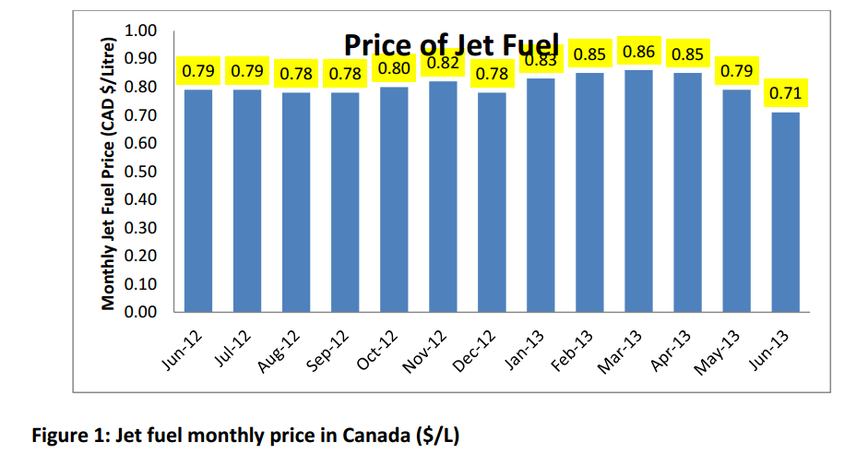

Table 2: Useful Information
Automobile fuel price | 1.20 | $/L
Fuel density (aircraft and automobile) | 0.80 | kg/L
Aircraft reserve fuel | 10.00 | %
Automobile average speed | 80.00 | km/hr
Aircraft fuel price | 0.80 | $/L
Automobile CO2 emission | 2.35 | kg/L
Airplane CO2 emission | 3.16 | kg CO2/kg Fuel
Halifax to Vancouver distance by car | 5 811 | km
CO2 fixed by the average tree per year | 50.0 | lb CO2/tree/year

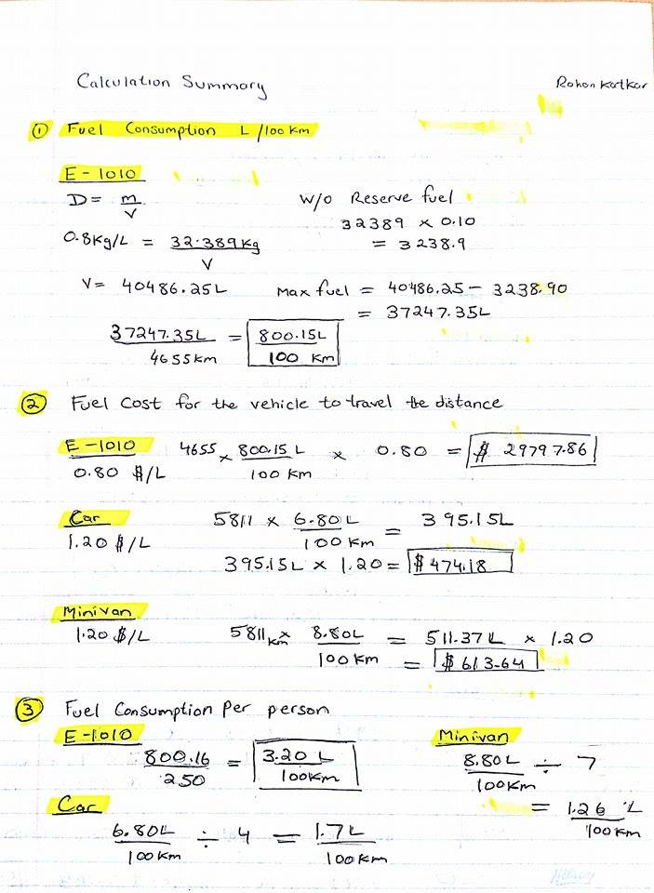
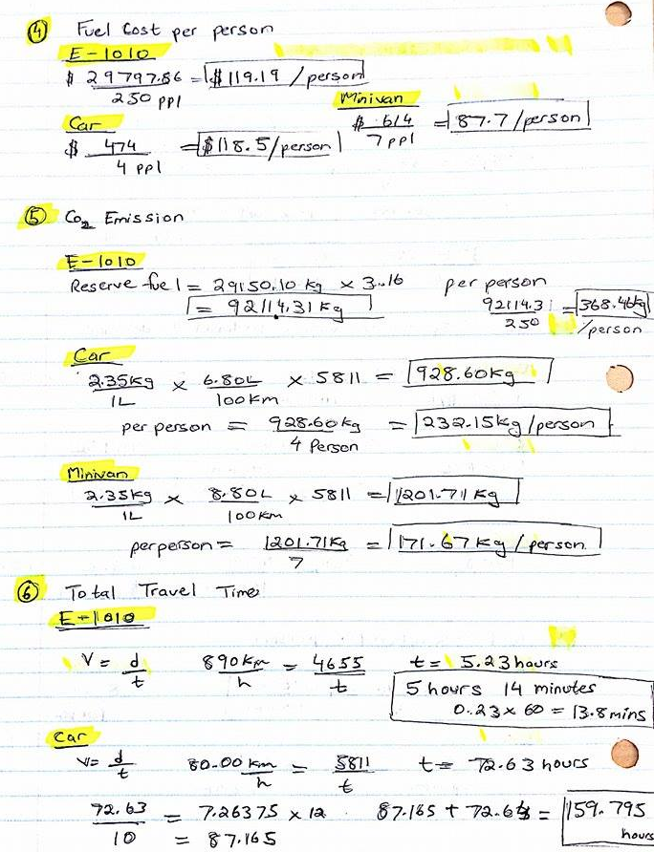

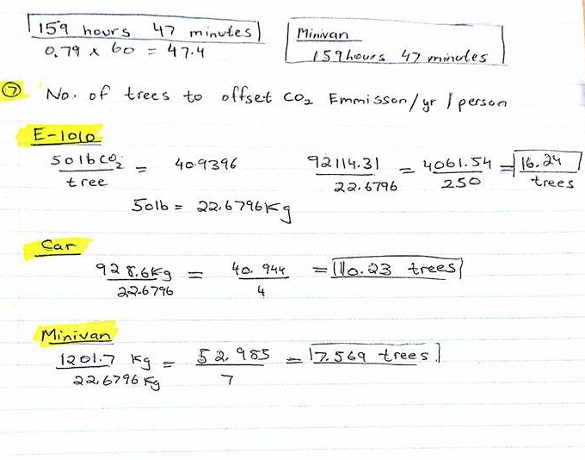

Table 3: Calculation Summary Table

 | Fuel Consumption L/100 km | Fuel Cost for the vehicle to travel the distance ($) | Fuel Consumption per person: 100% occupied seats L/100 km | Fuel Cost per person: 100% occupied seats ($) | CO2 Emission (kg) |  | Total Travel Time (hr) | Total Travel Time |  | No. of trees to offset CO2 emission /yr/person
 |  |  |  |  | Total | per person: 100% occupied seats | Total Travel Time (hr) | hr | min | No. of trees to offset CO2 emission /yr/person
E-1010  250 passengers | 8.0 x 10² | 3.00x10⁴ | 3.20 | 1.2x10¹ | 9.21x10⁴ | 368 | 5.23 | 5.00 | 14.0 | 16.0
Car– Sedan 4 passengers | 6.80 | 474 | 1.70 | 1.2 x 10¹ | 929 | 232 | 160 | 159 | 47.0 | 10.0
Minivan 7 passengers | 8.80 | 614 | 1.26 | 88 | 1.20x10³ | 172 | 160 | 159 | 47.0 | 8.00

