Film In-Class Test 2 Review

Genre
4 Elements of Genre:
1. Subject matter
2. Plot formulas
    - Basic conflict familiar to viewers
    - Basis for variations and transgressions in the narrative form
3. Conventions (thematic concerns and characterization)
    - Specific ways in which the formula plot is translated into visualized action
    - Plot (i.e. episodes that recur from film to film)
    - Form:
      - Stylistic elements which are part of the mise-en-scène,
      - Characterization
      - Performance
4. Iconography (visual settings)
    - Images and objects that are significant elements of the formula plot
    - Meaning from extra filmic sources (i.e. history, literature, popular culture)
    - Visual motifs
    - Emotional weight

Genre Evolution: a way of grouping genre films according to variations of formula plots, conventions and iconography.

Life Cycle of Genres
Primitive
- Initial phase.
- Emotional impact due to the novelty of the form and the plot.
- Conventions of the genre are established.
Classical
- Formula plot established.
- Conventions and iconography fully developed.
- Values and ideology are assured and shared by the audience.
ist
- More symbolic & ambiguous.
- Ideology and values less certain.
- Appeals more to the intellect than to the emotions.
- Conventions used to question or undermine popular beliefs.
Parodic/Reflexive
- The genre is considered exhausted.
- Conventions and formal elements reduced to clichés.
- Parodic: Comedic tone.
- Reflexive: self-conscious awareness of belonging to a genre

The Romantic Comedy I
- Subject Matter: courtship and romance of heterosexual couple
- Narrative resolution: ability of the couple to overcome obstacles
- Closure: getting the couple together
- Compatibility of the couple:
  - Narrative
  - Casting
  - Performance
- Situations that disrupt the social order
- Narrative is constructed around formation of heterosexual couple.
- Transgression & inversion of gender roles creates comedy:
  - Narrative: parody, satire
  - Comedic style: farce, cross-dressing
- Closure realigns heterosexuality as normality
- Heterosexuality as a construct:
  - Gender traits
  - Forms of behaviour
  - Forms of interaction
- Screwball Comedy`
  - Screwball: crazy
  - Ruling each other out until recognizing love for each other
  - Comedies of equality
  - Gender roles inverted
  - Dialogue asserts personality and timing (interaction)
  - Characters represent attitudes about sexuality, class and romance
- Commitment Comedy
  - Establishment of the couple
  - Focus on courtship
  - Commitment comedy is where narrative focuses on the courtship. There’s a couple and they are focused on throughout the story.
- These films juxtapose the working protagonist with a love interest for whom attaining wealth is unimportant. The working characters do not give up their professions and accept the easy lives of their counterparts. On the contrary, the upper class hero/heroine leaves a life of inherited wealth so that the couple can be united
- These characters’ professional obligations are balanced with personal, or romantic, commitments. These comedies all end in marriage or the promise of marriage. These films narratives center on the ideal couple coming to realize that their fun and play together indicate their compatibility and this form a sound basis for a successful marriage. Financial and personal commitments are linked in the resolutions of commitment comedies. Commitment comedies link professional and romantic commitments, often at the expense of other, previously held goals. Both partners must make some sacrifice to reach the correct balance b/w professional and personal concerns. In all cases, the working character’s willingness to give up single life is presented as a desirable goal. The working partner is often presented as too heavily focused on career commitments, and he/she is forced to relinquish some career-oriented goal.
- Commitment comedies share more than merely these general themes. They share a great many plot elements. By examining character roles or spheres of action, we can begin to see how character types perform identical actions across a number of films.
- First partner, initial partner, second partner, conscience partner, and blocking figure are the character types usually involved
- The first partner is initially involved in an unsuitable relationship. This character represents one half of the ideal couple, and much of the action will involve these characters’ gradual realization that his or her prospective spouse, the initial partner, is not a good mate. The second partner is the second half of the ideal couple. Conscience figures are those people who advise one or both of the ideal partners on their relationship. The blocking figures are characters that complicate the relationship between the ideal couple. In any number of ways, these characters either purposely or inadvertently strive to keep the ideal couple apart.
- Commitment comedies begin with a couple about to be married. Their relationship is flawed due to those characters’ unwillingness or inability to balance the various commitments that marriage and career entail. The ideal partner is then introduced and shown to possess the qualities that keep the initial partner from becoming a well-rounded person. The ideal partner provides the missing piece, which has kept the initial partner from attaining true happiness. At the end thee ideal couple achieves the right balance between their personal and professional lives. The struggle to maintain that balance then becomes the subject of reaffirmation comedies
- Functions?

Reaffirmation (Remarriage) Comedy
  - Winning back the affections of a former partner
  - Emphasis on class and common past
  - Fascination for rich and famous
  - Represent attitudes of/towards class
  - More interested in feelings than in courtship
- Reaffirmation comedy is winning back the affection of the partner. A couple that breaks up and gets back together. Ex of reaffirmation Adams rib, example of commitment. Watch both of those films

- Are continuations of the stories established in commitment comedies? The tensions between personal and professional concerns, which were resolved (or at least forgotten) in commitment comedies resurface in reaffirmation comedies as lost or perverted goals. This issue is one that distinguishes reaffirmation comedies from what Stanley Cavell calls comedies of remarriage.
- At the beginning of these films, the comic/romantic couple is married or has been married previously. Their marriage, however is shaky and in most cases leads quickly to divorce if it has not already done so when the plot begins
- One spouse leaves the other in all reaffirmation comedies. However, often the spouse who is left has abandoned the relationship emotionally long before the physical separation.
- The character in reaffirmation comedies has already attained financial security. Their problems are related to lost goals and values, and to the imbalance between the various commitments they have made
- The rich cannot remedy their problems and conflicts by using their financial resources.
- All of these films focus on the romantic couples road toward recapturing some important yet temporarily missing aspect of their relationship. These films reaffirm the value of the characters’ original goals and ideals, ending in the reunion of the couple and restored balance between various commitments
- Narratives focus on ways to establish society on the conservative values that inherent in the work ethic and heterosexual love and marriage. Many of these comedies emerged in later years to reinforce these values, and restate their viability and their importance during times which although still bleak, were not as desperate as they were in the mid 1930s
- In reaffirmation comedies, the first and second partners constitute the ideal couple. The first partner initiates a new relationship first. The first blocking figure is the new love interest of the first partner. In most of these films there are at least two possible “new” relationships. The second new relationship is usually much shorter and/or more tenuous than that involving the first partner and the first blocking figure. The new character involved in this second relationship is the second blocking figure. The conscience figure functions in much the same way as in commitment comedies, advising the central couple ton various aspects of their reconciliation. The common denominator is the element that keeps the ideal couple in contact with each other.
- Functions?

It is difficult to define screwball comedy according to such easy identifiable elements as setting and iconography. Unlike the west of the western, the urban milieu of the gangster film or the monsters of the horror film, the screwball comedy has no identifiable setting or easily definable character styles.

Classifying films as comedies because they contain jokes, comic moments and humorous situations is problematic because obvious non-comedies contain a great many such situations

The fact that these two types of films express two parts of the same overall myth is particularly clear when examining films that explore both parts of the myth.

It is far more common for romantic comedies to emphasize comic lines of dialogue in short, often abrupt, sight gags that don’t build and develop like those in many comedian comedies. It is difficult to describe the relationship between humor and narrative in these films, because it involves seizing on those individual lines of dialogue, which do not have a great deal of meaning apart from the function of characterization.

The humor in commitment and reaffirmation comedies defines characters rather than advances the plot.
This structure constitutes a screwball comedy world, which is in some important ways different from that of comedian comedies. The comedian’s world is one of order, which the comedian disrupts, often in very pronounced and important ways. The screwball comedy universe doesn’t structure the humor around a comedian; in screwball comedies most characters participate in humor production. Although almost none of the jokes or gags are as well developed as those in comedian comedies, they are more evenly spread around. Rather than portraying a central humorous character, these films portray generally humorous world whose inhabitants all have roles in humor production.

Romantic Comedy II: The Nervous Romance
Sex Comedies
- The 50s and 60s
- Seen as middlebrow sex-comedies: all about sex without sex
- More conservative reading
- Emphasis on hyper masculinity/femininity: physicality and emotions highly exaggerated
- Secondary characters highly masculinized or femininized
- Rely in parody (mainly by performance/acting)

The Wrong Partner
- Complicate and prolong the narrative, delay resolution
- 2 narrative functions:
  - Generates tension
  - Focus of jokes
- Ideological functions:
  - Points of comparison/contrast
  - Personality trait or motivation to be cast aside
  - Embody extreme or old ideological attitudes.
- Importance of acting/performance to establish character traits
- Use of a second couple to complement/comment on the main one.
- Use of family and/or friends to embody the “incorrect” values

The Nervous Romance
- Mid 60s and early 70s: discourse of “sexual revolution”
- Mid 70s: counter-discourse warning dangers of “revolution”
- RC as genre threatened by:
  - Individual fulfillment
  - Sex as instrument, not as fulfillment of couple
  - Blame placed on women (feminism)
- Women:
  - post-feminist emotional wilderness
  - narcissistic personalities
  - self-seeking desires
- Men:
  - try to regain self-respect
  - relationships with women they can control
- Films become catalogue of difficulties initiating, establishing and sustaining relationships
- Men are from Mars and Women are from Venus!
- Characters must make own rules and compromises
  - desire and language
  - self and other
Differences will ultimately be overcome (RC) Vs. Differences are too big. Characters are too selfish (NR)
- Focus on melodramatized male ejects/displaces woman from the central place of the narrative.
- Nostalgia for traditional romance/romanticism
- Formally audacious
- Self-reflexive
- Conventions:
  - Romantic Comedy
  - Stand-up Comedy
  - Melodrama
- Non-linear narrative
- Disintegration of traditional roles in heterosexual romance
- Nostalgia for “old” romanticism

Romantic Comedy III: A New Romance
The Classic Romantic Comedy
- Basic narrative structure – boy meets girl, boys loses girl, boy gets girl in the end
- Differences between the man and the woman are eventually overcome
- Comedy is usually found in a love-hate conflict –or via secondary characters
- Focus on the courtship and romance of the heterosexual couple (ideology of stable man dependent & domesticized female)

The Nervous Romance
- Basic narrative structure – boy meets girl, boys loses girl, boy gets girl in the end
- Differences between the man and the woman are eventually overcome
- Comedy is usually found in a love-hate conflict –or via secondary characters
- Focus on the courtship and romance of the heterosexual couple (ideology of stable man dependent & domesticized female)

Steve Neale identifies four main features:
- Asserting values of old-fashioned heterosexual romance.
  - Reclaiming conventions of classical Romantic Comedy.
- Nervousness relabeled as “eccentricity.”
  - Hallmarks of either or both member of the couple.
  - Neurosis/Nervousness/Eccentricity cured, marginalized, and sometimes adopted by the right partner.
- Return to a linear narrative.
  - Suggests events in courtship actually leading somewhere.
  - Counters threat of female independence.
- Use of romantic music.
- Evocation and endorsement of signs and values of “old-fashioned romance.”
- Catalogue of “oldies” performed by original crooners or re-recorded by contemporary artists.

The New Romance
- Mid-1980s: new group of RC appear.
- Wishful embrace of idealized heterosexual union.
- Steve Neale calls them New Romances

- One partner is ‘cured’ when they come in contact with the ‘liberating eccentricity’ of the other partner
- The ‘wrong partner’ is the one who ultimately remains permanently neurotically eccentric
- The heroine/female is somewhat contained; positioning of the heroine returning to a traditional role

- Films become self-conscious
  - evoking heterosexual intimacy
  - endorsing its signs and values
  - full awareness of fantastical nature (wish-fulfillment).

- Neale distinguished between the ‘nervous romances’—films such as Sleepless in Seattle, which represent a frank return to the old-fashion values of traditional heterosexual romance
- both rutnik and neale characterize the new romantic comedies as self-consciously establishing a link with their own tradition, insisting on the validity of its conventions and suggesting an unbroken line of continuity with the filmic and literary history of the genre.
- Paradigmic films as Annie hall and others, among many others, show marriage or the prospect of a wedding seem to have become less central elements of the genre and, certainly, less centrally associated with the happy ending. In other no less successful cases, the more unambiguous project of a lasting monogamous heterosexual relationship is put in inverted ommas, openly parodied, as if the films were afraid to feature a wedding between their protagonists as the culmination of hteir love. Even though it may be argued that the nominal asense of wedlock, or hter films’ nervous slef-consciousness about it, are just as poses to adapt superficially to the zeitgeist, and, some things seem to have changed. It is not that loe features less centrally it is itill hard to imagine a romantic comedy without love), but perhaps what the films pit against the everpresent dangers of fragmentation and dissolution threatening its central tenet is not any more, or not so clearly, the concept of romantic love either in Wexman’s or Giddens’s sense, but something slightly significantly different
- The sexualization of love obvisouly affected the discourse of romantic love even in case such as screwball comedy, in which the sexual drive was not represented in direct fashion but in more metaphoric or displaced ways. More recently, however, sex has become more and more separated from the sphere of love and romance and acquired a certain prestige as a medium of pleasure and self-expression, even though, to a very larg extent, it still remains entangled with the emotional and moral resonances of love.these often conflictive meanings of sex as a part of the ethos of romantic love and sex as a medium of pleasure in itself as a carrier of individual identity, and further, the relation of both meanings to an institution such as marriage that has been in crisis since the beginning of the 20th century, have gradually found their way, in more or less direct or displaced manners, intor the structure of contemporary romantic comedies.

Horror: Return of the Repressed (Robin Wood)
- Horror:
  - defusing of impulses that are not acceptable in other areas of society,
  - social articulation of taboo subjects.
- “Low” and “disreputable” genre makes possible to present subversive narratives
- Robin Wood’s “An introduction to the American Horror Film”: one of the most influential articles on the academic study of horror films.
- Freudian principle of "repression."
- Society represses certain forces which would threaten to destabilize it.
- Repression does not entail suppression or censoring.
"Surplus repression (…) is specific to a particular culture and is the process whereby people are conditioned from earliest infancy to take on predetermined roles within that culture (…) [it] makes us (if it works) into monogamous heterosexual bourgeois patriarchal capitalists" (Wood 7-8).

  - What’s repressed it doesn’t disappear.
  - It goes underground and gains (subversive) power.
  - It comes back (the monster) to threaten normality.

Examples:
Sexuality:
Female
- In male dominated culture, where power, money, law, social institutions are controlled by past, present, and future patriarchs, woman as the other assumes particular significance. The dominant images of woman in our culture are entirely male-created and mal-controlled. Owman’s autonomy and independence are denied; on to women men project their own innate, repressed femininity in order to disown it as inferior (to be called ‘unmanly’ ie like a woman is the supreme insult)
Homosexuality/Bisexuality
- First, sexual energy itself, together with its possible successful sublimation into non-sexual creativity—sexuality being the source of creative energy in general. The ‘ideal’ inhabitants, and whose sublimated sexuality (creativity) is sufficiently fulfilled in the totally non-creative and overwhelming majority of its members. The ‘ideal’ in other words, is as close as possible to an automation in which both sexual and intellectual energy has been reduced to a minimum. Otherwise the ‘ideal is a contradiction in terms and a logical impossibility, hence the necessary frustration, anxiety and neuroticism of our culture.

- bisexuality—which should be understood both literally (in terms of possible sexual orientation and practice) and in a more general sense. Bisexuality represents the most obious and direct affront to the principle of monogamy ad its spportive romantic myth of ‘theone right perosn’, the homosexual impulse in both men/woman represents the most obvious threat to the norm of sexuality as reproductive and restricted by the ideal of family. But more generally we confront here the whole edifice of clear-cut sexual differentiation that bourgeois-capitalist ideology erects on the flimsy and dubious foundatons of biological difference: the social norms of masculinity and femininity, the social definitions ofmanlisness and womanliness, the whole vast apparatus of oppressive male/female myths, the systemic repression from infancy (blue for boy) of the man’s femininity and the owmans masculinity, in the interst of forming human beings for specific predetermined social roles

- Thirdly, the particularly severe repression of female sexuality/creativity; the attrivution to the female of passivity, her preparation for her subordinate and dependent role in our culture. Clearly, a crucial aspect of the repression of bisexuality is the denial to women of drives culturally associated with masculinity: activeness, aggression, self-assertion, organizational power, creativity itself.

- Fourthly—and fundamentally—the repression of the sexuality of children, taking different forms of infancy, through ‘latency’ and puberty, and into adolescence—the process of moving, indeed from repression to oppression, from the denial of the infants nature as sexual being to the veto on the expression of sexuality before marriage

- None of these forms of repression is necessary for the existence of civilization in some form (ie, none is basic)—for the development of our humanness. Indeed, they impose limitations and restrictions on that development, stunning human potential. All are the outcome of the requirements of the particular, surplus-repressive civilization in which we live.
  - The proletariat
  - Other cultures
  - Ethnic groups
  - Alternative ideologies
  - Children

Most fundamental repression: sexuality
- Challeng es the "normal" and "natural." heterosexual monogamous relations.
- Audiences reaction:
  - Ambivalence
  - Sympathy
  - Cheering
  - Identification

Returned of the repressed in horror films:
- The monster represents repression, the monster wants to destabilize normality (societal norms). We cheer for he monster because we are trying to repress those feelings of sex violence and chaos

Difference between repression and oppression
- Repression: psychologically shielding things away from yourself
- Oppression being shielded away from other people

Return of the Repressed (Reading)
- Popularity and Disreputability
- The popularity of horror films has a peculiar characteristic that sets the horror film apart from other genres: it is restricted to aficionados and complemented by total rejection, people tending to go to horror films either obsessively or not at all. They are dismissed with contempt by the majority of reviewer-critics, or simpy ignored…many people who go regularly to horror films profess to ridicule them and go in order to laugh—which is not true, generally speaking of western or the gangster movie.
- Dreams and Nightmares
- Analogy frequently invoked between films and dreams is usually concerned with the experience of the audience. The spectator sits in darkness, and the sort of involvement the entertainment film invites necessitates a certain switching-off of consciousness, a losing of oneself in a fantasy-experience. But the analogy is also useful from the point of view of the filmmakers. Dreams—the embodiment of repressed desires, tensions, fears that our conscious minds rejects—become possible when the “censor” that guards our subconscious relaxes in sleep, though even then the desires can only emerge in disguise, as fantasies that are “innocent” or apparently meaningless.
- Concept of entertainment—the thought that it is only entertainment to act as a kind of partial sleep of consciousness. For the filmmakers as well as for the audience, full awareness stops at the level of plot, action, and character, in which the mot dangerous and subversive implications can disguise themselves and escape detection. This is why seemingly innocuous genre movies can be far more radical and fundamentally undermining than works of conscious social criticism, which must always concern themselves with the possibility of reforming aspects of a social system whose basic rightness must not be challenged. The old tendency to dismiss the Hollywood cinema as escapist always defined escape merely negatively as escape from but escape logically must also be escape to. Dreams are also escapes, from the unresolved tensions of our lives into fantasies, yet the fantasies are not meaningless; they can represent attempts to resolve those tensions in more radical ways than our consciousness can countenance.
- Popular films, then respond to interpretation as at once the personal dreams of their makers and collective dreams of their audiences—the fusion made possible by the shared strutures of a common ideology. It becomes easy, if this granted to offer a simple definition of horror films: they are our collective nightmares. The conditions under which a dream becomes a nightmare are a) that the repressed wish is from the point of view of consciousness, so terrible that it must be repudiated as loathsome, and b) that it is so strong an powerful as to constitue a seiorus threat. The disreutability noted above—the general agreement that horror films are not to be taken seriously—works clearly for the genre viewd from this position. The sensor in both common and Freudian sense) is lulled into sleep and relaxes vigilance.
- The Surrealists
- Its worth nothing here that one group of intellectuals did take American horror movies very seriously indeed: the writers, painters, and filmmakers of the surrealist movement. The association is highly significant given the commitment of the surrealists to freud, the unconscious, dreams, and the overthrow of repression
- Basic Formula
- At this stage it is necessary to offer asimple and obvious basic formula for the horror film: normality is threatened by the Monster. I use normality here in a strictly non-evaluative sense, to mean simply “conformity to the dominant social norsm”; one must firmly resist the common tendency to treat the wolrd as if it were more or less synonymous with health. The very simplicity of this formula has a number of advantages
  - A. It covers the entire range of horror films, being applicable whether the monster is avampire, a giant gorilla, an extraterrestrial invader, an amorphous gooey mass or child possessed by the Devil, and this makes it possible to connect the most seeminly heterogenous movies
  - It suggests the possibility of extension to other genres: substitute for “monster” the temr “Indians” for example and one has a formula for large number of classical westerns
  - Although so simple, he formula provides three variables: normality, the monster, and crucially, the relationship between the two. The definition of normality in horror films is in general oringly constant: the heterosexual monogamous couple, the family, and the social institutions (police, church, armed forces) that support and defend them. The monster is of course, much more protean, changing from period to period as society’s basic fears cloth themselves in fashionable or immediately accessible garemnts—rather as dreams use material from recent memory to express conflicts or desires that may go back to early child hood.
- It is the third variable, the relationship between normality and the Monster, that constitutes the essential subject of the horror film. It too changes anddevelopes, the development taking the form of a long process of clarification or revelation. The relationship has one privileged form: the figure of the doppelganger, alter ego, or doule, a figure that has recurred constantly in wetern culture, epecialy during the past hundred years.
- Ambivelence
- The principle of goes far beyond the monsters being sympathetic. Ambivalence extends to our attitude to normality. Central to the effect and fascination of horror films is their fulfillment of our nightmare wish to smash the norms that oppress us and which our moral conditioning teaches us to revere. The overwhelming commercial success of the omen cannot possibliy be explained in terms of a simple unequivocal horror at the devils progress
- Freudian Theses
- Finally one can simply state the two elementary (and closely interconnected) Freudian theses that structure this article: that in a society built on monogamy and family there will be an enormous surplus of sexual energy that will have to be repressed; and that what is repressed must always strive to return.
- It is as important to notice the basic motifs that recur obstinately thoruhgout the evolution of the horror film in western culture as it is to be aware of the detailed partiulariiteis of individual films.
- Normality
- The Monster
- Relationship

The horror film since the 60s has been dominated by 5 recurrent motifs:
1. the monster as a human psychotic or schizophrenic: psycho
2. The revenge of nature: The birds
3. Satanism, diabolic possession, Anti-christ: the exorcist, the omen
4. The terrible child (often closely connected to the above). To the first three films in © add: night of the living dead,
5. Cannibalism: night of the living dead, texas chainsaw massacre

Horror II: Gendered Horror
- Monster vs. “Normal” Culture
- Gendered Horror
  - Monster vs male/female victims
  - Monster vs usually female survivors
  - Monster vs male/female viewers

Laura Mulvey How is gender represented in horror films?
The male gaze, women are very sexualized/objectified, man is standing up strong

- “Visual Pleasure in Narrative Cinema” (1975)
- The Male Gaze
  - Passive (to be looked at) females – the objects for male objectification
  - Active (looking) males – possessors of the male gaze
      - Male characters in the film
      - Male viewers in audience
      - Male eye of the camera

It begins in the marketing…
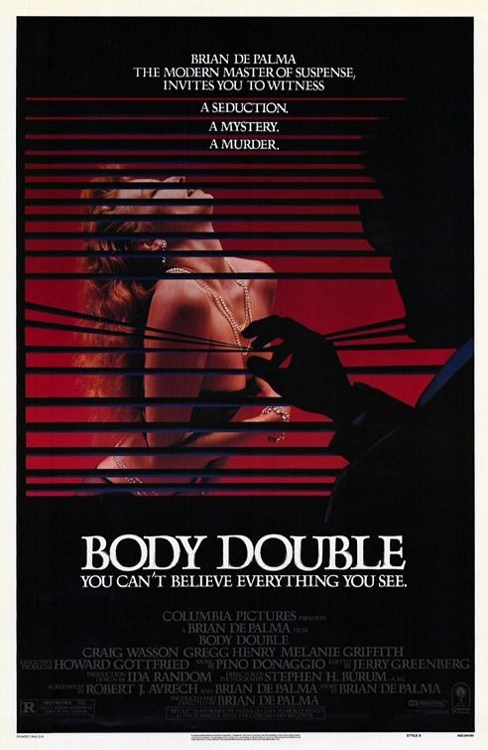
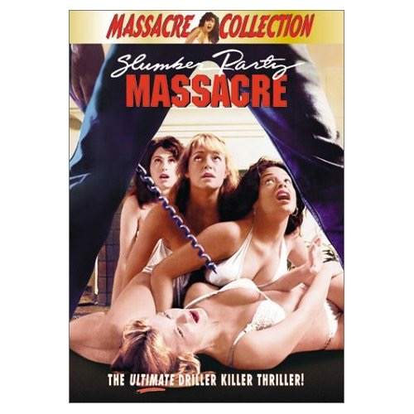
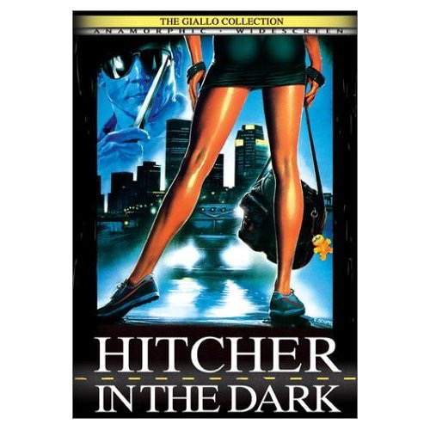
- The male is unidentifiable in these promotional images, while the women are clearly exposed
- Male Death – quick, detached, less interesting
- Female Death – prolonged, visceral, eroticized, gory
Complicating the Male Gaze
- Sexually ineffectual male-“penis trouble” killer/voyeur

The Final Girl (Clover)/Surviving female (Pinedo)
- Overly feminized monster
- Starts off sexy and ends up being independent, intelligent, and resourceful
- The final girl scene is justified because the female is defending herself and has the right to destroy them
- However the killer does sometimes escape IE Halloween where the girl is sobbing at the end
- Final Girl: the girl portrays masculine qualities, shes the strong female, has the necessity of survival, against the monster throughout the entire film, resourceful, innocent, shes not having sex or doing drugs example is Stephanie from stepfather.
- Ill-defined and mutable gender identities in Horror Films: Sleepaway Camp (Robert Hiltzik, 1983)
  - Teased by the camp because she’s a virgin
  - Killer is shot through POV shot until the end where she’s the final girl but she is doing the killing
- What is being repressed? Is stephanie the final girl? (the stepfather)

The stepfather as feminist in horror film

Horror III: Is this Horror?
- Robin Wood: horror films articulate impulses that are not “socially acceptable” (taboo). Impulses are repressed in our culture.
- Oppression:
  - Negative outcome experienced by people targeted by the arbitrary and cruel exercise of power in a society or social group.
  - Primarily used to describe how a certain group is being kept down by unjust use of force, authority, or societal norms.
  - Most commonly felt and expressed by a widespread, if unconscious, assumption that a certain group of people are inferior.
  - Repression:
  - Psychological act of excluding desires and impulses (wishes, fantasies or feelings) from one's consciousness and attempting to hold or subdue them in the subconscious.
  - Considered unconscious
  - Can often be detrimental.
- Horror films: “the return of the repressed”.
- Society has a fear of physicality in general and of sexuality in particular (Sex and Other)
- Horror films become outcome:
- Normality (conformity with social norms) is always threatened by the monster.

Horror films can represent threat from 2 different positions:
Progressive:
- Monster is contained at the end but its presence has subverted the bourgeois patriarchal norms of society
- Dominant ideology is disintegrating and there is no escape.
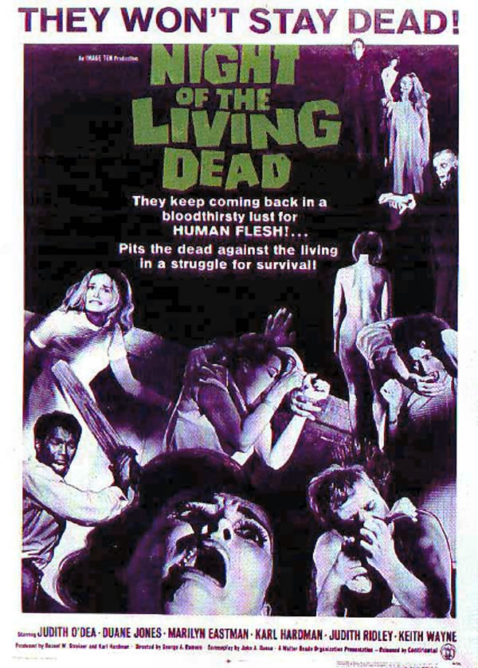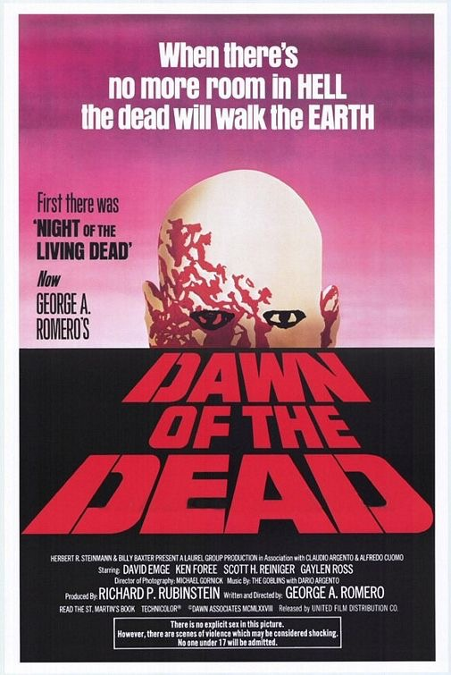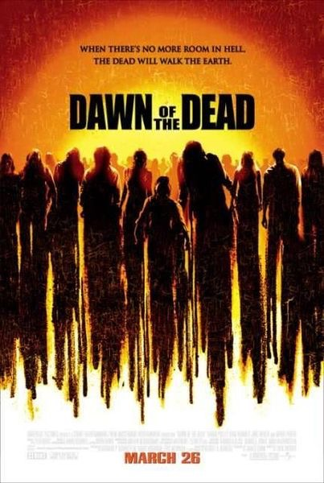

Reactionary:
- Designation of the monster as simply evil (thus justifying its repression) or as a punisher for breaking social rules (mainly sexuality).
- Films reinforce dominant ideology by sanctioning those who fit the social standards.
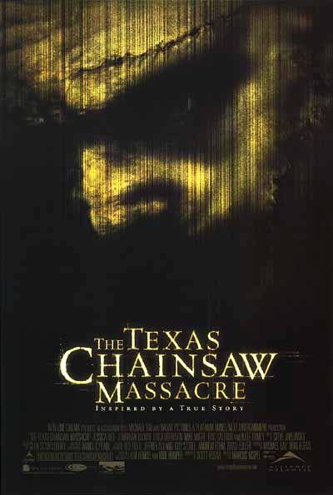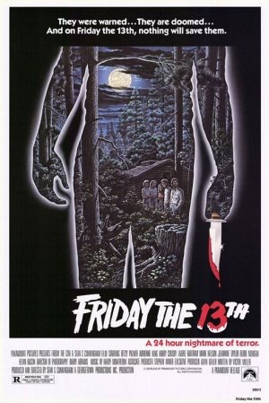

Genre Evolution and cycles: organized according to formula plots, narrative, formal conventions, and iconography.
- Grouping of films needs to consider also unlimited possibilities of mutation and regeneration
- No clean-cut genres so… subgenres.

Transgeneric films:
- Combine the formula plot, conventions and iconography of two or more specific genres.
- Based on hybridity instead of distinction.
Jukebox scene (Shaun of the Dead)
- Zombie iconography/conventions but at the same time they are used as parody
- Clear distinction of 3 terms – parody (clear imitation of style of film) , pastiche (playing a mod on that style), satire (lampooning films, parody of zombie films but is a satire of british upper and middle class)

Four cycles that break down genre:n
Formula plots
Narrative/formal conventions
Iconography
GOOD FOR BUILDING AN ESSAY
Comedy:
Nervous romance
New romance

Ex romantic comedy is transgeneric
It is based on hybridity, not as much distinction
How do these two genres blend?
Horror where villian goes to space in the end = sci fi horror
2 monsters fall in love and its some kind of serendipity = romantic comedy horror?
Shaun of the dead = zom/rom/com

