Cognitive-Experiential Domain
Personal Construct Theory – assumes ppl are like amateur scientists i.e. they hold theories about how world works (things will work out for the best). People motivated to “make sense” of important events (why did I flunk the test?)
- Proposes each person possess unique filters for interpreting/anticipating events (event belief does it make sense no go back to change belief if yes then continue)
- Function – help organize, interpret, predict ppl’s behaviour (filters determine how you act in future)
Locus of Control – general tendency to explain events in life: do you tend to accept or deny personal control/responsibility? (are you undercontrolled or controlled)
- Do you believe you can stop yourself from catching cold?
  - If yes, then have INTERNAL sense of locus of control – I control outcome
  - If no, then EXTERNAL sense of locus of control – others control outcome
  - Nomothetic approach – looks at ONE trait across many ppl; Idiographic approach – one person across many traits.
Learned Helplessness – builds on locus of control; Seligman was trying to see if dogs can learn to avoid getting shocked – half of the dogs would get a warning them shock on the feet; after a while the dog whimpers lays down and just takes the shock (learned to be helpless). Now they get the dogs to go to new track with a fence, pic above, and escape the shock, Dogs that were taught they could escape over the fence never went over the fence. DOGS that have NOT have been trained to jump fence DO jump fence to escape fence. Results: dogs learned to be helpless, learn they have no control, even when put in new environment where option to escape, they don’t even try.
- Doing anything is hopeless = can be applied to humans.
- In humans: we do something & expect reward & reward doesn’t come leads us to 3 questions:
  - Is cause Stable vs Unstable?
  - Is cause Internal vs External?
  - Is cause Global vs Specific?
  - If answer is: Stable, Internal, Global, then one feels helpless (why bother trying learned model of depression = Pessimistic Explanatory Style
  - Depression 3 deficits: cognitive (see world in neg view), emotional, motivational (stop trying when know outcome will be failure)
Optimism/Pessimism – self-efficacy: can one successfully do the necessary behaviours? Belief you are competent, if you don’t think you will do it you won’t.
- Optimism – generalized belief/confidence things will turn out for best
- Pessimism – generalized belief/doubt things will turn out for best (reluctant to take chances bc things won’t work out).
- Defensive Pessimism – history of doing well i.e. go into exams expecting worse even though will do okay; very anxious prior to test situation; anxiety motivates performance (do better)

Optimism/Pessimism vs Realism:
- Positive Orientation to future: imagine desired outcome (getting married – moving in will be great)
- Negative Orientation to future: imagine undesired outcome (getting married – ill lose freedom)
- Realistic Orientation: imagine mix of desired and undesired possible outcomes (getting married – both moving is good and loss of freedom)
- Not Future Oriented: getting married in 6 weeks – don’t even think about it.
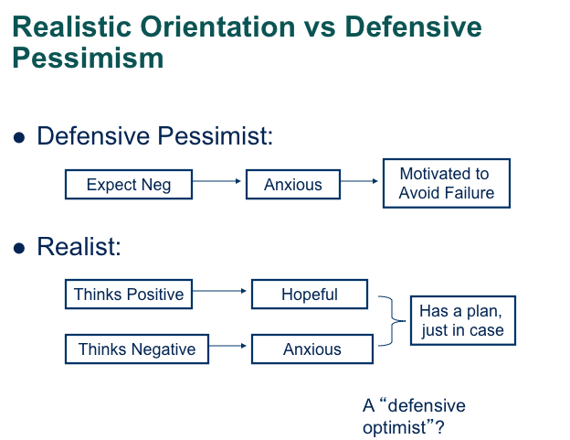
(Mastery Orientation) Implicit theories of intelligence:
- Is intelligence something that is fixed and immutable (an entity), or something that is fluid and something that can be cultivated (incremental)? Influences how you respond to feedback
  - Entity theorists: failure means one is stupid, become defensive “I’m no good at this, but I’m good at something else” – defense to cover up fixed intelligence.
  - Incremental theorists: failure -> one should work harder, try a different way (seek mastery)

Emotions: some ppl consistently happy, sad, angry:
- Extraverts: happier, positive affectivity
- Neurotics: more anxious, negative affectivity
Defining Happiness – Hedonistic (self-induldgent) perspective: happiness is lots of positive affectivity (no NA), satisfaction in life (Happiness = (PA – NA) + SWL (satisfaction with life)).
- Very happy ppl more extraverted, emotionally stable (low N)
- Increase happiness by being optimistic, have a plan, help others.
Depression – pervasive sad mood, no interest in things (unmotivated), view self as worthless.
- Evolutionary adaptation – smoke detector principle: body’s signal that something’s wrong.
- Imbalance of neurotransmitters – norepinephrine, serotonin, dopamine
- Diathesis-Stress Model - predisposing vulnerability + stress = higher risk of depression
Personality & the Self
McAdams – metaphor: personality is like a house (three level structure)
- Biological domain – stuff we don’t see but it’s the foundation of our structure
- Dispositional domain – extraversion/Neuroticism: when you walk into house that’s what you see FIRST – entry level of understanding a person (i.e. first impression). MOST SALIENT (aware, in view)
- Cognitive/Emotion Domain/Intrapsychic Domain: second floor of house – in this level of personality, you know more about this person (i.e. you ego is super powerful in you – someone knows that about you; your goals; passions; motivations).
- Identity – Attic – really gives the house it’s shape = character – gives us our identity (very few ppl get to know about us, we spend the most time trying to define who am I) (hard to study in lab)

Self-concept – your identity (name, gender, ethnicity, your roles i.e. parent, self you hope to be or afraid of becoming)
Possible Selves – what selves do you want to become?
- Markus – we are highly motivated by possible selves – selves we hope to become or afraid of becoming.
  - I.e. afraid of becoming unemployed – motivated to get a job now to prevent that of happening.
- Represent (approach – want to become & avoidance - afraid to become) goals & incentives for future behaviour
  - Provide an evaluative & interpretive context for current view of self
  - Provide a focus & organization for the pursuit of goals (selves you care about most – makes you construct a plan – goals to reaching possible self *ROAD MAP*)
- Balance between possible desired & feared selves
  - possible selves motivate behaviour, provide incentives
    - motivation could wane if possible selves are only desired selves, need afraid to become selves to maintain motivation (e.g., become fantasies, wishes)
Development of Self: 18 months: recognize self in mirror (red dot experiment – Gallup 1977), boundaries of self (chimps, orangutans, elephants, dolphins, orcas also recognize self)
- 18-24 mos, child knows what he/she looks like
  - uses pronouns, pretend play (know what’s real & not real), learns rules of behaviour, what is expected
- 2-3 yrs, learns about own sex & age (I’m older than some, younger than others)
- Ages 3-12: what am I (not) good at?
  - social comparisons (I’m good at tennis cause I’m better than my friends)
  - private self-concept (things I know about myself others don’t know)
- Teens: perspective taking

Self-Concept Clarity: More Clear self-concept -> higher self-esteem, less anxiety & depression, higher conscientiousness (Campbell et al., 1996)
- SCC (Self-Concept Clarity) during adolescence (13-16; van Dijk et al., 2014)
  - higher SCC -> less depr & anx next yr
  - higher SCC corr with open communication with parents
- Western cultures vs Eastern cultures (Campbell et al., 1996)
  - Western cultures favor “knowing thy self”
    - low scores on SCC -> confusion (bad – since focus is individuality)
  - Eastern cultures favor fitting in, harmony
    - low scores on SCC (good) -> more attuned to social context (good – creates harmony)

Self-Esteem – extent to which you like yourself (or various self-concepts); an attitude (negative or positive)
- High self-esteem – greater persistence after failure, are happier, better academically (but these just correlations not causation, so self-esteem doesn’t mean good academic performance)
- Easier to lower self-esteem than to raise it: IQ test grad school entrance – you did great vs you did bad = you did bad had longer lasting effects on self-esteem reduction than you did great lasted 15 mins on raising self-esteem.
- Inflated sense of self-esteem = NARCISSISM (inflated sense of how great they are – better off then really are)
  - Narcissism – core sense/deep down know you are not that great but project you are really great, so when someone says you aren’t great creates conflict/anxiety.
  - Social Desirability – inflated sense of self-esteem

Measuring Self-Esteem = Implicit Self-esteem – self as organizing structure in memory (things about self remembered better than things not connected to ourselves – feeling attached to those self-aspects; Explicit self-esteem – me saying how great I am on questionnaire.
- Implicit Association Test – me & good/ other & bad; me & bad / other & good (asked to associate when you see a word that is reflective of you i.e. your name and put in category me or others. If high self-esteem easy (faster reaction time) to associate positive words with self rather than bad words.

Theories about Self-Esteem:
- Carl Rogers – Humanist Assumptions: people are good, ppl have innate need to grow (General Actualizing Tendency - A natural tendency to develop all of one’s capacities in ways that maintain and enhance the organism), see world as others see it (walk in their shoes). Roger’s perspective: ppl have free will, personal control, & personal responsibility.
  - What is self-esteem? Rogers: self-esteem is feeling that one is accepted; worthy of love, respect.
  - In order to facilitate the self-actualizing process: you must have positive regard.
    - Positive regard: the experience that you are
      - making a positive difference in the lives of others,
      - receiving warmth, acceptance, liking from others
    - Unconditional positive regard:
      - When others communicate to you that you are accepted, valued, worthwhile simply for being who you are (no matter what)
  - Typical situation: PROBLEM: we assume we are Valued, accepted when you meet “conditions of worth”
  - Avoid “unworthy” experiences and seek those experiences deemed “worthy” by others
  - Give up own ideal self (i.e. becoming a doctor) you are only being seen as worthy when pursue someone else’s ideal (becoming a teacher); only valued when doing what others think I should be doing = low self-esteem.
    - i.e., “conditional positive regard” :
      - person represses true self
      - blocked actualizing tendency
      - “extrinsically” motivated (only doing things because other ppl are telling you to do it – for rewards they offer)
Intrinsic vs. Extrinsic Motivation: Deci & Ryan’s Self-determination Theory (2000)
  - People have an inherent need to act in autonomous, self-determined ways & engage in intrinsically meaningful tasks
  - When people feel their actions are autonomous:
    - Persist longer, Happier, Healthier

Lepper, Greene, & Nisbett (1973): 3-5 yr olds in daycare
  - First day: free play with Magic Markers
    - Observe extent to which children choose to play with markers (time = interest). Select kids showing interest
  - Two weeks later: child taken to “surprise room” & presented with Magic Markers
    - Draw picture for Guest?
  - 3 conditions:
    - Expect reward: if draw pic for guest get a “Good Player Award”
    - No reward
    - Unexpected reward: “Good Player Award”
  - 1 week later: Free play with Magic Markers (Time = interest)
      - Expect reward: 8.6% of free play time
      - No reward: 16.7% of free play time
      - Unexpected reward: 18.1% of free play time
  - suggests children lose interest when intrinsic activities are made extrinsic with incentives
Same with adults? What goals do you have & why are you pursuing them?
  - Intrinsic reasons: “because of the enjoyment or stimulation this goal would provide me”
  - Identified reasons: “because I really identify with the goal”
  - Introjected reasons: “because I would feel guilty/ashamed if I did not pursue this goal”
  - Extrinsic reasons: “because of the external rewards (money, prestige, grades) that this goal might bring”

Intrinsic motivation: desire to engage in an activity because we enjoy it
Extrinsic motivation: desire to engage in an activity because of external rewards or pressures
Overjustification effect - occurs when an expected external incentive such as money or prizes decreases a person's intrinsic motivation to perform a task.

Self-Determination Theory - Pursuit of Intrinsic goals -> leads to feelings of autonomy & competence
  - Autonomy, Competence, Relatedness are three fundamental needs
    - When met, we feel self-esteem and happiness; When needs are blocked, self-esteem and happiness suffer/reduce

- Self-esteem as a Sociometer - Maintenance of self-esteem is a fundamental need
- Sociometer: monitors the degree to which the individual is included/excluded from group
  - Exclusion, rejection from group could be fatal; Lowering self-esteem produces anxiety, shame
  - If one has low self-esteem, one is likely hypervigilant/on edge to others’ opinions of you
    - One negative comment can be devastating!
  - Leary et al. (1995): exclusion from group lowers self-esteem, but inclusions doesn’t consistently raise self-esteem. When self-esteem is threatened, people often seek evidence that they are still valued by others.
- Terror Management Theory - An existential-evolutionary theory; Survival as a prime motivation
- Humans’ knowledge of own mortality = creates Paralyzing anxiety or angst
- How to cope? Live a life of meaning and value = Constructed through social consensus (Cultural worldview)
- By identifying with a social or cultural group, we protect ourselves from threat of death
  - Achieve symbolic immortality (I’ll die but the group will live on so I am alive with that too)
- Self-esteem = living up to standards of cultural group: people seek self-esteem to buffer themselves against terror of death
Stress & Adjustment
- Primary Appraisal:
  - What is at stake?
    - Threat or benign (no threat)?
    - What does stressor mean to me?
- Secondary Appraisal:
  - What can I do about it?
    - Do I have sufficient resources (personal, social, monetary, etc) to deal with it?
    - Assessing abilities to cope/manage stressor
- Coping = cognitive & behavioural efforts to manage or alleviate perceived demands
  - social support: talking to a friend
  - cognitive reframing: it isn’t so bad, really
  - problem-focused coping: fixing what’s broken
  - emotion-focused coping: managing emotions
Lazarus’ Transactional Model of Stress:
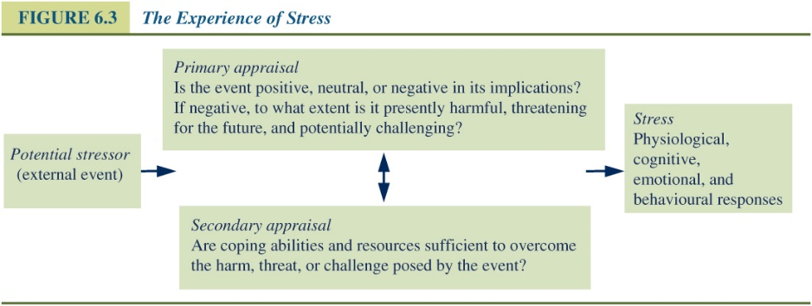
Hardiness - Some people resilient in face of major stressors
  - Hardiness:
    - Commitment, control, challenge
  - Kobasa, Maddi, & Kahn (1982): managers at firm going through breakup
    - those with high scores on Commitment, Control, Challenge before breakup less likely to get depressed, sick

Sociability and Susceptibility to Common Cold:
Cohen et al. (2003) exposed 334 quarantined volunteers to cold (rhinovirus)
- administered personality questionnaires, assessed social network size, social interactions etc
- sociability = extraversion + agreeableness + positive relationship style
- segregated for 5 days; measured symptoms of common cold
- Those with low sociability more prone to get the cold; those with high sociability had less of the cold/flu.
Susceptibility to Common Cold: Things that increase chance of infection - stressful events, poverty; Things that protect/buffer - social integration, perceived social support, sociability, positive affectivity.
Stress most likely to occur if situation is…
- Uncontrollable
- Ambiguous
- Negative Events
- Overload
Type A & Cardiovascular Diseases:
Risk factors for CVD: obesity, high blood pressure, smoking, high cholesterol, family history… and personality
- Type A: competitive/driven, time urgency, aggressive when frustrated
  - hostility/easily irritated factor is critical
- Type A’s: exaggerated cardiovascular activity after exposure to stress
Type A’s also have different neuroendocrine response, platelet activity, inflammation,

Stress process -> return body to baseline
- What about stress making one better? People who experience major events often say
  - It made me stronger, learned about self, Closer to family, Strengthened my faith, Reset priorities; stop & smell the roses
Posttraumatic Growth: How does it happen?
- One model: (Shattered Assumptions)
  - Recall Kelly’s Personal Construct Theory
    - Events sometimes “shatter” our assumptions, goals, expectations, ways of understanding selves & world
    - In rebuilding assumptions, goals, etc., personal constructs are revised
      - “Can’t believe how naïve I was…”
      - “Never thought I could survive something so difficult”
      - “You find out who your friends are”
- Another explanation: Cognitive Illusions model (Taylor, 1983)
  - Major stressors are often a threat to self-esteem. Defend threat to self by “selective” interpretation.
    - Downward social comparisons (“I am doing better than most”)
    - Regain mastery/control
    - See event as meaningful/purposeful
  - “Successful adjustment depends … on the ability to sustain and modify illusions that buffer … against present threats … and possible future setbacks”

Positive moods/emotions:
- help us think creatively, problem solve
- help us build hope, optimism
- help us build resources (e.g., social support, friendship)
- give us time out from stress (restorative)
- physiological changes

