Intro to Psych 2
- ---> Intelligence and Psychological Testing:
- —> Mental ability tests (intelligence-general, aptitude-specific ex:future potential, achievement tests ex:past knowledge)
- Personality scales (Measures motives, interests, values, and attitudes)
- These tests use the psychometric approach which include:
- 1.Standardization-test norms <everybody gets the same test>
- 2.Reliability-correlation<taking 2 variables and seeing how similar they are to each other> coefficient
- Correlation: The closer to +1 or -1, the stronger the correlation, 0 = no correlation, -0.55 or +0.55 = moderate, 0.30 = weak
- Negative correlation = Opposite directions
- Positive = Same direction
- 3. Validity
- Content Validity: Does the test, test what it should be testing?
- Criterion-related validity: Does the test represent how one is going to preform in a field related situation ex: pilot example —> bob scores low on test and scores low in pilot training = high validity, bob scores low on test and scores very high in pilot training = low validity
- Construct Validity: How closely are the questions related to each other?Everything is tight and related in order to assess a certain topic.
- —> The Evolution of Intelligence Testing
- Sir Francie Galton (1869) : Hereditary Genius, success ran in families, IQ must be genetic, however he was upper class therefore he was only exposed to upper class people (higher SES people). In that time only the wealthy had easy access to education, connections, resources.
- Alfred Binet and Theodore Simon (1905) : Binet-Simon Intelligence Scale was developed to identify children who were struggling in school. It was easy to administer. It calculated a mental/ cognitive age and compared it to your actual age.
- Lewis Terman (1916) : Stanford-Binet Intelligence Scale, intelligence Quotient (IQ) =Mental Age/ Chronological Age x 100
- David Wechsler (1955) - Wechsler Adult Intelligence Scale (WAIS) Figure 9.6 in textbook, Changed the test so it wasn’t so much focused on verbal material
- Charles Spearman: Analyzed the structure of intellect and found that specific mental talents were highly intercorrelated. Therefore all cognitive abilities share an underlying core.
- J.P. Guilford: Conlcuded that intelligence is made up of many separate abilities. According to him we may have as many as 150 distinct mental abilities.
- —> Reliability and validity of IQ tests:
- Exceptionally reliable: corrections into the .90s
- Qualified validity - valid indicators of academic and verbal intelligence, not general intelligence
- IQ tests have a correlation of .40s-.50s with school success
- Correlation of .60s-.80s with number of years in school
- IQ’s are quite stable, don’t change much over time
- —> Intellectual ability or mental retardation
- Assessing Mental Retardation:
- IQ 2 more & SD below mean
- 4 levels: mild , moderate, severe, profound (mild most common)
- Causes: Environmental/biological
- biological: ex: brain damage, chromosomal abnormalities
- environmental: bad environment, social class
- —> Giftedness:
- Identification issues: ideals vs. practice
- IQ 2 SD (standard deviations) above mean standard
- Stereotypes: weak, socially inept, emotionally troubled
- Lewis Terman (1929) - largely contradicted stereotypes
- Ellen Winner (1997) - moderately vs. profoundly gifted
- Giftedness and high achieving- beyond IQ
- Renzulli, Simonton, “hidden gifted”
- —> Heredity and Environment as Determinants of Intelligence
- Heredity:
- Family and twin studies
- Monozygotic: Identical twins: 1 egg, 100% genetically related
- Dizygotic: Fraternal twins: 2 eggs are released and fertilized by 2 separate sperm, 50% genetically related
- As genetic relatedness decreases so does correlation
- Identical twins raised in 2 separate environments still have a high correlation but there is a drop in correlation compared to ones who live in the same environment (environment has an influence)
- The Reaction Range: Environment enhances this, even if one has a lower IQ
- In a short time we are seeing significant increases in IQ scores, because of environment ex: new education, promoting intellectual growth, access to nutrition
- Cultural Differences in IQ:
- Heritability as an explanation
- Arthur Jensen (1969)
- Hernstein and Murray (1994) -The Bell Curve -> Intelligence is your genetic destiny
- Rushton Race, Evolution, and Behaviour: 3 behaviours: emotional, social and physical; claimed asians had bigger brains, less promiscuous, caucasians were in the middle for IQ, African-Americans had lower IQ, more promiscuous and “different bodies”
- Ruston measured the circumference of people’s heads to “measure the size of people’s brains"
- There can be environmental explanations to this, learning styles, language, interpretation (culture is an influence)
- Self-fulfilling prophecy: First test in 1890’s, group 1 (500 cards), group 2 (1500 cards)
- You tell someone they will do well they will
- If one has a genetic predisposition and you put them in a certain environment, it can change
- Direct and indirect influences can cause something to be true
- New Directions in the Assessment and Study of Intelligence:
- Increased emphasis on specific abilities
- New technology to look at the brain with technology: Grey and white matter is correlated with higher intelligence
- White matter= myelination, more insolation in the cell
- Higher IQ = Longer you will live
- Sternberg: Suggested that there are 3 types of intelligences
- Analytical intelligence: (Problem solving, analyzing information, academic)
- Creative intelligence: Can not be measured by a standardized test, thinking outside of the box
- Practical intelligence: Street smarts
- ***Know Gardner’s Eight Intelligence’s (Table 9.3)
- Difference between interpersonal and interpersonal
- Interpersonal: Ex: Therapist, communicating with another, how you read and compare others
- Intrapersonal: Understanding of one’s own emotions
- Goleman’s emotional intelligence (EQ):
- EI: Being able to understand and pick up on others and your own emotions through body language (a combination of intra and interpersonal). Someone who doesn’t have high EQ doesn’t have a lot of control over their emotions
- —> Chapter 10: Motivation & Emotion
- Motivational Theories & Concepts
- Motives: Needs, wants, desires leading to goal-directed behaviour
- Drive theories: Seeking homeostasis (balance), physical or emotional ex:I’m hungry, therefore you eat to get balanced again
- problem: ex: anorexia, fasting (ignoring physical imbalance to satisfy the spiritual imbalance)
- Incentive theories: Regulation by external stimuli ex: money, love
- Evolutionary theories: Everything we do is because we want to reproduce, maximizing reproductive success ex: aggression, competition between males, can also be non-sexual: scarce resources in the older times (food, money).
- Review the diversity of human motives (Biological and social)
- Motivation of Hunger & Eating: Biological Factors
- Older times they believed the stomach was what made you hungry, disproved by case studies where the stomach was removed and the patient was still hungry
- Brain regulation:
- Lateral and ventromedial hypothalamus: Responsible for hunger
- Paraventricular nucleus:
- Arcuate nucleus:
- Part of the nucleus that releases neurotransmitters, the secretion of these neurotransmitters increases hunger, serotonin decreases hunger
- The more glucose the more the decrease in hunger, the less sugar the more the increase in hunger
- Hormones: Insulin and leptin are responsible for regulating hunger
- More leptin: the hungrier we are
- Environmental Factors***
- Learned preferences and habits:
- Exposure
- When, as well as what
- Food-related cues:
- Appearance, odour, effort required
- Stress:
- Link between heightened arousal/negative emotion and overeating
- The Roots of Obesity:
- Evolutionary explanations:Humans live in environments where food is abundant and reliable.
- Genetic predisposition (BMI and adoption study): Identical twins are much more similar in BMI than fraternal twins; genetic factors account for much of the variation among people in the propensity to become overweight.
- The concept of set point: Your body weight is your body weight, you can change it temporarily but it will always go back to this set weight.
- Settling point: You can change your set point by changing certain lifestyle variables.
- Dietary Restraint: Often doesn’t work, leads to faulty cognitions (thinking)
- Eating Disorders:
- Sexual Motivation and Behaviour***
- Hormonal Regulations:
- Estrogens
- Androgens
- Testosterone: Correlated with sexual and increased aggressive behaviours
- Evolutionary factors:
- Males in all cultures put emphasis on physical attractiveness of their partners more than females. Physical attractiveness is associated with more successful birthing and health. Women look more for success in their partners because the male is responsible for providing for their offspring.
- Parental Investment Theory:
- The goal is reproduction. This theory suggests that basic differences between males and females in parental investment have great adaptive significance and lead to gender differences in matin propensities and preferences. (Look at figure 10.8)
- Gender differences in mate preferences
- Pornography:
- There’s little to no correlation between sex offenders and watching porn
- Increase to exposure in aggressive porn is shown to have a change in cognition with sexual behaviour. They see it as normal.
- The Human Sexual Response
- Masters and Johnson- 1966
- Stages:
- Excitement, plateau, orgasm, resolution
- The Mystery of Sexual Orientation:
- Heterosexual - Bisexual - Homosexual
- A continuum
- Theories in the past that attempted explain homosexuality
- Theories explaining homosexuality: Environmental theories, Freud held that a person must identify with the same-sexed parent. Behaviourists believe that homosexuality is learned through conditioning.
- Biological: Research suggests that there is a genetic predisposition to homosexuality, possibly based on the X chromosome.
- Prenatal hormones: Increased exposure to androgen i the mother, crosses to placental barriers which alters brain development and alters the development of sexual orientation.

***MISSING LECTURE
Chapter 11
1)Germinal stage = first 2 weeks (zygote)
-Conception, implantation, formation of placenta
2) Embryonic stage = 2weeks – 2 months
-Formation of vital organs and systems
3) Fetal Stage = 2 months – birth
- Bodily growth continues, movement capability begins, brain cells multiply
-Age of viability
Look at figure (11.1) Overview of fetal development
Motor Development
-Basic principles:
1) Cephalocaudal trend – we develop head down
2) Proximodistal trend – we develop center out (stomach out)
Maturation: Gradual unfolding of genetic blueprint
Developmental norms: median age
- Cultural variations
Environmental Factors and prenatal Development
Maternal drug use: Tobacco, alcohol, prescription and recreational drugs (LSD, cocaine). Marijuana is under questioning whether it affects the fetus or not, a research found that it may affect prenatal development in the frontal lobe.
Fetal alcohol syndrome: A cluster of symptoms, eyes possibly more spread apart, some cognitive development problems, motor problems as well, irritability, etc…
- Teratogens: every environmental factor that affects the fetus
Maternal illness and exposure to toxins:
- Rubella, syphilis, mumps, herpes, aids, severe influenza; can affect the vision of the fetus (genital herpes)
- Prenatal health care
- Prevention through guidance
Maternal nutrition and emotions:
- Malnutrition linked to increased risk of birth complications, neurological problems, and psychopathology
- Deprivation of food may cause lower IQ, intellectual problems
- Associated with premature birth and low birth weight
Trait anxiety: Anxiety as part of personality
State anxiety: If there’s trauma during the pregnancy, does it increase anxiety levels?
- Mothers who go under great duress are given the stress hormone: Cortisol, crosses placenta barriers and affects the brain development of the fetus, fetus can develop schizophrenia.
Stressed mothers = stressed children, not necessarily a causal link
Easy and Difficult Babies: Differences in Temperament
Longitudinal study:
- Advantages are ability to compare age groups, ability to observe a variable overtime
- Disadvantages: Hard to keep the same sample overtime, may only be 25 out of 40 left by the end of the study. Study is also long and expensive.
Cross-sectional research: Takes different groups of ages. Measures them all in the same day which eliminates the length of the longitudinal study.
Colbert effect
Longitudinal vs Cross- Sectional
Thomas, Chess, and Birch (1970)
3 basic temperament styles:
- Easy 40%
- Slow-to-warm-up 15%: Less predictable in sleeping and eating patterns, don’t have a positive affect
- Difficult 10%: Irritable, irregular in sleeping & eating
- Mixed 35%
These temperaments are stable over time, do not tend to change, when stability is seen in a trait then it is nature and not nurture.

Kagan & Snidman (1991)
Inhibited vs. uninhibited temperament
- Inhibited 15-20%: negative, don’t adapt to new people; become introverted adults, shy
- Uninhibited 25-30%: easygoing; become extroverted adults
These traits are stable over time and genetically based
Early Emotional Development: Attachment
- Separation Anxiety: is a healthy response **remember video with stranger and mom
- Ainsworth (1979)
- The strange situation and patterns of attachment
- 4 types:
- Secure: Child distressed when mom leaves and happy when mom returns
- Anxious-Ambivalent: Anxious when mom leaves, not comfortable when mom returns
- Avoidant: Doesn’t care if mom leaves, doesn’t care when mom returns
- Disorganized, disoriented: Rarer, possibly related with abuse, child is insecure whether they want their parent to leave or not.
You want to see the baby disorientated when the mom leaves and child happy when the mom returns
Developing secure attachment: Bonding at birth (fear, distress, happiness), cultural factors
Evolutionary perspectives on attachment
Attachment (relationship) occurs because it’s necessary to survive
Harlow’s experiment with monkeys:
Monkeys removed from the mothers at birth; they have an instinctive need to cling to something warm (cloth doll “mother”); this fulfills some of its needs. Only when hungry does the monkey let go of the cloth “mother”. The monkey seeks security before food.
Stage Theories of Development:
Personality
Stage theories, three components
Progress through stages in order
Progress through stages related to age
Major discontinuities in development
Erik Erikson (1963)
Eight stages spanning the lifespan
Each stage of our life is marked by a specific conflict (Freud)
Psychosocial crises (conflicts) determining balance between opposing polarities in personality
Student of Freud and agreed with his ideas
** 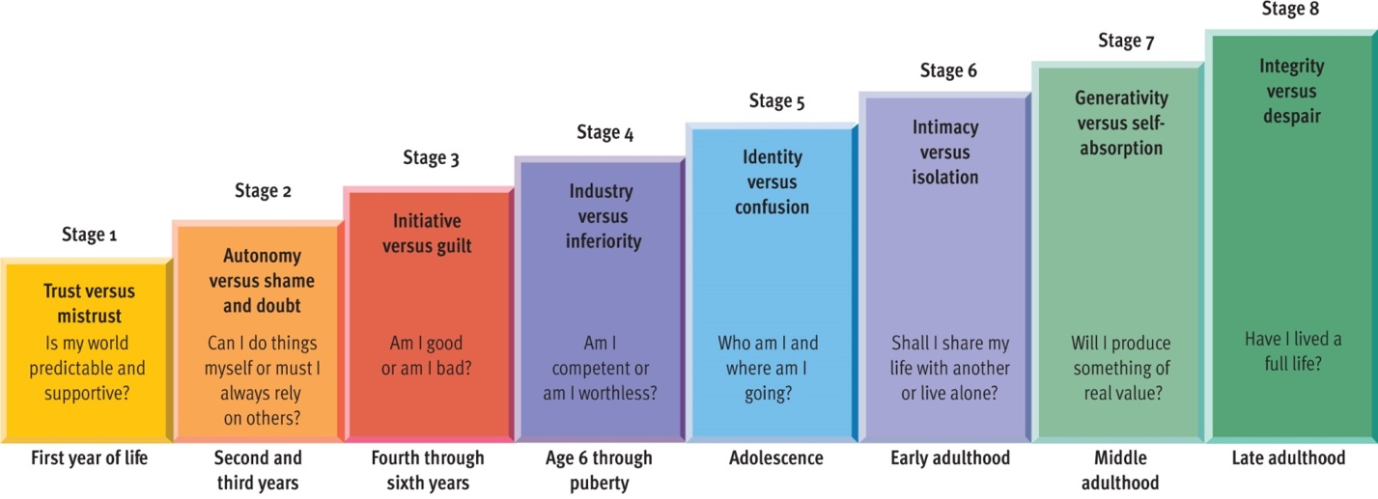*Know Erickson’s stage theory Figure 11.8

Development is enhanced when a crisis is resolved in favour of healthier alternative (which is listed for each stage)

Cognitive Development
Jean Piaget
Assimilation: Recognizing information/ Accommodation: Changing knowledge to accommodate the new information
4 Stages and major milestones
Sensorimotor: object permanence (even though the child is seeking an object they know it exists)
Preoperational: Centration (don’t see the big picture, focus too narrowly), egocentrism (can’t see the world from another’s perspective), symbolic thinking (they pick up an object and pretend it’s a phone), this stage is marked by inversibility (inability to work backwards)
Concrete Operational: Decentration, reversibility, conservation (understanding that even though the appearance of something changes doesn’t necessarily mean that the quantity changes) … (kids stop counting with their fingers, they can solve a problem in their head)
Formal Operational: Abstraction
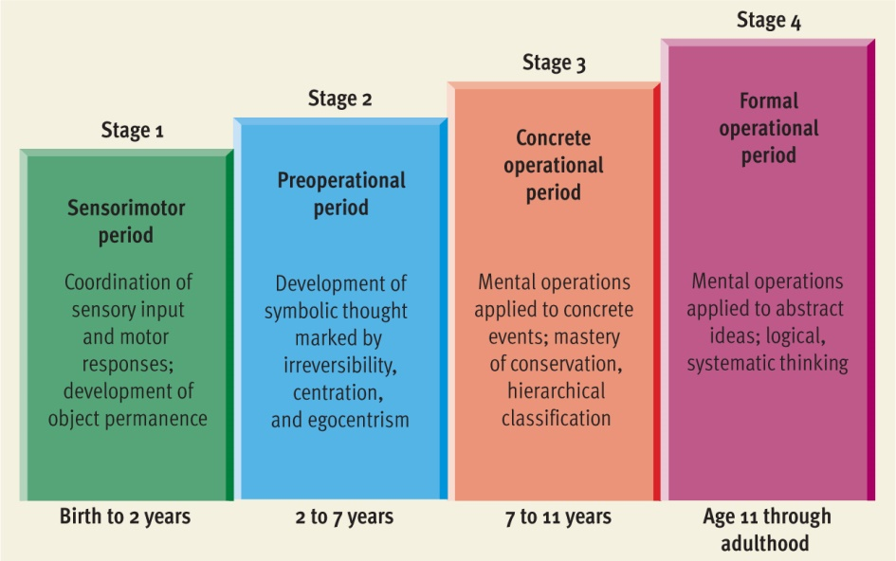
Lev Vygotsky: Introduced new ideas; first cognitive theorist who though that the way that you think and develop is affected by your family/ support, peers, etc… (working in groups is better for cognitive development)
Critical periods in development
Difference between critical and sensitive period: Critical period; if you don’t have the opportunity to develop in that area in that critical time, you will never be able to develop in that area.
Sensitive period: There are certain times when development is more likely to occur and you want the environmental supports to occur, if you don’t have these supports you will develop in those areas still but not fully.
Theory of Mind:
We act in accordance of our beliefs and at the age of 4 children understand at a much more sophisticated level how the mind works.
Moral Reasoning
Kohlberg
Reasoning as opposed to behaviour
Moral dilemmas were given: he assessed them
Measured nature and progression of moral reasoning
** Know the 3 levels
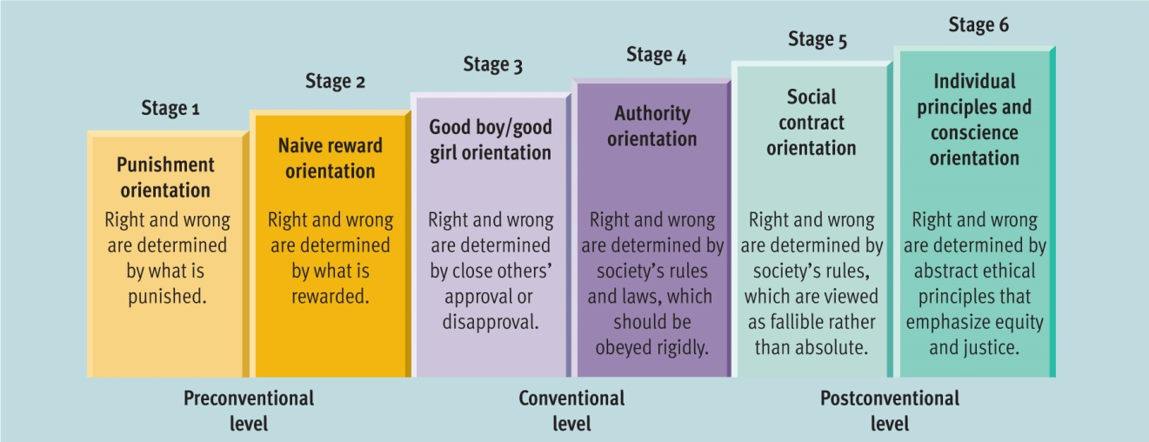
The Transition of Adolescence
Puberty:
Secondary sex characteristics: Start to develop (pre-puberty)
Primary sec characteristics: Menstruations, sperm (puberty); girls early onset is associated with negative outcomes (depression) and boys positive outcome. This is because if a girl starts to go into puberty earlier she’s different from the rest of the girls. With boys it represents more independence and leadership shown. The emotional climate can be related to when a girl starts menstruating, may make a girl start earlier. (Stress with dad). The girl gets a cue that there are not a lot of good me so her body gets ready early to go for the “good men”.
Erik Erikson: Key challenge is forming a sense of identity
James Marcia:
4 identity statuses: Foreclosure (2nd stage: children start to think of their beliefs and attitudes, who they are and what they think, a lot of what the kids say is what they’ve learnt through peers/family)
Moratorium (3rd stage, late adolescence, early adulthood, second guess and question everything we are, crisis period, learning new information and environment
Identity Diffusion (First stage, children don’t consider how they act, etc…)
Identity Achievement
The Expanse of Adulthood
Personality Development
Social development and family life (Early part of marriage is reported to have the most stress; children are not a good predictor of happiness (increase of stress)
Physiological changes: Vision, hearing, etc…
Neural changes
Cognitive changes: As we get older we do not decline cognitively, it is good to stay social and challenge your cognitive abilities.
Chapter 12
Personality Traits
Dispositions and dimensions
Five-Factor Model
- Extraversion: Outgoing, social, friendly
- Neuroticism: Worried, insecure, anxious
- Openness to experience: Imaginative, creative, flexible
- Agreeableness: Kind, easy-going
- Conscientiousness: Organized, responsible
Psychodynamic Perspectives
Freud’s Psychoanalytic Theory
Structure of personality
Id: Pleasure principle
Ego: Reality principle
Superego: Morality
Everyone has the Id, what happens with it depends on what happens early on in life
Levels of Awareness
Conscious
Unconscious: Where most of our personality is, the “Real you” lies here.
Preconscious
Conflict: Sex, aggression, anxiety, defense mechanisms
Know the following terms on a definition level***
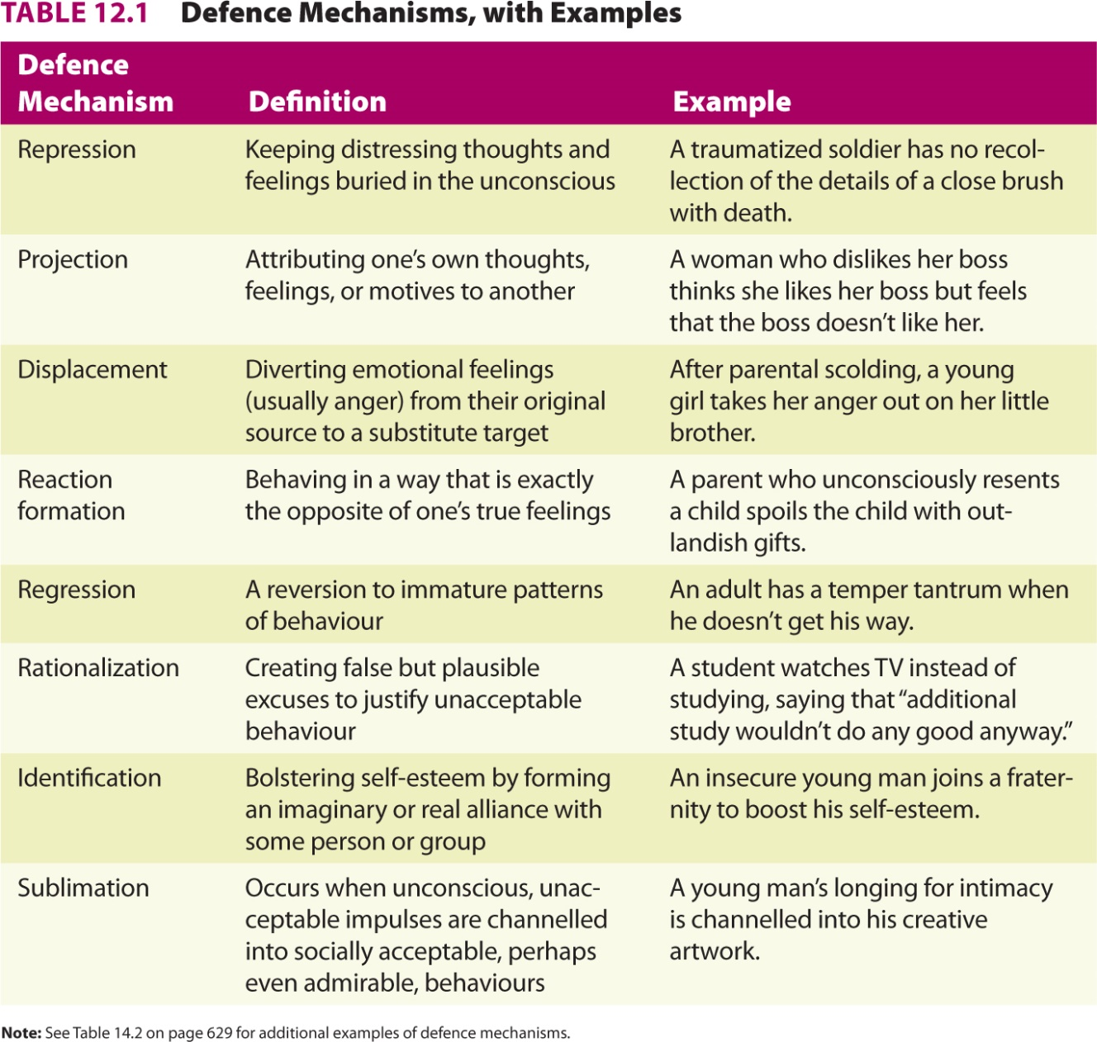
Psychosexual Stages
Sexual = Physical Pleasure
Personality is laid by the age of 5. The way children deal with different stages of development shape personality.
If you don’t successfully resolve the conflict in a certain stage then you wont move on, you will be fixated/ stuck in that stage.
Anal stage: Anal retentive
Phallic stage: Oedipus complex, oedipal crisis (boys), electra complex (girls); this crisis has to be resolved, children will start to identify with the same-sex parent. The problem is if one parent is absent/ divorce then the child doesn’t have that same-sex parent around. Sexual identity issues are possible.
Latency stage: Problems: If you don’t have good quality social contacts then they might push their sexuality to make contacts and don’t make good relationships.

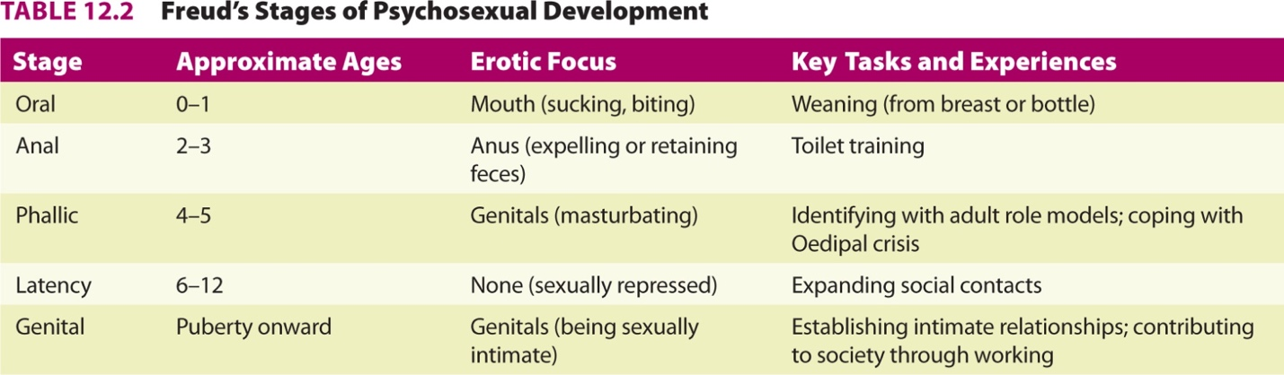

Psychodynamic Theorists
Carl Jung
- Analytical Psychology
- We are influenced by components that are not accessible and through therapy etc… we can bring out the unconscious
- Personal and collective unconscious: memory traces from our past that are in our genes which drive our behaviour. These memory traces come out in the form of images and symbols in our culture.
- Archetypes
- Introversion/ Extroversion
Alfred Adler
- Individual Psychology
- The foremost source of human motivation is striving for superiority
- Compensation for lack of self-esteem, worth, efficacy
- Inferiority complex leads to overcompensation
- Birth Order
Evaluating Psychodynamic Perspectives
Pros
- Insights regarding
- The unconscious
- The role of internal conflict
- The importance of early childhood experiences
Cons
- Poor testability
- Inadequate empirical base
- Sexist views
Behavioural Perspectives
Skinner’s ideas applied to personality
- Conditioning and response tendencies 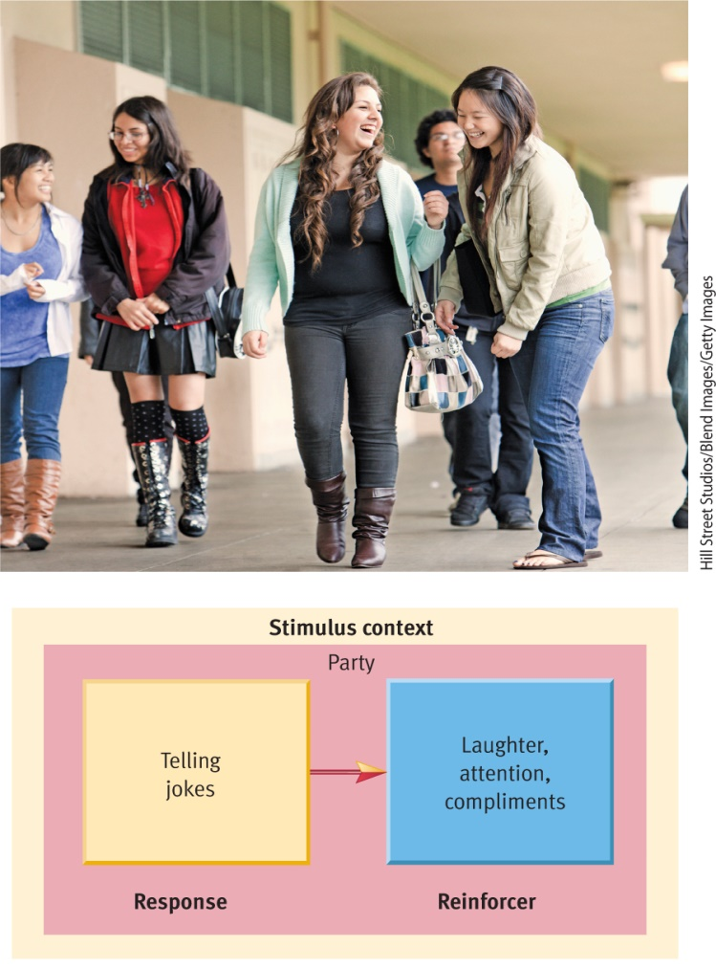
- Environmental determinism
- Ex: pigeon video (when the pigeon starts turning counter clockwise a light goes on and gives him food).
Bandura’s Social Cognitive Theory
- Social learning theory: Imitation through observational learning
- Ex: Bobo doll experiment
- Cognitive processes and reciprocal determinism: Bandura argues that internal mental events, external environmental contingencies, and overt behaviour all influence one another.
- Observational learning, models
- Self-efficacy
Mischel’s views
- Consider the power of the environment/ situation
- The person-situation controversy
- The interactional approach
Evaluating Behavioural Perspectives
Cons
- Over-dependence on animal research
- Fragmented view of personality (we are who we are because of our environment)
- Dehumanizing views
Pros
- Based on rigorous research
- Insights into effects of learning and environmental factors
Humanistic Perspectives
Carl Rogers
- Person-centered theory: Self-concept, a collection of beliefs about one’s own nature, unique qualities, and typical behaviour. We want a healthy and realistic self-concept and if we don’t we have incongruence. This is when what we think of ourselves doesn’t match with reality. Incongruence forms anxiety and stress.
- Conditional/ unconditional positive regard
- Incongruence and anxiety: Formed by subtle messages typically given from parents. Ex: the child doesn’t do well in a sport, the parent tell him to be better so they tell themselves to be better and then they go into the real world and there’s an incongruence.
- How to treat this incongruence: Change and restructure the self-concept.

- 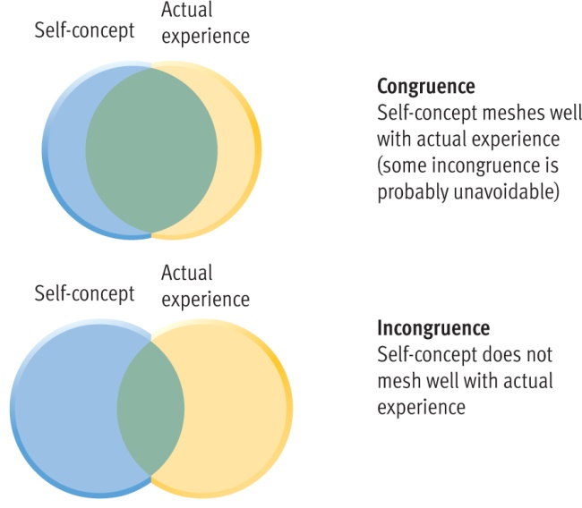
Abraham Maslow
- Self-actualization theory
- Hierarchy of needs: Only if we satisfy all these needs to we become self-actualized and have a healthy personality.
- The healthy personality
- Maslow hasn’t found someone who reflects his definition of someone with a healthy personality
- **Know this chart (definitions)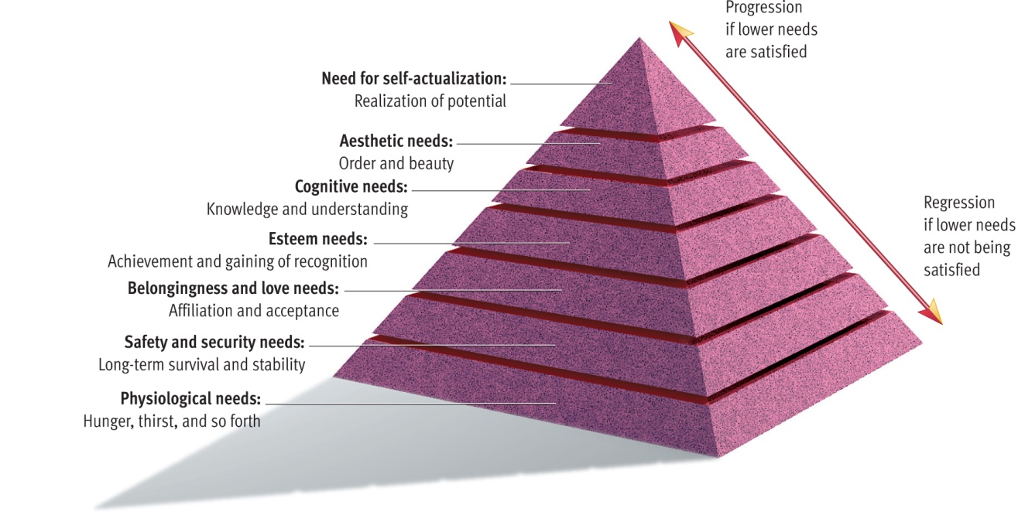
Evaluating Humanistic Perspectives
Pros
- Importance of subjective views
- Development of the idea of self-concept
- Optimistic growth and health oriented approach paved way for Positive Psychology
Cons
- Poor testability
- Unrealistic view of human nature
- Inadequate evidence
Biological Perspectives
- Eysenck’s theory
  - Three higher-order traits
    - Extraversion, neuroticism, and psychoticism
      - Determined by genes
- Behavioural genetics and personality
  - Novelty-seeking and genetics
  - Twin studies
- The evolutionary approach
  - Traits conducive to reproductive fitness
  - - Evolutionary analyses of personality suggest that certain traits and the ability to recognize them may contribute to reproductive fitness give a reproductive advantage.
Evaluating Biological Perspectives
Pros
- convincing evidence of genetic influence
Cons
- conceptual problems with heritability estimates
- artificial carving apart of nature and nurture
- no comprehensive biological theory
Contemporary Empirical Approaches to Personality Traits
- Narcissism
- Perfectionism (Self-oriented, other oriented (expect perfectionism from others), other prescribed)
Markus and Kitayama
- Study cultural differences in personality
- Independence(American) vs Interdependence (Asian) self-system
- Culture
MIDTERM
- Chapters 9-12
- 70 m/c questions
- Do sample Q&A will be posted on CU LEARN
- Know all concepts in BLUE in your chapter readings, summary at end of chapters, and use Mind Tap if you have it.
- Know Names and Theories
- Dates – NO
- Studies mentioned in class – YES
- Videos shown in class – NO

