Summary: Chapter 2- Structure and Function of the Nervous System

Chapter 2 is a review of..
- structure of nerve cells
- electrochemical properties of neurons
- anatomy of the nervous system

- 2 primary types of nervous system cells
1. neurons
a) sensory neurons- convert environmental sensation to electrical signal
b) interneurons- responsible for sensations, memory, decision making, cognition
c) motor neurons- direct behavioral response appropriate for the situation
sensory neurons -> interneurons -> motor neurons

2. glial cells (supporting cells)
^ support, insulation, protection

- 3 major external features of a neuron
1. Soma (Cell Body) – contains nucleus & other organelles
- maintains metabolic functions
2. Dendrites – treelike projections from soma
- receive info from other cells
3. Axon – conducts electrical signal from cell body to terminal buttons
- Contains axon hillock (where action potentials are generated)

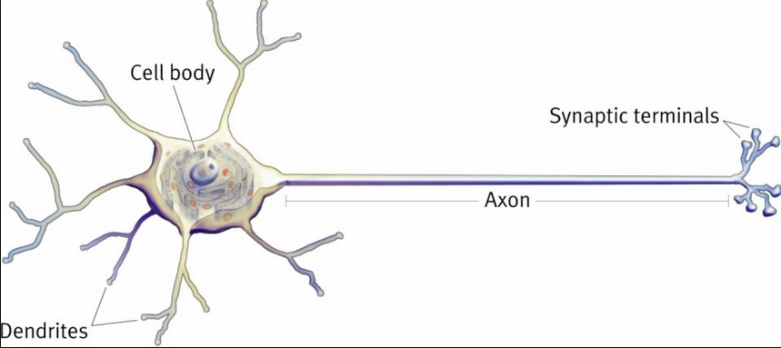

Note: all cells (including neurons) are filled w a salty gelatinous fluid (cytoplasm) and are also surrounded by a salty fluid (extracellular fluid) from which they take oxygen & nutrients. Also they have (mitochondria) which are responsible for generation energy (ATP)

- Axons and Terminal Buttons
- Axon Hillock – Where the A.P is generated
- Terminal Buttons – Usually located at the dendrites
^ contain – Synaptic Vesicles
^ contain – Neurotransmitters (N.T)

Note: Neurons are often named according to the N.T that they synthesize.
Ex. Cells that release dopamine are dopaminergic neurons.
- Myelin – Fatty insulation/coating for axons
- Made by layers of two different Glial Cells
a) Schwann Cells
b) Oligodendroglia
- Nodes of Ranvier – sites at which A.P is regenerated during conduction of electrical signal along axon.
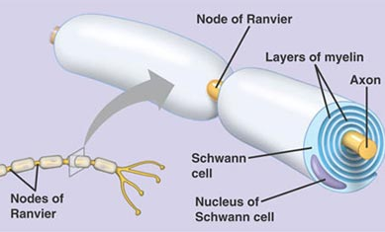

- Soma
-responsible for metabolic care of the neuron
- synthesis of proteins
- enzymes, receptors etc
- Transcription Factors – nuclear proteins that direct protein production.
- Transcription – occurs in the nucleus
- where messenger RNA (mRNA) makes copy of the active gene (DNA)
- Ribosomes – Link appropriate amino acids to form a protein.
^ This process is called Translation

- Axoplasmic Transport – the movement of proteins.
- Depends on the cytoskeleton
^ -matrix of tubular structures
- tracks along which packs of protein transport
-Anterograde Transport – carries new proteins toward axon terminals.
- Retrograde Transport – carries waste materials from axon terminals back to soma for recycling.
See figure ..

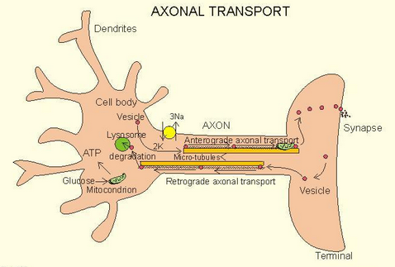

Ion Channels
- Specific to particular ion
- Always closed but can be opened by some stimuli
- referred to as gated channels
- Two Types
1. ligand gated – regulated by active ligand* binding to receptor site associated with the channel
*ligand – any molecule that binds to a receptor
2. voltage gated – regulated by voltage changes across the membrane

add:
Microglia – act as scavengers and work to remove dying cells where they may be neuron damge

Electrical Transmission within a Neuron

Resting Membrane Potential – There is always a difference in electrical charge inside and the cell compared to outside
- Inside is more negative that outside by approx. -70 mV
- due to more negative partcicles (ions) in cell and positive particles outside of cell
- Means that neuron is polarized in its resting state

Action Potential – rapid change in membrane potential propagated down the length of the axon
- to have an A.P occur the membrane potential must meet the threshold (-50 mV)
- at this point voltage gated Na+ channels open generating a rapid change in membrane potential

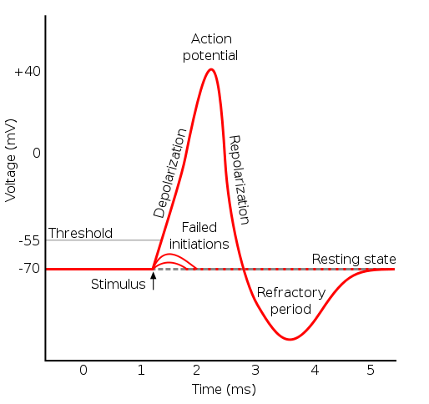

Absolute Refractory Period- after A.P when there is inability to open NA+ channels or respond to subsequent stimuli. (first)
Relative Refractory Period- more intense hyperpolarization is necessary to start an A.P. (second)

The Nervous System is composed of the Central Nervous System (brain and spinal cord) and the Peripheral Nervous System (all nerves outside of CNS)

Somatic Nervous System
- the part of the peripheral nervous system associated with skeletal muscle voluntary control of body movements. The somatic NS consists of afferent nerves and efferent nerves.
Afferent/Sensory Nerves – Towards the CNS
Efferent/Motor Nerves – Towards the muscles (causes movement)

Autonomic Nervous System
- the part of the nervous system responsible for control of the bodily functions not consciously directed, such as breathing, the heartbeat, and digestive processes.
Sympathetic- fight or flight
Parasympathetic- in times of rest to reserve energy

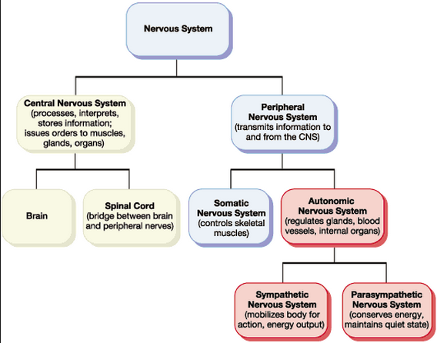

Note: the Somatic nervous system includes motor & sensory nerves.

Structural Features in CNS
- Meninges- Lies just within the skull. Has three layers ordered from the outside in (skull brain)
1. Dura Mater – toughest
2. Arachnoid - contains cerebrospinal fluid (CSF)
3. Pia Mater - thinnest. sits directly on nervous tissue

Neurotropic Factors- family of proteins that are responsible for the growth and survival of developing neurons and the maintenance of mature neurons.

Diencephalon - Posterior part of the forebrain, containing the epithalamus, thalamus, hypothalamus, and ventral thalamus and the third ventricle.

Telencephalon - most highly developed and anterior part of the forebrain, consisting chiefly of the cerebral hemispheres.

Limbic System- emotional responses, regulating motivated behaviour and learning.



