Chapter 14

Abnormal Behaviour: Myths, Realities and Controversies
- The medical model proposes that it is useful to think of abnormal behaviour as a disease…Thomas Szasz and others argue against this model, contending that psychological problems are “problems in living,” rather than psychological problems
  - Diagnosis – involves distinguishing one illness from another.
  - Etiology – apparent causation and development history of an illness
  - Prognosis – forecast about the probable course of an illness
  - Epidemiology is the study of the distribution of mental or physical disorders in the population.
  - Prevalence refers to the percentage of a population that exhibits a disorder during a specified time period.
  - Lifetime prevalence is the percentage of people who have been diagnosed with a specific disorder at any time in their lives. Current research suggests that about 44% of the adult population will have some sort of psychological disorder at some point in their lives
  - Concordance rate – indicates the % of twin pairs or other pairs of relatives who exhibit the same disorder
- Criteria of Abnormal Behaviour
  - In determining whether a behaviour is abnormal, clinicians rely on the following criteria: 1. Is it deviant, or does it violate societal norms, 2. Is it maladaptive, that is, does it impair a person’s everyday behaviour, and 3. Does it cause them personal distress?
  - All three criteria do not have to be met for a person to be diagnosed with a psychological disorder…diagnoses involve value judgments.
  - Antonyms such as normal vs. abnormal imply that people can be divided into two distinct groups, when in reality, it is hard to know when to draw the line

- Stereotypes of Physchological Disorders
  - Psychological disorders are incurable
  - People with psychological disorders are often violent and dangerous
  - People with psychological disorders behave in bizarre and are very different from normal people
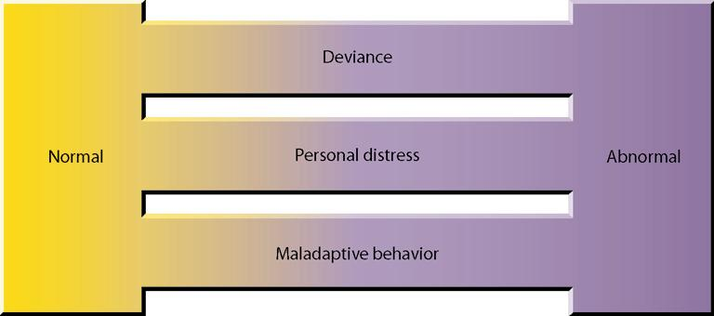
Normality and abnormality as a continuum. There isn’t a sharp boundary between normal and abnormal behaviour. Behaviour is normal or abnormal in degree, depending on the extent to which one’s behaviour is deviant, personally distressing, or maladaptive

- Reported one-year prevalence of psychological disorders. This figure presents the estimated percentage of people who have suffered from one of a selected set of psychological disorders in the years preceding the survey. The estimates represent people surveyed with the symptoms consistent with each type of disorder. The survey targeted Canadians 15 years and older and excluded members of the Armed Forces, First Nations people living on reserves, and people confined to health-care institutions. Source: Statistics Canada
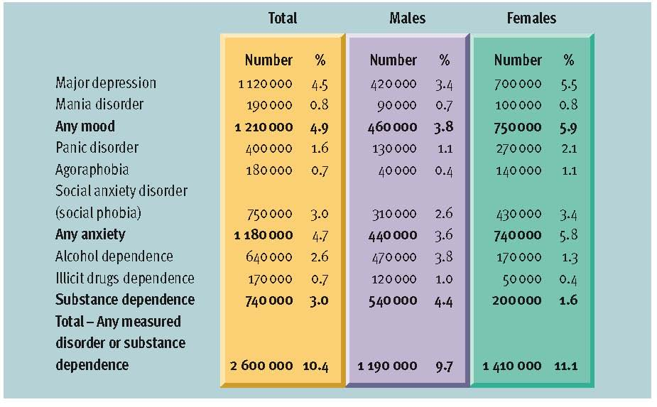

- Taxonomy of mental disorders was first published in 1952 by the American Psychiatric Association - the DSM (Diagnostic and Statistical Manaual of Mental Disorders – 4th ed.). This classification scheme is now in its 4th revision, which uses a multiaxial system for classifying mental disorders.
- The diagnoses of disorders are made on Axes I and II, with most falling on Axis I.
- The remaining axes are used to record supplemental information. A person’s physical disorders are listed on Axis III, and the types of stress they have experienced in the past year on Axis IV. Axis V estimates the individual’s current level of adaptive functioning.
- The goal of this multiaxial system is to impart information beyond a traditional diagnostic label.
  - Axis I – Clinical Syndromes
  - Axis II – Personality Disorders or Mental Retardation
  - Axis III – General Medical Conditions
  - Axis IV – Psychosocial and Environmental Problems
  - Axis V – Global Assessment of Functioning
- Multiaxial system – recognizes the importance of information besides a traditional diagnostic label (categorical approach)
- Next edition of DSM-5 to facilitate incremental updates to be released in 2013
- Comorbidity – the coexistence of two or more disorders
- Critics argue that the current categorical approach should be replace by dimensional approach
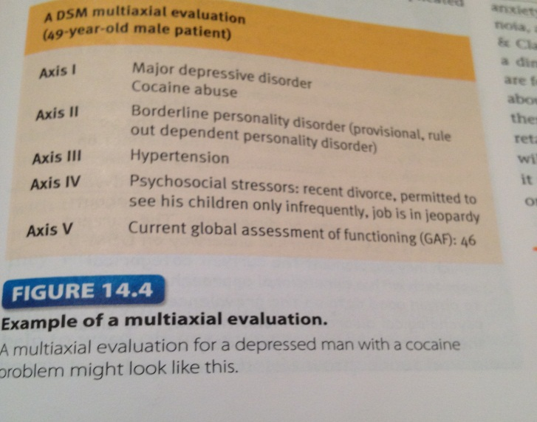
  - Dimensional approach – describes individuals pathology in terms of how they score on a limited number of continuous dimensions, such as the degree to which they exhibit anxiety, depression, etc

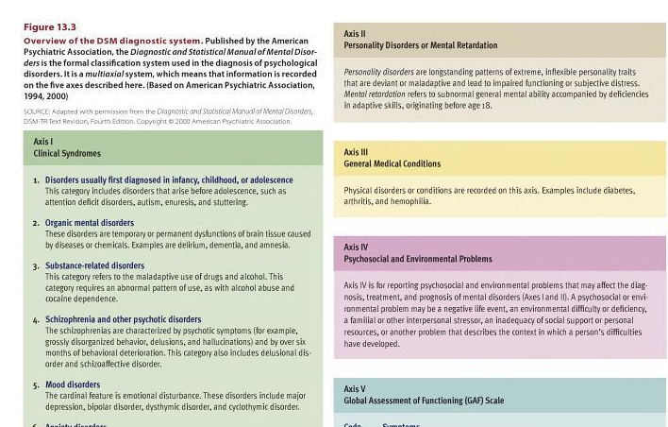
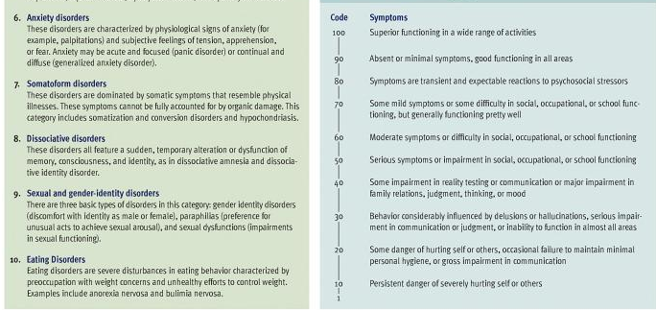
Anxiety Disorder
- Generalized anxiety disorder is marked by a chronic, high level of anxiety that is not tied to any specific threat; “free-floating anxiety” as it nonspecific worry constantly about yesterday’s mistakes and tomorrows problems; in particular family, finances, work and personal illness. Dread decisions accompanied by physical symptoms.
- Phobic Disorder is marked by a persistent an irrational fear of an object or situation that presents no realistic danger. Particularly common are acrophobia – fear of heights, claustrophobia – fear of small, enclosed places, brontophobia – fear of storms, hydrophobia – fear of water, and various animal and insect phobias. Objects or places triggers anxiety.
- Panic disorder is characterized by recurrent attacks of overwhelming anxiety that usually occur suddenly and unexpectedly. These paralyzing attacks have physical symptoms. After a number of these attacks, victims may become so concerned about exhibiting panic in public that they may be afraid to leave home, developing agoraphobia or a fear of going out in public. Two-thirds are women that suffer and occurs during late adolescence or early adulthood
- Obsessive-compulsive disorder (OCD) is marked by persistent, uncontrollable intrusions of unwanted thoughts (obsessions) and urges to engage in senseless rituals (compulsions). Common examples of compulsions include constant handwashing, repetitive cleaning of things that are already clean, and endless checking and rechecking of locks, etc. Obession and checking, symmetry and order, cleanliness and washing and hoarding
- Post-Traumatic Stress Disorder (PTSD) often elicited by an of a cariety of traumatic events; surfaces months and years after the events and is tied to memory. Women (10%) are more likely than men (5%),
  - Symptoms includes: nightmares and flashbacks, emotional numbing , alienation, problems in relation, vulnerability, eleveated sense of arousal, anxiety, anger and guilt
- Etiology of Anxiety Disorders
  - Twin studies suggest a moderate genetic predisposition to anxiety disorders. They may be more likely in people who are especially sensitive to the physiological symptoms of anxiety. Abnormalities in neurotransmitter activity at GABA synapses have been implicated in some types of anxiety disorders, and abnormalities in serotonin synapses have been implicated in panic and obsessive-compulsive disorders.
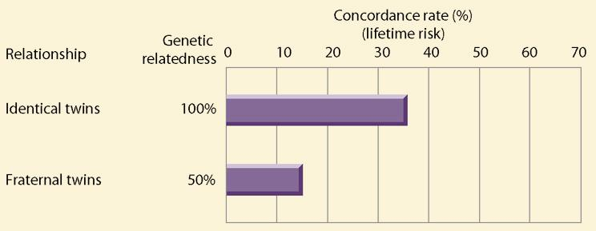
Twin studies of anxiety disorders. The concordance rate for anxiety disorders in identical twins is higher than that for fraternal twins, who share less genetic overlap. These results suggest that there is a genetic predisposition to anxiety disorders.

  - Many anxiety responses, especially phobias, may be caused by classical conditioning and maintained by operant conditioning. Parents who model anxiety may promote the development of these disorders through observational learning.
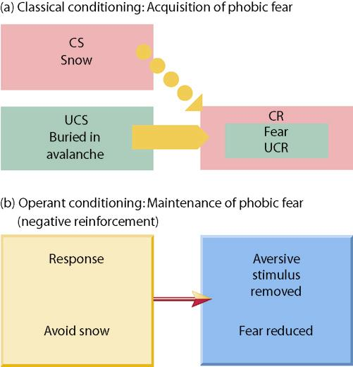
Conditioning as an explanation for phobias. (a) Many phobias appear to be acquired through classical conditioning when a neutral stimulus is paired with an anxiety-arousing stimulus. (b) Once acquired, a phobia may be maintained through operant conditioning. Avoidance of the phobic stimulus reduces anxiety, resulting in negative reinforcement.
  - Cognitive theories hold that people suffer from problems with anxiety because
    - Misinterpret harmless situation as threatening
    - Focus excessive attention on perceived threats
    - Selective recall information that seems threatening
  - The personality trait of neuroticism has been linked to anxiety disorders, and stress appears to precipitate the onset of anxiety disorders.

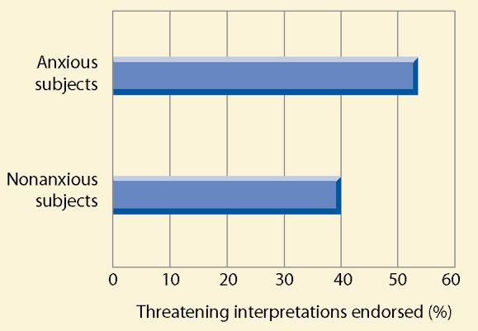
Fig 14.9 - Cognitive factors in anxiety disorders. Eysenck and his colleagues (1991) compared how subjects with anxiety problems and nonanxious subjects tended to interpret sentences that could be viewed as threatening or nonthreatening. Consistent with cognitive models of anxiety disorders, anxious subjects were more likely to interpret the sentences in a threatening light.
  - Stress often helps to precipitate the onset of anxiety disorders
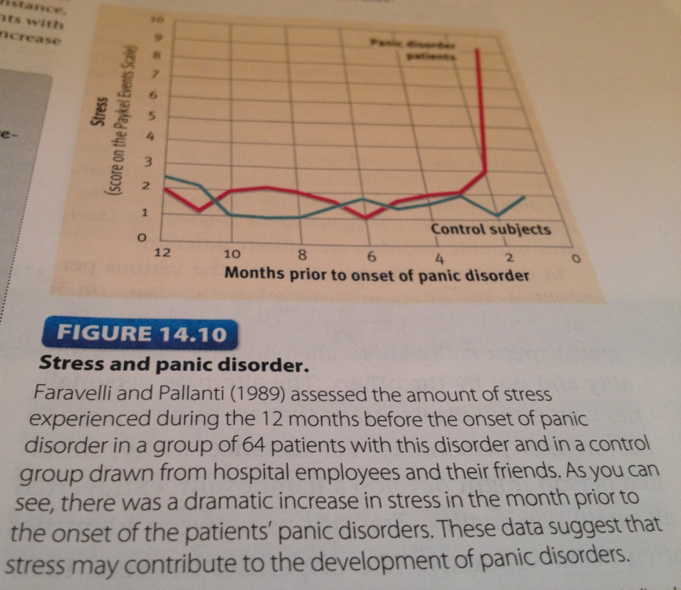

Dissociative Disorders
- Dissociative disorders are a class of disorders in which people lose contact with portions of their consciousness or memory, resulting in disruptions in their sense of identity
- Dissociative amnesia is a sudden loss of memory for important personal information that is too extensive to be due to normal forgetting. Memory loss may be for a single traumatic event or for an extended time period around the event
- Dissociative fugue is when people lose their memory for their entire lives along with their sense of personal identity…forget their name, family, where they live, etc., but still know how to do math and drive a car
- Dissociative identity disorder (formerly multiple personality disorder) involves the coexistence in one person of two or more largely complete, and usually very different, personalities.
  - DID is related to severe emotional trauma that occurred in childhood, although this link is not unique to DID, as a history of child abuse elevates the likelihood of many disorders, especially among females.
  - In a recent survey, only ¼ of American psychiatrists in the sample indicated that they felt there was solid evidence for the scientific validity of DID

Mood Disorders
- Mood disorders are a class of disorders marked by emotional disturbances of varied kinds that may spill over to physical, perceptual, social, and thought processes
- Major depressive disorder is marked by profound sadness, slowed thought processes, low self-esteem, and loss of interest in previous sources of pleasure.
  - called unipolar depression. Lifetime prevalence rate of unipolar depression is between 7 and 18%. Prevalence of depression is increasing, particularly in more recent age cohorts, and that it is 2X as high in women as in men.
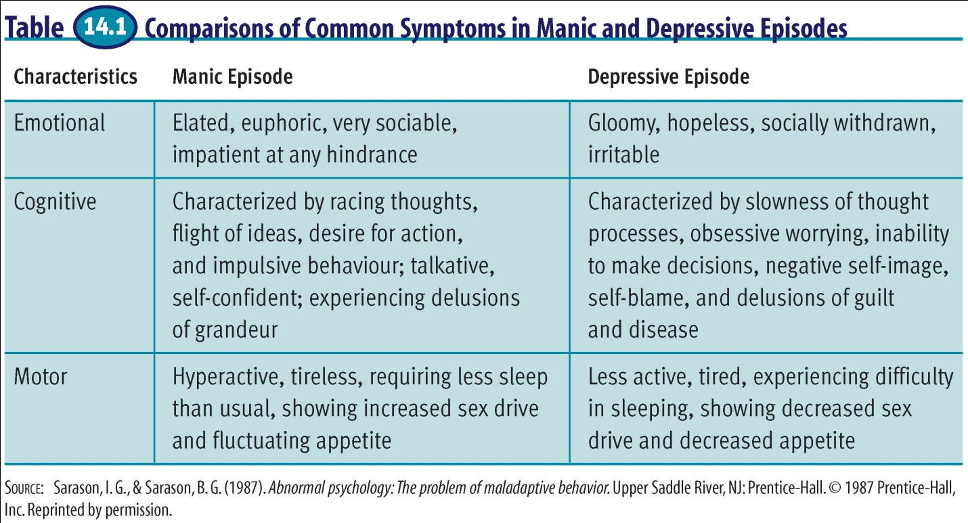

- Anhedonia - a diminished ability to experience pleasure
- Dysthymic disorder consists of chronic depression that is insufficient in severity to justify diagnosis of major depression
- Bipolar disorder (formerly known as manic-depressive disorder) is characterized by the experience of one or more manic episodes usually accompanied by periods of depression. In a manic episode, a person’s mood becomes elevated to the point of euphoria.
  - Bipolar disorder affects a little over 1%-2% of the population and is equally as common in males and females.
  - Spend more time in depressive state vs manic
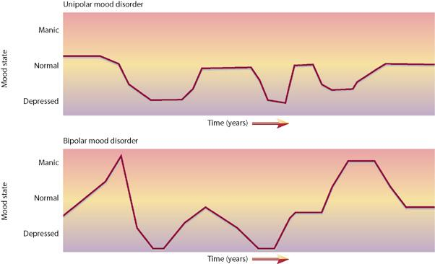
  - Most frequently occurs in 20s
Fig 14.11 - Episodic patterns in mood disorders. Time-limited episodes of emotional disturbance come and go unpredictably in mood disorders. People with unipolar disorders suffer from bouts of depression only, whereas people with bipolar disorders experience both manic and depressive episodes. The time between episodes of disturbance varies greatly with the individual and the type of disorder.

- People are given the diagnosis of cyclothymic disorder when they exhibit chronic but relatively mild symptoms of bipolar disturbance.
- Seasonal Affective Disorder (SAD) follows a seasonal pattern
  - Melatonin and circadian rhythms
- postpartum depression sometimes occurs after childbirth
- women attempt suicide 3X more often than men. But men kill themselves 4X more than women
- Twin studies suggest that heredity can create a predisposition to mood disorders. Environment factors probably determine whether this predisposition is converted into an actual disorder
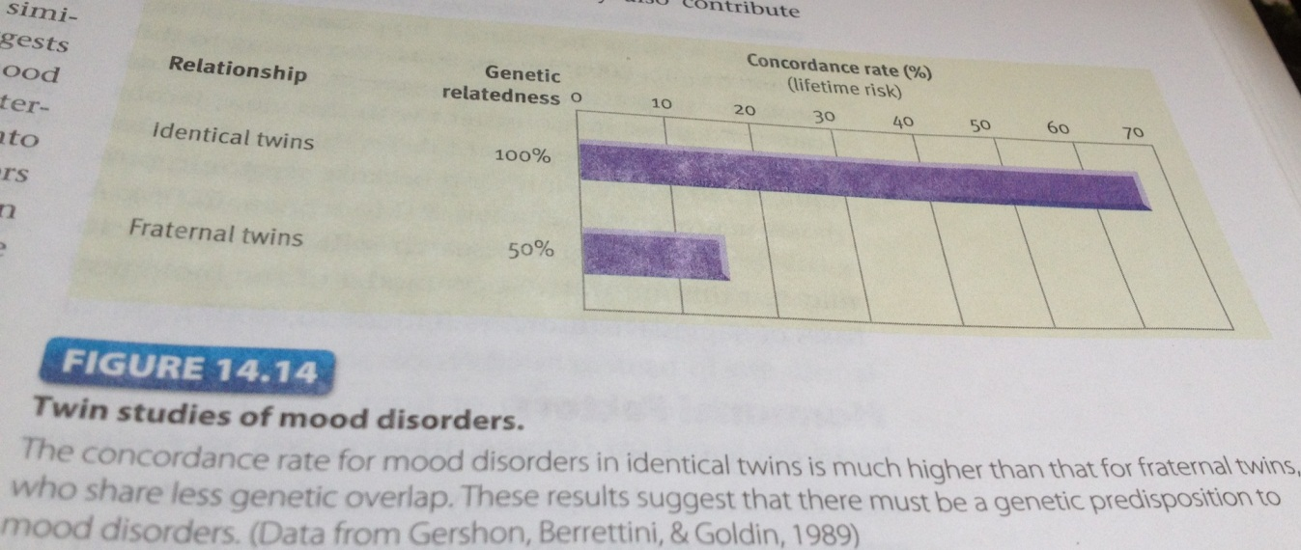
- The disparity in concordance between the two types of twins is greater for mood disorders than for either anxiety disorders or schizophrenic disorders, which suggests that genetic factors may be particularly important in mood disorders
- Evidence suggests genetic vulnerability to mood disorders. These disorders are accompanied by changes in neurochemical activity in the brain, particularly at norepinephrine and serotonin synapses.
  - Correlation between depression and reduced hippocampal volume
  - Depression suppress neurogenesis
  - antidepressant drugs elevate serotonin levels which leads to increase in neurogenesis and relieves depression

- Dispositional factors – factors that are internal i.e. mood
  - Correlation between trait perfectionism and depression
    - Self-oriented perfectionism: tendency to set high standards for oneself
    - Other-oriented perfectionism: setting high standards for other
    - Socially prescribed perfectionism: perceive that others are setting high standards for oneself

  - Beck model
    - Sociotropic individuals invested in interpersonal relationship (avoiding problems)
    - Autonomous individuals oriented towards their own independence and achievement
  - Blatt model
    - Introjective personality orientation: excessive self-criticism
    - Anaclitic orientation: involving overdependence on others
      - Both Beck’s and Blatt’s model are consistent with congruency model that suggest that personality variables operate as vulnerabilities in response to stressors related to that specific disposition
- Cognitive models suggest that negative thinking contributes to depression. Learned helplessness and a pessimistic explanatory style have been proposed by Martin Seligman as predisposing individuals to depression. Hopelessness theory, the most recent descendant of the learned helplessness model of depression, proposes a sense of hopelessness as the “final pathway” leading to depression…not just explanatory style, but also high stress, low self-esteem, and other factors combine in the development of depression. Current research also implicates ruminating over one’s problems as important in the maintenance of depression, extending and amplifying individuals’ episodes of depression.
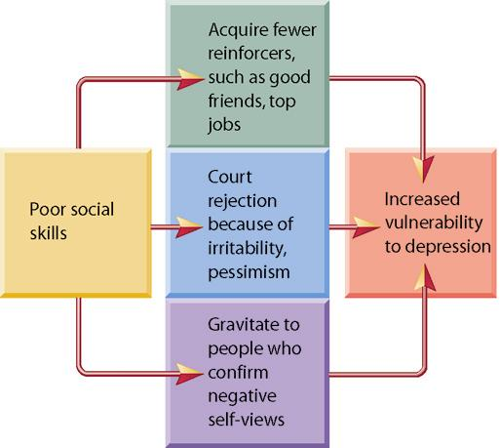
- Interpersonal inadequacies and poor social skills may lead to a paucity of life’s reinforcers and frequent rejection. Stress has also been implicated in the development of depressive disorders.

Interpersonal factors in depression. Behavioural theories about the etiology of depression emphasize how inadequate social skills may contribute to the development of the disorder.

- Featured study:
  - Asserts that negative thinking makes people more vulnerable to depression
  - Previous studies of correlation between negative thinking and depression used retrospective designs which look backward in time from known outcomes
  - This study used a prospective design, which moves forward in time, testing hypotheses about future outcomes
    - Difficult and time consuming
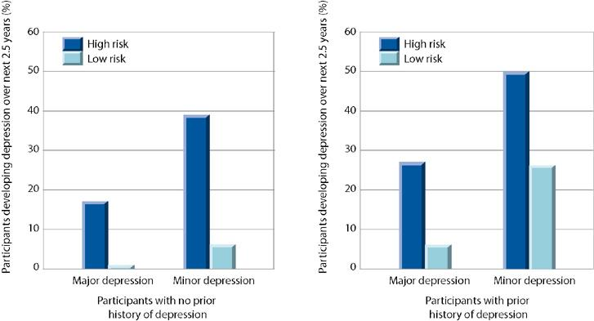
    - More insight about causation
Negative thinking and prediction of depression. Alloy and colleagues (1999) measured the explanatory style of first-year college students and characterized them as high risk or low risk for depression. This graph shows the percentage of these students who experienced major or minor episodes of depression over the next 2.5 years. As you can see, the high-risk students who exhibited a negative thinking style proved to be much more vulnerable to depression. (Data from Alloy et al., 1999)

Schizophrenic Disorders
- Schizophrenic disorders are a class of disorders marked by delusions, hallucinations, disorganized speech, and disorganized behaviour. Disturbed thought lies at the core of schizophrenia, whereas disturbed emotion lies at the core of mood disorders.
- Prevalence estimates suggest that schizophrenia occurs in about 1% of the population (several million people in the U.S.).
- General symptoms of schizophrenia include delusions, which are false beliefs that are maintained even though they clearly are out of touch with reality…belief that you a tiger, that private thoughts are being broadcasted to others, etc. Delusions of grandeur occur when people think they are famous or important. Chaotic thinking, or loose associations, is common in schizophrenia as well, where a person shifts topics in disjointed ways.
- Deterioration of adaptive behaviour involves noticeable deficits in the quality of a person’s routine functioning in work, social relations, and personal care.
- Hallucinations are sensory perceptions that occur in the absence of a real, external stimulus or are gross distortions of perceptual input…hearing voices.
- Disturbed emotion may manifest as little emotional responsiveness (blunted or flat affect) or inappropriate emotional responses (laughing at a story of a child’s death).
- A more favorable prognosis exists when the onset of the disorder is sudden and at a later age, the individual’s social and work adjustment was good prior to onset, the proportion of negative symptoms is low, and the patient has a good social support system
- Subtyping
  - Currently, in the DSM-IV, there are 4 subtypes of schizophrenia.
  - Paranoid schizophrenia is dominated by delusions of persecution, along with delusions of grandeur.
  - Catatonic schizophrenia is marked by striking motor disturbances, ranging from muscular rigidity to random motor activity.
  - In disorganized schizophrenia, a particularly severe deterioration of adaptive behaviour is seen…incoherence, complete social withdrawal, delusions centering on bodily functions.
  - People who clearly have schizophrenia, but cannot be placed in any of the above subtypes, are given the diagnosis of undifferentiated schizophrenia.
  - There are many critics of the current subtyping system for schizophrenia. Some theorists argue that the disorder should be conceptualized along two categories, positive symptoms – behavioural excesses or peculiarities, such as hallucinations, delusions, bizarre behaviour, and wild flights of ideas; and negative symptoms – behavioural deficits, such as flattened emotions, social withdrawal, apathy, impaired attention, and poverty of speech.
- Etiology
  - Research has linked schizophrenia to a genetic vulnerability and changes in neurotransmitter activity at dopamine, and perhaps serotonin, receptors. Structural abnormalities in the brain, such as enlarged ventricles, are associated with schizophrenia, as are metabolic abnormalities in the prefrontal and temporal lobes. Researchers theorize that positive symptoms are related to prefrontal abnormalities and negative symptoms to temporal abnormalities. The question remains to be answered re: whether these abnormalities are cause or consequence of schizophrenia.
  - The neurodevelopmental hypothesis of schizophrenia asserts that it is attributable to disruptions in maturational processes of the brain before or at the time of birth that are caused by prenatal viral infections or malnutrition, obstetrical complications, and other brain insults.
  - Studies of expressed emotion, or the degree to which a relative of a person with schizophrenia displays highly critical or emotionally overinvolved attitudes toward the patient, suggest that expressed emotion is a good predictor of the course of schizophrenic illness, negatively impacting prognosis.
  - Precipitating stress and unhealthy family dynamics have also been shown to be related to schizophrenia.
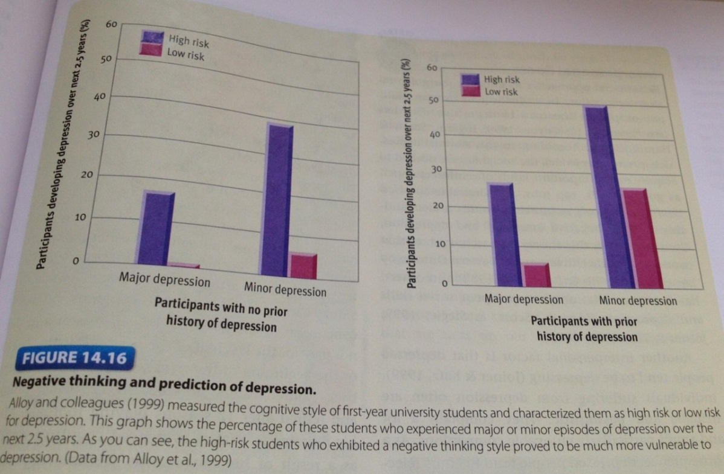

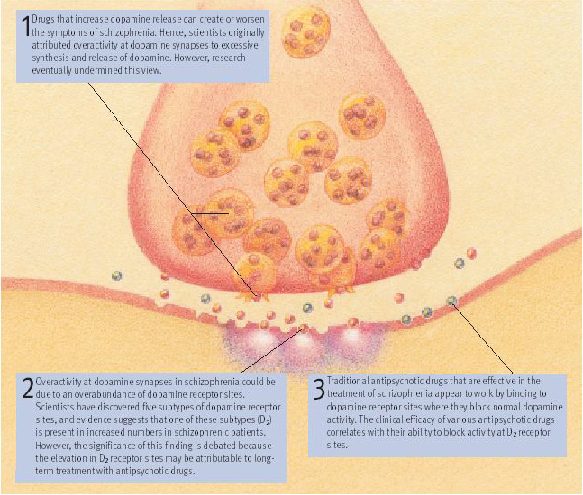
Fig 14.19 – The dopamine hypothesis as an explanation for schizophrenia. Decades of research have implicated over-activity at dopamine synapses as a key cause of schizophrenic disorders. However, the evidence on the exact mechanisms underlying this overactivity, which is summarized in the graphic, is complex and open to debate. Recent hypotheses about the neurochemical bases of schizophrenia go beyond the simple assumption that dopamine activity is increased. For example, one theory posits that schizophrenia may be accompanied by decreased dopamine activity in one area of the brain (the prefrontal cortex) and increased activity or dysregulation in other areas of the brain (Egan & Hyde, 2000). Moreover, abnormalities in other neurotransmitter systems may also contribute to schizophrenia.

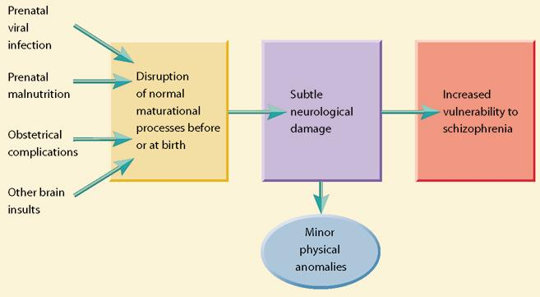

Fig 14.21 – The neurodevelopmental hypothesis of schizophrenia. Recent findings have suggested that insults to the brain sustained during prenatal development or at birth may disrupt crucial maturational processes in the brain, resulting in subtle neurological damage that gradually becomes apparent as a youngsters develop. This neurological damage is believed to increase both vulnerability to schizophrenia and the incidence of minor physical anomalies (slight anatomical defects of the head, face, hands and feet).

Personality Disorders
- Personality disorders are a class of disorders marked by extreme, inflexible personality traits that cause subjective distress or impaired social and occupational functioning
- Anxious-fearful cluster:
  - Avoidant – excessively sensitive to potential rejection, humiliation or shame
  - Dependent – excessively lacking in self-reliance and self-esteem,
  - Obsessive-compulsive – preoccupied with organization, rules, schedules, lists, and trivial details.
- Odd-eccentric cluster:
  - Schizoid – defective in capacity for forming social relationships,
  - Schizotypal – social deficits and oddities in thinking, perception, and communication,
  - Paranoid – pervasive and unwarranted suspiciousness and mistrust.

- Dramatic-impulsive cluster:
  - Histrionic – overly dramatic, tending to exaggerate expressions of emotion,
  - Narcissistic – grandiosely self-important, lacking interpersonal empathy,
  - Borderline – unstable in self-image, mood, and interpersonal relationships,
  - Antisocial – chronically violating the rights of others, non-accepting of social norms, inability to form attachments.
- Antisocial personality disorder/psychopathy - marked by impulsive, callous, manipulative, aggressive and irresponsible behaviour that reflects a failure to accept some social norms
  - Psychopathy checklist revised
- Etiology
  - Average concordance rate of 67% for identical twins in comparison to 31% fraternal twins and dysfunctional families

Other Disorders and related Info
- Autism: developmental disorder characterized by social and emotional deficits
- Insanity is not a diagnosis, it is a legal concept. Insanity is a legal status indicating that a person cannot be held responsible for his or her actions because of mental illness.
- The M’naghten rule holds that insanity exists when a mental disorder makes a person unable to distinguish right from wrong.
- Involuntary commitment occurs when people are hospitalized in psychiatric facilities against their will. Rules vary from state to state, but generally, people are subject to involuntary commitment when they are a danger to themselves or others or when they are in need of treatment (as in cases of severe disorientation).
- In emergency situations, psychiatrists and psychologists can authorize temporary commitment only for a period of 24-72 hours. Long-term commitments must go through the courts and are usually set up for renewable six-month periods.
- The principal categories of psychological disturbance are identifiable in all cultures, but milder disorders may go unrecognized in some societies.
- Relativistic view: mental illness vary greatly across cultures
- Uni./Pan cultural view: criteria for mental illness are much the same around the world
- Culture-bound disorders illustrate the diversity of abnormal behaviour around the world, as well as cultural influence.
- Koro is an obsessive fear that one’s penis will withdraw into one’s abdomen, seen only in Malaya and other regions of southern Asia.
- Windigo involves intense craving for human flesh and fear that one will turn into a cannibal, seen only among Algonquin Indian cultures.

PP & PA
- Multifactorial causation, interplay of heredity and environment, sociohistorical context in which psychology involves and influence of culture
- Anorexia nervosa – intense fear of gaining weight and dangerous methods to lose weight
- Bulimia nervosa – out of control over eating followed by unhealthy compensatory efforts i.e. self-induced vomiting
- Binge-eating – distress-inducing eating binges that are not accompanied by the purging, fasting and excessive exercise seen in bulimia

