Final Report
FINAL SUBMISSION
Wind Energy Conversion System

Carleton University
Prof. Alex Myers
CCDP 2100H

TEAM #5
Amin Qassoud
Mohit Lokhande
Mahmoud El Gaffarawi
Sougal Bouh Ali

08/15/2013

Executive Summary – Amin Qassoud

With the rising gas’s prices and global warming, the automobile market is increasingly interested in eco-friendly energy and higher energy efficiency. Composed from a receptor, a transformer and an adapter, the Wind Energy Conversion System (WECS) is a device that collects energy from the wind and supply the car with electricity. This device is located on the roof of the car. Its supporting main principles are: Torque, Betz Law, Electromagnetic Induction, Kinetic-Motion, ohm’s Law, Power, and Kirchhoff’s circuit Laws, Kirchhoff’s Current Law and Kirchhoff’s Voltage Law.
Energy efficiency and eco-friendly are the two main benefits of the wind energy conversion system.

Table of Contents
1. Introduction – Sougal Bouh Ali 1
1.1 Technical Report Purpose 1
1.1.1 Wind Energy Conversion 1
1.2 Patent Motivation 1
1.2.1 Economic advantages of Wind Energy 1
1.2.2 Environmental advantages of Wind Energy 2
1.3 Technical Report Overview 2
2. WECS Design Overview – Amin Qassoud 3
3. WECS Design Technical Aspects 6
3.1 Introduction – Sougal Bouh Ali 6
3.2 Receptor – Sougal Bouh Ali 7
3.2.1 Torque 7
3.2.2 Betz Law 9
3.3 Transformer – Amin Qassoud 12
3.3.1 Electromagnetic Induction 12
3.3.2 Lorentz Force from Original to Practical 14
3.3.3 Kinetic-Motion 15
3.3.4 Estimation of WECS’s Energy Efficiency 17
3.4 Adapter 19
3.4.1 Ohm’s Law – Mahmoud El Gaffarawi 19
3.4.2 Power – Mahmoud El Gaffarawi 22
3.4.3 Kirchhoff’s Circuit Laws – Mohit Lokhande 25
3.4.3.1 Kirchhoff’s Current Law (KCL) 26
3.4.3.2 Kirchhoff’s Voltage Law (KVL) 28
4. Conclusion - Sougal Bouh Ali 32
4.1 Summary and Concluding Remarks 32
4.2 Patentability and Suggestions for Future steps 32
References 34
Glossary 36

Table of Figures

Figure 1: Front view and side view of a WECS 4
Figure 2: Representation of the components of the Wind Energy Conversion System 5
Figure 3: Schematic diagram of the proposed WECS Design for hybrid cars 6
Figure 4: Illustration of a WECS Receptor’s shaft using the concept of Torque 7
Figure 5: The Ideal flow of the Wind known as Betz’s Tube [7] 9
Figure 6: Betz’s conclusion 10
Figure 7: Longitudinal view with transversal cut of wire with electrons moving towards 12
Figure 8: A magnet rotating in a wire loop [9, pp.26] 13
Figure 9: Representation of the earth magnetic field [9] 13
Figure 10: Representation of induced current by magnet moving inside a coil [9, pp.26] 13
Figure 11: Two velocity scenarios 16
Figure 12: Two similar scenarios regarding relative velocities (WECS / Wind) 18
Figure 13: The two primary principles of Ohm’s Law 19
Figure 14: Diagram of a common circuit 20
Figure 15: Unit abbreviations, SI units and units of measurements used in Ohm’s Law [8] 21
Figure 16: Power concepts, its different uses and what its measured in explained 23
Figure 17: Current in a node 27
Figure 18: Electrical Circuit 27
Figure 19: Loop Analysis 29
Figure 20: Comparison: Series Circuit Vs. Parallel Circuit 31

- Introduction – Sougal Bouh Ali
  - Technical Report Purpose
In this Technical Report, a system based on wind energy that fuels hybrid cars with electrical energy is proposed. This innovative system is named Wind Energy Conversion System (WECS), and its original Canadian Intellectual Property Office (CIPO) reference number is CA 2556490.

    - Wind Energy Conversion
Wind Energy is the kinetic energy of large masses of air circulating over the earth surface. Wind Energy Conversion is the process by which the wind is used to generate mechanical or electrical energy.

  - Patent Motivation
Wind is one of the most abundant renewable sources of energy in nature. Electrical systems based on wind energy are receiving widespread global attention as wind energy offers countless economic and environmental advantages [1].

    - Economic advantages of Wind Energy
In the 19th century, the low price of fossil fuels made WECS economically unattractive. With the oil crisis, research on WECS has been revived. A considerable amount of effort is made to generate electricity from WECS in order to save you from the increasing prices of gas [1].

    - Environmental advantages of Wind Energy
Nowadays, we are faced with environmental disasters that threaten our well-being. Rising pollution levels and dramatic climate change, demand a reduction in environmentally damaging emissions. One of the major sources of air pollution is in the production of electricity using fossil fuel. Preferred solutions to prevent these pollutants emissions are using renewable and cleaner sources of energy [1]. In fact, for every 1 J/s (~ energy released by explosion of one gram of TNT [2]) of electricity produced by wind, the emission of CO2 is reduced by 1 kg (a car which travels ~ 1500 km per year emits ~ 2800 kg of CO2 every year [3]).

  - Technical Report Overview
This Technical Report contains an overview of our WECS Design, an examination of its components’ technical aspects using 8 engineering principals, and a formal conclusion. Correspondingly, this report includes a reference for each citation in the document, and a glossary were the technical terms used throughout the report are defined using a Superscript number (e.g. Kinetic Energy).

- WECS Design Overview – Amin Qassoud
The “wind energy conversion system” (WECS) is the patent that our team will be writing and talking about. Its number and related hyperlink are respectively: 2556490, http://brevets-patents.ic.gc.ca/opic-cipo/cpd/eng/patent/2556490/ summary.html.
The “wind energy conversion system” (WECS) is the landmark that our team chose. Its ID and date of approval are respectively: 24867855, August 11, 1992. It was by Lund and Arnold. Its related patents are identified by the followings international classes: F03D 1/00; F03D 1/06; F03B 015/06; F03D 009/00; H02P 009/04.
Moreover, there are 4 others competing patents, but none of these apply to WECS to a cars.
As shown in figure 1 below, the WECS is located on the roof of the hybrid car. Its prime objective is to convert the wind kinetic energy into electric power which charges our car battery.
In fact it was found that at sustained speed of 70 km/h (i.e. Winds are at 70km/h), the WECS cover 40% of the energy need of the car. This is further detailed in section 3.3.3 where the principle of kinetic-motion.
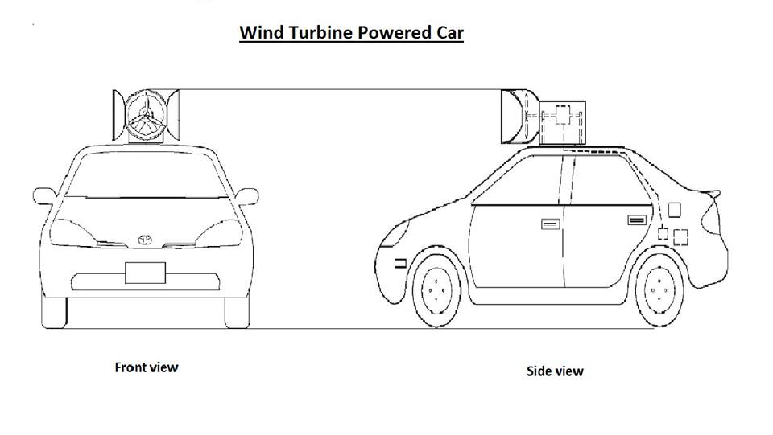
Figure 1: Front view and side view of a WECS
As shown in figure 2 below, the WECS is connected to the electrical system of the car through an electrical Adapter. This electrical Adapter is located at the back of the car. Here are our WECS’s three main parts [Figure1]:
- Receptor: Composed of the blades that are connected to the shaft, its main role is converting wind energy into mechanical energy.
- Transformation operator: Composed of a magnet and coil which transforms the mechanical energy into electrical energy. The coil is located under the case.
- Adapter: Composed from multivariable Resistances, its main role is to adapt the electrical current provided by the transformation operator to the electrical standards of the car.
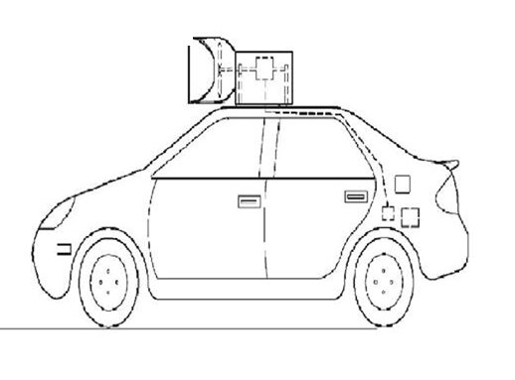
Blades
Blades
Adapter
Transformer
Wind

Multivariable Resistance
Magnet

Case (Black line)
Adapter
R
Electrical Energy
Coil (Blue line)

Figure 2: Representation of the components of the Wind Energy Conversion System

- WECS Design Technical Aspects
  - Introduction – Sougal Bouh Ali
There are different WECS configurations, however, the functional objective of these systems is the same: converting the wind’s kinetic energy in to electric power and inserting this electric power into a utility grid. In our case, this electric power will be used to charge our hybrid car’s battery. Figure 3 shows the block diagram of the basic components of our WECS Design.
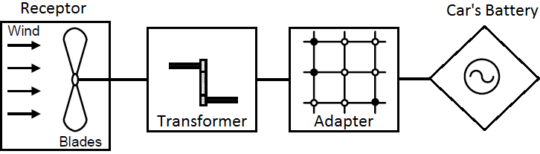
Figure 3: Schematic diagram of the proposed WECS Design for hybrid cars

The following sections describe the WECS Design components and their related engineering principles: 2 for the Receptor, 2 for the Transformer and 4 for the Adapter.

  - Receptor – Sougal Bouh Ali
    - Torque
Torque is the measure of the force which tends to rotate an object about an axis, in other words, torque is a turning force. This concept also known as moment of a force and angular acceleration was introduced by a Greek engineer named Archimedes of Syracuse [4].
In our WECS Design, the Receptor extracts power from the wind in mechanical form and transmits it to the Transformer by rotating the shaft. When power is being transmitted through the shaft, a torque T will be present. This torque is given by
$$T=\frac{P}{ω} N·\frac{m}{rad} \left(1\right) [5,pp.29]$$
Where $T$ is the torque in Newton*meter per radian (N*m/rad), $P$ is the mechanical power in Joules per second (J/s) known as the watt and $ω$ is the angular velocity in rad/s.

Equation 1: WECS's shaft torque equation

As shown in Figure 4 bellow, a WECS Receptor has a rotor with propeller-like blades that are connected to the shaft. As wind energy hits the blades, the rotor rotates, which causes the shaft to rotate as well. As the shaft rotates, it spins a generator to produce energy.
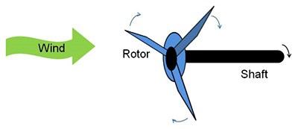
Figure 4: Illustration of a WECS Receptor’s shaft using the concept of Torque
In order to build the WECS Receptor’s shaft with sufficient strength and the WECS Receptor’s load properly sized, the shaft torque must be known.

Example: If a Receptor has a generator rated at 50 KW output, its shaft rotates at 188.5 rad/s and its maximum shearing stress is 55 x 10⁶ Pa, then the necessary shaft diameter is determined by first calculating the shaft Torque:
$$T=\frac{P}{ω}=\frac{50 000}{188.5}=265.3 N·\frac{m}{rad}$$
The shaft diameter is then calculated using the following equation:
$$D=2*\left(\sqrt[3]{\frac{2* T}{π*fs}}\right) m \left(2\right) [5,pp.31]$$
Where $D$ is the shaft’s diameter in meters (m), $T$ is the shaft’s torque in Newton*meter/radian (N*m/rad) and $fs$ is the shear force in Pascal (Pa).

Equation 2: WECS's shaft diameter equation

$$D=2*\left(\sqrt[3]{\frac{2*T}{π*fs}}\right)=2*\left(\sqrt[3]{\frac{2\left(265.3\right)}{π\left(55 x {10}^{6}\right)}}\right)=0.04 m=4 cm$$
It can be seen that a shaft of 4 cm diameter is rather strong as it compares to Boeings’ huge wind turbines shaft diameters that range from 1 cm to 10 cm [6]. Visually, 1 cm is the diameter of an average pen and 10 cm is the diameter of a coke can.

    - Betz Law
In 1919, a German Physicist named Albert Betz came up with a law stating the theoretical limit for the conversion of wind energy: no wind converter can convert more than 16/27 (or ~ 60%) of the wind's kinetic energy to mechanical energy, and that this maximum power output occurs when the downstream wind has 1/3 the speed of the upstream wind as shown in Figure 5 [7].
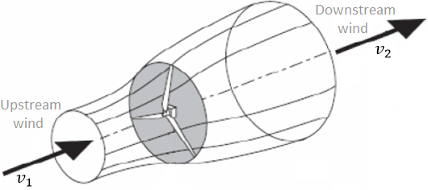
Figure 5: The Ideal flow of the Wind known as Betz’s Tube [7]

This law is normally referred to as “momentum theory” and has been derived from several principles [7]: the application of conservation of mass to get the mass which flows through the rotor’s surface per second, Newton’s second law of motion to get the power of the rotor, and the momentum of the air to get the total power of undisturbed air flow going through rotor’s surface.

In the end, Albert Betz obtained the following equation which limits the power output generated ($P/P_{0}$) as a function of the wind speed ($v_{2}/v_{1}$):
$$\frac{P}{P_{0}}=\frac{1}{2}\left(1-{\left(\frac{v_{2}}{v_{1}}\right)}^{2}\right)*\left(1+\left(\frac{v_{2}}{v_{1}}\right)\right) \left(3\right) [7,pp.5]$$
Where $P/P_{0}$ is the power output in watts, and $v_{2}/v_{1}$ is the wind speed in m/s [7].
Equation 3: Betz Law equation

Now the conclusion of Betz’s Law was that by analyzing the above equation 3, we obtain the graph in Figure 6, were the peak of the curve (0.593 or ~ 0.6) describes the maximum mechanical energy that can be extracted from the wind’s kinetic energy using a wind converter.
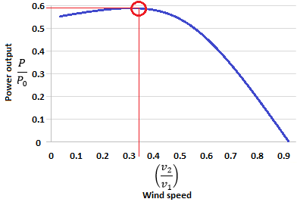
Figure 6: Betz’s conclusion
Thus, this maximum power output of 0.593 (16/27) is reached when the downstream wind ($v_{2}$) has 1/3 the speed of the upstream wind ($v_{1}$) [7], in other words, that is when $v_{2}/v_{1}= 0.33 (1/3)$ as illustrated in the graph above.

If we closely study the graph in Figure 6, it can be seen that the power output generated by the wind converter depends on the speed of the wind. Therefore, in order to extract more power from the wind, we can get around Betz limit by simply accelerating the wind going through the Receptor [8].
It is my assumption that in 1919, Albert Betz did not consider that wind converters will one day be used to generate power for hybrid cars.
Here is an example of how wind can be accelerated: a car accelerating creates its own wind, which in fact moves as fast as the car but in the opposite direction. So by having our wind converter on the roof of the car as shown in section 2.WECS Design overview, the Receptor will be exposed to an accelerating wind.
Additional examples on how the speed of the wind is related to the moving car will be given in section 3.3.2 kinetic-motion principle.
Thus, the ingenuity in our enhanced Wind Energy Conversion System is that it generates more power from the wind without considering Betz limit.

  - Transformer – Amin Qassoud
    - Electromagnetic Induction
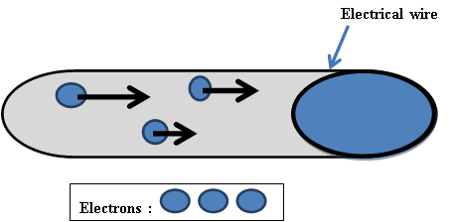
The Figure 7 below shows a longitudinal view with a transversal cut of a wire (represented in gray) where electrons are represented in blue circles and are moving in the same direction.

Figure 7: Longitudinal view with transversal cut of wire with electrons moving towards
This snapshot of electricity as arises from the movement of charged particles inside the wire. In this case the charged particles are the electrons.
The easiest process for converting mechanical energy into electrical energy is shown in Figure 8 by whew a magnet is rotated inside a wire loop. This process is called the principle of electromagnetic induction. [9, pp.25]

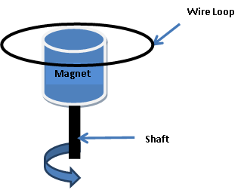
Figure 8: A magnet rotating in a wire loop [9, pp.26]
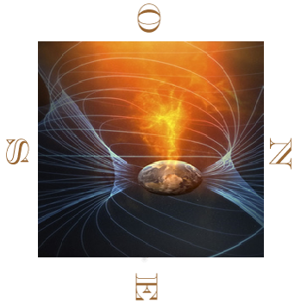
When a magnet is moved inside a coil (see Figure 10), it creates an electromagnetic field. This electromagnetic field is a positive charged field. This field generates a Lorentz force that churns all electrons inside the wire loop with the same constant speed. Compared to earth magnetic field, the example in Figure 9 is seen from the North Pole.
Figure 9: Representation of the earth magnetic field [9]
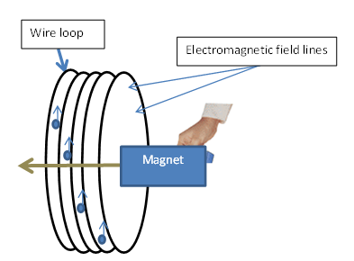
Figure 10: Representation of induced current by magnet moving inside a coil [9, pp.26]

    - Lorentz Force from Original to Practical
The force can be mathematically represented by the following equation:
$\vec{F} = q \vec{E} + q \vec{v} ˄ \vec{B}$ [9, pp. 22]
Where F is the Lorentz force, q is the charge of the particle (equal to 1.6 x10⁻²³ Coulomb for an electron) ,E is the electrostatic field, v the velocity of the particle and B is the magnetic field.

Equation 4: Equation of Lorentz.
Equation 1 states that in an electromagnetic field, charged particles have a non-zero velocity. The Lorentz force pushes electrons to move all inside the same direction at the same speed inside the wire. This movement creates electrical energy.
The electrostatic field E (e.g. High-tension wire voltage humming due to the electrostatic field which also contributes to cancer) tends towards zero (10⁻⁴¹ Coulomb) [9, pp.43]. Therefore, this equation can be reduced to:
F = q x v x B [9]
Where F is the Lorentz force, q is the charge of the particle (equal to 1.6 x10⁻²³ Coulomb for an electron) , v the velocity of the particle and B is the magnetic field.

Equation 5: Reduced Equation of Lorentz

    - Kinetic-Motion

This principle is based on the Lorentz force and the electromagnetic induction principle.
Velocity is the rate at which an object changes its position over time: the more distance an object travels over a same period of time, the greater velocity.
The velocity is mathematically represented by the following equation:
V_{A} = D / T [10, pp. 22]
Where V_{A} is the velocity of A the object A, D is the distance traveled by A and T the time needed by A to travel D.

Equation 6: Equation of Velocity

As shown in Figure 11 below, the principle of Kinetic-Motion states that the velocity of an object A relative to B is equal to the velocity of the object B relatives to A. In this example, both vehicles are heading towards and other with a same kinetic speed motion.

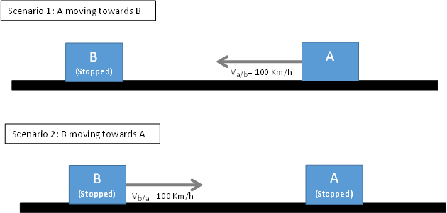
Figure 11: Two velocity scenarios

For two objects A and B, this principle is mathematically represented by the following equation:
V_{A/B} = V_{B/A} [10, pp. 22]
100km/h 100km/h

Where V_{A/B} is the velocity of A relative to B and V_{B/A} is the velocity of B relative to A to travel D.

Equation 3: Equation of Relative-Motion
Equation 7: Equation of Relative-Motion

In scenario 1, V_{A/B} is equal to 100km/h. In scenario 2, V _{B/A} is equal to 100km/h.

    - Estimation of WECS’s Energy Efficiency
The purpose of the following study is to estimate the minimum wind requirement and minimum production of electricity related to the WECS. Assuming:
- There is no wind.
- The car is moving in a straight path with a speed of 70 km/h.
- The magnet’s rotational speed found in the Transformer, at its best uses 45% of the total wind velocity. This assumption is based on iterations of various physical equations assuming a particular duck diameter size and propeller surface.
- The magnet will therefore be rotating at 31.5 Km/h. This generates a Lorentz force of 20 x 10⁻¹³ Newton. This magnetic force is too small that it does not have enough magnetic power to attract the ballpoint pen.

The principle of relative motion states that a car moving at a constant speed of 70 km/h in no absolute wind is equivalent to a stopped car where the wind is blowing at 70 km/h. For the WECS, we are interested in the speed of the car relative to the wind. This is shown in Figure 12.

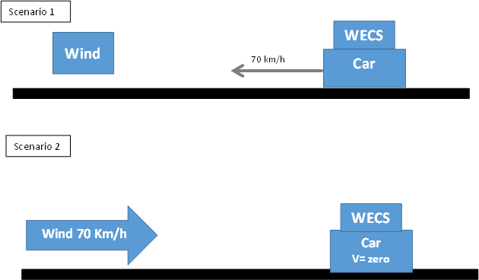

Figure 12: Two similar scenarios regarding relative velocities (WECS / Wind)

In sum, the 70 Km/h wind hits the blades with its full constant speed and delivers about 31.5km/h to the Transformer (assuming an efficiency of 45% as determined in assumption (c) ). Considering assumption (d) (the Lorentz force of 20x10⁻13 Newton) and its equation (where B is a function of F), the electrons will be churned by the Transformer’s rotating shaft to move with a velocity of 320 000 Km/h. Their movement which is 88 times faster than the sound spread, can produce 40% of the car’s needs. The car’s needs include headlights, ventilation system, signaling, stop lamps, radio.
  - Adapter
    - Ohm’s Law – Mahmoud El Gafarawi
The Adapter of the WECS reflects the principle of Ohm’s law, which is vital since it is used to determine the value of the current and voltage received, ensuring that the right amount of electrical energy being transferred into the battery of the vehicles doesn’t overcharge and fry it.
V = I R; P = I V; [11, pp. 1]

Where V is voltage in Volts, I is current in Amps , R is resistance in Ohms and P is power in Watts.
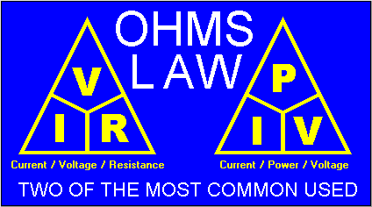
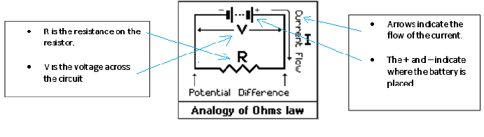
According to literature [12], the concept of resistance was first articulated by Georg Simon Ohm, who was the first to point out that voltage and current in a wire were related mathematically. Referring to the diagram below, Ohms Law is defined as the ratio or the flow of a potential difference (P) across the ends of a conductor (R; usually a wire) which creates a constant current (I). From this, and as illustrated in Figure 13, one can conclude that; Current equals Voltage divided by Resistance (I=V/R), Resistance equals Voltage divided by Current (R=V/I), and Voltage equals Current times Resistance (V=IR).
As for the second commonly used pyramid, Power equals Current multiplied by Voltage (P=IV), Current equals Power divided by Voltage (I=P/V) and last but not least Voltage equals Power divided by Current (V=P/I). Below is a diagram of a regular circuit.
In this enhanced patent, if the voltage running through the Adapter increases, the resistance remains the same while the current increases. Whereas, if the current increases and voltage remains constant, then power increases. Figure 14 shows a diagram of a simple circuit explaining the flow of electric current. The important factor here would be the Transformer and the battery’s temperature, if the calculations based on Ohm’s law were to produce accurate results it would remain constant. In the “real” world it hardly ever does.
Another reason why Ohm’s Law is dynamic is because; it is needed to help determine the voltage and current needed to start the car and wind turbine, and the power to keep them running. Ohm's Law deals with the relationship between voltage and current in an ideal conductor. This relationship is defined as the potential difference voltage (V)” across an ideal conductor is proportional to the current (I) through it.
Figure 13: The two primary principles of Ohm’s Law
Equation 8: Ohm's Law Equation
Figure 14: Diagram of a common circuit
Most prominently, Ohm’s law is used to ensure that the Adapter of the turbine does not over-capacitate and fry itself, including the Transformer during the process. This is why it is important to pump electricity into the batteries as quickly as it allows avoiding damages.
In a common household, a 120 volt outlet typically has a 15-amp circuit breaker, which equates to 1800 watts (equivalent to a kettle). Literature [13] indicates that an electric car can produce around 1,500 watts, or 1.5 kilowatt-hours. Since the battery in the vehicle of this patent normally needs 12 to 15 kilowatt-hours for a full recharge, it can take 10 to 12 hours to fully charge the vehicle using any household outlet.
By using a 240 volt circuit, the car might be able to receive 240 volts at 30 amps, or 6.6 kilowatts per hour. This arrangement allows significantly faster charging, and can fully recharge the battery pack in four to five hours. Figure 16 explains each of those variables used, their symbols and units of measurement.
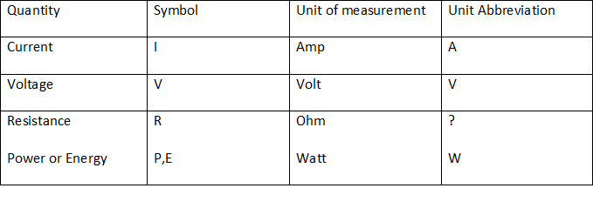
Figure 15: Unit abbreviations, SI units and units of measurements used in Ohm’s Law [8]

The amount of current needed to charge a power output of a 200 Kilowatt car battery with 42 volts running through the batteries circuits from its Adapter can be calculated by applying Ohm’s 2nd law (P = I ∙ V) to determine the current, this procedure will be explained below.
Solution: given: P = 200 KW ; V = 30 Volts
- Convert the given power to Watts, giving us => P = 200,000 W
- Applying the 2nd power principal of Ohm’s law: P = I ∙ V ;
- Switching the equation around to find I gives us the following equation: I = $\frac{P}{V}$ ;
- Now plug in the values and find the current.
I = $\frac{P}{V}$ = $\frac{200,000 W}{42 Volts}$ = 4761.9 Amps => 4762 Amps;

    - Power – Mahmoud El Gaffarawi
Equation 9: Power Principle
P = W / t [14, pp. 1]
Where and P is power in Watts, W is work done in Joules, t is time in seconds.
The Adapter [12] of the WECS also reflects the Power principle, which is the rate at which work is done, defined as work divided by time. The SI unit of power is J/s or Watts, whereas the SI unit of the work done is newton-meter or joule (J) and time in seconds. Most machines are designed and built to do work on objects, which is why we used the Power principal to help determine the maximum amount of power exerted on the WECS Adapter and how much it can withstand. Figure 17 describes the concept of power and its many forms.
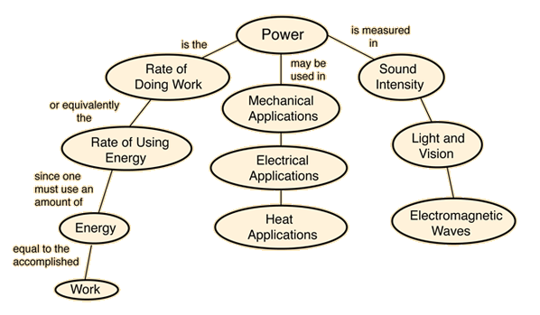
Figure 16: Power concepts, its different uses and what its measured in explained
From the Power Principle, one can derive that for every 1 kW per hour of electricity generated by wind, the work done on our automobile from the power generated to help move it without the use of fuel could be determined, thus no emissions of harmful gases and more environment friendly.
Ohms Law and the Power Principle both relate in a way, in which they involve the use of electricity and determination of the maximum electric power generated by both components of our enhanced patent on the Adapter, but Ohm’s Law holds to be of more importance in order to perfect this enhanced patent, since it is used the most to help us define multiple variables such as Voltage, Current, Resistance and Power. It is also used to help determine and regulate the amount of flow of electric power from the WECs turbine to its Adapter, through its Transformer and finally to the car’s engine. It ensures that turbines are not overloaded and avoids unwanted accidents ensuring the drivers’ safety at all times. Other benefits of this patent were an electric powered eco-friendly vehicle that not only helps keep the environment clean, but also saves the trouble on the driver from having to refill the cars tank with fuel every now and then and it saves money, leaving the driver in a win-win situation.

    - Kirchhoff’s Circuit Laws – Mohit Lokhande
There is a simple relationship between current and voltage in an electrical circuit. The relationship is determined by basic laws which are known as Kirchhoff's Circuit Laws. These laws were written by the German physicist named Gustav Kirchhoff, in 1845. Kirchhoff Laws address the conservation of electrical charge and the energy within electrical circuits. These laws are very helpful in determining the equivalent resistance in a complex electrical circuit and for specifying the currents flowing in the various branches of the electrical circuit. His two laws are known as Kirchhoff’s Current Law (KCL) and Kirchhoff’s Voltage Law (KVL). KCL deals with the current flowing around a closed circuit, whereas, KVL deals with voltage sources that are present in a closed circuit.
In our Wind Energy Conservation System (WECS) we are converting wind energy into electrical energy and are abiding with concept of energy conservation. KCL and KVL also respect the principle of energy conservation in the electrical circuit of our WECS. These two Kirchhoff Laws will help determine the most appropriate voltage needed to charge the car’s battery with the ideal amount of Current and Voltage. Kirchhoff’s Circuit Law also ensures the WECS circuits are not overloaded with current nor overheated with Voltage. These laws also help determine how much energy will be required to efficiently charge the car’s battery and specify the maximum amount of wind energy that can be processed by WECS. More details regarding KCL and KVL follow.

      - Kirchhoff’s Current Law (KCL)
Kirchhoff’s Current Law (KCL) states that the total current or charge entering a junction or node is exactly equal to the charge leaving the node [9]. It has no other place to go except to leave, as no charge is lost within the node. This law is alternatively known as Kirchhoff first Law. Zero is the algebraic sum of currents in a network of conductors which meet at a node. In other words, the algebraic sum of all currents entering and leaving a node must be equal to zero. In mathematical terms the equation can be written as follows:
$\sum_{j=1}^{N}{{I }_{j} (t)}$ [1, pp. 22]
Where ${ I }_{j} (t)$ is the j^{th} current entering the node through branch j and N is the number of branches connected to the node.

Equation 10: Kirchhoff’s Current Law

We can also say that the current entering into the node has to be equal to the current leaving the node, shown below in Figure 17.
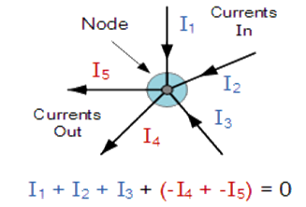
Current Entering (in blue) = Current Outgoing (in red)

Figure 17: Current in a node

KCL is a starting point of any analysis in any electrical circuit. Even though it may seem very simple, it is a powerful tool for solving complex circuits. Below (in Figure 18) is a simple electrical circuit, where we can detail the values of currents in closed loop circuits by using KCL.
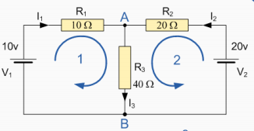
Figure 18: Electrical Circuit

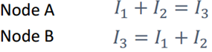
Where R is an electrical resistance, measured in Ohms (Ω)
V is an electric potential energy per unit charge, measured in joules per coulomb ( $J/C$)
I is a flow of electrical charge, measured in ampere (A)

Equation 11: Node Analysis

Kirchhoff’s Current law is one of the most fundamental principles in electrical engineering. It states that a charge can neither be created nor destroyed. In our Wind Energy Conversation system we are converting kinetic energy into electrical energy. We are not creating new energy nor destroying it but rather changing its form from kinetic to electrical energy.
      - Kirchhoff’s Voltage Law (KVL)
Kirchhoff’s Voltage Law is the second of Kirchhoff’s circuit law. It is also a result of the electrostatic field being conservative. It deals with the voltage drops at various branches in electrical circuits. It is by far the most important law in solving electrical circuits. In any closed electrical circuit there will be a potential difference. Kirchhoff’s voltage law deals with potential difference and helps us to solve any closed loop circuit. Kirchhoff’s voltage law states that the algebraic sum of the voltages around any loop is zero [9]. If this were not the case, then when we travel around a closed loop, the voltages would be indefinite. Electrical Circuits are conservative; meaning that the work required moving a unit charge around any loop is zero. This law is alternatively known as Kirchhoff's Second Law. In general the mathematical representations of Kirchhoff’s Voltage law can be written as followed:
$\sum_{j=1}^{N}{V_{j} (t)}$ [1, pp. 22]
Where ${V }_{j} (t)$ is the voltage across the j^{th} branch in loop containing N voltages.
$\sum_{j=1}^{N}{V_{j} (t)}$ [1, pp. 22]
Where ${V }_{j} (t)$ is the voltage across the j^{th} branch in loop containing N voltages.

Equation 12: Kirchhoff’s Voltage Law

Below in figure 19, an example of a simple electrical circuit is shown. Using Kirchhoff's Voltage law we are able to solve the voltage, current and resistance.
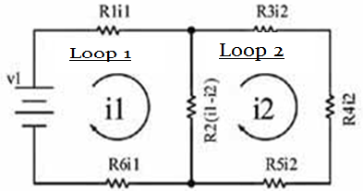
Figure 19: Loop Analysis

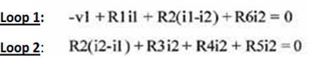
Where R is an electrical resistance, measured in Ohms (Ω)
V is an electric potential energy per unit charge, measured in joules per coulomb ( $J/C$)
I is a flow of electrical charge, measured in ampere (A)

V is an electric potential energy per unit charge, measured in joules per coulomb ( $J/C$)
I is a flow of electrical charge, measured in ampere (A)

Equation 13: Loop Analysis

In Kirchhoff’s Voltage law, the algebraic sign is used to keep track of the voltage polarity. In other words, as we traverse the circuit, it is necessary that the electrical circuit sums to zero. Therefore, it is important that we keep track of whether the energy level is increasing or decreasing as we go through each element. Kirchhoff’s voltage law is also the fundamental conservation law in electrical engineering. It states that energy cannot be created nor destroyed.
The WECS adaptor has electrical circuits. We have two circuit choices. One is a series circuit and another is a parallel circuit. Both circuits are show below:
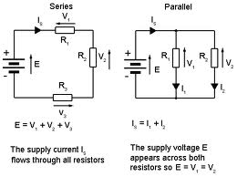
Figure 20: Comparison: Series Circuit Vs. Parallel Circuit

In a parallel circuit there is more than one conducting path back to the battery. As the charge makes its way from one terminal of the battery to the other, no matter which path it chooses, it must lose all its energy.
In a series circuit with a 6 V battery it will use all 6 V from its voltage source. The current depends on all the circuits’ resisting and consuming elements. For example, in a 110 -volt circuit that has two identical light bulbs in a series, the two are consuming 55 Volts each. If they are not identical then the voltage is split proportionally between the two. Kirchhoff’s circuit laws help us solve the electrical circuit and determine ideal voltages, resistances and currents that best apply to the cars’ battery and WECS.

- Conclusion - Sougal Bouh Ali
  - Summary and Concluding Remarks
In this technical report, an innovative wind energy conversion system (WECS) was described and proposed. Among its benefits: it will ultimately save car owners money, it is eco-friendly and it offers more vehicle energy efficiency. As described earlier, the WECS Receptor extracts mechanical energy from the wind’s kinetic energy and transmits it to the WECS Transformer which transforms the mechanical energy into electrical energy. Then the WECS Adapter adapts the electrical energy to better comply with the car’s 12 Volt electrical system. A 3-stage wind energy conversion (reception, transformation, adaptation) is proposed because of its robustness and excellent reliability for wind energy conversion.

  - Patentability and Suggestions for Future steps
This technical report also considered three main patent criteria: Novelty, Ingenuity and Utility.
The proposed design is novel and clever because it proposes a unique 3-stage wind energy conversion system that offers more energy efficiency that surpasses Betz’s ~ 60% limit for effective conversion of wind energy. In terms of its usefulness, it is assumed, hypothetically, that it should work but, for future steps, one could continue and complete the work of this technical report by developing a laboratory prototype of the proposed wind energy conversion system and test its validity and compatibility on a hybrid or other test car.
Further research could also be done to determine a more direct extraction of electrical energy from the wind’s energy, possibly regarding or leading to the development of a 2-stage wind energy conversion system.

In sum, WECS is one of much alternative renewable energy that could be better tapped to render the vehicles of tomorrow more energy efficient.

Professor Myers, your time and consideration is sought for this project application. We hope that you will accept and that you will finely appreciate this technical report. If you have any questions or feedback, please feel free to contact our liaison officer Sougal Bouh Ali at sougalbouhali@cmail.carleton.ca.

References
[1] L. Surugiu, and I. Paraschivoiu, "Environmental, social, and economical aspects of wind energy," Wind Energy, 35th Intersociety, vol.2, pp. 1167-1174.
[2] WolframAlpha Computational knowledge engine, Comparisons of 1 J/s [Online].
Available: http://www.wolframalpha.com/input/?i=1+j%2Fs
[3] Carbon Footprint, carbon footprint calculator for an average car [Online].
Available: http://calculator.carbonfootprint.com/calculator.aspx?tab=4
[4] R.C. Hibbeler, "Moment of a Force," in Engineering Mechanics Statics & Dynamics, 12th ed. Upper Saddle River, New Jersey: Pearson PH, 2010, ch.4, sec.1, pp.117-126.
[5] Gary L.Johnson (2001, November 21), "Wind Turbine Power, Energy, And Torque", in Wind Energy Systems, ch.4, pp. 29-35 [Online]. Available: http://www.rpc.com.au/pdf/wind4.pdf
[6] Boeing Engineering and Construction: Wind Turbine System Concept and Preliminary Design Report, Vol. II, Detailed Report, DOE/NASA 0002-80/2, NASA CR-159609, July 1979.
[7] Robert W. Bass (2007, June), "Resolution of Betz Theory” in Is The Albert Betz Law Stating The Maximum Wind Turbine Efﬁciency Of 16/27’s Accurate?, REV 1.3, pp. 4-6 [Online].
Available: http://www.innoventek.com/Betz_vs_Bass_Law_Rev1%205.pdf
[8] Q. Wang and L. Chang, "An intelligent maximum power extraction algorithm for inverterbased variable speed wind turbine systems", IEEE Trans. Power Electronics, vol. 19, pp. 1242 – 1249, Sept. 2004.

[9] Pierre Krempf, “Electrostatic Field” in ELECTROMAGNETIC MP, 3nd ed, Lyon, France: Breal, ,2004,pp. 5-55.
[10] I.Pierron and J.Berguam, “Energy of Systems an Solid” in Mecanique MP-PC,2nd ed,Paris,France:Breal,2004, pp. 22-155
[11] Walter Fendt. (November 23, 1997). Icient of friction. [Online].
Available: http://www.physics.uoguelph.ca/tutorials/ohm/Q.ohm.intro.html
[12] History of Ohm’s law and how it was invented. [Online].
Available: http://www.facstaff.bucknell.edu/mastascu/elessonsHTML/Resist/Resist1.html
[13] The Free Dictionary, Farlex. (July 27 2013). Definition of Adapter. [Online].
Available: http://www.thefreedictionary.com/adapter
[14] A discovery Company. Auto How Stuff Work. (1998-2013). How electric cars work. [Online]
Available: http://auto.howstuffworks.com/electric-car5.htm
[15] comPADRE. (1996-2013). The Physics Classroom. [Online].
Available: http://www.physicsclassroom.com/Class/energy/u5l1e.cfm
[16] J David and R Mark Nelms, “Kirchhoff’s Circuit Laws” , in Basic Engineering Circuit Analysis, Ninth Edition, Wiley, 2007, pp.29-35

Glossary
Electrical Energy: Energy made available by the flow of electric charge through a conductor.
The Free Dictionary, Farlex. (2013, July 15). Definition of Electrical Energy [Online].
Available: http://www.thefreedictionary.com/electrical+energy
Kinetic Energy: Energy which a body possesses by virtue of being in motion.
Oxford Dictionaries, Definition of Kinetic Energy in English [Online].
Available: http://oxforddictionaries.com/definition/english/kinetic-energy?q=kinetic+energy
Renewable Sources: Any natural resource (as wind or solar energy) that can be replaced naturally with the passage of time.
The Free Dictionary, Farlex. (2013, August 14). Definition of Renewable Sources [Online].
Available: http://www.thefreedictionary.com/renewable+resource
Fossil Fuels: Fuel consisting of the remains of organisms preserved in rocks in the earth's crust with high CO2 content.
Wolfram Alpha computational knowledge engine, Definition of Fossil Fuels. [Online].
Available: http://www.wolframalpha.com/input/?i=fossil+fuels
Mechanical Energy: energy that is possessed by an object due to its motion or due to its position. Mechanical energy can be either kinetic energy (energy of motion) or potential energy (stored energy of position).
The Physics Classroom. (2013 July 15). Definition of Mechanical Energy [Online]. Available: http://www.physicsclassroom.com/Class/energy/u5l1d.cfm

