Assignment 2
- The guest lecture was about wood and its use in buildings. Michelle Maybee, the guest speaker is from the Canadian wood council. The lecture started with the question “why wood?.” This question had multiple answers which were discussed thoroughly. The most important ones were its resistance to chemicals and its fire safety properties. Wood would be used in facilities that would include chemicals like pools since it’s not a reactive material so it wouldn’t react with chemicals in the facilities such as chlorine in the case of pools. The other thing is with fire safety, FRTW is a type of wood that’s treated chemically to decrease its flaming characteristics so that it won’t catch fire easily. Char, is a layer that’s used to cover wood so in case of a fire, this layer would burn but it would protect the inner wood and thus, it wouldn’t catch fire. The last main component when it comes to fire safety is compartmentalization; that’s where it’s made sure that the wood wouldn’t catch fire for a specific amount of time to allow people to get out of the building safely. This is because the building would be designed to have people safely go out of the building in case of an emergency not to prevent the building from being burned down. Another reason wood is good for building is its cost competitive. There is a large pool of trade people for wood as it’s a local material; those two factors make it easy and fast to be supplied for any project. Wood is a relatively light material; therefore, it doesn’t require much foundation. The foundation used would be reduced, from cost and amount perspectives, than any foundation for a steel building for example. These properties can be seen clearly in any wood frame since it is light and consists of small members therefore easy to handle. Wood frames are also flexible and have high strength which is why it is usually used in residential homes.
The next topic that was covered is Engineering Wood products. Engineering wood products have high strength to weight ratio which could be very useful in buildings. They have consistent and uniform engineering properties. When wood members are glued together, the glue is phenol based and doesn’t contain any urea. The glue would be less than 4% of the total weight and it would be inert once cured; meaning there will be no off gassing and thus no negative impact on the environment. Engineering wood products comes in pre-cut packages which helps reduce the on-site waste produced from cutting the members. Pre-fabricated construction included a few points which started with the controlled environment. Wood reacts to weather changes like any other material, it expands, contracts and can even rot if not handled properly. An advantage is, is details are enhanced and therefore the quality control is much higher. But most importantly, it’s quick and easy to install and it can also come in complete systems. Mass timber consists of simple connections between the walls, floors and roof and it’s resistant to earthquakes. Mass timber is also environmentally friendly since the on-site waste is minimized when it’s used. The last topic was panels. The first type was nail-lam panels, which is the post and beams. The second type was Glulam-on-flat panels. The third type was Cross-Laminated timber panels; it consists of dimension stacks crosswise that are glues together. They would be glued only on the wide face, not the edges and would typically be 3 – 7 layers thick. Panel sizes would vary by manufacture but they would be 0.6, 1.2 and 3 meters typically. There are also Laminated Veneer and Laminated strand lumber panels and Hybrid mass Timber panels.
- Read the peer reviewed article
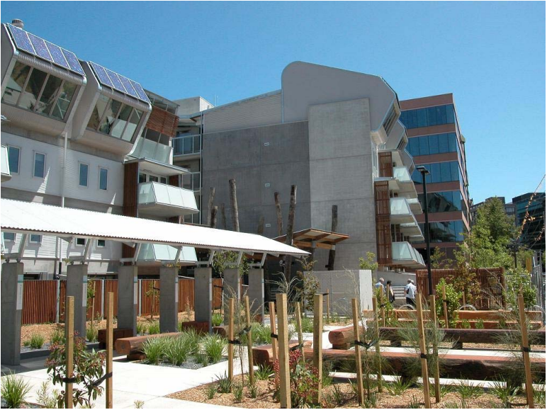
*Reference: Appleyard, Construction Materials Gypsum and Anhydrite , Industrial Minerals and Rocks , 5th Edition, S.J. Lefond, ed., AIME, 1983, pp. 183 198.
- K2 Apartments in Australia;
The building is a green building in Australia. The complex consists of 96 units’ one common room and 52 car parks. Approximately 50% of the apartments are designed for people with disabilities. Each apartment is anticipated to need 55% less mains electricity, 46% less gas from mains supply and 53% less mains water, including irrigation than a standard apartment annually.

*Reference: K2 Apartments. (2013, October 1). Retrieved November 24, 2014, from http://www.dhs.vic.gov.au/about-the-department/plans,-programs-and-projects/projects-and-initiatives/housing-and-accommodation/k2-apartments

- Types of cement
  - Type II of Portland Cement; Moderate sulfate resistant
  - Type III Portland Cement; high early strength
  - Type IV of Portland Cement; Low heat of hydration
  - Type I of Portland Cement; General Structure

- Four types of admixtures and why they might be used
  - Air Entrainers; to improve the cycles of freezing and thawing durability by introducing tiny uniformly distributed air bubbles in concrete. But increased air reduces strength.
  - Water-Reducing; increases the workability of fresh concrete without increasing the water to cement ratio. Lower water content results in high compression strength concrete.
  - Accelerators; used in cold weather applications to rapid rate of hydration generates heat that reduces risk of damage due to early freezing-maintains normal setting behavior despite the cold weather.
  - Retarders; used to offset accelerating effect of hot water on setting of concrete. Increases time between mixing and placing or delay setting for pumping concrete over considerable.

- Engineering wood has high strength to weight ratio since it’s manufactured from hardwood and has a range of strengths. It has consistent and uniform engineering valves and properties. Two advantages are it consists of glues wood layers so it has high strength and it is light at the same time. The other is the glue in it presents less than 4% of the weight and it’s inert once cured so there’s no off gassing. Four types are:
  - Laminated Veneer
  - Laminated Strand Lumber Panels
  - Hybrid mass Timber panels
  - Cross-Laminated panels

- Types of polymers:
  - Thermoplastics
  - Thermosets
  - Elastomers
- Asphalt is obtained from refined petroleum; it’s very sticky and highly viscous at room temperature. Asphalt is used in waterproofing, sealing and road pavement. Tar, on the other hand, is obtained from distillation of coal; on a hot day, it flows and on a cold day, it’s more brittle. Tar is used for surface treatment of wooden shingle roofs and boats.
- Steel is not a natural element, and like many other metals, it is thermodynamically non stable under normal atmosphere conditions and will produce energy and transform back into its original form, iron oxide or rust, that’s called corrosion. For corrosion to occur, three elements must be present; there must be at least two metals or one metal at two locations at different energy levels, an electrolyte and a metallic connection. In reinforced concrete, rebar is present at many areas at different energy levels, the concrete acts as the electrolyte and the metallic connection is present as wire ties, chair connections or even the rebar itself sometimes. Corrosion is an electrochemical process that is based on electron transfer. It is the main factor in concrete deterioration since rust takes more space than rebar and thus creating tensile forces on the concrete from the inside that the concrete isn’t designed to take and that causes the concrete to crack and fail.
Since load and surface area are directly proportional, the area is 0.8*area, the new load is roughly 0.8 * 500 = 400 MPa.

- True or false statements
  - False; since it’s relatively expensive, its use is limited to manufacture of furniture and decorative veneers.
  - False; thermoset polymers have higher temperature resistance than thermoset.
  - False; the purpose of the fiber is to enhance the polymer matrix properties. Reinforcing phase is harder, stronger and stiffer than the matrix, as severe as the primary load carrying member
  - True
  - True

