CHAPTER 1:

  - Ten Key Concepts to Retain for a Lifetime

The Individual
- Facing Tradeoffs: Scarcity in relation to wants means you face tradeoffs: therefore, you have to make choices
- Opportunity Cost: The cost of the choice you make is what you give up for it, or the opportunity cost
- Choosing A Little More or Less: Choices are usually made at the margin; we choose a “little” more or a “little” less of something
- The Influence of Incentives: The choices you make are influenced by incentives (incentives: a thing that motivates or encourages one to do something)

Interaction among individuals
- Specialization and Trade: Specialization and trade will improve the well-being of all participants
- The Effectiveness of Markets: Markets usually do a good job of coordinating trade among individuals, groups, and nations
- The Role of Governments: Governments can occasionally improve the coordinating function of markets

The Economy as a Whole and The Standard of Living
- Production and the Standard of Living: The standard of living of the average person in a particular country is dependent on its production of goods and services. A rise in the standard of living requires a rise in the output of goods and services
- Money and Inflation: If the monetary authorities of a country annually print money in excess of the growth of output of goods and services, this practice will eventually lead to inflation
- Inflation-Unemployment Tradeoff: In the short run, society faces a short-run tradeoff between inflation and its level of unemployment

  - The Economic Way of Thinking
The economic perspective: a viewpoint that envisions individuals and institutions making ration decisions by comparing the marginal benefits and marginal costs associated with their actions
-Economics is the social science that examines how individuals, institutions, and society make choices under conditions of scarcity. Central to economics is the idea of opportunity cost: the value of the next-best good or service forgone to obtain something

The economic perspective:
1. Scarcity and Choice
-We “cant have it all” so we must decide what we will have, and what we must forgo
-“There is no free lunch” it may be free to you, but there is a cost to someone- ultimately society
-Example: you have $100 that you can spend on a pair of jeans or shoes. The opportunity cost of buying the shoes is the jeans you could have purchase

2. Purposeful Behavior
-Human behavior reflects “rational self-interest” we look for and pursue opportunities to increase our utility (the pleasure, happiness, or satisfaction obtained from consuming a good or service)
-Because we weigh costs and benefits, these decisions are purposeful/rational, not random or chaotic
-Consumers are purposeful in deciding what goods and services to buy
-Business firms are purposeful in deciding what products to produce and how to produce them
-Government entities are purposeful in deciding what public services to provide and how to finance them
-People making decisions with some desired outcome in mind

3. Marginal Analysis: Comparing Benefits and Costs
-Marginal Analysis: the comparison of marginal (“extra” or “additional”) benefits and marginal costs, usually for decision-making
-Most decisions involve changes in the status quo (the existing state of affairs) ex: should you attend school for another year or not? Should you study an extra hour for an exam or not? Should a business expand or reduce its output? Should government increase or decrease health care funding?
-Example: you and your fiancé are shopping for an engagement ring. Should you buy a ¼ carat diamond, a ½ carat diamond, ¾ carat diamond, or larger one? The marginal cost of the larger diamond is the added expense beyond the smaller diamond. The marginal benefit is the greater lifetime pleasure (utility) from the larger stone.
-If the marginal cost if more than the marginal benefit, buy the smaller diamond.
-The marginal benefit associated with some specific option always includes the marginal cost of forgetting something else. Spending money on the larger diamond may mean forgetting a honeymoon to an exotic location (opportunity cost).

  - Theories, Principles, and Models
-Economics relies on the scientific method (definition: the systematic pursuit of knowledge through observing a problem, collecting data, and formulating, and testing hypotheses to obtain theories, principles, and laws). That procedure consists of several elements:
- Observing the real-world behavior and outcomes
- Formulating a possible explanation of cause and effect (hypothesis), based on those observations
- Testing this explanation by comparing the outcomes of specific events to the outcome predicted by the hypothesis
- Accepting, rejecting, or modifying the hypothesis based on these comparisons
- Continuing to test the hypothesis against the facts. If favorable results accumulate, the hypothesis evolves into a theory. A very well tested and widely accepted theory is referred to as an economic law or an economic principle (definition: a statement about economic behavior or the economy that makes it possible to predict the probable effects of certain actions) Combinations of such laws or principles are incorporated into models, which are simplifies representations of how parts of the economy work, such as a market or segment of the economy
- Economists develop theories of the behavior of individuals (consumers, workers) and institutions (businesses, governments) engaged in the production, exchange, and consumption of goods and services
- How are economic principles and models useful? They help analyze economic behavior and understand how the economy operates. They are the tools for ascertaining cause and effect within the economic system
- Generalizations: economic principles are generalizations (definition: statements of the nature of the relation between 2 or more sets of facts) relating to economic behavior or the economy itself. Economic principles are expressed as the tendencies of typical or average consumers, workers, or business firms
- Example: economist say that consumers buy more of a particular product when its price falls. Economics recognize that some consumers may increase their purchases by a large amount, others by a small amount, and a few not at all. This “price-quantity” principle holds both for the typical consumer and for consumers as a group
- Other-Things-Equal Assumption: (definition: the assumption that factors other than those being considered do not change)
- Graphical Expressions: many economic models (definition: a simplified picture of economic reality; an abstract generalization) are expressed graphically

  - Microeconomics and Macroeconomics

Microeconomics: (Definition: the part of economics concerned with decision making by individual customers, workers, households and business firms)
-We measure the price of a specific product, the number of workers employed by a single firm, the revenue or income of a firm, or the expenditures of a specific firm, government entity, or family. We examine the grains of sand, the rocks, and the shells, not the beach.

Macroeconomics: (Definition: it examines either the economy as a whole or its basic subdivisions or aggregates, such as the government, household, and business sector. An aggregate, (Definition: a collection of specific economic units treated as if they were one unit). Example: we might lump together the millions of consumers in the Canadian economy and treat them as if they were one huge unit called “consumers”. This helps seek structure of the economy and the relationship of its major aggregates.
-Macroeconomics speaks of such economic measures as total output, total employment, total income, aggregate expenditures and the general level of prices in analyzing various economic problems
-We examine the beach, not the grains of sand, the rocks and the shells.
-While the problem of unemployment is usually treated as a macroeconomic topic (because unemployment relates to aggregate production), economists recognize that the decisions made by individual workers on how long to search for jobs and the way specific labor markets encourage or impede hiring are also critical in determining the unemployment rate

Positive and Normative Economics
-Positive economics (Definition: the analysis of facts to establish cause-and-effect relationships).
-It includes description, theory development, and theory testing and avoids value judgments.
-It tries to establish scientific statements about economic behavior, & deals with what the economy is actually like.
-Normative economics (Definition: the part of economics involving value judgments about what the economy should be like) HINT: “ought” or “should” = normative
-Positive concerns what is, while normative embodies what ought to be
-Example:
Positive statement: “The unemployment rate in France is higher than that in Canada”
Normative statement: “France ought to undertake policies to make its labor market more flexible to reduce unemployment rates”

QUICK REVIEW:
-Economics examine how individuals, institutions, and society make choices under conditions of scarcity
-The economic way of thinking stresses (a) resource scarcity and the necessity of making choices, (b) the assumption of purposeful or rational behavior, and (c) comparisons of marginal benefit and marginal cost.
-In choosing among alternatives, people incur opportunity costs
-Economists use the scientific method to establish economic theories, cause-effect generalizations about the economic behavior of individuals and institutions
-Micro focuses on specific units of the economy
-Macro examines the economy as a whole
-Positive deals with factual statements (“what is”)
-Normative involves value judgments (“what ought to be”)

  - The Economic Problem
Definition: The need to make choices because society’s material wants for goods and services are unlimited but the resources available to satisfy these wants are limited (scarce)

The Budget Line
Definition: a curve that shows various combinations of two products a consumer can purchase with a specific money income

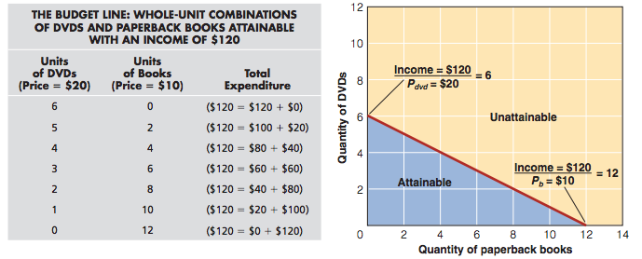

Attainable and Unattainable Combinations
-All combinations of DVD’s and books on or inside the budget line are attainable from the $120 of money income
-All combinations beyond the budge line are unattainable because it exceeds your $120 limit

Tradeoffs and Opportunity Costs
Definition of Tradeoff: the sacrifice of some or all of one economic goal, good or service to achieve some other goal, good or service
-To obtain more DVD’s, you must give up some books
Definition of Constant Opportunity Cost: a opportunity costs that remains the same for each additional unit as a consumer shifts purchases from one product to another along a straight-line budget line
-Example: to obtain the first DVD you trade off 2 books. So the opportunity cost of the first DVD is 2 books. To obtain the second DVD the opportunity cost is also 2 books. The opportunity cost of 1 extra DVD remains the same (=2 books) as more DVD’s are purchased. And in reverse, the opportunity cost of 1 extra book does not change (=1/2 DVD) as more books are bought.

Income Changes
-An increase in money income shifts the budget line to the right
-A decrease in money income shifts the budget line to the left

Society’s Economic Problem
-Should society devote more of its limited resources to the criminal justice system (police, courts, and prisons) or to education (teachers, books, and schools)?
-If it decides to devote more resources to both, what other goods and services does it forgo? Health care? Energy development?

Scarce Resources
-Society has limited economic resources. (Definition: all natural, human, and manufactured resources that go into the production of goods and services. Aka land, labor, capital and entrepreneurial ability)
-This includes factories and farm buildings and all the equipment, tools, and machinery used to produce manufactured goods and agricultural products; all transportation and communication facilities; all types of labor; and land and mineral resources

Resource Categories

- LAND
- All natural recourses used to produce goods and services
- Forests, mineral and oil deposits, water resources, wind power, sunlight and arable land

- LABOR
- Physical actions and mental activities that people contribute to the production of goods and services
- Logger, retail clerk, machinist, teacher, professional hockey player, and nuclear physicist

- CAPITAL
- Human-made resources (buildings, machinery, and equipment) used to produce goods and services
- Consumer goods satisfy wants directly, while capital goods do so indirectly by aiding the production of consumer goods. Example: large commercial baking ovens (capital goods) help make loaves of bread (consumer goods)
- The purchase of capital goods are referred too as investments (definition: spending for the production and accumulation of capital)

- ENTREPRENEURIAL ABILITY
- The human talents that combine the other resources to produce a product, make non-routine decisions, innovate, and bear risk

QUICK REVIEW
-Because wants exceed incomes, individuals face an economic problem: they must decide what to buy and what to forgo
-A budget line shows the various combinations of two goods that a consumer can purchase within a specific money income
-Straight-line budget constraints imply constant opportunity costs associated with obtaining more of either of the two goods
-Economists categorize economic resources as land, labor, capital and entrepreneurial ability

  - Production Possibilities Model and Increasing Opportunity Costs

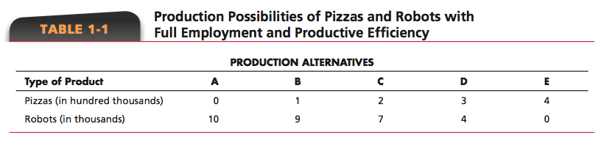

Definition of Production Possibilities Table: lists the different combinations of two products that can be produced with a specific set of resources, assuming full employment (the economy is employing all its available resources)

Pizza=consumer goods (products that satisfy our wants directly)
Industrial robots= capital goods (products that satisfy our wants indirectly by making possible more efficient production of consumer goods)

-At alternative A, the economy is devoting all its available resources to the production of industrial robots (capital goods)
-At alternative E, all resources would go to pizza production (consumer goods)
Those alternatives are unrealistic extremes; an economy typically produces both capital and consumer goods, as in B, C and D.
-As we move from A to E, we increase production of pizzas at the expense of the production of industrial robots
-Producing more pizzas= society chooses “more now” at the expense of “much later”
- =Fewer industrial robots
- This catches up with society over time because the stock of capital expands more slowly, thereby reducing future production

-As we move from E to A, society chooses to forgo current consumption, thereby freeing up resources that can be used to increase the production of capital goods.
-By building up its stock of capital this way, society will have greater future production, and therefore greater future consumption
-Society is choosing “more later” at the lost of “less now”

Production Possibilities Curve
Definition: A curve that displays the different combinations of goods and services that society can produce in a fully employed economy, assuming a fixed availability of supplies of resources and fixed technology

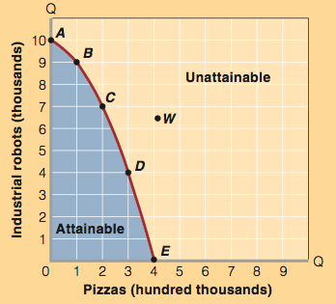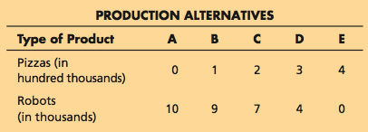

-Points on the curve=attainable as long as the economy uses all of its available resources
-Points inside the curve= also attainable but they reflect less total output which is not as desirable as points on the curve. This implies that the economy could have more of both robots and pizzas if it achieved full employment.
-Points beyond the curve= greater output than the output of any point on the curve. These are unattainable with the current availability of resources and technology

Law of Increasing Opportunity Costs
-Moving from A to B, the cost of 1 additional unit of pizzas is 1 unit fewer of industrial robots
-For society, the opportunity cost of each additional unit of pizzas is greater than the opportunity cost of the preceding one. How?
- Moving from A to B, just 1 unit of robots is sacrificed for 1 unit of pizzas
- Moving from B to C, we sacrifice 2 additional units of robots for 1 unit of pizzas
- Moving from C to D, we sacrifice 3 additional units of robots for 1 unit of pizzas etc.
-Definition: as the production of a good increases, the opportunity cost of producing an additional unit rises

Optimal Allocation
Of all the attainable combinations of pizzas & industrial robots, which is optimal (best)?
-Any economic activity should be expanded as long as MB exceeds MC and should be reduced if MC exceeds MB.
-The optimal amount of the activity occurs when MB=MC
-The best point on the PPC represents the most desirable mix of goods and is determine by expanding the production of each good until its marginal benefit=marginal cost

QUICK REVIEW
-The production possibilities curve illustrates (a) scarcity of resources, implied by the unattainable combinations of output lying outside the production possibilities curve, (b) choice among outputs, reflected in the variety of attainable combinations of goods lying along the curve, (c) opportunity cost, illustrated by the downward slope of the curve, and (d) the law of increasing opportunity costs, reflected in the bowed-outward shape of the curve
-A comparison of marginal benefits and marginal costs is needed to determine the best output mix on a production possibilities curve
-An economy that is fully employed and thus operating on its production possibilities curve must sacrifice the output of some types of goods and services to increase the production of others

  - Economic Growth, Present Choices, and Future Possibilities
QUICK REVIEW
-Unemployment causes an economy to operate at a point inside its production possibilities curve
-Increases in resource supplies, improvements in resource quality, and technological advances causes economic growth, which is depicted as an outward shift of the production possibilities curve
-An economy’s present choice of capital and consumer goods helps determine the future location of its production possibilities curve
-International specialization and trade enable a nation to obtain more goods than its production possibilities curve would indicate

