Assignment 1

(Only question 5 will be graded but you must answer all the questions)

Due: Tuesday, May 19th in the class or during the TA office hour on Wednesday, May 20th

Chapter 13

1. You receive $100 from the government as tax credit for using public transport. What happens to the GDP of Canada?

Chapter 14
2. Explain why the interest parity condition must hold if the foreign exchange market is in equilibrium.

3. Determine for each of the following cases, whether the interest parity condition holds or not, if 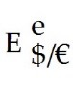 = 1.10

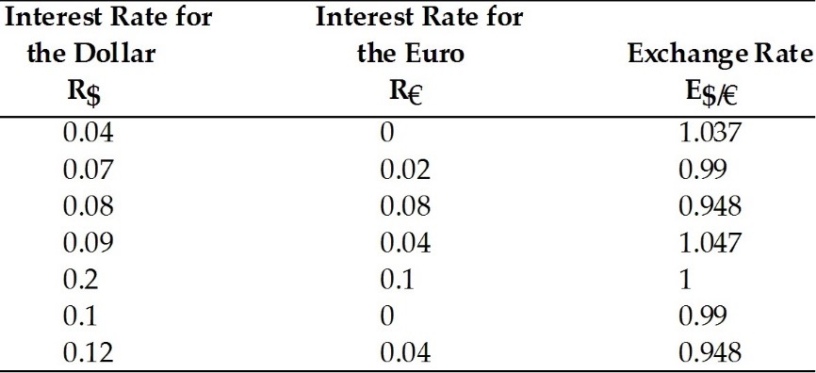

4. Explain and show in a graph why (holding interest rates constant), a rise in the expected depreciation in a country's currency leads to depreciation of that currency today.

Chapter 15
5. Using a figure describing jointly both the U.S. money market and the foreign exchange market, analyze the effects of an increase in the European real income on the dollar/euro exchange rate.

