LAW 122

Chapter 1

-Civil law: codified law
System that traces its origins back to ancient Rome
-Common Law: created by judges (rest of the provinces in Canada) [trace origins back to England]

THE NATURE OF LAW
Law: a law is a rule that can be enforced by the courts
The highest source of law that exists in society is the constitution. Basically, any legal matter that violates the constitution has no force or effect. (Section 52)

Charter of Rights and Freedoms
Part of Constitution since 1982
Rights and freedoms commonly affecting business:
-freedom of religion
-freedom of expression
-freedom of mobility
-right to equality: prohibited grounds of discrimination
include race, sex and religion, but not poverty

section 52: Constitution as supreme law. Law inconsistent with Charter “of no force or effect."

COURT HIERARCHY

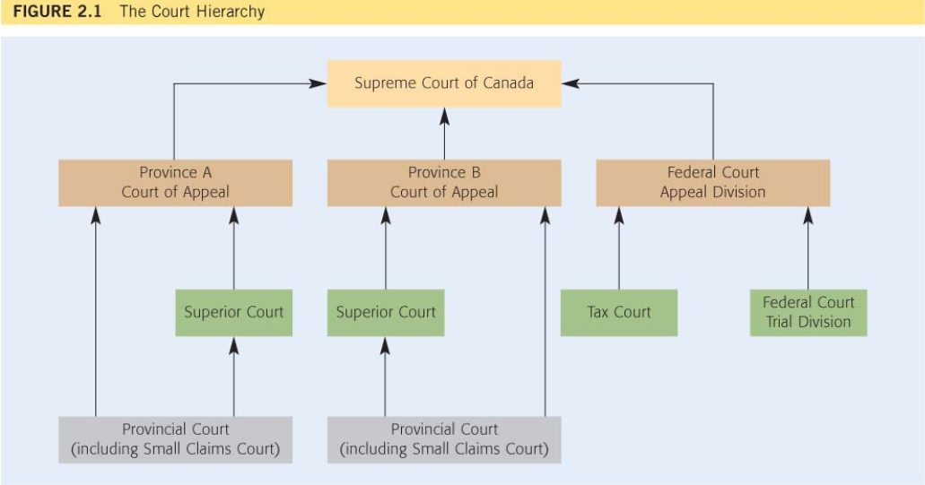

PUBLIC LAW: Is concerned with the governments and the ways in which they deal with their citizens
Constitutional Law: provides the basic rules of our political and legal systems. It determines who is entitled to create and enforce laws, also establish rights and freedoms (a.e. the charter)
Administrative law: is concerned with the creation and the operation of administrative agencies, boards, commissions and tribunals
Criminal Law: concerned with people who break rules that are designed to protect society as a whole
-White Collared Crimes: crimes committed by people in suits!!!!
Tax Law: concerned with rules that are used to collect money for public spending

PRIVATE LAW: concerned with rules applied in private matters (both parties in a private dispute are usually separate persons either organizations or corporations etc.)
Law of Turtz: a private wrong, an offense against a particular person
-Intentional torts: assault, false imprisonment, nasty things like that
-business Torts: Deceit and conspiracy
-Negligence: covers most situations in which one person carelessly hurts another
Law of Contracts: concerned with creation and enforcement of agreements, governs all transactions
Law of property: Concerned with acquisition, use, and disposition of property
-Real Property: involves land and things that are attached to land
-personal property: things that can be moved from one place to another
-intellectual property: involves things that consist of original ideas, such as patents and copyrights

There are several areas of law that deal with all forms of property: law of succession deals with distribution of a persons property after death. Law of trusts deals with a situation when which one person holds property on behalf of another.

COURT HIERARCHY: RANKED ACCORDING TO THEIR IMPORTANCE

The doctrine of precedent: says any court has to follow any that precedes it.
LITIGATION PROCESS pg. 30-41
-legal representation
-pleading
-pre trial activity
-the trial
-the remedy
-enforcement
-appeals
-costs

TURTLES pg. 66-67
-Intentional torts: when a person intentionally acts in a certain way
-some torts require proof that the defendant intended to hurt the plaintiff, while other are satisfied by the proof that the defendant merely intended to act in a certain way, even if they did not realize the plaintiff would be hurt
-Negligence: covers most situations in which one person acts carelessly
-strict liability torts: occurs when a person does something wrong without intention, and without acting carelessly; it’s enough that the defendant was responsible for the situation that resulted in the plaintiffs injury.

Trespass to Land: occurs when the defendant improperly interferes with plaintiffs land
Trespass to chattels: when defendant interferes with plaintiffs chattels in possession.
Remedies for trespass: compensation for loss, court may also award nominal damages if there was no loss, or punitive damage if the defendants wrong was shockingly bad.
Punitive damages: punish the defendant for acting very badly
Vicarious liability: when one is responsible for a tort committed by another person. (pg. 70)
-serves tort laws compensatory function by allowing the plaintiff to claim damages from both an employee and an employer.
-also serves tort laws deterrence by encouraging employers to avoid unusually hazardous activities and hire the best people available.

BUSINESS TORTS: pg. 106-113
-conspiracy: usually occurs when two or more defendants conspire with the purpose to cause a plaintiff a financial loss
-intimidation: when the plaintiff suffers a loss as a result of the defendants claim to commit an unlawful act against either the plaintiff or a third party.
-deceit: occurs if the defendant makes a false statement which they know to be untrue
-defamation: occurs when the defendant purposely a false statement that could lead a reasonable person to have a false opinion of the plaintiff slander: spoken defamation libel: written defamation, defamation cannot without publication.
Publication – when a statement is communicated to a third party.
Nuisance: when the defendant unreasonably interferes with the plaintiffs use and enjoyment of their own land
-example cases: physical damages, impairing enjoyment, or non-intrusive nuisance, e.g. installing a sewer system on own land that damages others pg. 117-118

CONTRACTS

Contract is a legally enforceable agreement

Essential elements of a contract
1.
intention to create legal relations
2.
meeting of the minds (offer and acceptance)
3.
exchange of value (consideration

Remember: Generally, doesn’t have to be in writing*

Parties must intend to create legal relations

Objective test: What would a reasonable person believe at time
when contract was formed?

General rule: There is a presumption of intent in commercial dealings against intent in social and family context.

-Exception to rule: Presumptions are rebuttable

-Meeting of Mind must be proven by

1.offer of terms
2.acceptance of terms

1. OFFER

Offer = willingness to contract on stated terms

-Offer must be communicated: Written Document, Oral Statement, Conduct

-Risk of contract creation through acceptance

Invitation to treat = willingness to receive offers:

• person responding to invitation makes an offer
• person making invitation may then accept the offer

•Offer turned into contract by acceptance

•Offer may be terminated before acceptance:
•revocation
•lapse of time
•rejection
•counter offer
•death or insanity
•Rule: if any of these things happen, the offer does not exist and can’t be accepted

Revocation = withdraw by offeror:

•offeror normally free to revoke at any time
•Even a “firm offer” can be revoked
•Firm offer = gratuitous promise to not revoke
•General rule: it is unenforceable
•Exception: it is enforceable if...
•Under seal
•Options: Offeror receives some value inreturn for a binding promise to keep the offer open for a specific period

Lapse of time:
offer or can set termination date, if no termination date set, court will infer reasonable time

2. ACCEPTANCE

Acceptance: agreement to offerors terms
•contract created immediately upon acceptance
•Acceptance must be in response to offer
•Forms of acceptance
•acceptance by promise – bilateral contract
•promise exchanged for promise, both parties have obligations: e.g.
I’ll pay $7500 and you
I’ll give me your car
•acceptance by performance

MORE ON CONTRACTS
Pre-contractual statements- a statement on party makes by words or conduct with the intention of inducing another party to enter into a contract.

- Puffs- an exaggeration (e.g. car sales: “This is the best car in the world”)
- Representation- things said in advance of the contract, might not become terms
- Terms- provision in an agreement that creates a legally enforceable obligation

Contract- an agreement that contains legally enforceable rights and obligations.

- Parties must have an intention to create legal relations.
- Must reach a mutual agreement through the process of offer and acceptance.
- Must enter into a bargain by each giving consideration.

Express Terms- statement made by one of the parties that was intended to create an enforceable obligation. Terms in the contract.
Implied Terms- arises by operation of law, either through common law or under the statute. Not stated in the contract but can still be enforced.

Standard Forms- mass produced documents usually drafted by a party who is in an economic position t offer certain terms on a “take-it-or-leave-it” basis. Often used for transactions that occur over and over again.

Exclusion Clause (limitation clause/waiver)- contractual term that seeks to protect one party from various sorts of legal liabilities.

Misrepresentation (pg.209-216)
- a false statement of an existing fact that causes a recipient to enter into a contract.
- If a non-contractual statement is false it’s a misrepresentation.
- If a contractual statement is not fulfilled it is considered a breach of contract
Types of Misrepresentation
- Innocent Misrepresentation- a statement a person makes carefully and without knowledge of the fact that it is false.
- Negligent Misrepresentation- a false, inducing statement made in an unreasonable or careless manner.
- Fraudulent Misrepresentation- occurs when a person makes a statement they know is false or that they have no reason to believe is true or that they recklessly make without regard to the truth.
Failure to speak will result in misrepresentation:
- when silence would distort a previous
- when a statement is half-true
- when the contract requires a duty of utmost good faith
- when a special relationship exists between the parties
- when a statutory provision requires disclosure
- when facts are actively concealed
Legal Consequences of Misrepresentation
Rescission
- cancellation of a contract, by the parties of the court, with the aim of restoring the parties, to the greatest extent, to their pre-contractual state.
- Restitution- involves a giving back and taking back on both sides.
- Affirmation- occurs when the misled party declares their intention to carry out the contract or otherwise acts as though it were bound by it.
Damages
- intended to provide monetary compensation for the losses that a person suffered as a result of relying upon a misrepresentation.

Incapacity (Pg. 237-241)
Capacity- is the legal power to give consent
People with limited capacity to create a contract:
- minors
- mentally incapacitated persons
- intoxicated persons
- corporations
- associations
- Indian bands and Aboriginal persons
- Public authorities

Unfairness during Bargaining (Pg. 251-254)
Duress
- Duress of person- physical violence or the threat of violence
- Duress of goods- occurs when one person seizes or threatens to seize anther person’s goods to force that person to create a contract.
- Economic duress- arises when a person enters into a contractual arrangement after bring threatened with financial harm.
Undue Influence
- the abuse of a relationship in order to influence someone and induce an agreement.
- Fiduciary relationship- one person is in a position of dominance over another
Unconscionable Transactions
- an agreement that no right minded person would ever make and no fair minded person would ever accept.

Discharge a contract (Pg. 262-281)
- Performance
  - Tender of Payment
  - Tender of Performance
- Agreement or Intention
  - Option to Terminate
  - Condition Subsequent and Condition Precedent
  - Rescission
  - Accord and Satisfaction
  - Release
  - Variation
  - Novation
  - Waiver
- Operation of Law
  - Frustration
  - Limitation Period
  - Bankruptcy
- Breach
  - Condition
  - Warranty
  - Intermediate

