31 January 2015
Department of Engineering and Design
Herzberg Laboratories, 1125 Colonel by Drive
Ottawa, Ontario K1S 5B6

Department of Linguistics and Language studies
Cheryl Cundell
1125 Colonel By Drive
Ottawa, Ontario K1S 5B6

Dear Dr. Cundell:
I am submitting this report to obtain approval in regards to Magnetic Nanoparticles in tumor treatments. Enclosed within this report is the proposal, Proposal Request.docx.

Sincerely,
Mustaf Ali

Magnetic Nanoparticles in Tumor Treatment
1.0 Introduction
The reason for this report is to fulfill a requirement of the CCDP2100 Section N course. The purpose of this document is to obtain proposal approval to conduct further research regarding Magnetic Nanoparticles in tumor treatments. This report includes two sections; the first section contains a brief background in Nanotechnology and Magnetic Nanoparticles in tumor treatment, and the second contains a formal project description.

2.0 Background on Nanotechnology and Magnetic Nanoparticles
Nanotechnology can be defined as the combination of science, engineering and technology conducted at a Nano-scale [1]. The applications of Nanotechnology, specifically in the field of Medicine, has endless possibilities. Magnetic Nanoparticles in the application of drug delivery systems is an example of just one possibility. Magnetic Nanoparticles are particles that are manipulated using a magnetic field. These particles consist of chemical compounds such as iron, nickel and cobalt, which allow an external magnet to dictate the direction in which they travel. The link this has with Medicine is that, drugs have optimum effect at a certain range of time; above or below this certain range the drug can have toxic side effects. Utilizing the direction in which the particles travel and the moment in which the drugs are released can have a better effect towards the patient. Tumor hypoxia, which is a condition in which the body or a region of the body is deprived of oxygen, is a life-threatening disease which could be diagnosed using Magnetic Nanoparticles. The problem with many traditional tumor agents is that they are not able to penetrate into the hypoxia zones. Normal particles would not be able to penetrate these zones however particles under the influence of external magnetic fields are capable of this task.
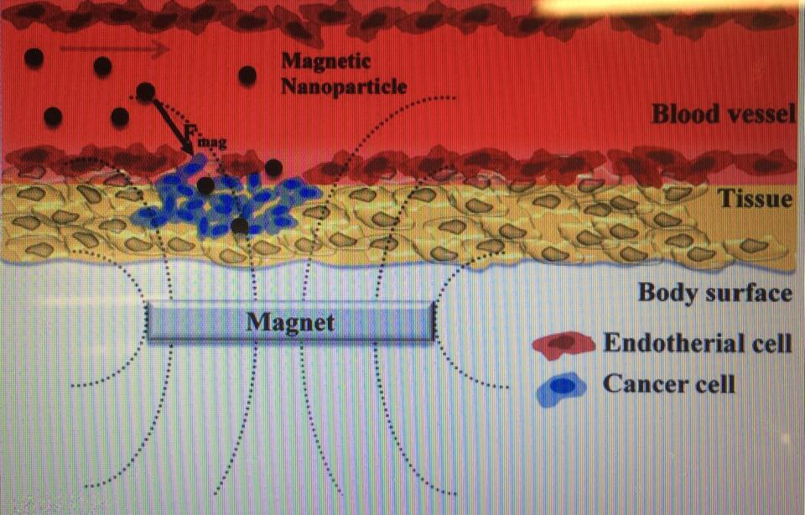
Figure 1.1 illustrates the process by which nanoparticles are carried through the body
This procedure is known as Wogonin [2]. Wogonin is an old traditional Chinese medicine which is toxic to cancer cells, however the shortcoming of this procedure is that it has low water solubility which makes it restricted to clinical administration only. However, with the technology of Magnetic Nanoparticles, we are able to use magnetic nanoparticles to coat the cells which would increase water solubility of the drug and enhance its effects.

3.0 Project Description
Magnetic Nanoparticles in Treatment of Tumors
Research Question | Theory/Principle/Concept | Source Course(s) | Possible Source(s)
- The process by which Magnetic Nanoparticles works/travels within the body | - Magnetic Fields  - Chemical Compounds | - Chemistry 1101  - Physics 1004
- How the addition of magnetism affects/targets the cell | - Cell cycle  - Cell division | - BIOL 1003
Task | Proposed hours | Date Start | Date End
Technical Concept Explanation | 6 | January 19th,2015 | February 9th,2015
Technical Concept Presentation (group) | 8 | February 10th,2015 | March 3rd,2015
Oral Presentation meetings/rehearsal (group) | 3 | February 23rd,2015 | March 3rd,2015
Technical Concept Final Presentation (group) | 4 | March 3rd,2015 | March 24th,2015
First Draft of Final Technical Report | 8 | March 3rd,2015 | March 10th,2015
Second Draft of Final Technical Report | 3 | March 10th,2015 | March 17th,2015
Final Draft of Final Technical Report | 3 | March 17th,2015 | March 24th,2015
Final Technical Report Presentation (group) | 3 | March 17th,2015 | March 24th,2015
This project is compiled by four individuals including myself; they are Elliot Yeung, Tyler Camara and Michael Aide. The following chart illustrates the schedule by which we’ll use to complete our tasks.
4.0 Conclusion
The purpose of this document is to obtain proposal approval to conduct further research regarding Magnetic Nanoparticles in tumor treatments. The benefit the audience and I would acquire form this research is awareness of Tumor Hypoxia and knowledge pertaining this disease. This research would also provide a gateway to brilliant discoveries using Magnetic Nanoparticles. If you have any further questions, please do not hesitate to contact me via email at mustafali@cmail.carleton.ca

References
[1] B. Bharat “Introduction to Nanotechnology” in Springer Handbook of Nanotechnology. Howard D.Winbigler Berlin: Springer-Verlag, 2004
http://lib.myilibrary.com.proxy.library.carleton.ca/Open.aspx?id=71658. Accessed January 15,2015

[2] L.Wang, H.Zhang, B. Chen and G.Xia “Effect of Magnetic Nanoparticles on apoptosis and cell cycle induced by Wogonin,”: http://www.ncbi.nlm.nih.gov/pubmed/22359456
Accessed February 2.

