Global Management 200
Business and the Dynamic New Workplace

Management
Lecture 1

Planning Ahead – Study Questions
- What are the challenges of working in new economy? How will you survive in these times.
- What are organizations like in the new workplace? Very flat structures. No hierarchy. Work within teams. Transferable skills
- Who are managers and what do they do? Create drive, lead to the objective. Management in based on 4 concepts. Plan, Organize, Leading, Controlling.
- What is the management process?
  - Plan
  - Organize
  - Lead
  - Control
- How do you learn the essential managerial skills and competencies?

Overview of 21st century workplace
Must adapt to rapidly changing society – wireless Internet is new
Economy is global and driven by innovation and technology. – Out sourcing to India etc, Youtube, Netflix
High Performing companies gain extraordinary results from people working for them
Interdependent, knowledge based – prove that you are relevant at your job, team work

Intellectual Capital:
- People are the ultimate foundations of organizational performance.
- Intellectual capital is the collective brainpower or shared knowledge of a workforce that creates value
- A knowledge worker adds to intellectual capital in organization

Globalization:
- National boundaries of world business have largely disappeared
  - Everything is now international, Cheaper labour
- Globalization is the worldwide interdependence of resource flows, product markets, and business competition that characterize the new economy.

Technology:
- Continuing transformation of the modern workplace through – Internet, WWW, Computers, IT
- Increasing demand for knowledge workers with the skills to fully utilize technology – the experts
- Changes the way we do business

Diversity:
- Workforce diversity reflects differences with respect to gender, age, race, ethnicity, religion, sexual orientation, and able-bodiedness
- A diverse and multicultural workforce both challenges and offers opportunities to employers
- Find a common ground and similarities
- Race is less of an issue in Canada than USA
- Emotional intelligence

Ethics:
- Code of moral principles
- Society requires businesses to operate according to high moral standards
- Emphasis today on restoring the strength of corporate governance

Careers:
- Career of 21st Century won’t be uniformly full-time and limited to a single large employer
- Skills must be portable and always of current value
- “Generation Job-less”
- Move around jobs to learn new skills, take now opportunities, transferable skills

Study Question 2: What are organizations like in the new workplace?
Critical skills for success in the new workplace:
- Mastery
- Contacts
- Entrepreneurship
- Love of technology
- Marketing
- Passion for renewal - Passion to develop yourself

Organization:
- A collection of people working together to achieve a common purpose
- Organizations provide useful goods and/or services that return value to society and satisfy customer needs

Organizations are open systems:
- Composed if interrelated parts that function together to achieve a common purpose
- Interact with their environments
- Transform resources inputs into products outputs (goods and services)
- Environmental feedback tells organization how well it is meeting the needs of customers/society
- Resource Inputs (supplies): people, money, materials, technology, information
- Product Outputs (consumes): finished goods &/or services

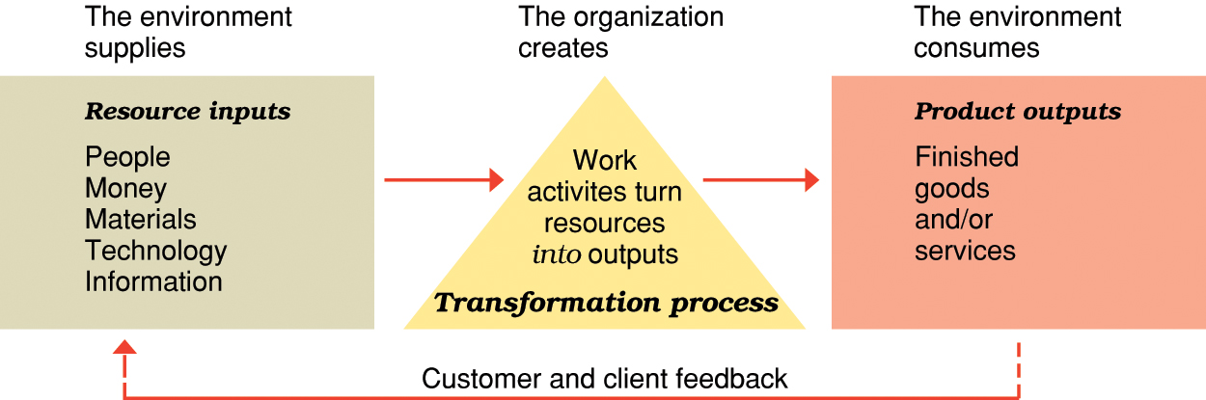

Organizational performance:
- Value is created when an organization’s operations adds value to original cost of resource inputs
- When value creation occurs:
  - Businesses earn a profit
  - Nonprofit organizations add wealth to society
- Productivity
- An overall measure of the quantity and quality of work performance with resource utilization taken into account
- Performance effectiveness
- An output measure of task or goal accomplishment
- Performance efficiency
- An input measure of the resource costs associated with goal accomplishment
- High goal attainment, good resource utilization is desirable

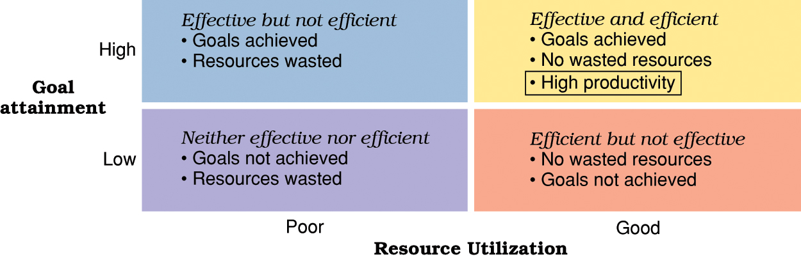

Workplace changes that provide a context for studying management:
- Belief in human capital
- Demise of “command and control”
- Emphasis on teamwork
- Preeminence of technology – IT is very important
- Embrace of networking
- New workforce expectations
- Concern for work-life balance
- Focus on speed – first mover advantage. Be the first in the market and take it over because competitors enter

Importance of human resources and managers:
- “Toxic workplaces” treat employees as costs
- High performing organizations treat people as valuable strategic assets
- Managers must ensure that people are treated as strategic assets
- People can do more than they are paid for if they are given the right incentives
- Calling employees or students by their first name can increase performance

Manager:
- Is person in an organization who supports and is responsible for the work of others
- Managers support those whose tasks represent the real work of the organization

LEVELS of Management:
Top managers – responsible for performance of an organization as a whole or for one of its larger parts. Not for units. Futuristic
Middle Managers – in charge of relatively large departments or divisions
Project Managers – Coordinate complex projects with task deadlines. Temporary work
Team Leaders/Supervisor – in charge of a small work group of non-managerial workers. Day to day operations

Responsibilities of Team Leaders:
- Plan meetings & work schedules
- Clarify goals and tasks and gather ideas for improvement
- Appraise performance and counsel team members
- Recommend pay raises and new assignments
- Recruit, develop and train team members – They understand the wants and needs of the company and can make these operates efficient
- Encourage high performance & teamwork
- Inform team members about organizational goals & expectations
- Inform higher levels of work unit needs and accomplishments
- Coordinate with other teams and support the rest of the organization – Everyone is working towards the same goal

TYPES of Managers:
Line Managers – responsible for work activities that directly affect organization’s outputs
Staff Managers – use technical expertise to advise/support efforts of line workers
Functional Managers - responsible for a single area of activity (Ex: Sales Managers, Production Manager)
General Managers – responsible for more complex units that include many functional areas (In charge of more than one unit)
Administrator - work in public & non-profit organizations

Managerial performance and accountability:
- Accountability is the requirement of one person to answer to a higher authority for relevant performance results
- Effective managers fulfill performance accountability by helping others to achieve high performance outcomes and experience satisfaction in their work.

Quality of work life (QWL):
- An indicator of the overall quality of human experiences in the workplace.

QWL indicators:
    - Fair pay
    - Safe working conditions
    - Opportunities to learn and use new skills
    - Room to grow and progress in a career
    - Protection of individual rights
    - Pride in work itself and in the organization

High performing managers:
- Are well informed of their team’s needs.
- Work alongside those they supervise.
- Provide advice and develop support for their team.
- Help their people perform to the best of their abilities.
- Employees need job satisfaction

The organization as an upside-down pyramid:
  - Reflects the changing nature of work today.
  - A manager’s job is to support workers’ efforts.
  - Whole organization is devoted to serving the customer.
  - Recruit knowledge workers, employees need to add value

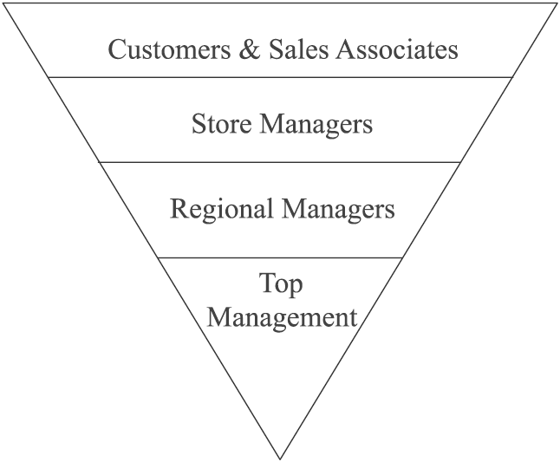

Study Question 4: What is the management process?
- Management is the process of planning, organizing, leading, and controlling the use of resources to accomplish performance goals.
- All managers are responsible for the four functions.
- The functions are carried on continually.
- We solve a problem and create another problem. Managers must plan ahead

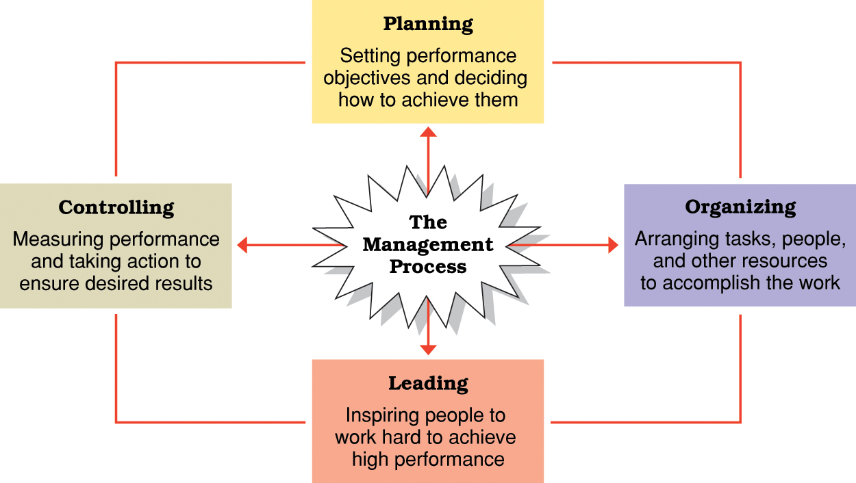

Functions of management:
Planning | Organizing | Leading | Controlling
The process of setting objectives and determining what actions should be taken to accomplish them. | The process of assigning tasks, allocating resources, and arranging the coordinated activities of individuals and groups to implement plans. | The process of arousing people’s enthusiasm to work hard and direct their efforts to fulfill plans and accomplish objectives. | The process of measuring work performance, comparing results to objectives, and taking corrective action as needed.

Managerial activities and roles:
  - Informational roles
    - Involve giving, receiving, and analyzing of information.
    - Look at the population, demands, trends
  - Interpersonal roles
    - Involve interactions with persons inside and outside the work unit.
  - Decisional roles
    - Involve using information to make decisions in order to solve problems or address opportunities.

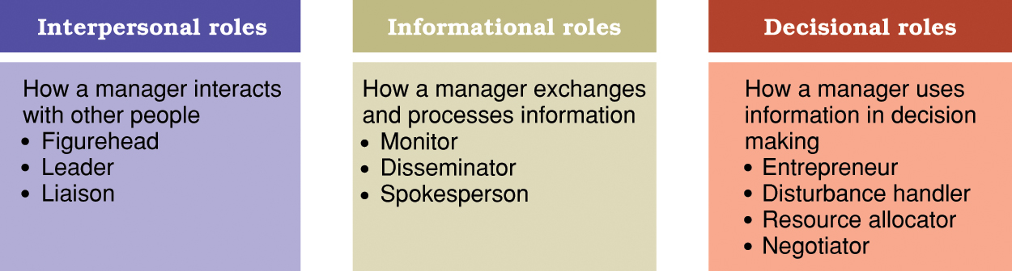

Characteristics of managerial work:
  - Managers work long hours
  - Managers work at an intense pace – Competition is fast
  - Managers work at fragmented and varied tasks – To survive in this industry you have to be multi talented, prioritize
  - Managers work with many communication media
  - Managers work largely through interpersonal relationships

Managerial agendas and networks:
  - Agenda setting
- Development of action priorities for one’s job.
- Include goals and plans that span long and short time frames.
  - Networking
- Process of building and maintaining positive relationships with people whose help may be needed to implement one’s work agendas.
- Build and maintain positive relationships with people, trust

Essential managerial skills:
Skill:
- The ability to translate knowledge into action that results in desired performance.
  - Technical skill — the ability to apply a special proficiency or expertise to perform particular tasks.
  - Human skill — the ability to work well in cooperation with others. Very important because everyone needs to know how to work well with people
  - Conceptual skill — the ability to think critically and analytically to solve complex problems.

Katz’s Essential Managerial Skills:

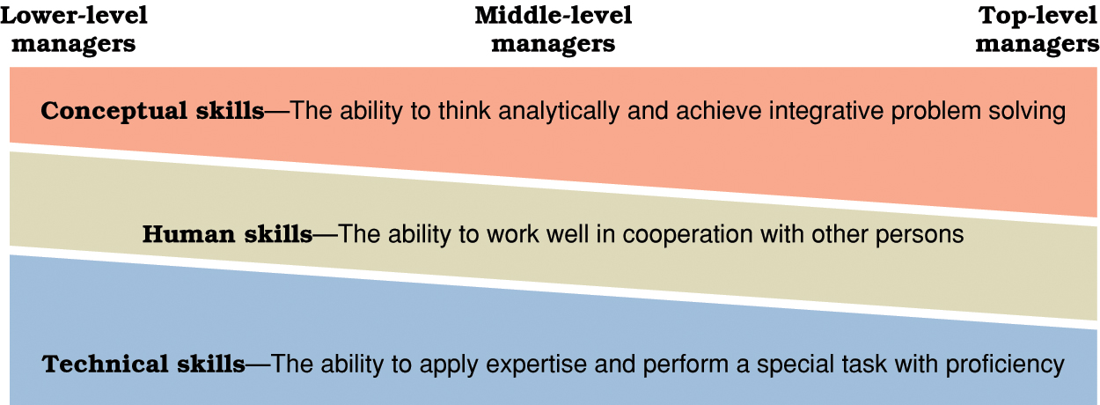

Managerial competency:
- A skill-based capability that contributes to high performance in a management job.

Managerial competencies are implicit in:
  - Planning, organizing, leading, controlling
  - Informational, interpersonal, and decision roles
  - Agenda setting and networking

Competencies for managerial success:
  - Communication
  - Teamwork
  - Self-management
  - Leadership
  - Critical thinking
  - Professionalism

Information and Decision Making
Lecture 2

Outline
- Information technology and the new workplace
- The role of information in the management process
- Information and decision-making
- Steps in decision making process
- Current issues in managerial decision-making

Information technology and the new workplace
- Knowledge and knowledge workers provide a decisive competitive factor in todays economy

Knowledge worker:
- Intellectual capital
- Knowledge and intellectual capital are irreplaceable organizational resources
- The productivity of knowledge and knowledge workers depends on:
- Computer competency – can you use the computer to add value to the company (Excel)
- Information competency

IT & New Workplace
- Electronic commerce (B2C e-commerce, B2B e-commerce)

- Stages of development in e-commerce:
- Secure an online identity
- Establish a Web presence
- Enable e-commerce
- Provide e-commerce and customer relationship management
- Utilize a service application model

- IT facilitates communication and information sharing, reduction in the number of middle managers, better organizational structure and excellent coordination and control

IT & New Workplace:
- IT builds relationships with external environment
- IT has changed the new workplace (email, P2P – Peer to peer file sharing)
- Data is raw facts and observations
- Information is data made available for decision-making
- Good information must be Timely, High Quality, Complete, Relevant and Understandable

The role of information in the management process
- Data > Information > Decision-making
- Information exchanges with the external environment and within the organization

- The external & internal information needs of the organization is essential for solving problems and making decisions
Intelligence information > | Internal information > | Public information
Gathered from stakeholders and external environment | Flows up, down, around and across organization | Disseminated to stakeholders and external environment

- Information system
- Management information system (MIS)
- Decision support system (DSS) – Adware, software that support management decisions
- Artificial intelligence (AI) – software that thinks like people
- Expert system (ES) – branch of artificial intelligence
- Intranets and corporate portals – interaction between the organization
- Extranets and enterprise portals – platform of communication between organization and supplier or customer
- Electronic data interchange (EDI)

Advantages of IT
- Planning advantages
- Organizing advantages
- Leading advantages
- Controlling advantages

- The manager is the processing nerve centre

Information and Decision Making:
- A performance deficiency is actual performance being less than desired performance.
- A performance opportunity is actual performance being better than desired performance.
- Problem solving is the process of identifying a discrepancy between actual and desired performance and taking action to resolve it.
- A decision is a choice among possible alternative course of action.

Programmed decisions:
  - Apply solutions that are readily available from past experiences to solve structured problems.
  - Structured problems are ones that are familiar, straightforward, and clear with respect to information needs.
  - Best applied to routine problems that can be anticipated.

Non-programmed decisions:
  - Develop novel solutions to meet the demands of unique situation that present unstructured problems.
  - Unstructured problems are ones that are full of ambiguities and information deficiencies.
  - Commonly faced by higher-level management.

Crisis decision-making:
  - A crisis involves an unexpected problem that can lead to disaster if not resolved quickly and appropriately.
  - Rules for crisis management:
    - Figure out what is going on.
    - Remember that speed matters.
    - Remember that slow counts, too.
    - Respect the danger of the unfamiliar.
    - Value the skeptic.
    - Be ready to “fight fire with fire.”

Decision environments:
  - Certain environments -
    - Offer complete information about possible action alternatives and their outcomes.
  - Risk environments -
    - Lack complete information about action alternatives and their consequences, but offer some estimates of probabilities of outcomes for possible action alternatives.
  - Uncertain environments -
    - Information is so poor that probabilities cannot be assigned to likely outcomes of known action alternatives.

Problem-solving approaches or styles:
  - Problem avoiders.
    - Inactive in information gathering and solving problems.
  - Problem solvers.
    - Reactive in gathering information and solving problems.
  - Problem seekers.
    - Proactive in anticipating problems and opportunities and taking appropriate action to gain an advantage.

Systematic versus intuitive thinking:
  - Rational VS Flexible
  - A combinational of both systematic and intuitive thinking leads to excellent problem solving
    - Systematic thinking approaches problems in a rational, step-by-step, and analytical fashion.
    - Intuitive thinking approaches problems in a flexible and spontaneous fashion.
    - Multidimensional thinking applies both intuitive and systematic thinking.
    - Effective multidimensional thinking requires skill at strategic opportunism.

Five-step decision-making process:
  - Identify and define the problem
  - Generate and evaluate possible solutions
  - Choose a preferred course of action and conduct the “ethics double check.”
  - Implement the decision
  - Evaluate results

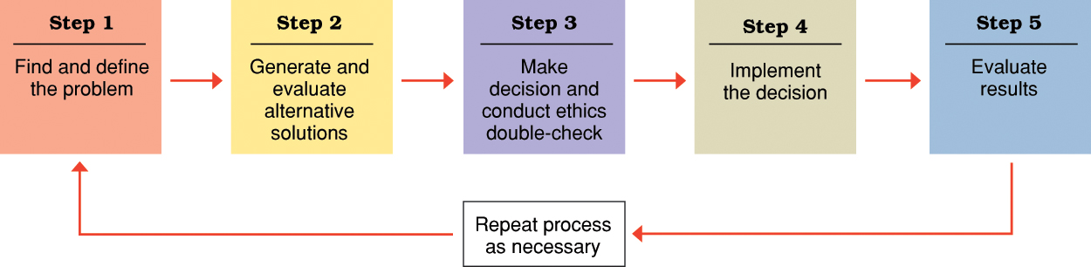

Differences in the classical and behavioural models of managerial decision-making:
- Simon in 1956
- Sudden environment is never a case in business

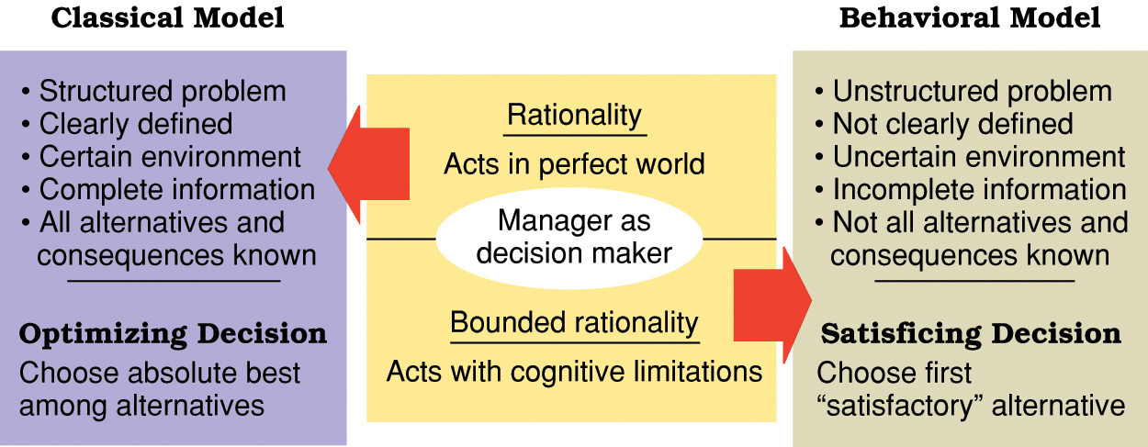

Types of heuristics for simplifying decision-making:
  - Availability heuristic:
    - People use information “readily available” from memory as a basis for assessing a current event or situation.
  - Representativeness heuristic:
    - People assess the likelihood of something happening based upon its similarity to a stereotyped set of occurrences.
  - Anchoring and adjustment heuristic:
    - People make decisions based on adjustments to a previously existing value or starting point.

- Escalating commitment:
  - The tendency to increase effort and apply more resources to a course of action that is not working.
  - Make mistake once and then keep making it

Ways to avoid the escalation trap:
    - Set advance limits and stick to them.
    - Make your own decisions.
    - Carefully determine why you are continuing a course of action.
    - Remind yourself of the costs.
    - Watch for escalation tendencies.

Potential advantages of group decision-making:
- Greater amounts of information, knowledge, and expertise are available.
- More action alternatives are considered.
- Increased understanding and acceptance of outcomes. (In the concept of “we”)
- Increased commitment to implement final plans.

Potential disadvantages of group decision-making:
  - Pressure to conform
  - Minority domination may occur
  - Decision-making takes longer

Summary:
- Knowledge management
- Chief knowledge Officer (CKO)
- Knowledge management requires a culture that values learning fosters a learning organization
- Ethical decision making

- Ethical decision satisfy the following criteria:
    - Utility
    - Rights
    - Justice
    - Caring

Global Dimensions of Management
Lecture 3

The international management challenges of globalization
- Key concepts in the challenges of globalization:
- Global economy – USA dollar is most recognized
- Globalization
- International management
- Global manger
- Europe – European union (EU)
- The Americas – NAFTA, FTAA
- Asia & Pacific
- Africa – SADC (South Africa Development Community), ECOWAS (economic community of west African states)

Forms and opportunities of international business
- Reasons for engaging in international business: profits, customers, suppliers, capital, labor
- Market entry strategies involve the sale of goods or services to foreign markets but do not require expensive investments
- Types of market entry strategies:
- Global sourcing: The process of purchasing materials or services around the world for local use
- Exporting: Selling locally made products in foreign markets
- Importing: Buying foreign-made products and selling them domestically
- Licensing agreement: One firm pays fee for rights to make or sell another company’s products
- Franchising: A fee is paid for rights to use another firm’s name and operating methods

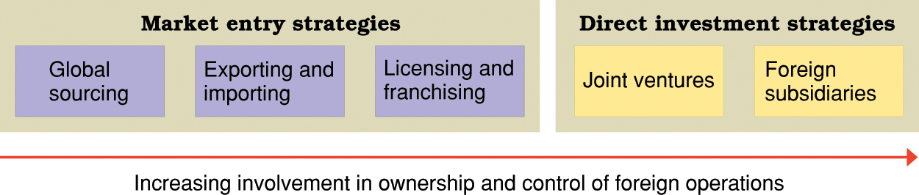

Direct investment strategies require major capital commitments but create rights of ownership and control over foreign operations.
- Types of direct investment strategies:
- Joint ventures: operates in a foreign country through co-ownership by foreign and local partners
- Foreign subsidiaries: local operation completely owned by a foreign firm
      - Greenfield investment - builds an entirely new operation in a foreign country

- Criteria for choosing a joint venture partner:
  - Familiarity with your firm’s major business.
  - Strong local workforce.
  - Future expansion possibilities.
  - Values its customers
  - Strong local market for partner’s own products.
  - Good profit potential.
  - Sound financial standing.

- Complications in the global business environment:
  - Environment is complex, dynamic, and highly competitive
  - Global business executives must deal with differences in the environment of business in different countries
  - World trade organization resolves trade and tariffs disputes among countries
  - Protectionism can complicate global trading relationships
- A multinational corporation (MNC) is a business with extensive international operations in more than one foreign country.
- Mutual benefits for host country and MNC:
- Shared growth opportunities
- Shared income opportunities
- Shared learning opportunities
- Shared development opportunities

Lecture 4

Kopi Luwak
Kopi (Coffee) Luwak (Palm Civet Cat) – You can get it from islands of: Sumatra, Bali, Java (Islands > Indonesia: $8-10 > $5)
$60 pounds a cup, $80 Canadian a cup
Capture Luwak, bad for nature. Business people will spend whatever to take these seeds to make the coffee but the people of the area are concerned that it is bad for the environment. Waste of resources.
Most expensive coffee

Frank and Oak
From Montreal
Good use of ecommerce: B2B (Aldo, Burgundy) B2C (people, men) – website is secure
Business model: Order online, shipping is free (alliance with Canada Post)
Hunt club, return shipping is free too
Monthly updates based on demand and trends
Business model reduces middleman markup
Continuous improvements

Mandarin
Hello – Ni Hao
Thank you – Xie Xie
You are welcome – Bu Ke Qi

Congo
Second largest in Africa (Algeria is the largest)
King Leopold 1880-1904 – handed over to Belgian government
1880 – 20 million
1904 – 10 million
Slaughtered 10 million
- Rubber
- Copper
- Uranium (E=mc2)
- Coltan (smartphones) 70% from congo
- Cadmium (batteries, computers)
Used to be called Belgian Congo, then Zaire, then DRC (Democratic Republic Congo)
Lacks intelligent and infrastructure development

Russia
Largest country on the planet
Kalashinikov (AK47) most common gun, very innovative
Communism to capitalism
Iron Ore – can be found in a place called Gubkin
Place called Kalugo – Volkswagen (Germany company) entered, then Volvo, Peugeot
The entrance of these companies can lead to many job employment and opportunities
Place called Tolyatti – created car brand Lada
Moscow – highest number of millionaires, other capital cities

Lecture 5

Classical School of Thought
Approaches include:
- Scientific management
- Administrative principles
- Bureaucratic organization

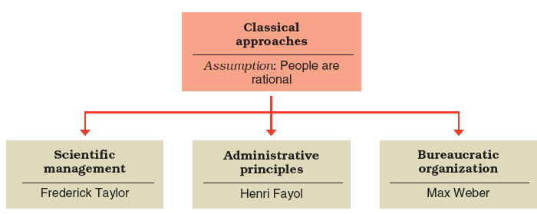

- Scientific management (Frederick Taylor)
- The father of scientific management
  - Develop rules of motion, standardized work implements, and proper working conditions for every job.
  - Carefully select workers with the right abilities for the job.
  - Carefully train workers and provide proper incentives.
  - Support workers by carefully planning their work and removing obstacles.

- Scientific management (the Gilbreths)
  - Motion study; Science of reducing a job or task to its basic physical motions.
  - Eliminating wasted motions improves performance.

- Administrative principles (Henri Fayol) — rules of management:
  - Foresight — to complete a plan of action for the future.
  - Organization — to provide and mobilize resources to implement the plan.
  - Command — to lead, select, and evaluate workers to get the best work toward the plan.
  - Coordination — to fit diverse efforts together and ensure information is shared and problems solved.
  - Control — to make sure things happen according to plan and to take necessary corrective action.

- Administrative principles (Henri Fayol) — key principles of management:
  - Scalar chain — there should be a clear and unbroken line of communication from the top to the bottom of the organization.
  - Unity of command — each person should receive orders from only one boss.
  - Unity of direction — one person should be in charge of all activities with the same performance objective.

- Administrative principles (Mary Parker Follett)
- Groups and human cooperation
- Forward looking management insights

- Bureaucratic organization (Max Weber)
  - Bureaucracy
    - An ideal, intentionally rational, and very efficient form of organization.
    - Based on principles of logic, order, and legitimate authority.

Classical School of Thought

- Characteristics of bureaucratic organizations: | - Possible disadvantage of bureaucracy:
- Clear divisions of labour  - Clear hierarchy of authority  - Formal rules and procedures  - Impersonality  - Careers based on merit | - Excessive paperwork or “red tape”  - Slowness in handling problems  - Rigidity in the face of shifting needs  - Resistance to change  - Employee apathy

Behavioural Management
- Human Resource Approaches Include:
  - Hawthorne studies
  - Maslow’s theory of human needs
  - McGregor’s Theory X and Theory Y
  - Argyris’s theory of adult personality

- Hawthorne studies
  - Initial study examined how economic incentives and physical conditions affected worker output.
  - No consistent relationship found.
  - “Psychological factors” influenced results.
  - Relay assembly test-room studies – the subjects will alter their behaviour to give the examiner the results they want. When subjects feel respected they will increase output and productivity
  - Employee attitudes, interpersonal relations and group processes.
  - Lessons from the Hawthorne Studies – incentives don’t guarantee that people will increase output or productivity

- Maslow’s theory of human needs
  - A need is a physiological or psychological deficiency a person feels compelled to satisfy

  - Need levels: (continuous, once you accomplish one you go on to the next)
- Physiological
- Safety
- Social
- Esteem
- Self-actualization

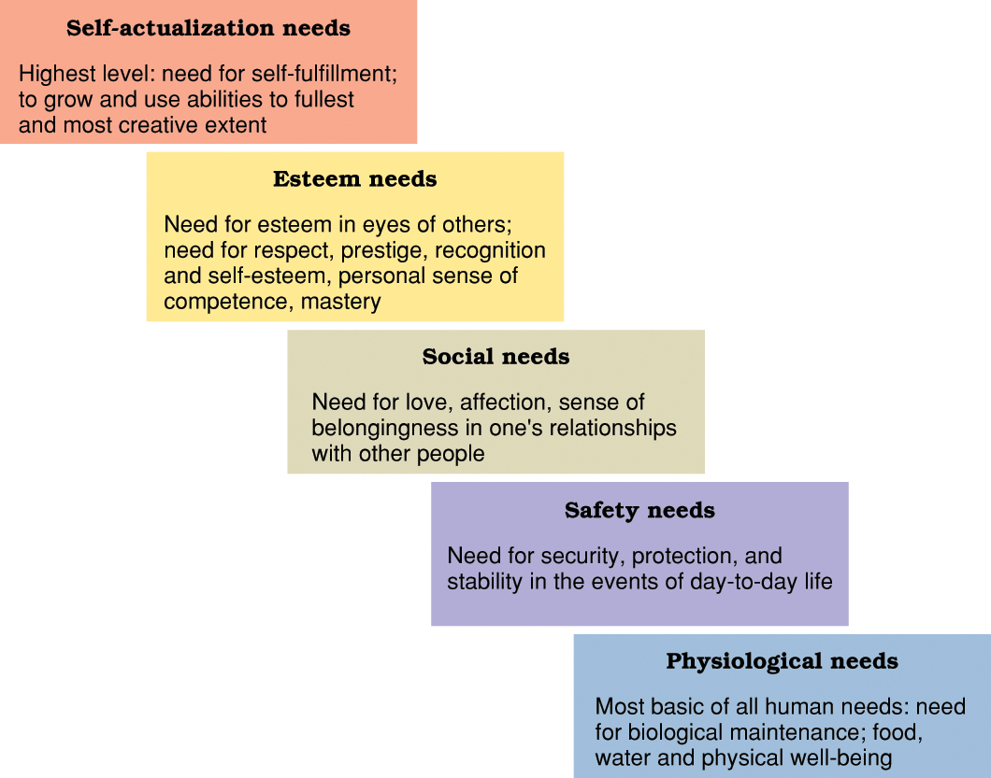

- Maslow’s theory of human needs
  - Deficit principle
    - *A satisfied need is not a motivator of behaviour.
  - Progression principle
    - A need becomes a motivator once the preceding lower-level need is satisfied. Once a need is satisfied you want to move to the next level
  - Both principles cease to operate at self-actualization level.

- McGregor’s Theory X assumes that workers: | - McGregor’s Theory Y assumes that workers are:
- Dislike work  - Lack ambition  - Are irresponsible  - Resist change  - Prefer to be led  (X is for WRONG) | - Willing to work  - Capable of self control  - Willing to accept responsibility  - Imaginative and creative  - Capable of self-direction  (Y is for YES)

- Implications of Theory X and Theory Y:
  - Managers create self-fulfilling prophecies.
  - Theory X managers create situations where workers become dependent and reluctant.
  - Theory Y managers create situations where workers respond with initiative and high performance.
    - Central to notions of empowerment and self-management.

- Argyris’s theory of adult personality
  - Classical management principles and practices inhibit worker maturation and are inconsistent with the mature adult personality.
  - Management practices should accommodate the mature personality by:
    - Increasing task responsibility
    - Increasing task variety
    - Using participative decision making

Role of Quantitative Analysis in Management
- Management science or (operations research) foundations:
  - The scientific applications of mathematical techniques to management problems
    - Mathematical forecasting makes future projections useful for planning
    - Inventory modeling controls inventories mathematically
    - Linear programming calculates how to allocate scarce resources among competing uses
    - Queuing theory allocates service personnel/workstations to minimize service cost and customer waiting time
    - Network models break large tasks into smaller components for better coordination
    - Simulations
- Quantitative analysis today
  - Staff specialists help managers apply techniques
  - Software and hardware developments have expanded the horizon
  - Good judgment and appreciation for human factors should support quantitative analysis

- Organizations as Systems:
An organization is an open system with subsystems under the main system. There should be no boundary and the information should be two ways. The environment should be able to interact with the organization and vice versa.
  - System
    - Collection of interrelated parts that function together to achieve a common purpose.
  - Subsystem
    - A smaller component of a larger system.
  - Open systems
    - Organizations that interact with their environments in the continual process of transforming resource inputs into outputs.

- Contingency thinking
  - Tries to match managerial responses with problems and opportunities unique to different situations.
    - Especially individual or environmental differences.
  - No “one best way” to manage.
  - Appropriate way to manage depends on the situation.

- Quality and performance excellence
- Eight Attributes of performance excellence:
  - A bias toward action
  - Closeness to the customer
  - Autonomy and entrepreneurship
  - Productivity through people
  - Hands on and value driven
  - Sticking to the knitting
  - Simple form and lean stuff
  - Simultaneous loose tight properties

- Management themes of the 21st century
- Global awareness
- Contemporary businesses must learn to become learning organizations
- Core ingredients of learning organizations:
  - Mental models
  - Personal mastery
  - Systems thinking
  - Shared vision
  - Team learning

- To survive the competition in this 21st century, managers must be:
  - Global strategist – understanding the interconnections among nations, cultures and economies
  - Master of technology – comfortable with information technology
  - Inspiring leader – attracting and motivating workers to achieve high-performance culture
  - Model of ethical behaviour – acting ethically in all ways

Planning Processes and Techniques
Lecture 6

- Planning
The process of setting objectives and determining how to best accomplish them.
- Objectives
Identify the specific results or desired outcomes that one intends to achieve.
- Plan
A statement of action steps to be taken in order to accomplish the objectives.

- Steps in the planning process:
Define your objectives – Measurable
Determine where you stand vis-à-vis objectives – Compare your situation, your position in the market, develop objectives to change the future
Develop premises regarding future conditions
Analyze and choose among action alternatives – You must have options
Implement the plan and evaluate results

- Benefits of planning:
Improves focus and flexibility.
Improves action orientation.
Improves coordination and Control.
Improves time management

Types of Plans
- Short-range and long-range plans
Short-range plans = 1 year or less
Intermediate-range plans = 1 to 2 years
Long-range plans = 3 or more years
- People vary in their capability to deal effectively with different time horizons.
- Higher management levels focus on longer time horizons.

- Strategic and Operational (Tactical) Plans
Strategic plans — set broad, comprehensive, and longer-term action directions for the entire organization.
Operational (Tactical) plans — define what needs to be done in specific functions to implement strategic plans:
Production plans
Financial plans
Facilities plans – infrastructure, living environment
Marketing plans – tastes and preferences of people, always changing, demographics etc
Human resource plans

Planning tools and techniques
  - Policies and procedures
Standing plans: Policies and procedures that are designed for repeated use

- Policy: Broad guidelines for making decisions and taking action in specific circumstances.
- Rules or procedures: Plans that describe exactly what actions are to be taken in specific situations.

- Budgets and project schedules

- Single-use plans: Only used once to meet the needs and objectives of a well-defined situation in a timely manner

- Budgets
  - Single-use plans that commit resources to activities, projects, or programs
  - Fixed, Flexible, and zero based budgets
- Projects
  - One-time activities that have clear beginning and end point
  - Project management and project schedules

- Forecasting
Making assumptions about what will happen in the future – You need to try and predict the future
Qualitative forecasting uses expert opinions.
Quantitative forecasting uses mathematical and statistical analysis – Time series data
All forecasts rely on human judgment.
Planning involves deciding on how to deal with the implications of a forecast

- Contingency planning
Identifying alternative courses of action that can be implemented if circumstances change (short term) – About NOW!
Contingency plans anticipate changing conditions
Contingency plans contain trigger points

- Scenario planning
A long-term version of contingency planning – About the FUTURE!
Identifying alternative future scenarios.
Plans made for each future scenario.
“worst-case” and “best-case” scenarios
Increases organization’s flexibility and preparation for future shocks – Shock absorber

- Benchmarking
Use of external comparisons to better evaluate current performance and identify possible actions for the future.
Adopting best practices of other organizations that achieve superior performance

- Use of staff planners
Coordinating and planning function for the total organization or one of its major components
Possible communication gaps between staff planners and line management – Get all staff involved and working as a team to avoid gaps. Get everyone on the same page

- Participation and involvement
Participatory planning requires that the planning process include people who will be affected by the plans and/or will help implement them.
Benefits of participation and involvement:
    - Promotes creativity in planning.
    - Increases available information.
    - Fosters understanding, acceptance, and commitment to the final plan
- Being involved increases commitment because staff feels a sense of ownership. Our plan, not your plan.

Midterm

The best employees share all of the following characteristic except
- High performance expectation
- Both value and respect for work life balance
- Good at attracting and retaining talented employees
- Utilizing talents and values
- Exploiting natural environment

Are successful because they are better than their competitiors at gaining extraordinary results from the people working for them
D. High performing companies

The study of _ should enable an individual – Management

Can not guarantee long term employment

Shared knowledge, brain power – intellectual capital

World wide interdependence of Resource flows, product markets, and business competition that characterizes the new economy – globalization

_ is a code of moral principle that sets standards of what is “good” and “right” as opposed to being “bad” or “wrong” – ethics

stockholders interests should not be a primary consideration when organizations make decisions affecting the environment
Someone whose mind is a critical asset to employers and who adds to the intellectual capital of the organization is a knowledge worker

An organization is a collection of people working together to achieve common purpose

Mass production proved to be a little value in the modern economy not an accurate description of the history of management

Motion study is the science of reducing a job or task to its basic physical motions

Pioneers using motion study Management tool – frank and lillian

Motion studies provided the basis for later advances in which of the following management areas : job sim, incentive wages, work standards

The _ principle, as defined by henri states that there should be a clear and unbroken line of communication from top to bottom in the organization’s hierarchy of authority – scalar chain

_ is an ideal, intentionally rational, and very efficient form of organization founded on the principle of logic, order and legitimate authority – bureaucracy

Bureaucracy you will not get promoted based on social status

Hawthorne Studies – did not start to look at social factors but ended that way

