Psychedelics

- class of drug that causes halucinations and out of body eperiences
- natural and synthetically produced
- heightened sensory awareness
- Classification
  - Anticholinergic -> Scopolamine
  - Catecholaminelike – Mescaline, ecstasy
  - Serotoninlike – LSD
  - Glutaminergic NMDAR antagonists – Ketamine
  - Opiod kappa receptor agonist – Salvinorin A

Anticholinergics (Scopolamine)
- an acetylcholine antagonist (stops it from doing what its supposed to)
- binds to receptor but no intrinsic activity
- found in the plant Beautiful woman (atropa belladonna)
- Scopolamine
  - Acts in the PNS
  - Competitive antagonist at muscarinic R
  - Anticholinergic syndrome:
    - Dry mouth
    - Reduced sweating
    - Dry skin
    - Increased body temp
  - Low doses:
    - Drowsiness
    - Amnesia
    - Mental confusion
    - Absence of REM
  - High Doses
    - Delirium
    - Coma
    - respiratory depression

Catecholaminelike Psychedelics
- structurally similar to NE, DA, amphetamines
- have amphetamine like properties plus….
- Include
  - MDMA
  - Mescaline
  - Myristin (from nutmeg)
  - Elemicin (from nutmeg)
- Interacts with DA receptors
- Psychedelic actions via 5-HT2A receptor
Mescaline
- found in peyote cactus
- crown is cut, dried to a hard brown disk
- disk referred to as a “mescal button”
- can be chewed or soaked to make a drink
- used for religious purposes by Natives
- Effects:
  - Agonist of 5-ht receptor
  - Peak plasma concentration 1-2 hrs
  - Produces an acute psychotomimetic state
  - Targets the visual system
  - Effects for up to 10 hrs
- MDMA effects
  - Structurally similar
  - Psychedelic effects are dose dependent
  - More potent and toxic than mescaline
  - Induces serotonergic neurotoxicity
  - Exact mechanisms of action are unknown
  - Used recreationally or as an entheogen

Ecstasy (MDMA)
- 1960’s love drug
- 80’s dallas gay clubs
- 90’s to present, intro rave culture
- psychedelic effects strengthen experience
- top 4 used illicit drugs
- low cost of 5-10$
- high concurrent polydrug use
- Symptoms during periods of activity:
  - Hyperthermia
  - Tachycardia
  - Convulsions
  - Kidney failure
  - Cardiac arrhythmias
  - Death
- Fatal syndrome, malignant hypothermia

Serotoninlike Psychedelics (LSD)
- lysergic acid diethylamide (LSD)
- found in the Ipomoea purpurea plant seeds
- agonistic action at the 5 ht receptor
- LSD activates:
  - Medial prefrontal cortex
  - Anterior Cingulated Cortex
- Low level of toxicity i.e non-lethal
- Effects:
  - Alterations in perception
  - Temporal changes
  - Visual alteration
  - Euphoric mood
- Individual can experience a bad trip
- Halucinogen persisting perception disorder (HPPD)
- Flashback of visual experience after drug action has passed
- Symptoms:
  - Long term
  - Recurrent
  - Unpleasant dysphoric affect
- LSD-induced psychedelic experience phases:
  - Somatic Phase: CNS Stimulation and autonomic changes
  - Sensory (perceptual) Phase: sensory distortions and pseudohallucinations
  - Psychic phase: max drug effect “bad trip”

Glutaminergic NMDAR Antagonists
- ketamine and phencyclidine
- structurally unrelated to other psychedelics
- initially used in anesthesia
- effects are not on 5ht, Ach or DA
- can produce schizo like symptoms
- ketmine blocks by
  - blockade of open channel via site within receptor
  - reduction in the frequency of opening by binding to site on the outside of R
- dissociated individuals from their environment
- Induces a psychotic state:
  - Rigid
  - Unable to speak
  - Appear very drunk
  - Amnesia
  - Coma/stoupor (high doses)

OPIOIDS

Pain
- acute
  - caused by soft tissue damage
  - infection
  - inflammation
  - short lived
- Chronic pain
  - Longer lasting
  - Linked with long term illness or disease
  - May have no apparent cause
  - Can trigger other issues
  - Difficult to assess and diagnose
  - quality of life can go down
  - get into a situation with the patient vs. the doctor
  - detective and have red flags, could be an addict
- Nociception
  - Refers to the system that carries signals of damage and pain to the brain
  - Nociceptive nerons have cell bodies in the dorsal root ganglia
  - Can detect mechanical, thermal and chemical stimuli
- Nociception transmission
  - Bidirectional axons synapse in dorsal horn of the spinal cord
    - information is going from site of injury to the spine to the dorsal horn of the spinal cord and to your brain and it goes back to see what it should do
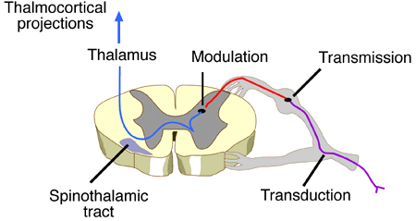
  - signal continues to brain where its processed

Opioids
- can modulate symptoms of pain
- opium is the nectar that comes out of the poppy plant
- mimics endogenous endorphins/enkephalins
- blind to opiod receptors
- opioid agonists
Opioids (sources)
- natural
  - from the resin of poppy seeds
  - morphine, codine, thebaine
- Semi Synthetic
  - Created from natural opioids
  - Heroin, oxycodone, hydromorphone
- Fully synthetic
  - Derived in a lab
  - Methadone, fentanyl

Opiod Receptors
- three types of receptors
  - mu
  - kappa
  - delta
- up to 17 types have been reported
- differential distribution in the brain
- Mu receptors are found in
  - Thalamus
  - Striatum
  - Spinal cord
  - Pariaquaductal gray
  - Brainstem nuclei
- Has analgesic effects, alters repiration
- Kappa receptors are found in
  - Basal ganglia
  - Nucleus accumbens
  - hypothalamus
  - pariaquaductal gray
  - deep cerebral cortex
- antagonize mu receptro activity
- modest analgesia, dysphoria, little or no respiratory depression

Classification of opioid receptors
- pure agonists:
  - strong binding to receptor
  - i.e, morphine (mu receptor)
- pure antagonists
  - strong binting to receptor with no activity
  - i.e. naltrexone (mu)
- mixed agonist-antagonist
  - agonist at one receptor antagonist at another
  - pentazocine
- partial agonists
  - binds and has low intrinsic activity
  - buprenorphine
Morphine
- main derivative from opium poppy “juice”
- more potent than codine
- Most effective pain killer
- Pharmacokinetice
  - Liver produces active metabolites
  - Metabolites are 10-20 times more potent analgesic than morphine
  - Half life is 3-5 hours
  - Morphine ----liver metabolism--- Morphine -6-glucuronide
- Reward pathway
  - VTANucleus accumbens prefrontal cortex
- Pharmacodynamics
  - gaba normally being released regulated the amount of dopamine being released
  - morphine slows the release of gaba which allows for increased dopamine activation (dopamine reward pathway)
- pharmacological effects
  - analgesia
  - euphoria
  - sedation
  - sonse of tranquility
  - respiratory depression
  - supression of the cough reflex
  - pupil constriction
- tolerance and dependence
  - tolerance to opioids is quick and severe
  - high potential for abuse
  - can produce withdrawal symptoms
    - restlessness
    - dysphoria
    - anxiety insomnia
    - explosive diarrhea
  - withdrawal symptoms can be addressed using RAAD (rapid anesthesia aided detox
  - pt is given a pure opioid antagonist (naltrexone) and sympathetic blocker (clonidine)
  - pt remains asleep under anethesia
  - upon awakening, oral dose of naltrexone
  - continue with psychotherapy
Other pure Opioid agonists
- Codeine
- Heroin
- Oxycodone
- Fentanyl

FOOD ADDICTION

Why do we Eat?
- factors that mediate food intake:
  - homeostasis
  - emotional state (stress, boredom)
  - hedonism (pleasure)
- simple biological model
  - Humoral (arising from the body) signals Hypothalamus Food Intake
- Hunger stimulating GI peptides Ghrelin (stomach, pancreas)
  - Levels increse before food consumption
  - Levels are lower in obese individuals
  - Sleep can influence ghrelin levels
  - Activates a portion of the DA reward pathway
- Adiposity Signals – Satiety signals
  - Hormones
    - Leptin (adipose)
    - Insulin (pancreas)
    - Cholecystokinin (CCK)
    - (small intesitne)
- mechanism of action for leptin at hypothalamus
  - antagonizing the effects of neuropeptide Y (stimulant)
  - antagonizing the effects of andandamide
  - promote synthesis of a-MSH (apetite supressant)
- mech. Of action for insulin
  - causes cells to take up glucose from blood
  - stops the use of fat as an energy source by inhibiting the release of glucagos
  - when control of insulin levels fails, patients can develop diabetes mellitus
Look at the diagram of the stomach
- Triggers that stimulate hunger are cyclical
  - Ghrelin
    - Preprandial rise
    - Orexigenic agent
    - Stimulates eating
  - Leptin
    - Postprandial rise
    - Anorexigenic agent
    - Inhibits eating
- Hypothalamus – primary regulatory center for food intake and body weight
  - Mice were very obese
  - Helped in the discovery of leptim
  - Administration of leptin reversed the effect
- Dual Center hypothesis
  - The hypothalamus has two distince regions
    - Ventromedial hypothalamus (Hunger)
    - Lateral hypothalamus (Satiety)
  - Each region regulates the opposing action

Why do we eat too much?
- three factors which influence consumption
  - disrupted neurobiology
  - poor impulse control
  - environmental factors
- chart:
  - if there is more food to be eaten we will eat more
  - you eat less when the candies are further away and even less if you cant see them even though you know where you are
- Personal food consumption has increased
  - Serving sized
  - Food access
  - Social context
  - Stress
How much should we be eating
- 3000 calories because I'm an active 21 year old male

Why do we eat too much
- what is obesity
  - a metabolic state where excess fat accumulates in peripheral tissues including
    - adipose
    - muscle
    - liver
  - BMI > 30

How fat are we
- canada is 35 in the world with 61%

Physiological Effects
- does foor consumption activate reward centers
- similar activation of brain centers in the dopamine reward pathway
  - nucleus accumbens
  - prefrontal cortex
  - ventral tagmental area
  - amygdala
- food consumption is associated with increases in DA levels in the NA
- in food addicts, this DA release can be significant

Model of Food Addiction
- food addiction is associated with an obsessive compulsive relationship with food
- symptoms
  - frequent periods of uncontrollable binges
  - consume food beyond the point of satiety
  - feeling guilt and depression
  - excessive time and thought devoted to food
  - preoccupation with body weight

Food addiction
- food addiciton can lead to the development of an eating disorder inluding
  - bulimia
  - binge eating disorder
- trigger food can activate the reward centers of the brain and can cause the release of 5ht
- increased depression and anxiety due to low levels of 5-ht
- abstinence from addictive food and food eating process causes withdrawal symptoms
  - mood swings
  - agitation
  - faintness
  - headaches
  - dysphoria
  - hypoglycemia
- is food addiction a “real” addiction
  - Criteria
    - Tolerance
    - Withdrawal
    - Investment
    - Social change
  - Obesity Behaviour
    - Increased consumption for satiety
    - Depression dysphoria
    - Time spent eating, costs
    - Fear of rejection

Anabolic Steroids
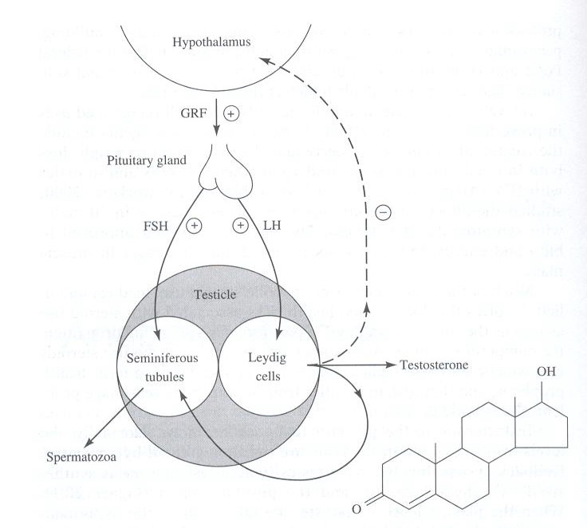

- the production of testosterone sends a negative feedback loop that tells the hypothalamus to stop

Testoserone Synthesis
- involves
  - hypothalamus
  - pituitary gland
  - testes
- negative feedback loop
  - TS levels detected by hypothalamus R
  - Low levels cause release of GRF
- GRF stimulates the pituitary to produce
  - FSH
  - LH
- FSH & LH act on testes to
  - Induce speratogenesis
  - Synthesis/release of testosterone
Steroids
- effects of excessive steroid use
  - block regular testosterone release
  - reduce spermatogenesis
  - decrease male fertility
  - increase muscle mass
  - more masculine appearance
  - increased aggression
- anabolic effects
  - increased protein synthesis
  - increased appetite
  - bone remodeling and growth
  - increased production of RBC
- androgenic effects
  - increased hair growth
  - increased vocal chord size
  - increased libido
  - growth of clit
  - increased breast size in men
Steroid Effects
- supratherapeutic doses can
  - increase tonic/burst muscle
  - better strengthen and endurance
  - hypogonadal state
  - lower HDL and increase LDL
  - risk of liver disorders
- therpeutic uses for anabolic steroids
  - TS replacement for hypogonadism
  - Certain blood amnesial
  - Muscle loss after trauma
  - Muscle loss due to disease
Steroid Mechanism
- rapidly absorbed by GI tract
- metabolized by enzymes
- metabolite ANDROSTANOLONE is active
Physiological effects
- changes in behavior and motivation
- increased aggression
- steroid induced aggression vs. behaviour
- potential screen for individ with violent behavior
Physical dependence
- Users can suffer from withdrawal syndrome
  - Moderate to severe depression
  - Fatigue
  - Restlessness
  - Insomnia
  - Loss of apetite
  - Decreased libido
  - Suicide idealation

Addiction of Pleasure: sex and gambling addiction

Gambling
- definition
  - wagering money or something of value on an event with an uncertain outcome with the primary intent of winning additional money and/or material goods
- most countries regulate gambling
Pathological Gambling
- an individual begins to show biological symptoms related to their addiciton to gambling
- recognized as a mental.psychiatric disorder (DSM-III)
- DSM IV: an impulsive control disorder that is chronic and progressive mental illness
- Criteria
  - Preoccupation
  - Tolerance – higher wages needed
  - Withdrawal symptoms - restless or irritability
  - Escape
  - Chasing – win back losses with more gambling
  - Lying
  - Stealing – to fuel the addiction
  - Loss of control – unsuccessfull attempts to reduce gambling
  - Illegal acts
  - Risked significant relationship – gamble despite risking or losing relationship, job
  - Bailout – turn to fam for money
Responsible Gambling
- criteria
  - do for entertainment rather than income
  - balance their participation with other activities
  - don’t gamble alone
  - accept losses as cost of entertainment
  - set a budget and stick to it
  - don’t borrow money to gamble
  - take breaks
Gambling Phases
- winning phase
  - increased frequency/amount
  - unreasonable optimism
- losing phase
  - thoughts revolve around gambling
  - lying / stealing / unable to pay debts
- depression phase
  - remorse / panic
  - alienation
- critical phase
  - responsible thinking
  - personal refelection
- rebuilding
  - self respect returs
  - regain family and friends trust
- growth phase
  - preoccupation with gambling decreased
  - more self awareness

Biological basis
- similar to chamical addiction
- lower levels of NE have been shown
- NE secreted during stress, arousal
- Pathological gambler are compensationg
- fMRI data shows parallels with drug addiction
- deficiencies in 5-HT are also proposed

How Much Gambling
- Largest growth seen
  - Online gambling
  - Video lottery terminals

Sexual Addiciton
- also called sexual compulsion
- form of psychological addiciton
- no in the DSM
- prominent in both males and females
- rates of gambling addiction seem to be higher than sexual addiction but when we look at actual data. why would gambling addiction seem higher than sex addiction
  - some people dont report it
  - social stigma
  - under diagnosed
  - cant blame someone else about your sex addiction
  - impact on you social relationships
  - the idea that i hook up with prostitues all the time has a negative conotation
  - guilt
  - no avenues to goto for help

Sexual Addiction
- definition
  - an overwhelming need for sex and are so intenselt preoccupied with this need that is interferes with your job and your relationships
  - spend inordinate amounts of time in sexually related activities and neglect important aspects of your day to day life
  - failing repeatedly at attempts to reduce or control your sexual activities or desires
- symptoms
  - compulsivity
  - continuation despite consequences
  - obsession
Sexual Addicition Epidemiology
- hard to detect because of low report
- some cases associated with
  - OCD
  - Narcissistic personality disorder
  - Bipolar disorder
Sexual Addiction
- enjoyment of journey not destination
- sometimes referred to as “chemical” addicts (DA)
- OCD creates conditioned response
  - Masterbation
  - Anonymous sex
  - Prostitutes
- Can develop tolderance and dependence
Types of Sexual Addiction
- compulsive masterbation
- compulsive sex with prostys
- lots of one stands
- multiple affairs or serial relationships
- frequent patronizing of topless bars, modeling studios, sexual massage parlors
- peeping toms
- inappropriate (“accidental”) contact
- despair
  - specific sexual behavior does not lead to statisfaction, therefore hopelessness, depression

Screening Sexual addiction
- It a secret
- Is is abtrusive or degrading to self/others
- It is used to avoid painful feelings
- It is not part of a caring committed relationship

Etiology of Sexual Addiciton
- trauma
- impaired neurochemistry
- developmental impairments
- early life exposure to sex/sexual situations

Sexual addiction treatment
- assessment for comorbidity ..
- 12 – step process
  - SAA
- CBT
- Pharmacotherapy?

