LAW122 – All Chapter Notes

Law Chapter 1

- Risk Management – is the process of identifying, evaluating and responding to the possibility of harmful events.
- You must identify, evaluate and respond to the legal risks involved
- A business probably cannot exist without taking some chances.
- Risk avoidance – some risks are so serious, they should be avoided all together
- Risk reduction – some risks can be reduced to an acceptable level through precautions
- Risk shifting – If a risk can not be avoided or reduced than it can be shifted to another party
- Risk acceptance – Sometimes it is appropriate to accept the risk
- Insurance – Is a contract where one party agrees, in exchange for a price, to pay a certain amount of money if another party suffers a loss.
  - Liability insurance – provides a benefit if the purchaser is held liable for doing something wrong.
  - Property insurance – provides a benefit if the purchaser’s property is damaged, lost or destroyed.
- Exclusion and limitation clauses – Is a contractual term that changes the usual rules of liability
  - The clause may attempt to exclude all risk of liability or it may exclude the amount of compensation that is available.
- Incorporation – To avoid some personal liability risks, many businesses are set up as corporations or companies. The largest benefit is limited liability (the company may go down but the people behind it are safe).
- In-house counsel – company may create its own legal department – more efficient risk protection

An Introduction to the Legal System
- Law – is a rule that can be enforced by the courts.
- Sometimes it is difficult to choose between moral obligations and legal obligations – producing clothes in unsafe working conditions

A Map of the Law
- Civil law – systems trace their history to ancient Rome (QUEBEC)
- Jurisdiction – is a geographical area that uses the same set of laws
- Common law – systems trace their history to England

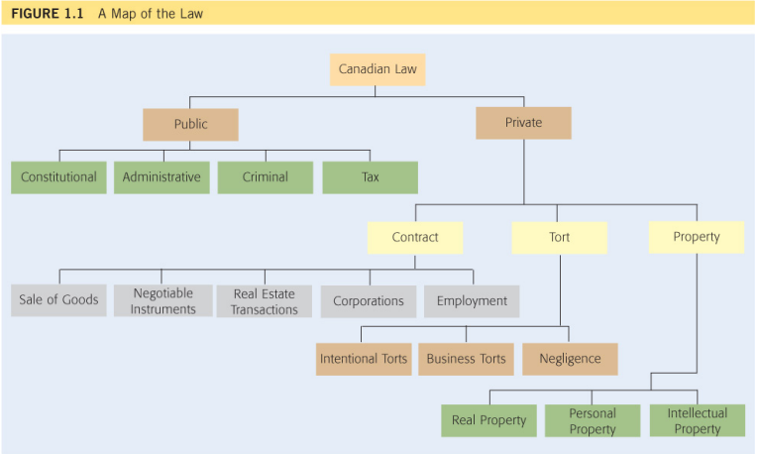

Public Law
- Public Law – is concerned with governments and the ways in which they deal with their citizens
  - Constitutional law – provides the basic rules of our political and legal systems. It determines who is entitles to create and enforce laws, and it establishes the fundamental rights and freedoms that Canadians enjoy.
  - Administrative law – is concerned with the creation and operation of administrative agencies and tribunals.
  - Criminal Law – deals with offences against the state. Concerned with people who break the rules that are designated to protect society as a whole.
    - White-collar crimes – are committed by people in suits. A manager who steals from the petty cash drawer.
    - Corporate crime – fraud…
  - Tax Law – is concerned with the rules that are used to collect money for the purposes of public spending
Private Law
- Private Law – is concerned with the rules that apply in private matters.
  - Law of tort – is a private wrong. Ex. Crime against a person
    - Intentional torts – assault or false imprisonment
    - Business tort – deceit and conspiracy
    - Negligence – carelessly hurts another person
  - Law of contracts – is concerned with the creation and enforcement of agreements.
    - The sale of goods, use of negotiable instruments, real estate transactions, operations of corporations and the employment relationship between the employer and their workers.
  - Law of property – is concerned with the acquisition, use and disposition of property
    - Real property – land and things that are attached to land
    - Personal property – things that can be moved
    - Intellectual property – original ideas
Overlap
- A single event can trigger more than one set of rules
- Some situations involve various types of law

Sources of Law

The Constitution
- The constitution – is the document that creates the basic rules for Canadian society including its political and legal systems. Two consequences:
  - 1. Every other law in the country must be compatible with it
  - 2. The constitution is very difficult to change

Divisions of Power
- Federal – Canada is a federal country because it has two levels of government
  - Parliament of Canada (Ottawa) governs the country as a whole.
    - The House of Commons – members of parliaments who are elected from every province and territory.
    - The Senate consists of senators who are appointed to their jobs
    - Queen of England remains our head of state but in reality the country is run by the political party that has the most MPs. The leader of that party is the prime minister.
- Provincial and Territorial
  - The elected body or legislature is usually called the Legislative assembly
- Sections 91 and 92 of the Constitution established a division of powers, which states the areas in which each level of government can create laws.
- Federal government has the residual power – gives the federal government authority over everything that is not specially mentioned
- A government sometimes tries to create a law outside of it own area. When it does so, it acts ultra vires, which literally means “beyond the power.” As a result of section 52 of the Constitution such laws have “no force or effect”
- The doctrine of federal paramountcy – determines which law is pre-eminent based on the Constitution’s division of power.

Charter of Rights and Freedoms
- Charter of Rights and Freedoms (1982) was introduced to protect basic rights and freedoms.
  - Democratic rights (sections 3-5)
  - Legal rights in criminal cases (8-14)
  - Official languages and minority language education (16-23)
  - Aboriginals and multiculturalism (25 & 27)
  - Business Sections
    - Fundamental Freedoms
2 Everyone has the following fundamental freedoms
- Freedom of conscience and religion
- Freedom of opinion, thought belief…
- Freedom of peaceful assembly
- Freedom of association
    - Mobility Rights
6 (1) everyone has the right to enter, remain and leave Canada
(2) Every citizen of Canada and every person who has the status of permanent resident of Canada has the right
a) To move to and take up residence in any province
b) To pursue the gaining of a livelihood in any province
    - Equality Rights
15 (1) every individual is equal before and under the law
(2) Subsection (1) does not preclude any law, program or activity including race, age, national or ethnic origin, color, religion, sex or physical disability
  - Since the Charter is part of the Constitution, any law that is inconsistent with it has “no force or effect.” DOES NOT CONTAIN PROPERTY RIGHTS
    - Ex. Business closed on Sundays law was declared invalid because it discriminates against non-Christians (freedom of religion)
- Property rights – are rights to enjoy property
- Economy rights – are rights to carry on economic activities
- Government Restrictions
  - Government Actions – The charter was introduced to govern the relationship between the individual and the state.
  - Corporations – The charter does not apply against private corporations. It is not in favor either. It depends on the circumstance
  - Reasonable limits – Section 1 of the charter states that its rights and freedoms are subject to such reasonable limits prescribed by law as can be demonstrably justified in a free and democratic society.
  - Notwithstanding Clause – Section 33 may allow Parliament or a legislature to create and enforce a law “notwithstanding” the fact that it violates the Charter

Charter Remedies
- Declaration – A court may simply declare that the Charter has been violated. The legislature must then find some solution to the problem
- Injunction – A court may take a more active role. It may impose an injunction that requires the government to address the problem in a certain way. The choice lies with the judge.
- Striking down - Going even further a court may strike down or eliminate a statute that violates the Charter. Decisions may be immediate or they may be temporarily suspended.
- Severance, reading down and reading in – Sometimes a court may save a statute by re-writing part of it. If only one part of a statute is offensive, it may be severedor cut out.
- Damages – A plaintiff who wins a private lawsuit usually receives damages for the injuries or losses that have been suffered.

Parliamentary Supremacy – means that while judges are required to interpret constitutional and statutory documents they must also obey them

Legislation – is law that is created by Parliament or a legislature
- The most important kinds of legislation are statutes or acts
- Laws created by Parliament or Legislature
  - Two categories: statutes and subordinate legislation
- Statutes: legislative process
  - Introduced as “bill”
  - Majority support through series of “readings”
  - Sometimes public consultation follows
  - Finalized by “royal assent”

Subordinate legislation – is the term given to rules that are created with the authority of Parliament or the legislature
- Created under Parliament’s or legislature’s authority
- Example of municipality (town or city)
  - Province creates municipality
  - Province gives municipality power to pass by-laws
  - By-law – is a type of subordinate legislation that is created by a municipality

The Courts (Third source of law)
- Judges play a crucial role. They must interpret and apply the words that appear in the Constitution and legislation.
- Common law
  - Systems – legal system traced back to England
  - Sources – refers to rules that are created by judges rather than by legislators or the drafters of the constitution
  - Courts – Judge made rules

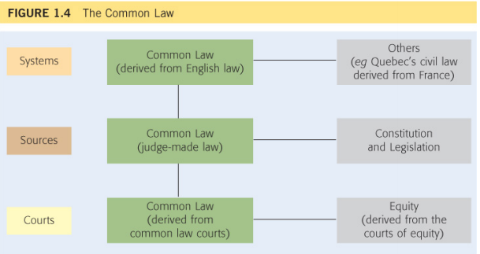

Law of Equity
- Equity – fairness
  - The Nature of Equity – judges cannot base decisions solely on equity
  - One set of courts – courts of law and courts of equity joined into one.

LAW 122 Chapter 2

The Litigation Process: Who Can Sue and Be Sued?
Who has access to the courts in Ontario? Who can be sued in an Ontario court?
- All adults, regardless of their citizenship.
- Corporations, even if they are incorporated outside of Ontario. (Remember that the law treats corporations as legal persons for some purposes.)
- Trade unions.
- Special cases:
  - Children: children can sue and be sued, but a parent or litigation guardian must represent them.
  - Adults suffering from a mental incapacity (e.g., dementia or Alzheimer’s): they can sue and be sued, but a litigation guardian must represent them.
  - Unincorporated organizations, such as clubs, amateur teams, and community groups, are generally not recognized in law as “persons”. Thus, these organizations cannot sue or be sued as an organization.
    - If you want to sue a club, you must sue individual members of the club. If members of a club wish to pursue legal action against another party, they must bring their legal action as individuals.
    - Trade unions, however, are an important exception to this rule
    - Legislation has now made it possible to sue the government under some circumstances.
- The person who initiates a lawsuit is called the plaintiff. The person being sued is called the defendant. The law suit as a whole is frequently called the action.
The Litigation Process: Class Actions

In Ontario, the Class Proceedings Act governs class actions. You should read this Act, particularly s. 1, 5, 6, and 9.

Section 1

Definitions

1. In this Act,
- “common issues” means,
- common but not necessarily identical issues of fact, or
- common but not necessarily identical issues of law that arise from common but not necessarily identical facts; (“questions communes”)
- “court” means the Superior Court of Justice but does not include the Small Claims Court; (“tribunal”)
- “defendant” includes a respondent; (“défendeur”)
- “plaintiff” includes an applicant. (“demandeur”) 1992, c. 6, s. 1; 2006, c. 19, Sched. C, s. 1 (1).

Section 5 & 6

Certification

5. (1) The court shall certify a class proceeding on a motion under section 2, 3 or 4 if,
- the pleadings or the notice of application discloses a cause of action;
- there is an identifiable class of two or more persons that would be represented by the representative plaintiff or defendant;
- the claims or defences of the class members raise common issues;
- a class proceeding would be the preferable procedure for the resolution of the common issues; and
- there is a representative plaintiff or defendant who,
- would fairly and adequately represent the interests of the class,
- has produced a plan for the proceeding that sets out a workable method of advancing the proceeding on behalf of the class and of notifying class members of the proceeding, and
- does not have, on the common issues for the class, an interest in conflict with the interests of other class members. 1992, c. 6, s. 5 (1).
Idem, subclass protection
- (2) Despite subsection (1), where a class includes a subclass whose members have claims or defences that raise common issues not shared by all the class members, so that, in the opinion of the court, the protection of the interests of the subclass members requires that they be separately represented, the court shall not certify the class proceeding unless there is a representative plaintiff or defendant who,
- (a) would fairly and adequately represent the interests of the subclass;
- (b) has produced a plan for the proceeding that sets out a workable method of advancing the proceeding on behalf of the subclass and of notifying subclass members of the proceeding; and
- (c) does not have, on the common issues for the subclass, an interest in conflict with the interests of other subclass members. 1992, c. 6, s. 5 (2).

Evidence as to size of class
- (3) Each party to a motion for certification shall, in an affidavit filed for use on the motion, provide the party’s best information on the number of members in the class. 1992, c. 6, s. 5 (3).
Adjournments
- (4) The court may adjourn the motion for certification to permit the parties to amend their materials or pleadings or to permit further evidence. 1992, c. 6, s. 5 (4).
Certification not a ruling on merits
- (5) An order certifying a class proceeding is not a determination of the merits of the proceeding. 1992, c. 6, s. 5 (5).

Section 6

Certain matters not bar to certification

6. The court shall not refuse to certify a proceeding as a class proceeding solely on any of the following grounds:
- The relief claimed includes a claim for damages that would require individual assessment after determination of the common issues.
- The relief claimed relates to separate contracts involving different class members.
- Different remedies are sought for different class members.
- The number of class members or the identity of each class member is not known.
- The class includes a subclass whose members have claims or defences that raise common issues not shared by all class members. 1992, c. 6, s. 6.

Section 9
Opting out
9. Any member of a class involved in a class proceeding may opt out of the proceeding in the manner and within the time specified in the certification order. 1992, c. 6, s. 9.
- In order to bring a class action, a representative plaintiff must take steps to have the class certified. (Certification basically means that the Court has decided to allow the claims of the individual members of a proposed class to be joined together)
- The Class Proceeding Act states that a judge will certify a class if the following requirements are met:
- There is a “cause of action” (a legitimate claim recognized by the law). The representative plaintiff does not have to prove his case during the certification phase, but he must show that there is some basis in law and in fact for the claim being made.
- Members of the proposed class must have common issues. That is, the claims of class members must involve similar (but not necessarily identical) questions of fact or law. Here are some examples:
  - The class members are all suing the same defendant in relation to the same product line or service or in relation to the defendant’s employment practices.
  - The class members all suffered the same sort of injury.
  - The class members suffered different injuries, but the injuries arose from the same incident.
  - There must be a representative plaintiff. The facts of the representative plaintiff’s case must be typical of all the members of the class.
    - They have the responsibility to have a workable plan for fairly representing the all members of the class
    - The representative plaintiff must demonstrate that he or she has a workable plan to notify all potential members of the proposed class. People are not required to be part of a class action; they are allowed to sue the defendant on their own
    - In Ontario, class actions are “opt-out”, which means that people are deemed to be included in a class action unless they specifically opt-out of participating.
  - A class action must be the preferable procedure for addressing the various claims
- As with all legal class proceedings, someone has to pay for the costs of the action, including the lawyers’ fees.
  - Section 17(7) of the Act allows a Representative Plaintiff to ask the court for an order that permits him or her to ask other members to contribute to the cost of lawyers’ fees and disbursements. The Representative Plaintiff is not entitled to any special form of compensation such as payment for the time and effort expended on bringing the class action.
  - The Class Proceedings Act also permits a lawyer to charge contingency fees in class actions. Contingency fees are fees that are only payable if the case is successful.
The Litigation Process: Legal Representation
- There are three broad options for obtaining legal representation in the litigation process:
  - You can represent yourself; you can hire a paralegal; or you can hire a lawyer.
- Clients can sue their lawyers and paralegals for carelessness (negligence) and for intentional wrongdoing. But they may not have enough money.
  - Lawyers and paralegals in Ontario are required to hold professional liability insurance. This insurance provides compensation to clients who have suffered losses as a result of a lawyer’s or a paralegal’s carelessness.
  - The Law Society also maintains an Assurance Fund to compensate people who have suffered losses as a result of a lawyer’s or a paralegal’s dishonest conduct.
The Litigation Process: An Overview of the Life of a Legal Action

The basic steps in a legal action are set out below.
Cause of Action occurs.
- Action must be commenced within applicable limitation period

Pleadings
- The parties exchange various filings that outline the issues that they will raise at trial and the facts upon which they will rely.

Pre-trial Activity
- Parties have the opportunity to "discover" each other's case through the exchange of documents and pre-trial examination of witnesses, which occurs under oath. Discovery gives the parties an opportunity to evaluate the relative strength of the other party's case and to gauge how much the claim is really worth.
- Parties have a pre-trial conference in which they meet with a judge. The judge may give the parties a frank assessment of which side is likely to win if the case goes to trial. This gives the potential losing party more incentive to settle.
- In some cases, there is court-mandated mediation.

Determination of Claim
- The parties either settle or the case goes to trial. The vast majority of cases settle before trial.
- If the case goes to trial, the plaintiff must prove its case on a balance of probabilities. In other words, every important part of the plaintiff's claim must be shown to be more likely true than not. (The claim must be probably true.)
- At trial, the defendant is found either liable (and therefore responsible) or not liable. If the defendant is held liable, the plaintiff will be awarded a remedy. The most common remedy is compensatory damages.

Enforcing the Judgment
- If the plaintiff wins an award of damages, the defendant becomes a judgment debtor. The plaintiff now has the difficult task of getting its money from the defendant.

Appeals
- In some cases, a party may appeal all or part of a judgment. This means that the party (called an appellant) asks a higher court to review the case and to decide if the judge made the correct legal decision. Appeals are very different from trials. See Figure XX below for more details.

- There are rules that require that claims be made and that various pleadings are filed in a timely way.
- Limitation Periods: Limitation periods are the period of time within which an action must be started. Legal claims must be made within a certain period of time or the court will not allow the claim to proceed. These time periods are governed by statute, and can range from six days to 21 years. Most common is in Ontario is 2 years from the date on which the plaintiff should have become aware that he or she had a claim against the defendant.
  - If the plaintiff misses the limitation period, she still has a claim…but she cannot enforce that claim through the courts unless there are very special circumstances - this means that the plaintiff likely will not be able to get a remedy.
  - A special exception applies to debts, however. If a debtor acknowledges a debt after the limitation period expires, the creditor may bring an action to recover the outstanding monies even though the limitation period has passed
- Pleadings: There are strict limits on the time that each party has to respond to the other’s pleadings. The failure to file your pleadings in response to the other party’s pleadings could have disastrous results.
If you are served with a statement of claim or other form of pleading, you should immediately contact your lawyer. Do not wait. There are serious consequences to missing filing deadlines.

The Litigation Process: Remedies and Enforcing Judgment
- If the plaintiff wins its case at trial, the plaintiff will be entitled to a remedy.
- In civil litigation, the most common remedy is compensatory damages. Other remedies, along with a brief description of these remedies, are set out in the table below.
Remedy | Description | Example
Compensatory damages | Pay the plaintiff money to compensate for the plaintiff’s loss | Provide an injured plaintiff with the amount he lost as a result of not being able to work and the amount spent on medical bills
Punitive damages | Pay the plaintiff money as a means of punishing the defendant for acting very badly | Punish an insurance company that made up allegations of arson in order to avoid paying a benefit under an insurance policy
Nominal damages | Pay the plaintiff a very small amount of money (e.g., $1) to recognize symbolically that the defendant acted wrongfully even though the plaintiff did not suffer any loss | Recognize the right of a store that sued for trespass even though the unwanted customer did not do any harm
Specific performance | Order the defendant to fulfill a contractual promise  ***equitable remedy | Force a defendant who promised to sell a piece of land to the plaintiff to go through with the sale
Injunction | Require the defendant to act in a certain way (e.g., to do something or to stop doing something)  ***equitable remedy | Force the defendant to stop cutting through the plaintiff’s backyard or force a construction company to remove its equipment from a neighbour’s property
Rescission | Terminate a contract  ***equitable remedy | Eliminate a contract that was created by a con artist who tricked an elderly couple into signing

- Once a defendant has been found liable and ordered to pay damages, the defendant becomes a judgment debtor (because the defendant owes the plaintiff a debt pursuant to a judgment). If a judgment debtor does not pay, the plaintiff has a few options.
  - The plaintiff can garnish the judgment debtor’s income by getting a court order that requires the debtor’s employer to pay a portion of the debtor’s wages to the plaintiff.
  - The plaintiff can also get a court order to seize and sell some of the judgment debtor’s assets, such as land, vehicles, computers, or other equipment. – cannot be stripped bare
The Litigation Process: Costs

- Litigation is expensive. The costs of an action include lawyers’ fees, disbursements (e.g., charges for photocopying), and filing fees.
- The general rule is that the losing party pays the costs of the winning party, although the costs that are awarded are set using specific formulae that do not reflect the actual costs of the litigation.
  - Typical cost award covers between 40 to 50 percent of the actual costs of litigation, although in unusual cases the award may be as high as 70 to 80 percent. Thus, even if you win at trial or on appeal, you will still have to pay a portion of your own costs. Moreover, cost awards do not cover the internal costs of litigation.
- Contingency fee agreements can reduce the risk associated with the high costs of litigation. When a client has a contingency fee agreement with a lawyer, the client only has to pay the lawyer’s fees if the lawsuit is successful.
  - You will pay high legal fees if successful
The Litigation Process: Appeals
- In some cases, the losing party may appeal to a higher court. During an appeal, a higher court (the appellate court) will decide whether a mistake was made in the court below.
  - The party that appeals the lower court’s decision is called the appellant and the party that seeks to uphold the lower court’s decision is called the respondent.
- In Ontario, certain trial decisions can be appealed to the Superior Court as a matter of right, but virtually all cases appealed to the Ontario Court of Appeal require the leave of the court to proceed and all cases heard by the Supreme Court of Canada require the leave of the court. “Leave” means that the appellate court must give its permission for a party to bring its appeal before that court.
- Appellate courts focus on the law, not on the facts. The issue before appellate courts is whether the lower court made a legal error. As a general rule, appellate courts accept the factual findings established at trial. Do not focus on witnesses and evidence.
- The appellate court may affirm (i.e., uphold) the decision of the lower court; reverse the decision of the lower court; vary the decision of the lower court; or order a re-trial.

The Court System: The Courts in Canada
- Each province has its own court system that is separate from the courts in other provinces. In addition, the federal government has its own court system to address matters that come within federal jurisdiction under s. 91 of the Constitution
- The Supreme Court of Canada is the highest court throughout Canada; it sits at the top of the court hierarchy in every province and in the federal court system.
- Canadian courts are arranged in a specific hierarchy according to their importance.
The Federal Court System Hierarchy

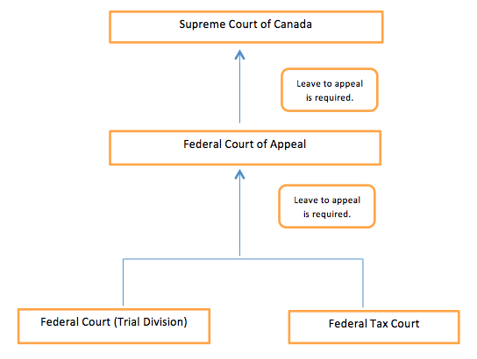
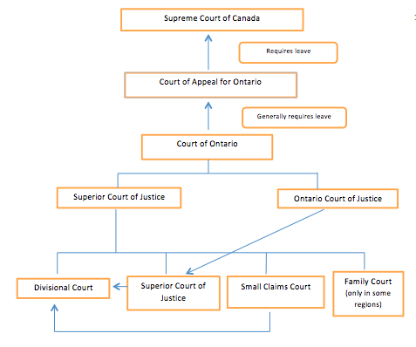
Small Claims
- Small Claims Court serves a special function in Ontario and other Canadian provinces. These types of courts deal with claims that involve a limited amount of money. In Ontario, the current limit for a small claims case is $25,000. This means that the maximum amount of damages that the Court can award is $25,000. A plaintiff who has suffered a loss of $30,000 may still bring an action in Small Claims Court; however, the plaintiff will only receive a maximum of $25,000 and will have to abandon his claim for the remaining $5000.
- Small Claims Court is generally faster, simpler, and less expensive than trials brought in the Superior Court of Justice. The rules of evidence are relaxed and the filing fees for things like a Statement of Claim are less than in other courts.
- Some drawbacks
  - Types of Remedies: Small claims courts in Ontario do not have equitable jurisdiction and thus they cannot award equitable remedies such as injunctions or specific performance.
  - Monetary Limits: Small claims courts can only hear small claims, and what counts as a “small claim” is defined in terms of the amount of money at stake. These courts have no jurisdiction to award damages in excess of the small claim limit.
  - Types of Claims: As a general rule, small claims courts mostly deal with cases in which the plaintiff is suing for either a limited amount of money or the return of a piece of property that the plaintiff already owns.
  - Geographical limits: Certain geographical limits apply, including procedural rules about where a small claims court action must be started.

The Court System: Court Hierarchy and the Doctrine of Precedent
- Judges are bound by the doctrine of precedent, which means that the court must follow the decisions of any court that is above it in its hierarchy.
- The Ontario Court of Appeal must follow the decisions of the Supreme Court of Canada, but not the Ontario Superior Court, the Federal Court of Appeal, or the court of appeal from any other province.
- The Ontario Superior Court of Justice is bound by the decisions of the Supreme Court of Canada and the Ontario Court of Appeal since both of these courts are above the Superior Court in the Ontario hierarchy.
- Decisions from courts in other jurisdictions (provincial, federal, or even from other countries) are considered persuasive but not binding. In other words, a judge can consider the decisions from courts outside of her court’s hierarchy and she can choose to apply those decisions, but she is not bound to do so.
- The provincial court hierarchies are not part of the federal court hierarchy, and vice versa. For the purposes of the doctrine of precedent and court hierarchies, a decision of the Federal Court of Appeal carries the same weight as the decision of another province’s court of appeal in Ontario: the decision is persuasive but not binding.

Administrative Tribunals
- Administrative tribunals are bodies that exercise power delegated to them by the government for specific purposes.
- These tribunals administer various statutes, that is, they enforce the statutory and regulatory requirements and resolve disputes related to the application of the statute.
- In terms of their character, tribunals fall somewhere between the government and a court.
- Examples of tribunals include the Ontario Human Rights Tribunal, the Competition Tribunal, the Labour Board of Ontario, and the National Parole Board.
Alternative Dispute Resolution
- Alternative Dispute Resolution (ADR) is any process that allows parties to resolve their dispute without going to court. ADR offers alternatives that can preserve business relationships and expedite the settlement of a dispute, often at a much lower cost to the parties than litigating the dispute in court.
- There are three major types of ADR: negotiation, mediation, and arbitration.
  - In a negotiation, the parties to the dispute attempt to resolve their differences through discussion and direct bargaining. This is the most common form of ADR. Its advantages include:
- It is usually quicker, less complicated, and less expensive than litigation and other forms of ADR.
- The parties are in control of the process and decide the outcome themselves.
- It can preserve relationships and allows the parties to stay on good terms with each other.
- It is a private procedure and therefore can be used to avoid bad publicity.
- Negotiation also has some disadvantages. They include:
- If a dispute has already become acrimonious, negotiation likely won’t be successful since it requires the parties to cooperate.
- There are no set time limits for resolving a matter by negotiation. Parties can therefore drag a matter out in the hopes that the other party will give up, lose interest, or run out of resources.
- Inequalities of bargaining power can result in unfair settlements.
- Confidentiality may not be the desired outcome. A person may want others to know about the defects in a particular product.

- Mediation is similar to negotiation, except in mediation, the parties are assisted by a neutral third party, called a mediator, to settle their dispute.
- The mediator effectively acts as a bridge between the parties and helps the parties to find common ground.
- This may involve meeting with the parties together or separately, clarifying information, outlining the issues for the parties, listening to the parties, discussing the relative strengths and weaknesses of each parties’ position, and suggesting possible solutions.
- A key characteristic of mediation is that it is not binding.
- Consequently, like negotiation, mediation does not offer a conclusive end to a dispute since a decision cannot be imposed on the parties.

- Arbitration is a process in which a neutral third party, called an arbitrator, imposes a decision on the parties to a dispute. With very few exceptions, arbitration is binding and thus offers a conclusive end to a dispute.
- However, the arbitration process is typically much less formal than court proceedings, which makes the process faster and cheaper than litigation.
- Parties retain some degree of control in arbitration since they typically select the person who will arbitrate their dispute.
- As a general rule, the decision of the arbitrator will be binding upon the parties and the parties will have to obey this decision. Moreover, the parties will have to comply with the process and procedures established for the arbitration.
- One advantage to arbitration is that it can be used to resolve high complex disputes by someone who has expertise in the subject matter of the dispute. Sometimes the resolution of a dispute requires a decision-maker who understands the complexities of the issues in disputes. In such cases, arbitrations can be effective since the parties can select an arbitrator with the specialized expertise necessary to hear their case.

Law Chapter 3 – Torts

Introduction to Tort Law
- A tort generally consists of a failure to fulfill a private obligation that was imposed by law
- French word meaning “wrong” – which came from Latin word “tortus”

Torts and Crimes
- A tortfeasor is a person who has committed a tort
- Example – I owe you can obligation personally to not make defamatory statements about your past. If I were to tell your employer you were convicted of murder. I would be a tortfeasor and they would be able to sue me.
- A tort occurs when a person breaks a private obligation, a crime occurs if a person breaks a public obligation.
  - Examples:
    - If I hit you, I will commit the tort of batter and the crime of assault.
    - If I take your car, I commit the tort of conversion and the crime of theft.
    - If I sneak into your house, I commit the tort of trespass to land and the crime of break and enter
Torts and Contracts
- One similarity and four differences between torts and contracts
  - Structure (similarity) – Both tort and contracts involve primary and secondary obligations. Primary obligations tell people how they ought to act and secondary obligations tell people how they must act
  - Source of Primary Obligations (diff) – Obligations in tort are simply imposed by law. Obligations in contract are created by parties
  - Privity (diff) – Only people who can sue or be sued on a contract are the parties themselves. In tort there is no need for parties (because it is imposed by law)
  - Compensation (diff) – Available in both contract and tort but calculated differently for each. The purpose of imposing obligations in tort law is to prevent harm. The purpose of imposing obligations in contracts is to provide benefits. Torts look backward and contracts look forward
  - Risk Management (diff) – Tort obligations are imposed by law, they are more likely to take a person by surprise and they may require more than a person is actually capable of providing. Because obligations in contract are created voluntarily, they should never take by surprise and they should never have to pay more than they have.

Types of Torts
- Torts require balance of competing interests
  - Protecting free choice vs deterring harmful behavior
  - Encouraging innovation vs compensating losses
  - Physical harm vs economic loss
- Torts differ on basis of mental culpability
  - Intentional – Knew what you were doing
  - Negligence - Carelessness
  - Strict liability – when someone did something wrong but without intention
    - Strict = liability without intention or negligence
    - Liability based on responsibility for prohibited event but subject to defense of voluntary assumption of risk
    - Restricted to unusually dangerous activities
    - Activity permitted but liability for any harm

General Principles of Tort Law
- Liability Insurance – is a contract in which an insurance company agrees, in exchange for a price, to pay damages on behalf of a person who incurs liability
- It also includes a duty to defend – requires the insurance company to pay the expenses that are associated with lawsuits brought against the insured party
- Liability insurance creates an interesting tension between two of tort laws most important functions
  - Liability insurance contributes to the compensatory function (aims to fully compensate people who are wrongfully injured) of torts
  - Liability insurance undermines tort law’s deterrence function (discourages people from committing torts by threatening to hold them liable for the losses they cause

Vicarious liability
- Vicarious liability – occurs when an employer is held liable for a tort that was committed by an employee.
- Justifications for vicarious liability
  - Enhances compensatory function by allowing the plaintiff to claim damages from both an employee and an employer
  - May enhance deterrence function by encouraging employers to avoid unusually hazardous activities and to hire the best people available
  - Fairness: business bears cost of operation
- Employer is not liable every time an employee does something wrong – only in workplace
- Independent contractor – is a worker who is not as closely connected to the employers business as in an employee
- Vicarious liability does not relieve the employee of responsibility rather it allows the plantiff to sue both the employer and the employee
- An employer can be vicariously liable or personally liable in the same situation

Remedies
- Compensatory damages
  - Defendant is required to pay for the losses that it caused
  - Compensation in tort is designed to put the plaintiff back into the position that that party enjoyed before the tort occurred, compensation contracts usually designed to put the plaintiff forward into the position that that party expected to enjoy after the contract was performed
  - Remoteness – A loss is remote if it would be unfair to hold the defendant responsible for it
    - No liability if loss reasonably unforeseeable by defendant
    - Rule inapplicable to intentional torts
- Mitigation – occurs when the plaintiff takes steps to minimize the losses that result from the defendants tort (Example page 71)
  - No liability if loss reasonably avoidable by plaintiff
- Punitive damages – are intended to punish the defendant
  - Punish outrageous or reprehensible behavior
  - Less common and less generous than in America
  - Nominal damages – symbolically recognized that the defendant committed a tort even though the plaintiff did not suffer ant loss
    - Symbolically recognize commission of tort
    - Awarded for some torts if plaintiff suffered no loss
- Injunctions (non-monetary award) – is a court order that requires the defendant to do something or refrain from doing something

Alternative Compensation Schemes
- An alternative compensation scheme is a system that allows a person who has suffered an injury to receive compensation without brining an action in tort. 2 systems are especially important:
  - Workers compensation
  - No-fault insurance
- Two main reasons for the rise of alternative compensation
  - Provides compensation only a person is injured as a result of a wrongful fact
  - Tort law is inefficient

Law Chapter 4 – Intentional Torts

- Intentional Torts – involve intentional, rather than merely careless conduct.
  - Assault, battery, invasion of privacy, false imprisonment, trespass to land, interference with chattels
  - It is enough if the defendant knew that a particular act would have consequences, the plaintiff does not have have to prove that the defendant intended to either cause harm or commit a tort.

Assault and Battery
- Assault – occurs when the defendant intentionally causes the plaintiff to reasonably believe that offensive bodily contact is imminent.
  - Not based on physical contact, it based on a reasonable believe that such contract will occur. Swing a fist and not making contact could be assault.
  - It is enough that the plaintiff reasonably believed that bodily contact would occur: As a result, you may commit an assault by pointing a gun in my direction.
  - Must be reasonable immediate (imminent)
  - Assault can occur even when the plaintiff was not frightened
- Usually not worth the price of litigation so it is usually joined with a claim for battery
- Battery – consists of offensive bodily contact
  - It is enough for if the defendant causes something, such as a knife, to touch the plaintiff, or their clothes or something they are holding.
  - Not every form of contact is offensive. If you gently brush past me it is okay but if you kiss me than that can be battery
- Good to know assault and battery for companies that deal with large crowds

Invasion of Privacy
- Tort law has not caught up to knew technology (camera phones, broadcasting tv online)
- There is no general tort of invasion of privacy because the courts want to support freedom of expression and freedom of information. They care concerned about defining the concept of privacy in a way that strikes a fair balance between the parties. They have trouble calculating compensatory damages such as embarrassment.
- Still covered indirectly under several torts
  - Trespass to land – someone comes to your yard and takes pics
  - Breach of confidence – employee posted detailed personal info about boss on internet
  - Private information – Naomi Camble sue newspaper for posting pics of her coming out of NA meeting.
  - Misappropriation of personality – using unauthorized celebrity pics to sell own product
  - Negligence – newspaper ignoring judge and posting names in trial

False Imprisonment
- False imprisonment - occurs when a person is confined within a fixed areas without justification
  - An actual prison is not necessary (pretty much can be trapped anywhere – cant easily escape)
  - Physical force is not necessary, the detention may be psychological
  - A business reduces risk by calling a police offer to make the call but there still can be some risk
  - Even though the business did not direct a police officer to make an arrested (cannot be held liable for false imprisonment), it may be liable for tort of malicious prosecution – occurs when the defendant improperly causes the plaintiff to be prosecuted.
    - The court has to be satisfied (i) the defendant started the proceedings, (ii) out of malice or for some improper purpose and (iii) without honestly believing on reasonable ground that a crime had been committed and that (iv) the plaintiff was eventually acquitted of the alleged crime.
- Content – is a complete defense to all intentional torts.
- An imprisonment is only false if it is done without authority. Basic rukes are found in criminal code
  - A police officer may arrest anyone who is reasonably suspected of (i) being in the act of committing a crime or (ii) having committed a serious crime in the past. If that test is satisfied, the police officer cannot be held accountable.
  - A private citizen (security guards) is entitled to make an arrest only if a crime is actually being committed by the suspect

Trespass to Land
- Trespass to land – occurs when the defendant improperly interferes with the plaintiffs land.
  - If a customer refuses to leave your store at closing you can use reasonable force to remove them but be careful of battery
  - You can be arrested for trespassing, in fact 30,000 arrests were made over past 20 years
  - Usual remedy for a trespass to land is compensation for the harm it caused.

Interference with Chattels
- Chattels – are moveable forms of property. Most important:

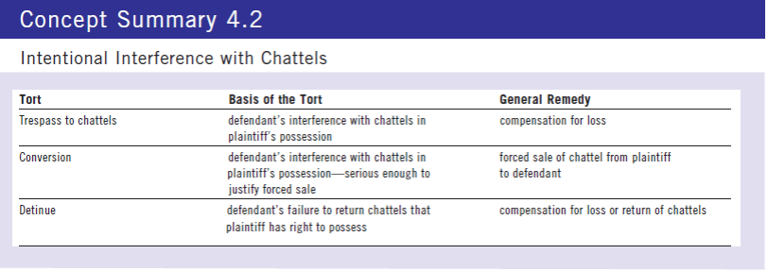

- Conversion –Courts consider all of the facts including:
  - The extent to which the defendant exercised ownership
  - “ “ intended to assert a right that was inconsistent with the plaintiff’s right to the property
  - The duration of the defendants interference
  - The expense and inconvenience caused to plaintiff
- Detinue
  - Tort comes to an end when the defendant returns the property to the plaintiff
  - If the property is not given by time of trial, the plaintiff can ask the court to compel the defendant to do so. It is the only tort that allows court to ask defendant to return property
  - The right of reception – allows a person to take their own property back

Defenses to Intentional Torts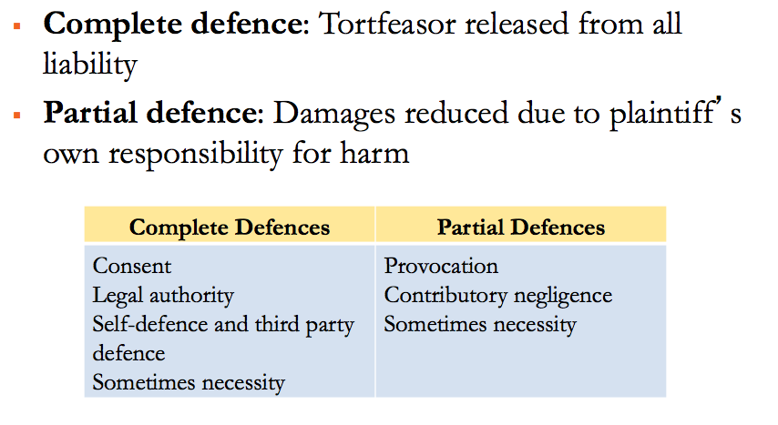
Complete Defense – protects the tortfeasor from all liability
- Consent – exists if a person voluntarily agrees to experience an interference with their body, land or goods.
- Legal Authority – provides a person with a lawful right to act in a certain way
- Self Defense – consists of the right to protect oneself from the violence and the threat of violence
- Necessity – applies if the defendants act were justified by an emergency

Partial Defenses – allows a court to reduce damages on the basis of the plaintiff’s own responsibility for a loss or an injury
- Provocation – consists of words or actions that would cause a reasonable person to lose self-control
- Contributory Negligence – occurs when the plaintiff is practically reasonable for the injury that the defendant tortuously caused

Lecture
Intrusion upon seclusion Elements – intention to intrude upon plaintiffs private affairs (some expectation of privacy)
- The defendants’ actions were intentional or reckless
- The defendant invaded the plaintiff’s private affairs or concerns without lawful justification
- Reasonable person would regard the invasion as highly offensive, causing distress, humiliation or anguish
- No need to establish hard to a recognized economic interest
- Damages will be modest

Law Chapter 5- Miscellaneous Torts Affecting Business

Conspiracy
- Conspiracy – usually occurs when two or more defendants agree to act together with the primary purpose of cause the plaintiff to suffer a financial loss.
  - Tort of conspiracy is hard to prove
  - The courts are reluctant to find that the defendants co-operated for the primary purpose of hurting the plaintiff
  - If the defendant’s actions were otherwise lawful, then conspiracy is difficult to establish because the court will require proof that the defendant’s primary purpose was to hurt the plaintiff.
  - If the defendant’s actions were unlawful then they might have committed a tort so the court will only require that the defendant’s should have known their actions might hurt people.

Intimidation
- Intimidation - Occurs when the plaintiff suffers a loss as a result of the defendants threat to commit an unlawful act against either the plaintiff or a third part
  - Loss results from threat to commit unlawful act
  - Plaintiff must prove
    - Threat to break duty in tort, contract, or crime
    - Intimidated party submitted to threat
  - Plaintiff need not prove defendant intended to cause
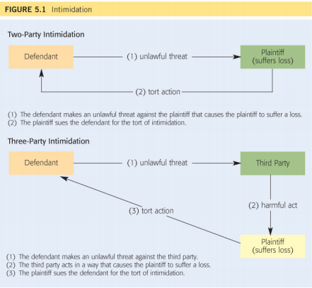
    - Loss or damage

- Two-party intimidation – occurs when defendant directly coerces the plaintiff into suffering a loss
- Three-party intimidation – occurs when the defendant coerces a third party into acting in a way that hurts the plaintiff
- The basic rules stay the same
  - Plaintiff must prove that the defendant threatened to commit an unlawful act, such as a crime, a tort, or even a breach of contract.
  - The tort does not occur unless the threatened party gave in to the intimidation
  - As long as other elements of the tort are established, there is no need to prove the defendant indented to hurt the plaintiff

Interface with Contractual Relations
- Interface with Contractual Relations – occurs when the defendant disrupts a contract that exists between the plaintiff and a third party
  - Direct inducement to breach of contract – occurs when the defendant directly persuades a third party to break its contract with the plaintiff. Requires 4 factors:
    - The defendant must know about the contract that exists between the third party and the plaintiff. The defendant does not have to know all details
    - The defendant must intend to cause he third party to breach that contract. The defendant does not have to intent to hurt the plaintiff.
    - The defendant must actually cause the third party to breaks its contract with the plaintiff.
    - The plaintiff must suffer a loss as a result of the defendants conduct.
  - Indirect inducement to breach of contract – occurs when the defendant indirectly persuades a third party to break its contract
    - Liability depends on the same factors above PLUS proof that the defendants actions themselves were unlawful

Unlawful Interference with Economic Relations
- Unlawful Interference with Economic Relations – may occur if the defendant commits an unlawful act for the purpose of causing the plaintiff to suffer an economic loss
  - Example - Plaintiff sold calendars to health care professionals. Calendar also has ad spots for drug companies. When the defendant said the calendars contravened its code of conduct the business took a large blow. It was untrue - plaintiff won.

Deceit
- Deceit – occurs if the defendant makes a false statement, which it knows to be untrue, with witch it intents to mislead the plaintiff, an which causes the plaintiff to suffer a loss
  - First the defendant must make a false statement. That requirement is easily met if the defendant says or writes something that is positively untrue. But there are other ways…
    - Caveat Emptor “ let the buyer beware” – the buyer is responsible for asking questions
    - Half-truth
    - Failing to update information
  - Second the defendant must know, at the time of making the statement, that it is false.
  - Third, the defendant must make the statement with the intention of misleading the plaintiff.
  - The plaintiff must suffer a loss as a result of reasonably relying on the defendants statement
    - The defendant’s statement normally has to refer to a past or present fact.
    - Occasionally a statement of fact may be implied by an opinion, a prediction or a puff.
Occupiers’ Liability
- Occupiers’ liability – requires an occupier of premises to protect visitors from harm
  - An Occupier – is any person who has substantial control over premises
  - A visitor – is any person who enters onto premises
  - Premises – include more than land
  - Common Law Rules
    - Trespassers, licensees, invitees and contractual entrants. Number of problems with traditional system
      - First, It can lump together different types of people
      - Second, it is often difficult to distinguish between the different categories
      - Third, a visitor’s status may change from one moment to the next.
      - Fourth, it often is difficult to decide whether a danger is hidden or unusual.
      - They have modified these common law rules
        - An occupier must do more than simply refrain from intentionally or recklessly hurting a trespasser. The occupiers obligations are determined by a number of factors:
          - The age of trespasser
          - The reason for trespasser
          - The nature of the danger that caused the injury
          - The occupier knowledge of that danger
          - The occupiers cost of removing that danger
        - Licensees and invitees are now generally treated the same
  - Statutory Rules
    - Note the most important differences between the common law and the legislation
      - First, the common law generally applies only to dangers that are created by the condition of the premises. The legislation also applies to activities that occur on the premises
      - Second, the standard of care no longer depends upon a visitor’s classification. An occupier must use reasonable care, which depends upon a number of factors, including:
        - The potential danger to the visitor
        - The occupier’s cost of removing the danger
        - The purpose of the visit
        - The nature of the premises
      - Third, the statutes generally allow an occupier to avoid liability by issuing a warning
      - Fourth, under the common law, a landlord generally cannot be held liable for injuries that a person suffers while visiting a tenant. The primary reason is that a landlord has ownership, but not control, over the premises and therefore is not an occupier

Nuisance
- Nuisance – occurs when the defendant unreasonably interferes with the plaintiff’s use and enjoyment of its own land.
  - A nuisance occurs if the defendant interferes with the plaintiff’s use of its land. Interference can happen in many ways. Simple cases involve physical damage to the plaintiff or its property
  - Can also occur if the defendant creates a smell or a sounds rgar impairs the enjoyment of the plaintiffs property
  - It may even be possible to commit in non-intrusive nuisance, without causing anything to travel onto the plaintiffs property
  - Certain types of activities generally will not support a clain in nuisance:
    - The defendant builds something on its own property that ruins the plaintiffs view of a lake
    - The defendant paints its building a color that reduces the market value of the plaintiff house
  - A nuisance occurs only if the defendant interference is unreasonable. It is unreasonable if it causes physical damage. The courts also consider:
    - The nature of the neighborhood
    - The time and day of the interference
    - The intensity and duration of the interference
    - The social unity of the defendants conduct
    - The defendants motivation
  - Defenses to Nuisance
    - Statutory authority – means that the defendant caused a nuisance while acting under legislation
  - Remedies for Nuisance
    - Most common are compensatory damages (regular rules apply) and injunctions

The Rule in Rylands v Fletcher
- The rule in Rylands v Fletcher – states that the defendant can be held strictly liable for a non natural use of land if something escapes from it property and injures the plaintiff
  - First, the defendant must have made a non-natural use of it land. Some courts say that it refers to any use of land that creates a special danger; others say that the defendant must cerate a special and unusual danger.
  - Second, something associated with a non-natural use must escape from the defendants land and cause the plaintiff to suffer a loss
  - Third, most torts are based on some from of fault. The defendant is usually liable only if it intentionally or a least carelessly caused the plaintiff injury. A defense may be available in exceptional circumstances:
    - The plaintiff may be consented to the defendant’s non-natural use of it land
    - The escape may be been caused by a third party or a natural force that the defendant could not have guarded against
    - The plaintiff injury may have been the inevitable result of an activity tha the defendant was statutorily authorized to do

Defamation
- Defamation – occurs when the defendant makes a false statement that could lead a reasonable person to have a lower opinion of the plaintiff
  - First, it can be satisfied even if the defendant did not intend to refer to the plaintiff
  - A claim for defamation can be made by any sort of living person
  - Defamation may be difficult may be difficult to prove if the defendant made a statement about a group of individuals
- Lawyers sometimes draw a distinction between slander and libel
  - Slander – is a defamatory statement that is spoken
  - Libel – is a defamatory statement that is written
- There cannot be defamation without publication
  - Publication – occurs when a statement is communicated to a third party

Defenses to Defamation
- Justification – occurs if the defendants statement is true
- Privilege – is an immunity from liability
  - Absolute privilege provides complete immunity
  - Qualified privilege permits persons in positions of authority or trust to make statements or relay or report statements that would be considered slander and libel if made by anyone else
- Public Interest Responsible Journalism – occurs when a journalist, despite getting some facts wrong, acted in accordance with the standards of responsible journalism in publishing a story that the public was entitled to hear.
- A fair comment – is an expression of an opinion regarding a matter of public importance
  - First the defense is intended to protect informed decisions
  - The defendants opinions must concern an issue of public interest such as a cultural, religious or political matter.
  - The defense applies as long as the opinion in question could honestly be held
- Remedies
  - Usually compensatory damages to repair losses and sometimes for personal distress
  - Sometimes punitive damages for outrageous conduct
  - Injunction to prevent defamation
    - Rarely awarded due to concern for free speech
    - Requires clear evidence that defamation is likely

Injurious Falsehood
- Injurious Falsehood – occurs when the defendant makes a false statement about the plaintiff’s business that causes the plaintiff to suffer a loss.
  - Slander of Title
  - Slander of Quality
- Must prove three elements
  - Defendant made false statement to third party
  - Defendant acted out of malice
  - Persuasive evidence that false statement caused loss

Law Chapter 6 – Negligence

- Tort of Negligence – determines whether the defendant can be held liable for carelessly causing injury to the plaintiff. The tort of negligence requires the plaintiff to prove that the defendant:
  - Owned a duty of care, in that it was required to act carefully toward the plaintiff
  - Breached the standard of care by acting careless
  - Caused harm to the plaintiff
- Defendant may be able to avoid liability by proving a defense. Three possibilities: The defendant may show that the plaintiff…
- Was guilty of contributory negligence that caused or contributed to the injury
- Voluntarily assumed the risk of bring injured by the defendant
- Was injured while engaged in some form of illegal behavior

Duty of Care
- Duty of Care – exists if the defendant is required to use reasonable care to avoid injuring the plaintiff
  - If there is not duty of care, there cannot be liability, even if the defendant carelessly injured the plaintiff.

Test for Determining the Existence of Duty of Care
- Based on Donoghue v Stevenson (p. 131) the Canadian Courts have developed a unique test for the creation of a duty of care
- Facts
  - Donoghue visited café and drank ginger beer that had a decomposed snail and got sick
- Legal Issue
  - Should the manufacturer owe a duty of care to consumer (if someone who it did not sell to)?
- Holding
  - If the D can reasonably foresee that their actions or omissions are likely to injure the person affected, then D ought reasonably to have them in contemplation when directing its mind to the acts or omissions in question.
- The judge will first ask whether or not the duty of care question has already been answered for the particular type of case that is being litigated
  - If the question has not been answered then it is necessary to ask 3 questions:
- Was it reasonably foreseeable that plaintiff could be injured by defendant’s action?
- Was there sufficient proximity between parties?
  - Special rules apply to careless statements
- If yes to first two questions, should duty be denied for policy reason?
Reasonable Foreseeability
- Objective Test
  - “would reasonable person have foreseen risk of loss?”
    - sufficient if not far-fetched (even if not probable)
- Purpose of requirement: fairness
  - unfair to hold defendant liable for every loss
    - impossible to prevent unforeseeable event
  - unfair to deny liability for subjective deficiencies
  - (i.e. D didn’t know)
    - plaintiff entitled to expect reasonable conduct

Proximity
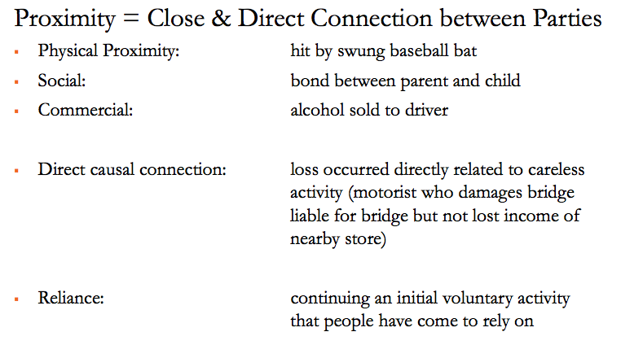
Duty of Care for Professional Statements
- Negligent statements are a common business risk
- Most lawsuits involving complaints about professional advice involve claims of careless statements
  - Legal advice regarding actionable claims
  - Auditing advice regarding management of companies
  - Medical advice regarding medication
  - Investment advice regarding health of companies
- Liability more likely if
  - defendant claimed special knowledge
  - statement communicated on serious occasion
  - statement made in response to inquiry
  - defendant received financial benefit
  - statement of fact rather than pure opinion
- Liability less likely if
  - statement accompanied by disclaimer
- Test for duty of care existing for statements
  - Defendant knew that plaintiff, either individually or as member of defined group, might rely on statement, and
  - Plaintiff relied on the statement for its intended purpose
- Risk management
  - Be careful about providing information and advice
  - Use disclaimers
  - Be careful relying on statements made by others
Duty of Care and policy
- Sometimes hard to distinguish proximity from policy
  - Proximity: focus on parties’ relationship
  - Policy: focus on effect existence of duty would have on society and legal system.
  - Courts ask if recognition of duty would:
    - Open the floodgates
    - Interfere with political decisions
    - Hurt a valuable type of relationship

Breach of the Standard of Care
- Standard of care – tells the defendant how it should act
- The standard of care is breached – when the defendant acts carelessly
- The reasonable person test – requires the defendant to act in the same way that a reasonable person would act in similar circumstances.
  - objective test
    - defendant cannot hide behind own deficiencies
    - plaintiff entitled to expect reasonable conduct
    - standard applied at time of alleged breach (no hindsight)
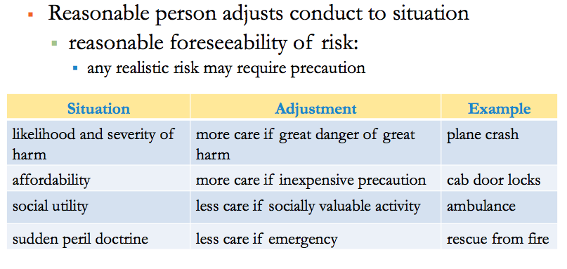

The Standard of Care for Professionals: Professional Negligence
- Reasonable Professional
- Professional people must live up to the training that they received or have claimed to receive
- More may be expected out of a specialist than a generalist
- Special allowances are not made for beginners
- It is unfair to judge someone in hindsight
- Carelessness is different than mere errors of judgment
- A professional that follows an approved practice generally cannot be held liable
- Compliance with a statutory standard may protect a defendant

The Standard Care for Manufactured Products: Product Liability
- Product Liability – can occur when a person is injured by a product
- Injury caused by manufactured products
  - American courts, product liability uses strict liability
    - manufacturer liable for any defects
  - Canadian courts use negligence
    - manufacturer liable only for careless defects
- In product liability actions, easy to prove duty is owed, so case usually turn on whether standard was breached
- Types of product liability
  - careless manufacture of specific item
    - liability is likely to be imposed
  - careless design of product line
    - widespread issue: narrower scope of liability based on balancing
  - careless failure to warn of risk of harm
    - specific requirement reflects circumstances
    - manufacturer, seller, or installer may be liable
    - learned intermediary rule” in appropriate situations
- Examples
- Design: design flaw with the product – should have been detected from an early stage in a product’s development.
  - Vitek TMJ Implants – used teflon (known to cause immunological issues but failed to do research and failed to recall)
- Manufacturing: Production process had some kind of error that wasn’t noticed during quality control.
  - Would a reasonable person have used a similar manufacturing process? Available standards; known risks & available precautions
- Warning: quality product but fails to give accurate warnings that regulate the use of the product.
  - Product not to be used by children under a certain age (need clear writing on product packaging)

Causation of Harm
- Liability only if breach of standard caused loss
- Causation involved a two-step inquiry
  - step 1: factual causation, primarily question of fact the but-for test
  - step 2: legal causation, primarily question of fairness
    - the remoteness principle
      - no liability – even if factual causation – if unfair
- Step 1 – But-for-test
  - Requires the plaintiff to prove that it would not have suffered a loss but for the defendants carelessness
- General approach: But-For Test
  - If the defendant had not acted carelessly, would the plaintiff still have suffered the same loss?
    - if yes: defendant did not cause loss, so not liable
    - if no: defendant did cause loss, so may be liable
- Rules
  - Proof on balance of probabilities (at least 51%)
  - All-or-nothing approach: full compensation if probable causal connection, none if not
  - Breach was a cause – not necessarily only cause
    - Still recover 100% from D
  - Several defendants may cause single injury
    - joint and several liability to plaintiff
      - P can recover 100% of damages from either or part from each
      - If court attributes cause 70/30 the D’s can recover against each other
- Step 2 – Remoteness
  - A loss is remote if it would be unfair to hold the defendant responsible for it
- Even if defendant caused harm, no liability if loss was too remote
  - reasonable foreseeability of harm
    - sufficient if not far-fetched (even if not probable)
  - reasonable foreseeability to type of harm is relevant
    - not whether the manner in which harm occurred was not reasonably foreseeable
- Thin Skull Principle
  - Thin skull refers to those unusually vulnerable to loss
  - The rule: if some harm reasonably foreseeable to normal person, thin skull person entitled to full recovery
    - if some harm reasonably foreseeable
      - plaintiff can recover for entire injury
    - if no harm reasonably foreseeable
      - plaintiff cannot recover for any part of injury
- Remoteness and Intervening Acts
  - Intervening act is an event occurring after defendant’s carelessness that causes subsequent harm
  - The rule: liable if foreseeable chain of events
    - eg patient infected while in hospital for surgery
      - defendant liable for injury requiring surgery
      - defendant also liable for foreseeable infection
    - eg patient struck by lightning in hospital parking lot
      - defendant liable for injury requiring hospitalization
      - defendant not liable for unforeseeable accident

Defenses
- Duty + breach of standard + causation of loss = presume liability
- Defendant may limit or avoid liability through defence
- Most important negligence defences
  - Contributory negligence – occurs when a loss is caused partly by the defendant’s carelessness and partly by the plaintiff’s own carelessness
  - Basis: loss is caused partly by defendant and partly by plaintiff’s own carelessness
    - Forms of contributory negligence include unreasonably entering into dangerous situation, contributing to creation of accident, or contributing to extent of injury
  - Effect of defence
    - apportionment of responsibility
    - damages reduced to reflect plaintiff’s contribution
  - Voluntary assumption of risk – applies if the plaintiff freely agreed to accept a risk of injury
  - Basis: plaintiff freely accepted both physical and legal risk of injury (gave up right to sue for injury)
  - Effect of defence
    - complete defence (not merely apportionment)
    - courts interpret this narrowly because of harsh result
  - Risk management
    - consider proper use of effective exclusion clauses
  - Illegality – may apply if the plaintiff suffered a loss while participating in an illegal act
  - Basis: plaintiff injured while engaged in illegal activity
  - Defence applies only when plaintiff’s claim undermines integrity of legal system, which occurs when
    - plaintiff tries to profit from wrongdoing
    - plaintiff tries to escape criminal penalty
  - Effect of defence
    - Complete defense (not merely apportionment)
    - Courts interpret narrowly because of harsh result
Law Chapter 7 – The Nature and Creation of Contracts

- Contract – is an agreement that creates rights and obligations that can be enforced by law
  - Contract is a legally enforceable agreement
  - Promises and contracts
    - simple promise is not legally enforceable
    - ontractual promise is legally enforceable
  - Essential elements of a contract
    - intention to create legal relations
    - meeting of the minds (offer and acceptance)
    - exchange of value (consideration)
    - capacity and legality
- Meeting of the minds – is a shared decision to enter into legal transaction on a particular basis
- Exchange of value – occurs when the parties each give up something

Comparing Tort and Contract
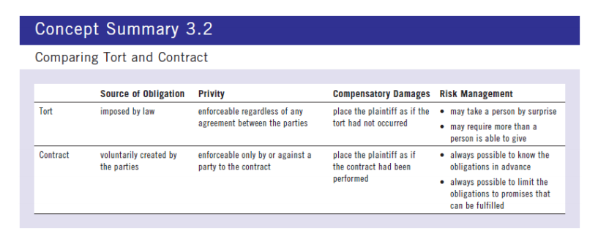

Intention to Create Legal Relations
- Intention to Create Legal Relations – arises if a reasonable person would believe that the parties intended to create a legally enforceable agreement
- Parties must intend to create legal relations
- Objective test of intention
  - what would a reasonable person believe?
  - test applied at time of purported contract

Meeting of the Minds (O&A)
- Contract requires a “meeting of the minds”
  - a shared decision to enter into a legal trasaction
- Parties must mutually agree to terms
  - one party proposes terms through an offer
  - other party agree to terms through an acceptance
Offer

A. The Nature of an Offer
- Offer – is an indication of a willingness to enter into a contract on certain terms
- Offeror – is a party who offers to enter into a contract
- Offeree – is a party who receives an offer to enter into a contract
- Offers and risk management
  - Offer creates risk of contract creation through acceptance,
  - While statement short of offer does not
- NOT EVERY PROPOSAL IS AN OFFER
B. Invitation to Threat
- Invitation to treat – is an indication of a willingness to receive an offer
  - Person responding to invitation becomes offeror
  - Person making invitation becomes offeree
- Objective test to determine between offers and invitations
  - Would a reasonable person believe the person making the statement was prepared to enter a contract upon receipt of an acceptance?
- Types of Invitations
  - Shelf display: Store that displays an item makes an invitation to treat (accept an offer). The shopper that takes it to the cash and offers $ for the item, makes an offer and the store that accepts the $, accepts the offer. [Pharmaceutical Society of Great Brtiain v. Boots Cash Chemists (Southern) Ltd. [1953]
- Advertisements: Store that places ad to sell cars makes an invitation
- Catalogues: Store that lists items for sale makes an invitation
  - Exceptions to Invitations to Treat (i.e. it is an offer)
    - Offers to sell a limited number of items or one specific item: Ebay
C. Communication of an Offer
- Requirement of communication
  - offer must be communicated
    - eg offer contained in undelivered letter ineffective
  - offer must be communicated as offer
    - eg Bonus offer by Co. received as typing assignment ineffective [Blair v. Western Mutual Benefit Association, 1972]
- Communication may take many forms
  - written document
  - oral statement
  - conduct
D. The Life of an Offer (the offer still Exists)
- Offer turned into contract by acceptance
- Offer may be terminated before acceptance
1. revocation
2. lapse of time
3. death or insanity
4. rejection
5. counter offer
- If any of these things happen, the offer does not exist and can’t be accepted

Revocation
- Revocation – occurs if the offeror withdraws an offer
  - offeror normally free to revoke at any time
  - revocation must be communicated to offeree
- Firm offers (not very firm) – occurs when the offeror promises to hold an offer open for acceptance for a certain period
  - gratuitous promise to not revoke: unenforceable unless under seal (discussed under “Consideration”)
- Options – is a contract in which the offeror is paid in exchange for a binding promise to hold an offer open for acceptance for a specific period.
  - contractual promise by offeror to not revoke: is enforceable
  - Why enforceable? b/c the option is a separate contract
- Tender – is an offer to undertake a project on particular terms
  - Tender process: a common business practice
    - eg city wants to construct new library
      - City needs to attract offers from builders so it issues an invitation to treat (make an offer to the city) and city promises to accept the best offer
      - potential builders need to prepare offers
  - Parties’ concerns in tendering process
    - potential for waste or procedural injustice
      - city worried about withdrawn bids – General rule allows each bidder to revoke their offer at any time prior to acceptance bidders worried about fair selection process
  - Factual/Actual process
    - city calls for tenders (offers) to build library
    - builders submit tenders to build library
    - city selects winning tender
  - Legal process: the bidding process creates two contracts
    - Contract A: between city (offeror) and any bidder (offeree) that submits an offer to build (K to hold a fair tendering process in exchange for submission of an irrevocable bid i.e. K to select winning tender)
    - Contract B: invitation to treaty by city becomes a K between bidder (offeror) and city (offeree)when city accepts offer to build
  - Contract A obligations
    - parties required to honour terms of contest
    - city required to fairly select best bid
    - builders prohibited from revoking offers
  - Contract B obligations
    - builder must build library as promised in offer
    - city must pay as promised in acceptance
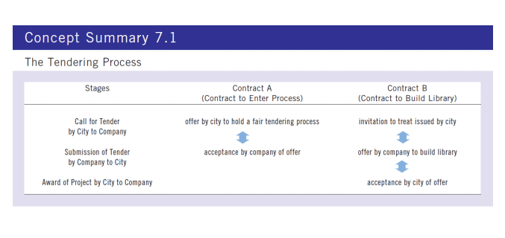

- Lapse of Time
  - Offer lapses by passage of time
  - Offeror can set termination date
  - if no termination date set, court will infer reasonable time
    - Depressed real estate for farmland – reasonably open for weeks
    - Shares in a volatile market – reasonably open for minutes
- Offer generally lapses if death or insanity
    - no meeting of minds with dead or insane person
    - exception if proposed contract would not require personal performance
- Rejection – occurs when the offeree refuses an offer
- Counter Offer – occurs when an offeree responds to an offer by indicating a willingness to enter into a contract but on different terms
  - A battle of the forms – occurs when each party claims to have entered into a contract on the basis of its own standard form doc.
Acceptance
- Acceptance: agreement to offeror’s terms
  - contract created immediately upon acceptance
- Acceptance must be in response to offer
  - no contract if “cross-offers”
- Forms of acceptance
  - acceptance by promise
  - acceptance by performance
Acceptance by Promise
- Bilateral contract – occurs when a promise is exchanged for a promise
- Acceptance – occurs when an offeree agrees to enter into the contract proposed by the offeror
  - Acceptance may occur in a number of ways
    - Words
      - words may be written or spoken
      - Offeror can dictate method of acceptance (in writing by email)
    - Conduct
      - conduct may signify acceptance (eg handshake)
    - Silence
      - silence alone cannot be acceptance
        - T/F companies that send you unsolicited products and instruct that they will bill unless they hear from you does not create a contract + you can use them. (Ontario Consumer Protection Act)
        - silence plus prior agreement may be acceptance (book club)
- Acceptance at a Distance
  - Dealing at a distance creates special legal issues
    - Is acceptance effective when sent or when received?
    - Does acceptance occur where sent or where received?
    - Who bears risk of communication never arriving?
  - Answers depend on whether using instantaneous or non-instantaneous communications
    - Instantaneous communication – is any form of communication in which there is little or no delay in the interaction between the parties
    - The general rule – states that acceptance by instantaneous communication is effective when and where it is received by the offeror
  - The postal rule
    - Non-instantaneous communication – any form of communication that involves a substantial delay between the time that it leaves one person and reaches another
    - Postal rule – states that an acceptance that is communicated in a non-instantaneous way is effective where an when the offeree send it
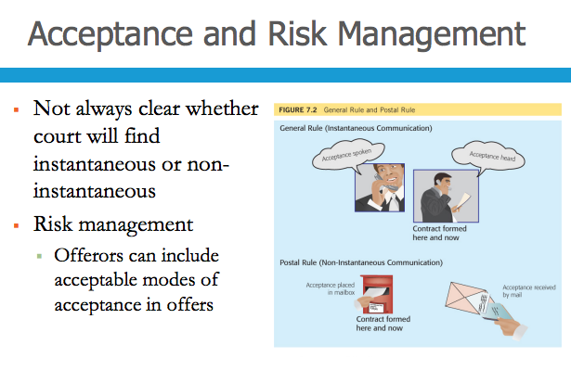
Acceptance by Performance
- Unilateral contract – occurs when an act is exchanged for a promise
  - Nature of unilateral contract
    - contract created once requested act performed
    - offeree must intend to accept offer
    - one-sided obligations after contract created

Law Chapter 8 – Consideration and Privity

Consideration
- Gratuitous promise - is a promise for which nothing of legal value us given in exchange
- Consideration – exists when a party either gives (or promises to give) a benefit to someone else or suffers (or promises to suffer) a detriment to itself.
- Main goal of contract law is to enforce bargains
  - promise is (generally) unenforceable unless mutual
- Consideration can be either a benefit or a detriment
  - each party must either…
  - (promise to) provide benefit to someone or
  - (promise to) suffer detriment to self
- Must move from each party – but not to other party
  - “I’ll pay $5000 to your brother if you transfer a car to my sister”
- Consideration must be sufficient
  - Sufficient: any value from a legal perspective
    - money, goods, land, or services
    - but not “love and affection”
- Consideration need not be adequate
  - Adequate: exchange of equal value
    - Courts will not save someone from a “foolish” bargain
- Adequate consideration – has essentially the same value as the consideration for which it is exchanged

Forbearance to Sue
- Forbearance to Sue – is a promise to not pursue a lawsuit
- Forbearance to sue: give up right of action
  - Forbearance as consideration
    - if underlying claim was valid
      - Valid consideration: sacrifice right to sue for full amount
    - if underlying claim was invalid
      - no actual right of action to be sacrificed
      - Valid consideration: loss of right to pursue apparent claim
      - Invalid consideration if no honest belief in underlying claim
Past Consideration
- Mutuality of Consideration – requires that each party provide consideration in return for the other party’s consideration
- Past Consideration – consists of something that a party did prior to the contemplation of a contract
- Recall mutuality of consideration:
  - Each party must give consideration in exchange for other’
- Past consideration
  - consideration given before contract contemplated
  - no mutuality and therefore no consideration
    - eg promise to pay $100 given after service provided
- Sometimes confused with implied promise to pay reasonable price, which is valid consideration

Pre-existing Obligation
Pre-existing Obligation – is an obligation that existed, but was not actually performed before the contract was contemplated.
- Determining whether valid consideration to give new promise to perform existing obligation not yet fulfilled
  - eg “I’ll perform the contract if you pay me $500 extra”
- Situations involving pre-existing obligation
  - pre-existing public duty
  - pre-existing obligation owed to third party
  - pre-existing obligation owed to same party
- Pre-existing Public Duty
  - Promise to perform pre-existing public duty
    - public officer promises to perform for extra pay
      - police: “I’ll investigate if you promise to pay $500”
  - No consideration
    - public official gives nothing new
      - police already obliged to investigate
    - against policy to enforce agreement
      - avoid incentive for public servant to misbehave
- Pre-existing contractual Obligation owed to Third Party
  - Promise to perform duty owed to third party
    - old contract promise repeated for new contract
      - “I’ll perform contract with X if you pay me $500”
  - Sufficient consideration
    - new benefit for new party under new contract
      - you acquire right to enforce my performance
- Pre-existing Contractual Obligation Owed to the Same Party
  - Promise to perform obligation owed to same party
    - old contractual promise repeated for new contract
      - “I’ll perform our contract if you pay me $500 extra”
  - No consideration
    - no new benefit for same party
      - you already have right to enforce my performance
    - against policy to enforce agreement
      - avoid incentive to threaten breach to get extra pay

Situation | Can a Pre-existing obligation generally provide consideration for a new contract
Public Duty | No
Owed to Third Party | Yes
Owed to Same Party | No

Promise to Forgive an Existing Debt
- Promise to discharge debt upon part payment
  - “You owe me $500…pay $200 and forget the rest”
- Unenforceable because no new consideration
- Exceptions
  - promise under seal (below)
  - promise exchanged for new benefit (eg early payment)
  - statute (not all jurisdictions)
    - promise enforceable if part payment actually received

Promises Enforceable without Consideration
- Generally, a promise is enforceable only if it is contained in a contract that is supported by consideration. That rule is subject to two major exceptions:
  - Seal
  - Promissory estoppel

Seals
- Seal – is a mark that is put on a written contract to indicate a party’s intention to be bound by the terms of that document even though the other party may not have given consideration.
- Seal: special mark on document
  - must be applied when contract signed
  - need not take any particular form
- Significance of seal
  - symbolizes seriousness of promise
  - promise enforceable even without consideration
  - party agrees to give something for nothing
  - commonly used in connection with guarantees

Promissory Estoppel
- Estoppel – is a rule that precludes a person from disputing or retracting a statement that they made earlier.
- Estoppel: prevents disputing or retraction a statement
  - A person may be estopped from unfairly denying truth of prior statement made to somone who relied on it
- Promissory estoppel: prevents retraction of promise
  - that another party has relied upon
    - e.g., “You only have to pay me at half the rental rate”
  - promise enforceable even without consideration
- Promissory Estoppel – is a doctrine that prevents a party from retracting a promise that the other party has relied upon
- Requirements
  - promise made within context of an existing legal relationship
    - promissory estoppel as shield and not sword
  - promise that existing rights will not be enforced
  - representee reasonably relies upon promise that would make it unfair for the representor to retract the promise.
  - representee is innocent of inequitable behavior
- Effect : variation or suspension of existing rights
  - promise retractable on notice (unless unfair)
- ENFORCING A PROMISE TO FORGIVE A DEBT TABLE (pg 187)

Privity of Contract
- Stranger - is someone who did not participate in the creation of the contract
- Privity of the contract – doctrine refers to the relationship that exists between the individuals who created the contract
- Privity is the relationship between contractual parties
  - Parties: people who created contract
- General rule: only parties to a contract can sue or be sued under the contract
- Stranger (or third party): someone without privity
  - cannot sue or be sued under contract
  - irrelevant that stranger is beneficiary of contract
    - “I’ll pay $5 000 to your sister if you give me your car”
- Some jurisdictions have abolished privity rule
- Others have exceptions to general rules of privity
  - Assignment
  - Trusts
  - Statute
  - Employment
  - Himalaya Clause
Assignment
- Assignment – is a process in which a contractual party transfers its rights to a third party
- The assignor – is the contractual party who assigns its contractual rights
- The assignee – is the contractual party who assigns its contractual rights
- The debtor – is the original contracting party against whom the assigned right can be enforced
- Assignment: process of transferring rights
- Parties to assignment
  - Assignor: party transferring rights
  - Assignee: party receiving rights
  - Debtor: party owing obligation
- Forms of assignment
  - equitable assignment
  - statutory assignment
  - assignment by operation of law
  - Figure 8.1 (p. 189)
- Equitable assignment – is an assignment that was traditionally enforced by the courts of equity
- Equitable assignment: enforced by courts of equity
- Requirements for equitable assignment
  - oral or written, but written desirable for risk management
  - with or without notice to debtor, but notice desirable
- Taking assignment subject to the equities
  - assignee and assignor subject to debtor’s claims
    - same contract: all claims regardless of notice
    - different contract: only claims arising before notice
- Subject to the equities – means that the debtor can generally use the same defenses and counterclaims against the assignee that it could have used against the assignor.
- Statutory assignment – is an assignment that conforms with the requirements of a statute.
- Statutory assignment: created under statute
  - must be written
  - must provide debtor with written notice
  - must be absolute - not conditional and incomplete
    - unconditional (not dependent upon future event ) and complete
- Effect of non-compliance with requirements
  - invalid as statutory assignment
  - may be valid as equitable assignment
- Assignments by Operation Law
  - Most assignments arise from intention
  - Some assignments arise by operation of law
    - bankruptcy: assignment to trustee in bankruptcy (Chapter 24)
    - death: assignment to personal representative
- Vicarious performance – occurs when a contractual party arranges to have a stranger perform its obligations
  - Rights generally can be assigned (equitable or statutory)
    - can assign right to receive $500
  - Obligations generally cannot be assigned
    - cannot assign obligation to act in a movie
  - Vicarious performance (stranger performs contractual obligations) is allowed when:
    - need not personally perform non-personal duty
  - Vicarious performance is not assignment
Trusts
- Trust – occurs when one person administers property on behalf of another
- The trustee – is the person who hold the property on behalf of the other
- The beneficiary – is the person whose behalf the property is held
Statute
Employment
Himalaya clause – is special term of contract that protects a third party beneficiary from liability

Law Chapter 9 – Representations and Terms

Pre-Contractual and Contractual Statements
- Contractual Terms – is a provision in an agreement that creates a legally enforceable obligation
- Pre-contractual representation is a statement only one party makes by words or conduct with the intention of inducing another party to enter into a contract
  - Statements made during negotiations (pre-contract)
1. puffs: mere sales words – no consequences
2. representations: induce contract – not part of contract but possible consequences (if false i.e. misrepresentation)
3. terms: contractual promises – certain consequences
- eg the statements you make in an offer become the terms of the contract upon acceptance
- Can ground a claim of breach of contract if false
Test: parties’ objective intentions

Misrepresentation – a false statement of fact that causes the recipient to enter into a contract
- Opinion – the statement of a belief or judgment
- Statement of future conduct – is not a statement of fact as it is only an indication of a persons future intentions
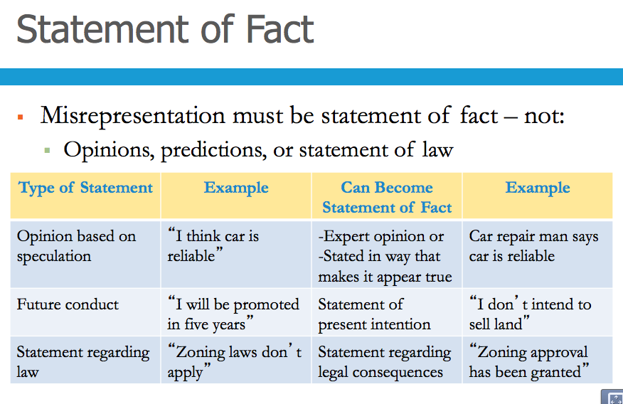

Silence of Misrepresentation
- Parties are not required to disclose material facts during pre-contractual negotiation, no matter how unethical non-disclosure may be.
- 6 occasions when the failure to speak will amount to misrepresentation:
- When Silence would distort a previous assertion
  - Could falsify a statement that was previously true. If changes occur that affect earlier representations, the party much communicate changes.
- When a statement is a half truth
  - Ex. Sign claim ticket at dry cleaner with cotton shirt that tells you it excludes liability for damaged caused to silk but it ALSO excludes damages to all other fabrics = half truth
- When the contract Requires a Duty of Utmost Good Faith
  - When party is in a unique position to know material facts.
  - Ex. Insurance companies need to know as much as possible to determine how much to change for coverage.
- When a Special relationship exists between the parties
  - Duty of disclosure may arise because there is trust
- When a Statutory Provision Requires Disclosure
  - Insurance legislation
  - Some Financial officers
- When facts are actively concealed
  - Take steps to hide something

Inducement
- In order to be a “misrepresentation”, the false statement of fact must have induced deceived party to enter into the contract

Three types of misrepresentation
- Innocent misrepresentation – is a statement a person makes carefully and without knowledge of the fact that is false
  - No knowledge of falsity of statement
  - No carelessness in making statement
- Negligent misrepresentation – a false, inducing statement made in an unreasonable or careless manner
  - Must prove all elements of negligence
    - No knowledge of falsity
    - Statement made in careless disregard of facts
- Fraudulent misrepresentation – occurs when a person makes a statement they know is false or that they have no reason to believe is true or that is reckless.
  - Known to be false, or made with no honest belief in its truth, or made recklessly

Legal Consequences of Misrepresentation
- Rescission – is the cancellation of a contract, by the parties or the court, with the aim of restoring the parties, to the greatest extent possible, to their pre-contractual state
- Restitution – involves a giving back and taking back on both sides
- Affirmation – occurs when the misled party declares an intention to carry out the contract or otherwise act as though it is bound by it
- Damages – are intended to provide monetary compensation for the losses that a person suffered as a result of relying upon misrepresentation

Contractual Terms
- Express Terms – is a statement made by one of the parties that a reasonable person would believe was intended to create an enforceable obligation
- If an agreement is written, oral statements cannot be used. Called Parol evidence – is not contained within the written contract
  - Exceptions:
    - To rectify or fix a mistake
    - To prove the contract was never really formed or defective
    - To resolve ambiguities in the doc
    - Does not contain parties full agreement
- Collateral contract – is a separate agreement on party makes in exchange for the other party’s entry into the main contract

Interpretation of Express Terms
- Literal approach – assigns words their ordinary meaning
- Contextual approach – goes beyond the four corners of the document by looking at the parties presumed intentions an their circumstances
- Golden rule – says that words will be given their plain, ordinary meaning unless to do so would result in absurdity
- Contra proferentem rule – ensures that the meaning least favorable to the author will prevail

Implied Terms
- Implied terms – arises by operation of law, either through the common law or under a statute.
- Terms implied by court
  - Implied only when necessary to parties’ intentions
  - Need:
    - An obvious consequence of parties’ agreement
    - Business efficacy test: term required for contract to make commercial sense
      - Usage and custom: term reflects standard practice in field
      - Previous dealings: parties habitually included term
      - Agreement’s legal character: term necessary in specific field
- Terms implied by Statute
  - Statute may automatically include term
    - Treated as if expressly included by parties
    - Some implied terms are mandatory while others are merely default terms that the parties may expressly modify
  - Very common in commercial agreements
    - eg Sale of Goods Act (Chapter 13)
    - eg consumer protection laws (Chapter 25)

Standard Form Agreements
- Standard form agreements – are mass-produced documents usually drafted by a party who is in an economic position to offer certain terms on a take-it-or-leave-it basis
  - Banks use these forms when creating new contracts for customers
  - Signature is proof of assent to terms
    - Signer bound even if document not read
    - Signer bound even if terms not understood
    - Possible exception: if no reasonable chance to read eg customer rushed
- Exclusion Clause – is a contractual term that seeks to protect one party from various sorts of legal liability
  - Clauses to exclude or limit liability
    - May exempt party entirely: eg “not liable for any loss”
    - May exclude certain liability: “not liable for carelessly caused damage”
    - May cap damages: eg “liable limited to $500”
  - Often included in standard form agreements
  - Valid means of allocating risks
    - Alert parties to need for insurance or extra care
  - Requires to enforce:
    - Term must be clear and unambiguous
      - Ambiguities interpreted against drafter
    - Reasonable notice to affected party
      - Heavier onus for unusual or harsh terms
    - Assent by affected party
      - Signature is best evidence of acceptance of clause
    - Usually not enforced if unconscionable or unfair
- Standard Form Ticket Contracts
  - Terms often printed on tickets and receipts
    - Ski tickets
  - Enforcement depends upon notice
    - reasonable notice must occur before contract is created
    - heavier burden for unusual or harsh terms
    - perhaps no burden for obvious terms
  - Enforcement depends upon assent
    - signature is best evidence of acceptance
      - generally effective even if term not read
- Standard Form Contracts
  - Risk management and Standard Form Contracts
    - use well tested contracts with proven record of use over time
    - use clear, unambiguous language for onerous terms
    - consider using plain language throughout contract
    - for onerous and unusual terms
      - ensure staff gives reasonable notice to customers
      - require customers to indicate agreement to be bound (eg initials)
- Types of Boilerplate Clauses – is a clause that is used repeatedly without any variation
  - Several types
    - exclusion clauses (discussed above)
    - force majeure clauses
    - confidentiality clauses
    - arbitration clauses
    - jurisdiction clauses
    - entire agreement clauses

Law Chapter 10 – Contractual Defenses

Incapacity to Contract
- Capacity – is the legal power to give consent (sometimes to understand)
- We consider 7 groups who have no capacity or only limited capacity to create contract:
  - Minors,
  - Mentally disabled
  - Intoxicated
  - Corporations
  - Associations
  - Indian bands and Aboriginals
  - Public Authorities
Personal Incapacity
- Minors (1)
  - Age of majority is the age at with a person is held fully accountable in law
  - Minors – are people who have not reached the age of majority
  - A contract is Voidable if a minor is entitled to avoid the legal obligations that it created
    - Must give back any benefits received under contract
  - Exception:
    - Categories of enforceable contracts
      - Contracts for necessities of life
        - E.g., food, clothing, shelter, education, medicine
        - Minor must pay reasonable price
      - Employment contracts
        - Enforceable if beneficial to minor
- Mental Incapacity (2)
  - If Judicially a party is declared mentally incompetent
    - Total incapacity to contract
Contracts are void and cannot be enforced
  - Mentally incompetent but not judicially declared
    - Most contracts voidable if other party knew of disability
    - But capacity to contract for necessities of life
  - Risk management:
    - Train employees to recognize potential capacity issues
- Intoxication (3)
  - Intoxication may render contract voidable if:
    - Way too drunk to understand circumstances and
    - Other party aware of extent of intoxication
  - Voidable contract must be avoided promptly once sober or will be considered affirmed (days)

Business Corporations (4) and Associations (5)
- Only legal persons can have capacity: human beings and corporations
- Associations therefore usually lack capacity
  - Egg clubs, charities, societies
- Risk management issues
  - Ensure that members are able to fully perform
    - Contracting with members of associations
    - Full burden and risk falls upon individuals within association
    - Contract not enforceable against other members
- Chartered corporation – are treated the same as individuals who have reached the age of majority
- Statutory corporations – have limited contractual capacity

Indian Bands and Aboriginal Rights (6)
- Indian Band – is a body of Aboriginal people whose land and money are held by the crown

Public Authorities (7)
- Public authority acting on behalf of government has general contractual capacity
  - Aside from any specific statutory authority
  - Limited by Constitutional division of powers

Absence of Writing
- Normally contracts not required to be written
- Exception: Statute of Frauds renders some contracts unenforceable if not evidenced in writing
  - Guarantee for repayment of debt
  - Sale of interest in land (may include leases)
  - Contracts not to be performed within one year
  - Statute in force except in BC and Manitoba

Types of Contracts that must be evidenced in Writing
- Guarantee – is a contractual promise by a third party, called a guarantor, to satisfy a debtor’s obligation if that debtor fails to do so
  - Indemnity – is an unconditional promise to assume another’s debt completely
- Contracts for the Sale of an Interest in Land
- Contracts Not to Be Performed within a year

Writing Requirements
- Contract written, or a note or memorandum provides evidence of it:
  - Contract’s essential elements (parties, subject matter, price)
  - Signature (interpreted broadly)
  - Several documents may be pieced together
- Effect of non-compliance
  - Contract is unenforceable but not void
  - Sufficient to transfer property
  - Neither party can take action in court

Consumer Protection and Writing Requirements
- Certain consumer agreements to be in writing
  - Personal development services contracts
- Sometimes written copy of contract must be provided
  - Internet contracts requiring consumer to pay more than a prescribed amount in advance
- Requirements helps to prevent the exploitation of consumers and to reduce the incidence of disputes

Mistakes

Mistakes preventing the creation of contracts
- Mistaken identity
  - Material mistake – is one that matters to the mistaken party in an important way
- Mistake about subject matter

Mistakes Rendering Impossible the Purpose of the contracts
- Mistake about existence of the subject matter

The Doctrine of Frustration
- A contract is frustrated when some event makes performance impossible or radically undermines its very purpose
  - After contract is signed beach house burns down
  - Insufficient if performance just more difficult or expensive
- Doctrine of frustration tries to strike a fair balance among the parties. Requires a decision about who will bear the loss.
  - Governing rules
    - Doctrine of frustration applies only if neither party is responsible for the frustrating event
    - Contract may determine who bears loss (force majeure clause)
    - Default rules at common law and under statute
      - Statutory in Alberta, British Columbia, Manitoba, Newfoundland and Labrador, New Brunswick, Ontario, Prince Edward Island
  - Common law rules (all-or-nothing)
    - Purchaser can recover price if no benefit received
      - No recovery even if very small benefit received
    - Seller has no claim even if expenses incurred
- Documents mistakenly signed… non est factum – this not my deed

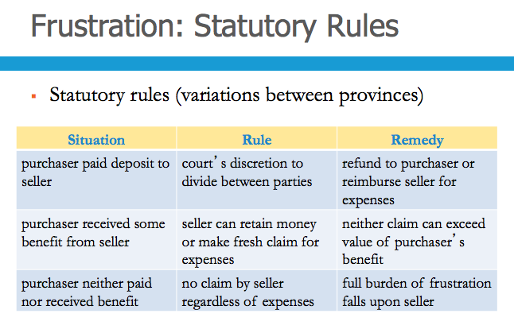

Unfairness During Bargaining

Duress
- Duress of Persons – refers to the physical violence or the threat of violence
- Duress of Goods – occurs when one person seizes or threatens to seize another persons goods to force that person to create a contract
- Economic Duress – arises when a person enters into a contractual arrangement after being threatened with financial harm
  - Must determine if illegitimate pressure or commercial reality
  - Contract more likely voidable if:
    - Threat made in bad faith
    - Victim could not reasonably resist
    - Victim acted promptly once pressure removed
    - Victim protested at time of threat (if practical)
    - Victim did not have legal advice before succumbing

Undo Influence
- Undue influence – is the abuse of a relationship in order to influence someone and induce an agreement
- Undue influence: overpowering will
  - Duress is external threat of harm
  - Undue influence is internal manipulation
    - Manipulation may be deliberate or inadvertent
    - “Innocence” is no defense
- Rules depend upon parties’ relationship
  - Pre-existing fiduciary (one person in position of dominance over the other) relationship
  - No pre-existing fiduciary relationship
- Fiduciary relationship occurs when a person is in position of dominance over another
  - Egg physician-patient, law-client, priest-penitent
- Undue influence presumed if fiduciary
  - Fiduciary party must rebut presumption:
    - Show transaction was fair
    - Show weaker party received independent legal advice (ILA)
- No Fiduciary Relationship…
  - Party alleging undue influence must prove it
    - There is no presumption of undue influence
    - Difficult proof if no imbalance in power
  - Opposing party can adduce evidence of equality
    - Show fairness of transaction
    - Show fairness of bargaining process
  - Risk management
    - Refrain from bullying tactics, recommend ILA

Unconscionable Transactions
- Unconscionable Transactions – is an agreement that no right minded person would ever make and no fair minded would ever except
- Improvident Bargain – is a bargain made without regard to the future
- Presumptions rebutted by proof that: bargaining process was fair, other party received independent legal advice
- Some jurisdictions have unconscionability legislation
  - Disclosure requirements
  - Cooling off periods
  - Prohibited use of unfair terms, such as exclusion clauses
  - Broad discretion to the court to render harsh or
  - Unconscionable agreements ineffective

Illegality
- Legal Agreements – are expressly or implicitly prohibited by statute (directly or indirectly)

Statutory Illegality
- Illegal to transact contrary to regulatory statute
  - Eg apples cannot be sold unless graded
  - Eg interest rate violating Criminal Code
- Violating contracts not automatically set aside
  - Courts assess legality by examining
  - Seriousness of consequences of invalidating
  - Social utility of the consequences
  - Class of persons for whom prohibition was enacted

Common Law Illegality
- Illegal to contract to commit crime or tort
  - Eg repentant assassin cannot be sued for breach of contract
- Illegal to contract contrary to public policy
  - Eg damage nation’s safety, promote corruption or sexual immorality
- A vague and occasionally abused head of judicial power
- May include some covenants in restraint of trade

Restraint of Trade – is a contractual term that unreasonably restricts one party’s liberty to carry on a trade business or profession in a particular way
- Prohibition on carrying on business (non-competition)
  - May be limited temporally (eg two years)
  - May be limited geographically (eg 200 kms)
- Common to certain types of contracts
  - Eg keep ex-employee from competitor
  - Eg keep store vendor from new establishment
- Burden to prove that restraint is reasonable
  - Restraint tested against total circumstances

Law Chapter 11 – Discharge and Breach

Discharged by Performance
- Discharge – a contract is discharged when the parties are relieved of the need to do anything more
- When a contract has been discharged, it means that it has been performed and is no longer a pending, legal obligation.
- Test: To discharge a contract is to end the obligation by agreement or by carrying it out
- Most Contracts end in discharge through: Performance, agreement, operation of law and breach

- Performance – occurs when the parties fulfill all of the obligations contained in the contract
  - The parties generally have to do exactly what the contract says but usually, time is not of the essence. If no time is specified – reasonable amount of time
  - Substantial Performance - Exception to Rule: If Contract is performed
    - Performance generally satisfies the contract but incomplete in some minor way, can treat contract as discharged
      - Entitled to contractual damages for defect
      - Exception to Exception - difficulties with entire contracts: no payment due unless all work performed
  - Tender of Payment – is a payment of money to a certain value
    - Debit cards, credits cards, cheques
  - Tender of Performance
    - Damages – is the amount of money that the court may order the defendant to pay to the plaintiff
    - Substantial Performance – generally satisfies the contract but is defective or incomplete in some minor way
    - Entire contract – says that no part of the price is payable unless all of the work is done

Discharged by Agreement
- Option to terminate – is a contractual provision that allows one or both parties to discharge a contract without the agreement of the other (mutual discharge)
- Condition subsequent – is a contractual term that states that the agreement will be terminated if a certain event occurs
- True Condition Precedent – is a contractual term that states that an agreement will come into existence only if and when a certain event occurs
- Condition Precedent – is a contractual term that states that while a contract is formed immediately, it does not have to be performed unless and until a certain event occurs
- Rescission – occurs when the parties agree to bring their contract to an end (executory on both sides to do rescission)
  - A contract is executory – if a party has not fully performed their obligations
  - A contract is executed – if a party gas fully performed their obligations (no rescission can be done)
- Release – is an agreement under seal to discharge a contracts
  - Parties agree (under seal) to discharge a contract (without fresh consideration)
  - Arises where one party has completed their contractual promise, and agrees to release the other party from further performance of the contract.
- Conditional Contract
  - Parties agree (at outset) that contract is affected (discharged) by an event
    - Agree at outset
    - Contract must be performed only if event occurs
    - Eg sale of house conditional on sale of purchaser’s house
  - Contract comes into existence but only requires performance if the condition is met
- Accord and Satisfaction – occurs when a party gives up its right to demand contractual performance in return for some new benefit
  - Arises where one party is in breach of the contractual agreement and the other party agrees to release the party who is in breach by requiring performance of another promise, which would then mean that the previous agreement has been discharged by accord (the new promise) and satisfaction (performance)
  - One Party has performed
    - Method used to discharge partially performed contract
      - Party that performed gives up right to other’s performance
      - Non-performing party gives new consideration
        - Eg original: $5000 for two cars à accord and satisfaction: $5000 for car and boat
- Variation – involves an agreement to vary the terms of an existing contract
  - Variation: small changes to existing contract
    - Contract retained but on new terms
  - Consideration required for enforcement
    - Contract not yet performed by either party
    - Each party agrees to new terms
    - Each party gives up right to original performance
      - § Eg original: 20 lawns cut for $2 000 à variation: 15 lawns cuts for $1,500
- Novation – is a process in which one contract is discharged and replaced with another (used for substantial changes to K)
  - Two-party novation: same parties, different contract
    - Eg original: A agrees to sell B shares in Alpha Inc. à novation: A agrees to sell B shares in Beta Inc.
  - Three-party novation: different parties, same contract
    - Eg original: contract between A and B à novation: contract between A and C (B released)
- Waiver – occurs when a party abandons a right to insist on contractual performance. Similar (perhaps identical) to promissory estoppel
  - Requirements of waiver
    - Enforceable without consideration or seal
    - No particular form required
    - Requires clear intent to waive rights
    - Likely requires reliance by other party
    - Retraction possible upon notice (unless unfair)

Discharge by Operation of Law
- Contract may be discharged by operation of law
  - Examples of operation of law
    - Frustration: contract impossible to perform (Chapter 10)
    - Lapse of limitation period (Chapter 2)
      - Rights are unenforceable but not extinguished
      - Statute of limitation – require a party who has suffered a beach of contracts to sue within a certain period of time
    - Bankruptcy: inability to pay debts (Chapter 24)
      - No discharge if bankruptcy caused by misconduct

Discharge by Breach of Contract
- Q: When there is a breach (failure to fulfill contractual promise) when can the innocent party discharge?
- A: Two conditions
  - 1. If the breach substantially deprives the innocent party of the expected benefit of the agreement; and
  - 2. It depends upon type of term breached
- Condition: substantial term
- Warranty: lesser term
- Intermediate: hybrid term
- Breach – occurs whenever a party does not perform precisely as promised
- A term is a Condition – term is a condition if innocent party would be substantially deprived of expected benefit of contract due to its breach.
  - Either affirm contract and claim damages or
  - Discharge contract and claim damages
- A term is a Warranty – if the innocent party would not be substantially deprived of the expected benefit of the contract if a breach occurred
  - Innocent party has no significant option
    - Must affirm contract, no option to discharge agreement
    - May claim damages
- A term is Intermediate – if, depending upon the circumstances, the innocent party may or may not be substantially deprived of the expected benefit of the contract in the event of breach
- Breach and Risk Management
  - To guard against difficulty distinguishing between conditions, warranties and intermediate terms
    - Parties may define types of terms in their contract
  - Seek legal advice before attempting to discharge contract by breach

Types of Breach
- Breach of a condition, warranty or intermediate term can occur in one of four ways:
  - Defective performance (most common) – occurs when a party fails to properly perform an obligation due under a contract
  - Deviation – occurs when a ship, train or truck departs from the route agreed between the parties
  - Anticipatory breach – occurs when a party indicates in advance, by words or conduct that it does not intend to fulfill an obligation when it falls due under a contract
  - Self-induced impossibility – party renders performance impossible
    - Contrast: frustration (neither party at fault)

The Effect of Discharge for Breach
- Parties relieved of need to perform in future
  - Contract not wiped out altogether, as it survives for purposes of contractual liability
  - Parties need not perform primary obligations
  - But contract still effective for some purposes
Eg exclusions clauses, liquidated damages

Law Chapter 12 – Contractual Remedies

Damages
- Damages – is an award of money that is intended to cure a wrongful event, such as breach of contract
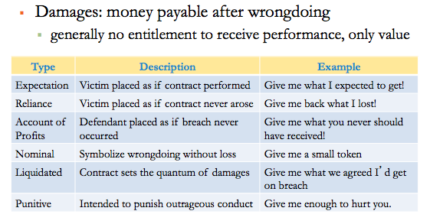
- Expectation Damages – represent the monetary value of the benefit that the plaintiff expected to receive under the contract
  - Plaintiff does not receive performance, but instead value of performance at time of agreed performance (i.e. delivery etc.)
  - Forward-looking damages
    - Plaintiff monetarily placed as if contract performed
      - “Give me what I expected to get!”
  - Backward looking damages are easily justified (recovering)
  - Calculation of expectation damages
    - Expected benefits minus expect
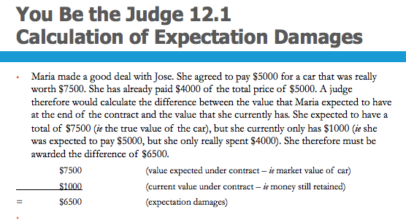
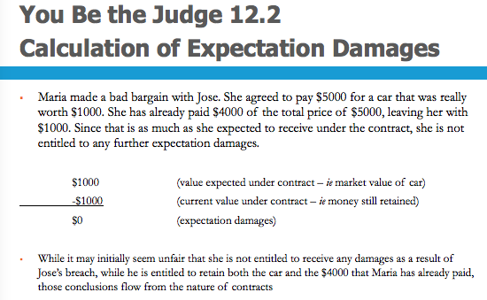

Issues for Expectation Damages
- Difficulty of Calculation
  - Awarded even if calculation is imprecise
    - Eg damages for lost chance in beauty contest
  - Not awarded if calculation is totally speculative
    - Eg value of treasure in supposedly sunken ship
- Alternative Performance
  - Expectation damages difficult to quantify if contract allows defendant to perform in a variety of ways:
  - Hamilton v. Open Window Bakery Ltd (2004) SCC
  - Facts:
    - Contract allows employer to terminate employment:
      - Any time, without notice, if employee acts in a manner detrimental to company’s reputation OR
      - Any time after 18 months, by giving 3 months’ notice
  - Issue:
    - Award damages for expected length of contract or earliest allowable termination. Damages calculated on the basis of the least onerous option — “the minimum acceptable performance”
- Intangible Losses and Emotional Distress
  - Intangible loss: loss that has no apparent economic value
    - Disappointment, anger, frustration, sadness
  - Damages for emotional distress traditionally denied
    - Rationale: difficult to assess value, and contracts are commercial arrangements for money not feelings
  - Now usually available if peace of mind was expected contractual benefit (vacation/dog died).
  - Emotional distress treated in same manner as other types of loss
Limitations to Expectation Damages
- Expectation damages may be reduced by
  - Causation and remoteness
  - Failure to mitigate losses
- Remoteness – a loss is remote if it would be unfair to hold the defendant legally responsible for it
  - In order to recover losses:
    - Loss must in fact be caused by breach
    - Loss must not be legally remote from breach
  - Loss is not remote if either:
    - Defendant knew or should have known of risk of loss
  - Test applied at time contract is created (no hindsight)
  - Remoteness as a rule of fairness
    - Contract price reflects exposure to risk
    - Defendant not paid to accept unforeseeable risks
  - Risk management
    - Before entering contract, ensure other party aware of any unusual losses you may suffer as a result of contractual breach UNLESS you are prepared to accept such risk yourself

Victoria Laundry (Windsor) Ltd. V. Newman Industries Ltd 1949]
- Facts: Contract for Boiler Delivery by boiler maker (D) and laundry owner. Defendant broke the contract for failing to deliver the boiler 20 weeks late. P suffered two types of losses (weekly laundry income & government contract)
- Issue: Is D liable for both types of expectation losses?
- Test: Is loss too remote?
- Holding: Loss for weekly laundry is not too remote (b/c reasonable person would know that this loss might occur).
- Loss for government contract is too remote (b/c so unusual no reasonable person would know).

- Mitigation of Damages
  - Mitigation – occurs when the plaintiff takes steps to minimize the losses flowing from the defendants breach
    - Failing to mitigate is a bad business decision
    - Plaintiff only responsible for taking reasonable steps to mitigate the loss
    - Damages are denied only to the extent that the plaintiff unreasonably failed to mitigate
    - Plaintiff can recover the costs associated with mitigation
- Reliance Damages – represent the monetary value of the expenses and opportunities that the plaintiff wasted under a contract
- Nominal Damages – symbolize the fact that the plaintiff suffered a wrong when the defendant broke a promise
  - Breach of contract is actionable per se
    - Wrongful even if plaintiff suffers no loss
  - Nominal damages
    - Symbolize wrongdoing without loss
    - Limited to small amount (eg $10)
  - Risk management
    - Avoid suing for nominal damages. May result in cost award. Judges do not like to waste time on trivial matters
- Liquidated Damages – represent a genuine attempt to estimate the value of the loss that may occur as a result of a breach. Must be distinguished from penalties – require a party to pay an exorbitant amount if it breaches the contract
  - Genuine pre-estimate of possible losses in contract
    - Rationale: avoid litigation and provide incentive to perform
  - Effect of liquidated damages
    - Recovery of agreed amount if breach
    - Actual size of loss (larger or smaller) irrelevant
- Punitive Damages – are intended to punish the defendant and discourage other people from behaving badly
  - Intended to punish and discourage outrageous conduct
  - Awarded in addition to compensatory damages
  - Not as common or large in Canada as in USA
  - General requirements for punitive damages
    - Acting in harsh, vindictive, reprehensible or malicious manner
    - Commission of independently actionable wrong
      - Eg different breach of contract, tort of negligence

Equitable Relief
- Specific Performance – occurs when the court orders the defendant to fulfill a contractual obligation to do something
  - Court order to perform contractual action
    - “Do what you promised to do!”
  - Plaintiff receives actual performance of defendant’s contractual obligations
  - Discretionary nature of equitable remedies
    - 1. Awarded only if appropriate in circumstances
    - 2. Denied if plaintiff does not have “clean hands”

Other Requirements of Specific Performance
1. Damages inadequate: cannot buy substitute
Eg unique land, family heirloom, private shares
2. Mutuality: available to both parties
Eg cannot be awarded against (or to) infant
3. Judicial supervision: once-and-for-all order
Eg grocery store not forced to remain open
4. Personal services: prohibition on slavery
Eg actress not required appearing in movie

Injunction – occurs when the court orders the defendant to not do something that is prohibited by the contract
- Court order to obey contractual prohibition
  - “Don’t do what you promised not to do!”
- Generally wider scope of availability
  - Specific performance: large limit on freedom
    - Cannot do anything other than required act
  - Injunction: small limit on freedom
    - Can do anything other than prohibited act

Exclusion Clauses
- Exclusion Clause – excludes or limits liability for breach of contract
  - Contractual term limiting liability (see Chapter 9)
  - Exclusion clauses allowed by freedom of contract
    - Court nevertheless protects consumer
      - Clause should be unambiguous, read narrowly against drafter
      - Clause must be reasonably drawn to consumer’s attention
      - Must prove other party agreed to exclusion clause
      - Exclusion clause cannot apply to fundamental breach
  - Fundamental Breach – consists of a breach that goes to the very “core” of the contract

Unjust Enrichment
- Unjust Enrichment – is a cause of action that requires proof of an enrichment to the defendant, a corresponding deprivation to the plaintiff, and the absence of any juristic reason for the defendant enrichment
- Restitution – requires the defendant to give back the enrichment that it received from the plaintiff.

- Independent cause of action
- Available only if contract does not exist (void, voidable, unenforceable, or discharged by breach)
- Requirements for unjust enrichment
  - Enrichment to defendant
  - Corresponding deprivation to plaintiff
  - Absence of juristic reason for enrichment
- Remedy for unjust enrichment is restitution
  - Give back what you received from me!”
  - Defendant returns value of transferred benefit

