Abstract
In this experiment, two “sub-experiments” were done. One dealing with Spinacia vulgaris and different densities, demonstrating Yoda’s law of slef-thinning. Another dealing with Paramecium aurelia, Paramecium bursaria, and Paramecium caudatum in a control chemostat versus an experimental chemostat, demonstrating the paradox of the plankton. The former is a result of intraspecific competition (meaning within species), and the ladder is a result of interspecific competition (between species). These also include the idea of Liebig’s law of the minimum, and Gause’s competitive exclusion principle. Using simple observation techniques to collect data, SPSS was then utilized to analyze this data. The first experiment yielded a linear relationship with a negative slope. The second experiment concluded no significant difference so the null of no different was accepted. The first experiment was sound with literature and the equation for Yoda’s law. The second experiment however did not quite match expected results.
Introduction
In any population, there is always competition taking place over resources, whether it is between species or within a species group. Intraspecific competition refers to the “sharing”, or lack thereof, of either habitat space or niche, food and nutrition, mating partners, etc. Two possible types of intraspecific competition are either interference competition, where direct interaction occurs, or exploitative competition, where one individual uses up a resource before another can get to it. Interspecific competition is the same idea, only between different species within an ecosystem.
Justus von Liebig proposed the Law of the Minimum. The Liebig Law of the Minimum was largely based on plant ecology, however can be applied to any population ecology. It suggests that the growth of a population is not limited by the total amount of resources, but rather the most deficient one, explaining the effects of intraspecific competition (Hiddink and Kaiser, 2005). Also dealing with plants, Yoda’s law of self-thinning describes the relationship between population density and biomass. As the population increases in size, there becomes more individuals competing for a resource which becomes increasingly more limited (Weller, 1987). In general the more fit individuals will beat out the weaker ones, but the resources being split between more individuals causes each to acquire less, so the mean mass of each individual becomes smaller, although the biomass can increase.
In 1934, Georgy Gause performed experiments which helped him produce his theory of the competitive exclusion principle. One of these experiments was titled “Behaviour of mixed populations and the problem of natural selection” (Gause and Witt, 1935), which deals with interspecific competition. The competitive exclusion principle states that two species competing for the same resource, assuming no other factors change, cannot indefinitely coexist (Levin, 1970). Alfred Lotka and Vido Volterra came up with mathematical models, which explain the phenomenon of the competitive exclusion principle. With this in mind, in vast lakes we come across the plankton paradox. Many phototropic phytoplankton species thrive at the same time within a lake. Theoretically, one stronger suitor should outcompete the rest of the species until there is only one species left in the lake. This, however, is simply not the case. And thus puts the competitive exclusion principle into question. However, it is explained by a process called contemporaneous disequilibrium, and they are able to coexist with spatiotemporal variability (Hutchinson, 1961).
The first experiment performed is to produce evidence to support Yoda’s Law of Self-Thinning by observing Spinacia vulgaris in 3 different densities and analyzing its biomass in these different conditions. The null hypothesis is that the mean mass of the plant does not depend on the density of the population. The second experiment is to explore the plankton paradox by observing the number of Paramecium aurelia, Paramecium bursaria, and Paramecium caudatum and analyzing the population dynamics. The null hypothesis is that the control and the experimental conditions are not different.
Methods
For each experiment, an experimental portion was done as well as an analytical portion. In the first experiment, spinach, Spinacia vulgaris, was planted in pots with either a small amount, a medium amount, or a large amount. After allowing them to grow all for the same amount of time, each plant was harvested by cutting them at the soil surface with a razor blade. Each plant was then measured from the end where it was cut to the end of the stem, where it starts to branch off. These measurements were added up for each pot to determine the total height of the pot. The dimensions of the pot were also measured to determine the surface area and with that and the number of plants in the pot, the density was determined (plants/cm²). Next the biomass was measured by weighing the entire pile of plants harvested per pot. The mean mass is simply this number divided by the number of plants in the pot.
For the analytical portion, based on the fact that the x-axis is a scalar set of data, a Trends test needed to be done. Assuming that plant density and plant mean mass have a cause-and-effect relationship, regression analysis was used. In SPSS, go to Transform, Compute Variable. Double click Arithmetic, double click Lg10, double click Density, name the new data Log_Den, the press OK. The same procedure was followed but this time using mean plant mass instead of density and naming it Log_Mass. Next, go to Graphs, Legacy Dialogs, Scatter/Dot, then choose Scatter and click Define. Select Log_Den as the x-axis and Log_Mass as the y-axis. Click OK. This produced a scatter plot for further analysis.
In the second experiment, three Paramecium species were used: Paramecium caudatum, Paramecium aurelia, and Paramecium bursaria. A control chemostat was made, where the three species were left to reproduce simply with their food (bacteria and yeast). The experimental chemostat had this plus a snad/gravel mixture on the bottom, snails, fish, Didinium, aquatic macrophytes, and algae. There was a sample for each left for 7 days, 14 days, 21 days and 28 days. A slide was removed from the jar and it was wiped with a Kim wipe. In a group of 4 each person was responsible for one of the period lengths, for both the control and the experimental. After mixing the control culture, one drop was placed on one side of the slide and another on the other side of the slide. One drop of Protoslo was added to each drop to slow down the Paramecium. A cover slip was added and then under the microscope at 40X magnification, the number of each species was counted and added up. The same procedure was done for the experimental culture.
For the analytical portion, based on the fact that the x-axis is a nominal set of data, a Difference test needed to be done. Since there are two groups of counts where there is replication and the observations are not paired, a t-test was used. Since day 28 would give the Paramecium the most time to reproduce, they should be more abundant and thus better show a significance where there might be one. In SPSS go to Data, Select Cases, and select If condition is satisfied. Then choose the Day variable and type in “=28”. Press Continue then press OK. Assuming normality, the test was run. Go to Analyze, Compare Means, Independent Samples t-test. In the pop-up window select all the Paramecium counts as the Test Variable and Code as the Grouping Variable. Click Define Groups and type 1 and 2 in the boxes, as this is how “control” and “experimental” are named in the spreadsheet. Click Continue and then OK. This produces two tables for further analysis. To create the graphs for comparison, go to Graphs, Legacy, Error Bar, Clustered. In the pop-up window, for the Variable select a Paramecium count (repeating these steps for all three), for Category Axis select Day, and Define Clusters by Code.

Results

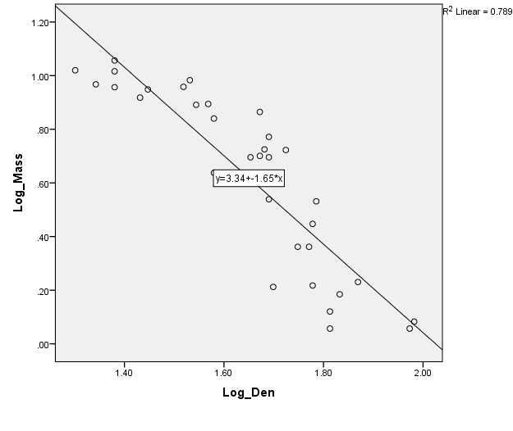
Figure 1. Log transformed data of the mean mass of plants by the density of the pot giving a linear relationship.

In figure 1, the log of the mean mass of plants is plotted against the log of the density of the pots. There is a linear relationship with a negative slope.

Table 1. Model summary of the log transformed data of the mean mass of plants by the density of the pot giving the R and R² values.
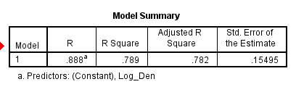
In table 1, the R-value represents the Pearson Correlation Coefficient of 0.888ª. The R square value represents the Coefficient of Determination which is 0.789.
Table 2. ANOVA of the log transformed data of the mean mass of plants by the density of the pot giving the degrees of freedom and the p-value.
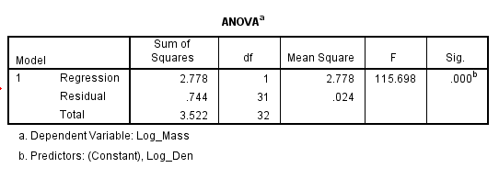
In table 2, it shows that there is 1 degree of freedom. There is a significance, or p-value, which is less than 0.05 therefore we reject the null.

Table 3. Coefficients of the test of the log transformed data of the mean mass of plants by the density of the pot giving the constant and the slope.
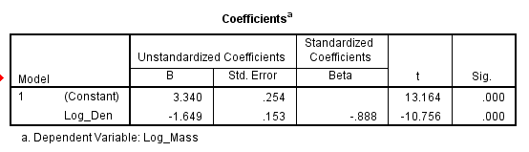

In table 3, the constant under B represents the y-intercept, which is 3.34. The “Log_Den” under B represents the slope, which is -1.649. This gives a line equation of y=3.34-1.649x which defines the relationship between plant density and mean mass.

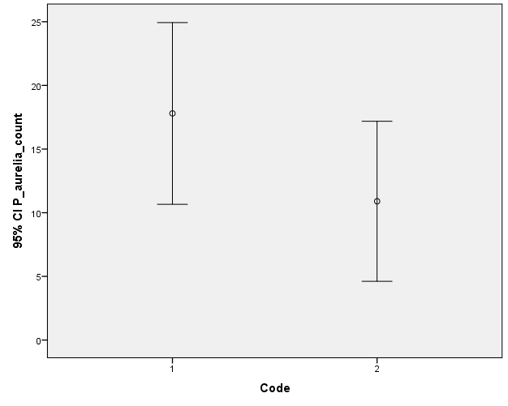
Figure 2. Paramecium aurelia mean abundance on day 28 in the control culture (1) and in the experimental culture (2) with error bars showing the difference between the two environments.

In figure 2, the control abundance seems to be slightly higher than the experimental abundance, as the mean of the control is just barely higher than the “whiskers” of the experimental.
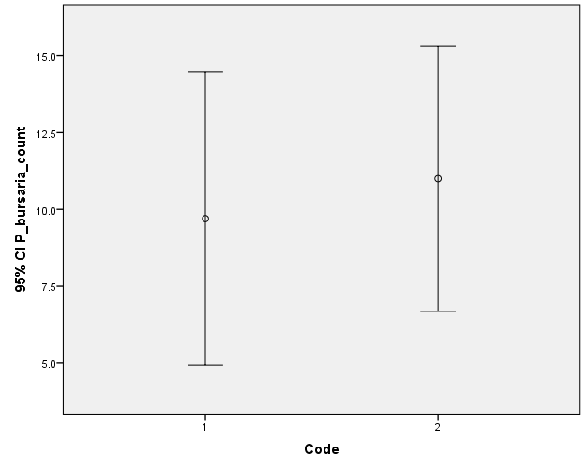
Figure 3. Paramecium bursaria mean abundance on day 28 in the control culture (1) and in the experimental culture (2) with error bars showing the difference between the two environments.

In figure 3, the control abundance is very slightly smaller than the experimental abundance, but there is no significant difference.
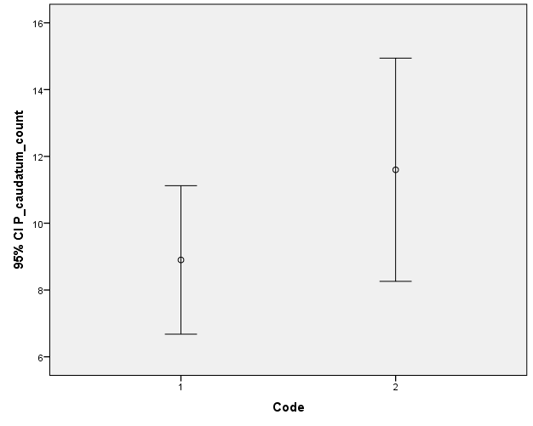
Figure 4. Paramecium caudatum mean abundance on day 28 in the control culture (1) and in the experimental culture (2) with error bars showing the difference between the two environments.

In figure 4, the control abundance is smaller than the experimental abundance, and the mean of the experimental is very slightly above the “whiskers” of the control.
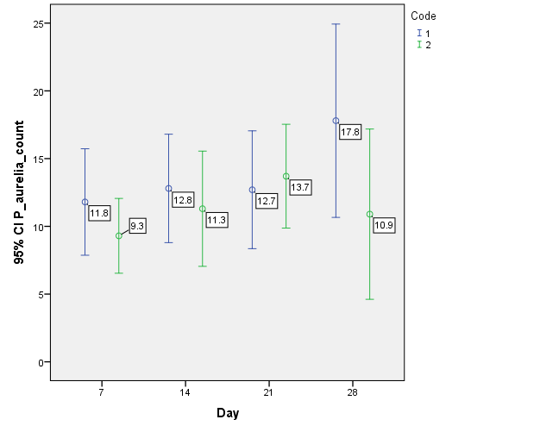
Figure 5. Paramecium aurelia mean abundance on day 7, day 14, day 21, and day 28 in both the control culture (1, blue) and the experimental culture (2, green) showing the trends of increasing days.

In figure 5, it is not very obvious, but the mean seems to increase as the days increase.
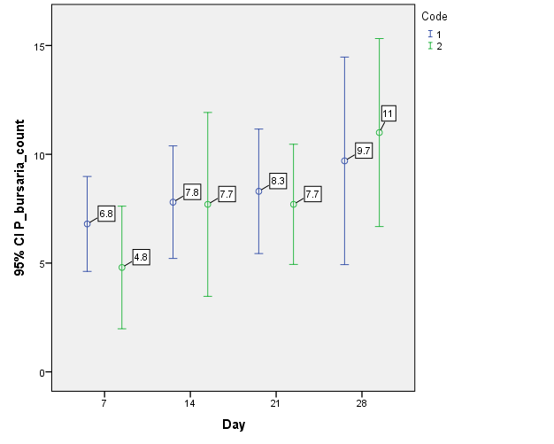
Figure 6. Paramecium bursaria mean abundance on day 7, day 14, day 21, and day 28 in both the control culture (1, blue) and the experimental culture (2, green) showing the trends of increasing days.

In figure 6, it seems that the abundance is increasing as the days increase, with the most abundance on day 28.
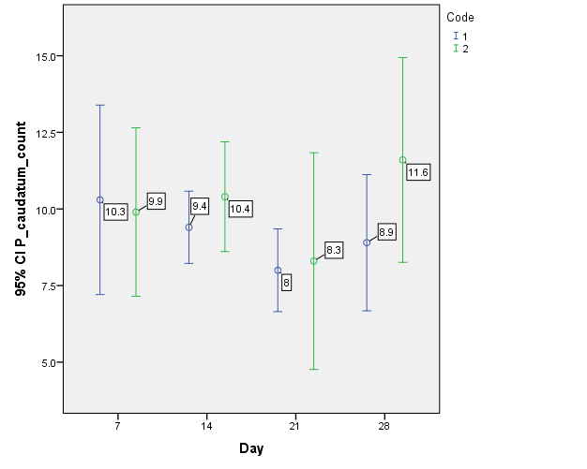
Figure 7. Paramecium caudatum mean abundance on day 7, day 14, day 21, and day 28 in both the control culture (1, blue) and the experimental culture (2, green) showing the trends of increasing days.

In figure 7 there is no clear trend at all.

Table 4. Group statistics for the t-test of P. aurelia, P. bursaria, and P. caudatum showing the mean for the control condition and the experimental condition.
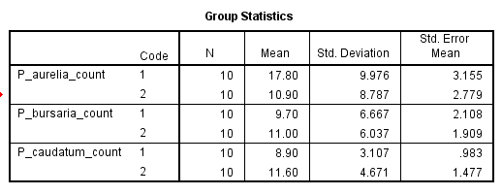
In table 4, the means for P. aurelia, P. bursaria, and P. caudatum are listed for both the control culture and the experimental culture. In the control environment, P. aurelia had 17.8, P. bursaria had 9.7, and P. caudatum had 8.9. In the experimental environment, P. aurelia had 10.9, P. bursaria had 11, and P. caudatum had 11.6.
Table 5. Independent samples test between control culture and experimental culture for P. aurelia, P. bursaria, and P. caudatum, showing the Leven’s test, degrees of freedom, and p-value.
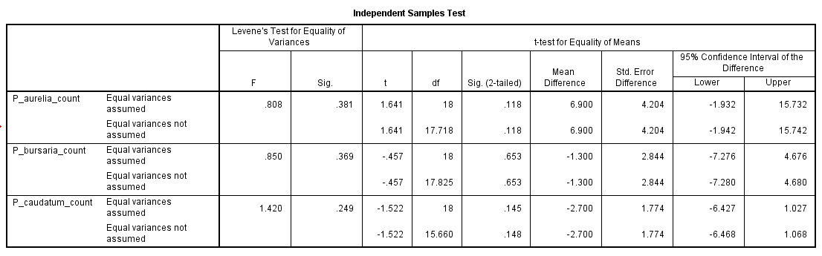
In table 5, the Levene’s test shows that there is equal variance in all three Paramecium species. The test statistic for P. aurelia is 1.641, -0.457 for P. bursaria, and -1.522 for P. caudatum. Each has 18 degrees of freedom. P. aurelia has a p-value of 0.118, P. bursaria has a p-value of 0.653, and P. caudatum has a p-value of 0.145. All of these are above 0.05, so the null hypothesis is accepted for all three.
In the control group, the P. aurelia was the most dominant on day 28 while P. caudatum was the least dominant. In the experimental group, P. caudatum was the most dominant on day 28 while P. aurelia was the least dominant. P. bursaria was always in the middle. The relative change (Experimental/Control) was 0.61 for P. aurelia with the most change, 1.3 for P. caudatum, and 1.13 for P. bursaria with the least change.
Discussion
Yoda’s law of self-thinning is mathematically defined by log (mean plant mass)= -3/2 * log (density) + C . The slope of -3/2 is the same as -1.5. The resulting equation of this experiment was log (means plant mass)= -1.649 * log (density) + 3.34. The slope is slightly larger, but is essentially in agreement with the theory. The null hypothesis was also rejected, since the p-value was less than 0.05, which suggests that plant mean mass depends of plant density.
Biologically speaking, when looking at plants, this is true because plants compete for light. The smaller ones cannot hold their leaves high enough to catch the light and keep a positive carbon balance, and this causes them to die. There is also competition for nutrients, and when they are limited, the roots of the stronger plants will beat out the weaker plants (Hamilton et. al., 1995).
The relationship might not apply if there are any plant growth factors which are not accounted for by the law, then the equation will not apply. If these factors happened to cancel each other out then the equation would still be valid (Zeide, 1987). There is, however, sufficient evidence which suggests that the Law of Self-Thinning isn’t an accurate relationship. Lonsdale (1990) says that it is too general, and that other researchers have found evidence that the slope is much more variable than Yoda and other researchers had suggested, and that it is variable based on the plant biology. The linearity of the graph, as well, is more-so an exception than it is a rule, suggesting that there can be a curved relationship instead.
The null hypothesis was not rejected for the paramecium. Thus, the hypothesis that there is no difference between the control environment and the experimental environment is accepted. Statistically there was no significance, but in figure 2 and 4, it seems that there is significance, that is just barely met. However, there is very high variance so the graphs are more of a general representations and should not be relied on for the final say, leaving the significance to the actual statistics. Regardless, Paramecium aurelia was the most affected by the experimental condition, where the abundance decreased.
That being said, based on the plankton paradox, theoretically there should be a difference. As Huisman and colleagues (2001) suggest, more biodiversity within an ecosystem should promote non-equilibrium of the species, so that all can be successful. In this experiment the experimental environment is a perfect example of this as it has sand and gravel on the bottom, snails, fish, Didinium, aquatic macrophytes and algae, on top of the three Paramecium species in question and their food. In a less diverse environment (like the control culture in this experiment) it should reach equilibrium, where one of the species beats out the rest, and therefore is much more abundant than the rest.
Based on the results of these two experiments, we can apply these ideas to real examples of population ecology. Populations succeed in smaller densities, because as the density becomes larger, limited resources become used up and intraspecific competition becomes a big problem. Even applying it to humans, for example. Since we also have a social component in our populations, we tend to attempt to have everyone survive. So if the food source becomes scarce, with a higher density there would be more people to share it with. Since everyone is now getting much less nutrition, each individual becomes weaker. In most other species, the stronger individuals will simply beat out the weak, so the weak die out.
In a sense, interspecific competition works the same way. Gause’s competitive exclusion principle says that no two species with identical niches can coexist. So essentially, the strongest species beats out the rest of the species with the same niche. Although, if two species are equally strong, one will beat out the other simply by chance (meaning they both have a chance). But in more biodiverse ecosystems, such as lakes, the spatiotemporal variation will allow for multiple species with the same niche to be successful. This is why in any lake we see many species of phytoplankton at a given time.

References

Hiddink, J., & Kaiser, M. (2005). Implications of Liebig's law of the minimum for the
use of ecological indicators based on abundance. Ecography, 28(2): 264-271.

Weller, D. (1987). A Reevaluation of the -3/2 Power Rule of Plant Self-
Thinning. Ecological Monographs, 57(1): 23-23.

Gause, G., & Witt, A. (1935). Behavior of Mixed Populations and the Problem of
Natural Selection. The American Naturalist, 69(725): 596-596.

Levin, S. (1970). Community Equilibria and Stability, and an Extension of the
Competitive Exclusion Principle. The American Naturalist, 104(939): 413-413.

Hutchinson, G. (1961). The Paradox Of The Plankton. The American
Naturalist, 95(882): 137-137.

Hamilton, N. (1995). In Defence of the -3/2 Boundary Rule: A Re-evaluation of Self-
thinning Concepts and Status. Annals of Botany, 76: 569-577.

Zeide, B. (1987). Analysis of the 3/2 Power Law of Self-Thinning. Forest Science,
33(2): 517-537.

Lonsdale, W. (1990). The Self-Thinning Rule: Dead or Alive? Ecology, 71(4): 1373-
1373.

Huisman, J., A. Johansson, E. Folmer, F. Weissing. (2001). Towards a solution of the
plankton paradox: The importance of physiology and life history. Ecology Letters, 4(5): 408-411.

