SOWK STATS

Ch. 1 Underlying Ideas Behind Stats

- Positivism
  - Things should be understood scientifically even social behaviour. Be familiar with quantitative methods as well as qualitative.
- Vienna circle of logical positivists

- Post-positivist
  - Believe more in interpretivism. Believes that the values and beliefs brought by researchers is good for the development of knowledge. More modern than positivism.
- Interpretivism

- Why Stats?
  - You need to be able to back up your research with quantitative data as proof. Qualitative research methods is also equally important describe why the numerical data is the way that it is.
- The structural perspective
  - Middleman and Goldberg
- Chapter 1 – Foundation: The Underlying Ideas Behind Statistics
- Basic Concepts
  - Datum - plural
  - Data – singular
  - Population – All possible measurements in the study. Ex. You would ask every single BSW students. Descriptive is known as a Parameter.
  - Sample – Refers to a portion of the population that is a representation of the population that it was taken from. Ex. Some BSW students are selected out of all BSW students. Descriptive is known as Statistics.
- Measurement Characteristics
  - Reliability – The degree to which a measure yields consistent results.
  - Validity – The degree to which a measure is truly reflects the idea that it was intended to measure.
- Defining Variables
  - Conceptualization - The process of defining what is meant by a variable/concept
  - Operationalization – The process of developing a variable that measures a concept
- Types of variables
  - Independent Variable – controlled for or held constant.
  - Dependent variable – Influenced by independent variable.
    - Look at examples in slides
- Number of variables in the study
  - Univariate – looks at one variable
  - Bivariate – looks at two variables
  - Multivariate – looks at more than 2 variables
    - Look at examples in slides
- Hypothesis
  - Testable statement of the relationship between two or more variables
  - Types of hypothesis:
    - One-tailed – Directional hypothesis. You guess which way the direction will go of the research.
    - Two tailed – Non directional Hypothesis. States a relationship without guessing the outcome.
    - Null – States that there is no relationship
      - Look at slides for examples
- Defining Relationship: Causal vs Non-causal relationships
  - Causal – The Independent Variable (IV) caused the change in the Dependent Variable (DV)
  - Non-causal – There is an association between the IV and the DV, but that does not mean that the changes in the IV caused changes in the DV.
    - Look at examples in the slides
- Levels of measurements
  - Nominal - classifying observations into categories that cannot be ranked from high to low
  - Ordinal - classifying observations have an inherent order to them, but distances between the levels/attributes can’t be measured
  - Interval/Ratio
    - Interval - classifying observations that have an inherent order to them, and the distances between the levels/attributes can be measured and are equally spaced
    - Ratio - classifying observations that have an inherent order to them, and the distances between the levels/attributes can be measured and are equally spaced AND have an absolute zero point
      - Look at slides for examples

Ch. 2 Frequency Distributions & Graphs

- History Of Empiricism Introduction
  - Quantitative methods based on empiricism and the positivist approach to research can be consistent with the structural perspective and many anti-poverty activists use a quantitative approach to advocate for social change.
  - While empiricism was first developed primarily by white male philosophers, it was eventually and more recently modified by feminist scholars whose work on empiricism brought it to a point where it was much more in keeping with a structural and anti-oppressive approach.
  - In this lecture, I will trace the history of empiricism from the early writings of Aristotle, followed by the contributions made by the British empiricists, and ending with the modifications proposed by feminist empiricists.
- What is Empricism
  - Empiricism, which is closely linked to positivism, is the belief that only knowledge based on direct observation through the senses can be accepted as a scientific fact.
- What is Positivism
  - Positivism is a research paradigm that holds that social behavior can be studied and understood in a rational, scientific manner
- Positivism
  - The term Positivism was coined by early French sociologist, Auguste Comte.
  - The most influential advocates were a group of philosophers who were collectively known as the “Vienna Circle of Logical Positivists” .
  - They believed that any variable which cannot be directly represented by a measurement operation has no place in science.

Aristotle
  - He influenced social dynamics, sociology, etc.
  - Is known as the father of modern science. Father of empiricism.
- John Locke
  - Had an influential role in empiricism.
  - Tabula Rasa – Born as a blank slate
- Feminist Empiricism
  - They couldn’t shift things to drastically right away, so they were in agreement with the other empiricist views, but slowly modified them to match their own perceptions.
  - They lean towards interpretivism because they think that you cannot separate values from the individuals.
- Chapter 2:
- Part 1: Frequency Distributions and Graphs
  - Quantitative Data
    - Descriptive statistics – They just summarize the characteristics or relationships between variables.
    - Inferential statistics – When you can look at your data and generalize it to the whole population. Look at slide 21.
- Frequency Distributions
  - Array – You just wrote a quiz and someone received an 8, other a 6, other 4, other 8, other 10. Display in an array…
    - Answer: Just put them in order from lowest number to highest. 4, 6, 8, 8, 10.
  - Absolute Frequency Distribution Table – Make a table and count the number of times each number shows up and put it in a table. The value section would be all the numbers that show up, while the AFD would show the number of times that he number was present.
  - At the bottom of the table you add up the sample. N=Sample.
  - Cumulative Totals of the Value Categories – You add up all the AFD numbers as you go along in order to get the CFD category.
  - APD – Find % of frequency distribution.
  - CPD – Is the total of the % distribution.
- Grouped Frequency Distribution
  - 0-10
  - 11-20
  - 21-30 etc.
- Meaningful Grouping
  - If it’s out of 100 it makes sense to do the groupings, like 0-10, 11-20, 21-30 etc.
- Using Frequency Distributions to Analyze Data
  - Using percentages allows you to compare groups with uneven numbers.
- Part 2: Graphs
  - Point of origin – Where x and y meet on a graph.
  - X axis – Horizontal axis
  - Y axis – Vertical axis
- Bar Graph/Line Diagram
  - The Bars cannot touch in a bar graph. It can be flipped to the side.
  - There are no rules as to when to use a bar graph or a line graph
- Pie Chart
- Histogram
  - Looks like a bar graph, but the bars are touching. At nominal or ordinal you cannot use this type of graph. Interval/ratio level is the best use of this graph.
- Frequency Polygons
  - Polygons are normally used to display data at the interval/ratio level, but can be used to display interval/ratio data that has been transformed into ordinal data.
- Stem-and-Leaf Plots
  - Data is displayed horizontally
  - Makes it possible to see all possible case values
- Displaying Data: Cautions
  - Only use graphs to display data if they will help the reader understand the data, if they are redundant or confusing, they should not be included.
    - Do not try to cram too much information into one graph
    - Graph Junk
    - Unlabelled axes
    - 3D effects
    - Gridlines
    - Moiré effects

Ch. 3 Measures of Central Tendency & Variability

- Measures of Central Tendency
  - 3 Types:
    - Mode
      - … is the value that occurs most often.
      - Can be used with all 3 levels of data.
      - Main disadvantage is that it lacks the precision of some of the other methods of describing central tendency.
      - Variables can be bimodal
        - Example: Consider the following data set;
          - 5,3,8,5,4,7,4,5,6,6
          - Display in an array; 3,4,4,5,5,5,6,6,7,8
          - Mode = 5
        - Example: bimodal
          - Array: 3,4,4,4,4,5,5,5,5,6,6,7
          - Mode: 4 and 5
    - Median
      - Median is the half way point in the list of values.
      - It divides an array of values into two equal halves.
      - If an odd number of values in the array, simply take the middle one
      - If an even number of values in the array, take average of the two middle values
      - Data must be ordinal or interval/ratio level
      - It is the least affected by extreme values (outliers)
        - Consider the following array: 2, 3, 3, 4, 4
        - (odd number of values)
        - Median = 3

        - Consider the following array; 2, 3, 3, 4, 4, 5,
        - (even number of values)
        - The halfway point lies between the 3 and the 4.
        - Median = 3.5
    - Mean
      - The most common method of describing central tendency.
      - Is easy to compute: just total the values and divide by the number of values (…average)
      - Data must be interval/ratio level
      - Main disadvantage: it is affected by extreme values (outliers).
        - Consider the following data set; 5,3,8,5,4,7,4,5,6,6
        - Add all values: = 53
        - Divided by 10 = 5.3
        - Mean = 5.3
      - Our first not-so-scary equation: calculating the mean
        - ∑: capital sigma. A quick way of writing “addition”
        - or “add it all up”
        - x: Stands for a data point
        - x-bar: mean of x
        - n: Sample size

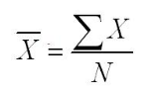
        - Example: 1,2,3,4,4,5 n=6

x-bar=1,2,3,4,4,5/6

x-bar=19/6

x-bar=3.17
  - Population vs. Sample Difference
- Population | - Sample
- N | - n
- µ | - x-bar
- σ | - s
  - Which to use: Mode, Median or Mean
    - …is a personal decision based on what describes the data most accurately.
    - Nominal data: mode should be used
    - Ordinal data: both mode and median
    - Interval/ratio data
      - With a skewed distribution (such as income distributions), the median is often used.
      - Normally distributed: mean is used most often
    - In perfect normal distributions, the mode, the median and the mean all are represented by the same value.
- Variability
  - Measures of variability can tell us about the degree of dispersion or the degree of variation among the values.
  - Variability is also called dispersion.
  - In this lecture, we will focus on four different measures of variability:
    - Range
    - mean deviation
    - variance
    - standard deviation
- Variability: Range
  - The distance that encompasses all values within a data set
  - Range = maximum value - the minimum + 1
  - One is added so that all the values are included.
  - Main disadvantage, it is influenced by outliers.
    - Sample of 8 students’ in this course:
    - E.g.: ages: 17, 30, 25, 22, 21, 19, 32, 50
    - Range = 50 – 17 + 1 = 34 possible ages
    - If you take away the 50 year old student from the sample…
    - Range = 32 – 17 + 1 = 16 possible ages
- Variability: Mean Deviation
  - The mean deviation is the average amount that the values of a variable differ (or deviate) from the mean.
  - REMINDER: Order of operations…. BEDMAS
  - Brackets, Exponents, Division, Multiplication, Addition, Subtraction
  - Mean Deviation
    - Calculate the mean
    - Subtract the mean from each data point
    - Take absolute value of each
    - Add them all up
    - Divide by sample size
    - 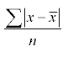
      - Example: Consider the following array;
      - 1,2,3,4,5, The mean is 3
      - 1 - 3 = -2
      - 2 - 3 = -1
      - 3 - 3 = 0
      - 4 - 3 = 1
      - 5 - 3 = 2
      - 2 + 1 + 0 + 1 + 2 = 6
      - 5 The mean deviation = 1.2

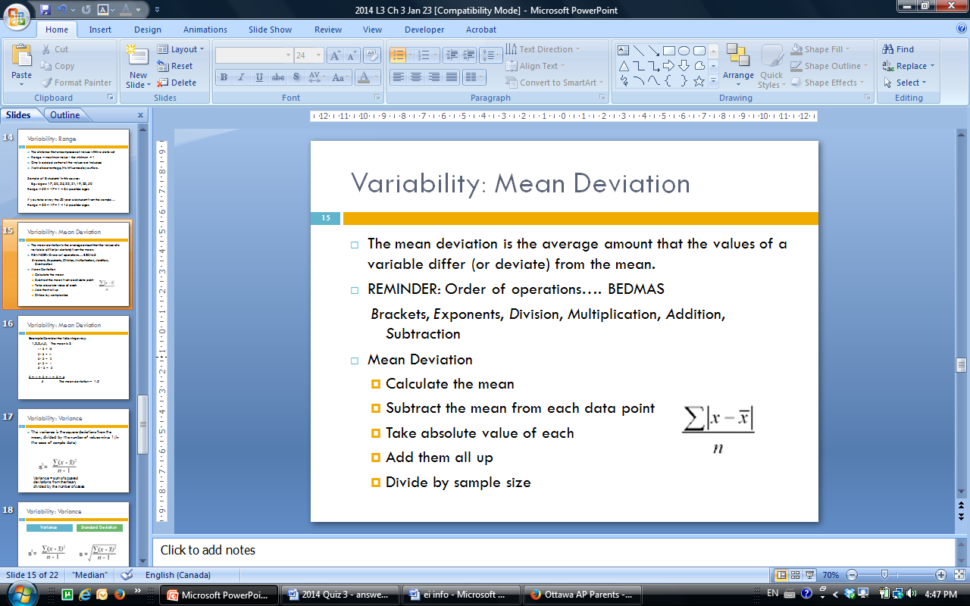
- Explaining Standard Deviation
  - Standard deviation is another measure of how spread out the data are
  - Take the following example:
    - 2, 4, 6, 8, 10
  - What would you guess is the standard deviation?

  - Take the following example: 2, 4, 6, 8, 10
    - Come up with another set of 5 numbers with the SAME standard deviation?
      - 1, 3, 5, 7, 9
      - 47, 49, 51, 53, 55
      - 2050, 2052, 2054, 2056, 2058
    - Come up with another set of 5 numbers that would have a bigger standard deviation?
      - 2, 5, 8, 11, 13
      - 2, 4, 6, 8, 11
    - Come up with another set of 5 numbers that would have a smaller standard deviation?
      - 1, 2, 3, 4, 5
      - 2, 4, 6, 8, 9
- Variability: Standard Deviation
  - Most commonly reported measure of variability
  - Mean and standard deviation very often reported together in research literature
    - 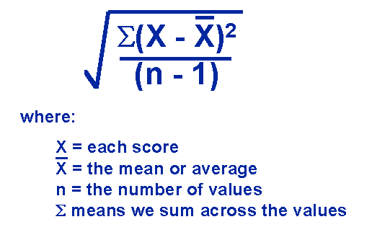
- Variability: Variance
  - Variance

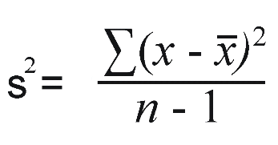
  - Standard Deviation

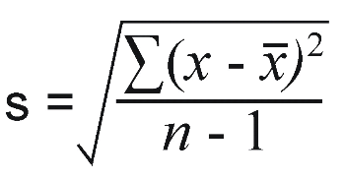
- Variability: Standard Deviation
  - Standard Deviation
    - Calculate the mean
    - Subtract the mean from each data point
    - Square each new value
    - Add them all up
    - Divide by sample size minus 1
    - Take the square root of this number
    - LOOK AT SLIDE 26 FOR EXAMPLE
      - Weird example using dogs… may help to visualize though!
        - http://www.mathsisfun.com/data/standard-deviation.html
    - Consider the following array: 2,3,3,4,4,4,5,5,6 Mean = 4 n= 9

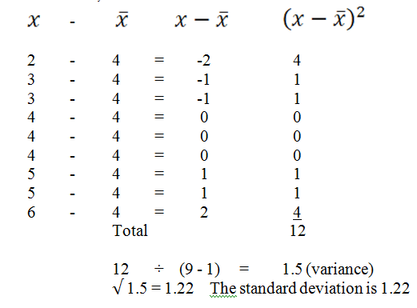
- Variability: Variance
  - The variance is the square deviations from the mean, divided by the number of values minus 1
  - Variance
    - Calculate the mean
    - Subtract the mean from each data point
    - Square each new value
    - Add them all up
    - Divide by sample size minus 1
    - Variance = sum of squared deviations from the mean, divided by the number of cases minus 1
  - Variance: a non-negative number which gives an idea of how widely spread the values of the random variable are likely to be; the larger the variance, the more scattered the observations on average.
  - Variance is non-standard therefore is not useful for comparing, unless the group which is being compared has used the same unit of measurement (cm, inches, same questionnaire etc).
    - The standard deviation is better for comparison purposes and is expressed in the same units as the mean

Ch. 4 Normal Distributions

- Skewness
  - Some distributions are skewed
  - Skewed distribution: ends do not taper off in a similar manner in both directions; assymetrical
  - Positively skewed distribution: tail to the right of the curve. More data in the right tail than would be expected in a normal distribution.
  - Negatively skewed distribution: tail to the left of the curve. More data in the left tail than would be expected in a normal distribution.
- The Normal Distribution
  - When a curve is free of skewness it is said to be symmetrical. If the distribution is symmetrical and bell shaped, it is called a normal distribution.
- The Normal Curve/Distributions
  - Bell shaped
  - Symmetrical
  - Free of skewness
  - Mean, median, mode all fall at approximately the same point

Properties of Normal Distributions
  - The mean, the median, and the mode are all at the highest point and in the centre of the curve.
  - The total area under the curve is said to total 1.0 or 100%. 50% below the mean and 50% above.
  - The normal distribution contains 6 standard deviations, three above the mean and three below.
  - The ends of the curve (tails) never touch the horizontal axis reflecting the fact that there may be extreme values (outliers) or beyond three standard deviations.
  - The distance of one standard deviation above the mean is equal to the distance of one standard deviation below.
  - Nearly all the area (99.74%) falls within three standard deviations of the mean.
- Kurtosis
  - Kurtosis is the degree to which a distribution is peaked as opposed to flat, or the degree to which values cluster around the centre as opposed to being more heavily concentrated at the tails
  - There are 3 different types of kurtosis
  - Distributions that are:
    - peaked are described as leptokurtic.
    - flat are described as platykurtic.
    - neither peaked not flat are described as mesokurtic.

Kurtosis Types

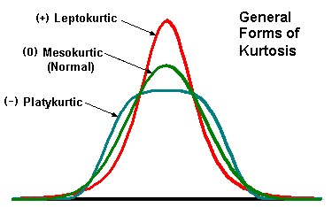
  - Normal distribution is the green one
- Kurtosis and Standard Deviations
  - Standard Deviation is measuring how much the measures vary.
  - The mean median and mode is 0 in the example graph on slide 12.
  - The Leptokurtic will have smaller deviations and have very little variance.
  - The Platykurtic will have larger deviations and have larger variances.
- Outliers
  - very high or very low values, relative to the typical pattern in a distribution
  - First graph - positive, linear relationship, but the ones out of the way are called outliers.
  - Second graph – red dots are the outlier
  - Slide 13
- Variations of Normal Distributions
  - Blue red and yellow have a mean, median and mode of 0.
  - Green does not.
  - Slide 14
- Income and Central Tendency: The Effect of Outliers – Skewness
  - Outliers – Cases with values either higher or lower relative to the typical patterns in a distribution. They have the effect of skewing data.
  - Skewing – significantly pulling the distribution in one direction
  - Outliers may need to be removed from the data for analyses, but this removal needs to be justified
    - The mean is affected by outliers, the median and mode are not.
      - Look at slide 16 and 17
- Income and Central Tendency: The Effect of Outliers
- Slide 18, 19 and 20
  - Positive screw
  - Mean is greater than the mode
    - These two outliers have caused the normal curve to have a “tail” on the right-hand side and skewed it positively (towards larger values).
    - Because the mean is greater than the mode, this implies that more cases with higher values (possible outliers) are present in the data.
      - This means that the mean will fall to the right of the mode.
    - The opposite applies for negatively skewed distributions (the mean will fall to the left of the mode).
- Calculation Z Scores
- Review of Terms : Percentiles
  - Percentiles
    - Indicates rank compared to other
    - If you scored 56% on a test, you may feel that you have done poorly. However, if you find out that the percentile of your score was 96, you would probably feel a whole lot better. Why? Because 95% of the students did more poorly that you did.
- Z-Scores
  - Z scores are also called standard scores
  - They allow us to make direct comparisons on measurements taken from two different groups
  - To calculate the z score simply divide the raw score minus the mean by the standard deviation.
  - z = raw score – mean

standard deviation
- Z-Score Formulas
  - To calculate the z score simply divide the raw score minus the mean by the standard deviation.
  - 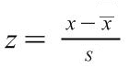
  - X-line = Mean
  - S = Standard Deviation
- Calculating z-score examples
  - What is the z score for a raw score of 81 when the mean is 75 and the standard deviation is 5?
  - Z = 81 - 75 = 6 = 1.2

5 5
  - What is the z score for a raw score of 70 when the mean is 75 and the standard deviation is 5?
  - Z = 70 - 75 = - 5 = -1

5 5
  - What is the z score for a raw score of 15 when the mean is 30 and the standard deviation is 5?
  - Z=15-30/5 = -15/5 = -3
    - Do Other Examples
- Converting Z Scores to Percentile Scores
  - By using a z table (the table that describes the area under the normal curve) you can convert z scores into percentiles.
  - Step 1: look up the z score in table 4.3 on p. 74
    - Go down the left hand column to find the number that you want to one decimal point
    - Then, go across the top row to pick up the second decimal point
    - Find where your column and row meet up, and this is your number (area under the normal curve)
  - If the z score is positive you must add 50 to the area under the normal curve number (p. 74, Table 4.3) .
  - If the z score is negative, you must subtract the number (found on p. 74, Table 4.3) from 50.
  - If it’s positive you add it, if it’s negative you subtract it to find the percentile.
- Practice
- If z = 1.00
  - Use table on pg. 74 of text book
  - Get 34.13
  - Not surprising as z scores and the standard normal curve are the same thus z=1 is the same as standard deviation = 1 when the standard deviation is a perfect standard normal curve
  - Add 34.13 to 50 (because z is positive) = 84.13%ile
- What is the percentile if the z score is 1.26?
  - Using the table describing the area under the normal curve, the number indicated for 1.2 is 39.62
  - Since the z score is positive, we add 50.
  - 39.62 + 50 = 89.62
  - The percentile is 89.62
- What is the percentile if the z score is -1?
  - Again using the table describing the area under the normal curve, the number indicated for 1 is 34.13.
  - Since the z score is negative, we subtract 34.13 from 50.
  - 50 - 34.13 = 15.87
  - The percentile is 15.87
- Steps to calculate the z score and percentile of a given data point
  - Step 1: Calculate mean and standard deviation
  - Step 2: Convert raw score to z score using the z score formula (need mean and standard deviation)
  - Step 3: Look up percentile rank for z score using Table 4.3 on p. 74
Step 4: add 50 if z score is positive, or subtract from 50 if it is negative

Ch. 5 Hypothesis Testing: Basic Principles

  - Sample
    - Selection of people to rep entire pop.
  - Alternative Explanations for Relationships within Samples
    - Rival Hypothesis
      - Other variables or phenomenon that may have interfered with the relationship. Independent/ Dependent Variables.
        - Homelessness (IV) Drug use(DP) A third variable could be an increased experience with violence in the past or mental health, these are considered rival hypothesis.
        - Maturation – any change in the participants over the course of the study. This could be in shorter studies or longitudinal ones.
        - Attrition – when you lose participants from the study.
    - Research Design Flaws
      - Measurement errors – consistent, deliberate or unintentional distortion of the measurement of variables that can distort the quality of the data and the subsequent analysis of the results. Can go undetected.
        - Systematic error - occurs when the researcher is using an invalid measure (not measure what they think it is measuring – not valid)
        - Random error - could occur because of:
          - mood or health changes on the part of respondents
          - Researcher error such as input error into SPSS
          - Terminology that the participant doesn’t understand
        - Measurement bias –
          - Biased wording
          - Social desirability bias
          - Culutral bias (translation)
        - Sampling bias - is the systematic distortion of a research sample. The sample you selected may not be typical of the population you are investigating.
          - e.g.: anger management group: court mandated or voluntary?
        - How do we know our sample isn’t biased?
          - Random selection
          - Random assignment to experimental and control groups
          - Large sample size (n)
    - Probability, Interference and sampling errors
      - Larger sample sizes are better because they are more likely to rep the rest of the pop better.
- Sampling Error
  - Refuting Sampling Error
    - Replication of Study, which would be to redo the study, but that’s expensive etc.
  - Statistical Analyses
    - Looking at data from a single study, you can arrive at the same conclusion and it’s cheaper.
  - Statistical Significance
    - You can allow for about 5% sampling error, if it is more, you must say that your study has not worked out.
  - p value
    - When relationship between variables found within the sample occurred by chance or sampling error.
    - P value of 0-1.00
      - p of 0 means that it happens all the time. Ex. People that smoke will always get cancer.
      - p of 1.00 means that there is no relationship.
      - p of less than 0.5 is good for researchers.
      - The closer to 0, the less there is a chance of error.
      - p must be to 3 decimal places
  - Research/Alternative Hypothesis
    - …is the hypothesis that we are trying to prove.
    - … is a a tentative answer to a research question derived through a review of the literature.
    - …is a testable statement. For example, if after a thorough review of the literature, you conclude that group work is more effective in working with abusive men than individual work, you could formulate this conclusion into a testable statement. This statement would be your research hypothesis.
  - Null Hypothesis
    - Research hypothesis are not considered “proven” or not proven, only that we found support for the hypothesis or we did not
    - If no support for the research hypothesis, then the null hypothesis was supported.
    - Example:
    - Research hypothesis: Adolescents are more likely to smoke cigarettes if one of their caregivers is a smoker
    - Null hypothesis: There is no relationship between adolescent smoking and caregiver smoking.
  - Errors in drawing conclusions about relationships
    - 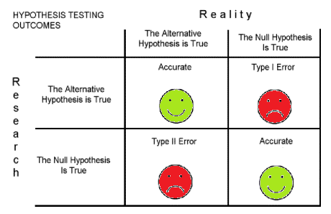
    - Look at slides 30 & on.
Video Clip: probability, chance, alternative hypothesis, sampling error, and the role of research.

Lecture 7

- Use Nonparamentric Tests:
  - If the dependent variable isn’t at the interval ratio level.
  - Have a built in power for some of the assumptions that were not made in the parametric tests.
- Degrees of Freedom
  - SPSS tells you the degrees of freedom.
- Criteria for T-test
  - Keep these thing in mind when figuring out which test to run for assignment.
- One Sample t Test: Explanation
  - When to use it when:
    - Research study has one random chosen sample etc.…

- **YOU REJECT THE NULL HYPOTHESIS IF IT GOES BEYOND THE VALUE RANGE.**

- SPSS – t Test
  - Paired t-test (Compare means of groups)
    - Whether husbands and wives w/ infertility probs feel equally anxious. Administers infertility
    - Research question …is there a difference in the anxiety of husbands and wives who are infertile.
      - Analyze button at top, then compare Means button.
      - Select Paired t-test
      - Move husband to variable 1, then wives to variable 2.
    - It will do all the math for you.
    - You really want to focus on the t-score, the p value, and the thing between t-score and p value on the chart.
  - 6th floor dunton tower

