15th century - Early Renaissance in Italy and North Europe
Renaissance is a sort of light of humanization after what was called "dark ages"
- People were accomplishing things before, but it's about a change in ideas
  - Medieval: religion > much more connected to scriptures
  - Renaissance: rebirth in the interest in classical antiquities

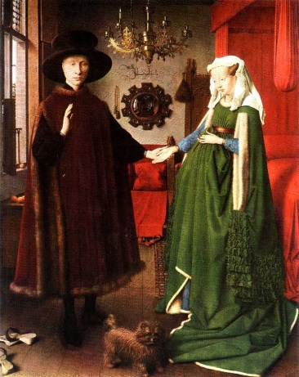
Jan Van Eyke, The Arnolfini Portrait, 1434. Oil on wood panel
- It doesn't seem to have the same religious significance
- The woman looks pregnant, but she's more likely to be holding her gown on her belly to look pregnant
  - The mirror shows that there is someone staring at them
    - On the wall there is the artist's signature
    - Actually it's weird, because he wrote "Jan van Eyck was here"
      - Serving as a witness to the marriage and signing the painting as a legal document
  - Medallions around the mirror = sins
  - Only one candle on the chandelier = the light of God
  - They're not wearing shoes: sign of respect, they're standing on a holy ground
  - The details are actually incredible, considering the small sizes of the painting
  - The dog has three meanings:
    - Loyalty: Its position between these two people
    - Wealthy (those little pets that rich women carried with them
      - As well as the mirror itself: one of the last technologies, at those times
    - Funerary significance
      - The bride might be Arnolfini's first wife (and not Giovanna Cremini, who was just a child at the time the painting was made) who died

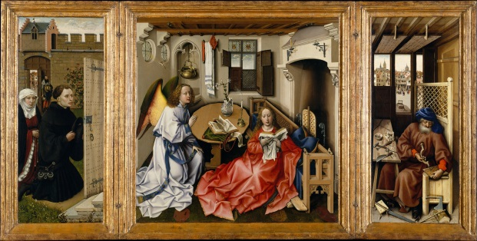
The Mèrode Triptych (or altarpiece) by Robert Campin (1425-1430). Oil on wood panel
- The annunciation
- In the centre: the scene is supposed to be set in a biblical time, but looks more like it's set in modern times
- The lilies on the table symbolizes the purity of the virgin (the vase is Mary, who is the vessel that will bare Christ)
- A little baby Jesus flying through the window
  - There's a light coming from the window Jesus came from that points directly on Mary's womb
- On the right panel: a carpenter (Joseph, Mary's husband), but it's separated. Joseph's significance is less than Mary's, because he was not seen as the direct parent of Jesus
  - Mousetraps that he's building: reference to two possible sources
    - Biblical reference: Jesus is going to be the trap that God sets for the Devil
    - Augustine: Jesus is the mousetrap for a sin
- On the left panel: patrons
  - Walled garden: another symbol for the Virgin's purity
  - Their faces are not staring directly through the door; they're looking inside themselves, basing on their inner fate, instead of witnessing the scene

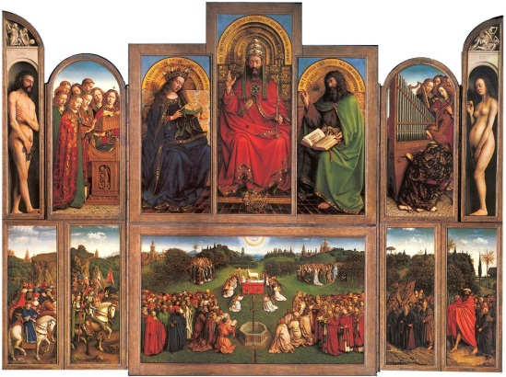
Ghent Altarpiece, Hubert and Jan van Eyck, 1432, oil on panel
- Scene of annunciation
- On the higher register: prophets and sibyls (mythological figures) that predicted the arrival of Christ
- On the bottom:
  - two figures at either end: the patrons who committed the work of art, to stress their devotion to Christ
  - Classical sculptures in the middle: two Saints, Saint John the Baptist and Saint John the Evangelist
- The authors purposely chose to use dull colors, in order to make the figures not pop one against the other
- Oil paint dries slowly, so authors didn't have the time and the chance to give many details on their works
  - From the middle (holy) to the sides (secularity)
  - Christ enthroned in the center (Holy)

Humanism
A concept rooted in the appreciation of the antique, but still a fundamentally religion-based movement in this period: focused on the importance of man, who was understood as the most important of God's creations
Humanists saw classical works as inspiration and as a guide
- During the Renaissance, Classical ideas were elevated above contemporary ideals
Man is important --> artists from a mere artisan figure to an intellectual figure

Florence: the most prominent city for art in the Italian peninsula, ruled by a committee or a series of senates (councils of people)
- Strong mercantile class, who earned money, instead of inheriting it from previous generations
- Social hierarchy has nobility, but moving down there is the merchant class
  - The De Medici family
    - Ruled the republic of Florence (Cosimo de Medici was the patriarch of the city)
- Private individuals who commissioned works

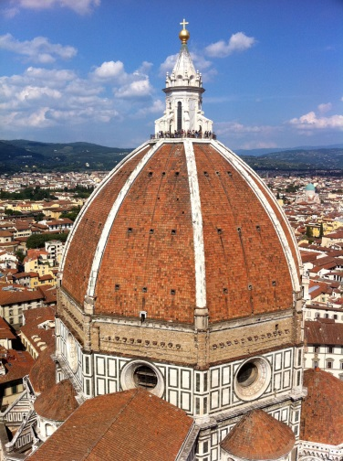
Filippo Brunelleschi
- Architect
- The Dome of the Cathedral, 1420-36, Florence
- Most important building in the city, as religion was still very important in the Quattrocento
- Balance and harmonious proportions, desire to make thing that men can relate to more easily and that was of their sizes --> easy rationalized spaces (vs. Medieval architecture: desire to build something bigger and bigger) --> Disegno: harmonious and beautiful design
- The original Cathedral was very large, so the surface were the Dome needed to be built was enormous
  - He used a dome within a dome

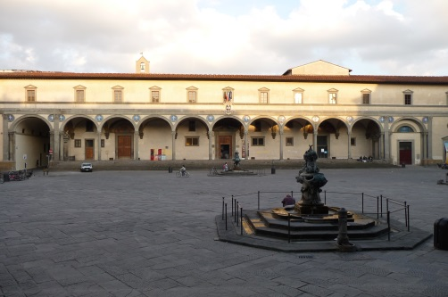
- Loggia of the Ospedale degli Innocenti, 1491, Florence
  - External portico that would have sheltered people from the rain and the sun
    - Series of arches built on Pythagorean proportions
    - Classical fundaments of mathematics
  - Important features of building meant to have civic functions such as helping people

Donatello
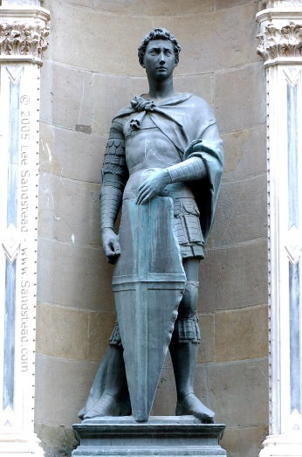
- Sculptor
- Emphasis on the human figure, just like classical antiquity
- Orsanmichele
  - Public building
    - Donatello sculpture outside of the building
      - St. George (1415-17, marble)
      - He slayed the dragon and defended his kingdom
      - Protection of the city
      - Sense of vulnerability through the expression of St. George's face, even though he is a brave warrior
      - Shield and sword
      - Meant to create that personal and emotional connection with the viewer
      - Low relief which portrays St. George slaying the dragon

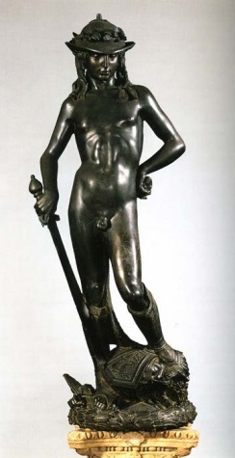
- David (1446-60?), bronze
  - Young boy (vs. Michelangelo's David, who's portrayed as an adult) and not very muscular
  - He burdens the classical ideal of beauty
    - Contrapposto: sense of naturalism, a scene taken out from real life; it gives proportion (in terms of disegno)
  - Significance to Florence: Florentines saw themselves as the underdogs, just like David
    - Small and powerless figure who earned God's grace and managed to face opposite forces
  - His hat is a contemporary and popular style (flowers and leaves adorning him)

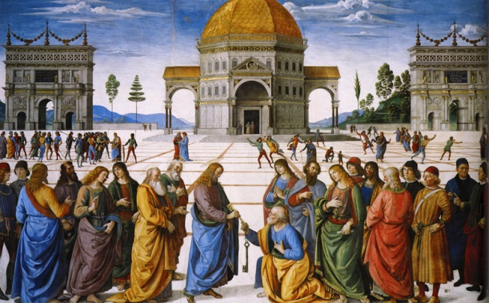
Painting as well was largely influenced by mathematical principles
- Artists engaging with iconography, such as the Bible
- Harmonious balance and proportion of figures and spaces

Perugino, The delivery of the keys, fresco, 1481-82
  - Chapel described by Plato, planned by Alberti and finally rendered by Perugino

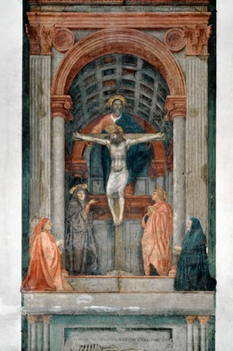
- Masaccio, The holy trinity with the Virgin, St. John and two donors (1425-27), Fresco painting
  - Very detailed
  - Scene of the crucifixion, with the holy trinity
  - Linear perspective: precisely mathematical equation that creates the illusion that the surface is recessing into the wall
  - Classical elements of architecture, such as the capitals of the columns
- Masaccio, 1427, The tribute money, in the Brancacci Chapel, fresco
    - Three distinct scenes happening at the same time
  - Three separated vanishing points that separate the three scene
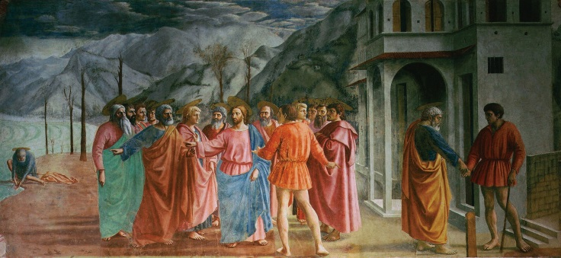
  - Narrative told in a very complex and sophisticated way, using mathematical calculations to demonstrate that the scenes are separated

Vocabulary
- Humanism: shift from religion-focused art to human-focused art
- Antiquity: the time Renaissance artist were reflecting back upon, ancient Greece and ancient Rome
- Central plan church: circular building, there's one main point (the center)
- Basilican plan church: longitudinal, cross-shaped
  - Nave: long rectangle of a basilican plan church
  - Transept: short rectangles on the side of the basilican plan church
- Facade: the face of a building
- Disegno: harmonious balance and harmony of proportions, a concept invented by Alberti
  - Es: The Dome of the Cathedral of Florence, by Brunelleschi
- Contrapposto: a posture used in sculpture, something like an S shape, on one side
  - Es: Donatello’s David More dynamic and feels more naturalized
- Atmospheric perspective: the images that are not the true focus of the picture are portrayed as blurred, so that the main figure(s) can pop out
- Linear perspective: further things are portrayed as smaller, but not necessarily blurrier
- Altarpiece: a work of art with more than one panel, used for religious purpose (churches)
- Annunciation: the archangel Gabriel announcing Mary that she's going to bear Jesus in her womb
- Oil in panel: Painting on the wood, it dries more slowly and gave artists more time to blend their colors together
  - They firs covered the wood with gesso, in order to create a smooth surface
- Iconography: symbols or motives whose true (and sometimes hidden) meaning can be understand through the possession of previous knowledge
  - Pre-iconographical: practical experience, things you can observe without special knowledge
  - Iconographical: reading of symbols that we can understand based on knowledge we have from outside sources (bible, myths, literary sources, etc.)
  - Iconological: we use our knowledge of historical context in order to analyze the work

