Ayotunde Ogala
100943660
Charles Nwokotubo
100953861

Lab 3
Section 13O 8:35am

- INTRODUCTION
This lab involves the construction of a T-Bird Tail-Light Control Using a CPLD. The T-Bird of this lab has two sets of three taillights in a row. The lights in the T-Bird are conditioned to flash based on which of its three switches; L, B and R is on at any given time. A circuit, which perfectly obeys the conditions for the lights flashing, is to be designed and then the logic simulated using ModelSim. Hardware will then be programmed on a CPLD (complex Programmable Logic Device), to show the lights flashing.

2.0 SPECIFICATIONS
In this lab, the authors designed a T-Bird Tail Light. It has two sets of three taillights in a row. The lights are controlled by three switches, labeled L, R, and B. Conditions for the lights of the Tail Bird are:
Turning on both L and R turns on the emergency flashers. Then all six lights flash
on and off continuously for half-a-second each. When L and R are both off, pushing
B lights all six lights.
When L or R (not both) is on with B, the taillights on the appropriate side should flash as for a turn (sequentially from left to right) and the lights on the other side should be steadily lit to show braking. The steady brake light overrides the Emergency flashers.
The design of this T-Bird tail light control will be done using a continuously running clock, which alternates between on and off.
The circuit was designed on a computer and then a simulation was carried out to test the designed circuit. Owing to the fact that the design was simulated with the use of computer software, there was no limit to the number of logic gates or wires being used.

3.0 DESIGN
Taking all the specifications for the circuit into consideration, the authors began by designing a divide-by-two circuit, which takes the clock frequency (CLK), halves it and sends it to the output Q0. By doing this, one is able to generate 4 different states of the combination of Q0 and CLK. The authors took advantage of the “remembering” ability of a flip-flop and simply added an inverter linking the input and the output (D and Q0) while the clock frequency was fed into the C1 terminal. Figure 1 illustrates the schematic of the divide-by-two circuit.
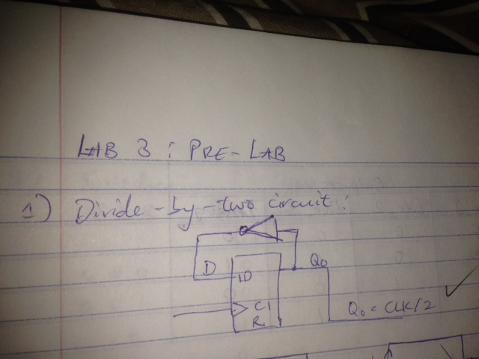
FIGURE 1: DIVIDE-BY-TWO CIRCUIT

In order to ensure the circuit worked, a timing diagram including D, Q0 and CLK was drawn and the result analyzed. Figure 2 illustrates the timing diagram.
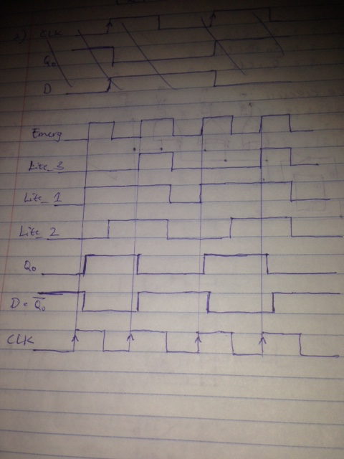
FIGURE 2: TIMING DIAGRAM

Right before the first rising clock edge, the flip-flop stores the value of D (1) and sends it to Q0 just after the rising edge. The value of Q0 (now 1) is then inverted and sent to D, thus D becomes zero and stays zero till it meets the next rising clock edge (which is a period away from the first). Thus the period of Q0 becomes double that of the clock frequency. The divide-by-two circuit works perfectly.

3.2 COUNTER CIRCUIT
The next stage was the design of a counter circuit, which comprises of the divide-by-two circuit and a few logic gates. This circuit takes the signals connected to the flip-flop and uses logic to generate a particular sequence in Lite_1, Lite_2 and Lite_3. The sequence illustrates the flashing of the taillights and is as follows: 000 -> 100 -> 110 -> 111. In order, to generate this sequence, the authors designed a truth table and used it to derive equations for each Lite output. Figure 3 illustrates the truth table and equations.
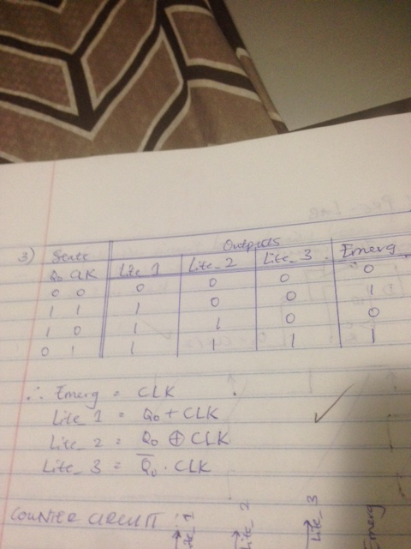
FIGURE 3: COUNTER CIRCUIT TRUTH TABLE AND EQUATIONS

As observed in Figure 2, the Emerg signal was the same as the clock signal hence the equation: Emerg = CLK. Figure 4 illustrates the schematic of the counter circuit.
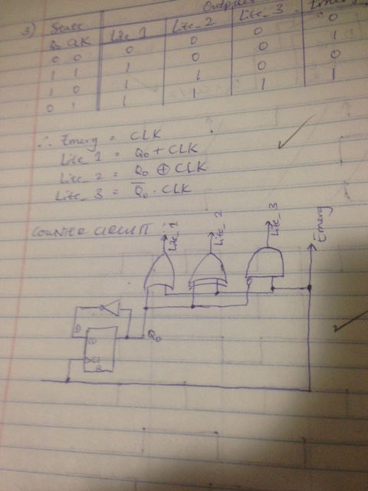
FIGURE 4: COUNTER CIRCUIT

3.3 CONTROL BOXES
The Lite and Emerg signals are then fed into control boxes along with three independent switches B, L and R. The control boxes consist of left and right components and are used to determine what the left and right taillights do for the different combinations of the switches B, L and R.

3.31 LEFT CONTROL BOX
The authors started by designing a truth table, taking all the specifications into account. Figure 5 illustrates this truth table.
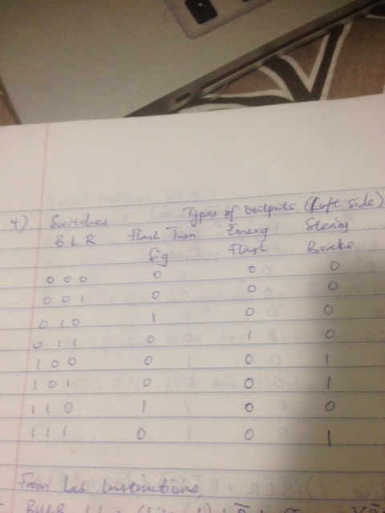
FIGURE 5: LEFT CONTROL BOX TRUTH TABLE
The columns of the table were then entered into a 5-variable multiple output karnaugh map and looped accordingly to derive the equations for BULB_L1, BULB_L2 and BULB_L3 (this was done in the lab instructions). Figure 6 shows these equations.
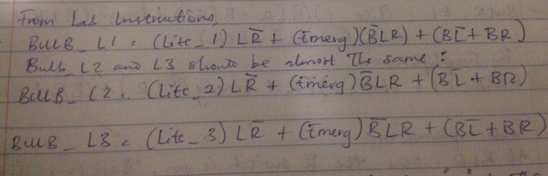
FIGURE 6: LEFT CONTROL BOX EQUATIONS

Using the above set of equations, a logic circuit for the left control box, with seven inputs and three outputs, was designed. The schematic of this circuit is illustrated in Figure 7.
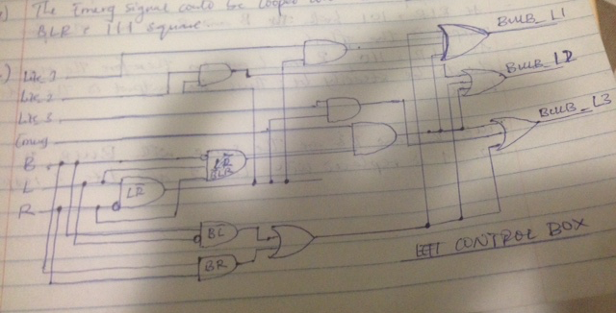
FIGURE 7: LEFT CONTROL BOX CIRCUIT

3.32 RIGHT CONTROL BOX
The design of the right control box also involved making a truth table by taking the specifications into account. Figure 8 illustrates the truth table for the right control box.
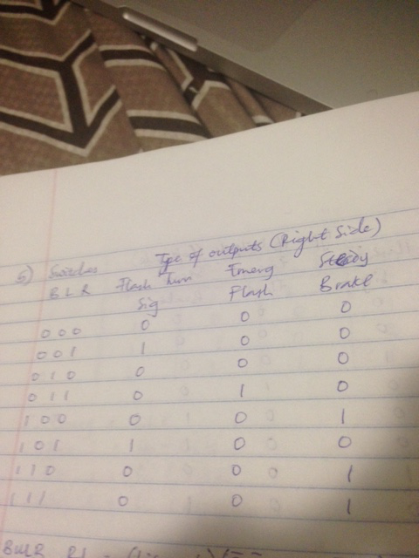
FIGURE 8: RIGHT CONTROL BOX TRUTH TABLE
This table is only slightly different from that of the left control box. Figure 9 illustrates the derivation of the equations as well as the explanation for the table differences.
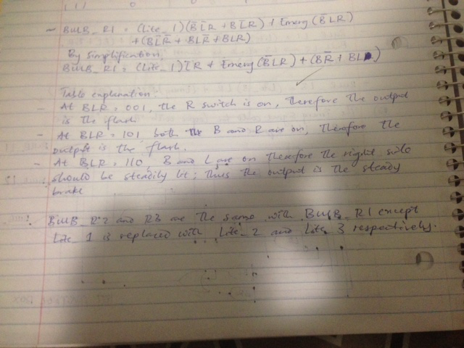
FIGURE 9: RIGHT CONTROL BOX EQUATIONS AND TABLE EXPLANATION

It was not necessary drawing the schematic if the right control box by hand as it was very similar to the left control box. However, certain differences are pointed out in the text shown in Figure 10.

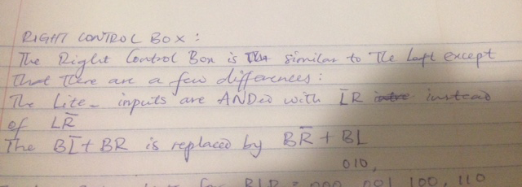
FIGURE 10: RIGHT CONTROL BOX DIFFERENCES

3.4 TEST FIXTURE
The test fixture given had tests for BLR = 000, 010, 001, 100 and 110. Therefore, tests for 011, 101 and 111 had to be added to it.

4.0 IMPLEMENTATION AND TESTING
As mentioned in the introduction, this lab was carried out with the use of virtual logic simulation software. Thus, each sub-circuit was built individually and the outputs coming from one sub-circuit were translated to the inputs of the next sub-circuit as needed.

4.1 IMPLEMENTATION AND CIRCUIT BUILDING
The first step was to build the counter circuit as illustrated in section 3.2. Recall that the counter circuit consists of flip-flop divide-by-two circuit and a series of logic gates leading to the outputs Lite_1, Lite_2, Lite_3 and Emerg. Figure 11 illustrates the schematic of the counter circuit as built on the software.
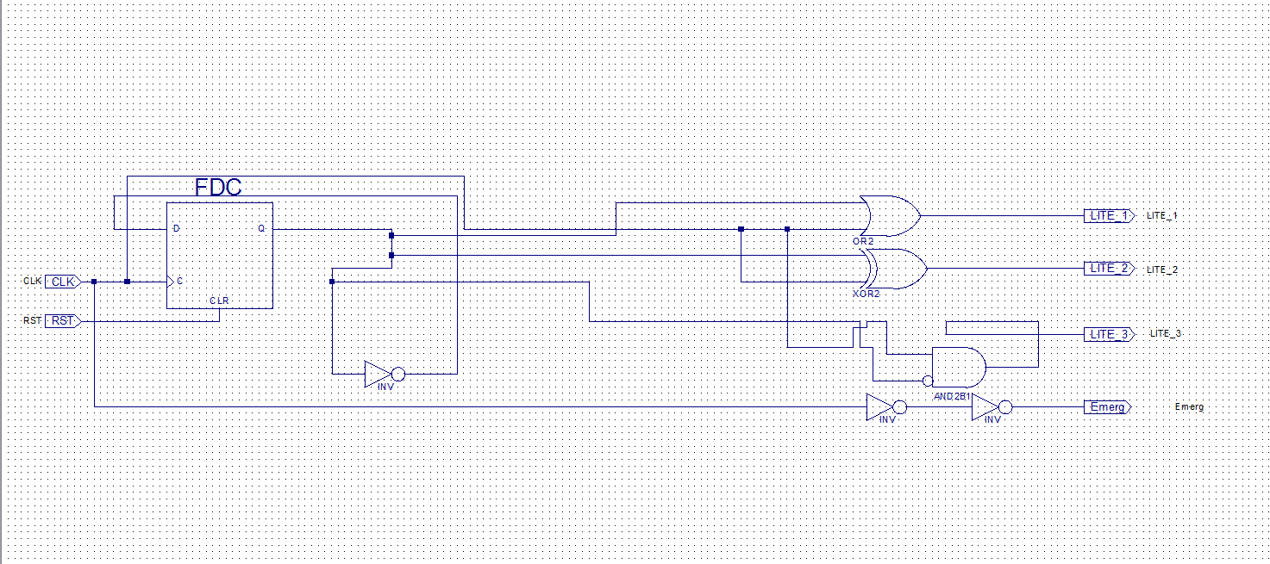
FIGURE 11: COUNTER CIRCUIT IMPLEMENTATION

One can observe that the clock signal is not directly fed into the Emerg port as stated in the design section (3.2). This is due to the fact that the software does not allow an input port to be connected directly to an output one. Hence, two inverters are placed in a row between said input and output.
The very next step was to build the left control box circuit as designed in section 3.31 using the output ports from the counter circuit as inputs. Figure 12 illustrates the schematic of the left control box as built on the software.
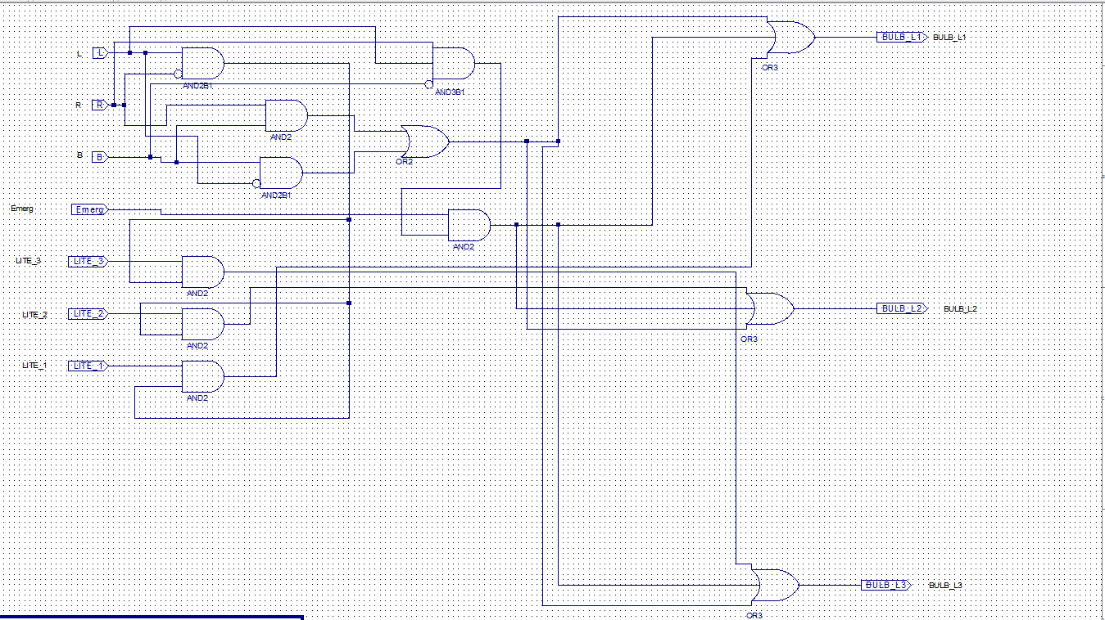
FIGURE 12: LEFT CONTROL BOX IMPLEMENTATION

The last step of circuit building was to construct the right control box circuit as designed in section 3.32 using the output ports from the counter circuit as inputs. Figure 13 illustrates the schematic of the right control box as built on the software.
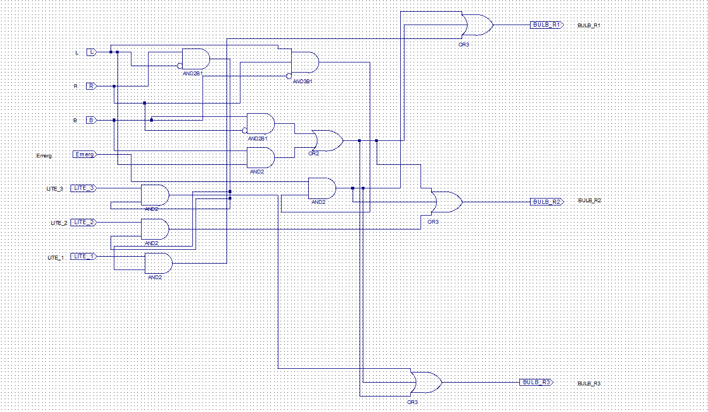
FIGURE 13: RIGHT CONTROL BOX IMPLEMENTATION

After construction of the circuit was complete, the authors compiled and ran the project. At first, the resulting waveform was a series of horizontal lines comprising of both red and green colors. However, after consulting the TA and analyzing closely, it was discovered that some connections within the circuit were not made properly. This was rectified thus the red lines disappeared and all that had to be done was to adjust the zoom level.

4.2 TESTING
The testing of the designed circuit involved two stages. The first was analyzing the waveforms produced by the circuit and the test fixture while the second was by simple experimentation on the CPLD.

4.21 WAVEFORM ANALYSIS
The Verilog test fixture is as follows:
// Verilog test fixture schematic TBirdTestFixture.v - Jan 30, 2005

`timescale 1s / 1ms

module TBird_TestFixture;

// Outputs from your circuit
wire BULB_L1, BULB_L2, BULB_L3, BULB_R1, BULB_R2, BULB_R3;
wire CLK;

// Inputs to your circuit
reg L, R, B, RST, fCLK;

// Generate a clock,
real Time;
initial
begin
fCLK=0; Time=0;
forever #0.5 Time=Time+0.5; //Keep track of time in sec.
end //$time in ModleSim gave ps?

always // (0.5 sec)/4 = 0.0625 sec.
begin #0.062 fCLK=~fCLK; // Correct lack of 4 digit time resolution.
#0.063 fCLK=~fCLK; // by using a slightly asymmetric clock.
end

// Make signals in tbirdtop visable in the test fixture.
wire Emerg, LITE_1, LITE_2, LITE_3;
// Emerg error corrected, Tue, Jan 8,2011
assign Emerg=UUT.Emerg, LITE_1=UUT.LITE_1, LITE_2=UUT.LITE_2, LITE_3=UUT.LITE_3;

// TESTS START HERE
// ================================================================

// Set all the switches low initially
initial begin
L=0; R=0; B=0;

// Do an initial reset to make Q0 =0 at the start of the simulation.

RST = 0;
#0.1 RST = 1; // Set RST high after a 0.1 s delay
#1.7 RST = 0; // Set RST low after an additional 1.7 s delay
// These fractional delays are so we don't change switches
// exactly on the clock edge.

//Test 0: No switches on Time = 0.1+1.7 = 1.8s
L = 0;
R = 0;
B = 0;
#5 // Delay 5s for a total of 6.8s
#3 // Delay 3s for a total delay of 9.8s

//Test 1: Left signal;
// This test starts at about 10 sec. (9.8s)
L = 1; R=0; B=0; // B and R remain at 0
#7 // Delay 7s for a total of 16.8s
L = 0; //Leave flat lines between tests
#3 // Delay 5s for a total of 19.8s

//Test 2: Right signal on, Left off; starts at about 20 s (19.8s)
R = 1; L=0; B=0; // L and B remain at 0
#7 // Delay 5s for a total of 26.8s
R = 0;
#3 // Delay 5s for a total of 29.8s

//Test 3: Brake; at about 30 s
B = 1; L=0; R=0;
#7 // Delay 7s for a total of 36.8s
B = 0;
#3 // Delay 3s for a total of 39.8s

//Test 4: Brake and left flashers; starts at about 40 s
B = 1; L = 1; R=0;
#7 // Delay 7s for a total of 46.8 s
L = 0; B = 0;
#3 // Leave some flat lines between tests

// Make Test 5 easy to find by starting it at about 50 s

//Test 5:
// This test starts at about 50 s
#7 B = 0; L = 1; R = 1;
// Delay 7s for a total of 56.8 s
L = 0; R = 0;
#3 // Delay 7s for a total of 59.8 s
//Test 6:
#7 B = 1; L = 0; R = 1;
// Delay 7s for a total of 66.8 s
B = 0; R = 0;
#3 // Delay 7s for a total of 69.8 s

//Test 7:
#7 B = 1; L = 1; R = 1;
// Delay 7s for a total of 76.8 s
B = 0; L = 0; R = 0;
#3 // Delay 7s for a total of 79.8 s

#10 $stop;

Tests 5, 6 and 7 were manually added to account for all combinations of B, L and R.
Figure 14 illustrates the resulting waveform after simulation was complete.

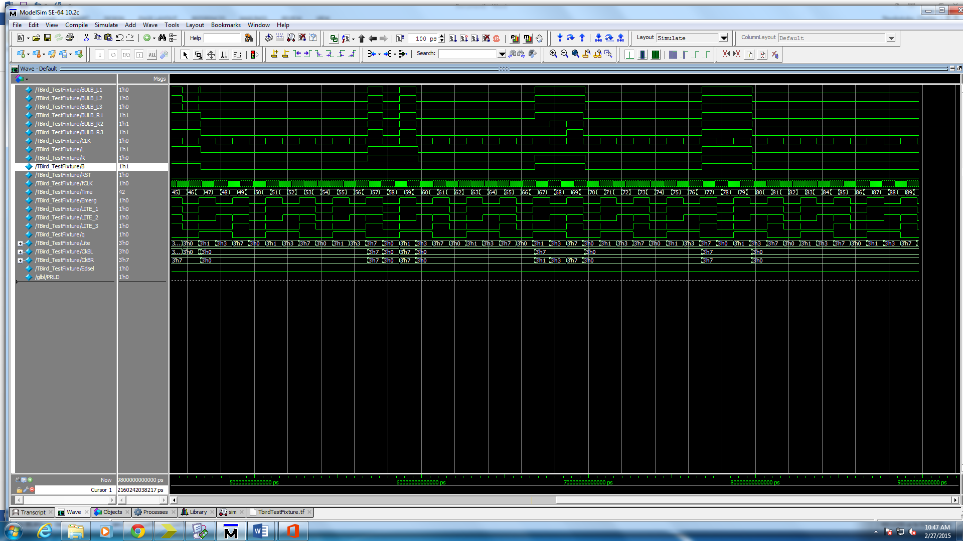
FIGURE 14: RESULTING WAVEFORM

Figure 15 illustrates a test case on the waveform.
FIGURE 15: TEST CASE

Taking out the first portion of the waveform, one can observe that BLR = 110. According to the truth tables in sections 3.31 and 3.32, the lights on the left side should flash sequentially while those on the right should be steadily lit. It can be observed that bulbs R1, R2 and R3 are always on while L1, L2 and L3 are just returning from a 111 state.

4.22 CPLD TESTING
After the waveform was analyzed and deemed correct, the virtual circuit was made into a program and was downloaded into the CPLD. Applying different combinations of the BLR switches yielded the correct results as stated in the specifications. Hence, the tail lights worked perfectly.

5.0 CONCLUSION
The authors were able to design a perfectly working T-Bird taillight that works based on the conditions stated in the specifications of the lab. The implementation and testing of the circuit were made easy due to a very small number of errors made in the design of the circuit. The problems faced were minor and were easily dealt with as the circuit diagrams were checked and some wiring errors were discovered and fixed. In general, the TA and lab coordinator were very helpful with debugging, testing and simulation.

