Chapter 1
  - Describe what sport and exercise psychology is
- Sport and exercise psychology is the scientific study of people and their behaviors in sport and exercise contexts and the practical application of that knowledge.
- Two objectives sport psychologists study:
- Understand the effects of psychological factors on physical or motor performance. i.e. anxiety, lack of confidence, coach’s influence, imagery.
- Understand the effects of physical activity participation on psychological development, health, and well-being. i.e. does participating in physical activity reduce anxiety, improve self-esteem, become more aggressive, enhance personality.

  - Understand what sport and exercise psychology specialists do

Sport Psychologists serve 3 primary roles in their professional activities:
- 1.Research
- Try to attain advance knowledge in the field of sports. i.e. studying what motivates children to be involved with youth sport.
- In a team effort, study problems such as exercise adherence, psychology of athletic injuries, and role of exercise in the treatment of HIVs. Sport psychologists then share findings with each other and ultimately this produces advances, discussing, and healthy debate at professional meetings.
- Teaching
Teach sport psychology at various levels.
- Consulting
Consult with individual athletes or athletic teams to develop psychological skills for enhancing competitive performance and training.

Clinical sport psychologists have extensive training in psychology so they can detect and treat individuals with emotional disorders. Are licensed psychologists. i.e. can help treat drug abuse and eating disorders.
Educational sport psychology specialists have extensive training in sport and exercise science, physical education, ad kinesiology; and they understand the psychology of human movement, particular as it relates to sport and exercise contexts. They are considered “mental coaches” who educate athletes and exercisers about psychological skills and their development. They are not trained to work with individuals who have severe emotional disorders.

  - Understand major developments in the history of sport and exercise psychology
Period 1: Early Years (1893-1920)
First Experiment: People tend to perform better in groups then individually
Done by Norman Triplett (1897): Cyclists rode faster and more efficient in groups
E.W Scripture studied the mental aspect and discovered how sport might develop character in people – isolated sudies
Period 2: Griffith Era (1921-1938)
Coleman Griffith is the father of American Sport Psychology. Published Psychology of Coaching and Psychology of Athletics.
Period 3: Preparation for the Future (1939-1965)
Franklin Henry studied the psychological aspects of sport and motor skills acquisition, and initiated many systematic research programs- scientific development.
Dorothy Hazeltine Yates was first woman sport psychologist and researcher. She developed the relaxation-set method, teaching boxers to use relaxation and positive affirmations to help manage emotions and enhance performance.
Period 4: Establishment of Academic Sport Psychology (1966-1977)
Bruce Ogilvie on of the first consultants that began working with athletes and teams. Father of North American applied sport psychology.
Studied how psychological factors – anxiety, self-esteem, and personality influence motor skill performance and how participation in sport influences psychological development.
Period 5: Multidisciplinary Science and Practice in Sport and Exercise Psychology (1978-2000)
Development of Exercise psychology.
Dorothy Harris advanced the cause of women and sport psychology. Helped establish the PSU graduate program in sport psychology. First woman member of International Society of Sport Psychology.
Period 6: Contemporary Sort and Exercise Psychology
Strong, diverse, and sustained research programs are evident around the world.
Avksenty Puni studied psychological preparation for athletic competition focusing on realistic goals, uncompromising effort, optimal emotional arousal, high tolerance for distractions and stress, and self-regulation was groundbreaking and far ahead of what was being done in America at the time.

  - Distinguish between scientific and professional practice knowledge

When we apply science to psychology, the goals are to describe, explain, predict, and allow control of behavior.
It is not simply an accumulation of facts discovered through detailed observations but rather a process, or method, of learning about the world through the systematic, controlled, empirical, and critical filtering of knowledge acquired through experience.

General guidelines for research:
- Uses a systematic approach to studying a question. It involves standardizing the conditions; for example, one might assess the children’s self esteem under identical conditions with a carefully designed measure.
- Involves control of conditions. Key variables in the research (i.e. changes in self esteem) are the focus of study, with other variables being controlled (i.e. the same person doing the teaching) so they do not influence the primary relationship.
- The method is empirical, which means its based on observation. Objective evidence must support beliefs, and this evidence must be open to outside evaluation and observation.
- The method is critical, meaning that it involves rigorous evaluation by the researcher and other scientists.

Ultimate goal is to come up with a theory: a set of facts that present a systematic view of some phenomenon in order to describe, explain, and predict its future occurrences. i.e. The Social Facilitation Theory by Zajonc. The theory suggests an audience creates arousal in the performer, which hurts performance on difficult tasks that have not been learned and helps performance on well-learned tasks.

A way to build, support, and refute theory is by conducting studies and experiments.
Study: involves an investigator’s observing or assessing factors without changing the environment in any way. i.e. comparing effectiveness of goal setting and self talk in improving athletic performance by giving a questionnaire t high school students before a marathon.
Studies have limited ability to identify cause and effect relations between factors.

An experiment manipulates the variables along with observing them and then examines how changes in one variable affect changes in others. Involves two different groups: experimental vs. control group. i.e. One might experiment by giving an experiment group of runners training on how to set goals and to use imagery. The control group of runners will receive no training. If the experimental group outperformed the control group, the cause for this would be known.

Scientifically derived knowledge is reliable, that is, scientific findings are consistent or repeatable.
Scientists are trained to be as objective as possible and one of their goals is to collect unbiased data- facts not influenced by personal feelings.

Negative aspects:
It is slow and conservative because reliability of results must be judged by others.
Sometimes it is reductionist. It may be too complex to study all the variables of a situation simultaneously; the researcher may select isolated variables that are of the most critical interest. Doing this compromises the understanding of the whole picture.
Overemphasis on internal validity- Results based on well scientists conform to the rules of the methodology. Needs to have external validity, for it to have chance to have true significance.

Professional Practice Knowledge refers to knowledge gained through experience. It comes from different sources: scientific method, systematic observation, single case study, shared public experience, introspection (examine your thoughts and feelings), and intuition (immediate apprehension of knowledge in the absence of conscious, rational process). Example on page 15.

It is guided trial-and-error learning.
The practical knowledge more holistic than the scientifically derived knowledge, because it reflects the complex interplay of many factors- psychological, physical, technical, strategic, and social. Unlike scientific method, tends to absorb novel or innovative practices.
Practical theories do not have to wait to be scientifically verified, can be used immediately.

Negatives:
Produce fewer and less precise explanations.
Greater susceptibility to bias
Less reliable and definitive

Integrate experiential and scientific knowledge
To take an active approach, one must blend scientific knowledge of sport/exercise psychology with professional practical knowledge- makes for effective applied practice. i.e. Relate scientific knowledge to your own experience as an athlete. Evaluate how effective these ideas are and where they work best. These findings may not hold true 100% of the time due to probability.

  - Compare and contrast orientations to the field
- Psychophysiological orientation believes that the best way to study behavior during sport and exercise is to examine the physiological processes of the brain and their influences on the physical activity. Typically assess heart rate, brain rate activity, and muscle actions potentials.
- Social-Psychological orientation focuses on how behavior is determined by a complex interaction between the environment and one’s personal makeup. i.e. examine how a leader’s style and strategies foster group cohesion and influence participation in an exercise program.
- Cognitive-Behavioral orientation assumes that behavior is determined by both the environment and cognition, with thoughts and interpretation playing an especially important role. i.e. develop self-report measures to assess self-confidence and anxiety. Then would see how these assessments are linked to changes in an athlete’s behavior. Tennis players were either burned out or not burned out were surveyed. Results showed burned out players had less motivation compared to non-burnt out players. Also reported being more withdrawn, had more perfectionist personality tendencies, and used different coping strategies for stress. Thus, links athlete’s thoughts/behaviors and athlete’s burnout status were examined.

Chapter 2 Personality and Sport
  - Describe what makes up personality and why it’s important
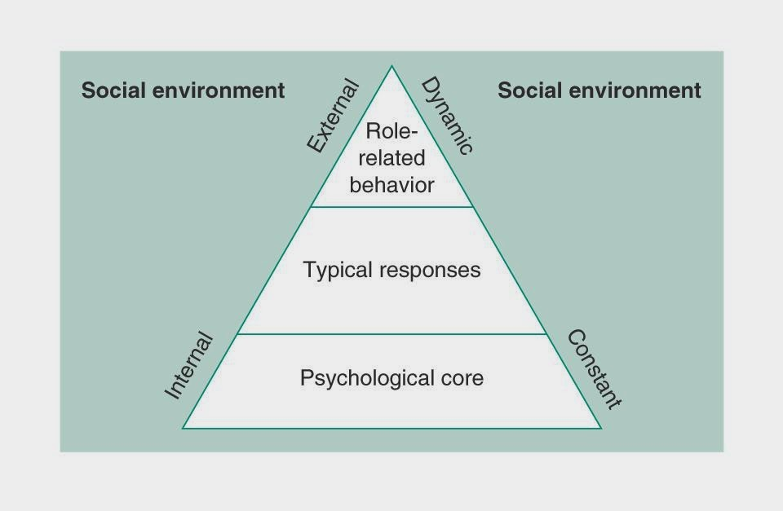
Personality – is the sum of characteristics that make a person unique. The study of personality helps us work better with students, athletes, and exercises.

Psychological Core - Psychological core is known as the most basic level of your personality. This component includes your attitudes, values, interests and motives, and beliefs about yourself. It is the most stable.

Typical Responses - Typical responses are the ways we each learn to adjust to the environment or how we usually respond to the world around us. Good indicators of psychological core.

Role Related Behavior - Role-related behaviour changes as your perceptions of the environment change. Different situations require playing different roles.

- Stability and change are desirable in personality. The core, or stable, aspect of personality provides the structure we need to function effectively in society, whereas the dynamic, or changing, aspect allows of learning.

  - Discuss major approaches to understanding personality
- Psychodynamic Approach – characterized by two themes.
Firstly, it places emphasis on unconscious determinants of behavior.
  - Id (our instinctive drives) – “sex crazed monkey” or someone who wants something right away.
  - Superego (one’s moral conscience) – something blocking us from achieving our goals. Athlete how do not want to be pushed to achieve goals.
  - Ego (the conscious personality) – a balance of id and superego. The athlete needs to be motivated to achieve the goal.
Secondly, focuses on understanding the person as a whole rather than identifying isolated traits or dispositions.
Weakness – focuses almost entirely on internal determinant of behavior, giving little attention to the social environment.
Not al behaviors of an athlete are under conscious control and that at times it may be appropriate to focus on unconscious determinants of behavior.
- Trait Approach – assumes the fundamental traits of personality are relatively stable and does not consider the particular situations that might also influence an individual’s behavior. Assumes that personality traits are enduring and consistent across a variety of situations. An athlete is likely to behave the same regardless of the situation.
The big 5 model – consists of neuroticism (nervousness), extraversion (enthusiasm) vs. introversion, openness to experience, agreeableness, and conscientious (achievement striving, self discipline).
- Situation Approach- argues that behavior is determined largely by the situation/environment.
Draws form social learning theory – explains behavior in terms of observational learning (modeling) and social reinforcement (feedback).
The environment influences and reinforcements shape the way you behave,
- Interactional Approach – considers the situation and person as determinants of behavior – Both the situation at hand and an individual’s personality traits.
- Phenomenological Approach – believes that behavior is best determined by accounting for both situations and personal characteristics. However, instead of focusing on fixed traits as the primary determinant of behavior, psychologists examine the individual’s understanding and interpretation of himself and his environment. An individual’s subjective experiences and personal views of the world and of himself are critical.

  - Identify how personality can be measured
- Using an interactional approach, one should assess both psychological traits (an individuals’ typical style of behaving) and states (the situation’s effect on behaviors).
- The situations effect on an individual’s behavior = state
- Trait and State Measures – trait can be how you generally feel about a situation whereas the state is how you feel “right now” at a particular moment in time.
- Situation Specific Measures – predicts behavior more reliably for given situations because they consider both the personality of an individual and the specific situation (interactional approach). i.e. students do poorly on tests when they became overly anxious. This measure would then evaluate how much anxiety the student feels before the test.
- We can predict behavior better when we have more knowledge of specific situation and the ways individuals respond to particular types of situations.
- Sport Specific Measures – predicts behavior in sport settings. Instead measuring anxiety of student before taking a test one would measure anxiety of the student before a basketball game.
- Important to consider fluctuations of feelings before and during competition in evaluating personality and reactions to competitive settings.

  - Assess personality tests and research for practicality and validity
- Personality test users must know the principles of testing and measurement error, know their limitations relative to administration and interpretation, avoid using tests alone for team selection, always give explanations and feedback, assure confidentiality, take an intra-individual approach to testing, and understand and assess specific personality components.
- All psychological tests contain a degree of measurement error; use caution interpreting their results.
- Using only psychological tests to select players for a team is an abuse because the tests are not accurate enough to be predictive. Must be considered in conjunction with physical performance measures, coach evaluation, and the actual levels of play.
- Before taking a test, athletes need to be told the purpose of the test and should receive feedback about the results. Should assure athletes of confidentiality.
- Intra-individual approach – how you are feeling relative to how you usually feel. Compare individuals against their own baseline levels rather than against normative information.
- To measure someone’s personality, need to understand the individual’s psychological core. To measure deeper aspects of personality use a projective test – include pictures or written situations, and test takers are used to project their feelings and thoughts about these materials.

  - Understand the relationship between personality and behavior in sport and exercise

- No specific personality profile has been found that consistently distinguishes athletes from non-athletes.
- Few personality differences are evident between male and female athletes, particularly at the elite level.
- Morgan developed a mental health model that he reported to be effective in predicting athletic success. The model suggests that positive mental health as assessed by a certain pattern of Profile of Mood States (POMS) scores is directly related to athletic success and high levels of performance.
- Successful athletes are characterized by what Morgan called the iceberg profile. The iceberg profile of a successful athlete shows vigor(physical strength and good health) above the mean of the population but tension, depression, anger, fatigue, and confusion below the mean of population.
- Again, this is not a suitable method to be used for team selection – participants could be “faking good” to impress their coaches or skew results.
- Mood changes in athletes should be compared with their own previous mood levels and not with large group norms.
- Can help psychologists determine which personality traits are associated with successful athletes, and once these traits are understood, can help develop psychological skills in athletes to improve performance.
- Personality tests are useful tools that help us better understand, monitor, and work with athletes and exercisers. They are not magical instruments that allow us to make generalizations about individual’s behavior and their performances.

- Type A behavior – is characterized by strong sense of urgency, an excess competitive drive, and an easily aroused hostility.
- Result of Type A behavior - Considerable evidence points to the sociocultural environment. i.e. such as parental expectations of high standards of performance.
- Type A behavior causes increase in chance of cardiovascular disease – Type A behavioral patterns can be altered through exercise and this can reduce the risk of cardiovascular disease.

- Exercise appears to have a positive relationship with Self-Concept, however no prove.
- Exercise and increased levels of fitness appear to be associated with increases in self-esteem, especially among individuals initially low in self-esteem.

  - Describe how cognitive strategies relate to athletic success
- Adopted Phenomenological approach to studying personality and turned from studying traditional traits to examine those mental strategies, skills, and behaviors that athletes use for competition and their relationship to performance success.
- Successful athletes = Arousal regulation and management, high self-confidence, better concentration and focus, feelings of being in control, positive imagery, commitment and determination, goal setting, well developed mental plans and well developed coping strategies.
- Athletic Coping Skills Inventory 28 (ACSI) – developed by Smith, Schutz, Smoll, and Ptacek. Validated measure of sport-specific psychological skills. Subscale score include; coping with adversity, peaking under pressure, goal setting, concentration, freedom from worry, confidence, and coachability.
  - Second study conducted on minor leagues baseball players – studies conclude psychological skills accounted for significant portion of performance variations in batting and pitching, and these skills contributed even more than physical ability.
  - Third study with Greek athletes – studies conclude that elite athletes coped better with adversity, better at goal setting, and mental preparation.
  - Again, ACSI should not be used for team selection.
- Qualitative approach – a growing methodological trend in the field.
- In-Depth Interviews probe the coping strategies that athletes use before and during competition.
- Mental planning is a large part of cognitive strategy. I.e. refocusing plans.

Apply what you know of personality in sport and exercise settings to better understand people’s personalities
- Consider both personality traits and situations.
- Be an informed consumer.
- Be a good communicator
- Be a good observer
- Be knowledgeable about mental strategies.

Chapter 3 Motivation
  - Define motivation and its components
- Motivation – the direction and intensity of one’s effort.
  - Direction of effort refers to whether an individual seeks to, approaches, or is attracted to certain situations. i.e a coach motivated to attend a coaching clinic.
  - Intensity of effort refers to how much effort a person puts forth in a particular situation.
- Vague definitions leads to – misunderstand and conflict if student does not understand meaning of motivation & coaches may not know how strategies to increase motivation interact.

  - Describe typical views of motivation and whether they are useful
- Trait Centered View – contends that motivated behavior is primarily a function of individual characteristics. This approach ignores environmental influences – not used for guiding professional practice.
- Situation Centered View – motivation level is determined primarily by situation. Not all situations affect an individual’s motivation/performance thus; it is not used for guiding professional practice.
- Interactional View – motivation results from examining how participant factors (personality, needs, interests, and foals) & situational factors (win-loss record of team, coach) interact with each other.

  - Detail useful guidelines for building motivation
- Consider both situations and traits in motivating people – to enhance motivation, you must analyze and respond not only to a player’s personality but also to the interaction of personal and situational characteristics. Because motivation may change over time, you should continue to monitor people’s motives for participation even months after they’ve begun.
- Understand People’s multiple motives for involvement
Identify why people participate in physical activity.
- Self-Determination theory (Edward Deci and Michael Ryan) – contends that all people are motivated to satisfy three needs which include, feeling competent, autonomous (i.e. a pitcher wants to decide what pitch to throw to win the game), and social belonging.
- People have multiple motives. i.e. want to lift weights to increase muscle mass and feel good about yourself.
- People have competing motives. i.e. want to go to the gym after work but also want to spend time with the family.
- People have shared and unique motives.
- Gender differences in motivation
- Cultural emphasis affects motives
Observe Participants and continue to monitor moves
- Observe the participants and see what they like/dislike about the activity.
- Talk to others who know the participant
- Periodically ask the participant to write out or tell you their reasons for participation
- Change the environment to enhance motivation
- Using what you learned from your participants to structure the sport environment to meet their needs.
- Some participants are interested in physical activity for competition while others are interested for recreation.
- Provide multiple opportunities – elite athletes want rigorous physical training but also seek enjoyment.
- Adjust to individuals within groups – most difficult and important component of structuring sport is to individualize coaching and teaching. i.e. a player who is self-critical, the coach will provide more positive reinforcement.
- Influence motivation
- As a coach, you are critical to the motivational environment and you influence motivation bot directly and indirectly.
- Use behavior modification to change undesirable participant motives
- Use behavior modification techniques to change undesirable motives and strengthen weak motivation.
- Non motivational factors also influence the environment – biomechanical, psychological, sociological, medical, and technical factors.

Define achievement motivation and competitiveness and indicate why they are important
Achievement motivation - refers to a person’s efforts to master a task, achieve excellence, overcome obstacles, perform better than others, take pride in exercising talent.
Competitiveness – a disposition to strive for satisfaction when making comparisons with some standard of excellence in the presence of evaluative others.
Achievement motivation in sport and exercise settings focuses on self-competition, whereas competitiveness influences behavior in socially evaluative situations.
Important to look at a situation specific achievement orientation: some people are competitive in one setting and not in another
We are interested in how a person’s competiveness and achievement motivation influences a wide variety of behaviors, thought, and feelings, including: Choice of activity, effort to pursue goals, intensity, and persistence in the face of failure.

  - Compare and contrast theories of achievement motivation
1) Need Achievement Theory – is an interactional view that considers both personal and situational factors as important predictors of behavior. Five components:
- Personality factors – each of us has two underlying achievement motives: to achieve success and to avoid failure.
- Situational Factors – need to focus on the probability of success in the situation and the incentive value of success.
- Resultant Tendencies
- Emotional Reactions – how much pride or shame an athlete experiences when succeed or failing.
- Achievement Behavior – focuses on how the four components interact to influence behavior. i.e. high achievers select challenging tasks, prefer intermediate risks, and perform better when evaluated.
- Framework for all contemporary achievement motivation explanations. Task preferences and performance predictions.

2) Attribution Theory – focuses on how individuals explain their successes and failures.
Attribution causes include:
Stability – a factor to which one attributes success or failure is either fairly permanent or unstable)
Locus of Causality – a factor that is either external or internal to the individual
Locus of Control – A factor that is not under control
Attributions affect expectations of future success or failure and emotional reactions, i.e. A swimmer wining a race attribute success to a stable factor (talent). Will want to race again in the future.
3) Achievement Goal Theory – three factors interact to determine and person’s motivation: achievement goals, perceived ability and achievement behaviour.

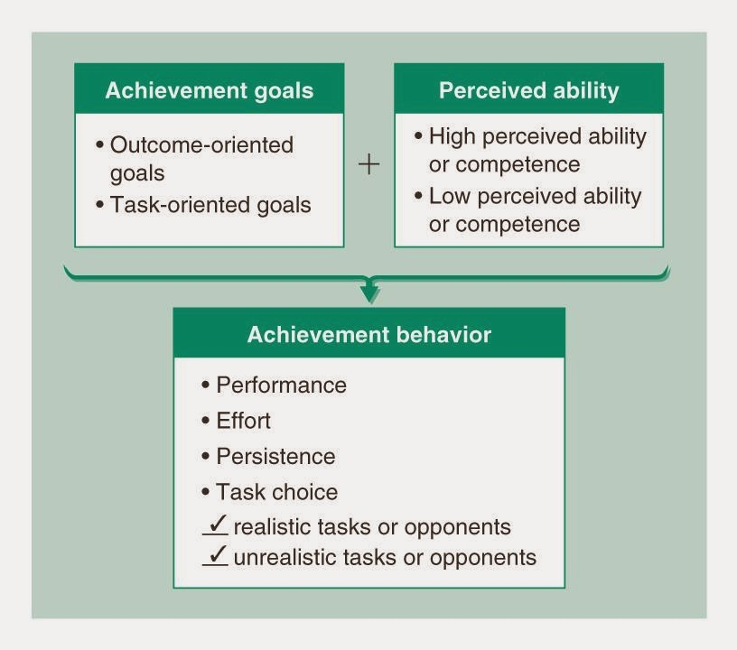
Outcome goal orientation – focus is comparing yourself with others.
Task orientated goals – focus is on improving relative to your own past performances, to self improve.

- To understand someone’s motivation, we must understand what success and failure mean to that person. The best way to do that is to examine a person’s achievement goals and they interact with that individual’s perception of competence, self-worth or perceived ability.
- It is best to adopt a task orientation, which emphasises comparisons with your own performance standards rather than with the performances of others.
- Outcome orientated people have more difficulty maintaining high perceived competence. They judge success by how they compare with others. Have a low maladaptive achievement behavioural pattern. They are likely to make excuses, cease efforts, and perform worse in evaluative situations.
- Social goal orientation – judge their competence in terms of affiliation with the group and recognition of being liked by others. Linked to participant enjoyment, intrinsic motivation and competence.
- Achievement behaviour patterns are explained by how participants view their ability. Entity view adopts an outcome goal focus, where a person sees their ability as fixed and unable to be changed through effort. On the other hand, incremental focus, the person adopts a task goal perspective and believes they can change their ability through hard work and effort.
- Motivational climate of mastery/task goal orientation – positive attitudes, increased effort, and effective learning strategies. In contrast a motivational climate of outcome orientation has been linked to low persistence, low effort, failure.
4) Competence Motivation Theory – people are motivated to feel worthy or competent and moreover, that such feelings are primary determinants of motivation.
- The theory contends that athletes’ perceptions of control (feeling control over whether they can learn and perform skills) work along with self-worth and competence evaluations to influence their motivation.
- Influences motivation indirectly by influencing emotional states (enjoyment, anxiety, pride) that in turn influences motivation.

  - Explain how achievement motivation develops

Achievement motivation & competitiveness develops through 3 sequential stages:
- Autonomous competence stage – occurs before age of 4 years, focus on mastering their environment and on self-testing.
- Social comparison stage – Focus on directly comparing your performance with others.
- Integrated stage – involves both social comparison and autonomous achievement strategies. Begin to learn to know when it is appropriate to compete and compare yourself with others and when it is appropriate to adopt self-referenced standards.

  - Use fundamentals of achievement motivation to guide practice
Create climates that enhance achievement and counteract learned helplessness.
- Recognize interactional factors in achievement motivation
- Emphasizing individual task goals and downplaying outcome goals
- Monitoring and providing appropriate atrributional feedback
- Teaching participants to make appropriate attributions
- Discussing with participants when it is appropriate to compete and compare themselves socially and when it is appropriate to adopt a self-referenced focus
- Facilitating perceptions of competence and control

Chapter 4 Arousal, Stress, and Anxiety
  - Discuss the nature of stress and anxiety (what and how they are measured)
- Arousal – intensity of motivation in a particular moment.
- To measure arousal we look at changes in these physiological signs: heart rate, respiration, and biochemistry.
- Anxiety – is a negative emotional state characterized by nervousness, worry, and apprehension and associated with arousal of the body. Thought component – cognitive anxiety (degree to which one worries or has negative thoughts) & somatic component (provoked by something and arouses you) – degree of arousal perceived.
  - State anxiety – refers to the ever-changing mood component.
  - To measure state anxiety- use global & multidimensional self-report measures. People rate how nervous they feel (self report) from scales of low to high.
  - Trait Anxiety – is a part of personality. It is a behavioral disposition to perceive as threatening circumstances that objectively may not be dangerous and to then respond with disproportionate state anxiety.
  - Similar to state anxiety except ask question like how do you typically feel? In a certain situation.
  - A person’s level of trait anxiety influences on how that person views the world.
- Stress – substantial imbalance between demand and response capability, under conditions where failure to meet that demand has important consequences. It is a process.
  - Stage 1: environmental demand – can be physical or psychological.
  - Stage 2: Perception of demand – amount of physical/psychological threat perceived.
  - Stage 3: Stress Response – response to the perception of the situation. i.e. muscle tension, attention changes, state anxiety (cognitive & somatic).
  - Stage 4: Behavioral consequences – actual behavior of individual under stress.

  - Identify the major sources of anxiety and stress
- Situational stress - The more important an event, the more stress provoking it will be. The greater the degree of uncertainty an individual feels about an outcome or others’ feelings and evaluations the greater the state anxiety and stress.
- Personal stress – trait anxiety and self-esteem. High trait anxiety and low self esteem are related to heightened state anxiety reactions in athletes.
- Social physique anxiety – a personality disposition and is the degree to which people become anxious when others observe their physiques.

Explain how and why arousal and anxiety related emotions affect performance
- Arousal-related emotions, such as cognitive and somatic state anciety are related to performance. Arousal and anxiety influence performance by inducing changes in attention and concentration and by increasing muscle tension.
- Drive theory: as an individual’s arousal or state anxiety increases, so too does their performance.
- Hanin’s individualized zones of optimal functioning - Individuals have a zone of optimal state anxiety in which their best performance occurs.
- Multi-dimensional theory – predicts that cognitive state anxiety (worry) is negatively related to performance
- Hardy’s catastrophe model – predicts that physiological arousal is related to performance in an inverted U fashion, but only when an athlete is not worried or has low cognitive state anxiety.
- The Inverted-U hypothesis is based on the Yerkes-Dodson Law, this predicts the relationship between arousal and quality of performance. The inverted-U hypothesis states that arousal causes an increase in performance, but only up to a point, this is called the 'optimal point'.
- Kerr’s interpretation of reversal theory – how a performer interprets arousal may influence performance
- Jone’s distinction between the direction and intensity of anxiety. Contend that viewing anxiety as facilitative (in control in a sense that you are able to control it) leads to superior performance whereas viewing it as debilitative leads to poor performance.
- Increased arousal and state anxiety causes increased muscle tension and fatigue and can interfere with coordination.
- Arousal and state anxiety narrow one’s attention field, decreases environmental scanning, and causes a shift to the dominant attention style and to inappropriate cues.
- An optimal recipe of emotion sis related to peak performance, and when performers are outside this optimal range, poor performance results. The optimal combination of emotions needed for peak performance does not necessarily occur at the midpoint of the arousal-state anxiety continuum, and the relationship between arousal and performance depends on the level of cognitive anxiety (worry) a performer exhibits.

  - Compare and contrast ways to regulate arousal, stress, and anxiety
- An interactional model of motivation should guide coaches in their efforts to help students manage arousal and state anxiety. Creating a positive environment and a productive orientation to mistakes and losing is an effective way to manage stress.
- Guidelines to manage stress:
- Identify optimal combination of arousal-related emotions needed for best performance
- Recognize how personal and situational factors interact to influence anxiety, arousal, and performance.
- Recognize the signs of increased arousal and anxiety in participants
- Tailor coaching and practices to individuals
- Develop confidence in performers to help them cope with stress/anxiety.

Chapter 5 Competition and Cooperation
  - Understand the difference between completion and cooperation
- Competition – a social process that occurs when rewards are given to people based on their performance relative to that of other competitors. Furthermore, the social evaluation component of completion is seen as critical to this process because competition always involves a comparative judgment and performers are evaluated on how well they do.
- Cooperation – a process through which performance is evaluated and rewarded in terms of the collective achievement of a group of people working together to reach a common goal.

  - Describe the process of competition
The four stages of competition:
- Objective competitive situation – an individual’s performance is compared with some standard of excellence, in the presence of at least one other person who is aware of the criterion for comparison.
- Subjective competitive situation – involves how a person perceives, accepts, and appraises the objective competitive situation.
- Response
- Consequences – either positive or negative.

  - Detail the psychological studies of competition and cooperation
- Studies suggest that cooperative activities produce more open communication, sharing, trust, friendship, and even enhanced performance than competitive activities do. These differences were found in laboratory and field studies, as well as in a variety of experimental games.
- People will compete even when it is irrational to do so, and competitiveness is hard to stop.

  - Discuss the social factors influencing completion and cooperation
Social environments are a major influence in competitive and cooperative behaviors. i.e. parents encouraging kids to play hockey.

  - Explain why competition can be both good and bad
- Competition is neither good nor bad. IT is neither a productive nor a destructive strategy – it is simply a process.
- It can lead to positive or negative outcomes.

Chapter 6 Feedback, Reinforcement, and Intrinsic Motivation
Explain how positive feedback and negative feedback influence behavior

Understand how to implement behavior modification programs
Discuss the different types of intrinsic motivation and extrinsic motivation
Describe the relationship between intrinsic motivation and external rewards
Detail different ways to increase intrinsic motivation
Describe how such factors as scholarships, coaching behaviors, completion, and feedback influence intrinsic motivation
Describe the flow state and how to achieve it

