Marketing Study Notes – Carleton University 2014

CHAPTER 1

Marketing
- a set of business practices designed to plan for and present an organizations products/services in ways that build effective consumer relationships.

Marketing Plan
- a written document with the analysis of current situation, SWAT marketing objectives, strategy

Need
- Basic necessities

Want
- a way someone chooses to satisfy a need ie. Personality, cultural

Market
- a group of people who want/need a companies product and are willing and able to buy it

Target market
- a group of people to whom the firm sells to

Marketing mix
- Product, Place, price, promotion
- Firms use this to respond to the wants of the TM
- Product: Creating Value
- Price: Transacting Value
- Place: Delivering Value
- Promotion: Communicating Value
Goods
- Tangible items

Services
- Intangible benefits produced by people or machines

Value
- The relationship between what they get and what they gave

Value Based Marketing
- Providing customers with more benefits to cost. Still bringing in return for company

Transactional Orientation
- A transactional orientation regards the buyer–seller relationship as a series of individual transactions, so anything that happened before or after the transaction is of little importance.

Relational Orientation
- Buyers and sellers develop a long term relationship

Supply chain
- The group of firms and set of techniques and approaches a firm uses to make and deliver goods and service

Core Concepts
- Create value, communicate, deliver value, create long term relationships

Sales Orientation
- Firms rely on a sales team to sell, focus is only on sales

Product Orientation
- Belief that a good product will sell itself
- Marketers only communicate it is available

Market oriented
- Marketers celebrate the consumer
- Communicate attributes of the product

CHAPTER 2

The marketing Plan
- Define the mission and objectives of the business and evaluate the situation by assessing how various players inside and out may effect our firms potential for success

Implementation Phase
- Evaluating different opportunities by engaging in segmentation targeting and positioning

Control Phase
- Managers evaluate the performance of the marketing strategy and take corrective action

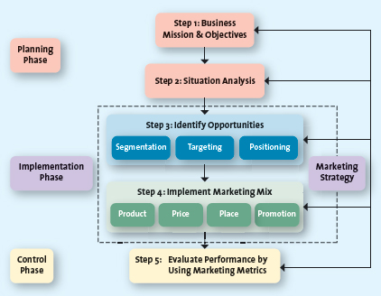

Mission Statement
- a broad description of a firms objectives and the scope of activities

Situation Analysis
- Evaluating the internal and external environment (SWAT)

STP
- Segmentation, targeting and positioning
- Firms use it to evaluate opportunities and increase sales

Market Segments
- A group of consumers who act similarly to a firms marketing efforts

Market Segmentation
- Dividing the market into distinct groups based on similar characteristics

Target Marketing
- Process of evaluating the attractiveness of various segments and deciding which to pursue

Market Positioning
- Defining marketing mix variables so that target customers have a clear view of what they are buying compared to competitors

Strategic Business Unit
- Division of a business which can be managed independently as it markets a specific product to a specific group

Product Line
- Group of products that consumers see as similar

Relative Market Share
- A measure of the products strength in a market

Market Growth Rate
- Annual rate of growth of the market in which a product competes

Downsizing
- Reducing market, or closing store locations

Marketing Strategy
- Identify a firms TM, marketing mix, and the plan to sustain a competitive advantage

Customer Excellence
- Focus on retaining loyal customers
Operational Excellence
- Focus on efficient operations and supply chain management
Product Excellence
- Focus on achieving high quality products
Locational Excellence
- Focus on a good physical location and internet presence

CHAPTER 3

Competitive intelligence
- Gathering info about competitors to anticipate what will happen in the market rather than react

Macro Factors
- Culture, demographics, social, technology, economic, political
- (CDSTEP)

Culture
- Shared beliefs, values and morals of a group of people

Generational Cohart
- Group of people in the same age group

Tweens
- Ages 9-12. In between teens and children
Generation Y
- People between the ages of 13-32. Biggest Cohert since the baby boom
Generation X
- People between 36-47
Baby Boomers
- People born after WWII. Ages 48-66
Seniors
- Fastes growing Cohurt. Ages 65+

Green Marketing
- Strategic effort by a firm to supply consumer with eco friendly products

Economic Situation
- Factors that would affect if how the consumer would spend money ie. Recession

Foreign Currency Fluctuations
- Changes in the value of a countries currency relative to another country

CHAPTER 4

Consumer Behavior

Need recognition
- Developed an unsatisfied need and want a desired state
- Functional Needs: Performance of product (shoes)
- Psychological Needs: Personal gratification (500 dollar shoes)

Information Search
- Searching for options that satisfy your need
- Internal Search: Examines his money and knowledge about product
- External Search: Talks with friend or family or sales person to gather more info
- Internal locus of control: You have control of outcome
- External locus of control: Fate has control of outcome
- Actual or perceived risks (delay of search)
  - Performance risk (doesn’t work)
  - Financial risk (cost of product)
  - Social Risk (is it in)
  - Physiological risk (harmful)
  - Psychological risk (the way people feel about it)

Alternative Evaluation
- Once knowledgeable, you consider other alternatives
- Determinant attributes: Product that are important to the buyer and could have deciding factor
- Compensatory decision rule: Trades off characteristics comparing two or more
- Noncompensatory decision rule: choose product based on a subset of its characteristics regardless of the attributes

Purchase Decision
- You decide on which is the best for you based on your criteria

Post Purchase
- Company following up about your purchase
  - Customer Satisfaction: is it meeting your needs
  - Cognitive Dissonance: Interanl conflict after you bought product wondering if it was the right buy
  - Customer loyalty: repeated purchases from same company

Factors Influencing Buying

Psychological Factors
- Motives (hierarchy of needs: physiological, safety, love, esteem, self actualization)
- Attitude
- Perception
- Learning
- Lifestyle

Social Factors
- Family
- Reference Groups
- Culture

Situational Factors
- Purchase situation (buy something nicer for someone else)
- Shopping situation (buy something better when in store)
- Temporal state (buy something because you are in the mood)

CHAPTER 5

The Segmentation Targeting Positioning

Step 1: Strategy or objectives
- Find firms mission and objectives
- SWAT analysis
Step 2: Segmentation Bases
- Develops descriptions of all the different segments
- Needs, wants, and characteristics
- Helps the firm understand the profile of the customers in each segment
- Bases for segmenting markets
  - Geographic: Country, continent, regions
  - Demographic: Age, gender, race, income
  - Psychographic: Lifestyle, personalities, social class
  - Behavioral: Benefits, usage, loyalty
- Geodemographic segmentation groups demographic, geographic and lifestyles together
  - People in the same area often buy similar things
- PSYTE cluster groups neighborhoods into different lifestyle clusters
Step 3: Evaluate Segment Attractiveness
- Evaluating if the various segments are attractive to market
- Use descriptive criteria
  - Identifiable: Who are they
  - Reachable: Able to communicate to them
  - Profitable: is it big enough to generate profit
  - Responsive: Good outcome
Step 4: Select Target Market
- Select market based on segmentation strategy
- Undifferentiated segmentation when the good doesn’t differ between two markets
- Differentiated segmentation when firms target several market segments with a defferent offering for each
- Concentrated Segment Strategy when an organization selects a single taget market and focuses all energy to them
- Micromarketing when firm tailors a product for your needs
Step 5: Identify and develop positioning strategy
- Mental picture or perception of the company
- Positioning Strategies
  - Value
  - Product attributes
  - Benefits
  - Competition
- Positioning using perceptual mapping
  - Displays two or more dimensions and the position of the brand to the consumer
  - Repositioning when firms change their targets to different segments

Chapter 6

Product: Anything of value to the consumer

Innovation: Transformation of an idea to a product

Market saturation: Same product year after year

Pioneers: New products into the world

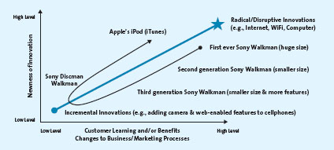

First mover: Pioneers that introduce a new market

Diffusion of innovation: Process by which the use of innovation spreads throughout a markey group, over time and over various categories of adopters

Innovators: People who want to be the first to own a product

Early adopters: Don’t take as much risk as innovators, like to buy product after careful review

Chapter 7

Core customer value: the basic problem solving benefit of the product

Associated services: non physical aspects of the product (warrenty)

Consumer Products: P+S used by people for their personal use

Types of products:
Specialty products- products in which customers show such a strong preference that they will expand considerable effort to search for the best suppliers.

Shopping products- products in which cusumers spend a fair amount of time considering alternatives (furniture)

Convenience products- products in which the consumer is not willing to spend any effort to evaluate prior to purchase

Unsought products- Products in which consumers hardly buy or never buy (new products)

Product mix- the complete set of all products offered by the firm

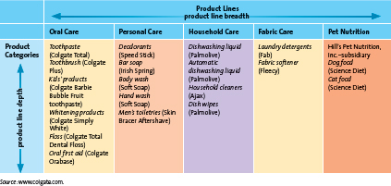

Product category- assessment of items that the customer sees as reasonable alternatives

Brands- names terms designs or symbols

Product mix breadth- number of product lines
- capture new evolving markets….or delete old line

Product mix depth- number of products within that product line
- address changing consumer preferences
- delete product catagories

Value of branding
Brands facilitate purchasing- brands are recognizable and signify a level of quality therefore help the consumer to make quick decisions

Brands establish loyalty- continuous use of certain brand give trust to consumer

Brands protect from competition and price competition- Brands allow for precieved superiority over others allowing for different prices and less competition

Brands reduce marketing costs- well known brands don’t require as much marketing to get sales

Brands are assets- legally protected through trademarks and copyrights and thus constitute a unique ownership for the firm

Brands impact market value- having well known brands have a direct impact on the company bottom line

Brand equity- set of assets and liabilities linked to a brand that add to or subtract from the value provided by the product or service

Brand Awareness- measures how many consumers in a market are familiar with the brand and what it stands for and have an opinion on the brand

Perceived value- The relationship between the benefit of a product and its cost

Brand associations- the mental links that consumers make between a brand and its key product attributes (logo, slogan)

Brand personalities- set of human characteristics associated with the brand (male, female, fresh, fun loving)

Brand loyalty- Buying the same brand repeatedly

Manufacturer brands- brands that are owned by the manufacturer

Store brands- brands owned and managed by retailers

Generic- sold without brand names

Corporate brand- use of all its own corporate name to brand all its product lines and products

Corporate and product line brands- combination of family name and individual brands to distinguish a firms products

Individule brands- using individual brand names for all products

Choosing a name:
-Suggestive of benefits
- easy to pronounce
- register it for a trademark
- easy to translate

Brand extension- using the same brand name for new products being introduced to the same market

Brand dilution- brand extention adversely affects consumers perceptions about the core brand (Cadbury started making soups and people didn’t think as much about the chocolate)

Cobranding- Practice of marketing two or more brands together

Brand licensing- Contractual agreement between firms where one firm allows another to use its brand logo in exchange for a negotiated fee.

Packaging:
Stand-up, reclosable zipper pouches
Aluminum beverage cans
Aseptic packaging
Child-resistant/senior-friendly packages
Green and biodegradable packaging

Chapter 8

- Distribution channel- The set of institutions that transfer the ownership of goods from the point of production to the point of consumption
- Wholesalers- firms that buy products from manufactures and resell them to retailers and retailers sell products directly to consumers
- Logistics management- the integration of two or more activities to plan, implement and control the efficient flow of raw materials, in process inventory and finished goods from the point of origin to the point of consumption
- Functions preformed by intermediaries
  - Transactional function
    - Buying
    - Risk taking
    - Promotion
    - Selling
  - Logistical Function
    - Physical distribution
    - Storing
  - Facilitating function
    - Gathering info
    - Financing
- Direct Distribution- direct distribution channels allow manufaturers to deal directly with consumers
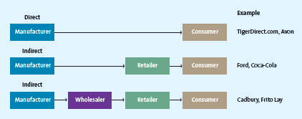
- Indirect distribution- one or more intermediaries
- Multichannel distribution- mix of both direct and indirect
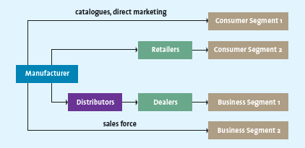
- Distribution intensity- number of channel members to use at each level of the supply chain
  - Intensive- get as many products into as many outlets as possible
  - Exclusive-sell to very few retailers, appropriate customers representing their products
  - Selective-between the two
- Channel conflict- members in channel are in disagreement
- Virtical marketing system- members act as unified system, realize each other parties goals
- 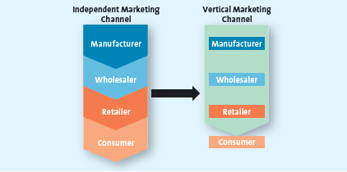
- Administered vertical marketing system- no common ownership and no contractual relationships
- Contractual vertical marketing systems- independent firms at different levels of the supply chain join together through contacts to obtain economies of scale and coordination and to reduce conflict
- Franchising- contractual agreement between a franchinsor and a franchisee the allows the franchisee to operate a retail outlet, using a name and format developed and supported by the franchisor
- Direct supply chain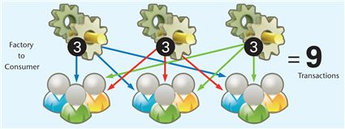
- Indirect supply chain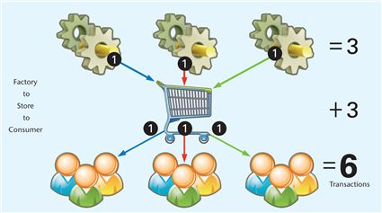
- Distribution centre- facility for the receipt, storage and redistribution of goods to the company stores or customers
- Logistics management: making info flow
- Flow 1- customer to store
- Flow 2- store to buyer
- Flow 3- Buyer to manufacturer
- Flow to manufacturer
- Flow 5 store to distribution centre
- 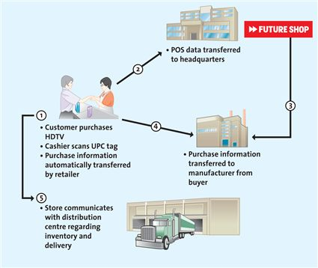
- data warehouse- consumers purchase data collected at the point of scale, moves to huge database
- 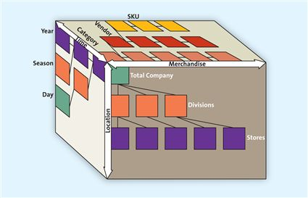
- Electronic data interchange- computer to computer exchange of business documents from a retailer to a vendor and back
- Advanced shipping notice- an electornic document that the supplier sends the retailer in advance of a shipment to tell the retailer exactly what to expect in the shipment
- Strategic relationship- the supply chain members are committed to maintain the relationship over long term

