Logger Pro Software and Electrostatics Experiment
PHYS – 1004
Winter 2014

XXXXXXXX

Partner: Oscar Zambrano
Date Performed: January 23, 2014
Date Submitted: January 30, 2014
TA’s Name: Ken Moats
Section: L8A
Workstation: 14

Purpose
The goal of the Logger Pro software and Electrostatics lab is to learn how to record and analyze data with the use of the software and also to learn to measure and calculate the electric charge deposited on objects.

Theory
  - Part A
In this part of the experiment we will test Newton’s second law of motion, which can be seen as the equation:
$F=Ma$ (1.1)
The force sensor will be used to measure the amount of force a certain mass has, which will be recorded into Logger Pro with the help of LabQuest MINI interface. This part of the lab is also an introduction to using both these software’s. By measuring the force of different masses and recording those in a table to produce a graph of a straight line which will result in an equation of the form:
$y=mx+b$ (1.2)
The graph produced will be that of force versus mass. In equation 1.2 m is equal to the slope, which in this case is the gravitational constant, and b is equal to the y-intercept. Once a line is fit to the results we will have our measurements and errors which are taken from the equation of the fit. These values will be used to compare to the accepted gravitational constant value in Ottawa of 9.806132 ± 0.000015 $m/{s^{2}}$.
  - Part B
Static electricity can be seen in many different forms, some of which include when your hair stands on end on dry days, getting shocked in the playground on the slide, sticking a balloon to the wall, and in the case of this experiment, rubbing a plastic rod with fur. When a plastic rod is rubbed with fur it gains electrons from the fur, which causes it to become negatively charged.
Coulombs law can be used to identify the force, $\overset{⃑}{F}$ between two point charges $q_{1 }and q_{2}$ which are separated by a distance r in a vacuum. Coulombs law can be represented as the following equation, keeping in mind that $Ɛ_{0}$ is equal to the permittivity in a vacuum.
$$\overset{⃑}{F}=\frac{1}{4πƐ_{0}}\frac{q_{1}q_{2}}{r^{2}}$$
(1.3)
An electroscope is used to detect if an object, in this case, the plastic rod, is charged. An electroscope consists of a glass container with two metallic plates suspended from a metal rod. The rod passes through a stopper (made of a material that does not conduct electricity) and down into the jar, the opposite end of the rod has a spiral piece on it. The two leaves hang parallel to each other when not charged, but if an object is charged the leaves (metallic plates) inside the class container will separate, the more negative or positive the charge the more the leaves will repel each other, and the further apart they will spread. This is because charges spread over metallic objects. When a charge is brought towards the electroscope tip the charge is transferred from the rod into the electroscope, traveling down into the leaves, which in turn will repel each other as they both induced the same charge (remember: same sign charges repel).
For the purposes of the lab a plastic rod is used as the charged object (acquired negative charge after being rubbed with fur). If it is assumed that the charge is at the end of the leaves then to calculate the Coulomb force this equation will be used:
$$\overset{⃑}{F}=\frac{Q^{2}}{4πƐ_{0}d^{2}}$$
(1.4)
In this situation it is assumed that both plates have an equal charge and that $Ɛ_{0}=8.85×{10}^{-12}\frac{C^{2}}{Nm^{2}}$ . When the leaves of the electroscope form an inverted V the electroscope is at equilibrium, meaning the forces in both the x and y direction must sum up to be zero. Using $θ$ as the angle between the plates and L as their length we can get equation 1.5. The electroscope in this experiment has a mass, m of 0.1 g and the length is 3 cm.
$$\frac{d}{2L}=sin\frac{θ}{2}$$
(1.5)
Which can be used to derive equation 1.6 which can be used to find the charge each of the two leaves has, giving the charge of the plastic rod.
$$Q=4Lsin\left(θ/2\right)×\sqrt{πƐ_{0}mg×tan\left(θ/2\right)}$$
(1.6)
In order to obtain the number of electrons present you divide the net charge by the charge of an electron ($e=1.602×{10}^{-19 }C$).
$$N_{e}=\frac{Q}{e}$$
(1.7)

Apparatus
  - Part A
This apparatus consists sits upon a table and consists of a computer, with Logger Pro software launched with a template graph already set up. The LabQuest MINI interface is connected to the computer through USB and the force sensor is plugged into the LabQuest MINI. The force sensor is fastened to a metal rod with a clamp high enough so that the mass hook, which is hanging from the force sensor does not touch the table surface during the lab. Different masses are placed on the mass hook throughout the experiment and the forces is given on the screen and the masses are imputed manually into Logger Pro. The weights range from 10 grams – 500 grams.
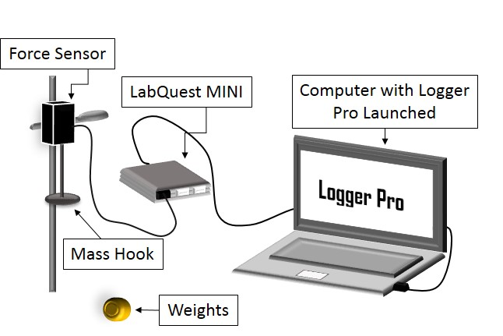

FIGURE 1 – Apparatus for Part A
  - Part B
The first part of part B the rod, fur, and electroscope were used. The fur was used to chage the plastic rod and was then placed near the electroscope, causing the leaves to separate if the rod was properly charged. The second hald of part B the charge sensor, computer, metalic container, rod and fur were used. The Charge sensor is connected to the metalic container with two aligator clips, which is connected to the LabQuest MINI and to the computer in order to obtain the charge on the rod.
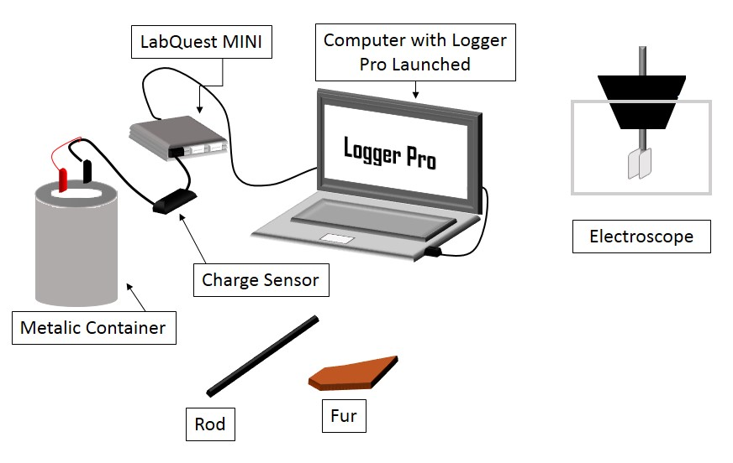

FIGURE 2 - Apparatus for Part B

Observations
  - Part A
We weighed 17 different masses which included the mass of the mass hook (50 g). Each mass gave a different force in Newton’s. See graph on page 9.
Event | Force (N) ± 10 N | Mass (kg)
1 | 0.486 | 0.05
2 | 0.583 | 0.06
3 | 0.790 | 0.08
4 | 0.984 | 0.10
5 | 1.471 | 0.15
6 | 2.470 | 0.25
7 | 4.448 | 0.45
8 | 6.430 | 0.65
9 | 11.376 | 1.150
10 | 5.437 | 0.55
11 | 2.479 | 0.25
12 | 3.460 | 0.35
13 | 1.586 | 0.16
14 | 1.779 | 0.18
15 | 1.977 | 0.20
16 | 4.448 | 0.45
17 | 5.441 | 0.55
Table 1 - Force Obtained by Weighing Different Masses
 | Value | Error
m value | $$9.898 N/{kg}$$ | $$0.004032 N/{kg}$$
b value | $$-0.004578 N$$ | $$0.001734 N$$
Table 2 - Linearly Fit Equation Values
  - Part B
Discharged Electroscope: The plates lay parallel to each other, almost touching.
Electroscope with charged rod close: When the rod is charged and brought close to the tip f the electroscope the plates repel each other greatly, forming an inverted V.
Electroscope with charged rod very close: When the charged rod is brought even closer to the electroscope the plates repel each other a little more.
Electroscope with charged rod touching: When the charged rod is brought to touch the electroscope the leaves repel each other. This is because the electroscope is initially discharged, meaning the charges inside the electroscope are distributed evenly. When the negative object is brought to touch the electroscope all of the negative charges, move down to the leaves, because same charges repel. However, now all the negative charges are in the two leaves, which causes them to repel each other.
Permanently charging electroscope: When the rod was brought towards the electroscope the plates separated as normal, when a finger was placed on the tip with the rod still in proximity the plates dropped back down again. When the rod and finger were both removed the plates yet again repelled each other forming an inverted V shape. The process of permanently charging the electroscope is called charging by induction, as usual when the negatively charged rod is brought close the negative charges travel away from the rod and into the leaves which separate, when a finger is toughed to the tip all of the electrons leave the electroscope and enter the body, when the rod is then taken away from the electroscope the positive charge is left over. The charge then spreads evenly around the electroscope, causing both plates to be positively charge, and repelling each other.
Estimated Distance (cm) | 2 ± 0.5
Mean (nC) | -17.35
Standard Deviation | 0.2469
Sample Number | 64
Table 3 - Sensor Observations

Calculations
  - Part A
Calculating t for the m value in $y=mx+b$
Given: Note: $N/{kg}=m/{s^{2}}$  $$x_{1}=9.898 N/{kg}$$  $$x_{2}=9.806132 m/{s^{2}}$$  $$σ_{x_{1}}=0.004032 N/{kg}$$  $$σ_{x_{2}}=0.000015 m/{s^{2}}$$ | Required:  $$t= ?$$  Equation:  $$t=\frac{\left|x_{1}-x_{2}\right|}{\sqrt{σ_{x_{1}}^{2}+σ_{x_{2}}^{2}}}$$
Solution:
$$t=\frac{\left|x_{1}-x_{2}\right|}{\sqrt{σ_{x_{1}}^{2}+σ_{x_{2}}^{2}}}$$
$$t=\frac{\left|9.898 m/{s^{2}}-9.806132 m/{s^{2}}\right|}{\sqrt{{\left(0.004032 m/{s^{2}}\right)}^{2}+{\left(0.000015 m/{s^{2}}\right)}^{2}}}$$
$$t=\frac{\left|0.091868 m/{s^{2}}\right|}{\sqrt{0.000016257{m^{2}}/{s^{4}}}}$$
$$t=\frac{\left|0.091868 m/{s^{2}}\right|}{0.004032027 m/{s^{2}} }$$
$$t=22.78456455$$
$$t≈22.78$$

Paraphrase:
The value of t is 22.78, meaning that the measurements are inconsistent.

Calculating t for the b value in $y=mx+b$
Given: Note: $N/{kg}=m/{s^{2}}$  $$x_{1}=-0.004578 N$$  $$x_{2}=0 N$$  $$σ_{x_{1}}=0.001734 N$$  $$σ_{x_{2}}=0 N$$ | Required:  $$t= ?$$  Equation:  $$t=\frac{\left|x_{1}-x_{2}\right|}{\sqrt{σ_{x_{1}}^{2}+σ_{x_{2}}^{2}}}$$
Solution:  $t=2.640138408$  $$t≈2.64$$ | Paraphrase:  The value of t is 2.64, meaning that the measurements are close to being consistent but are inconsistent.

  - Part B
Calculating the charge and number of electrons on the rod using the electroscope
Given:  L = 3 cm 0.03 m  d = 2.5 ± 0.5 cm 0.025 ± 0.005 m  m = 0.5 g 0.0005 kg  $$Ɛ_{0}=8.85×{10}^{-12}\frac{C^{2}}{Nm^{2}}$$  $$g=9.8 m/{s^{2}}$$  $$e=1.602×{10}^{-19 }C$$ | Required:  $$Q= ?C$$  $$N_{e}= ?$$  Equations:  $$\frac{d}{2L}=sin\frac{θ}{2}$$  $$Q=4Lsin\left(θ/2\right)×\sqrt{πƐ_{0}mg×tan\left(θ/2\right)}$$  $$N_{e}=\frac{Q}{e}$$
Solution:  Calculating ϴ  $$\frac{d}{2L}=sin\frac{θ}{2}$$  $$θ=\sin^{-1}\left(\frac{2d}{2L}\right)$$  $$θ=2\sin^{-1}\frac{\left(0.025\right)}{2\left(0.03 m\right)}$$  $$θ=2\sin^{-1}\left(\frac{5}{12}\right)$$  $$θ=49.24863°$$  $$θ≈49.2°$$ | Calculating Q  $$Q=4Lsin\left(θ/2\right)×\sqrt{πƐ_{0}mg×tan\left(θ/2\right)}$$  $$Q=4\left(0.03\right)sin\left({49.24863}/2\right)×\sqrt{π\left(8.85×{10}^{-12}\right)\left(0.0005\right)\left(9.8\right)×tan\left({49.24863}/2\right)}$$  $$Q=5.590×{10}^{-10} C$$  Calculating $N_{e}$  $$N_{e}=\frac{Q}{e}$$  $$N_{e}=\frac{5.590×{10}^{-10} C}{1.602×{10}^{-19 }C}$$  $$N_{e}=3.489388265×{10}^{9}$$
Paraphrase:
The charge on the plates was $5.590×{10}^{-10} C$ and there were $3.489388265×{10}^{9}$ electrons present.

Calculating the number of electrons on the rod using the Logger Pro values
Given:  Estimated Distance = 2 ± 0.5 0.02 ± 0.005 m  Mean = -17.35 nC $-1.735×{10}^{-8} C$  Standard Deviation = 0.2469  Sample Number = 64  $$e=1.602×{10}^{-19 }C$$ | Required:  $$N_{e}= ?$$  Equation:  $$N_{e}=\frac{Q}{e}$$
Solution:
$$N_{e}=1.083×{10}^{11}$$

Results
The first portion of the experiment was used as an introduction to Logger Pro software and the LabQuest MINI interface, both of these were used in order to produce a graph of force versus mass in order to measure the gravitational constant. The gravitational constant was found to be 9.898 ± 0.004032 $m/{s^{2}}$, this is the m value of the linearly fit equation. When the measured gravitational constant was compared with the actual gravitational constant it can be said that the measurements were inconsistent as we acquired a t value much larger than 2. The linearly fit equation should have had a y-intercept value of 0 ± 0 N, however we found b to be -0.004578 ± 0.001734 N.
The charge on the plates of the electroscope was$5.590×{10}^{-10} C$, maning the charge on the plastic rod was the same and there were $3.489388265×{10}^{9}$ electrons present. The charge on the rod using Logger Pro was found to be $-1.735×{10}^{-8} C$, giving a total of $1.083×{10}^{11}$ electrons present.

Discussion
In part B of the lab the results of the charge on the rod were very different from each other, they differed in 10², which is a significant amount. This is because there were many assumptions made during this portion of the lab. The estimate of the distance between the plates (d) could have affected the results greatly. This is a cause for error for many reasons, namely because it is very hard to estimate any distance while looking through glass, and also because the measuring tool (a metre stick) was much too large to measure such a short distance.
The electroscope is a great and simple took which can be used to calculate the charge on an object, however, it does have a downside, just by looking at the electroscope it is not possible to tell the difference of whether or not the charge is positive or negative, unless the charge on the object is known, in that case, the charge on the electroscope would be identical.
Static electricity is generated when one substance rubs against another, which we know from the theory section of this report. Static electricity needs a conductor to be able to move around, if there is no conductor the electric charge will not be able to move. Water is a conductor, and humidity is the amount of water that is in the air, therefore the higher the humidity, the more conductive the air becomes. When there is a high humidity the charge is freer to move, as air is a conductor and it will then become hard to have anything have static energy.
Accuracy is the closeness of measurements to their actual value and precision is the reliability of the instrument and results. Knowing these two definitions the charge sensor is more precise and the electroscope is the more accurate instrument.

