Flow Through a Venturi Meter
MAAE 2300
Winter 2015

XXXXXXXXXX
XXXXXXX
XXXXXXXXX

TA’s Name: Gang Xu gangxu@cmail.carleton.ca
Date Performed: March 2, 2015
Date Submitted: March 9, 2015

  - Summary
The purpose of this experiment was to gain a working understanding of how Bernoulli’s equation is applied in a legitimate flow, and the physical meaning of the terms static pressure, stagnation pressure, and dynamic pressure as discussed in class. In addition to this, the experiment allowed the comparison of ideal, frictionless predictions of Bernoulli’s equation to the actual flow through the Venturi meter.
  - Nomenclature
$$C_{v}$$ | Venturi coefficient | $$P_{atm}$$ | Atmospheric pressure 101325 Pa
$$Q_{ideal}$$ | Ideal volumetric flow rate (mm³/s) | $$P_{d}$$ | Dynamic Pressure (Pa)
$$Q_{actual}$$ | Actual volumetric flow rate(mm³/s) | $$P_{s}$$ | Static Pressure (Pa)
$$h_{atm}$$ | Atmospheric head (mm) | $$P_{tap}$$ | Pressure at each tap along the Venturi
$$h_{in}$$ | Height of water for the inlet manometer tube | $$h_{tap}$$ | Height of the water in the manometer tubes for the taps
$$h_{th}$$ | Height of water for the manometer tube connected to the Venturi throat | $$P_{in}$$ | Inlet pressure
$$ρ_{water}$$ | Density of water 1000 kg/m³ | $$v_{n}$$ | Velocity normal to the direction of flow
$$ρ_{air}$$ | Density of air 1.20 kg/m³ | $$v_{th}$$ | Velocity at throat (mm/s)
x_{in} | Distance from the reference to the beginning of the slope | x_{tap} | Distance from the reference to each tap
x_{th} | Diameter at each tap | ᴓ_{th} | Diameter of the Venturi throat
ᴓ_{in} | Diameter of the inlet | ᴓ_{tap} | Diameter at each tap

  - Flow Analysis
Bernoulli’s equation
$P_{atm}+\frac{1}{2}ρV_{1}^{2}+ρgz_{1}=P_{2}+\frac{1}{2}ρV_{2}^{2}+ρgz_{2}$ [1]
Calculate Venturi Coefficient
The following equations were used to calculate the venturi coefficient:
Static Pressure: $P_{static}=P_{atm}+ρ_{fluid}g∆h$ [2]
Velocity at tap: $V_{2}=\sqrt{\frac{2(P_{atm}-P_{static})}{ρ_{air}}}$ [3]
Diameter: $d_{1}=2m\left(0-Distance from tap 1\right)+17.9578$ [4]
Diameter: $d_{2}=\left(-2m\left(190-Distance from tap 1\right)-4.2926\right)+17.9578$ [5]
Cross-Sectional Area at tap: $A_{1}=\frac{π}{4}d^{2}$ [6]
Volumetric Flow rate: $Q_{Actual}=V_{1}A_{1}$ [7]
Q_{Ideal} was calculated using the following equations:
Velocity at throat: $v_{th}=\sqrt{\frac{\frac{2(P_{in}-P_{th})}{ρ_{air}}}{1-{\left(\frac{A_{th}}{A_{in}}\right)}^{2}}}$ [8]
Ideal Volumetric Flow rate: $Q_{ideal}=v_{th}A_{th}$ [9]
Venturi Coefficient: $C_{v}=\frac{ Q_{actual}}{ Q_{ideal}}$ [10]
Calculating Pressures
Ideal velocity at tap: $v_{ideal}=\frac{Q_{actual}}{A}$ [11]
Ideal Pressure at tap: $P_{ideal}=\frac{1}{2}ρ_{air}{\left(v_{in}-v_{ideal}\right)}^{2}+P_{in\left(g\right)}$ [12]
Calculating Dynamic, Static, and Stagnation pressures
Dynamic Pressure: $P_{dyn}=\frac{1}{2}ρ_{air}v_{th}^{2}$ [13]
Static Pressure: $P_{stat}=ρ_{water}g(h_{ref}-h_{th})×0.001$ [14]
Stagnation Pressure: $P_{stag \left(g\right)}=P_{dyn}+P_{stat}$ [15]

  - Experimental Setup and Procedure
The following image (Figure 1) is the experimental set up for the experiment. It consist of a bell-mouth inlet which draws air from the room which is followed by a venturi meter (Figure 2) which has sixteen static pressure tubes attached to it which are connected to a manometer. In order to produce suction a vacuum cleaner is connected to the downstream end of the venturi. The vacuum has a dial attached to it controlling the flow rate of air sucked through the system. When the vacuum is turned suction occurs, causing the green fluid (water) in the manometer tubes to rise. The water level in the manometer tubes will enable the calculation of pressure at each of the venturi static pressure taps.
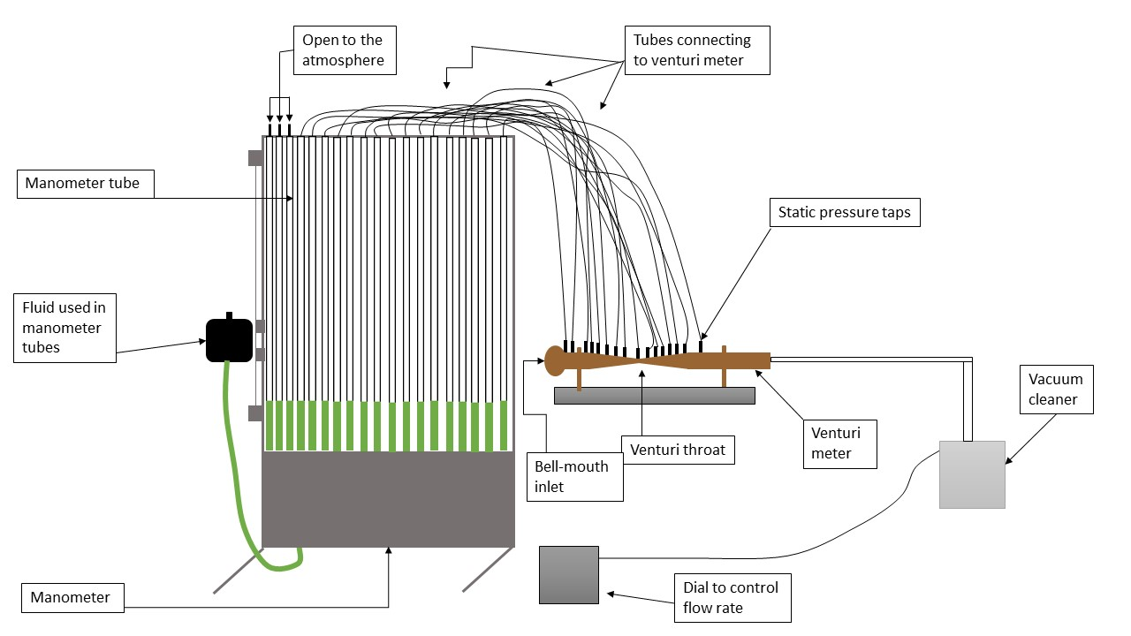
Figure 1 - Flow Through a Venturi Meter Apparatus
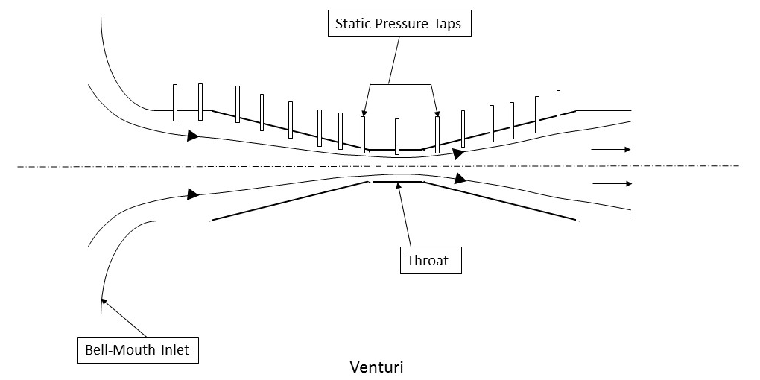
Figure 2 - Cross Section of Venturi Meter
The procedure for this lab was followed according to that in the Laboratory Experiments Manual “MAAE 2300 Fluid Mechanics I – Laboratory Experiments”. The process was completed at two different flow rates, the first on being at a higher flow rate that the second one. Three of the manometer tubes were open to the atmosphere.

  - Results and Discussion
The final value for the venturi coefficient was found to be 0.92 for flow one and 0.94 for flow two. These values of Venturi coefficients are in a good range as the ideal condition Venturi coefficient is 1. The Venturi coefficient was found with the use of the ideal volume flow rate which was calculated to be 0.025 and 0.022 respectively for flow one and flow two.
In this lab we were also able to use the knowledge of, stagnation, static and dynamic pressure. The dynamic pressure is calculated to be 4836.33 Pa and 3737.61 Pa for flow one and flow two, the static pressure was 4836.33 Pa and 3737.61 for flow one and flow two, and lastly the stagnation pressure was found to be 9672.66 Pa and 7475 Pa for flow one and flow two.
The following graphs represent the pressure distribution along the Venturi for each of the flow rates compared to the static pressure distributions calculated from Bernoulli’s equation and continuity.

In both of the graphs above are very similar. In both cases the static pressure is below the static pressures calculated from Bernoulli’s equation.
It should also be noted that Bernoulli’s equation could only be used in this case as it was assumed that the streamline in question had no friction (or viscous effects), the flow was both steady and incompressible and there was no work or heat transfer process taking place alone the streamline.
However, Bernoulli’s equation does not model the flow properly. This means that the results we are getting are more of an approximation rather that a true value, as many assumptions were made.
See table 4 for a full list of the recorded calculations and results.

  - Conclusions
From the results of this experiment it can be concluded that as the cross sectional area of a Venturi meter decreases, the streamline flowing through it will increase in velocity, it can also be concluded that as the Venturi meter cross sectional area decreases the static pressure also increases.

  - References
[1] D. Feszty, MAAE 2300 Fluid Mechanics I – Laboratory Exercises, Department of Mechanical and Aerospace Engineering, Carleton University, Revised January 2010
[2] C.T. Crowe, D.F. Elger, and J.A. Roberson, Engineering Fluid Mechanics, 9th Ed., John Wiley & Sons, 2008

Appendix 1
  - Data Tables
System Number: | 3
Specific Gravity (S.G.): | 1.0
Intake Diameter: | 1.045 inches | 2.654 cm | 26.54 mm
Throat Diameter: | 0.707 inches | 1.796 cm | 17.96 mm
Table 1 - Experiment Information
Static Pressure Tap Number | Height of Manometer: Flow 1  (±2 mm) | Height of Manometer: Flow 2  (±2 mm) | Distance of Tap from Inlet (mm) | Distance of Tap from Throat (mm)
1 | 180 | 162 | 0 | 133
2 | 180 | 162 | 25 | 108
3 | 182 | 164 | 50 | 83
4 | 206 | 182 | 66 | 67
5 | 228 | 198 | 75 | 58
6 | 274 | 234 | 89 | 44
7 | 326 | 274 | 100 | 33
8 | 408 | 336 | 113 | 20
9 (Throat) | 580 | 468 | 133 | 0
10 | 530 | 444 | 155 | 20
11 | 402 | 334 | 167 | 33
12 | 356 | 300 | 180 | 45
13 | 300 | 254 | 192 | 58
14 | 270 | 232 | 205 | 70
15 | 248 | 216 | 217 | 83
16 | 230 | 200 | 242 | 108
17 (atm) | 86 | 88
18 (atm) | 86 | 88
19 (atm) | 86 | 88
Table 2 - Data Measured During Experiment

Cv Flow 1 | 0.920734
Cv Flow 2 | 0.936818
Dynamic Pressure Flow 1 | 4836.33 | Pa
Dynamic Pressure Flow 2 | 3737.61 | Pa
Static Pressure Flow 1 | 4836.33 | Pa
Static Pressure Flow 2 | 3737.61 | Pa
Stagnation Pressure Flow 1 | 9672.66 | Pa
Stagnation Pressure Flow 2 | 7475.22 | Pa
Table 3 - Final Results for Flow 1 and 2

Appendix 2
  - Sample Calculations
  - Venturi Coefficient Calculation:
The sample calculations are for FLOW 1
Calculate Venturi Coefficient
Q_{Actual} was calculated using the following equations:
$101325+1000*9.81*\left(\frac{180-87}{1000}\right)=102237.33 Pa$ [2]
$\sqrt{\frac{2(101325-102237.33)}{1.2}}=39 \frac{m}{s}$ [3]
$2*-0.0477*\left(0-16\right)+17.9578=25.02 mm$ [4]
$\left(-2*0.042926*\left(190-130\right)-4.2926\right)+17.9578=21.39 mm$ [5]
$\frac{π}{4}{(\frac{21.39}{1000})}^{2}=0.00036 m^{2}$ [6]
$39*0.00055=0.022 \frac{kg}{s}$ [7]
Q_{Ideal} was calculated using the following equations
$\sqrt{\frac{\frac{2(106161.33-102237.33)}{1.2}}{1-{\left(\frac{0.000266775}{0.000553057}\right)}^{2}}}=92.32 \frac{m}{s}$ [8]
$92.32*0.000266775=0.025 \frac{kg}{s}$ [9]
$\frac{ 0.0233}{0.025}=0.95$ [10]
Calculating Pressures
$\frac{0.022}{0.00055}=39 \frac{m}{s}$ [11]
$\frac{1}{2}*1.2*{\left(39-44\right)}^{2}+102492.39=102508.09 Pa$ [12]
Calculating Dynamic, Static, and Stagnation Pressures
$\frac{1}{2}*1.2*{89.78}^{2}=4836.27 Pa$ [13]
$1000*9.81*\left(580-83\right)×0.001=4836.33$ [14]
$4836.3+4836.3=9672.6$ [15]

