Carleton University

Laboratory Report

Course #: PHYS-1004 Experiment #:3

Introduction to the Oscilloscope
Student Name
Student Number

Date Performed:
Date Submitted:
Lab Period:
Partner:
Station #:
TA:

Purpose
The purpose of this lab was to formulate a base knowledge of how to use oscilloscope and function generator. This was done by creating numerous functions and a circuit, and measuring their voltage in volts compared to time in milliseconds. This also allowed us to observe how functions behave differently dependent on their frequency and the difference between AC and DC functions.

Theory
In the first part of the lab we were tasked with comparing the frequency calculated by the function generator and the oscilloscope. This was done by creating a sine function on the generator and finding the associated frequency.
$$f=1/T$$
Where f is the frequency in hertz (Hz) and T is the length of the period in seconds (s). However for this lab we calculated the frequency by connecting the oscilloscope to the function generator and recording the value given.
Due to the large difference in frequency between our frequency for trial #1 and #5, ln was used to create a smaller dispersion.
$ln⁡(\frac{f_{gen}}{1Hz})$ and $ln⁡(\frac{f_{osc}}{1Hz})$
Where f_{gen} is the measured frequency by the function generator and f_{osc} is the frequency measured by the oscilloscope.
The error for the ln functions then becomes,
$$σ_{ln}=\frac{σ_{x}}{x}$$
Where x is the frequency value in Hz and $σ_{x}$ is the error on x.

For the second part we needed to calculate the peak-to-peak voltage (V_{pp}) this can be measured by the following equation.
$$V_{pp}=Max-Min$$
Where max is the highest point on the wave and min is the lowest.
We also needed to calculate the root mean square voltage which can be done with the following formula solely if the function is a sine wave.
$$V_{rms}=\frac{V_{pp}}{2\sqrt{2}}$$
For the third part we had to calculate the quality factor, Q, which can be done with the following equation.
$$Q=\frac{V_{DC}-V_{R}}{V_{DC}}$$

Where, V_{DC} , is the average value of a Direct Current of a circuit containing a diode, and V_{R} is the peak-to-peak voltage of the Alternating current of the same circuit. Alternatively, the equation can be written as.
$$Q=\frac{V_{avg}-V_{pp}}{V_{avg}}$$
And the error for the quality factor can be found with:
$σ_{Q}=Q\sqrt{{(\frac{σ_{Vavg}}{V_{avg}})}^{2}+ ({\frac{σ_{Vpp}}{V_{pp}})}^{2}}$
Where Q is the calculated quality factor, $σ_{Vavg}$is the error on V_{avg} and $σ_{Vpp}$is the error on V_{pp}.

Apparatus
The apparatus used for this lab was a DK precision function generator which was used to generate the sinusoidal functions for parts 1 and 2, as well as to measure the frequency of the functions. A circuit board to create a circuit used in parts 3 to create the 4 graphs. A diode that was added in for certain sections of part 4. A Rigol DS1052E digital oscilloscope, used to calculate frequencies, view graphs and find values such as V_{avg} ,V_{rms} , V_{Dmm} and V_{pp} . And finally, a laptop running Logger-Pro which was used to create figure 5 and compare the frequencies calculated by the oscilloscope and function generator.

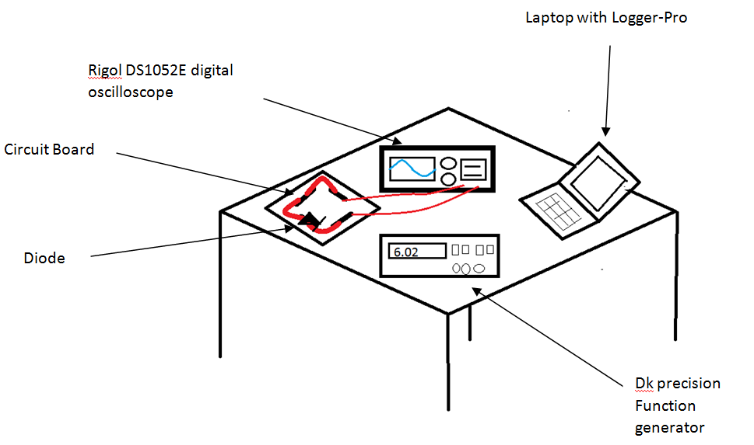
Figure 1: Work Station for oscilloscope lab
The DK precision Function generator had an error of 2 in the last stable digit.
The Rigol DS1052E digital oscilloscope had an error of 2 in the last stable digit.

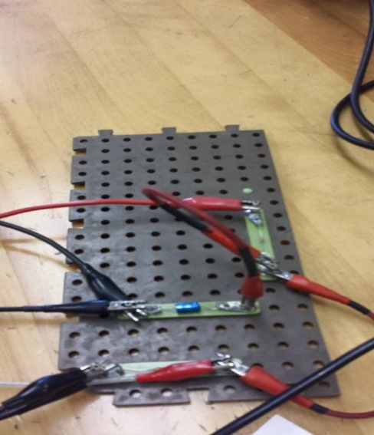
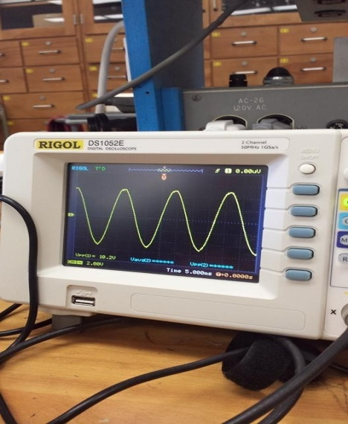
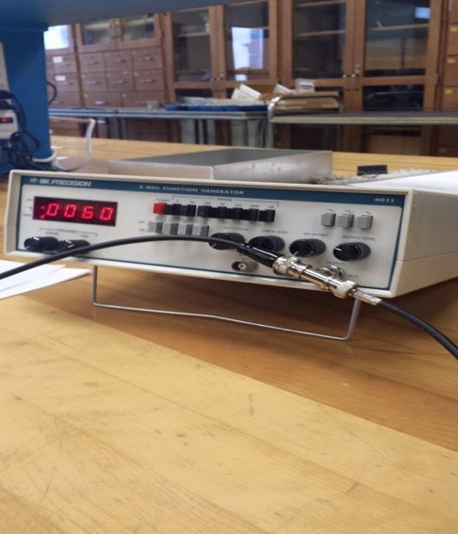
Observations
Figure 4: Circuit board containing diode
Figure 2: Rigol DS1052E Oscilloscope
Figure 3: DK Precision Function generator
Table 1: Frequencies to ln
𝑓_{𝐺𝐸𝑁} ± 𝜎_{𝑓𝐺𝐸𝑁} | 𝑓_{𝑂𝑆𝐶} ± 𝜎_{𝑓𝑜𝑠𝑐} | 𝑙𝑛 ( 𝑓_{𝐺𝐸𝑁} /1Hz) ±𝜎_{𝑙𝑛(𝑓𝐺𝐸𝑁)} | 𝑙𝑛 ( 𝑓_{𝑜𝑠𝑐} /1 Hz) ± 𝜎_{𝑙𝑛(𝑓𝑜𝑠𝑐)}
61 ± 2 Hz | 62 ± 2 Hz | 4.111 ± 0.033 | 4.127 ± 0.032
589 ± 2 Hz | 580 ± 20 Hz | 6.378 ± 0.003 | 6.363 ± 0.034
5700 ± 200 Hz | 5700 ± 200 Hz | 8.648 ± 0.035 | 8.648 ± 0.035
63000 ± 2000 Hz | 62000 ± 2000 Hz | 11.035 ± 0.032 | 11.035 ± 0.032
630000 ± 20000 Hz | 610000 ± 20000 Hz | 13.353 ± 0.032 | 13.321 ± 0.033

Output knob position | V_{rms} ± $σ_{Vrms}$ | V_{Dmm} ± $σ_{Dmm}$ | V_{pp} ± $σ_{Vpp}$
 | 1.92 ± 0.02 V | 1.880 ± 0.02 V | 5.61 ± 0.2 V
 | 4.29 ± 0.2 V | 4.178 ± 0.02 V | 12.4 ± 0.2 V
 | 7.06 ± 0.2 V | 6.879 ± 0.02 V | 20.4 ± 0.2 V
Table 2: Different frequencies effect on Vrms, Vdmm and Vpp

Calculations
$$Q=\frac{V_{DC}-V_{R}}{V_{DC}}$$
$$Q=\frac{3.05-0.17}{3.05}$$
Q=0.94
$$σ_{Q}=Q\sqrt{{(\frac{σ_{VDC}}{V_{DC}})}^{2}+({\frac{σ_{VR}}{V_{R}})}^{2}}$$
$$σ_{Q}=0.94 \sqrt{{(\frac{0.2}{3.05})}^{2}+ {(\frac{0.01}{0.17})}^{2}}$$
$$σ_{Q}=0.94 \sqrt{0.00429+0.00346 }$$
$$σ_{Q}=0.94 x 0.08803$$
$$σ_{Q}=0.08$$

Results
Throughout this lab only many calculations were made to eventually solve for the quality factor and its error. The first calculation was the frequency using the oscilloscope and the function generator and their respective errors. The frequencies and their errors were then replaced with unit-less values using ln and graphed in figure 5. Ideally the slope of the line comparing the two values by each method would have been 1 with a y intercept at 0. However because we did not get identical frequencies from the generator and oscilloscope the slope was 0.9958 ± 0.001566 with the y intercept at 0.02725 ± 0.01457.
We then calculated the V_{rms} , V_{Dmm} and V_{pp} at three separate frequencies as seen in table 2, to observe how different frequencies affect each answer. It was found that the values increased as the frequencies increased. It was also found that a quarter turn of the output knob in a clockwise direction increased the V_{rms} by 2.45 ± 0.1 V, the V_{Dmm} by 2.5 ± 0.2 V and the V_{pp} by 7 ± 1V.
Finally, we built a circuit and using the different graphs illustrating the voltage, we found the V_{avg} and V_{pp} which were used to calculate the quality factor. The desired quality factor was 0.95 and our calculated Q factor was 0.94 ± 0.82.

Discussion
During this lab we looked at how the different techniques and tools that can be used with a oscilloscope. We started by comparing the frequencies calculated by the oscilloscope and function generator, for the most part both devices had similar accuracy. However for the first and second trials the function generator was more accurate, then once the frequencies got into the thousands both the oscilloscope and function generator had similar calculated frequencies and the same errors. For the majority of the trials the oscilloscope returned lower values than the function generator. The desired results for this section of the lab was to obtain the same frequencies for each trail from both the function generator and oscilloscope making the line of best fit on figure 5 a straight line with a slope of 1. However, when completing the lab we only got the same values once, this may have been due to the value we had chosen to be our last stable digit. Our line of best fit had a slope of 0.9958 ± 0.001566 which is extremely close to the desired slope. The slope shows how close the frequencies calculated were to each other and because ours is near 1 that means that they were very close to each other for every trial. Before graphing the data we transfered all the frequencies to a ln value because our frequencies ranged from 61 to 630000 which would have created an exponential line making it harder to analyze.
For the second part of this lab we learned how to use the oscilloscope to calculate certain values for us such as V_{pp}, V_{Dmm} and V_{Rms} along with others. This is important because these values help to solve for other unknowns such as the quality factor (Q), which was needed in part 3. Along with figuring out how to display these values on the oscilloscope we were also able to figure out a connection between changing the frequency and their respective values.
Finally, for the third part we created a circuit and graphed 4 different situations involving the circuit. In Figure 6, the top left graph represents the voltage in the circuit, it is a sine function showing that the voltage is constintly changing from positive and negative.
The second graph, top left, shows the effects of a diode on the system without a capacitor. Those effects being eliminating the negative portion of the sinusodal function. Diodes only allow current to pass through in one direction, therefore we can conclude that in our lab experiment the positive current is traveling in the direction that the diode allows to pass through. Because the diode only allows the positive voltage to pass through while stopping negative voltage. If we were to turn the diode around then only then only the negative portion of the sinusodal function would be shown, because the positive portion would be blocked.
The third graph, on the bottom left, shows the effects of both the diode and capacitor in the system. This graph is shown in direct current as opposed to alternative current, shown in the other graphs. The third graph shows the voltage slowly being lost and then quickly replenished by the capacitor. This graph was important because it was used to calculate the V_{avg}, the distance from 0 in the y axis to the average voltage. This value is important because it allows us to calculate the quality factor.
Lastly, the forth graph shows the same system as the third graph just in alternative current and zoomed in further. Similarly, you can see the voltage going down uniformly followed by a sharp spike returning the voltage to the initial voltage. We used this graph to calculate the peak-to-peak voltage which is the second value needed to calculate the quality factor.
With the V_{avg} and V_{pp} we calculated the quality factor and recieved a value of 0.94 ± 0.083 which was close to the expected value of 0.95.

