Chapter 4

Workplace Emotions, Attitudes & Stress
LO 1: Explain how emotions and cognition (conscious reasoning) influence attitudes and behavior.

Emotions In The Workplace

- Emotions

  - Are physiological, behavioral and psychological episodes experienced toward an object, person or event that create a state of readiness?

- Emotions are directed towards someone or something

- Emotions are experiences that represent change in:

  - Physiological state (blood pressure, heart attack)

  - Psychological state (thought process)

  - Behavior State (Facial Expression)

- Most Emotions are subtle and occur without our awareness

Types of Emotions

- People experience many emotions and they have various combinations of emotions but they all have two common features

- 1st common feature

  - Emotions generate a core evaluation called core affect that something is good or bad, helpful or harmful, to be approached or to be avolided

  - All emotions communicate that the perceived object or event is positive or negative

- 2nd common feature

  - All emotions produce some level of activation; that is they generate some level of energy within us

  - Some emotional experiences are strong enough that they make us consciously motivated to do something

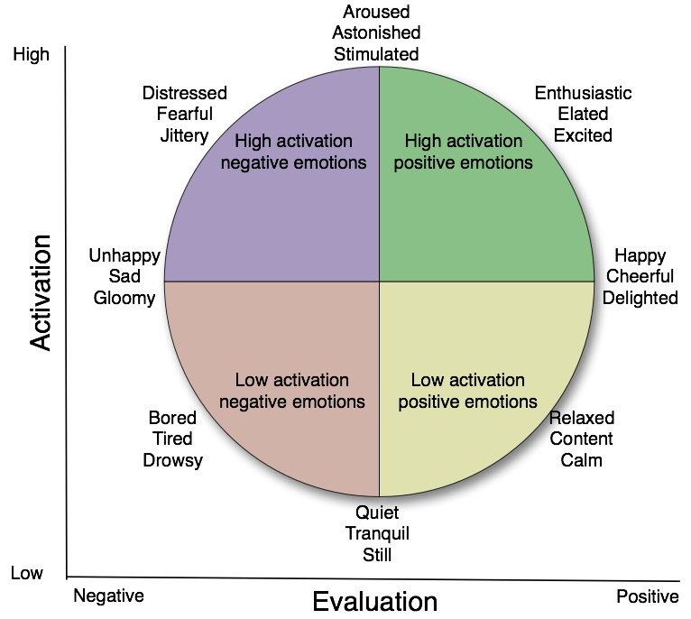 This is the Cirumplex Model of Emotions

Emotions, Attitudes and Behavior

- To understand how emotions influence our thoughts and behavior in the workplace we need to know about attitudes

- Attitudes

  - Represent the cluster of beliefs, assessed feelings and behavioral intentions towards a person, object or event (called an attitude object)

Attitudes Vs. Emotions

Attitudes | Emotions
Judgments about an attitude object | Experience related to an attitude object
Based mainly on rational logic | Based on innate and learned Reponses to environment
Usually stable for days or longer | Usually experienced for seconds or less

Model of Emotions, Attitudes and Behavior

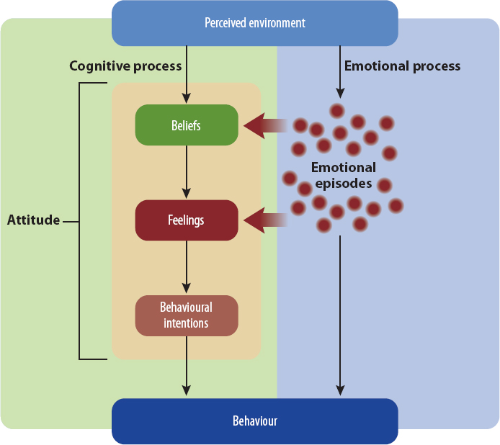 Model of Emotions, Attitudes and Behavior
- Beliefs

  - These are your established perceptions about the attitude object

  - Basically what you believe to be true

  - E.g. you might have beliefs that are perceived facts that you acquire from experience and other form of learning

- Feelings

  - Feelings that represent your conscious positive or negative evaluations of the attitude object

  - Basically the calculation of good or bad based on beliefs about the attitude object

- Behavioral Intentions

  - Intentions that represent your motivation to engage in a particular behavior regarding the attitude object

  - Calculated motivation to act in response to the attitude object

- Attitudes are also more likely to influence behavior when they are strong meaning that they are anchored by strong emotions

- Problem: Attitudes ignore important role of emotions in shaping attitudes

How Emotions Influence Attitudes and Behavior

- Emotions play a central role in forming and changing employee attitudes

- The right side of (Model of Emotions, Attitudes and Behavior) illustrates the process which is like a cognitive process

  - Also brings perceptions of the world around us

- Our brain tags incoming sensory (bodily) information with emotional markers based on a quick and imprecise evaluation of whether that info is supports or threatens our innate drive

  - Emotional markers are not calculated feelings they are automatic and non-conscious emotional responses based on a very thin slice of sensory information

- Example – Attitude on Mergers

  - You might feel nervousness, worry or relief upon learning that your company intends to merge with a competitor

  - The fuzzy dots on the (Model of Emotions, Attitudes and Behavior) illustrates the numerous emotional episodes you experience upon hearing the merger announcement
    - Emotional episodes can be thinking about the merger, discussing the merger with co worker

  - These emotions are transmitted to the reasoning process, where they are logically analyzed along with other information about the attitude object

  - Therefore while you are consciously evaluating whether is the merger is good or bad, your emotions are already sending normative signals which then sways your conscious evaluation

  - We often listen on our emotions to help us consciously decide whether to support something or oppose

- There is potential conflict between cognitive and emotional processes

- This conflicting experience indicates that the persons logical analysis of the situation (left side of the model) cant identify reasons to support the automatic emotional reaction (right side of the model)

Generating Positive Emotions at Work

- Companies are aware of the dual cognitive emotional attitude process because they try to inject more positive experiences in the workplace

- They actively create more positive than negative emotional episodes which produces more positive work attitudes

- (Model of Emotions, Attitudes and Behavior) – notice the arrow from emotional episodes to behavior

  - It indicates that emotions directly (without conscious thinking) influence a persons behavior

Cognitive Dissonance

- Emotions and attitudes usually lead to behavior, but the opposite sometimes occurs through the process of cognitive dissonance

- Cognitive Dissonance
  - Is a condition that occurs when we perceive an inconsistency between our beliefs, feelings and behavior

  - Inconsistency generates emotions such as feeling hypocritical that motivates us to create more consistency by changing one or more of these elements

- Example – You work for an Oil Company

  - You work at an oil sands company that seemed environmentally friendly

  - Until you hear that news accuse of the company creating environmental damage

  - This internal tension occurs because your “green” self concepts (beliefs) and positive regard for environmentalism (feelings) are inconsistent with your employment at a company with a poor environmental record

- People experience an internal tension because they want to see themselves as rational creatures

- Working for a company that has a poor environmental reputation seems inconsistent with your beliefs and attitudes about environmentalism,

  - Would be motivated to reduce that discrepancy (difference)

- How do people reduce cognitive dissonance?

  - Changing behavior is one option, but it is more difficult and often more costly than changing beliefs and feelings.
  - E.g - You might be very reluctant to quit your job with the oil sands company

  - Changing behavior is particularly difficult when others know about the behavior, you performed the behavior voluntarily, and the consequence of the behavior can't be undone

  - Although you could quit your job, you can't hide the fact that you work for an oil sands company or claim someone forced you to work there

  - Difficult to undo or change behavior, people instead reduce cognitive dissonance by changing their beliefs and feelings

  - As an employee at an oil sands company, you might convince yourself that problems with the company's environmental record have been exaggerated

    - Or that they fail to take into account the company's most recent environmental initiatives

Emotions and Personality

- Emotions are also partly determined by a person's personality, not just workplace experiences

- People experience positive emotions as a natural trait

- People with more positive emotions typically have higher emotional stability and are extroverted

- Those who experience more negative emotions tend to have higher neuroticism (lower emotional stability) and are introverted

- Positive and negative emotional traits affect a person's attendance, turnover, and long-term work attitudes

- Actual situation in which people work has a noticeably stronger influence on their attitudes and behavior

LO 2: Discuss the dynamics of emotional labor and the role of emotional intelligence in the workplace.

Managing Emotions at Work

- Emotional labor
  - Effort, planning, and control needed to express organizationally desired emotions during interpersonal transactions

- Everyone is expected to abide by display rules

- Display Rules

  - Norms requiring us to display specific emotions and to hide other emotions.

- Jobs that demand emotional labor

  - Emotional labor demands are higher in jobs requiring a variety of emotions (e.g., anger as well as joy)

  - More intense emotions (e.g., showing delight rather than smiling weakly),

  - Jobs where interaction with clients is frequent and longer

- Emotional labor also increases when employees must precisely rather than casually abide by the display rules

  - This particularly occurs in the service industries, where employees have frequent face-to-face interaction with clients.
Emotional Dissonance
- Emotional Dissonance

  - The Conflict between required and true emotions

- Emotional labor can be challenging for most of us because it is difficult to conceal true emotions and to display the emotions required by the job.

  - Joy, sadness, worry, and other emotions automatically activate a complex set of facial muscles that are difficult to prevent and equally difficult to fake

- Pretending to be cheerful or concerned requires adjustment and coordination of several specific facial muscles and body positions.

- Meanwhile, our true emotions tend to reveal themselves as subtle gestures, usually without our awareness.

- Emotional labor also creates conflict between required and true emotions, called emotional dissonance.

  - The larger the gap, the more employees tend to experience stress, job burnout, and psychological separation from self

- This problem can be minimized through deep acting rather than surface acting.

  - Surface acting

    - Involves pretending to show the required emotions but continue to hold different internal feelings.

  - Deep acting

    - Involves changing true emotions to match the required emotions.

    - Train yourself to actually feel the emotion you are supposed to express.

    - Requires considerable emotional intelligence

Emotional Intelligence

- Emotional Intelligence
  - A set of abilities to perceive and express emotion, assimilate emotion in thought, understand and reason with emotion, and regulate emotion in oneself and others

- The dimensions of Emotional Intelligence organizes emotional intelligences into four quadrant

  - Self-awareness of emotions.

  - Self-management of emotions.

  - Awareness of others' emotions

  - Management of others' emotions
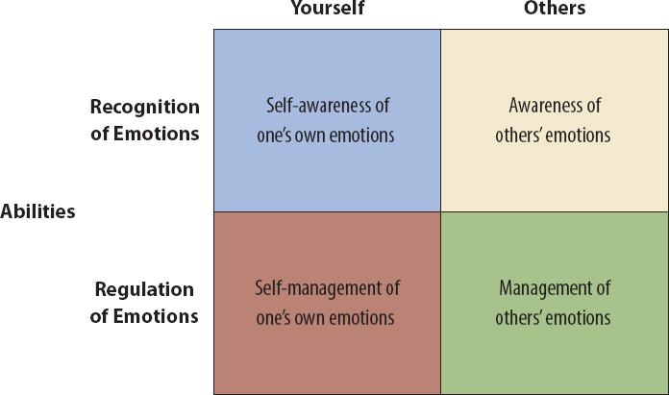 Dimensions of Emotional Intelligence
- Self-Awareness of Emotions

  - Ability to perceive and understand the meaning of your own emotions

  - More sensitive to emotional responses to events and understand their message

  - Self-aware people are better able to listen in on their emotional responses to specific situations and to use this awareness as conscious (aware) information

- Self-Management of Emotions

  - Emotional intelligence includes the ability to manage your own emotions

  - try not to feel angry or frustrated when events go against us

  - try to feel and express joy and happiness toward others when the occasion calls for these emotional displays

  - deep acting described earlier requires high levels of the self-management component of emotional intelligence

- Awareness of Others' Emotions

  - Ability to perceive and understand the emotions of other people.

  - Awareness of other people's emotions is represented by empathy

  - Empathy

    - Having an understanding of and sensitivity to the feelings, thoughts, and situations of others

    - ability includes understanding the other person's situation, experiencing his or her emotions, and knowing his or her needs even though unstated.

- Management of Others' Emotions

  - Managing other people's emotions

  - Includes

    - Consoling people who feel sad,

    - Emotionally inspiring your team members to complete a class project on time

    - Getting strangers to feel comfortable working with you

    - Managing dysfunctional emotions among staff who experience conflict with customers or other employees

- jobs involve social interaction with co-workers or external stakeholders, so employees need emotional intelligence to work effectively.

- Emotional intelligence is particularly important for managers because their work requires management of their own emotions and the emotions of others.

- People with high Emotional Intelligence are better at:

  - Interpersonal relations,

  - Perform better in jobs requiring emotional labor,

  - Are superior leaders,

  - Make better decisions involving social exchanges,

  - Are more successful in many aspects of job interviews,

  - Are better at organizational learning activities.

- Teams whose members have high emotional intelligence initially perform better than teams with low Emotional Intelligence

- Emotional intelligence does not improve some forms of performance, such as tasks that require minimal social interaction
Improving Emotional Intelligence
- Emotional intelligence can be learned

  - Business students had higher emotional intelligence scores after taking an undergraduate interpersonal skills course.

- Personal coaching, plenty of practice, and frequent feedback are particularly effective at developing Emotional Intelligence

- Emotional intelligence also increases with age; it is part of the process called maturity

LO 3: Summarize the consequences of job dissatisfaction as well as strategies to increase organizational (affective) commitment

- Job satisfaction

  - A person's evaluation of his or her job and work context, is probably the most studied attitude in organizational behavior

  - appraisal (evaluation) of the perceived job characteristics, work environment, and emotional experiences at work

  - Job satisfaction is best viewed as a collection of attitudes about different aspects of the job and work context

- How satisfied are employees at work?

  - The answer depends on the person, the workplace, and the country

- Problems with determining job satisfaction

  - Surveys often use a single direct question, such as “How satisfied are you with your job?”

    - Many dissatisfied employees are reluctant to reveal their feelings in a direct question because this is tantamount (equal) to admitting that they made a poor job choice and are not enjoying life

  - Cultural values make it difficult to compare job satisfaction across countries

  - Job satisfaction changes with economic conditions

Job Satisfaction and Work Behavior

- A useful template for organizing and understanding the consequences of job dissatisfaction is the exit-voice-loyalty-neglect (EVLN) model

- Exit-Voice-Loyalty-Neglect (EVLN)

  - The four ways, as indicated in the name, that employees respond to job dissatisfaction

- Exit

  - Exit includes leaving the organization, transferring to another work unit, or at least trying to get away from the dissatisfying situation

  - Job dissatisfaction builds over time and is eventually strong enough to motivate employees to search for better work opportunities elsewhere (traditional theory)

  - Specific “shock events” quickly energize employees to think about and engage in exit behavior.

    - For example, the emotional reaction you experience to an unfair management decision or a conflict episode with a co-worker motivates you to look at job ads and speak to friends about job opportunities where they work

    - This begins the process of re-aligning your self-concept more with another company than with your current employer

- Voice

  - Voice is any attempt to change, rather than escape from, the dissatisfying situation

  - Voice can be a constructive response, such as recommending ways for management to improve the situation

    - It can be more confrontational, such as filing formal grievances or forming a coalition to oppose a decision

  - Extreme, some employees might engage in counterproductive behaviors to get attention and force changes in the organization

- Loyalty

  - “Loyalists” are employees who respond to dissatisfaction by patiently waiting

  - Some say they “suffer in silence”, for the problem to work itself out or be resolved by others

- Neglect.

  - Neglect includes reducing work effort, paying less attention to quality, and increasing absenteeism and lateness.

  - Generally considered a passive activity that has negative consequences for the organization.

- Which of the four EVLN alternatives do employees use?

  - Depends on the person and situation

  - Person’s self-concept

    - Some people avoid the self-image of being a complainer, whereas others view themselves very much as taking action when they dislike a work situation

    - Self-concept relates to personal and cultural values as well as personality

    - For example, people with a high-conscientiousness personality are less likely to engage in neglect and more likely to engage in voice

  - Past experience

    - Employees who were unsuccessful with voice in the past are more likely to engage in exit or neglect when experiencing job dissatisfaction in the future

  - Loyalty

    - Employees are more likely to quit when they have low loyalty to the company, and they are more likely to engage in voice when they have high loyalty

  - Depends on the situation.

    - Employees are less likely to use the exit option when there are few alternative job prospects
Job Satisfaction and Performance

- Workers tend to be more productive to some extent when they have more positive attitudes toward their job and workplace

- Why isn't the job satisfaction-performance relationship even stronger?

  - general attitudes (such as job satisfaction) don't predict specific behaviours very well.

    - The EVLN model explained, dissatisfaction might lead to turnover, complaining, or patiently waiting rather than reduced performance (a form of neglect).

  - Only when employees have considerable control over their job performance

    - People working on an assembly line, for example, would produce about the same quantity and quality output no matter what they think about their job.

  - Job performance might cause job satisfaction, rather than vice versa

    - Higher performers receive more rewards (including recognition) and, consequently, are more satisfied than low-performing employees who receive fewer rewards

    - Connection between job satisfaction and performance isn't stronger because many organizations do not reward good performance very well.
Job Satisfaction and Customer Satisfaction
- This employee-customer relationship is illustrated in the service profit chain model

- Service Profit Chain Model

  - A theory explaining how employees job satisfaction influences company profitability indirectly through service quality, customer loyalty and related factors
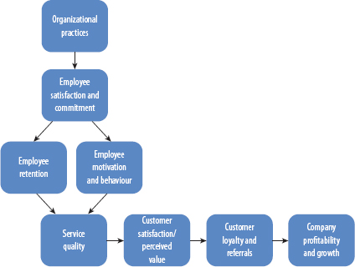 Service Profit Chain Model

- workplace practices affect job satisfaction, which influence employee retention, motivation, and behaviour.

- employee outcomes affect service quality, which then influence customer satisfaction and perceptions of value, customer referrals, and ultimately the company's profitability and growth

- Behind the service profit chain model are two key explanations why satisfied employees cause customers to be more satisfied

  - First, employees are usually in a more positive mood when they feel satisfied with their jobs and working conditions

    - Employees in a good mood display friendliness and positive emotions more naturally and frequently, and this causes customers to experience positive emotions, which translate into a more positive service experience (i.e., higher service quality).

  - Second, satisfied employees are less likely to quit their jobs, so they have better knowledge and skills to serve clients.

    - Lower turnover also enables customers to have the same employees serve them, so there is more consistent service.

    - Some evidence indicates that customers build their loyalty to specific employees, not to the organization, so keeping employee turnover low tends to build customer loyalty

Job Satisfaction and Business Ethics

- Job satisfaction is also an ethical issue that influences the organization's reputation in the community

- People spend a large portion of their time working in organizations, and many societies now expect companies to provide work environments that are safe and enjoyable
Organizational Commitment
- Organizational commitment represents the other half (with job satisfaction) of what some experts call “overall job attitude.”

- Organizational commitment (affective commitment)

  - Employee's emotional attachment to, identification with, and involvement in a particular organization

  - Affective commitment is a person's feeling of loyalty to the place where he or she works

- Affective commitment differs from continuance commitment

- Continuance Commitment

  - An employees calculative attachment to the organization whereby employee is motivated to stay only because leaving would be costly

  - Choose to stay because the calculated (typically financial) value of staying is higher than the value of working somewhere else

Consequences of Affective and Continuance Commitment

- Affective commitment can be a significant competitive advantage

  - Loyal employees are less likely to quit their jobs and be absent from work

  - Have higher work motivation and organizational citizenship, as well as somewhat higher job performance

- Organizational commitment also improves customer satisfaction because long-tenure employees have better knowledge of work practices and because clients like to do business with the same employees

- Employees with very high loyalty tend to have high conformity, which results in lower creativity
- There are also cases of dedicated employees who violated laws to defend the organization.

- Employees with high levels of continuance commitment are more likely to have lower performance and are less likely to engage in organizational citizenship behaviors

- Employees with high continuance commitment are more likely to use formal grievances

- Employees with high affective commitment engage in less formal problem solving when employee-employer relations sour

- Employers still need to win employees' hearts (affective commitment) beyond tying them financially to the organization (continuance commitment)

Building Organizational Commitment

- Justice and support

  - Affective commitment is higher in organizations that fulfill their obligations to employees and abide by humanitarian values, such as fairness, courtesy, forgiveness, and moral integrity

  - Organizations that support employee well-being tend to cultivate higher levels of loyalty in return

- Shared values

  - The definition of affective commitment refers to a person's identification with the organization, and that identification is highest when employees believe their values are congruent with the organization's dominant values.

  - Employees experience more comfort and predictability when they agree with the values underlying corporate decisions. T

    - Comfort increases their motivation to stay with the organization.⁷³

- Trust

  - Trust refers to positive expectations one person has toward another person or group in situations involving risk.

  - Trust means putting faith in the other person or group.

    - Employees have stronger commitment to the organization when they trust its leaders.

- Organizational comprehension (understanding)

  - Organizational comprehension refers to how well employees understand the organization, including its strategic direction, social dynamics, and physical layout

  - Awareness is a necessary prerequisite to affective commitment because it is difficult to identify with or feel loyal to something that you don't know very well.

- Employee involvement.

  - Employee involvement increases affective commitment by strengthening the employee's psychological ownership and social identity with the organization

  - Employees feel that they are part of the organization when they participate in decisions that guide the organization's future

  - Employee involvement also builds loyalty because giving this power is a demonstration of the company's trust in its employees

- Organizational commitment and job satisfaction represent two of the most often studied and discussed attitudes in the workplace

- Each is linked to emotional episodes and cognitive judgments about the workplace and relationship with the company

