Chapter 5: Morphology
What is Morphology?
- Is the study of words and parts of words- the underlying rules behind the structure of words
- Not all languages have the same morphological rules
- Morphology is closely linked to the study of the lexicon.
  - Lexicon is our mental dictionary; stores information about words and the lexical rules that we use to build them
  - For each entry/morpheme: It includes information on meaning, pronunciation, syntactic category, rules for expansion of words, making related words, spelling (if literate in language)
  - Lexicon size is estimated by the ratio of words vs. total words from a random selection of 5 pages or so of a dictionary
  - Average high school students knows ~ 60,000 words Kids learn ~9words/day
What is a Morpheme?
- A Morpheme is the smallest unit of meaning in a word
- The form of a word, its suffixes and prefixes, help us determine the syntactic category ( set of words that share a significant number of grammatical characteristics- ex. Verb or noun)
- A morpheme is not the same as a syllable, Mississippi has more than one syllable but only one morpheme
- Words can be monomorphemic (one morpheme) or polymorphemic (more than one morpheme)
  - Example: racehorse is p.m. and catapult is m.p. since catapult is not related to the feline (cat)
- A word is a “a morpheme or combination of morpheme to which we attach meaning”
Free and Bound Morphemes:
- Morphemes are either bound (must be attached to another morpheme- trans and mit) or free (can stand alone as a word- cat and drink)
- Affixes are bound morphemes, including prefixes, suffixes, infixes, and circumfixes
- Prefixes come before the word such as dis-, un-, for- etc. while suffixes comes after such as –ment, -ion, etc
- An infix is an affix that attachés within a word root. For example in the Inukitut language of Western language the infix –pallia-, this must be inserted into a verb root. Ex. Nungup + pallia + jut = nunguppalliajut meaning “they are ‘gradually’ disappearing”
- There is only one basic type of infix in English called the expletive infixation (process by which a words is inserted inside another morpheme) which adds emphasis. Eg. abso-FUCKING-lutely (others include gosh, darn, etc.)
- Native English speakers have intuition in where to put the expletive infixation (before the syllable that receives the more stress, won’t fit otherwise). If the first syllable is stressed then it goes after the secondary stress basket-***-ball
- The circumfix is the type of affix that surrounds another morpheme. Example, the German, ge—t, which creates the perfective form of certain verbs kommen (to come) Er ist gekommt (he has come)
- A clitic is a morpheme that is phonologically dependent on another word but is grammatically independent- eg do not… the not becomes /ɘnt/ the have in could have becoming /ɘ/ (coulda). They are a hybrid between affixes and free morphemes
Roots:
- A root is a morpheme to which an affix can attach to
- A bound root is a non-affix morpheme that cannot stand alone. For example –ceive (receive, perceive, deceive, etc.) it is clearly distinct from permit, denote, etc. but the ceive cannot stand alone as a word, and is thus is a bound root
- Productive Rule: a rule that regularly applies in the formation of new words or forms of words. Eg. addition –ion to verbs (transmit +ion), most words in English follow non-productive rules such as lukewarm and unkempt
- Interdigitation is a root in which morphemes are added in between each part, for example s-l-m… Moslem, Islam, salaam…. S-l-m meaning peace
Derivational Affixation:
- Affixes that attach to other morphemes to form new words that are spate entries in our mental dictionary, or lexicon
- E.g. The affix –able attaches to verbs, deriving adjective. Thus the affix derives a new word, a new dictionary entry ( not within the same word class for suffixes)
- Affix –ity adds to verbs to create nouns. Verb+ ment = noun. Adjective + ness= noun, adjective + ize = verb, adjective + ly =adverb
- Derivational prefixes un + happy, dis +enchant, semi + soft although they don’t change the word class the words do not have the same meaning and are in different entries in our mental dictionary
- Like suffixes they attach to specific categories. For example ex +noun, anti + noun,, de +verb, in + adjective
Word Trees:
- Affixes can determine the syntactic category of a word: Words that end in –able are adjectives, words that end in –ish are also adjectives, etc
- Steps:
  - Break it down into morphemes
  - Find the Root
  - Compare similar words to see how to add the affixes to the root
  - Build the word hierarchically (some morphemes must be attached before others, contained within others)
- Derivational Affixes attach before Inflectional
- Ambiguity:
  - I can’t lock the door because it is unlockable. = [ un [lockable]] not + lockable
  - I can unlock the door because it is unlockable= [[un lock] able] unlock +able
  - This is because “un” has two different meaning in English. Un + noun means not, while un + verb (reveres the action- the opposite)
Inflectional Affixation:
- Inflectional Affixes do not change the category of the word to which they attach, nor do they create new dictionary entries (it adds grammatical information to a word)
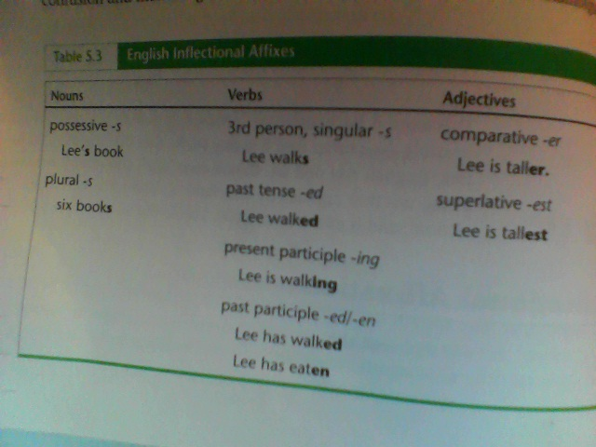
- Some might think that the overlap in forms of inflectional affixes would cause confusion however children appear to have no problem mastering the English inflectional system (Ex. The difference between adding an s to a noun vs. a verb)

Inflectional Affixation of English Nouns:
- Number:
  - English nouns productively express number (plural or singular) in the form of –s
  - Some of words that end with –s already have been adopted from other languages and thus we keep their rules for changing to plural (Latin -syllabus/syllabi, Old English mutated – goose/geese, Old English zero: deer/deer, old English –en plurals child/children)
  - Be careful somethings the end in –s are actually singular (pluralia tantum) ex. Scissors, pants etc.
- Case:
  - Case can express the grammatical function of a noun phase (is it a subject, direct object, indirect, etc.)
  - Most noun phrases are not inflicted (do not change form) between cases in English but in German they do:
    - Nominative Case: (subject) der, Accusative Case: (direct object)den , Dative Case: (indirect object) dem
  - English expresses distinctions in only two ways: on pronouns and in possessive (genitive) noun phrases
    - Eg. Nominative I bought a car, Accusative- She like me, Dative- Give it to me (no difference from Accusative), Genitive- This is my car.
- Gender:
  - Many languages distinguish nouns in terms o grammatical gender- as masculine, feminine, or neuter
  - Sometimes words that introduce/follow these nouns must agree in gender, thus they change la nuit blanche
Inflectional Affixations of English Verbs:
- The form of the verb that has no inflections at all is the infinitive (base verb preceded by to in English)
- The only form of the verb in the present tense that expresses tense inflection is the third-person singular form, which is affixed by –s I sleep vs. He sleeps
- Many English verbs form the past tense with the affix –ed (walked) others by vowel mutation e.g. run -> ran sing -> sang . Or sometimes both sleep/slept etc.
- A strong verb express inflictions through vowel mutations alone, and weak verbs are verbs that expressed through regular affixation or both
- Some languages like the Icelandic language, change the past tense by mor affixes based on tense, person, and number
- The affixes –ing (present) and –en/-ed/-t (past) occurs on English participles, the forms of main verbs that occur with auxiliary verbs have and be
- Julia is talking vs. Julian has talked
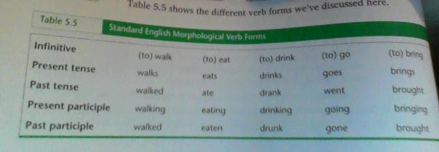
Participles as Markers of Social Class:
- Participles are often markers of social class (as reflected in the following quote from Carl Sandburg: “I never made a mistake in grammar but once in my life and as soon as I done it I seen it”)
- Because of the overlap in the past-tense and past-participle forms of many verbs such as (I walked, I have walked), a common process in English is to extend this pattern to other verbs, even those whose past-participles form is different from the past tense
- Some are stigmatized ( I have sung rather then I have sang) and some are not stigmatized for example I have sewed vs. I have sewn
- Sometimes the past-participle is being used in the past tense (very stigmatized). I saw vs. I seen
- Some are based on certain situations example struck (in baseball) and stricken (in legal terms)
- Some add –en to the past tense to form the past participle. Example I have bought, I have boughten (less standard). It seems like were torn unconsciously whether to add an affix –en to the past tense to make it a past participle or to lose the distinction

Suppletive Verbs and Adjectives:
- These are words that one form of a word has no phonological similarity to a related form of the word.
- Example: go/went for verbs or good/better/best for adjectives usually there is a historic reason though

