Chapter 3: Phonetics Describing Sounds
Phonetics: the study of sounds
- We know a great deal about the complex sounds and the sound system of English; it is not something we think about but comes effortlessly
- Spelling is a cultural artefact, and is not necessarily language!
- There is not a one-to-one correspondence between sound and spelling, so linguists use a system for describing sounds of language in which each sound is represented by a single symbol (IPA- International Phonetic Alphabet)
  - Example: cough, enough, though, and though all end in ough, but have different sounds
  - Example: “ee” sound in plea, tee, deceive, tangy, key, ski, brie, people, algae
  - Example: some are silent like in know, dumb
  - Single sounds can be presented by two letters thin, that or one letter representing more than one sound unite, untie, xylophone
The Solution- IPA:
- Linguists use a one-to-one sound to symbol convention that accurately tells them how to document any speech sound
- Languages would have Arabic would have trouble writing the sound in words
- IPA: Is the Solution
- It is a systematic approach to documenting speech sounds using articulatory specifications
- Natural class is a set of sounds that have certain phonetic features in common
- The one’s in grey are voiced, white are voiceless

Phonemes:
- Are distinctive sounds in a language that makes a difference in the meaning of a word
  - For example, sometimes p’s sound like b’s, yet we consider them all p’s
- Different languages have different phonemes for example English has forty while !Xu (Southern Africa has 141! The most common are : /p, t ,k/
- Phonemes are determined using the minimal pair test
  - Two words form a minimal pair when they differ by exactly one sound (not letter)
    - E.g. bat-pat, bought-bat, bat-bad
- Suppose you land on an alien planet and your task is to figure out what sounds are used in alien language. You could do this using the minimal pair test, to determine the phonemes
- Two types of Phonemes: Vowels and Consonants
Consonants:
- Are sounds characterized by closure or obstruction of the vocal tract
- There are only 24 different consonant phonemes in English
- Consonants are described using 3 dimensions
  - Voicing: Voice of Voiceless
  - Place of Articulation:
  - Manner of Articulation
Place of Articulation:
- Refers to the place, in the vocal tract, where there is an occlusion, impeding air flow, which when released makes sound
- POA:
  - Bilabial: “two lips,” The sounds in this group are all made by bringing both lips together or almost together
  - Labiodental: “lip, tooth” sounds are made with the lower lip against the upper front teeth
  - Interdental: “between, teeth” sounds are made with the tip of the tongue between the front teeth.
  - Alveolar: the sounds in this group are made with the tongue tip at or near the alveolar ridge.
  - Palatal: the sounds in this group are made with the tongue near your palate (hard part past the alveolar)
  - Velar: the sounds in this group are made with the tongue near the velum (the soft part of the roof of your mouth (behind palate
  - Glottal: this is a sound made at the glottis, the space between the vocal folds

Manner of Articulation:
- Manner is the most unclear of the articulatory dimensions. It is related to how the consonant is articulated
  - Stop (Plosive): Tight spot in your mouth, so air can’t escape. Release the contraction causing an explosion
  - Fricatives: the sounds in this group are made by forming a nearly complete stoppage of airstream where the sounds quickly moves past the area of articulation
  - Affricates: sounds in this group are made by briefly stopping the airstream completely and then releasing the articulators slightly so that friction is produced (start as a stop and finish as fricatives)
  - Nasals: the sounds in this group are made by lowering the velum and letting the airstream pass primarily through the nasal cavity
  - Glides: the sounds in this group are made with only a slight closure of the articulators tongue closer to roof of mouth- (any more open would be a vowel)
  - Liquids: The sounds in this group result when a obstruction is formed by the articulators but is not narrow enough to stop the airflow or to cause friction
    - /l/ a lateral liquid tongue touches the roof of the mouth (near the alveolar ridge, and air flows around the sides of the tongue
    - /r/ is described as a bunched liquid because for most American English speakers the tongue is bunched up under the palate
  - Other Names: Approximant (dynamic tongue movements starts in one place ends in another). Trill (rapid movement of the articulator). Tap, Flap (short ballistic movement goes up and hits the top and comes back down). Lateral refers to the air escaping the sides of your mouth.

Voicing:

- Voicing is the vibration of the vocal folds
- All consonants are either voiced or voiceless
- The airflow coming out of the lungs can meet resistance at the larynx or voice box. The resistance can be controlled by the different position and tension in the vocal cord/folds which are two muscular bands of tissue that stretch fro from the front to back of the larynx, behind the Adam’s Apple
- When relaxed and breathing their open, when there just enough tension/air in the muscles in the cords they vibrate when you speak /s/ vs ./z/
Vowels:
- Vowels are produced with no occlusion in the vocal tract
- Vowels have a continuous production
- Classified using dimensions related to the position of the tongue
  - Height
  - “Backness”
  - Tenseness
  - Rounding (of lips)
- We mainly hear consonants when there with vowels
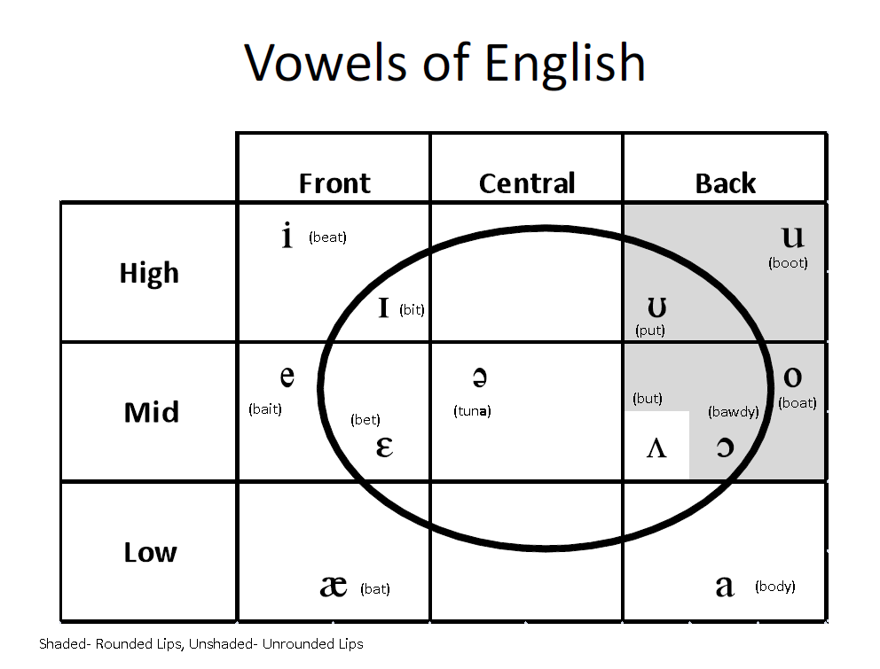
- While Consonants all the parts of the mouth impede the air in the mouth, air rushes out past a restriction. In vowels, it is made using a more open (air comes out easily, no restriction)

- It is sometimes hard to distinguish the mid-central. /ɘ/ is the vowel that is unstressed while /Ʌ / in stressed syllables. You can detect the difference when comparing the sounds bun and Cuba (stressed and unstressed)
- Another distinction is the lax and tense vowels. The tense vowels are made with more muscular constriction ( /i/ in beet, /e/ in bait, /u/ as in boot, and /o/ as in boat) The rest are said to be lax. The other is the rounded vowels (mid-high back)
Diphthongs:
- Are two-part vowel sound consisting of a vowel and a glide in one syllable
- In English we have three phonemic diphthongs /ay/ (as in wide and sky), /aw/ (as in loud and cow), and /oy/ (as in toy and foil)
- In some dialects, however, the /ay/ is a monophthong so wide is closer to /wad/ and sky is like /ska/ and /oy/ is more like /ol/ in oil and foil
- Sometimes the tense vowels are often pronounced as diphthongs
  - /iy/ - beat /uw/- boot /ey/- bait /ow/- boat
  - When we make diphthongs out of momphthongs when speaking other languages, it is evident we have an “American Accent”
Cross-linguistic differences:
- No language uses all the possible the human vocal tract can produce
- Each language slices up the field of possible sounds differently
- It not just the most popular sounds that are listed in the chart, All the sounds are linguistically meaning to someone

Syllable Consonants:
- In English, the lqiouds /l/ and /r/ and the nasals /m/ and /n/ can be syllabic consonants (consonants that fill a vowel slot, when no vowel is present)
  - Example: runner and ribbon have no vowel sounds, to indicate a syllabic consonants we put a dot the consonant sound. Or add a backwards e in front. However it does have a vowel sound in nonsense or nine. So be careful

Other Vowel Distinctions:
- Length: duration of the sound. Ex. Bit/bid longer after the voiced consonant (not considered part of the chart, since it doesn’t make a new word if its long or short, other languages it does though)
- Tone: variations of pitch that makes a difference in the meaning of words. This happens in some Chinese dialects
- Stress: relative emphasis given to syllables in a word.
- Nasalization: production of a speech sound with the velum lowed so that most of the airflow passes through the nose rather than the mouth. They have this in such languages as French (nasal or not changes meaning)
Vowel Shifts:
- Mouth and jaw have fairly little different variations in movement for consonants. Across the languages, they will sound pretty similar.
- Vowels are freer; they are a lot to move free. Even though consonants sometimes change, vowels have a lot more shift. It what we notice in the differences between languages.
- Vowels are highly malleable-> there’s no anchoring as with consonants, where articulators have a place of articulation
- Great Vowel shift- (see chart).
  - During the Middle English period, the seven tense vowels underwent a shift. It was a gradual process (14th Century to 17th Century).
  - One vowel’s articulation point was raised, and this shifted the next vowel up, however the highest vowels had no one to go so they because diphthongs (see below)

- The Northern Cities Chain Shift
  - Is a series of changes in the vowels in Northern Cities such as Chicago and Buffalo; Each vowel shifted to a new place of articulation thus pushing the next vowel along to yet another new place of articulation.

Segments in Contrast:
- Segments are said to be in contrast or to be distinctive or be in opposition In a particular language when their presence alone may distinguish forms with different meanings from each other
  - /s/ vs. /z/ sip vs. zip or /i/ vs. /ej/ heat vs. hate
- Segments that contast with each other in a particular language are said to be phonemes of the language
Phonemes and Allophones:
- Aspiration: puff of air that accompanies the initial voiceless consonants in such words as pat and tick put not in put
- The consonant chart in Table 3.1 has only one /p/. That’s because it is only one /p/ phoneme in English. However, we’ll see that it useful to indicate that there are two allophones of /p/- two predictable phonetic variants of a phoneme /p/
- A superscript h indicates aspiration
- Phonological Rule of English: When when /p/ is in a certain position it is aspirated
  - /p/ becomes aspirated when it occurs at the beginning of a stressed syllable. Otherwise, it is unaspirated.
  - Also applies to /t/ (tack vs. stack) and /k/ (cat vs. scat)
  - Sometimes aspiration in languages are actually phonemes (not English)
The Science of Sound:
- The Uvula controls the fork between mouth and nose (we can control it)
- How do we make sounds? Where in the mouth/throat they are produced?
- Speech is very much linked to respiratory system (the lungs), pumping air taking in air, etc. Speech takes advantage of this pumping mechanism. Speech is necessarily a movement air. I contract my lungs, I push air out my lungs, up through the trachea, past the glottis , the air continues into my oral cavity, there the air will hit various parts of the mouth (the palate, teeth, etc.) It then escapes the mouth, and causes pressure fluctuations (like a pebble into a pond) it causes the air outside the mouth to move. The pressure fluctuation hits your ear, then your ear tympanic membrane which makes electrical signals which then sends to the brain which processes the signal
- Brain and ear are so finely tune to the language, that we can understand these fluctuations of air pressure. It’s a very simple mechanical pressure.

