Chapter 1 Readings
Tuesday, January 06, 2015
8:31 PM
Chapters 1 and 2: Introduction to Psychological Science and Research Methodology
Psychology: the scientific study of behavior thought and experience and how they can be affected by physical mental social and environmental factors
The Scientific Method
- A person who follows a system of observing predicting and testing is conducting science
- Not based on the subject but use of the Scientific Method
- Scientific Method: A way of learning about the world through collecting observations, developing theories to explain them and using the theories to make predictions
Hypotheses: Making Predictions
- A hypothesis can be supported or rejected you do not prove a hypothesis
Theories: Explaining Phenomena
-theories are built from hypotheses that are repeatedly tested and confirmed
-science is self-correcting as new evidence increases
-Theories : are not the same as opinions or beliefs, not equally plausible, not measured by popular belief
The Biopsychosocial Model
-biological influences = brain structures chemicals, hormones, external substances ex. Genetics of behaviour and psychological disorders
-psychological=memories emotions personalities and how these shape our responses to people ex. Decision making language memory personality
-social=family peers ethnicity and culture has a effect on behavior ex. Attraction, Attitudes and stereotypes, conformity
-all of these influence each other
Building Scientific Literacy
- Scientific literacy: The ability to understand analyze , and apply scientific information
- SL involves 4 skills 1: gathering knowledge about the world 2: Explaining it using scientific terms and concepts 3: using critical thinking 4: applying and using information
- Generalization allows for insight beyond the confines of the lab
Critical Thinking, Curiosity, And A Dose of Healthy Skepticism
-Critical Thinking: Involves exercising curiosity and skepticism when evaluating the claims of others, and with our own assumptions and beliefs
-not a belief philosophy or faith does not always guarantee a correct answer but helps find and justifies good answers
-involves skepticism
-principle of parsimony: simplest of all competing explanations of a phenomenon should be the one we accept
1.2| Psychology's Philosophical and Scientific Origins
-Empiricism: knowledge comes from experience : whatever we see or measure should be observable and logical explanations of how the observations fit together
-Determinism: belief that all events are governed by lawful, cause-and -effect relationships
-does natures laws apply to how we think and act? Free will vs. determinism
-compelling evidence that suggests some of our behaviors are determined
Influences From the Ancients: Philosophical Insights into Behavior
-ancient Egyptian doctors noticed that damage to different brain areas led to impairments
-Hippocrates (460-370 BCE) developed the world's first personality classification scheme 4 humours flowed through the body and influenced both health and personality which included blood,yellow bile,black bile, phlegm
-Galen of Pergamon suggested that the four humours combined to form temperments which are:
Sanguine:(blood) tendency to be pleasure seeking, impulsive and charismatic
Choleric: (Yellow bile) a tendency to be ambitious, energetic, aggressive
Melancholic: (black bile) tendency to be independent perfectionistic and a bit introverted
Phlegmatic: (Phlegm) tendency to be quiet relaxed and content with life
-Zeitgeist: refers to a general set of beliefs of a particular culture at a specific time in history
- This had an impact on psychological science because it implied materialism: the belief that humans and other living things are composed exclusively of physical matter
- Opposite is dualism which is the belief of a mind or soul separate from the body
Influences From Physics: Experimenting with the mind
- Gustav Fechner (1801-1887) : studied sensation and perception, questioned how the mental and physical worlds interacted 'Psychophysics'
Influences From Evolutionary Theory: The Adaptive Functions of Behavior
-Darwins theory of natural selection can help explain human and animal behaviour, because certain behaviours helped people survive and reproduce
Influences From Medicine: Diagnoses and Treatments
-clinical psychology , the field of psychology that concentrates on the diagnosis and treatment of psychological disorders
-brain localization idea that parts of the brain are associated with specific mental abilities
- Mid 1800s localization was studied with Phrenology: examination of surfaces of the skull later was abandoned 2 well known examples: Paul Broca & Tan located where speech production was located from damage on Tans skull 2nd: Karl Wernicke id Wernicke area for language comprehension
- Franz Mesmer: hypnosis which caught attention of Freud which led to psychoanalysis
- Psychoanalysis: psychological approach that attempts to explain how behavior and personality are influenced by unconscious processes
- Consciousness includes perceptions thoughts a sense of self and sense of control unconscious mind that exerts itself in strange ways hypnosis allowed entrance into unconscious mind
- He emphasized physiological needs relating to survival and reproduction as influences on behavior
The Influence of Social Sciences Measuring and Comparing humans
-Sir Francis Galton: early pioneer of statistical methods for measuring human traits. developed ways of measuring eminence-- combination of ability morality and achievement; Galton was one of the first to scientifically take on the question of nature and nurture relationships: The inquiry into how herdity and environment influence behavior and mental processes
- This bias led into the scientific justification of eugenics
The Beginnings of Contemporary Psychology
-by 1800s zeitgeist changed and study of human behaviour became its own discipline :psychology
Structuralism and Functionalism: The Beginnings of Psychology
-Wilhelm Wundt (1832-1920) responsible for establishing psychology as an independent scientific field
-his primary research method was introspection meaning to look within, also developed reaction time as a measurement of mental effort.
-Edward Titchener adopted introspection methods and created a map of the structure of human conciousness.
Structuralism: was an attempt to analyze conscious experience by breaking it down into basic elements and to understand how these elements work together
- Believed that mental experiences were made up of a limited number of sensations, analogous to elements in physics and chemistry
- William James (1842-1910) wrote The Principles of Psychology published in 1890. In contrast to structuralism which looks for permanent unchanging elements of thought, he preffered to explain how our thoughts and actions help us adapt to our environment.
- Functionalism: Study of the purpose and function of behavior and conscious experience
- From this POV it is important to figure out what purpose it may have served over the course of evolution today this is known as evolutionary psychology
The Rise of Behaviorism
-Edwin Twirmyer(1873-1943): American psychologist interested in reflexes used a bell to indicate the mallet used to test was going to go down after hitting the leg . Once it stopped the leg continued to react from the sound of the bell, a process called classical conditioning which became the focus of Behaviorism
- Behaviorism: had a singular focus on studying only observable behavior with little to no reference to mental events or instincts as possible influences on behaviour
- Twitmyer received little recognition and credit often goes to Ivan Pavlov and his experiments with dogs
- In North America John B watson championed behavourism: he began to believe that all behaviour could be explained through conditioning and argued that introspection was too subjective to consider
- Watson applied scientific approach to advertising and discovered that consumers knowledge was not that important as long as positive emotions existed (why advertising uses cute animals, clad women etc..)
- B.F Skinner 1904- 1990: viewpoint that the foundation of behaviour was how an organism responded to reward and punishment this concept challenged the concept of free will and was resisted by those who believed that humans could rise above reward-based motivations
Humanistic Psychology Emerges
-To behaviorists human experience was the product of a lifetime of rewards, punishments, and learned associations To the psychoanalysts human experience was the result of unconscious forces at work deep in the human psyche from both perspectives the individual was merely a product of forces that operated on her with little to no control over destiny
-Contrastingly Humanistic psychology : focuses on the unique aspects of each individual human, each persons freedom to act, his or her rational thought and the belief that humans are fundamentally different from other animals
- Two figures of humanistic psychology were Carl Rogers (1902-1987) and Abraham Maslow (1908-1970) focused on factors that lead to productive and fulfilling life, sought to understand the meaning of personal experience
- Contrasts with psychoanalytic tradition which focused on illness and also contrasted with behaviorism proposing freedom to act
The Brain and Behavior
-Karl Lashley (1890-1958) - examined how size and location of brain damage affected maze navigation performance, 2 findings that location did not affect performance because long term memories are stored throughout many parts of the brain 2nd Principle of mass action size of lesion did have an effect
-Donald Hebb (1904-1985) found that cells that fire together wire together known as Hebbs Law
- Wilder Penfield (1891-1976) and Herbert Jasper : able to create maps of sensory and motor cortices in the brain
The Cognitive Revolution
-Hermann Ebbinghaus (1850-1909): collected data on remembering and forgetting. Most of what one learns will be forgotten rapidly
-Frederick Bartlett (1886-1969): found that our memory was not like a photograph but influenced by cultural knowledge and experiences
-Gestalt psychology an approach emphasizing that psychologists need to focus on the whole perception and experience rather than its parts
Social and Cultural Influences
-effect of other peoples on ones behaviour, took off in 1940s due to events in Nazi-Germany leading up to WW2
-large amount of intellectuals fled to North America to escape persecution who brought influence of gesalt psychology
-collaborations between sociologists and psychologists led to social psychology: the study of the influence of other people on our behaviour
-not all people responded to presence of others in the same way, which led to the development of personality psychology: study of how different personality characteristics can influence how we think and act
-Kurt Lewin (1890-1947) personality and social situations you are in interact B= f{I,E} all behaviors can be predicted and explained through understanding how an individual with a specific set of traits would respond in a context that involved a specific set of conditions.
-cross cultural psychology: comparisons about individual and group behavior among cultures
Chapter 2 readings - Principles of Scientific Research
Tuesday, January 06, 2015
8:32 PM
Five Characteristics of Quality Scientific Research
- It is based on measurements that are objective valid and reliable
- It can be generalized
- It uses techniques that reduce bias
- It is made public
- It can be replicated
Scientific Measurement: Objectivity Reliability and Validity
Objective measurements: the measure of an entity or behaviour that within an allowed margin of error, is consistent across instruments and observers
Variable: the object, concept, or event being measured
Operational definitions: Statements that describe the procedures and specific measures that are used to record observations
Validity: the degree to which an instrument or procedure actually measures what it claims to measure
Reliability: when it provides consistent and stable answers across multiple observations and points in time
- Test retest reliability determines whether scores are consistent across test sessions
- Alternate-forms reliability determines whether different forms of the same test produce the same results
- Observers score a behaviour or response : needs more than one rater to have high inter rater reliability
Generalizability of Results
Generalizability: Degree to which one set of results can be applied to other situations, individuals or events
Population: the group that researchers want to generalize about
Sample: a select group of population members
Random Sample: A sampling technique in which every individual of a population has an equal chance of being included
Convenience Samples: samples who are most readily available
Ecological Validity: results of a laboratory study can be applied to or repeated in the natural environment
Sources Of Bias in Psychological Research
-researcher bias: bias unintentionally introduced by the researchers, ex. Participants were treated differently
-Participant bias:participants introduce their own bias
-Hawthorne effect: a behaviour change that occurs as a result of being observed
What do we know about how bias affects research participants?
Demand characteristics: inadvertent cues given off by the experimenter or the experimental context that provide information about how participants are expected to behave
Social Desirability: participants respond in ways that increase the chances that they will be viewed favourably
Techniques that reduce bias
Providing anonymity and confidentiality to the volunteers, confidentiality means that results will be seen only by the researcher
Placebo effect: a measureable and experienced improvement in health or behaviour that cannot be attributable to a medication or treatment
- Due to this effect it is important to do blind studies Single-blind study: the participants do not know the true purpose of the study, or else do not know which type of treatment they are receiving. In this case the subjects are blind to the purpose of the study Double-blind study: a study in which neither the participant nor the experimenter knows the exact treatment for any individual
Sharing the Resultsg
-Academic Journals , which articles must go through peer review
Replication
Replication: process of repeating a study and finding a similar outcome each time
-this is to ensure that published results did not occur due to carelessness, dishonesty , or coincidence
Five Characteristics of Poor Research
- Untestable hypotheses- must be falsifiable
- Anecdotes- individual testimony used to make a claim as evidence
- Biased selection of available data- some politicians/corporations may only use data that backs their own view
- Appeals to authority- belief in an experts claim even with no supporting evidence is present
- Appeals to common sense- appears to be sound lacks evidence appeals to tradition or novelty
2.2| Scientific Research Designs
-All research designs have variables, operational definitions and data
Descriptive Research
-describes the characteristics used to inform other studies about why and how phenomenon occurs
Case Studies
- In depth report about details of a specific case. Ex. Phineas Gage got a rod stuck in his head which made him much more impulsive, inconsiderate, indecisive and impatient. Located in the frontal lobe
Naturalistic Observation
-observe and record behaviour as it occurs in subjects natural environment
Surveys and Questionnaires
-self reporting: a method which responses are provided by people being studied
Correlational Research
-involves measuring the degree of association between two or more variables, can be visualized with a scatter plot
-correlation has a direction positive= 2 variables change in same direction, negative = one increases while the other decreases
-also has magnitude/strength: refers to how closely changes are linked to another variable measured by the correlation coefficient 0=0 no relationship +/- 1 = 1 strong relationship note this is not a measure of causality
-Third variable problem - the possibility that a third, unmeasured variable is actually responsible for an established correlation between 2 variables.
-illusory correlations: relationships that exist only in the mind
Experimental Research
-only designs that can provide strong evidence for cause and effect relationships, minimum 2 variables, differences between correlational research and experiments is the random assignment of participants and control over the variables being studied
The Experimental Method
random assignment: a technique for dividing samples into 2 or more groups in which participants are equally likely to be placed in any condition of the experiment
Confounding Variable: variable outside of the researchers control that may affect or provide an alternative explanation for the results
Independent Variable: the variable that the experimenter manipulates to distinguish between 2 or more groups
Dependent Variable: observation recorded and compared across groups
Between-subjects design: an experimental design in which we compare the performance of participants who are in different groups one of these is the Experimental group: getting treatment while the other is the Control group: does not receive treatment
-criticisms of this design is that what if these groups are different due to chance
Within subjects design: an experimental design in which the same participants respond to all types of stimuli or experience all experimental conditions
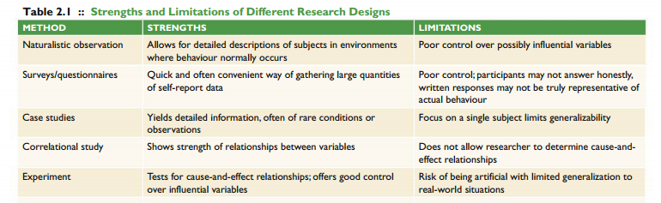
The Quasi-Experimental Method
- Research technique in which the 2 or more groups that are compared are selected based on predetermined characteristic rather than random assignment
- Cannot determine what it is about those groups that lead to the differences
Converging Operations
-when a theory holds up to dozens of tests using different designs then we can be confident of its accuracy

2.3| Ethics in Psychological Research
-1950s mind control techniques were tested on prisoners of war officially ended in 1973
Promoting the Welfare of Research Participants
Research Ethics Board: a committee of researchers and officials at an institution charged with the protection of human research participants
-protects individuals in 2 ways
(1) The committee weighs potential risks to the volunteers
against the possible benefits of the research, and
(2) it requires that volunteers agree to participate in the
research (i.e., they give informed consent).
OBTAINING INFORMED CONSENT
all participants must provide
informed consent: A potential volunteer must be informed (know the purpose, tasks, and risks involved in the study) and
give consent (agree to participate based on the information provided) without pressure.
at minimum, the following details should be provided
• The topic of the study
• The nature of any stimuli (e.g., images, sounds, smells)
to which they will be exposed
• The nature of any tasks (e.g., tests, puzzles) they will
complete
• The approximate duration of the study
• Any potential physical, psychological, or social risks
involved
• The steps that the researchers have taken to minimize
those risks
deception: misleading or only partially informing participants of the true topic or hypothesis under investigation.
psychological research includes the following elements in determining whether full consent is given:
• Freedom to choose. Individuals should not be at risk for financial loss, physical harm, or damage to their reputation
if they choose not to participate.
• Equal opportunities. Volunteers should have choices. For example, if the volunteers are introductory psychology students seeking course credit, they must have non research alternatives available to them for credit should they choose not to participate in a study.
• The right to withdraw. Volunteers should have the right to withdraw from the study, at any time, without penalty.
The right to give informed consent stays withthe participants throughout the entire study.
• The right to withhold responses. Volunteers responding to surveys or interviews should not have to answer
any question that they feel uncomfortable answering
-After participating in the research study, participants must undergo a full debriefing, meaning that the researchers
should explain the true nature of the study, and especially the nature of and reason for the deception
THE RIGHT TO ANONYMITY AND CONFIDENTIALITY
-Anonymity means that the data collected during a research study cannot be connected to individual participants.
Confidentiality includes at least two parts. First, researchers cannot share specific data or observations
that can be connected with an individual. Second, all records must be kept secure

THE WELFARE OF ANIMALS IN RESEARCH
-Is it ethically acceptable to create disease-like symptoms in animals if it could lead to discoveries that could help thousands—or sometimes millions—of people?

REBS FOR ANIMAL-BASED RESEARCH
-
Three main areas of ethical treatment are emphasized by researchers and animal welfare committees. The
fi rst is the basic care of laboratory animals—that is, providing appropriate housing, feeding, and sanitation for
the species. The second is minimization of any pain or discomfort experienced by the animals. Third, although
it is rare for a study to require discomfort, when it is necessary,the researchers must ensure that the pain can be
justified by the potential benefits of the research

2.4| A Statistical Primer
Descriptive Statistics
descriptive statistics: a set of techniques used to organize, summarize, and interpret data. This gives you the “big
picture”
to describe and understand the data are of three types: frequency, central tendency , and variability.
FREQUENCY
-distribution portrayed through histograms or bar graphs
-normal distribution curve: symmetrical distribution with values clustered around a central mean value
Negatively skewed distribution: curve has a tail extended to the left
Positively Skewed Distribution: tail is extended to the right
CENTRAL TENDENCY
-where scores cluster together, measure of the central point of a distribution
-Mean = avg, Median=50th percentile Mode= highest frequency
-if normal distribution then researchers use mean if skewed then researchers need to reevaluate whats best (usually median or trimmed mean) mode is used usually only for categories of data eg which politician is likely to win
VARIABILITY
- Degree to which scores are dispersed in a distribution (spread vs cluster)
- High variability =larger amount of numbers at extreme ends of a continuum
- Low variability= most scores are similar
- Can be caused by measurement errors, imperfect measurement tools, differences between participants in study or characteristics of participants
Standard Deviation: measure of variability around the mean links central tendency and variability - estimating the average distance from the mean
Hypothesis Testing: Evaluating the Outcome of the study
Hypothesis test: a statistical method of evaluating whether differences among groups are meaningful or could have been arrived at by chance alone
-statistical significance: means of the groups are further apart than what you would expect them to be by random chance alone
-based on researcher making 2 hypotheses , 1 null hypothesis: assumes differences are due to chance
2 experimental hypothesis: assumes differences are due to variable controlled by experimenter
-probability of results being true is called the p value p< 0.05 is usually the cutoff point if less than 0.05 then there is a less than 5% chance that the results were due to chance
-alternative to significance testing Jacob Cohen developed power analysis to calculate effect sizes

Chapter 3 Readings - Biological Psychology
Monday, January 19, 2015
11:08 PM
-Martie Haselton (evolutionary psychologist) studies how human behavior evolved to solve problems related to survival and reproductive success women tend to dress better at their peak level of fertility 'signaling'
- Nature vs. nuture debate: not one or the other but a continuum some traits subject to greater influence from genetics (nature) while others are more environmentally based (nurture). Most important, we now know that genetics and experience are never independent. Therefore, the modern scientific nature–nurture question does not split them into two exclusive possibilities.
Rather, we ask, How do nature and nurture interact to produce behavior?
Heredity and Behavior
THE GENETIC CODE
-behaviors are influenced by genes just as physical characteristics are
-This genetic material is organized into genes , the basic units of heredity; genes are responsible for guiding the process of creating the proteins that make up our physical structures and regulate development and physiological processes throughout the lifespan
-Genes are composed of segments of DNA (deoxyribonucleic acid) , a molecule formed in a double-helix
shape that contains four nucleotides: adenine, cytosine, guanine, and thymine (see Figure 3.1 ). These nucleotides are typically abbreviated using the first letter of their names—A,C, G, and T. Each gene is a unique combination of these four nucleotides
-This is the individual’s genotype , the genetic makeup of an organism—the unique set of genes that comprise that individual’s genetic code. This sequence represents the code used to create proteins.
-The result of these instructions is an organism’s phenotype ,the physical traits or behavioural characteristics that show genetic variation, such as eye colour, the shape and size of facial features,
and even personality. This phenotype develops because of differences in the nucleotide sequencing of A, C, G, and T, as well as through interactions with the environment
-Genes are organized in pairs along chromosomes ,structures in the cellular nucleus that are lined with all of the genes an individual inherits . Humans have approximately 20 000–25 000 genes distributed across 23 pairs of chromosomes, half contributed by the mother and half by the father ( if 3 trisomy : cause things like down syndrome)
-If two corresponding genes at a given location on a pair of chromosomes are the same, they are referred to as homozygous . If the two genes differ, they are heterozygous
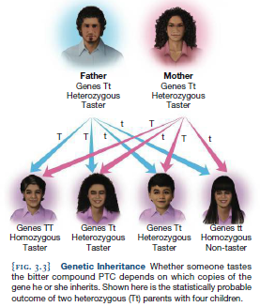
BEHAVIOURAL GENOMICS: THE MOLECULAR APPROACH
- Behavioral genomics is the study of DNA and the ways in which specific genes are related
to behavior. Ex. Human genome project
- behavioural genomic research does have its limitations. For example, although a single gene
has been identifi ed as a risk factor for Alzheimer’s disease,not everyone who inherits it develops the disease. The same is true for many other conditions.
-usually a result of multiple genes
BEHAVIOURAL GENETICS: TWIN AND ADOPTION STUDIES
- Behavioural genetics is the study of how genes and the environment influence behaviour.
Behavioural genetic methods applied to humans typically involve comparing people of different levels of relatedness ,such as parents and their off spring, siblings, and unrelated
individuals, and measuring resemblances for a specific trait of interest. However, the group that has provided the most insight into the genetic effects on behaviour is twins.
- Monozygotic twins come from a single ovum (egg), which makes them
genetically identical (almost 100% genetic similarity). An ideal comparison group, dizygotic twins (fraternal twins)come from two separate eggs fertilized by two different sperm cells that share the same womb; these twins have approximately 50% of their genetics in common.
-Behavioural geneticists use twin studies to calculate heritability — a statistic, expressed as a number between zero and one, that represents the degree to which genetic differences between individuals contribute to individual differences in a behavior or trait found in a population. A heritability of 0 means that genes do not contribute to individual differences in a trait, whereas a heritability of 1.0 indicates that genes account for all individual differences in a trait.
heritability scores do not simply reflect how much genetics contributes to the
trait itself. Rather, heritability scores tell us the degree to which genetics explain differences between people with that trait.
-researchers study adopted kids to see if the child is more like their adoptive family (represents nurture) or their biological parents (represents nature)
- Intelligence before 16 is usually related to their adoptive while after is closer to their biological indicating that some genes do not exert influence until later in life
- North american studies do not generalize to the whole world
GENE EXPRESSION AND BEHAVIOUR
-Almost every cell in our bodies contains the same genes, the basic unit of heredity. But, only some of these genes are active, leading to the production of proteins (or other gene products like ribosomal RNA); the other genes are inactive and do not influence protein production.Of the approximately 20 000-25 000 genes in the human genome, between 6000 and 7000 are active in
the human brain. These genes influence the development of different brain structures, the production of chemicals that allow brain cells to communicate with each other, and the refinement of connections between cells that allow large-scale brain networks to form
-Factors such as diet, stress level ,and sleep can influence whether genes are turned on or
off . This study of changes in gene expression that occur as a result of experience and that do not alter the genetic code is known as epigenetics .
-relationship between gene stress and depression- a gene related to the release of serotonin short and long people who inherit 2 copies of the short gene are at greater risk for depression 2 long not as likely to develop depressio heterozygous - intermediate response to stressful events
Evolutionary Insights into Human Behaviour
-Darwin’s theory of natural selection , the process by which favourable traits become increasingly common in a population of interbreeding individuals, while traits that are unfavourable become less common
-evolution the change in the frequency of genes occurring in an interbreeding population over generations
-How Traits Evolve Evolution through natural selection requires both that a trait be heritable (i.e., be passed down through reproductive means) and that certain individuals within a breeding population have a reproductive advantage for having the trait.
EVOLUTIONARY PSYCHOLOGY
- Lots of opposition because it opposes the belief that world was created by a god as is
-evolutionary psychology attempts to explain human behaviors based on the beneficial function(s) they may have served in our species’ development.
INTRA- AND INTERSEXUAL SELECTION
-adaptations have evolved in order to increase chance of mating to pass on genetic material to future offspring
-intrasexual selection , a situation in which members of the same sex compete in order to
win the opportunity to mate with members of the opposite sex ex. Rutting by caribou
- Intersexual selection , a situation in which members of one sex select a mating partner based on their desirable traits. Ex. Symmetrical faces as more attractive
- Colour red - males find woman wearing red more attractive -redis associated with sexual receptivity in many animals, including humans. Female baboons and chimpanzees—species that are evolutionarily close to humans—have redder chests and genitals when they are near ovulation than at other times of their cycles - effect is age specific
- Women valued men with strong financial prospects, status, and good health whereas men placed a greater emphasis on physical beauty, youth, and other characteristics that relate to reproduction
- This difference could be due to females having limited number of eggs so less opportunity and requires resources for raising a child
EVOLUTION, THE BRAIN, AND BEHAVIOUR
-Homo habilis (“handy man”): first of our ancestors to use stone tools
-Homo erectus(“erect man,”): based on its ability to walk upright.Homo erectus had a brain that
was approximately one-third larger than that of Homo habilis- allowed humans to make fire and more precise tools
-Homo sapiens (“wise men”).Homo sapiens arose in Africa and quickly spread throughout
the world. Their brains were slightly larger than Homo erectus’ , and were the first to come up with symbollic representations of ideas (cave paintings)
- 3 reasons human brains are so powerful
1) more folds and grooves called the cerebral cortex
- Frontal lobe is more developed - critical for our ability to form plans, solve problems, make decisions, and control our attention and actions, among many other functions
- Sections of the skull are not fused at birth allowing brain growth to occur neotony (allows humans to develop larger brains while also being able to exit the birth canal)
EVOLUTION AND COGNITION
-hunter gatherer theory of sex differences in cognition: males responsibilities favored spatial skills whilst women memory for the location of objects- males with higher testosterone did better on task than low testosterone males
3.2|How the Nervous System Works: Cells and Neurotransmitters
Neural Communication
- neurons , one of the major types of cells found in the nervous system, that are responsible for sending and receiving messages throughout the body
THE NEURON
-purpose is to fire, receive and transmit information to/from other neurons
- All have a cell body: the part of a neuron that contains the nucleus that houses the cell’s genetic material- genes in the cell body synthesize proteins and allow it to function
- Input from other cells comes from the neurons dendrites : small
branches radiating from the cell body that receive messages from other cells and transmit those messages toward the rest of the cell
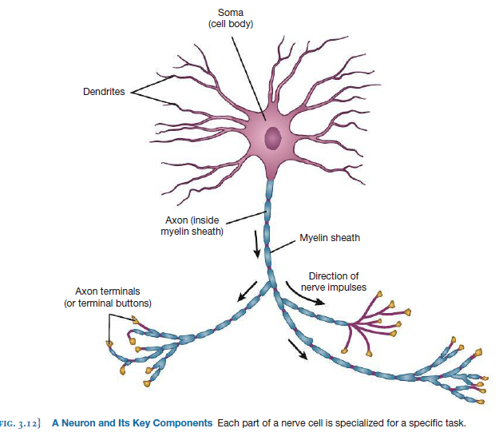
-messages travel across the neuron to the base of the cell body to the section known as the axon hillock if there is enough stimulation it will cause a chemical reaction that flows down to the rest of the neuron
-The activity will travel from the axon hillock along a tail-like structure that protrudes from the cell body. This structure, the axon , transports information in the form of electrochemical reactions from the cell body to the end of the neuron . When the activity reaches the end of the axon, it will arrive at axon terminals , bulb-like extensions filled with vesicles
-These vesicles contain neurotransmitters the chemicals that function as messengers allowing neurons to communicate with each other
-Sensory neurons receive information from the bodily senses and bring it toward the brain. Neurons that respond to touch or pain sensations of the skin bring the message toward the spinal cord and to the brain. In contrast, motor neurons carry messages away from the brain and spinal cord and toward muscles in order to control their flexion and extension
-The physical structure of a neuron is related to the function it performs
-
GLIAL CELLS
-Glial cells are specialized cells of the nervous system that are involved in mounting immune
responses in the brain, removing waste, and synchronizing the activity of the billions of neurons that constitute the nervous system .- outnumber neurons by 10 to 1
- To insulate the axon glial cells form a white substance called myelin , a fatty sheath that insulates
axons from one another, resulting in increased speed and efficiency of neural communication
THE NEURON’S ELECTRICAL SYSTEM: RESTING AND ACTION POTENTIALS
-when a neuron is not transmitting information the outside of it has a lot of positively charged sodium and potassium ions while the inside is mostly negative with chloride ions with a charge of −70 millivolts
This is relatively stable and termed the resting potential
-resting state has 2 forces electrostatic gradient (outside and inside have different charges) and the concentration gradient (more ions on one side of the membrane compared to the other)
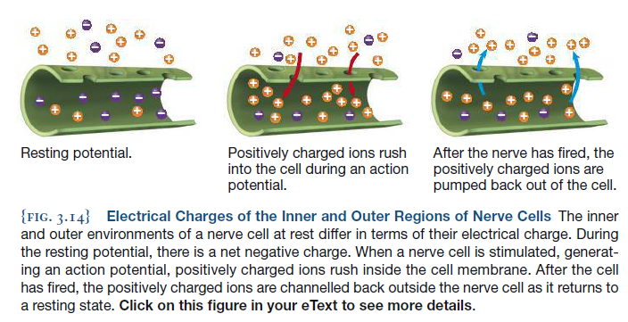
-ions have a tendency to travel from high concentration to low concentration, if ion channels open up then +ve ions would rush into the cell (because outside is mostly postive/high concentration) if enough of these ions get through and reach the threshold (-55mv) then the neuron initiates an action potential
-action potential: a wave of electrical activity that originates at the base of the axon and rapidly travels down its
length when this occurs the charge changes from -70 mv to +35mv (does not occur all at once, moves down the axon until it reaches the axon terminal) - once it reaches the axon terminal it signals the release of transmitters into the synapses: small spaces that separate individual nerve cells .-
-The cell that releases these chemicals is known as the presynaptic cell (“before the synapse”) whereas the cell that receives this input is known as the postsynaptic cell (or “after the synapse”)
-As soon as this occurs the ion channels close and sodium ions are pumped out of the cell returning it to a resting state this can cause it to be hyperpolarized (more negative than its resting state making it less likely to fire) this lasts for about 2-3 seconds and is known as the refractory period: brief period in which a neuron cannot fire
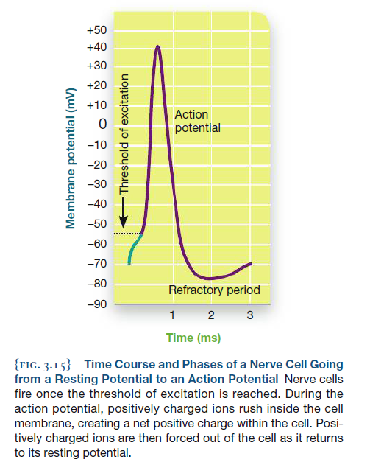

- Neuron always fires at the same intensity and speed all-or-none principle : Individual nerve cells fire at the same strength every time an action potential occurs.
- The strength of sensation is determined by the rate at which nerve cells fire, and number of neurons stimulated (A stimulus is experienced intensely because a greater number of cells are stimulated, and the firing of
each cell occurs repeatedly)
The Chemical Messengers: Neurotransmitters and Hormones
-once neurotransmitters reach the postsynaptic neuron the binding of the neurotransmitter can have 2 effects 1) excitatory: membranes potential becomes less negative therefore increases the chance for action potential to occur
2)Inhibitory: decreased likelihood that an action potential will occur (more negative)
- After neurotransmitter molecules have bound to postsynaptic receptors of a neighboring cell, they are
released back into the synaptic cleft , the minute space between the axon terminal (terminal button) and the dendrite (very important because it allows the neuron to be able to refire)
-after released into the synapse the neurotransmitter they can be broken down by enzymes or
go through reuptake , a process whereby neurotransmitter molecules that have been released
into the synapse are reabsorbed into the axon terminals of the presynaptic neuron

TYPES OF NEUROTRANSMITTERS
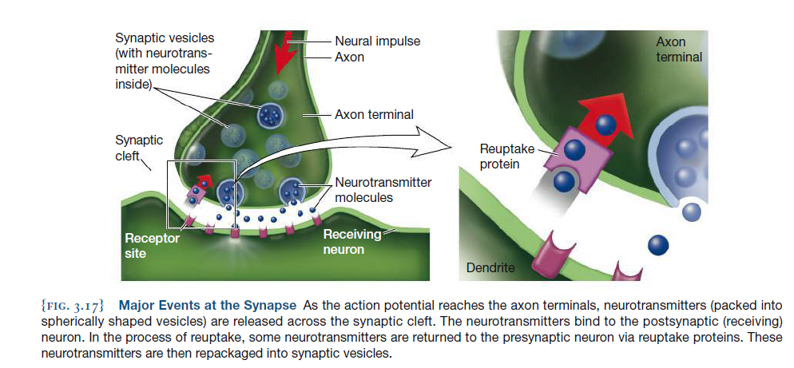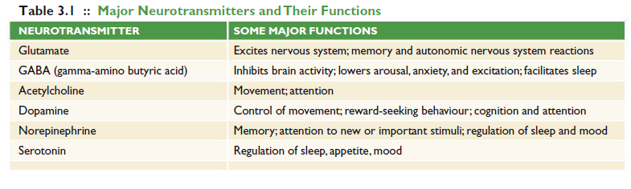
- The most common neurotransmitters are glutamate and GABA :
Glutamate is the most common excitatory neurotransmitter in the brains of vertebrates (involved in ability to form new memories abnormal functioning associated with triggering of seizures due to epilepsy)
-GABA ( gamma-amino butyric acid ): is the primary inhibitory neurotransmitter of the nervous system , meaning that it prevents neurons from generating action potentials
-When GABA binds to receptors, it causes an influx of negatively charged chloride ions to enter the cell, which is the opposite net effect of what
happens when a neuron is stimulated. As an inhibitor,GABA facilitates sleep
-Acetylcholine is one of the most widespread neurotransmitters within the body, found at the junctions between nerve cells and skeletal muscles; it is very important for voluntary movement- it binds to receptors on muscles changes the electrical properties leading to a contraction of that muscle
- Link between nervous system and muscles is known as neuromuscular junction
- Additionally acetylcholine activity in the brain is associated with attention and memory
- Where the neurotransmitter is released has an effect on what roles it will serve
- Dopamine: is a monoamine neurotransmitter involved in such varied functions as mood, control of voluntary movement, and processing of rewarding experiences.
(breadth of processes due to the fact it is released in 3 different pathways )
-Attention is also influenced by our overall alertness or arousal, a characteristic that is affected by the
neurotransmitter norepinephrine. Norepinephrine:(also known as noradrenaline ) is a monoamine synthesized from dopamine molecules that is involved in regulating
stress responses, including increasing arousal, attention, and heart rate- formed in the brain stem and is part of the flight or fight response with epinephrine produced by the adrenal glands in the kidneys
-serotonin: is a monoamine involved in regulating mood, sleep, aggression, and appetite -formed in the brain stem and projects through the brain and spinal cord
- Many antidepressants block the reuptake of serotonin to ensure it stays in the synapses for longer duration serotonin is also related to
Perception of pain
Pain and Substance P
-not simple many processes and neurotransmitters responsible with response to painful stimuli (serotonin,norepinephrine, and dopamine have all been implicatedin some part of the pain response)
-Substance P: a neurotransmitter involved in the experience of pain .- found packed in middle of brain in a structure called periaqueductal grey recieves pain and temperature related input from spinal cord and sends it to different areas of the cerebral cortex then to the rest of the body-also found
in the amygdala (which responds to fear and arousal) and the hypothalamus(which is related to fight-or-flight responses and the release
of different hormones). Pain is both a sensation and emotional response
-Fred Lembeck and others noted that Substance P was found in the dorsal root of the spinal cord, an area that transmits pain information back to the brain
-when tissue on the skin surface is damaged,sensory nerves carry messages to the spinal cord and then up to the brain. In turn, these CNS structures release Substance P, giving rise to the perception of pain.
-pain is important because it tells you to stop doing something that is harmful for your body
-congenital insensitivity to pain: a condition where people lack the ability to perceive pain research has shown that these people lack substance P receptors in the peripheral nerves
- Emotion and pain: social “pain” resulting from being rejected activates similar brain areas as physical pain
- This is important because problems with pain translate into reduced work productivity, increased health care costs, and, for some people, an increased risk of developing
dependence on or addiction to prescription painkillers so understanding can improve lives of chronic pain sufferers
DRUG EFFECTS ON NEUROTRANSMISSION
Agonists are drugs that enhance or mimic the effects of a neurotransmitter’s actions (ex. Nicotine ,
(Xanax) is a GABA agonist—it causes relaxation by increasing the activity of this inhibitory neurotransmitter)
- Can behave directly or indirectly 1)direct agonist physically binds to that neurotransmitter’s receptors at the postsynaptic cells (e.g., nicotine
molecules attach themselves to receptors that acetylcholine molecules would normally stimulate).2) A drug that
acts as an indirect agonist facilitates the effects of a neurotransmitter, but does not physically bind to the same part of the receptor as the neurotransmitter. For example,
a drug that blocks the process of reuptake would be an indirect agonist A drug that attaches to another binding site on a receptor but does not interfere with the neurotransmitter’s binding would also be an indirect agonist
-antagonists inhibit neurotransmitter activity by blocking receptors or preventing synthesis of a neurotransmitter (ex. Botox blocks acetycholine by attaching to receptor sites paralyzing the muscles and preventing wrinkles considered a direct antagonist because it binds to the receptors)
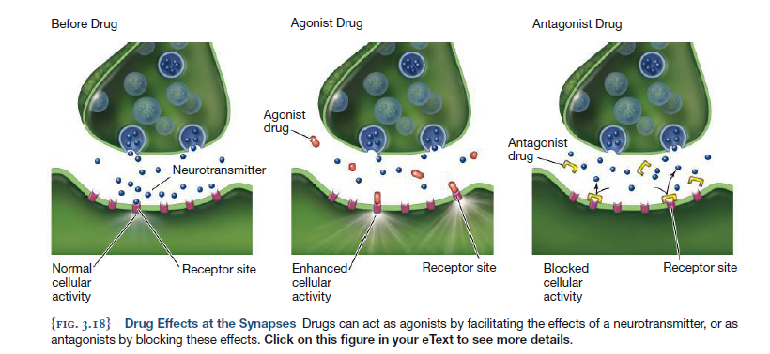
HORMONES AND THE ENDOCRINE SYSTEM
- Hormones are chemicals secreted by the glands of the endocrine system
- Generally, neurotransmitters work almost immediately within the microscopic space of the synapse, whereas hormones are secreted into the bloodstream
and travel throughout the body. Thus, the effects of hormones are much slower than those of neurotransmitters.
- Nervous system and endocrine system contributes to homeostasis: the balance of energy, metabolism, body temperature, and other basic functions
that keeps the body working properly
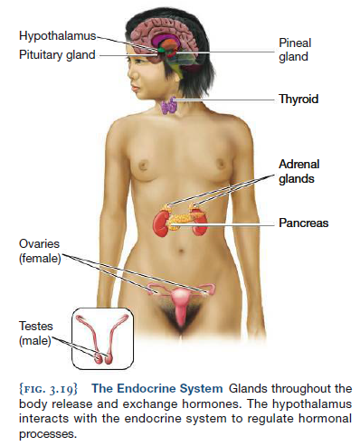

Hypothalamus: , a brain structure that regulates basic biological needs and motivational systems
The hypothalamus releases specialized chemicals called releasing factors that stimulate the pituitary gland — the master gland of the endocrine system that produces
hormones and sends commands about hormone production to the other glands of the endocrine system
- stress is loosely defined as an imbalance between perceived demands and the perceived resources available to meet those demands
- Hypothalamus helps you physically prepare for stress by signaling to the pituitary gland to release a hormone into the bloodstream that stimulate the adrenal glands
- adrenal glands: a pair of endocrine glands located adjacent to the kidneys that release stress hormones, such as cortisol and
- Epinephrine Cortisol and epinephrine help mobilize the body during stress, thus providing enough energy for you to deal with the sudden increase in activity necessary to
respond to the stress-inducing situation
- Endorphin: , a hormone produced by the pituitary gland and the hypothalamus that functions to reduce pain and induce feelings of pleasure (usually released during strenuous exercise, sex or injury) They act on portions of the brain that are attuned to reward, reinforcement, and pleasure, inhibiting the
perception of pain and increasing feelings of euphoria
- Testosterone is a hormone that serves multiple functions ,including driving physical and sexual development over the long term, and surging during sexual activity and
in response to threats
3.3|Structure and Organization of the Nervous System
THE CENTRAL NERVOUS SYSTEM
- consists of the brain and the spinal cord
THE PERIPHERAL NERVOUS SYSTEM
-a division of the nervous system that transmits signals between the brain and the rest of the body and is divided into two subcomponents, the somatic system and the autonomic system
- somatic nervous system: consists of nerves that control skeletal muscles, which are responsible for voluntary and reflexive movement; it also consists of nerves that receive
sensory input from the body
- autonomic nervous system , the portion of the peripheral nervous system responsible for regulating the activity of organs and glands -includes 2 subcomponents 1)
sympathetic nervous system is responsible for the fight-or-flight response of an increased heart rate, dilated pupils, and decreased salivary flow—responses
that prepare the body for action 2)parasympathetic nervous system helps maintain homeostatic balance in the presence of change; following sympathetic arousal, it works to return the body to a baseline, nonemergency state .
- 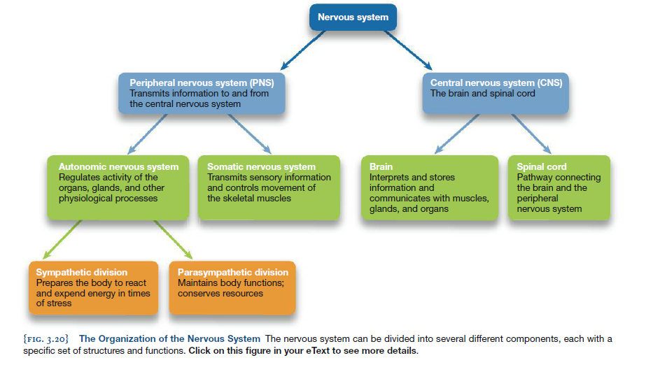

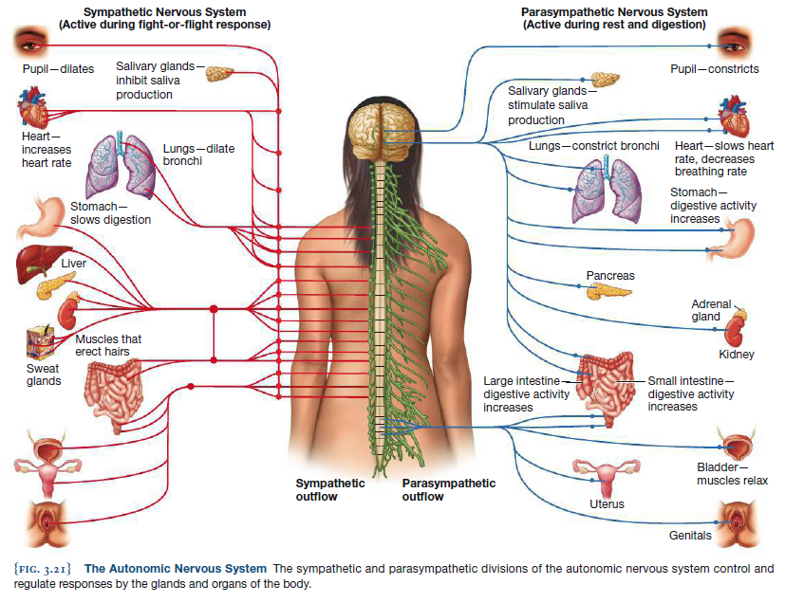
The Brain and Its Structures
-brain appears to be divided into two halves known as cerebral hemispheres within each it can be divided into 3: 1) hindbrain 2) midbrain 3) forebrain
-note that these are integrated so still have influence on each other
THE HINDBRAIN: SUSTAINING THE BODY
- brain stem , which is the “stem” or bottom of the brain and consists of two structures: the medulla and the pons
Nerve cells in the medulla connect with the body to perform basic functions such as regulating breathing, heart rate, sneezing,
salivating, and even vomiting Pons is in charge of wakefulness and dreaming pons is also part of a number of networks including
those that control balance, eye movements, and swallowing
- the reticular formation extends from the medulla upwards to the midbrain. The
reticular formation influences attention and alertness. When you wake up in the morning, you can thank (in part) your reticular formation. This structure also communicates with cells in the spinal cord involved with movements related to walking and posture.
- The cerebellum (Latin for “little brain”) is the lobe-like structure at the base of the brain that is involved in the monitoring of movement, maintaining
balance, attention, and emotional responses- recent research shows that it may have functions beyond movement (attention and emotional control, impulsivity known as symptoms for cognitive affective behavioural syndrome) probably due to its connections to the hypothalamus

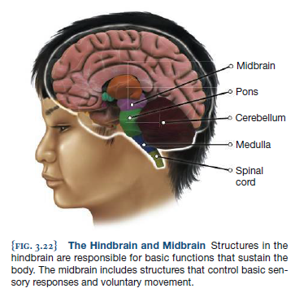

THE MIDBRAIN: SENSATION AND ACTION
- Midbrain: which resides just above the hindbrain, primarily functions as a relay station between sensory and motor areas
- Capture your visual attention is influenced by the superior colliculus (plural colliculi ).
- This ability to move your auditory attention is influenced by another midbrain structure,the inferior colliculus (plural colliculi)
- Note again that these do not act as independent units but are part of larger networks ex. the substantia nigra. This midbrain area has connections
to structures in the forebrain ); this network of dopamine-releasing cells is involved with the control of movements. Parkinson’s disease—a condition
marked by major impairments in voluntary movement—is caused by a loss of the dopamine- producing cells in
this network.
THE FOREBRAIN: EMOTION, MEMORY, AND THOUGHT
- forebrain , the most visibly obvious region of the brain, consists of all of the neural structures that are located above the midbrain, including all of the folds and
grooves on the outer surface of the brain; the multiple interconnected structures in the forebrain are critical to such complex processes as emotion, memory, thinking, and reasoning.
- The forebrain also contains spaces called ventricles . Although the ventricles appear hollow, they are filled with cerebrospinal fluid, a solution that
helps to eliminate wastes and provides nutrition and hormones to the brain and spinal cord. Cerebrospinal fluid also cushions the brain from impact against the skull.
Sitting next to the ventricles are the basal ganglia , a group of three structures that are involved in facilitating planned movements, skill learning, and integrating sensory and movement information with the brain’s reward system-The basal ganglia form networks that promote and inhibit movements
- Damage can lead to parkingsons disease and Huntington's disease The basal ganglia are also affected in people who have Tourette’s syndrome—a condition marked by erratic and repetitive facial and muscle movements
(called tics ), heavy eye blinking, and frequent noise making such as grunting, snorting, or sniffing. The excess dopamine that appears to be transmitted within the
basal ganglia contributes to many of the classic Tourette’s symptoms
- Some parts are involved in emotions of pleasure and reward (tasty foods or monetary) forms a network with nearby structure called the nucleus accumbens which accompanies many pleasurable experiences
- 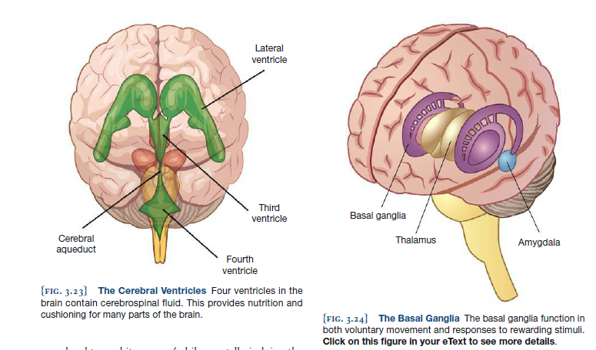
- Another major set of forebrain structures comprises the limbic system: an integrated network involved in emotion and memory
- One key structure in the limbic system is the amygdala , which facilitates memory formation for emotional events, mediates fear
responses, and appears to play a role in recognizing and interpreting emotional stimuli, including facial expressions.
- The hippocampus is critical for learning and memory, particularly the formation of new memories
- The hypothalamus serves as a sort of thermostat, maintaining the appropriate body temperature, and it regulates drives such as aggression
and sex by interacting with the endocrine system. In fact, regions of the hypothalamus trigger orgasm for both females and males
- Thalamus: a set of nuclei involved in relaying sensory information to different regions of the brain
- 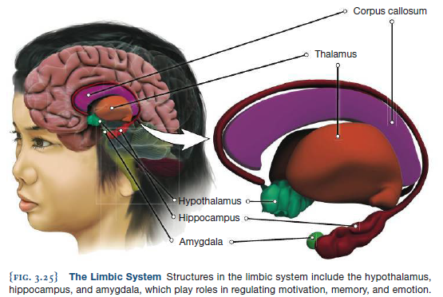
THE CEREBRAL CORTEX
- cerebral cortex is the convoluted, wrinkled outer layer of the brain that is involved in multiple higher functions, such as thought, language,
and personality.
- Because the skull can only be so large, the brain has countered this constraint by forming a wrinkled
surface—thereby increasing the surface area of the cortex. More surface area means more neurons and, likely,
greater cognitive complexity.
- The cerebral cortex consists primarily of the cell bodies and dendrites of neurons; these parts of the neuron give the outer part of the brain a grey-brown colour.
- The axons of these neurons extend throughout the brain and allow communication between different neural regions to occur. Most of these axons are wrapped in
a white, fatty substance called myelin which helps speed up the transmission of neural impulses.
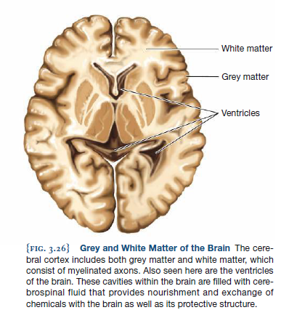
THE FOUR LOBES
- The occipital lobes are located at the rear of the brain and are where visual information is processed:
- parietal lobes are involved in our experiences of touch as well our bodily awareness:
At the anterior (front) edge of the parietal lobe is the somatosensory cortex —a band of densely packed nerve cells that
register touch sensations (dependent on sensory receptors present at each body part) Regions within the parietal lobes also function in
performing mathematical, visuospatial, and attention tasks. So when damage can lead to neglect (damage on right side leading to ignoring left half of visual field)
- temporal lobes are located at the sides of the brain near the ears and are involved in hearing language and some higher-level aspects of vision such as object and face recognition Different sections of the temporal cortex perform different roles. The anterior (front) part of this region is involved with memory for semantic knowledge-
The superior (top) part of the temporal cortex is known as the auditory cortex—it is essential for our ability to hear. Damage to this region
leads to problems with hearing despite the fact that the patient’s ears work perfectly; this condition is known as cortical deafness--
Slightly behind this region, near the back of the temporal lobe, is Wernicke’s area, which is related to understanding language (Wernicke,
1874). The close proximity of the hearing and language comprehension areas makes sense, as these two functions are closely related
- frontal lobes are important in numerous higher cognitive functions, such as planning, regulating impulses and emotion, language production, and voluntary movement: Toward the rear of the frontal lobes is a thick band of neurons that form the primary motor cortex , which is involved in the control of voluntary movement. Like the somatosensory cortex discussed above, the primary motor cortex is organized in a homunculus, with different
body areas requiring different amounts of space -The front two-thirds of the frontal lobes are known as the prefrontal cortex. This
region, which itself can be divided into a number of subsections, performs many of our higher-order cognitive functions such as decision making and controlling our attention
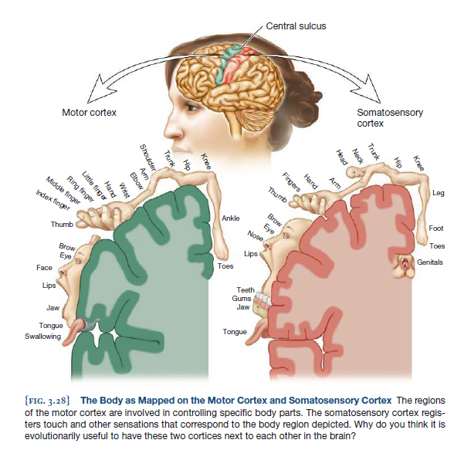

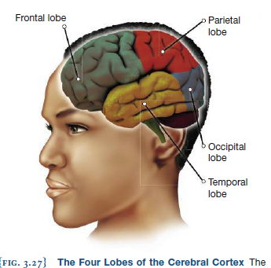

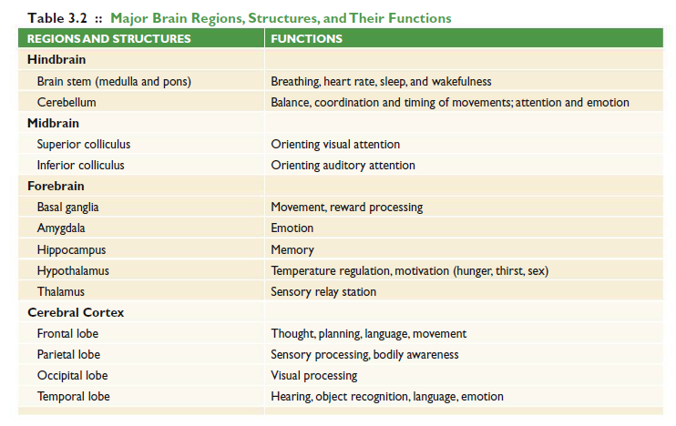
Psych@theGym
-Brain imaging studies have revealed that people who engage in regular exercise show improved functioning of the prefrontal cortex
compared to non-exercisers. In addition, people who exercise perform better than non-exercisers on tasks involving planning, scheduling, and multitasking

-4 lobes of the brain are found in both hemispheres, so communication between the 2 are very important crossing the midline of
the brain is a densely concentrated bundle of nerve cells called the corpus callosum , a collection of neural fibers connecting the two hemispheres. This thick band of fibers allows the right and left hemispheres to communicate with each other.
LEFT BRAIN, RIGHT BRAIN: HEMISPHERIC SPECIALIZATION
-the right hemisphere is specialized for cognitive tasks that involve visual and spatial skills, recognition of visual
stimuli, and musical processing. In contrast, the left hemisphere is more specialized for language and math
-understanding expanded with study of split brain patients (people whose corpus callosum was severed) - they responded differently to visual stimuli on right can match and verbalize it because the left side of the brain was receiving the info. When shown problem on left side where the right side of the brain processes it she could match but not verbalize it
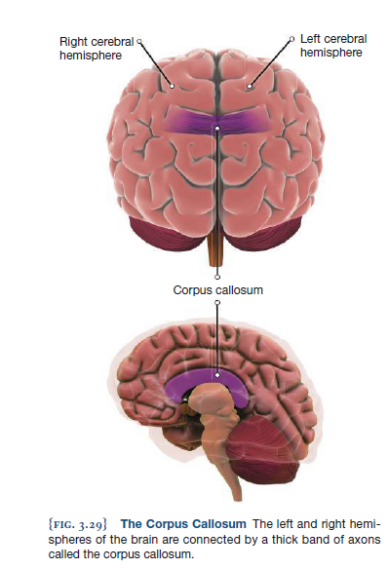
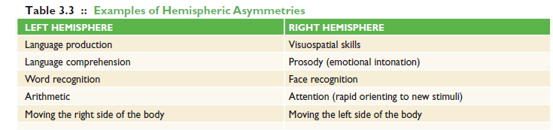

THE CHANGING BRAIN: NEUROPLASTICITY
-neuroplasticity — the capacity of the brain to change and rewire itself based on individual experience .
-Humans can do this to a limited degree in the peripheral nervous system as well. This is because chemicals called trophic factors (growth factors)
can stimulate the growth of new dendrites and axons. However ,the ability of the human brain to recover from damage is more limited. New neurons can form in adulthood, but only in a few regions such as part of the hippocampus
- We also have chemicals that inhibit growth of new axons near injured area because faulty connections may cause worse problems
- Melodic Intonation Therapy ). Researchers have found that some patients with damage to Broca’s area—a part of the left frontal lobe involved with the production of
speech—can actually sing using fluent, articulated words, even though they cannot speak those same words (used for stroke patients)
3.4|Windows to the Brain: Measuring and Observing Brain Activity
LESIONING AND BRAIN STIMULATION
-In order to gain more experimental control (and a much larger number of subjects), scientists often create brain damage in animals. This process is known as lesioning
, a technique in which researchers intentionally damage an area in the brain (a lesion is abnormal or damaged brain tissue). Creating lesions allows the researcher to isolate
single brain structures. He or she can then study animals with and without lesions to see how specific behaviours are changed by the removal of that brain tissue. The contro subjects are often part of a sham group, a set of animals that go through all of the surgical procedures aside from the lesion itself in order to control for the eff ects of stress,
anesthesia, and the annoyance of stitches.
- Some techniques can impair brain sections temporarily ex. transcranial magnetic stimulation (TMS) , a procedure in which an electromagnetic pulse is delivered to a targeted region of the brain (can also be used to stimulate)
- This procedure has the advantage that healthy human volunteers can be studied (as opposed to animals or brain-damaged people, many of whom are elderly).
Structural and Functional Neuroimaging
-Being able to examine the brains of living people and to measure neural activity while participants perform different tasks provides an astonishing window
into the mind.
STRUCTURAL NEUROIMAGING
- structural neuroimaging , a type of brain scanning that produces images of the different structures of the
brain. This type of neuroimaging is used to measure the size of different brain areas and to determine whether
any brain injury has occurred
3 types
- Computerized tomography (or CT scan ) is a structural neuroimaging technique in which x-rays are
sent through the brain by a tube that rotates around the head : A computer then calculates these differences
for each image that is taken as the tube moves around the head and combines that information into a three dimensional
image
- Magnetic resonance imaging (or MRI ) is a structural imaging technique in which clear images of the brain are created based on
how different neural regions absorb and release energy while in a magnetic field
- Diffusion tensor imaging (or DTI ) is a form of structural neuroimaging allowing researchers or medical
personnel to measure white-matter pathways in the brain
FUNCTIONAL NEUROIMAGING
-functional neuroimaging :, a type of brain scanning that provides information about which areas of the brain are active
when a person performs a particular behaviour
-A common tradeoff is between temporal resolution (how brief a period of
time can be accurately measured) and spatial resolution (a clear picture of the brain)
-electroencephalogram (or EEG ), which measures patterns of brain activity with the use of multiple electrodes
attached to the scalp
-event related potentials (or ERPs). ERPs use the same sensors as EEGs; however, a computer takes note of exactly when
a given stimulus (e.g., a smiling face) was presented to the participant. Useful for measuring when it takes place but not where
-magnetoencephalography (or MEG ), a neuroimaging technique that measures the tiny magnetic fields created by the electrical
activity of nerve cells in the brain.
-positron emission tomography ( or PET ), a type of scan in which a low level of a radioactive isotope is injected into the blood, and its movement to regions of
the brain engaged in a particular task is measured
-The greatest strength of PET scans is that they show metabolic activity of the brain. PET also allows researchers
to measure the involvement of specifi c types of receptors (e.g., types of dopamine receptors) in diff erent brain regions while people perform an experimental task
-A drawback is that PET scans take a long time to acquire—at least two minutes and can be used only on men (because radioactivity+ possible pregnancy of women)
-Functional magnetic resonance imaging (or fMRI )measures brain activity by detecting the influx of oxygen-rich blood into neural areas that were just active
-happy vs fearful faces : seeing faces would activate a region in the bottom of the right hemisphere known as the fusiform gyrus
-Faces expressing fear would activate the amygdala , and faces expressing happiness activate a wide network of structures in the frontal lobes
-provides good detail of where brain activity is occurring but only tracks in seconds not milliseconds like ERP and MEG
-note that this data is correlational in nature --just because a brain area is active while we perform a task
does not mean that it is necessary for that task.
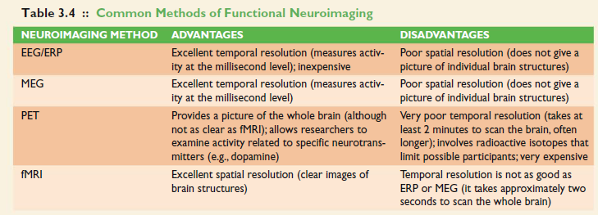

Chapter 4- Sensation and Perception
Sunday, January 25, 2015
12:41 AM
Sensing the World Around Us
-sensation , the process of detecting external events by sense organs and turning those stimuli into neural signals .
Perception involves attending to, organizing, and interpreting stimuli that we sense
- The raw sensations detected by the sensory organs are turned into information that the brain can process through transduction , when specialized receptors transform the physical energy of the outside world into neural impulses. - transduction of light is when it reaches receptors at the back of the eye, chemicals in the retina convert energy into nerve impulses that travel to numerous centers where color and motion are perceived
-transduction of sound takes place in the cochlea, where sound energy is converted into neural impulses that travel to the hearing centres of the brain
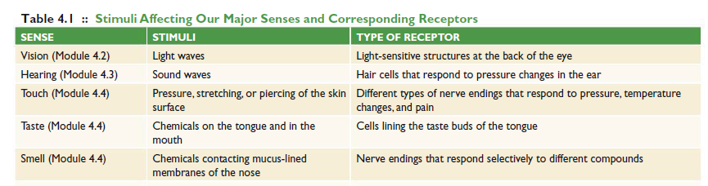

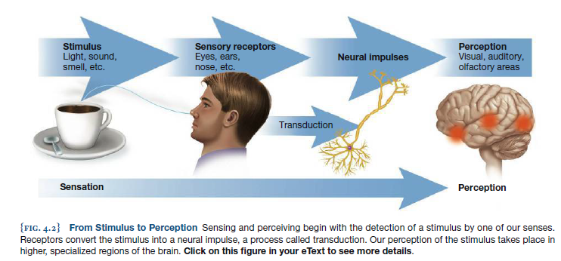
- the different senses are separated in the brain, was first proposed in 1826 by the German physiologist Johannes Müller and is known as the doctrine of specific nerve energies .
- The orienting response describes how we quickly shift our attention to stimuli that signal a change in our sensory world
- sensory adaptation , the reduction of activity in sensory receptors with repeated exposure to a stimulus . Sensory adaptation provides the benefit of allowing us to adjust to our surroundings and shift our focus to other events that may be important.
STIMULUS THRESHOLDS
- William Gustav Fechner (1801–1887), coined the term psychophysics : the field of study that explores how physical energy such as light and sound and their intensity relate to psychological experience
- absolute threshold —that is,the minimum amount of energy or quantity of a stimulus required for it to be reliably detected at least 50% of the time it is presented
- difference threshold is the smallest difference between stimuli that can be reliably detected at least 50% of the time .
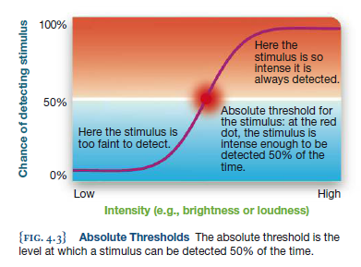
SIGNAL DETECTION
-Signal detection theory states that whether a stimulus is perceived depends on both sensory experience and judgment made by the subject
Perceiving the World Around Us
GESTALT PRINCIPLES OF PERCEPTION
- Gestalt psychology is an approach to perception that emphasizes that “the whole is greater than the sum of its parts.” In other words, the individual parts of an image may have little meaning on their own, but when combined together, the whole takes on a significant perceived form
Principles
- Figure Ground principle: objects or “figures” in our environment tend to stand out against a background.
- Proximity: We tend to treat two or more objects that are in close proximity to each other as a group. Because of their proximity
- Similarity: We tend to group together individuals wearing the same uniform based on their visual similarity
- Continuity: refers to the perceptual rule that lines and other objects tend to be continuous, rather than abruptly changing direction. The black object snaking its way around the white object is viewed as one continuous object rather than two separate ones.
- Closure: A related principle, called closure , refers to the tendency to fill in gaps to complete a whole object
-they demonstrate an incredibly important characteristic of the perceptual system: we create our
own organized perceptions out of the different sensory inputs that we experience
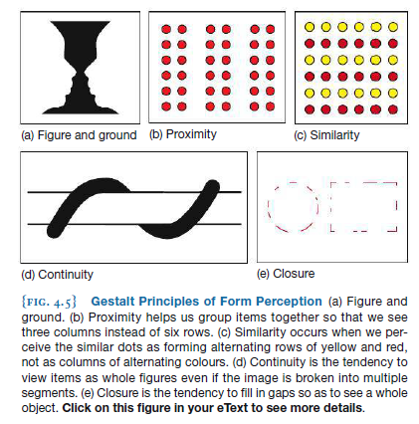

- top-down processing: ,when our perceptions are influenced by our expectations or by our prior knowledge.
- Bottom-up processing: occurs when we perceive individual bits of sensory information (e.g., sounds) and use them to construct a more complex perception (e.g., a message
- perceptual set —a filter that influences what aspects of a scene we perceive or pay attention to. But, focusing on particular patterns of stimuli also means that we are not focusing on other patterns; in some cases, we ignore pieces of information that don’t fit with our expectations
ATTENTION AND PERCEPTION
- divided attention: paying attention to more than one stimulus or task at the same time.
- selective attention: involves focusing on one particular event or task , such as focused studying, driving without distraction, or attentively listening to music or watching a movie.
- inattentional blindness: a failure to notice clearly visible events or objects because attention is directed elsewhere
4.2|The Visual System
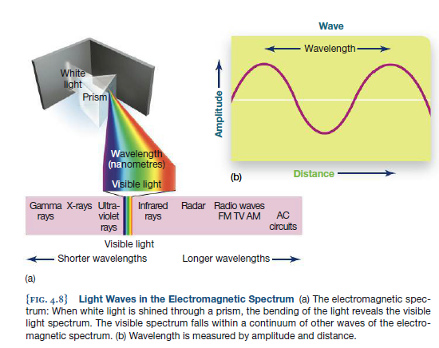
The Human Eye
- “light”actually refers to radiation that occupies a relatively narrow band of the electromagnetic spectrum
- The term wavelength refers to the distance between peaks of a wave—differences in wavelength correspond to different colours on the electromagnetic spectrum (red refers to long wavelengths while blue refers to short wavelengths)
- Amplitude refers to the height of a wave low amplitude are seen as dim colors while high amplitude are seen as bright colors
- 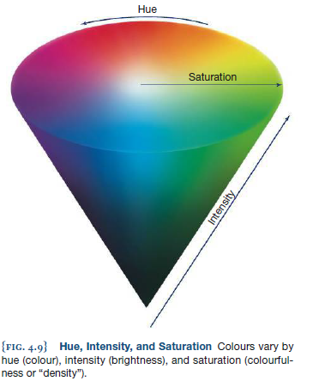
- hue(colour of the spectrum), intensity (brightness), and saturation(colourfulness or density)

THE STRUCTURE OF THE EYE
- The sclera is the white, outer surface of the eye and the cornea is the clear layer
that covers the front portion of the eye and also contributes to the eye’s ability to focus . Light enters the eye through the cornea and passes through an opening called the pupil
The pupil regulates the amount of light that enters by changing its size; it dilates (expands) to allow more light to enter and constricts (shrinks) to allow less light into the eye . The changes
in the pupil’s size are performed by the iris , a round muscle that adjusts the size of the pupil; it also gives the eyes their characteristic colour . Behind the pupil is the lens , a clear structure that focuses light onto the back of the eye . The lens can change its shape to ensure that the light entering the eye is refracted in such a way that it is focused when it reaches the back of the eye. This process is known as accommodation. When the light reaches the back of the eye, it will stimulate a layer of specialized receptors that convert light
into a message that the brain can then interpret, a process known as transduction . These receptors are part of a complex structure known as the retina
- The retina lines the inner surface of the eye and consists of specialized receptors that absorb light and send signals related to the properties of light to the brain . The retina contains
a number of different layers, each performing a slightly different function. At the back of the retina are specialized receptors called photoreceptors
- Information from the photoreceptors at the back of the retina is transmitted to the ganglion cells closer to the front of the eye. The ganglion cells gather up information from the photoreceptors; this information will then alter the rate at which the ganglion cells fi re. The
activity of all of the ganglion cells is then sent out of the eye through a dense bundle of fibres that connect to the brain;this structure is called the optic nerve . This nerve presents a challenge to the brain. Because it travels through the back of the eye, it creates an area on the retina with no photoreceptors, called the optic disc . The result is a blind spot— a space in the retina that lacks photoreceptors. -brain automatically fills this blank spot in
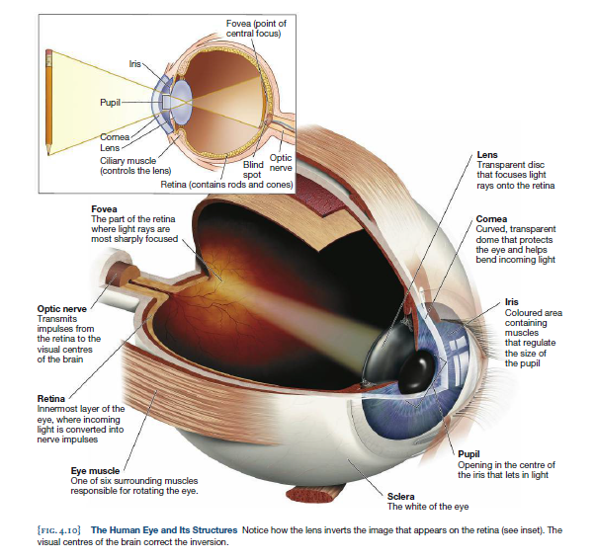

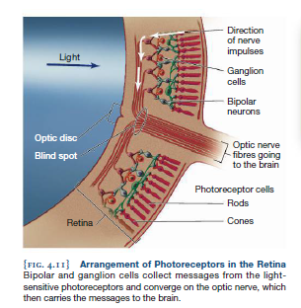
The Retina: From Light to Nerve Impulse
Two types of photoreceptors
- Rods: are photoreceptors that occupy peripheral regions of the retina; they are highly sensitive under low light levels
- Cones: are photoreceptors that are sensitive to the different wavelengths of light that we perceive as colour . Tends to be clustered around the fovea(the central region of the retina)
- The final layer that receives input of light consists of ganglion cells which outputs to the optic nerve ratio of ganglia cells to cones is 1:1 but for rods to ganglia cells its 10:1 (causing competition between rods) also it is limited to the periphery of the retina
Dark adaptation: is the process by which the rods and cones become increasingly sensitive to light under low levels of illumination
The Retina and the Perception of Color
- trichromatic theory (or Young-Helmholtz theory ): maintains that colour vision is determined by three different cone types that are sensitive to short, medium, and long wavelengths of light --this theory explains activity in terms of cones
- Ewald Hering proposed the opponent-process theory of colour perception:, which
states that we perceive colour in terms of opposing pairs: red to green, yellow to blue, and white to black. This type of perception is consistent with the activity patterns of retinal ganglion cells. (each of these cells inhibit each other cell simulated by red is inhibited by green)-- this theory explains what happens when ganglion cells process signals from
a number of different cones at the same time
COMMON VISUAL DISORDERS
- Color blindness most common form is trouble distinguishing between red and green due to inadequate proteins
- Shape of the eye: Nearsightedness, or myopia, occurs when the eyeball is slightly elongated, causing the image that the cornea and lens focus on to fall short of the retina (if person does laser eye surgery the surgeon will attempt to flatten the cornea)
if the length of the eye is shorter than normal, the result is farsightedness or hyperopia. In this case, the image is focused behind the retina. Farsighted people can see distant objects clearly but not those that are close by. ( surgeon will try to make cornea steeper)
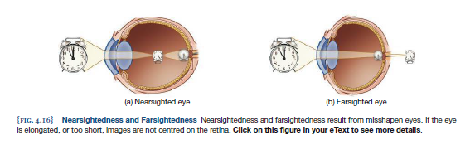

Visual Perception and the Brain
- Information from optic nerve first goes to the optic chiasm which is where the optic nerves cross at the midline of the brain- half travel to the same side of the brain (ipsilateral) and the other half travels to the opposite side (contralateral)
- The outside half of the retina (closest to your temples) sends its optic nerve projections ipsilaterally. In contrast, the inside half of the retina (closest to your nose) sends its optic nerve projections contralaterally
- Left half of the visual field brain processed by right hemisphere of the brain (and vice versa)
- Fibres from optic nerve connect to the thalamus which is made up of 20 different nuclei such as the lateral geniculate nucleus (LGN) is specialized for processing visual information. Fibres from this nucleus send messages to the visual cortex, located in the occipital lobe
- To make sense of incoming information there is a division of labor amongst specialized cells one set is called feature detection cells ; these cells respond selectively to simple
and specific aspects of a stimulus, such as angles and edges

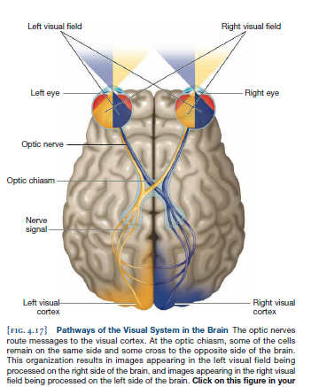

- There are 2 streams of vision 1)The ventral stream extends from the visual cortex to the lower part of the temporal lobe. 2)The dorsal stream extends from the visual cortex to the parietal lobe. Both streams are essential for our ability to function normally in our visual world
THE VENTRAL STREAM
- extends from the visual cortex in the occipital lobe to the anterior (front) portions of the temporal lobe. This division of our visual system performs a critical function: object recognition.
- perceptual constancy , the ability to perceive objects as having constant shape, size, and
colour despite changes in perspective . What makes perceptual constancy possible is our ability to make relative judgments about shape, size, and lightness. For shape constancy ,
we judge the angle of the object relative to our position. Color constancy allows us to recognize an object’s colour under varying levels of illumination Size constancy is based on judgments of how close an object is relative to one’s position as well as to the positions of other objects (top down processing)
THE DORSAL STREAM
- The dorsal stream of vision extends from the visual cortex in our occipital lobe upwards to the parietal lobe.
- Ventral stream identifies where while the dorsal stream locates it in space
- Research at Western University studied a middle aged woman (D.F) who had a damaged temporal lobe interfering with the ventral stream so her ability to recognize objects was impaired but could put a letter in a mailbox (dorsal was preserved) shows that this pathway is involved in visually guided movement
DEPTH PERCEPTION
- Binocular depth cues are distance cues that are based on the differing perspectives of both eyes. One type of binocular depth cue, called convergence , occurs when the eye muscles contract so that both eyes focus on a single object . Convergence typically occurs for objects that are relatively close to you
- Retinal disparity (also called binocular disparity), the difference in relative position of an object as seen by both eyes, which provides information to the brain about depth .- brain relies on both eyes individually and also from both working in stereo
- Most primates,including humans, have stereoscopic vision , which results
from overlapping visual fields. The brain can use the difference between the information provided by the left and right eye to make a judgment about the distance of the objects being viewed
- Monocular cues are depth cues that we can perceive with only one eye:
one such cue, is called accommodation During accommodation, the lens of your eye curves to allow you to focus on nearby objects. Close one eye and focus on a nearby object, and then slightly change your focus to an object that is farther away; the lens changes shape again so the next object comes into focus
- Another monocular cue is motion parallax ; it is used when you or your surroundings are in motion.

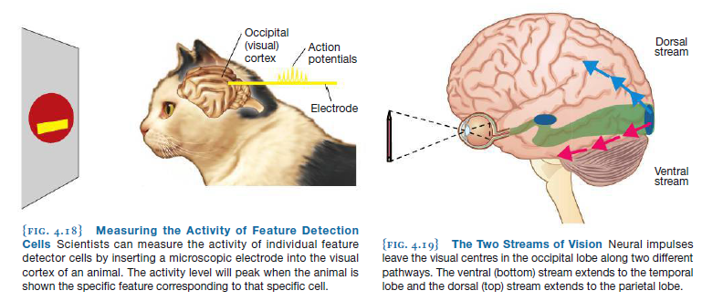
Face Perception
- Prosopagnosia: condition which prevents the recognition of faces
- fMRI, researchers have consistently detected activity in this region, now known as the fusiform face area (FFA) . This area appears to be specialized for recognizing upright faces the FFA responds more strongly to the entire face than to individual features

PSYCH @ THE ARTIST STUDIO
- 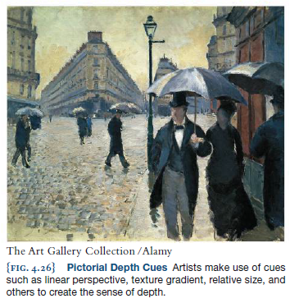
- Artists use depth cues to make 3d paintings by using pictorial depth cues
• Linear perspective : Parallel lines stretching to the horizon appear to move closer together as they travel farther away. This effect can be seen in the narrowing of the streets and the converging lines of the sidewalks and the top of the building in the distance. This effect is nicely demonstrated by the illusion in Figure 4.27 .
• Interposition : Nearby objects block our view of far-off objects, such as the umbrella blocking the view of buildings behind them.
• Light and shadow : The shadow cast by an object allows us to detect both the size of the object and the relative locations of objects. In addition, closer objects reflect more light than far-away objects.
• Texture gradient : Objects that are coarse and distinct at close range become fine and grainy at greater distances. In the painting, for example, the texture of the brick street varies from clear to blurred as distance increases.
• Height in plane : Objects that are higher in our visual field are perceived as farther away than objects low in our visual field. The base of the main building in the background of the painting is at about the same level as the man’s shoulder, but we interpret this effect as distance, not as height.
• Relative size : If two objects in an image are known to be of the same actual size, the larger of the two must be closer. This can be seen in the various sizes of the pedestrians.
4.3|The Auditory System
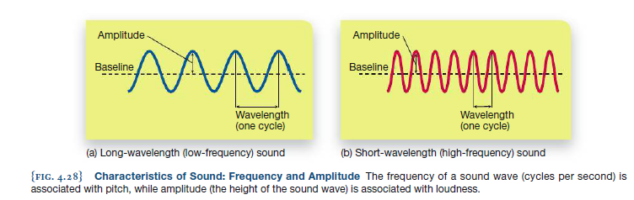
Sound and the Structures of the Ear
- the human ear, is to detect sound waves and to transform that information into neural signals. Sound waves are simply changes in mechanical pressure transmitted through solids, liquids, or gases. Sound waves have two important characteristics: frequency and amplitude
- Frequency refers to wavelength and is measured in hertz (Hz), the number of cycles a sound
wave travels per second
- Pitch is the perceptual experience of sound wave frequencies.
- High frequency sounds have short wavelengths and a high pitch while low frequency sounds have long wavelengths and a low pitch
- amplitude of a sound wave determines its loudness: High-amplitude sound waves are louder than low amplitude waves
- Loudness—a function of sound wave amplitude—is typically expressed in units called decibels (dB)
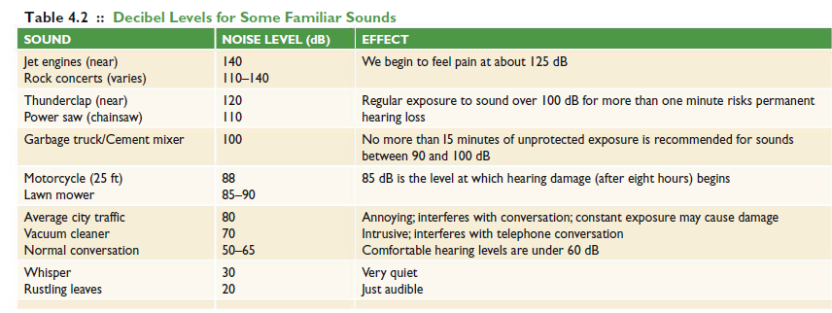

- 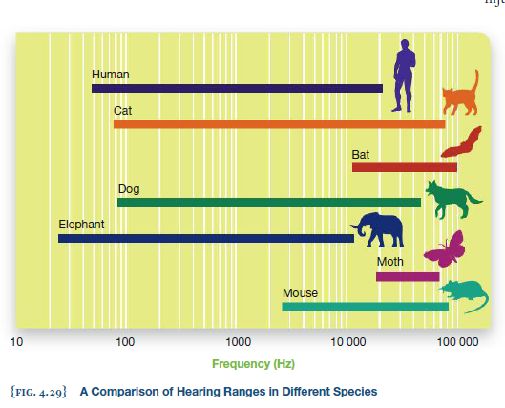
THE HUMAN EAR
- Divided into outer, middle, and inner regions
- The pinna , is the outer region that helps channel sound waves to the ear and allows you to
determine the source or location of a sound. The auditory canal extends from the pinna to the eardrum.
- Sound waves reaching the eardrum cause it to vibrate.
- The middle ear consists of three tiny moveable bones called ossicles , known individually as the malleus (hammer), incus (anvil), and stapes (stirrup). The eardrum is attached to these bones, so any movement of the eardrum due to sound vibrations results in movement of the ossicles.
- The ossicles attach to an inner ear structure called the cochlea — a fluid-filled membrane that is coiled in a snail-like shape and contains the structures that convert sound into neural impulses this is possible because of hair like structures that line the basilar membrane of the cochlea when it moves they stimulate the cells that comprise the auditory nerves
- The auditory nerves are composed of bundles of neurons that fi re as a result of hair cell movements. These auditory nerves send signals to the thalamus—the sensory relay station of the brain—and then to the auditory cortex, located within the temporal lobes
- 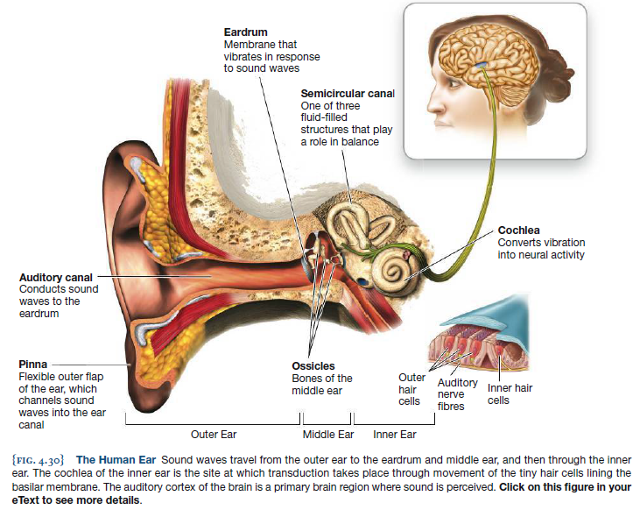
The Perception of Sound
SOUND LOCALIZATION: FINDING THE SOURCE
- sound localization , the process of identifying where sound comes from, is handled by parts of the brain stem as well as by a midbrain structure called the inferior colliculus
- 2 ways that we localize sound 1) slight time difference to determine direction (left ear may receive sound before right ear) 2) intensity by which it is heard by both ears Sound shadow
- The inferior colliculi (plural) detect differences in the times when sound reaches the left versus the right ear, as well as the intensity of the sound between one side and the other, allowing us to identify where it is coming from
THEORIES OF PITCH PERCEPTION
- How we perceive pitch is based on location (place) along the basilar membrane that sound stimulates, a tendency known as the place theory of hearing
- frequency theory , the perception of pitch is related to the frequency at which the basilar membrane vibrates
- volley principle . A single neuron cannot fi re more than 1000 times per second, but a group of neurons could certainly accomplish this feat. According to the volley principle, groups of neurons fire in alternating (hence the term “volley”) fashion. A sound measuring 5000 Hz can be perceived because groups of neurons fi re in rapid succession
- Place is most applicable to high pitches while frequency and volley theories better explains low pitches
- 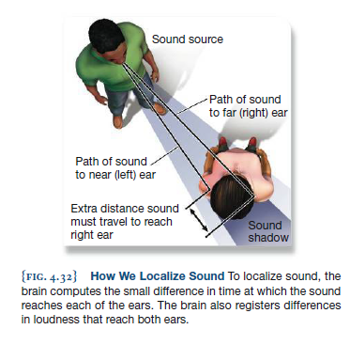
.
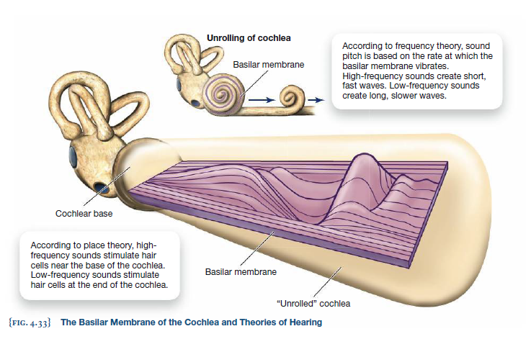

AUDITORY PERCEPTION AND THE BRAIN
- The primary auditory cortex is a major perceptual centre of the brain involved in perceiving what we hear
- the primary auditory cortex is surrounded by brain regions that provide additional sensory processing. This secondary auditory cortex helps us to interpret complex sounds, including those found in speech and music.
THE PERCEPTION OF MUSIC
- There is evidence from multiple types of research studies linking the perception of music to brain areas related to movement. Also it taps into experiences of emotions
Music, Emotion, and Advertising
-music is sometimes useful for remembering a product--
Music with meaningful lyrics had a more positive effect on memory for product information than instrumental music or nonsense lyrics
-Recent studies of the brain provide one possible explanation for the effectiveness of jingles.
Using EEG, researchers found that people learning verbal material that was sung (like a jingle) showed more coherent patterns of firing in the network of neurons in the frontal lobes than did people who heard the same material spoken normally. Thus, music provides structure, and structure aids memory.
4.4|Touch and the Chemical Senses
- synesthesia experience blended perceptions, such that affected individuals might actually hear colours or feel sounds
The Sense of Touch
Haptics is the active, exploratory aspect of touch sensation and perception
kinesthesis , the sense of bodily motion and position . Receptors for kinesthesis reside in the muscles, joints, and tendons. These receptors transmit information about movement and the position of your muscles, limbs, and joints to the brain
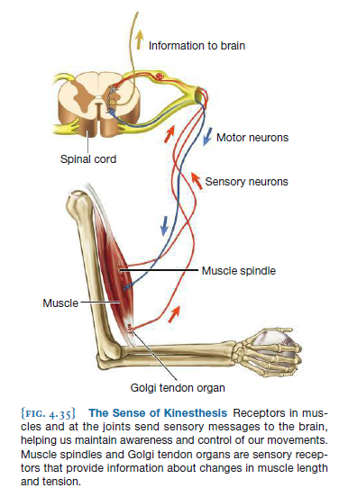
FEELING PAIN
- Nociception is the activity of nerve pathways that respond to uncomfortable stimulation .
- Two types of nerve fibres transmit pain messages. Fast fibres register sharp, immediate pain, such as the pain felt when your skin is scraped or cut. Slow fibres register chronic, dull pain, such as the lingering feelings of bumping your knee into the coffee table. Although
both slow and fast fibres eventually send input to the brain, these impulses first must travel to cells in the spinal cord; the fi ring of neurons within the spinal cord will influence how this pain is experienced.
- gate-control theory , which explains our experience of pain as an interaction between nerves that transmit pain messages and those that inhibit these messages
.-The spinal cord contains small nerve fi bres that conduct pain messages and larger nerve fibres that conduct other sensory signals such as those associated with rubbing, pinching,
and tickling sensations. Stimulation of the small pain fi bres results in the experience of pain, whereas the larger fibres inhibit pain signals
- Input from both large and small fibers are sent from spinal cord to the brain which branches off into two parts
1) the somatosensory cortex, registers the pain sensations occurring over the entire surface of the body.
2)the anterior cingulate gyrus, influences our attentional and emotional
responses to the pain; this brain region is found on the medial (middle) surface of the brain immediately above the corpus callosum.
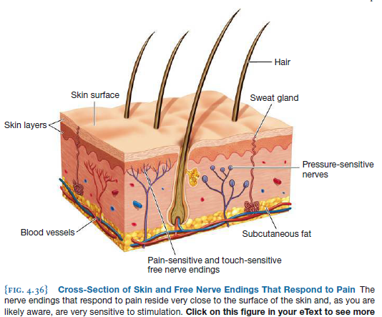

Empathy and Pain
- our own pain can be dramatically influenced by the pain of those around us
- If people can influence each other’s negative sensations, then it should be possible to influence each other’s positive sensations. Just as pain can be “contagious,” so too might happiness and well-being
PHANTOM LIMB PAIN
- Phantom limb sensations are frequently experienced by amputees,
who report pain and other sensations coming from the absent limb. Amputees describe such sensations as itching, muscle contractions, and, most unfortunately, pain.- this may be due to nerve cells in the cortex continuing to be active mirror box is one method of treatment (which may work due to reorganization of the somatosensory cortex)
The Chemical Senses:Taste and Smell
- THE GUSTATORY SYSTEM: TASTE The gustatory system functions in the sensation and perception of taste .
- The primary tastes include salty, sweet, bitter ,and sour. In addition, a fifth taste, called umami, has been identified Umami, sometimes referred to as “savouriness
- Taste is registered primarily on the tongue, where roughly 9000 taste buds reside. On average, approximately 1000 taste buds are also found throughout the sides and roof of the mouth
- Middle of tongue does not have very many taste receptors
- Taste receptors replenish themselves every 10 days
- Receptors for taste are located in the visible, small bumps ( papillae ) that are lined with taste buds and are distributed over the surface of the tongue.
- Sends a signal to the thalamus then to the gustatory cortex ; this region is located in the back of the frontal lobes and extends inward to the insula (near the top of the temporal lobe). Another region, the secondary gustatory cortex
THE OLFACTORY SYSTEM: SMELL
- The olfactory system is involved in smell—the detection of airborne particles with specialized receptors located in the nose . Our sensation of smell begins with nasal air flow bringing in molecules that bind with receptors at the top of the nasal cavity
- Within the nasal cavity is the olfactory epithelium , a thin layer of cells that are lined by sensory receptors called cilia —tiny hair-like projections that contain specialized proteins that bind with the airborne molecules that enter the nasal cavity
- These groups of cilia then transmit messages to neurons that converge on the olfactory bulb (on the bottom surface of the frontal lobes), which serves as the brain’s central region for processing smell. The olfactory bulb connects with several regions of the brain through the
olfactory tract, including the limbic system (emotion) as well as regions of the cortex where the subjective experience of pleasure (or disgust) occurs
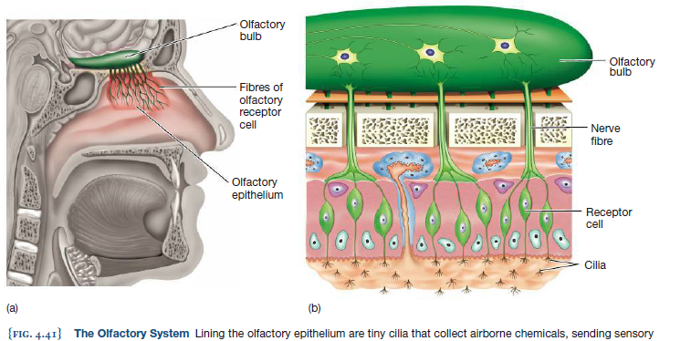
MULTIMODAL INTEGRATION
- 80% of our information about food comes from olfaction. This link between taste and smell is a perfect example of multimodal integration , the ability to combine sensation from different modalities such as vision and hearing into a single integrated perception
- McGurk Effect: movement of the speaker’s lips provided the viewer with the expectation
of a particular sound; this expectation biased the perception of the presented sounds
- The brains of people with synesthesia may contain networks that link different sensory areas in ways not found in other people

- 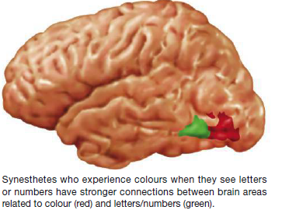

Chapter 5-Consciousness
Sunday, January 25, 2015
12:41 AM
REM behaviour disorder: people who act out their dreams
Consciousness: Persons subjective awareness including thoughts perceptions, experiences of the world, and self awareness
What is Sleep?
Biological rhythms
-circannual rhythm: yearly cycle which is a infradian rhythm which is any rhythm that occurs over a period of time longer than a day
-more frequent biological rhythms are referred to as ultradian rhythms
-Circadian rhythms: internally driven daily cycles of approximately 24 hours affecting physiological and behavioral processes includes tendency to be awake/asleep at different times
-Suprachiasmatic nucleus (SCN): part of the hypothalamus cells in the retina of the eye relay messages about light levels in the environment to the SCN which communicates to the pineal gland the pineal gland releases a hormone called melatonin which peaks in night time
- 2 explanations for our 24 hour rhythms 1) entrainment: biological rhythms become synchronized to external cues such as light temperature or even a clock
- Endogenous rhythms: biological rhythms that are generated by our body independent of external cues such as light
The Stages of Sleep
Polysomnography: A set of objective measurements used to examine physiological variables during sleep
-electroencephalogram : measures brainwaves using sensors attached to the scalp -- can be described by their frequency: number of up down cycles every second and their amplitude: the height and depth of the up down cycle
-beta waves high frequency low amplitude waves are characteristics of wakefulness as person shifts into sleep these waves tend to become slower larger and more predictable alpha waves
- EEG signals show 4 stages 1: brain waves slow down and become higher in amplitude (theta waves) breathing blood pressure and heart rate all decrease slightly after 10-15 minutes stage 2: brain waves continue to slow 'sleep spindles (clusters of high frequency but low amplitude waves) and K complexes (small groups of larger amplitude waves) as it progresses we respond to fewer external stimuli (like lights and sounds) 20 minutes later we enter stage 3 sleep brain waves continue to slow down and become delta waves (large looping waves with high amplitude and low frequency) which continues into stage 4 the deepest sections of sleep then it goes in reverse into stage 1 where it does not stay for ling instead it goes into REM sleep.
- REM sleep: stage of sleep characterized by quickening brain waves inhibited body movement and rapid eye movement it is also called paradoxical sleep because EEG waves appear to represent a state of wakefullness so distict that the other 4 stages are called NREM (non rem sleep)
- 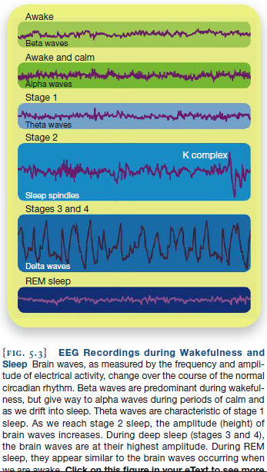
Why We need Sleep
Theories of sleep
Restore and Repair Hypothesis: The idea that the body needs to restore energy levels and repair any wear and tear experienced during the days activities
-lack of sleep can lead to cognitive decline, emotional disturbances and impaired functioning of the immune system
Preserve and Protect Hypothesis: Two more adaptive functions of sleep are preserving energy and protecting the organism from harm -- evolved to match sensory experience and their environment
Sleep Deprivation and Sleep displacement
Sleep deprivation: occurs when an individual cannot or does not sleep
-impairments from this include multitasking maintaining attention, assesing risks incorporating new information into a strategy, working memory inhibiting responses and keeping information in the correct temporal order
Sleep displacement: occurs when an individual is prevented from sleeping at the normal time although she may be able to sleep earlier or later in the day than usual
Jet Lag: Is the discomfort a person feels when sleep cycles are out of synchronization with light and darkness
Theories of Dreaming
Psychoanalytic Approach
- Sigmund Freud ' The interpretation of dreams' : he viewed dreams in terms of wish fulfillment he believed humans were motivated with primal urges with sex and aggression the most dominant and we find ways of suppressing these outside of our conscious awareness without this suppression the drives are free to create vivid imagery found in our dreams
- This vivid imagery can take 2 forms Manifest Content: Involves the images and storylines that we dream about. In many of our dreams the manifest content involves sexuality and aggression -- Freud believed that they had a hidden meaning
- Latent Content: the symbolic meaning of a dream built on suppressed sexual or aggressive urges because this is latent freud advocated for dream work the recording and interpreting of dreams
The Activation-Synthesis Hypothesis
-dreams arise from brain activity originating from bursts of excitatory messages from the pons, a part of the brain stem
- Burst of activity stimulates the occipital lobe and temporal lobes of the brain producing imaginary sights and sounds the brain stem initiates the activation component of the model, the synthesis component arises out of a different areas of the cortex to try and make sense of all the sounds images and memories-- researchers hypothesize that the frontal lobes area responsible with forming narratives play a role in the synthesizing process
- Implication is that the brain is able to work with and restructure information while we dream.
- Interestingly REM is not the only stage that affects our ability to learn some evidence that sleep spindles found in stage 2 are involved with learning new movements -- disrupting stage 2 sleep impaired performance on a pursuit- interrupting stage 2 had impact on rotor task in which participants try to move a computer mouse so that the curser follows an object on the screen while when asked to move as if object was in a mirror rem became essential suggests that the brain has different systems for processing simple and complex movements in different stages of sleep
Working the Scientific Literacy Model
- Activation synthesis model doesn’t provide the purpose of dreams
- Rosalind Cartwright proposed the problem solving theory: The theory that thoughts and concerns are continuous from waking to sleeping and that dreams might function to facilitate finding solutions to problems encountered while awake
- What do we know about REM sleep and learning? When deprived of REM sleep we experience REM rebound-- our brains spend increased amount of time in REM when given the chance
- REM affects some but not all types of memory: declarative memory ( study at trent with list of words and groups who had REM sleep NREM sleep or all sleep disrupted memory of words had no effect-- when given tests with more steps or procedures then deprivation of REM sleep reduced performance)
- Evidence that REM sleep may help us consolidate or maintain newly learned information, ability to problem solve - final few REM periods in the morning appear to be critical for learning
Disorders and Problems with sleep
Insomnia: a disorder characterized by an extreme lack of sleep ( to be considered a disorder it would have to occur for at least 3 months)
Onset Insomnia: when a person finds it difficult to fall asleep (30 minutes or more)
Maintenance insomnia: occurs when a person cannot easily return to sleep after waking in the night
Terminal insomnia or early morning insomnia: person wakes up too early and cannot return to sleep
Secondary insomnia: from depression, pain too much caffiene, drugs
Nightmares and Night Terrors
Nightmares: are particularly vivid and disturbing dreams that occur during REM sleep
- Correlated with psychological distress including anxiety, negative emotionality and emotional reactivity more common in females. Females also tend to have higher levels of depression and emotional disturbances
- Tore Nielson suggested that nightmares are due to problems with our brains emotion networks amygdala tend to be overactive in these individuals
- Night terrors: intense bouts of panic and arousal that awaken the individual typically in a heightened emotional state -- not dreams occur during NREM sleep increase in stressful periods
Movement Disturbances
During REM sleep the brain prevents movement by sending inhibitory signals down the spinal cord
Restless legs syndrome: persistent feeling of discomfort in the legs and the urge to continuously shift them into different positions
Somnambulism: sleepwalking a disorder that involves wandering and performing other activities while asleep occurs during NREM sleep
Sexomnia /sleep sex: engage in sexual activity such as touching of the self or others vocalizations and sex themed talk while in stages 3 4 of sleep
REM behavior disorder: act out the content of their dreams can be treated with benzodiazepines which inhibit the CNS (side effects to this drug so should only be given if person is threat to themselves or others)
Sleep APNEA
- Temporary inability to breath during sleep (twice as prevalent among men)
- Treatment involves dental devices that hold mouth in a specific position during sleep. Weight loss efforts should also accompany this treatment
- In severe cases CPAP (continuous positive airway pressure) device can be used to force air through the nose keeping the airway open through increased air pressure
- In rare cases it can be caused by the brains failure to regulate breathing which can happen for many reasons including damage to or deterioration of the medulla of the brain stem which is responsible for control of the chest muscles during breathing
- Can cause sleep deprivation from repeated waking up in the middle of the night --perform more poorly on tests requiring flexibility control of attention and memory
- Narcolepsy
- Extreme daytime sleepiness and sleep attacks , can go right to REM sleep
- Perhaps due to fewer brain cells producing hormone orexin resulting in greater difficulty in maintaining wakefullness
- Overcoming sleep problems
- For along time drugs prescribed for insomnia was barbiturates and Benzodiazepines but problems with their use were observed people developed tolerance so they needed higher doses and became dependent on the drugs (should only be used short term)
- 5.2| Altered States of Consciousness: Hypnosis, Meditation and Disorders of Consciousness
- Hypnosis: procedure of inducing a heightened state of suggestibility
- Most effective when they fall into 3 categories
- Ideomotor suggestions: related to specific actions that could be performed such as adopting a specific position
- Challenge suggestions: indicates actions that are not to be performed so that the subject appears to lose the ability to perform an action
- Cognitive perceptual suggestions involve a subject remembering or forgetting specific information or experiencing altered perceptions such as reduced pain sensations
Theories of Hypnosis
-based on an interaction between 1) automatic (unconscious) thoughts and behaviors and 2) a supervisory system referred to as executive processing
Dissociation theory: explains hypnosis as a unique state in which consciousness is divided into 2 parts an observer and a hidden observer
Social cognitive theory: explains hypnosis by emphasizing the degree to which beliefs and expectations contribute to increased suggestibility
Response expectancy-- whether the individual believes a treatment will work plays a large role in the actual pain relief experienced
Applications of Hypnosis
- Used in conjunction with other psychotherapies such as cognitive behavioral therapy (CBT) rather than as standalone treatment. Resulting cognitive hypnotherapy has been used as a treatment for depression anxiety eating disorders hot flashes of cancer survivors and irritable bowel syndrome
- Hypnosis works as well as drug treatments for acute pain which is intense temporary pain associated with medical or dental procedure effect on chronic pain is more complicated because some conditions are due to purely physical causes while others are psychological in nature
- Cannot recover lost memories through hypnosis
Meditation
-Meditation: any procedure that involves a shift in consciousness to a state in which an individual is highly focused, aware and in control of mental processes
- Focused attention mediation: when distracting or negative thoughts enter in ones thoughts and interfere with meditation people are taught to accept these thoughts in a nonjudgmental manner
- Open monitoring meditation: focused on moment by moment sensations
- Meditation cognition and emotion
- -enhances our ability to control what we pay attention to and to inhibit responses
- Mindfullness based stress reduction programs
- Disorders of consciousness
- 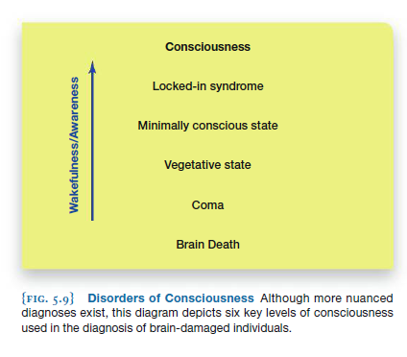
The lowest level of consciousness in a person who is still technically alive is known as brain death , a condition in which the brain, specifically including the brain stem, no longer functions Individuals who are brain dead have no hope of recovery because the brain stem regions responsible for maintaining basic life functions like breathing and maintaining the heartbeat do not function In contrast to brain death, a coma is a state marked by a complete loss of consciousness. It is generally due to damage to the brain stem or to widespread damage to both hemispheres of the brain persistent vegetative state , a state of minimal to no consciousness in which the patient’s eyes may be open, and the individual will develop sleep–wake cycles without clear signs of consciousness . For example, vegetative state patients do not appear to focus on objects in their visual fi eld, nor do they track movement. These patients generally do not have damage to the brain stem. If a patient emerges from this state within the first few months, he or she could regain some form of consciousness. In contrast, if symptoms do not improve after three months, the patient is classifi ed as being in a permanent vegetative state; the chances of recovery from that diagnosis decrease sharply minimally conscious state (MCS) , a disordered state of consciousness marked by the ability to show some behaviours that suggest at least partial consciousness, even if on an inconsistent basis. A minimally conscious patient must show some awareness of himself or his environment, and be able to reproduce this behaviour. Examples of some behaviours that are tested are following simple commands, making gestures or yes/no responses to questions, and producing movements or emotional reactions in response to some person or object in their environment locked-in syndrome , a disorder in which the patient is aware and awake but, because of an inability to move his or her body, appears unconscious
5.3| Drugs and conscious Experience
Short term Effects
The short-term effects of drugs can be caused by a number of different brain mechanisms including (1) altering the amount of the neurotransmitter being released into the synapse,
(2) preventing the reuptake (i.e., reabsorption back into the cell that released it) of the neurotransmitter once it has been released, thereby allowing it to have a longer influence on neurons,
(3) blocking the receptor that the neurotransmitter would normally bind to, or (4) binding to the receptor in place of the neurotransmitter. In all of these scenarios, the likelihood of the postsynaptic neurons fi ring is changed, resulting in changes to how we think, act,
and feel. Dopamine release in two brain areas, the nucleus accumbens and the ventral tegmental area , is likely related to the “high” associated with many drugs
Long term effects
tolerance , when repeated use of a drug results in a need for a higher dose to get the intended eff ect . physical dependence , the need to take a drug to ward off unpleasant physical withdrawal symptoms Psychological dependence occurs when addiction develops without any physical symptoms of withdrawal.
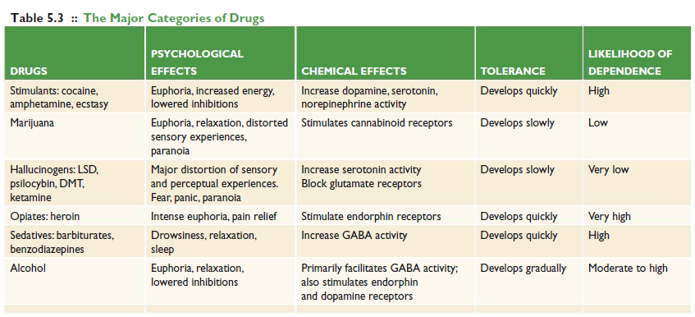
Commonly Abused Illegal Drugs
psychoactive drugs , substances that aff ect
thinking, behaviour, perception, and emotion
STIMULANTS Stimulants are a category of drugs that speed up the nervous system, typically enhancing wakefulness and alertness . There are a number of different types of stimulant drugs, ranging from naturally occurring substances such as leaves (cocaine) and beans (coffee) to
drugs produced in a laboratory (crystal meth ecstasy (3,4-methylenedioxy-
N -methylamphetamine or MDMA) , a drug that is typically classified as a stimulant, but also has hallucinogenic effects
HALLUCINOGENS
- Hallucinogenic drugs are substances that produce perceptual distortions . Depending on
the type of hallucinogen consumed, these distortions may be visual, auditory, and sometimes tactile in nature, such as the experience of crawling sensations against the skin.
- Hallucinogenic substances also occur in nature, such as psilocybin (a mushroom) and mescaline(derived from the peyote cactus). Hallucinogens can have very long-lasting eff ects—more than 12 hours for LSD, for example. These drugs may also elicit powerful emotional experiences that range from extreme euphoria to fear, panic, and paranoia.
- The effects of two of these hallucinogens, ketamine and DMT (dimethyltryptamine),last for about an hour. Ketamine (street names include “Special K” and “Vitamin K”) was originally developed as a surgical anesthetic to be used in cases where a gaseous anesthetic could not be applied, such as on the battlefi eld
MARIJUANA
- Thus far, we have discussed drugs that stimulate the central nervous system and drugs
that lead to altered states of consciousness. However, not all drugs neatly fi t into these distinct categories. For instance, marijuana is a drug comprising the leaves and buds of the Cannabis plant that produces a combinationof hallucinogenic, stimulant, and relaxing (narcotic)effects

