Intro to Silicon wafers and transistors
Moore’s Law – Silicon density doubles every 18 months
1971 – 2k transistors – 0.1 MHz
2014 – 4.3B transistors – 3600MHz
Size of transistor: 25 nm

Op-Amp
Uses: +,-, integration, differentiation
Applications: amplifiers, buffers, oscillators, filters
A: Open-loop Gain, ideal A=∞, real = 10⁴, 10⁶
V₀ = A(V₂ – V₁) Difference Amplifier
If V₂ = V₁, then V₀ = 0
V₂ and V₁ are said to be virtually shorted
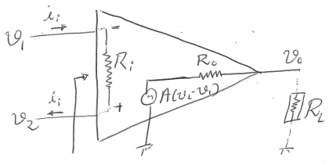
R_{i} is HIGH (∞), R₀ is LOW (0)

Inverting: V1- (amplifies and inverts signal)
Inv: A = -R2/R1 Non: A = 1+R2/R1
Summing: amplifies all inputs then adds them
Differentiator Circuit: Gain = RCω, 270° PS between Vin and Vout
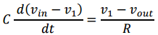
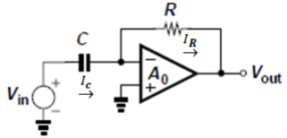
Integrator: Swap C and R (above)
Gain = 1/RCω, 90° PS between Vin and Vout
Low Pass
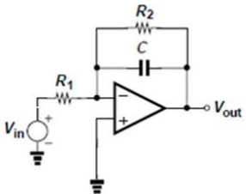High pass: Cap goes in series with R1

Semiconductor Physics & Diodes
R = pl/A (resis, physical parms, length, area)
Diode: Most fundamental analog device
Materials: Si, Ge, gallium arsenide, silicon carbide
Conductors: LOW resistance for current flow
Insulators: HIGH resistance for current flow
Semiconductors: Medium resistance - advants!
Free Electron: not confined to atom, -ve carier
Free Hole: acts as a positive charge carrier
Diffusion current: flow of carriers due to concentration gradient. HIGH LOW
Drift current: movement of carriers due to and electric field
Silicon: abundant in nature, 4 valence e-, forms crystalline lattice structure
Doping: makes intrinsic silicon impure, creating extrinsic silicon
N-type: introduce e- donor (ex: P)
P-type: introduce acceptor (ex: B)
Depletion region (DR): at the boundry p-n, e-s and holes combine and make it void of charge carriers
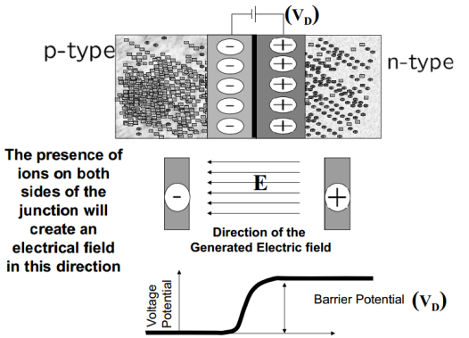
Depletion region creates a barrier separating p-n and obstruct movement of charge across it
Forward Bias: diode ON, reduces DR, only when voltage applied is higher than barrier potential (BP)
$$I_{D}=I_{S}(e^{V_{D}/nV_{T}}-1)$$
I_{D} Current thru diode
V_{D} voltage across diode
n ideality factor
I_{s} reverse saturation current
V_{T} thermal voltage (@ room temp 25mV)
V_{t} = kT/q
k Boltzman’s constant 1.38e-23
q 1.6e-19
Reverse Biasing: DR grows, applied voltage further reinforces the barrier potential, OFF,
Electric field across junction increases

Rectifier: Converts AC to DC
PIV: Peak Inverse Voltage
Two types: half (HWR) and full wave (FWR) bridge and center-tapped(below)
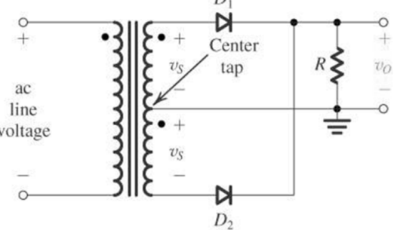
Zener Diodes: Breakdown Diodes, operate under RB, if FB, acts like a normal diode
Breakdown due to:
Zener Effect: increased Efield breaks the covalent bonds
Avalanche Effect: Kinetic energy of the minority carriers
Voltage Regulator Circuit: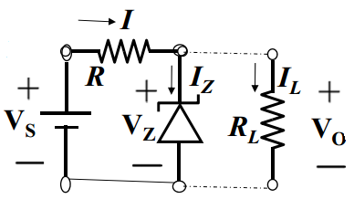
Peak Rectifers: +ve ½ cycle Cap charges fast,
-ve ½ cycle cap dischanges slowly, to be good, RC >>T
Clamper: Shifts DC level of given signal
Clipper: limits signal level to a certain magnitude, changes the wave shape

