RC Time Constant and RLC Circuits

PHYS-1004
Winter 2014

Date performed March 19, 2014
Date due March 26, 2014
Section L1B
Workstation 5

Purpose
The purpose of this lab was to understand the effects of a resistor and capacitor in a circuit, understand how to use resistors and capacitors in series or parallel, learn how to determine the behaviour of RC circuits when amplitude and frequency are changed, determine the oscillations of the RLC circuit and lastly, the behaviour of an RLC circuit when frequency is changed.

Theory
Part A: RC Circuits
In this part a RC circuit was constructed (refer to the schematics on page 27 in the lab manual). The behavior of the circuit was recorded as the circuit changed frequencies and amplitude. This was also repeated for each parallel and a series circuit. The generator was set to a square wave in order to know the charge and discharge values.
To find the voltage across the circuit Kirchoff’s rule will need to be used to find the relationships of the two voltages.
$$V_{0}=V_{C}+V_{R}=\frac{Q}{C}+IR$$
Eq (1)
Where $V_{C}$ is the voltage of the capacitor, $V_{R}$is the voltage of the resistor, Q is the charge of the capacitor I is the current, R is the resistance and lastly, C is the capacitance.
The equation which is differentiated with respect to time is the current at which the charge flows through the circuit.
$$R\frac{dI}{dt}+\frac{1}{C}\frac{dQ}{dt}=R\frac{dI}{dt}+\frac{1}{C}=0$$
Eq (2)
Where R is the resistance, Q is the charge, t is the time and C is the capacitance.
Where we arrive with
$$\frac{dI}{I}=-\frac{dt}{RC}$$
Eq (3)
Where R is the resistance, t is the time, I is the current and C is the capacitance.
When integrated along both sides, the equation is obtained
$$I=I_{0}e^{-\frac{t}{RC}}$$
Eq (3)
Where I is the current, I_{o} is the initial current at t=0, R is the resistance and C is the capacitance.
The equation below shows the equation for the time constant (τ).
$$τ=RC$$
Eq (4)
Where R is the resistance and C is the capacitance and τ is the time constant.
Once the power supply is at 0V and the capacitor is fully charged, charge will be emptied to the resistor. Using the loop equation the equations was formed.
$$\frac{V_{C}}{V_{0}}=e^{-\frac{t}{τ}}$$
Eq (5)
Where $V_{C}$ is the voltage of the capacitor, t is the time and τ is the time constant.
Part B: RLC Circuits
An example of a damped oscillator is a RLC circuit where the capacitor is assumed to be charged. RLC capacitors release its charge through solenoids and resistors which also induces the current in the solenoid. This then changes the current to the same direction and charges the capacitors polarity oppositely.
Angular frequency can be determined for a charged capacitor in a RLC circuit using the follow equation
$$w= \sqrt{\frac{1}{LC}-\frac{R^{2}}{{4L}^{2}}}$$
Eq (6)
Where w is the frequency, L is the inductance of the solenoid, C is the capacitance, and R is the resistance.
The equation that determines the natural oscillations of the circuit is
$$w_{o}=\frac{1}{\sqrt{LC}}$$
Eq (7)
Where $w_{o}$ is the natural oscillation frequency, L is the inductance of the solenoid and C is the capacitance.

Apparatus
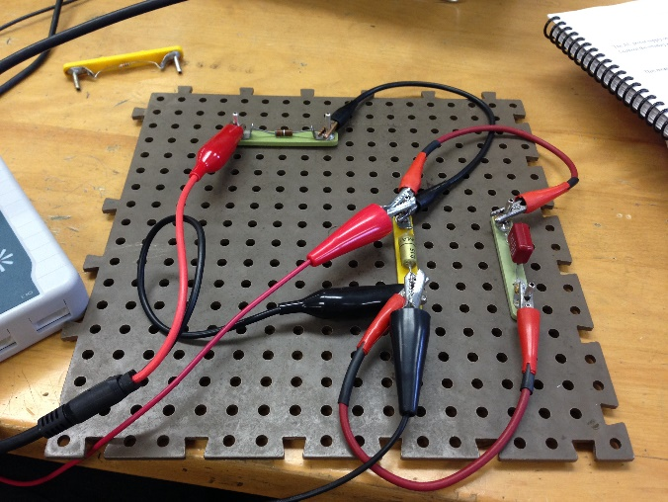
Figure 1: Circuit from Part A
Alligator clips
Green resistor (820 Ohm’s +/- 5%)
Yellow resistor (12000 Ohm’s +/- 5%)
Green capacitor (0.680 x10^-6 F +/- 10%)

Figure 2: Function generator box
Function generator box
Frequency
Cable connection

Figure 3: Laptop with logger pro

Potential (V) vs. Time (s) graph

Values obtained

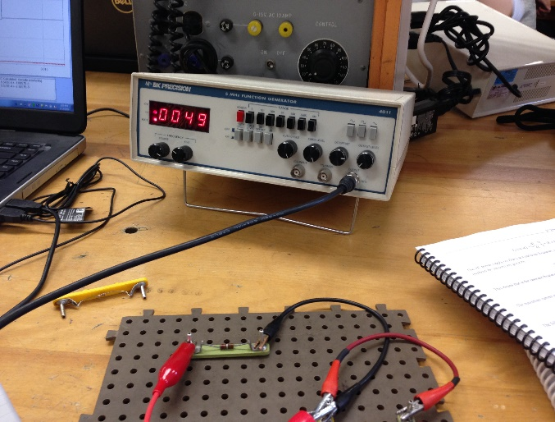
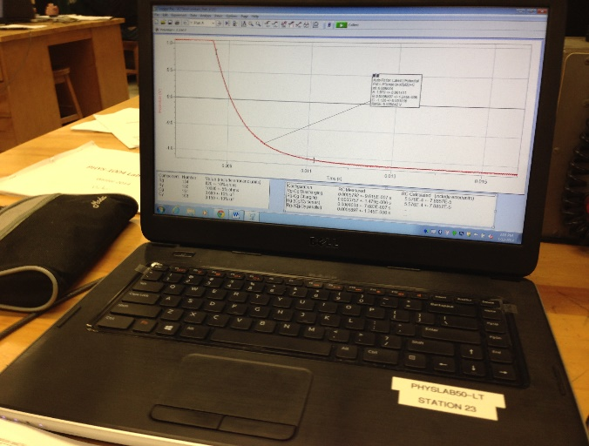

Resistors in series and parallel

Capacitors in series and parallel

Observations
The following data were recorded in the lab.
Component | Number | Value (including error and units)
Rg | 136 | 820 Ohm’s +/- 5%
Ry | 174 | 12000 Ohm’s +/- 5%
Cg | 155 | 0.680 x10^-6 F +/- 10%
Cy | 125 | 0.100 x10^-6 F +/- 10%

Configuration | RC Measured | RC Calculated (including error/units)
Rg-Cg Discharging | (5.935+/-0.006) x 10^-4s | (5.576+/-0.620) x 10^-4s
Rg-Cg Charging | (5.523+/-0.008) x 10^-4s | (5.576+/-0.620) x 10^-4s
Rg-(Cg/Cy series) | (8.909+/-0.203) x 10^-5s | (7.419+/-0.008) x 10^-5s
Rg-(Cg/Cy parallel) | (2.031+/-0.063) x 10^-5s | (6.396+/-2.793) x 10^-4s

Frequency (Hz) | W (rad/s) | Max Voltage (V)
1062.45 | 6676 | 2.174
500 | 3142 | 1.179
1500 | 9425 | 0.823
200 | 1257 | 0.992
2000 | 12566 | 0.326
1250 | 7854 | 1.517
800 | 5027 | 1.731
100 | 628 | 0.977
1100 | 6912 | 2.089
700 | 4398 | 1.483

Calculations
Part A: RC Circuits
Series circuit:
$$\frac{1}{C_{T}}=\frac{1}{C_{1}}+\frac{1}{C_{2}}$$
$$\frac{1}{C_{T}}=\frac{1}{0.680μF}+\frac{1}{0.100μF}$$
$$C_{T}=8.700 {x 10}^{-8}F$$
Parallel circuit:
$$C_{T}=C_{1}+C_{2}$$
$$C_{T}=0.680μF+0.100μF$$
$$C_{T}=7.80 {x 10}^{-7}F$$
Time Constant Calculated:
- R_{g}-C_{g} Charging and Discharging
$$τ=RC$$
$$τ=(820Ω)(0.680μF)$$
$$τ=5.576{ x 10}^{-4}s$$
- R_{g}-(C_{g}/C_{y} Series) Discharging
$$τ=RC$$
$$τ=(820Ω)(7.80 {x 10}^{-7}F)$$
$$τ=6.40 {x 10}^{-4} s$$
- R_{g}-(C_{g}/C_{y} Parallel) Discharging
$$τ=RC$$
$$τ=(820Ω)(8.700 {x 10}^{-8}F)$$
$$τ=7.13{ x 10}^{-5}s$$
Error on Time Constant
- R_{g}-C_{g} Charging and Discharging
$$σ=\sqrt{2}\left(0.10\right)\left(RC\right)$$
$$σ=\sqrt{2}\left(0.10\right)\left(5.576{x10}^{-4}s\right)$$
$$σ=7.8857{x10}^{-5} s$$
- R_{g}-(C_{g}/C_{y} Series) Discharging
$$σ=\sqrt{2}\left(0.10\right)\left(RC\right)$$
$$σ=\sqrt{2}\left(0.10\right)\left(6.40 {x 10}^{-4} s\right)$$
$$σ=9.05 {x 10}^{-5} s$$
- R_{g}-(C_{g}/C_{y} Parallel) Discharging
$$σ=\sqrt{2}\left(0.10\right)\left(RC\right)$$
$$σ=\sqrt{2}\left(0.10\right)\left(7.13{ x 10}^{-5}s\right)$$
$$σ=1.01 {x 10}^{-5} s$$
Part B: RLC Circuits
Angular Frequency (w=c)

$$w= \sqrt{\frac{1}{LC}-\frac{R^{2}}{{4L}^{2}}}$$
$$w= \sqrt{\frac{1}{(0.033H)(6.800x{10}^{-6}F)}-\frac{{100.0Ω}^{2}}{{4(0.033H)}^{2}}}$$
$$w=2106 Hz$$
Calculating Actual Value of B
A=V_{o}
$$B=\frac{R}{2L}$$
$$B=\frac{100.0 Ω}{2(0.033Hz)}$$
$$B=1515 Ω/Hz$$
Initial Frequency
$$w_{o}=\frac{1}{\sqrt{LC}}$$

$$w_{o}=\frac{1}{\sqrt{\left(0.033Hz\right)\left(6.800 x{ 10}^{-6}F\right)}}$$
$$w_{o}=6676 rad/s$$
Finding Frequency
$$f=\frac{w_{o}}{2π}$$
$$f=\frac{6676 rad/s}{2π}$$
$$f=1063 Hz$$
T-statistics test
$$t=\frac{\left|x_{1}-x_{2}\right|}{\sqrt{σ_{x1}^{2}+σ_{x2}^{2}}}$$
- Rg-Cg discharging $$t=\frac{\left|5.935-5.576\right|}{\sqrt{{0.006}^{2}+{0.620}^{2}}}$$
$t=$0.579
- Rg-Cg charging $$t=\frac{\left|5.923-5.576\right|}{\sqrt{{0.008}^{2}+{0.620}^{2}}}$$
$t=$0.560
- Rg-(Cg-/Cy Series)
$$t=\frac{\left|8.909-7.419\right|}{\sqrt{{0.203}_{}^{2}+{0.008}_{}^{2}}}$$
$$t=7.334$$
- Rg-(Cg-/Cy parallel)
$$t=\frac{\left|2.031-6.396\right|}{\sqrt{{0.063}_{}^{2}+{2.793}_{}^{2}}}$$
$$t=1.562$$

Results
Part A: RC Circuits
The capacitance of the series circuit was calculated to be $8.700 {x 10}^{-8}F$ while the parallel was $7.80 {x 10}^{-7}F$. Utilizing the calculated answers in the previous section we can conclude that the discharging and charging of R_{g}-C_{g} was $5.576{ x 10}^{-4}s$ ± $7.8857{x10}^{-5} s$. The discharging for the series was calculated to be $6.40 {x 10}^{-4} s$ ± $9.05 {x 10}^{-5} s$. Lastly, the discharging for parallel was found out to be $7.13{ x 10}^{-5}s$± $1.01 {x 10}^{-5} s$.
Part B: RLC Circuits
In this part the angular frequency was calculated to be 2106 Hz. The actual value of B was found out to be 1515. The initial frequency was calculated to be 6676 rad/s while the frequency was 1063 Hz. The 4 t-statistic tests for Rg-Cg Discharging, Rg-Cg Charging, Rg-(Cg/Cy series) and Rg-(Cg/Cy parallel) came out to be 0.579, 0.560, 7.334 and 1.562 respectively.

Discussion
Capacitors are implemented in electronic circuits for the reason to slow down the flow of charge and for feedback in oscillator circuits. A capacitor can be slowed down by a change in voltage and an increase in the resistance. Capacitors are most likely not good alternative to batteries because they do not hold enough charge for most practical uses and lose charge even when the circuit is open where as in a battery the charge is retained even when it is not connected to a circuit. Another reason capacitors are not very good alternatives to batteries is that they are significantly larger and would not be very practical.
In part A the t-statistic test was conducted for all 4 configurations of our circuit. The RC values obtained were all consistent except the Rg-(Cg-/Cy Series) which obtained a value of t = 7.334 (for a value to be consistent t has to be equal or less than 2). A possible source of error was not accurately selecting the proper charging and discharging points on the graph to assign the auto fit function. A method to increasing the accuracy (but not entirely) would be to clicking the zoom function and selecting the charge/discharge points from there.
For part C a source of error occurred for example when setting the frequency in the computer as 800 Hz while on the function generator the closest value achieved by turning the dials was 801 Hz. This error could have made our values slightly inaccurate. Another possible source of error would be the impurities in the metal of the connections that causes minor resistance. An improvement is to use a better conductor such as gold but it is obvious that that is extremely unlikely because it is very costly.

