Chapter 4
Designing and Analyzing Jobs
FUNDAMENTALS OF JOB ANALYSIS
-job: group of related activities and duties
-duties clear and distinct
-natural units of work, similar and related to eachother
-this minimizes conflict and enhances employee performance
-job can be held by single or multiple employees
-Position: tasts and responsibilities performed by one person
Use of Job Analysis Information
-Job Analysis: procedure firms use to determine tasks, duties, and responsibilities of each job, and human attributes (knowledge, skills, abilities) to perform it
-After this: job descriptions and job specification (human requirements)
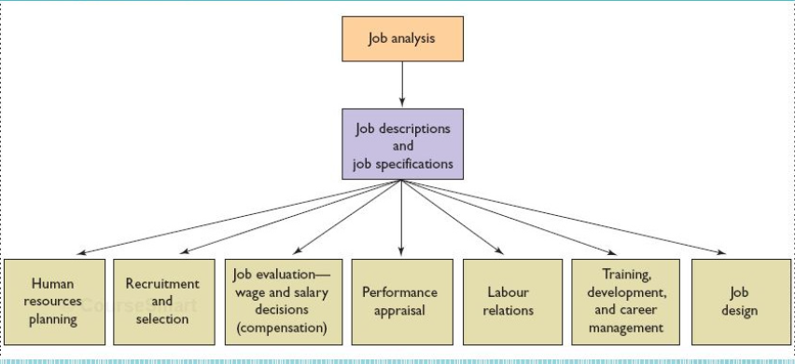
Human Resource Planning
-HR needs to kno job requirements
-if u know bout skills of current employees u can find jobs that can be filled internally which will require external recruitment
Recruitment and Selection
-Job description and specification decides who to hire
Compensation
-Job Analysis info determines compensation
-Evaluate skills, physical and mental demands, responsibilities, and working conditions (all assessed through job analysis)
-laws align with compensation
-Need to know about the job to determine if job requires overtime
Performance Management
-asses employee according to duties and responsibilities in job analysis
-routine tasks: use job analysis
-Complex jobs: supervisor
Labour Relations
-Union approval before finalizing job descriptions
-Union approed then classifies different jobs
Training, Development, and Career Management
-look how how good employees are with skills and compare to what the company wants with job analysis
-Whatever the employees are lacking in, should be in a training program
Restructing
-job anaylsis ensures all duties done
-description identifies unnecessary requirements, conflicts, concerns, etc reliminated through redesign and restricting
Steps in Job Analysis
Step1) Review Relevant Background Information flow of inputs to outputs from job under study
-review organization and process charts, and existing job decriptions
-process chart: diagram show flow of inputs to outputs of job
Organizational structure: the formal relationships amoung jobs in an organization
-no details in the chart
-choose structure appropriate to strategic goals
-bureaucratic, flat, and matrix structures
-Bureaucratic
-top down management approach
-many levels, hierarchical
-highly specially jobs narrowly defined
-focus on independent performance
-President to staff top to bottom
Flat
-Decentralized management spparch
-Few levels, Broadly defined
-Emphasis on teams and product development
Matrix
-Each job has two components: functional and product
-Finance personnel for product B responsible to both finance executie and product B executive

Step 2: Select Jobs to be Analyzed
Job design: The process of systematically organizing work into tasks that are required to perform a specific job
-strategy affects design
The Evolution of Jobs and Job Design
-work simplification: an approach to job design that involves assigning most of the administrative aspects of work (planning and organizing) to supervisors and managers, while giving lower-level employees narrowly defined tasks to perform according to methods established and specified by management
-work broken down to highly specialized repetitive tasks for efficiency
-industrial engeering: a field of study concerned with analyzing work methods; making work cycles more efficient by modifying, combining, rearranging, or eliminating tasks, and establishing time standards
-too much simplification reglets humans
-ex: assembly lines
-needs to satisfy psychological and physiological needs
-job enlargement (horizontal loading): a technique to relieve monotony and boredom that involves assigning workers additional tasks at the same level of responsibility to increase the number of tasks they have to perform
-job rotation: technique to relieve monotony and employee boredom that involves systematically moving employees from one job to another
-job
enrichment (vertical loading): any effort that makes an employee’s job more rewarding or satisfying by adding more meaningful tasks and duties
-ergonomics: an interdisciplinary approach that seeks to intergrate and accommodate the physical needs of workers into the design of jobs. Aims to adapt the entire job system: work, environment, machines, equipment and processes, to match human characteristics
Competency-Based Job Analysis
-writing job descriptions based on competencies rather than job duties
-emphasizes what employee is capable of rather than what they must do
-Competencies: Demonstratable characteristics of a person that enable performance of a job
-measureable and observable
-“To do this, the employee should be able to”
-Competency based job analysis: describing a job in terms of measureable, observable behaviour competencies an employee must exhibit to do a job well
-Traditional job focuses on what to accomplish, competency focuses on how to meet objective
Three Reasons to use Competency Analysis
-first: traditional job descriptions backfire if highperformance work system is goal
-too specific, then they wil think “that’s not my job”
-second: describing in terms of skills is more strategic. Encourage employee to support stategy
-Third: measurable skills support performance management process.
Examples of Competencies
-general/core (reading and writing)
-leadership
-tachnical/task/functional competencies
Team-Based Job Design
-Job designs that focus on teams than individual
-focus on whole and meaningful piece of work
team: group of people with complementary skills working toward common goal
-joint responsibility
-team based suited for flat and matrix organization structure
Step 3: Collecting Job Analysis Information
-qualitative and quantitative techniques to collect info about duties
The Interview
-individual and group interviews
-supervisory interviews
-Filling out job questionnaire
Interview Guidelines
-job analyst and supervisor work together to identify employee
-Rapport established quickly
-Checklist
Questionnaire
-obtaining job analysis information
-Position Analysis Questionnaire: a questionnaire used to collect quantifiable data concerning the duties and responsibilities of various jobs
-Quantitivescore on six dimensions
-Information input, mental processes, work output (physical activities and tools), relationship with others, job contect (physica and social environment), other job characteristics
-Functional Job Analysis (FJA) a quantitative method for classifying jobs based on types and amounts of responsibility for data, people, and things. Performance standards and training requirements also identified
-Training required
Observations
-watching employees perform work
-record frequenc of behaviour and nature of performance
-Can use prepared info (structured) or no prepared invo (unstructured) or combination
Participant Diary/Log
-Daily listings made by employees of every activity in which they enage along with the time each activity it takes

National Occupational Classification

-Refrence tool for writing job descriptions and job specifications
-Compiled by federal government
-occupation: collection of jobs that share some or all of a set of main duties
-Noc focuses on occupation
Step 4: verifying Information
-increases reliability and validity
-awareness of inconsistencies
Step 5: Writing Job Descriptions and Job Specifications
Job Descriptions
-A list of duties, responsibilites, reporting relationships, and working conditions of a job, one product of a job analysis
-what job does, how its done, and under what conditions performed
-Job identification: position title department, and location
-Job Summary: general nature of job. Main functions
-Relationships: relationships with inside and outside of organization
Duties and Responsibilies
-Authority: limits of authority
-Performance Standards/Indicators
-Working Conditions and Physical Environment
-Job Descriptions and Human Rights legislation
-no discurmination
Job specification: list of human requirements to perform job
(job analysis)
-Human traits and experiences
-physical demands analysis: identification of the senses used and the type, frequency,and amount of physical effort involved in a job
-Completing the Job specification Form
-Writing Competency-Based Job Description: ask superisors regarding responsibilies and activities, incidents that pinpoint success

Step 6: Communication and Preparations for Revisions
-need to reivise previous job descriptions and specification with organizational changes
-Job analysis must be structurd enough to allow for modivication with providing current and future employees at the same time

