Forensic Psychology Final Review

JURY DECISION MAKING: Chapter 7
The right to a Jury in Canada
- In Canada only some types of offences can proceed with jury trials, some defendants are given the option to a jury trial, but they may opt to be heard by a judge alone, relative to the total number of offences only a few are heard by a jury
- There are 3 types of offences in Canada
- Summary offences: involve a sentence of less than 6 months in prison, HOWEVER for some offences the maximum is 18 months with a fine of less than $2000, heard by a judge alone, DO NOT have a right to trial by jury
- Indictable offences: There are 3 types of indictable sentences
- Less serious heard by a judge alone (theft, obtaining money or property by false pretences, failure to comply with probation order)
- Highly serious offences tried by judge and jury (treason, murder, piracy) – However there is an exception in the criminal code that states if the attorney general and accused agree, the trial may be heard by a judge alone
- For some indictable offences the accused can decide whether the trial proceeds with a jury or judge alone (robbery, arson, sexual assault with a weapon) – if the accused does not make a decision the trial is heard by both a judge and a jury
- Hybrid offences: a cross between summary and indictable offences, the crown may choose whether to proceed as an indictable (max 5 year sentence) or summary (6 month sentence), if summary is chosen the defendant does not have a right to a jury

The Function of a Jury
Juries Act: Provincial and territorial legislation that outlines the eligibility criteria for jury service and how prospective jurors must be selected
Jury Summons: A court order that states a time and place for jury duty (must be 18 years old in Ontario, 19 years old in BC)
- Receiving jury summons does not guarantee one will be a juror, but not showing up to the courthouse can result in a severe legal penalty or jail time
- In Canada criminal trials have 12 jurors, if selected a prospective juror will be on the jury unless the lawyer presents one of two challenges (1) peremptory challenge (lawyer does not believe juror will reach a verdict in their favour) (2) challenge for cause (lawyer has specific reason to believe juror is unable to remain impartial)
Purpose and responsibilities of a jury include:
- Decide facts from trial evidence
- Education for the citizens
- Community consciousness
- NOT sentencing
Jury Nullification: Occurs when a jury ignores the law and evidence and reaches a verdict based on some other criteria
- May occur in instances when a jury believes the law is unfair given certain circumstances OR when jury believes punishment accompanying crime is too harsh (controversial issues – abortion, euthanasia)

Characteristics of a jury
- Representativeness
- Random selection from the community ensures that a jury is truly representative of the community
- Crown of defence can challenge the composition of a jury if they feel it is not representative of the community
- Impartiality
- Attitudinal prejudice/ discrimination: A juror must set aside any pre-existing biases he/she has that may relate to factors in the trial, and evaluate the case purely on evidence and facts
- Juror must ignore any non-admissible evidence that they may have heard in pre-trial media coverage
- Studies have proven that both positive publicity (less guilty verdicts) and negative publicity (more guilty verdicts) affects the outcome of a verdict
- Must have no connection to the defendant

Sources of juror bias
- Interest prejudice: having a direct interest in a case (Example: A juror may be related to a person being called to testify or may know someone who has been charged with the same offence)
- Specific Prejudice: Attitudes about the specific case (Example: A juror may hold specific beliefs or attitudes about an issue relating to the case impairing his ability to remain impartial)
- Generic Prejudice: Attitudes about crime or criminals in general (Example: Attitudes that all criminals “deserve what’s coming to them”)
- Normative prejudice: Refers to a juror believing that there is such a strong community sentiment in how the majority wants the case to turn out that it effects their ability to remain impartial to the case (Example: A case with grizzly murder details may cause the community to more readily assume guilt before knowing if the suspect is truly guilty or innocent)

Presumption of Impartiality
In Canada we have:
- Limits on pre-trial publicity during preliminary trials
- Limits on discussions by/between jurors
- 12 person juries (larger number of jurors)
- Reminders about sworn oaths

Do safeguards make a difference?
- Kramer et al. (1990): Receiving biasing information before viewing a trial can increase guilty jury verdicts
- Instructions to ignore pre-trial publicity does not significantly influence jury verdicts

Overcoming Partiality
Three solutions in Canada:
- Adjournment: A postponing of proceedings until any biasing effect can be dissipated
- A problem with this solution is that, jurors and witnesses’ memories can fade, eye-witnesses can also move or die
- Change of venue: If there is a large bias in the community regarding a specific case that may affect juror verdicts a change of where the trial proceeds (does not happen often but when it does, trial usually remains in the province)
- Challenge for cause: Request that a prospective juror be dismissed for a specific reason or claim that the person cannot be fair and remain impartial
- Predetermined questions approved by a judge may be asked to the prospective juror and answers can be examined
- Two jurors act as “triers” and question a third juror to determine whether or not the person is impartial, the position of triers rotates until a jury of 12 is selected and deemed impartial
- Criticisms: The process can be conducted in open court, in which prospective jurors may alter their answers in light of witnessing answers that lead to negative reaction/ jurors may find it difficult to be honest if answers are negative/ jurors may not be aware of their biases

Two Approaches to Jury Selection
- Broad attitudes and traits
- Determining defence or prosecution biases
- Example: Juror Bias Scale (used to determine if potential jurors may have specific attitudes that will not allow them to remain impartial during the course of the trial)
- A case specific approach
- Determining specific biases related to specific cases
- Example: The Harrisburg Seven

Studying Juror/Jury behaviour
- Interviews with Jurors (US): In trying to understand how jurors reached a specific verdict, logically we would think to ask them, however in Canada it is illegal to discuss what occurred during deliberation, these interviews ARE allowed in the states
- This methodology has high external validity, dealing with real words cases
- Criticisms: jurors may recall details inaccurately, may be unaware of why they reached that decision, conclusions are based on unreliable data, cause and effect relationship cannot be measured, alternative hypotheses cannot be ruled out
- Archival Records: records of trials can be reviewed to uncover relationships between variable, this methodology has high external validity
Criticisms: inability to establish cause and effect relationship, restricted to available data, researcher is unaware of how information was collected (could have used biasing techniques)
- Simulation Techniques: Simulating a trial and specific aspects of it, has high internal validity, and can reveal cause and effect relationships
Criticisms: Researcher control and constraints limit external validity, may not be representative of real jury pools,
- Field Studies: using actual jurors while they are serving on a jury so cooperation from the judge and courts is required, high external validity
Criticisms: hard to receive approval from courts, small sample of participants, appropriate comparison groups difficult to identify, confounding variables

Models of Jury Decision Making
Two main types of models
Mathematical Models: precise and testable, not realistic or intuitively reasonable, the verdict is a function of the calculation of relevant and irrelevant evidence
Example: Kassin and Wrightsman (1983) verdict is the result of two judgements
- Likelihood of commission – (DNA + no alibi + witness…)
- Threshold of reasonable doubt – LOC > TRD -> guilty verdict
Explanation Based Models: realistic and intuitively appealing, not precise or testable
Example: Pennington and Hastie (1986) – jurors organize information presented at trial into a story, judge provides the jurors with relevant law and verdict options, jurors find the best fit between story and verdict options
- Jurors listening to the same evidence may construct different stories and therefore reach different verdicts, jurors bring in individual beliefs and their own personal experiences while constructing a story
- The “story model” seems to be consistent with how jurors process information and reach verdicts

Influences on Jury Decision Making
- Actual trial evidence
- The way evidence is presented
- Beliefs of jurors
- Attitude toward crime and criminals
- Presence of expert witnesses
- Comprehension of trial

Black Sheep Effect: When evidence is strong, similarity between the defendant and the jury leads to punitiveness
Defendant Characteristics: If jurors hear about a previous criminal record they are more likely to reach a guilty verdict, verdicts have also been found to be more lenient when a defendant is attractive
Victim Characteristics: particularly relevant in sexual assault cases, in the mid 1980’s a woman’s sexual history was admissible in court if she was claiming assault

Disregarding inadmissible evidence (Kassin and Sommers 1997): mock jurors were presented with murder trial and a piece of evidence that was manipulated, when the defence lawyer objected, the judge either overruled or sustained the evidence, verdicts on both conditions were analyzed
- Conclusion: When asked to disregard evidence, jurors would disregard it if they were provided with a logical legitimate reason for doing so

Comprehension Aids
- Pre-trial instructions to jurors: It has been noted that jurors typically understand less than 50% of the legally dense instructions provided by a judge before trial, some reforms have been put in place to attempt to change that (rewriting instructions, providing written copy of instructions, pre and post evidence instructions, lawyers clarify legal instruction during presentation)
- Juror note taking: useful in memory aid and understanding
Criticisms: jurors who take notes may exert influence, jurors may rely heavily on note takers, may distract non note takers etc.
- Juror question asking: Jurors being allowed to ask questions to clarify details about the trial (usually has to do with legal terms)
Criticisms: Has not been proven to aid or be detrimental to jury verdicts

Other Influential Factors
- Size of the jury
- The decision rule

Polarization: When individuals tend to become more extreme in their initial position following deliberation
Leniency Bias: When jurors move toward a greater leniency after deliberation
Hung Jury: A jury that cannot reach a unanimous verdict

- In Canada a jury must reach a unanimous verdict or else a mistrial is declared, in the states however majority votes is sometimes implemented

FITNESS TO STAND TRIAL: Chapter 8
- Individuals charged with a crime are expected to be tried fairly, with that these individuals need to have an understanding of the charges, proceedings, and be able to prepare defence
- A defendant who is unable to do the above (due to mental illness) maybe found ``Unfit to Stand trial``
- Section 2 of the Criminal Code - `` Unable on account of having a mental disorder, to understand the nature of the proceedings, or communicate with counsel``
- The issue of a defendant`s fitness can be raised at any point in time from the arrest to the defendant`s sentence determination
- Approximately 5000 fitness evaluations are conducted in Canada annually

Defining fitness (R. v. Pritchard 1836)
- Is the accused able to assist in his/hers defence?
- Does the accused understand his/her role in the proceedings?
- Does the accused understand the nature of the proceedings?

-Two elements must be present for criminal guilt to be established:
(1) A wrongful deed (aka. Actus Reus)
(2) Criminal intent (aka. Mens Rea)

Assessment of Fitness
- Involves an assessment of the current mental state of the accused
- The GOAL is to determine whether it interferes with an individual’s ability to perform legal tasks
- If fit, the trial will continue, if unfit, an assessment will take place
- Can take between 5-30 days for assessment orders
- Assessment will typically be done by a psychiatrist or medical practitioner

Fitness Instruments
Fitness Test Revised (FIT-R)
- Semi-structured interview that assesses 3 psychological abilities stated in the criminal codes fitness standard
- Works as a screening device that will identify any mental disorder, responses are recorded and rated on a scale from 0 (no impairment) to 2 (severe impairment)
- After interview is complete, evaluator will make a decision regarding overall fitness
TO BE CONSIDERED FIT INDIVIDUAL MUST UNDERSTAND/BE ABLE:
- Proceedings (Example: possible pleas)
- Consequences (Example: range of penalties)
- To be communicative with counsel (Example: strategies)

MacArthur Competence Assessment Tool (MacCAT-CA)
- Structured interview containing 22 items that assess competencies in three areas (factual understanding of the legal system and adjudication process, reasoning ability, understanding own legal circumstance)
- Items are assessed via hypothetical scenarios presented to the defendant, a series of questions is asked to the defendant after, answers are rated and decisions of fitness are made based on significant scores

Fit vs. Unfit
- Viljoen and Zapf (2002) examined characteristics of 80 defendants referred for assessment and 80 who were not referred
- There proved to be a large number of differences between both defendants
- Example: referred defendants were less likely to understand the nature of proceedings and possible outcomes, there was no significant difference in being able to communicate with counsel

Treatment
- Individuals found unfit are typically held in hospital prior to trial
- Goal is to restore individual to fitness with as little delay as possible
- Medication is the primary form of treatment (sometimes requiring a treatment order)
- If an individual remains unfit after 90 days they are either detained in a hospital or conditionally discharged, they will be reviewed on an annual basis of every 2 years (1 year for youth), and in order for the case to go to trial the crown must provide sufficient evidence (known as a prima facie case)
- If fitness is restored, and then again lost during trial, the proceedings once again will stop
- Absolute discharge was only recently able to be issued if the following are true:
- Defendant is unlikely to ever become fit
- Defendant does not pose a serious threat to public safety
- A stay of proceedings is in the interest of the proper administration of justice

An Example: Ted Kaczynski
- 7 bombings
- Trial1997
- Defence wanted unfit
- Kaczynski disagreed
- Found fit and criminally responsible
- Plea bargained and pled guilty
- 4 life sentences

CRIMINAL RESPONSIBILITY: Chapter 8
Problems with Criminal Responsibility
- Insanity is a LEGAL concept NOT a medical or psychological concept
- Definition of insanity may vary from jurisdiction to jurisdiction
- Retrospective assessment has to be conducted of state of mind

Insanity: Impairment of mental or emotional functioning that affects perceptions, beliefs and motivations at the time of offence
- In legal context, insanity removes the responsibility for performing a particular act because of uncontrollable impulses or delusions

Defining Responsibility
M’Naughten Standard (Cognitive)
- Emerged after Daniel McNaughton shot a man in the back with no clear intention and was found not guilty due to insanity
- Three critical criteria regarding insanity in the M`Naughten standard that must be present at the time of the Crime:
- Must suffer from a defect of reason/disease of the mind
- Must not know the nature or quality of the act being performed
- Must not understand that it was wrong

Irresistible Impulse Test (Volitional)
- The accused could have the cognitive knowledge of what is right and wrong
- But still not be responsible if their illness results in an inability to control behaviour

ALI Standard (Cognitive/Volitional)
- Not responsible for actions if the accused lacks the capacity to appreciate the criminality of the act or to conform their conduct to the requirements of the law

Guilty but Mentally Ill (GBMII)
- Mentally ill but also but also guilty of the crime
- Undergo treatment until declared sane
- Prison for same term as offenders

NCRMD (R. v. Swain, 1991)
- In the mid-1970s a review of policies for offenders with mental illness was done and found that it was in conflict with the charter of rights and freedoms
- The ruling from the supreme court in this case was consistent with the review and foreshadowed the changes to the criminal code

-In 1992, BILL C-30 enacted and the following changes were made to the justice system:
- The term “not guilty by reason of insanity” was changed to “Not criminally responsible on account of mental disorder” (NCRMD)
- Wording was changed in section 16 of the criminal code: “Not legally responsible while suffering from a disorder that rendered the person incapable of appreciating the nature of the act or incapable of knowing that the act was wrong”
- Review boards were created to oversee the care and disposition of defendants found unfit or not criminally responsible on account of mental disorder
- In 1999, it was determined that an individual who is NCRMD should not be detained unless they pose a criminal threat to the public otherwise they should receive an absolute discharge

Assessment of Responsibility
- Only the defense can raise the issue, unless the guilty verdict has been handed down then the crown can raise the issue if they believe psychiatric treatment would best fit for the individuals needs
- However, the prosecution can deal with the issue once the defence raises it
- Responsibility is assessed using an assessment instrument
- Can take between 30 to 60 days for assessment orders

Rogers Criminal Responsibility Assessment Scale (R-CRAS)
- The only instrument of its kind, identifies insanity by measuring 5 topics, overall scores are considered after assessment when insanity is being determined
- 5 Topics
- Organicity
- Psychopathology
- Cognitive Control
- Behavioural Control
- Reliability of the report

“MSE”
- Identifies non-insanities
- Covers 3 topics:
1. General Psychological History
2. Mental state at time of offence
3. Current Mental Status

Treatment
- Three dispositions can be made if an individual is found NCRMD (least limiting to defendant)
- Absolute discharge (If defendant poses no risk to society)
- Conditional Discharge
- Order to be sent to a psychiatric facility
- Medication is the primary form of treatment if sent to a psychiatric facility, however patients do not need to comply with medication, it is only forced upon them when their mental health has deteriorated to the point that they cannot make decisions themselves about treatment
- If sent to a forensic hospital the disposition time will be capped (maximum period of time a defendant with mental illness can be affected by his/her disposition) after the maximum period has been reached defendant can be released without restrictions

Example: Jeffrey Dahmer
- Trial in 1992
- Killed and dismembered 17 young men
- Over a time period of 10 years
- Cannibalism
- Retained body parts
- Pre and post mortem sexual activity
- Expert witnesses brought in (ALI)

Defence VS. Prosecution
-Necrophilia - control and caution
-Overpowering - efficient disposal
-Cravings - planned disposal
-Distorted fantasies - Lack of activity
-Lack of control - fooled police
-Psychotic like - alcohol dependence
-Psychotic - paraphilia

High rates of mental Illness in offender populations may be due to
- Those with mental illness are likely to be arrested at a disproportionately high rate compared to those who do not have mental illness
- Individuals with mental illness are less adept at committing crime and more likely to get caught
- Those with mental illness are more likely to plead guilty because of an inability to get good representation or are not able to understand consequences of their plea

SENTENCING: Chapter 9

- Sentencing = Imposition of a legal sanction of persons convicted of an offence

Canadian Court System
- The Canadian court system is organized in a hierarchy made up of numerous courts addressing specific issues and cases, courts higher in the hierarchy possess more legal authority than courts below them
- At the top of the hierarchy is the “Supreme Court of Canada”

Goals of Sentencing (IMPORTANT)
- Denunciation: public condemnation of particular criminal or crime committed (show the public that this behaviour is unacceptable and will be punished)
- Specific Deterrent: Sentencing to reduce the probability that an offender will reoffend in the future
- General Deterrent: Sentencing to reduce the probability that members of the general public will offend in the future
- Incapacitation: deprive offenders of means to reoffend
- Rehabilitation: to restore and readapt a person into society, good mental/physical health, good character/reputation
- Reparation: A sentence where the offender has to make a monetary payment to the victim or community
- Promote Responsibility: give offenders a sense of responsibility for their actions

- Judges often consider more than one goal when handing down a sentence (Example: An offender may be sentenced to prison to separate them from society AND reduce probability that the offender will reoffend)
- Goals of sentencing can sometimes be incompatible (Example: Long imprisonment of an offender to separate them from society may not be effective in rehabilitating that offender)
- Different judges across Canada will likely hand down different sentences when dealing with similar offences/offenders (Example: different judges may have different ideas on what would be the most effective sentence)

Principles of Sentencing (IMPORTANT: NOT to be confused with GOALS)
- Principles of sentencing act as a guide when making decisions regarding an offence or an offender
- A sentence must be proportionate to the gravity of the offence
- A sentence must be proportionate to the responsibility of the offender
- A sentence should not deprive the offender from liberty if at all possible

Sentencing Options
- Absolute Discharge: offender is released into the community and is free to do what they please
- Reparation/Restitution: offender must make a monetary payment to the victim/community
- Fines: offender has to make a monetary payment to the courts
- Community Service
- Conditional Sentences: prison sentence served in the community
- Imprisonment: last resort, time served in federal penitentiaries

Other Things to Consider when Handing down a Sentence..
Dangerous Offender: A label attached to offenders who are proven to constitute a significant danger to others
Long-Term Offender: A label attached to offenders who are proven to be at high risk for re-offending

Are These Options Effective?
- Punishment based strategies generally are ineffective as they result in higher recidivism rates
- Fines and restitution are the only “get tough” strategies that showed a slight decrease in recidivism rates

The Death Penalty (DP)
In Canada: abolished in 1976/1999
In The US: 38 states permit the DP, 600 executions since reinstatement, 3500 inmates on death row

Arguments against the DP
- does not act as a deterrent
- is expensive
- is biased
- is handed down to innocent people

Sentencing Disparity = Variation in sentencing patterns that are not legally relevant to the case (can lead to serious injustices)
Unwarranted Sentencing Disparity = Variations in sentencing severity for similar crimes committed by similar offenders that result from reliance by the judge on legally relevant factors
Systematic Disparity = Consistent disagreement among judges about sentencing decisions because of factors such as how lenient judges think sentences should be
Unsystematic disparity = Inconsistencies in a judges sentencing decisions over time when judging the same type of offender or crime because of factors such as the judge’s mood

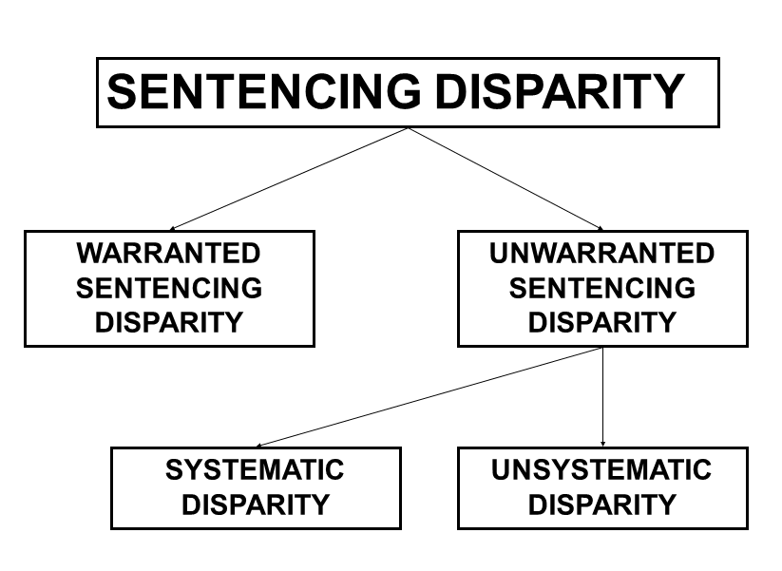
Studying Sentencing Disparity
- Simulations
- McFatter (1986): Conducted an experiment to measure sentencing disparity in which he provided 6 judges with 13 crime and offender descriptions ranging from minor fights to rape and murder
- Judges were asked to rate various aspects of the crime and give a recommended sentence, two months later they were given the same descriptions and asked to rate it again
- Results:
- There is a good deal of agreement among judges about the severity for sentences appropriate for each crime
- Despite these similarities, there are also many instances of unwarranted sentencing disparity (sentences handed down for an armed robbery varied drastically)
- Most of the disparity appears to come from unsystematic sources (inconsistencies in a certain judges sentencing over time)
- Sentencing statistics: The examining of official sentencing statistics in attempt to uncover variations in judicial sentencing decisions

Reducing Sentencing Disparity
- In Canada, sentencing disparity is almost inevitable as judges are granted a lot of discretion when handing down sentences however there are processes in use to try to minimize sentencing disparity
- Sentencing Guidelines: Guidelines that attempt to provide a more consistent structured way at arriving at a sentencing decision

Measuring Attitudes towards Sentencing
- Public opinion polls, focus groups, experimental research
- Major findings have shown that the public generally:
- Feel offenders are treated to leniently when it comes to sentencing
- Have a moderate amount of confidence in our criminal justice system, but generally see it in a positive light rather than a negative light
- Support a range of alternative sentencing practices
- Often public opinions are not based on fact and largely come from media influences
- Public opinions that feel the courts are too lenient may also stem from a fear of being victimized, citizens look to the judicial system for safety, those with the most fear of being victimized will more generally believe sentencing is too lenient

OFFENDER TREATMENT: Chapter 9

Historical Background
- Extensive debate in “what works” in offender rehabilitation
- Early literature reviews by Logan (1972) did not present favourable conclusions regarding the effectiveness of correctional interventions
- Martinson (1994) presented the “nothing works” conclusion in his paper that evaluated 231 primary studies
- New research suggests this is not true, Canadian researchers have led the way in establishing principles of effective correctional intervention that are valuable in determining specific interventions for specific offenders

Meta-Analysis
- Statistical aggregation of the results derived from many independent studies in order to integrate the findings
- Primary unit of analysis is the effect size, which reflects the degree to which the comparison and the treatment groups differ on a particular measure

Development of the Meta-Analysis
- First meta-analysis conducted in this area was by Garret (1985), which found that family/cognitive-behavioural treatment was the best
- Whitehead and Lab (1989) conducted a meta-analysis, but did not find promising evidence
- Andrews and colleagues decided to conduct their own meta-analysis on a broad sample of offender treatment studies
- Found support for their principles effective correctional treatment (ECT), which were human service, risk, need and responsivity

The Risk Principle
- Criminal risk can be predicted
- Higher levels of service should be provided for higher risk cases
- Criminals with low-risk of recidivism are unlikely to reoffend and may actually increase chances of reoffending if exposed to intervention with others who hold anti-social attitudes

Need Principle
- Interventions should target criminogenic needs (dynamic attributes that, when changed are associated with changes in the probability of recidivism) rather than non-criminogenic needs (also dynamic and changeable, but these changes are not necessarily associated with the probability of recidivism)

Examples of Criminogenic Needs:
- Changing anti-social attitudes
- Changing anti-social feelings
- Reducing anti-social peer associations
- Promoting Identification with pro-social role models
- Promoting familial affection/ communication
- Promoting familial monitoring and supervision
- Increasing self-control, self-management and problem solving
- Substance Abuse
- Academic and vocational deficits
- Recognition of risky situations (relapse prevention)

Examples of Non-Criminogenic Needs:
- Increasing self-esteem (without reductions inn anti-social thinking, feelings and peers)
- Focusing on vague emotional/personal problems
- Increasing cohesiveness of Antisocial peer groups
- Neighbourhood wide improvements without touching the needs of higher risk criminals
- Increasing conventional ambition (work/school) without concrete assistance to achieve them changing anti-social feelings
- Fear of punishment (ex. “Scared Straight” programs)
- Physical training programs

Responsivity Principle
- Refers to delivering treatment programs in a style and mode that is matched to the ability and learning style of that offender
- Match service to:
- What we know generally about offenders (general responsivity)
- Individual differences of offenders (specific responsivity)

- The study by Andrews and colleagues which focused on the effectiveness of using these three principles when deciding on offender treatment was successful, they hypothesized that interventions would be “appropriate” if they were consistent with these principles, “Inappropriate” if they were inconsistent and “unspecified” if there was a lack of information
- Offenders taking part in appropriate intervention programs showed lower rates if recidivism

“What Works”: Carleton University Meta-Analysis
- 374 comparisons (Example: police cautioning vs. additional processing, probation vs. custody etc.)
- Also coded for principles of risk, need and responsivity
- Created an appropriate treatment variable range (0-3) based on principles of ECT
- Explored their utility with specific populations
- Also explored the impact of staff characteristics on program effectiveness
- Findings:
- Only 2 of the comparisons produced a positive effect size of .20 or greater (.20 and .22)*
- The mean effect size was a minimal -.03
- More processing associated with slightly increased recidivism rates
- If any effect on recidivism, “less is better than more”

*Non-residential settings are key if maximum reductions in recidivism are desired (Community setting more effective)
*Effective correctional workers must be relied on

Parole in Canada
- Recognizes the value of actively reintegrating certain offenders into society as soon as possible to enhance their chances of rehabilitation
- In Canada, the National Parole Board is responsible for making decisions on which offenders may be granted parole
- Decisions are usually made at parole hearings with the offender (open to the public) after the offender has served 2/3 or seven years of their sentence (whichever is shorter) where a variety of factors are considered

Types of Parole
Temporary Absence: usually the first type of release offenders are granted (unescorted or escorted absences for substance abuse programs, counselling and training courses)
Day Parole: allows offenders to participate in community-based activities, must return to half way house or institution at the end of the day
Full Parole: allows the offender to serve the remainder of the sentence under supervision in the community
Statutory Release: The release of offenders from prison after they serve two-thirds of their sentence (with supervision)
- It has been noted that offenders granted parole based on assessment rather than statue-based parole are more likely to complete their supervision periods without a breach in conditions

RISK ASSESMENT: Chapter 10

Risk assessment informs:
- Sentencing (especially D.O hearings), classification, treatment needs, treatment intensity, parole decisions, level of supervision, notification decisions, release conditions etc.

- In the past offenders were regarded as either dangerous or not dangerous
- Today risk is regarded as a range in which an individual can vary in degree of dangerousness
- The probability of risk may change over time and is an interaction among a person`s characteristics, background and possible future situations that will affect whether or not a person will commit criminal behaviour

Risk Prediction = Assess the risk that people will commit violence in the future
Risk Management = Develop effective intervention strategies to manage that risk specific to the offender
When Are They Conducted?
- Routinely conducted in both civil and criminal contexts
- Civil Setting: refers to the private rights of individuals and legal proceedings connected with such rights (Examples: Civil commitment, child protection, immigration, school and labour regulations etc.)
- Criminal Setting: Occurs at every major decision point in criminal justice systems (pretrial, sentencing, and release)

Goals of Risk Assessment
- Improve accuracy
- Improve transparency
- Improve consistency

What do we consider in a risk assessment?
Risk factors: A variable that is related to recidivism
- Static risk factors: are fixed and unchanging even with treatment, most convenient, most frequently used, can be reliably measured and are easily predictive (Examples: Demographic variables, history of criminal behaviour, history of mental disorder)
- Dynamic risk factors: change with time, less convenient and reliable, less frequently used, BUT are sensitive to change, intervention can change level of risk
-2 types:
Stable dynamic = persistent and change slowly if at all (criminal attitudes, coping ability, impulse control)
Acute dynamic = rapidly fluctuating (negative mood, level of intoxication)

“Big 4” Risk Factors
- Criminal History
- Pro-criminal personality (Impulsive, aggressive)
- Pro-criminals attitudes
- Pro-criminal associates

NOT Risk Factors
- These are often mistakes for risk factors
- Low socio-economic status, personal distress/psychopathology (low self-esteem, depression), fear of punishment, verbal intelligence, remorse/empathy, offence severity

Approaches

- Unstructured clinical judgement: Decisions characterized by a substantial amount of professional discretion and lack of guidelines (Subjectively select, analyze and interpret risk factors, no predefined rules)
- Advantages: Idiographic, flexible
- Disadvantages: Inconsistent, low accuracy
- Actuarial Tools: Collect pre-specified risk factors and enter them into statistical models that combine and weight them (mechanical prediction involving predefined rules about what risk factors to consider, how info is collected and combined)
- Advantages: Consistent, high accuracy
- Disadvantages: Nomothetic, validity across different samples
Example: Violence risk appraisal guide (VRAG) Quinsey et al. (2001)
- Consists of 12 weighted static risk factors
- Added together to give overall probability of risk
- VRAG factors: PCL-R score, elementary school problems, personality disorder, separated from parents, failure on prior release, alcohol abuse, non-violent offence history, schizophrenia, never married, victim injury, female victim, age
- Administration: code presence of risk factors -> total the scores -> assign individual to 1 of 9 “bins” (1 being the lowest, 9 being the highest) -> estimate probability of violence

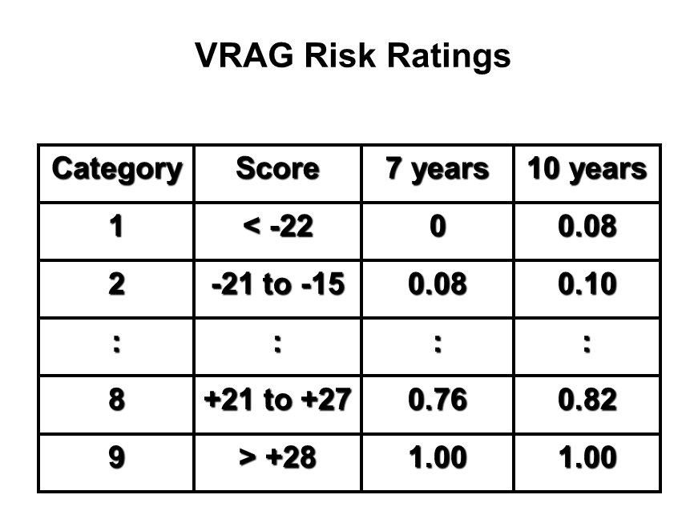
- Structured Clinical Judgement:
- Collect pre-specified risk factors while adding in any case specific details
- Final assessment of risk is a clinical judgement (informed by empirical risk factors)
- Advantages: Flexible, nomothetic-idiographic
- Disadvantages: Moderate accuracy (clinical judgement), Less consistent than actuarial
Example: HCR-20
Webster et al. (1997)
- 10 historical factors (previous violence, young age at first violence, relationship instability, employment problems, substance abuse problems, major mental illness, psychopathy, early maladjustment, personality disorder, prior supervision failure)
- 5 clinical factors (Lack of insight, negative attitudes, impulsivity, active symptoms of mental illness, unresponsive to treatment)
- 5 risk management factors (Plans lack feasibility, exposure to destabilizers, lack of personal support, noncompliance with remediation, stress)
- Any other case specific details
- Administration of HCR-20: Code presence of risk factors, code presence of case-specific risk factors, subjectively decide on level of risk
- Risk Ratings of HCR-20:
- Low Risk: monitor and intervene with low priority and intensity
- Mid Risk: monitor and intervene with some priority and intensity
- High Risk: monitor and intervene with high priority and intensity

Most Commonly Used
General Offending
- LSI-R (Level of service inventory, revised): static and dynamic risk factors, actuarial
- HCR-20: Static and dynamic risk factors, SPJ
- PCL-R (Psychopathy checklist, revised): Static and dynamic risk factors, actuarial, not actually a risk assessment measure (personality construct)
Violent Offending
- Measures for general offending work well here too
- VRAG (Violent risk appraisal guide): static factors, actuarial
Sexual Offending
- Static 99: Static factors, actuarial
- Stable 2007: Stable dynamic factors, actuarial
Domestic Violence
- SARA (Spousal assault risk assessment): Stable and dynamic, SPJ
- ODARA (Ontario domestic assault risk appraisal): Stable, incorporates victim assessment, actuarial

Evaluating Risk Assessment Tools
- Most Important: predictive accuracy
- Does it predict recidivism?
- Do the high risk offenders re-offend more than the low risk offenders?
- Also: Should be easy to use, easy to train people on, length of time, construct validity, consistent (inter-rater reliability)

Measuring Relative Predictive Accuracy
- Receiver operating characteristic analysis (ROC): A technique for measuring the accuracy of risk assessments by examining the four possible outcomes
- A True Positive: represents a correct prediction that a person who was predicted to engage in violent behaviour does
- A True Negative: is also a correct prediction that occurs when a person who was predicted to not be violent does not engage in violent behaviour
- A False Positive: represents an incorrect prediction when a person is predicted to be violent but is not
- A False Negative: also an incorrect prediction that occurs when a is predicted to be nonviolent but acts violently
- The implications of these risk assessments have very high stakes implications
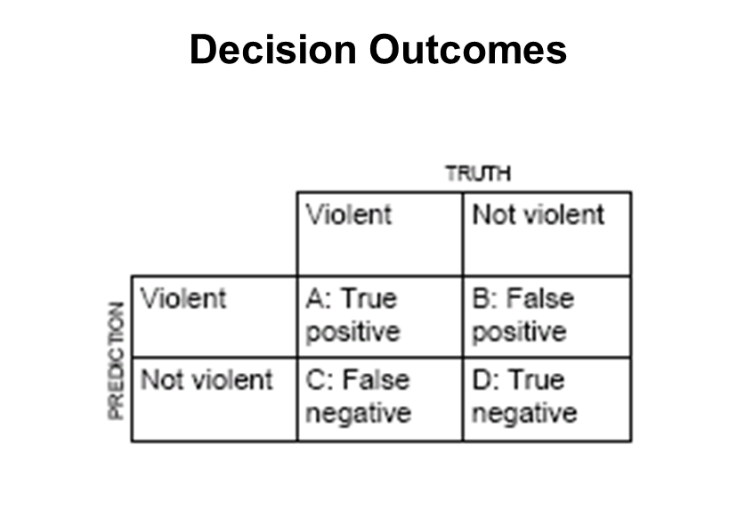
- A problem with predicting violence is determining base rates (representation of people in a given population who commit criminal or violent acts)
- It is difficult to predict violence when base rates are too high or too low, the general rule is that it is easier to predict frequent events than infrequent events

A ROC Graph
- For each possible cut off value (score), plot false positive rate (x axis) as function of true positive rate (y axis)
- Connect the dots and get a curve
- We can then measure the area under that curve to get an overall measure of predictive accuracy

ROC Interpretation
- AUC ranges from 0.50 (chance accuracy) to 1.00 (perfect accuracy)
- In other words the probability that a randomly selected recidivist will have a higher risk than a randomly selected non-recidivist

ROC: Strengths
- The only procedure that allows researchers to summarize accuracy in a way that is not biased by decision thresholds (Example: Scores on an assessment tool), or impacted by the rate of recidivism (like the correlation)

Levels of Predictive Accuracy
Clinical Judgements: AUC = 0.55
Actuarial Tools: AUC = 0.68 – 0.80
Structured Professional Judgement: AUC = 0.62 – 0.75

Psychopathy: Chapter 11
Psychopathy: A personality disorder defined by a collection of interpersonal, affective, and behavioural characteristics, including manipulation, lack of remorse or empathy, impulsivity and antisocial behaviours
- Psychopaths are often called “intraspecies predators” as they seek vulnerable victims for their own benefit

Psychopathy and Serial Killers
- Most serial killers are psychopaths, but most psychopaths are not serial killers
- Serial killers are often described as psychopathic (Ted Bundy, Clifford Olson, John Gacy, Ken Bianchi, Paul Bernardo)
- Most killers are not psychopaths

Psychopaths in the Population (BASE RATES)
- 90% of the population of serial killers ARE psychopaths
- 1% of the general population ARE psychopaths
- 10-25% of prison populations ARE psychopaths
- 44% of the population of killer of police officers ARE psychopaths

What is Psychopathy?
- A personality disorder characterized by:
- An arrogant, deceitful interpersonal style
- Deficient affective experiences
- Impulsive and irresponsible behaviours
- Early onset and diverse antisocial behaviours

How is Psychopathy Measured?

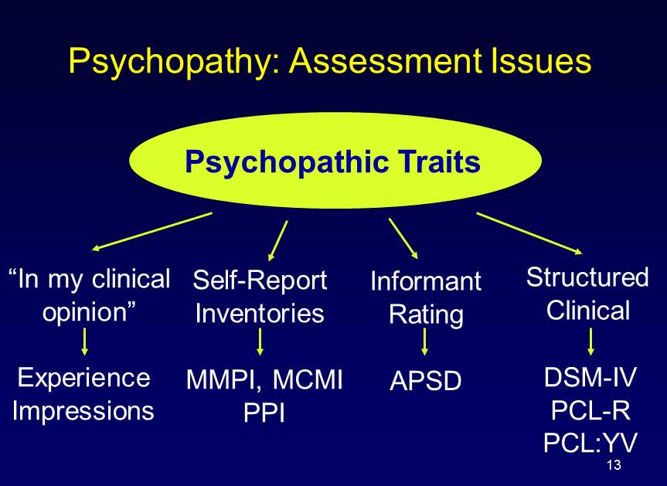

Hare Psychopathy checklist, Revised (PCL-R)
- Currently the most popular method of assessing psychopathy in adults developed by Robert Hare
- 20 items scored using: semi structured interview and file information used to assess interpersonal (Grandiosity, manipulativeness etc.), affective (lack of remorse, shallow emotions etc.), and behavioural (impulsivity, anti-social acts)
- Each item is rated on a 3 point scale: total ranges from 0-40
Psychopaths -> Score of 30 or higher
Middle scoring mixed group -> Score of 20 to 30
Non psychopaths -> Score of less than 20

SOME defining features of Psychopathy
- PCL-R Interpersonal features: Glib/ superficially charming, Grandiose (inflated self-worth), Manipulative (these features strongly related to predatory violence, emotional processing deficits, poor treatment response)
- PCL-R Affective features: Shallow emotions, Guilt, Callous/cold (these factors strongly related to reoffending, substance abuse, lack of education, poor family background)
- PCL-R Lifestyle Features: Impulsive, irresponsible, poor anger control, criminal behaviours

C.F. Abbott on Psychopaths – “Only an abstract, intellectual awareness of feelings of others”
- In other words, psychopaths can only imagine how certain emotions feel due to having knowledge about what those emotions are, they have never truly felt them themselves

Self-Report Psychopathy Scales
- A self-report measure of psychopathic traits
- Two of the most widely used are the Psychopathic Personality Inventory-Revised and the Self-Report Psychopathy Scale
Advantages:
- allows for measurement of attitudes or emotions that are not easily observed by other
- Easy to administer
- Not necessary to rely on inter-rater reliability since only the individual in completing it
Disadvantages:
- Psychopaths often lie
- May not have sufficient insight to assess own traits
- Difficult for psychopaths to report on specific emotions that they may not have experienced

DSM-IV Criteria for Anti-Social Personality Disorder (APD)
- Current age at least 18
- APD refers to a personality disorder in which there is evidence of conduct disorder before age 15
- After age 15 there must be 3 or more of the following criteria:
- Repeated criminal acts
- Irritability
- Recklessness
- Lack of Remorse
- Deceitfulness
- Impulsivity
- Irresponsibility

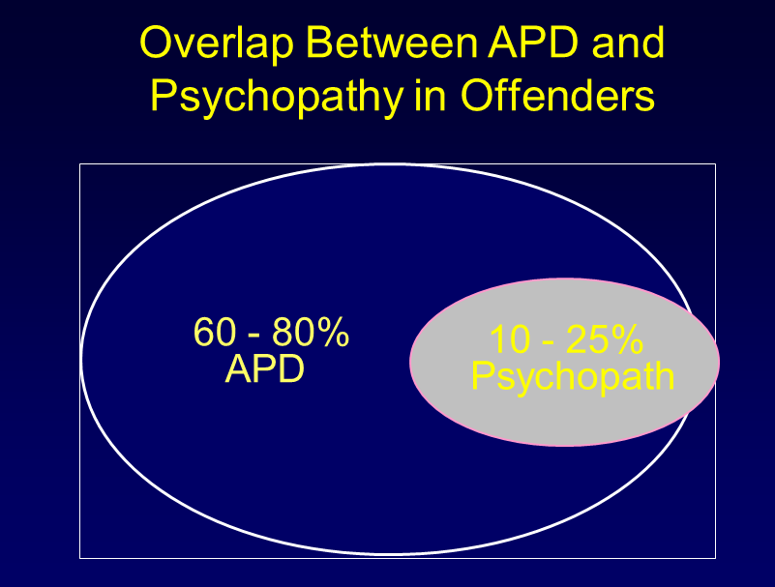

Why is Psychopathy Important?

Impact of Psychopathic Traits: Juvenile Death Penalty (Edens, Guy & Fernandez, 2003)
- Does the presence of absence of psychopathic traits impact layperson perceptions of what is an appropriate legal sanction?
- Juvenile capital defendant
- Psychopathic Traits: lacking remorse, callous, arrogant deceptive,
- Non-Psychopathic Traits: remorseful, accepting responsibility, respects others
Results = Psychopathic condition was more likely to select the death penalty and less likely to support that individual in rehabilitation

Psychopathy: Motives for Murder (Woodworth & Porter, 2002)
- 125 Canadian murders
- Classified murders as:
- Reactive = unplanned, crimes of passion, extreme provocation
- Instrumental = planned, settle a score

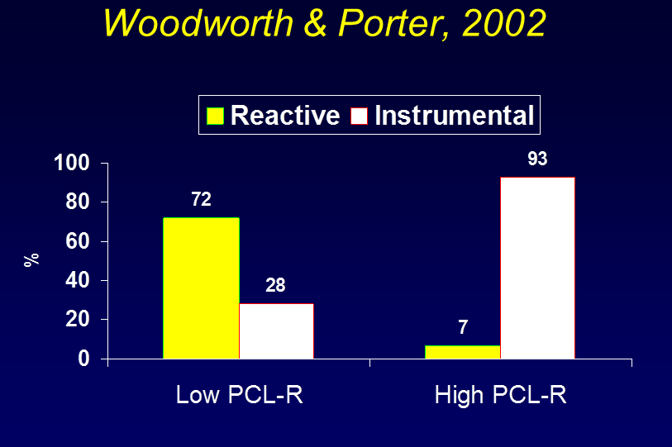

- Those who score HIGH on the PCL-R are more likely to commit INSTRUMENTAL murders, in other words psychopaths are more likely to commit planned and intentional murders

Psychopathy and General Reoffending (Hart, Kropp & Hare, 1988)
- Assessed 231 adult male offenders
- Release decision blind to PCL-R
- Parole
- Mandatory Supervision
- Follow up period: 3.5 years
- Outcome: revocation or new offence

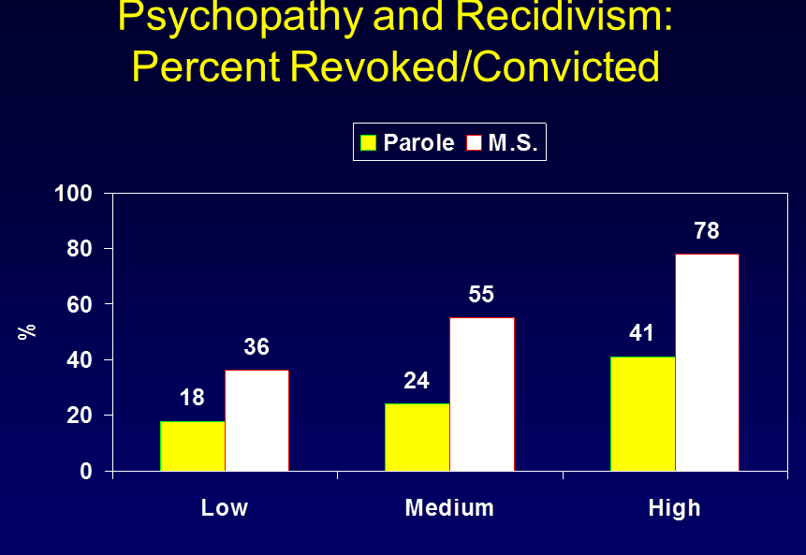
- As Psychopathy ratings increase, so do chances of reoffending, especially in instances of mandatory supervision

Psychopathy and treatment
- “Unlike most offenders psychopaths suffer little personal distress, see little wrong with their attitudes and behaviours, and only seek treatment when it is in their best interests to do so (seeking probation or parole)”

Psychopathy and Treatment (Rice, Harris & Cormier, 1992)
- Clinicians believe psychopaths are difficult to treat
- 176 treated patients/ 146 untreated patients
- Follow up period = 10 years
- Social Therapy Unit
- Minimum 2 year treatment program
- Foster responsibility and empathy
- Limited professional contact
- Entry to program non voluntary

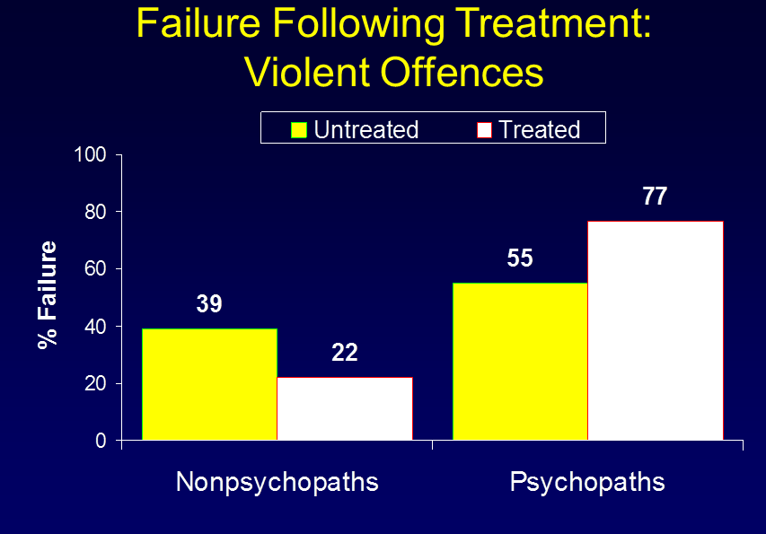
- Results were the opposite of what clinicians wanted, psychopaths in both the untreated and treated conditions had high rates of reoffending, especially when treated, nearly 80% of psychopaths reoffended

Psychopathy in Youth
- Research is increasingly focused on identifying the emergence of psychopathic traits in adolescence and that psychopathy doesn’t just appear in adulthood (develops gradually from various environmental and biological antecedents
- Two assessment instruments have been developed to asses psychopathic traits in youth
- Hare Psychopathy Checklist-Revised (Youth Version)
- Anti-Social Process Screening Device: assesses pre-cursors of psychopathic traits in children

What Makes Them Tick?
- We don’t know
- Not the sole result of poor parenting or abusive experiences
- Some clues from neuroscience
- Some believe that psychopaths have a deficit in in the experience of certain critical emotions (involved the disconnection between cognitive linguistic processing and emotional experience)

Response Modulation Deficit Theory: A theory that suggest psychopaths fail to use contextual cues that are peripheral to a dominant response set to modulate their behaviour
- If psychopaths are engaging in specific rewarded behaviour, they will not pay attention to other information that may inhibit their behaviour

Psychopathy and Affect Language
- They know the words but not the music
- They know the dictionary definition of words but not the meaning
- “They can learn to use dictionary words, and to reproduce the pantomime of feeling, but the feeling does not come to pass”

The Lexical Decision Task
- Words have both denotative (explicit, literal) and connotative (implied, implicit) meanings
- Evaluate words by:
- Lexical decision times
- Brain activity associated with the decisions
- Neutral and emotional words, pronounceable non-words briefly presented in random order on a computer screen
- Participants asked if what they saw was a real word

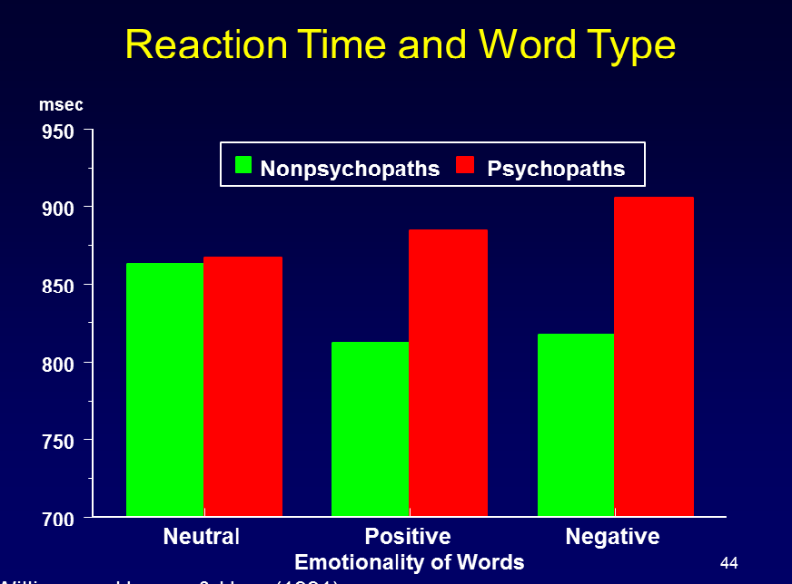

Intrator et. al (1997)
- Substance abusers
- Lexical decision task
- Assessed with PCL-R
- Radioactive tracer injected
- Blocks of neutral, emotional (negative) words
Results: Activation in non-psychopaths is widespread and primarily anterior
- Activation in psychopaths is more localized to posterior regions
- Implies that psychopaths perform the task in a superficial manner

Psychopathy and Startle Reflex
Startle reflex = reflex that occurs when something unexpected happens
- Primed is person is in negative emotional state of feeling threatened
- Reduced if person is in positive emotional state

Patrick et. al (1993)
- Incarcerated offenders
- Psychopaths vs. non-psychopaths
- Affective pictures
- Pleasant (babies, pets, erotica)
- Unpleasant (snake, weapons, mutilations)
- Neutral (objects)
- Present startle probes (very loud noises)
Results: Non-psychopathic people’s reflexes are as we expect (eye blink magnitude is higher or more severe during the viewing of unpleasant pictures rather than pleasant)
- Psychopathic people did not see much change in any condition (whether they were in the pleasant or unpleasant conditions they did not experience much change in eye blink magnitude)

