Chapter 1 - Taking risks & Making profits Within the Dynamic Business Environment

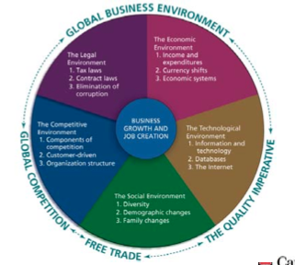
THE BUSINESS ENVIRONMENT

- Consists of the surrounding factors that either help or hinder the development of businesses.

1) The Legal Environment

Regulations Restrictions that provincial and federal laws place on businesses with respect to the conduct of their activities. They are meant to protect consumers as well as businesses.

The government can keep taxes and regulations to a minimum, thereby encouraging entrepreneurship and increasing wealth. Entrepreneurs are looking for a high return on investment (ROI), including investment of their time.

2) The Economic Environment

- This environment looks at income, expenditures, and resources that affect the cost of running a business. Businesses review the results of major economic indicators such as consumer spending, employment levels, and productivity.

3) The Technological Environment

Technology inventions or innovations from applied science or engineering research

Productivity the amount of output that is generated given the amount of output

E-Commerce the buying and selling of goods and services over the Internet. Only covers one aspect of e-business (i.e. the use of any electronic support for the commercial relationship between a company and individuals).

The Internet is very important in the B2B market, which consists of selling goods and services from one business to another.

E-Business refers to any information system or application (e.g. business software) that empowers business processes.

Database an electric storage file in which information is kept

- To survive in this new social media world, organizations must understand, navigate and adapt to this new landscape. 25% of businesses are leveraging social media as a way to connect and communicate with current potential customers.

4) The Competitive Environment

Scanning the competitive environment requires a look at the factors that drive competition:
- Entry
  - Must assess the likelihood of new entrants.
  - Barriers to entry vs. barriers to exit (make it difficult for firms to enter or leave the market)
- Power of Buyers and Suppliers:
  - Powerful buyers exist when they are few in numbers, there are low switching costs, or the product represents a significant share of the buyer’s total costs.
- Existing Competitors and Substitutes
  - Competitive pressure among existing firms depends on the rate of industry growth

Empowerment giving front-line workers the responsibility, authority, and freedom to respond quickly to customer requests.

5) The Social Environment

Demography the statistical study of the human population with regard to its size, density, and other characteristics such as age, race, gender, and income.

Baby-Boom Echo a demographic group of Canadians that were born in the period from 1980-1995; the children of the baby boomers

Baby Boomers a demographic group of Canadians that were born in the period from 1947-1966

6) The Global Environment

- The global environment surrounds all other environmental influences. Two important environmental influences over recent years have been the growth of global competition and the increase of free trade among nations.

- As businesses expand to serve global markets, new jobs will be created in both manufacturing and service industries. Global trade also means global competition.

Greening saving energy and producing less harmful products to environment

Chapter 3 – Competing in Global Markets

THE DYNAMIC GLOBAL ENVIRONMENT

Because the global market is so large, it is important to understand the languages of international trade. Canada is a large exporting nation
- Exporting selling goods and services to another country
- Importing buying products from another country

Comparative Advantage Theory a theory that states that a country should sell to other countries those products that it produces most efficiently and effectively, and buy from other countries those products it cannot produce as effectively or efficiently.

Absolute Advantage the advantage that exist when a country has a monopoly on producing a specific product or is able to produce it more efficiently than all other companies.

GETTING INVOLVED IN GLOBAL TRADE

When getting started globally it is important to observe and study global markets and, if you have the opportunity, travelling to different countries is a great way to observe foreign cultures and lifestyles and seeing if doing business globally appeals to you.

Balance of Trade a nation’s ratio of exports to imports

Trade Surplus a favorable balance of trade; occurs when the value of a country’s export exceeds that of its imports.

Trade Deficit an unfavorable balance of trade; occurs when the value of a country’s imports exceeds that of its exports.

Balance of Payments the difference between money coming into a country (from exports) and money leaving the country (for imports) plus money flows from other factors such as tourism, foreign aid, military expenditures, and foreign investment.

STRATEGIES FOR REACHING GLOBAL MARKETS

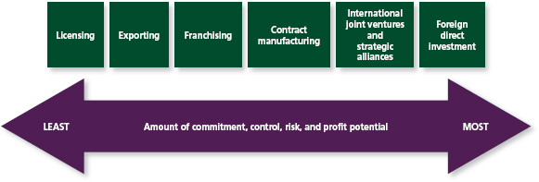
Licensing a global strategy in which a firm (the licensor) allows a foreign company (the licensee) to produce its product in exchange for a fee (a royalty).
- Benefits of licensing include:
  - Firm can generate revenues it wouldn’t have generated in its home market
  - Licensors spend little or no money to produce and market their products

Franchising a contractual agreement whereby someone with a good idea for a business sells the rights to use the business name and sell a product or service in a given territory in a specified manner.

Contract Manufacturing a foreign country’s production of private-label goods to which a domestic company then attaches its brand name or trademark; also called outsourcing.
- Enables a company to experiment in a new market without incurring heavy start-up costs such as building a manufacturing plant
- Labour costs are often low

Joint Venture a partnership in which two or more companies (often from different countries) join to undertake a major project.
- Benefits of international joint ventures include:
- Shared technology and risk
- Shared marketing and management expertise
- Entry into markets where foreign companies are often not allowed unless goods are produced locally

Strategic Alliance a long-term partnership between two or more companies established to help each company build competitive market advantages
- Strategic alliances don’t share costs, risks, management, or even profits.

Foreign Direct Investment (FDI) the buying of permanent property and businesses in foreign nations. As the size of a foreign market expands, many firms increase FDI and establish foreign subsidiary.

Foreign Subsidiary a company owned in a foreign country by the parent country
- Advantage of a subsidiary:
  - The company maintains complete control over any technology or expertise it may possess.

Multinational Corporation an organization that manufactures and markets products in many different countries and has multinational stock ownership and multinational management.

Chapter 4 – The Role of Government in Business

GOVERNMENT AFFECTS BUSINESS

Government activities that affect business can be divided into six categories:
- Crown Corporations
- Laws and Regulations
- Taxation and Financial Policies
- Government Expenditures
- Purchasing Policies
- Services

National Policy government directive that placed high tariffs on imports from the United States to protect Canadian manufacturing, which had higher costs.

CROWN CORPORATIONS

Crown Corporations companies that are owned by the federal or provincial government

Alberta Savings Trust Fund established when Alberta was prospering. It must operate on a sound financial basis, but, as much as possible, it makes investment decisions that will benefit Alberta.

Quebec Deposit and Investment Fund established to handle the funds collected by the Quebec Pension Plan. This company is used to guide economic development in Quebec and must operate on a sound financial basis. It has a lot of scope to make decisions that will benefit the Quebec economy.

Privatization the process of governments selling Crown corporations

Deregulation government withdrawal of certain laws and regulations that seem to hinder competition

TAXATION AND FINANCIAL POLICIES

Taxes are how all levels of government redistribute wealth. The revenue collected allows governments to discharge their legal obligations. This revenue is used to pay for public services, pay down debt, and fund government operations and programs. If the government wants to discourage consumption (cigarettes and alcohol) it may impose a sin tax.

Fiscal Policy the federal government’s effort to keep the economy stable by increasing or decreasing taxes or government spending.
- The government can use taxation to help move the economy in a desired direction (taxes may be raised when economy is booming to cool it off and slow down inflation).
- The government spends money in many areas. If the government spends more than the amount it gathers in taxes for a specific period of time (namely, a fiscal year), then it has a deficit.

National Debt (Federal Debt) the accumulation of government surpluses and deficits over time
- Increased government spending and borrowing stimulates and economy
- Reductions in the national debt have been the result of surpluses (an excess of revenues over expenditures)

Federal Budget a comprehensive report that reveals government financial policies for the coming year.
- This document shows how much revenue the government expects to collect, any changes in income, and other taxes, and whether a deficit or a surplus is expected

Monetary Policy the management of the money supply and interest rates controlled by the Bank of Canada. When the economy is booming BOC tends to raise interest rates in an attempt to control inflation. This makes money more expensive to borrow. BOC lowers money supply to slow down the economy.

Fiscal vs. Monetary Policy
- Fiscal taxes and spending
- Monetary control over interest rates and money supply

Subprime Mortgages loans targeted at people who don’t qualify for regular mortgages bc their credit records aren’t good enough or bc they don’t have a credit history. Some mortgages are interest-only loans that are lower in cost because no principal is paid down. Initially these loans come at very low rates (thus, subprime).

ROLES OF THE CANADIAN GOVERNMENT –FINAL THOUGHTS

Some people believe the best way to protect the Canadian economy is to reverse its current direction of privatization. Instead of withdrawing from active direction and participation in the economy, it should develop a long-term industrial policy of leadership and an active role in shaping the future of the economy.

Industrial Policy a comprehensive, coordinated government plan to guide and revitalize the economy

Chapter 5 – Ethics and Social Responsibility

ETHICS IS MORE THAN LEGALITY

Ethics standards of moral behaviour, that is, behaviour that is accepted by society as right versus wrong.

How is legality different from ethics?
Ethics reflects people’s proper relation with one another. Legality is more limiting; it refers only to laws written to protect people from fraud, theft, and violence.

How can we tell if our business decisions are ethical through 3 questions:
- Is it legal?
- Is it balanced?
- How will it make me feel?
Companies and individuals that develop strong ethics codes and use these questions have a better chance than most of behaving ethically.

MANAGING BUSINESSES ETHICALLY AND RESPONSIBLY

Compliance-Based Ethics Codes ethical standards that emphasize preventing unlawful behaviour by increasing control and by penalizing wrongdoers.

Integrity-Based Ethics Codes ethical standards that define the organization’s guiding values, create an environment that supports ethically sound behaviour, and stress a shared accountability among employees.

Whistleblowers people who report illegal or unethical behaviour

The following six-step process can help improve business ethics:
- Top management must support corporate code of conduct
- Employees must understand that expectations for ethical behaviour begin at the top and senior management expects employees to act accordingly
- Managers and others must be trained to consider the ethical implications of business decisions.
- Ethics office must be set up. Whistleblowers must feel protected from retaliation as oftentimes this exposure can lead to great career ad personal lost.
- Outsiders such as suppliers, subcontractors, distributers, and customers must be told about ethics program.
- Most critical step!!! Ethics code must be enforced.

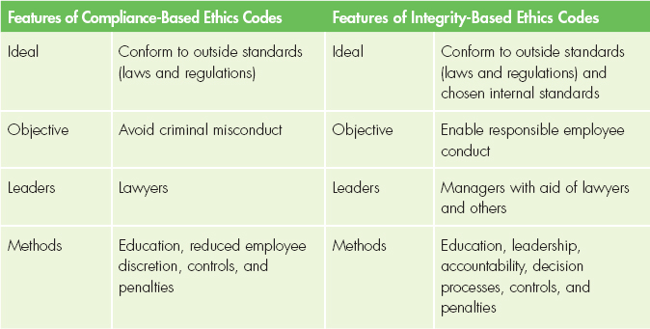

CORPORATE SOCIAL RESPONSIBILITY

Corporate Social Responsibility (CSR) a businesses concern for the welfare of society.

The social performance of a company has several dimensions:
- Corporate Philanthropy
  - Includes charitable donations to non-profit groups of all kinds. Example: Canadian Tire Foundation for Families
- Corporate Social Initiatives
  - Includes enhanced forms of corporate philanthropy that are more directly related to the company’s competencies. Example: FedEx and UPS shipped emergency relief supplies as part of 2004 Asian tsunami disaster relief.
- Corporate Responsibility
  - Includes everything from hiring minority workers to making safe products, minimizing pollution, using energy wisely, and providing a safe environment.
- Corporate Policy
  - Refers to the position a firm takes on social and political issues

Two different views of corporate responsibility to shareholders:
- The Strategic Approach
- Requires that management’s primary orientation be toward the economic interests of shareholders.
- The Pluralist Approach
- Recognizes the special responsibility of management to optimize profits, but not at the expense of employees, suppliers, and members of the community

Consumers have four basic rights:
- The right to safety
- The right to be informed
- The right to choose
- The right to be heard

Insider Trading an unethical activity in which insiders use private company information to further their own fortunes or those of their family and friends.

Social Audit a systematic evaluation of an organization’s progress toward implementing programs that are socially responsible and responsive.

Triple-Bottom Line (TBL) a framework for measuring and reporting corporate performance against economic, social, and environmental parameters. Corporations that use TBL focus on the economic value they add, but also on the environmental and social value they add and destroy?

There are four types of groups that serve as watchdogs, regarding how well companies enforce their ethical and social responsibility policies:
- Socially Conscious Investors: insist a company extend its own high standards to all its suppliers
- Environmentalists: apply pressure by publicly identifying companies that do not abide by the environmentalists’ standards
- Union Officials: hunt down violations and force companies to comply to avoid negative publicity
- Customers: take their business elsewhere if a company demonstrates unethical or socially irresponsible practices

Sustainable Development implementing a process that integrates environmental, economic, and social considerations into decision-making
Example: Sobeys and Loblaw’s have eliminated free plastic bags at checkout

INTERNATIONAL ETHICS AND SOCIAL RESPONSIBILITY

Fair Trade a growing social movement dedicated to making sure producers in developing countries are paid a fair price for the goods we consume (rather than exploiting desperately poor people), resulting in more money in their pockets

Many businesses are demanding socially responsible behaviour from their international suppliers by making sure their suppliers do not violate human rights and environmental standards.

Chapter 6 – Forms of Business Ownerships

SOLE PROPRIETORSHIPS

Sole Proprietorship a business that is owned and usually managed by one person

Advantages of Sole Proprietorship:
- Ease of starting and ending the business
- Being your own boss
- Pride of ownership
- Retention of company profit
- No special taxes
- Less regulation

Disadvantages
- Unlimited Liability – the risk of personal losses
- Limited financial resources
- Management difficulties
- Overwhelming time commitment
- Few fringe benefits
- Limited lifespan
- Possibly pay higher taxes

PARTNERSHIPS

General Partnership a partnership in which all owners share in operating the business and assuming liability for the business’s debts

Limited Partnership a partnership with one or more general partners and one or more limited partners

General Partner and owner (partner) who has unlimited liability and is active in managing the firm

Limited Partner an owner who invests money in the business but does not have any management responsibility or liability for losses beyond the investment

Limited Liability Partnership (LLP) a partnership that limits partners’ risk of losing their personal assets to only their own acts and omissions and to the acts and omissions of people under their supervision.

Advantages of Partnership
- More financial resources
- Shared management and pooled/complementary skills and knowledge
- Longer survival
- Shared risk
- No special taxes
- Less regulation

Disadvantages
- Unlimited liability
- Division of profits
- Disagreements among partners
- Difficulty of termination
- Partnership Agreements legal document that specifies the rights and responsibilities of each partner
- Possibly pay higher taxes

CORPORATIONS

Public Corporation Corporation that has the right to issue shares to the public, so its shares may be listed in a stock exchange

Private Corporation corporation that is not allowed to issue stock to the public, so its shares are not listed on stock exchanges; it is limited to 50 or fewer shareholders.

Advantages of Corporations
- Limited Liability
- Ability to raise more money for investment
- Size
- Perpetual life
- Ease of ownership change
- Ease of attracting talented employees
- Separation of ownership from management

Disadvantages
- Initial cost
- Extensive paperwork
- Double taxation
- Two tax returns
- Size
- Difficulty of termination
- Possible conflict with shareholders and board of directors

Corporate Governance the process and policies that determine how an organization interacts with its stakeholders, both internal and external

Articles of Incorporation A legal authorization from the federal/territorial government for a company to use the corporate format. The main advantage of being a federally incorporated company is that incorporation gives the company name added protection and guarantees its usage across Canada.

Chapter 7 – Entrepreneurship & Starting a Small Business

THE AGE OF THE ENTREPRENEUR

Entrepreneurshipaccepting the challenge of starting and running a business

Entrepreneurial ventures differ from small businesses in the following ways:
- Amount of wealth creation Successful entrepreneurial venture creates substantial wealth
- Speed of wealth creation Small business can generate profit over lifetime while entrepreneurial wealth creation is often rapid
- Risk
- Innovation

WHY PEOPLE TAKE THE ENTREPRENEURIAL CHALLENGE

Reasons people are willing to take the challenge of starting a business:
- New idea, process, or product
- Independence
- Challenge
- Family pattern
- Profit
- Immigrants

Entrepreneurial Team a group of experienced people from different areas of business who join together to form a managerial team with the skills needed to develop, make, and market a new product

Micro-Enterprises a small business defined as having fewer than five employees

Micropreneurs small-business owners with fewer than five employees who are willing to accept the risk of starting and managing the type of business that remains small, lets them do the kind of work they want them to do, and offers them a balanced lifestyle.

Affiliate Marketing an internet-based marketing strategy in which a business rewards individuals or other businesses (affiliates) for each visitor or customer the affiliate sends to its website

Intrapreneurs creative people who work as entrepreneurs within corporations

ENCOURAGING ENTREPRENEURSHIP: WHAT GOVERNMENT CAN DO

The mission of Canada Business is to improve the start-up, survival, and growth rates of small and medium-sized enterprises. This includes assisting with sound business planning, market research, and the use of strategic business information.

Entrepreneurs can also find assistance from incubators (centres that provide hands-on management assistance, education, information, technical and vital business support services, networking resources, financial advice, as well as advice on where to go to seek financial assistance).

GETTING STARTED IN SMALL BUSINESS

Business Establishment must meet at least one of the following minimum criteria:
- It must have at least one paid employee
- It must have annual sales revenue of $30,000,
- It must be incorporated and have filed a federal corporate income tax return at least once in the previous three years

Employer Business meets one of the business establishment criteria and usually maintains a payroll of at least one person, possibly the owner

Small Business a business that is independently owned and operated, is not dominant in its field, and meets certain standards of size in terms of employees or annual revenues

SMEs (small and medium-sized enterprises) refers to all businesses with fewer than 500 employees

MANAGING A SMALL BUSINESS

To help you succeed as a business owner, in the following sections we explore the five functions of business in a small-business setting:

1) Planning Your Business

Business Plan a detailed written statement that describes the nature of the business, the target market, the advantages the business will have in relation to competition, and the resources and qualifications of the owner(s).

2) Financing Your Business

Venture Capitalists individuals or companies that invest in new businesses in exchange for partial ownership of those businesses

Angel Investors private individuals who invest their own money in potentially how new companies before they go public

3) Knowing Your Customers

Market consist of people with unsatisfied wants and needs who have both the resources and the willingness to buy

4) Managing Your Employees

Entrepreneurs can best serve themselves and the business if they gradually recruit and groom employees for management positions. By doing this, entrepreneurs can enhance the trust and support of the manager among other employees and themselves.

5) Keeping Records

Small-business owners often say that the most important assistance they received is starting and managing the business involved accounting.

6) Looking For Help

Small-business owners have learned, sometimes the hard way, that they need outside consulting advice early in the process.

Chapter 8 – Management and Leadership

FUNCTIONS OF MANAGEMENT

Management the process used to accomplish organizational goals through planning, organizing, leading, and controlling people and other organizational resources.

Planning a management function that includes anticipating trends and determining the best strategies and tactics to achieve organizational goals and objectives

Organizing a management function that includes designing the structure of the organization and creating conditions and systems in which everyone and everything work together to achieve the organization’s goals and objectives.

Leading creating a vision for the organization and guiding, training, coaching, and motivating others to work effectively to achieve the organization’s goals and objectives

Controlling a management function that involves establishing clear standards to determine whether or not an organization is progressing toward its goals and objectives, rewarding people for doing a good job, and taking corrective action if they are not.

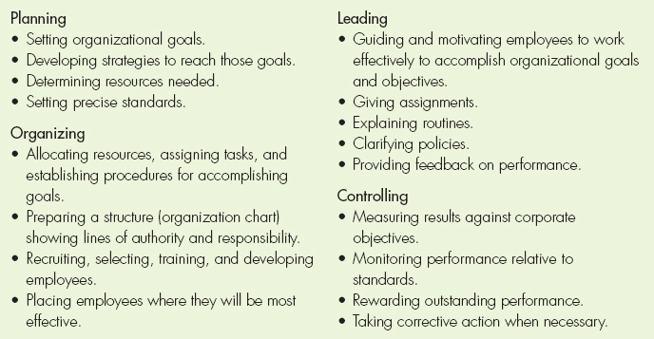

PLANNING: CREATING A VISION BASED ON VALUES

Vision an encompassing explanation of why the organization exists and where it is trying to head

Values a set of fundamental beliefs that guide a business in the decisions they make

Mission Statement an outline of the fundamental beliefs that guide a business in the decisions they make

Goals the broad, long-term accomplishments an organization wishes to attain

Objectives specific, measurable, short-term statements, detailing how to achieve the organization’s goals.

SWOT Analysis a planning tool used to analyze organizations strengths, weaknesses, opportunities and threats

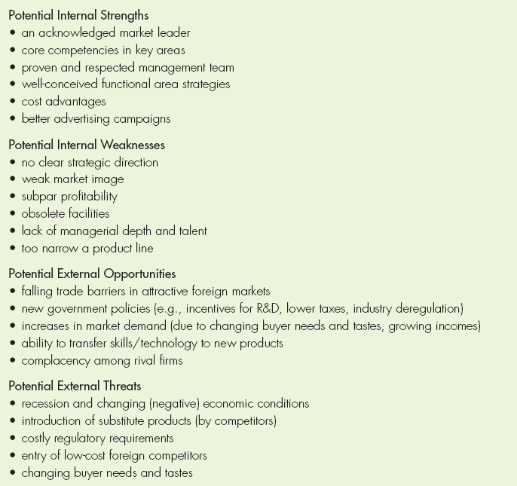

Strategic Planning the process of determining the major goals of the organization and the policies and strategies for obtaining and using resources to achieve these goals.

Tactical Planning the process of developing detailed, short-term statements about what is to be done, who is to do it, and how it is to be done.

Operational Planning the process f setting work standards and schedules necessary to implement the company’s tactical objective

Contingency Planning the process of preparing alternative courses of action that may be used if the primary plans do not achieve the organization’s objectives

Crisis Planninginvolves reacting to sudden changes in the environment. Crisis planning is a part of contingency planning.

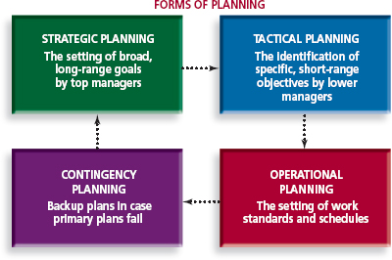
ORGANIZING: CREATING A UNIFIED SYSTEM

Organization Chart a visual device that shows relationships among people and divides the organization’s work; it shows who is accountable for the completion of specific work and who reports to whom

Top Management highest level of management, consisting of the president and other key company executives, who develop strategic plans
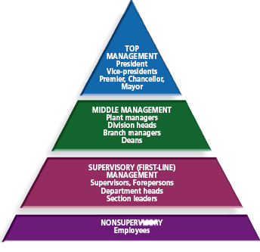
Middle Management the level of management that includes general managers, division manages, and branch and plant managers, who are responsible for tactical planning and controlling

Supervisory Management managers who are directly responsible for supervising workers and evaluating their daily performance.

A manager must have three categories of skills:
- Technical Skills involve the ability to perform tasks in a specific discipline or department
- Human Relations Skills involve communication and motivation; they enable managers to work through and with people
- Conceptual Skills involve the ability to picture the organization as a whole and the relationships among its various parts

LEADING: PROVIDING CONTINUOUS VISION AND VALUES

Leaders must:
- Communicate a vision and rally others around that vision
- Establish corporate values
- Promote corporate ethics
- Embrace transformational change
- Stress accountability and responsibility

Transparency the presentation of a company’s facts and figures in a way that is clear, accessible, and apparent to all stakeholders.

Most common leadership styles and how they can be effective:
- Autocratic Leadership
- Involves making managerial decisions without consulting others
- Effective in emergencies or with new, unskilled workers who need clear direction and guidance
- Participative (Democratic) Leadership
- Consists of managers and employees working together to make decisions.
- Many progressive organizations are highly successful using a democratic style of leadership that values traits such as flexibility, good listening skills, and empathy.
- Free-Rein (Laissez-Faire) Leadership
- Involves managers setting objectives and employees being relatively free to do whatever it takes to accomplish those objectives
- Often the most successful leadership style

Transformational Leadership occurs when visionary leaders can influence others to follow them in working to achieve a desired outcome or goal.
Works best where dramatically organizational change is required

Transactional Leadership associated with employees who are motivated by a system of reward.
The leader is given the power to assign tasks and their successful completion leads to rewards and reinforcement

Knowledge Management finding the right information, keeping the information in a readily accessible place, and making the information known to everyone in the firm

CONTROLLING: MAKING SURE IT WORKS

The control process is the heart of the management system because it provides the feedback that enables managers and workers to adjust any deviations from plans and to changes in the environment that have affected performance. Controlling consists of five parts:
- Establishing clear performance and standards. This ties the planning function to the control function. Without clear standards, control is impossible.
- Monitoring and recording actual performance (results)
- Comparing results against plans and standards
- Communicating results and deviations to the employees involved
- Taking corrective action when needed and providing positive feedback for work well done.

External Customers dealers, who buy products to sell to others, and ultimate customers (or end users), who buy products for their own personal use.

Internal Customers individuals and units within the firm that receive services from other individuals or units

Chapter 9 – Adapting Organizations to Today’s Markets

DECISIONS TO MAKE IN STRUCTURING ORGANIZATIONS

When designing responsive organizations, firms have to make decisions about several organizational issues:
- Centralizations versus decentralization
- Span of control
- Tall versus flat organization structures
- Departmentalization

1. Centralization versus Decentralization of Authority

Centralized Authority occurs when decision-making authority is maintained at the top level of management at the company’s headquarters. When a company needs radical changes, centralized decision-making is often necessary

Decentralized Authority occurs when decision-making authority is delegated to lower-level managers and employees who are more familiar with local conditions than headquarters management could be.

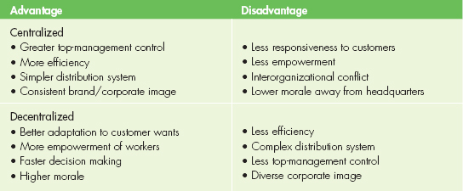

2) Span of Control

Span of Control refers to the optimum number of subordinates a manager supervises or should supervise. At lower levels, where work is standardized, it is possible to implement a wide span of control (15-40 workers).

Variables in span of control include the following:
- Capabilities of the manager – more experienced = broader
- Capabilities of the subordinates – more subordinates = narrower
- Geographical closeness – more concentrated the work area = broader
- Functional similarity – similar functions = broader
- Need for coordination – greater need for coordination = narrower
- Planning demands – more involved plan = narrower
- Functional complex – more complex functions = narrower

3) Tall versus Flat Organization Structures

Tall Organization Structures an organization structure in which the pyramidal organization chart would be quite tall because of the various levels of management. Less effective because inefficiencies in communication and decision-making.

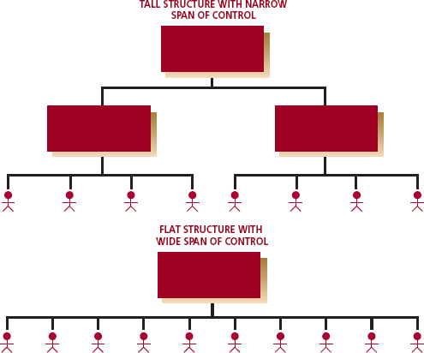
Flat Organization Structure an organization structure that has were layers of management and a broad span of control.

4) Advantages and Disadvantages of Departmentalization

Departmentalization is dividing an organization into separate units. Departmentalization groups workers according to their skills, expertise, or resource use so that they can specialize and work together more effectively.

ADAPTING TO CHANGE

Restructuring redesigning an organization so that it can more effectively and efficiently serve its customers.

Inverted Organization an organization that has contact people (like nurses) at the top and the chief executive officer at the bottom of the organization chart

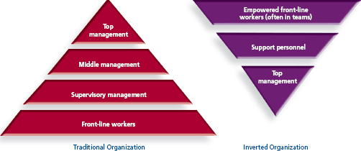

Total Quality Management (TQM) striving for maximum customer satisfaction by ensuring quality from all departments. TQM calls for continual improvement of present processes. Not efficient in bureaucratic organizations with many layers of management.

Continuous Improvement (CI) constantly improving the way the organization does things so that customer needs can be better satisfied.

Re-engineering the fundamental rethinking and radical redesign of organizational processes to achieve dramatic improvements in critical measures of performance.

Organizational (or Corporate) Culture is the widely shared values within an organization that provide coherence and co-operation to achieve common goals. Usually the culture of an organization is reflected in its stories, traditions, and myths.

- Some of the best organizations have cultures that emphasize service to others, especially customers. There is a friendly atmosphere offering a good product at a reasonable price. Companies that have such a culture have less need for close supervision of employees.

Formal Organization the structure that details lines of responsibility, authority, and position; that is the structure shown on organization charts. It is often too slow although it does provide helpful guides and lines of authority for routine situations.

Informal Organization the system of relationships and lines of authority that develops spontaneously as employees meet and form power centres; that is, the human side of the organization that does not appear on any organization chart. It is often too unstructured but extremely effective in generating creative solutions to short-term problems and creating friendship and teamwork among employees.

Chapter 10 – Producing World-Class Goods & Services

FROM PRODUCTION TO OPERATIONS MANAGEMENT

Production the creation of finished goods and services using the factors of production: land, labour, capital, entrepreneurship, and knowledge.

Production Management the term is used to describe all of the activities that managers do to help their firms create goods.

Operations Management specialized area in management that converts or transforms resources (including human resources) into goods and services.

Operations management has become much more focused on services, because by redirecting corporate thinking towards satisfying customer needs better than the competition, they retain their customers.

Operations Management Planning

Operations management planning helps solve many of the problems in the service and manufacturing sectors. These include facility location, facility layout, and quality control.

Facility Location is the process of selecting a geographic location for a companies operation. One strategy is to find a sit that makes it easy for consumers to use the company’s services and to communicate about their needs. Ex: Tim Horton’s are located in some gas stations; customers can buy gas and meals in one location.

Outsourcing

Taking operations management to the Internet

Facility location in the future

Facility Layout is the physical arrangement of resources (including people) in the production process. Facility layout depends greatly on the processes that are to be performed.

PRODUCTION PROCESSES

The production process consists of taking the factors of production (land, etc.) and using those inputs to produce goods, services, and ideas. Planning, routing, scheduling, and other activities are the means to accomplish the objective – output.

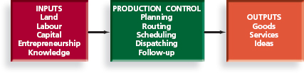
Form Utility the value producers add to materials in the creating of finished goods and services. Ex: transformation of silicon into computer chips.

Process Manufacturing the part of the productivity process that physically or chemically changes the materials. Ex: boiling the egg.

Assembly Process the part of the productivity process that puts together the components (eggs, toast, coffee), to make a product (breakfast).

Production processes are either continuous or intermittent.

Continuous Process long production runs (lots of eggs) turn out finished goods over time.

Intermittent Process here the production is run short (one or two eggs) and the producer adjusts machines frequently to make different products (like the oven in a bakery or the toaster in the diner).

Chapter 11 – Motivating Employees

MOTIVATION AND MASLOW

Maslows Hierarchy of Needs Theory of motivation that places different types of human needs in order of importance, from basic physiological needs to safety, social, and esteem needs to self-actualization needs.

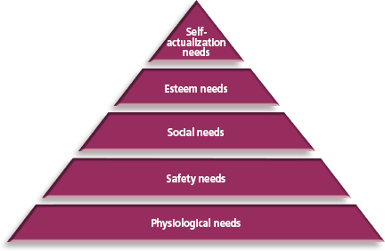
Theory of motivation that places different types of human needs in order of importance, from basic physiological needs to safety, social, and esteem needs to self-actualization needs.
To compete successfully, firms must create a work environment that includes goals such as social contribution, honesty, reliability, service, quality, dependability, and unity – for all levels of employees.

HERZBER’S MOTIVATING FACTORS

Motivators In Herzberg's theory of motivating factors, job factors that cause employees to be productive and that give them satisfaction.

Hygiene (Maintenance) Factors in Herzberg’s theory of motivating factors, job factors that can cause dissatisfaction if missing but that do not necessarily motivate employees if decreased. The absence of hygiene factors causes dissatisfaction, but their presence (maintenance) does not motivate. They do not motivate but must be present for employee satisfaction.

- Herzberg’s motivating factors led to the following conclusion – the best way to motivate employees is to make their jobs interesting, help them achieve their objectives, and recognize their achievement through advancement and added responsibility.

Motivator Examples: the work itself, achievement, recognition, responsibility, growth, and advancement.

Hygiene (Maintenance) Factors Examples: company policies, supervision, working conditions, interpersonal relations, and salary.

MCGREGOR’S THEORY X AND THEORY Y

Douglas McGregor held that managers would have one of two opposing attitudes toward employees. They are called Theory X and Theory Y

Theory X assumes that the average person dislikes work and will avoid it as much as possible. Therefore, people must be forced, controlled, and threatened with punishment to accomplish organizational goals.

Theory Y assumes that people like working and will accept responsibility for achieving goals if rewarded for doing so.

MEETING EMPLOYEE EXPECTANCIES: EXPECTANCY THEORY

Expectancy Theory Victor Vroom’s theory that the amount of effort employees exert on a specific task depends on their expectance of the outcome

Vroom contends that employees ask three questions before committing maximum effort to a task: (1) Can I accomplish the task? (2) If I do accomplish it, what is my reward? (3) Is the reward worth the effort?

Researchers David Nadler and Edward Lawler modified Vroom’s theory and suggested that managers follow five steps to improve employee performance:
- Determine what rewards employees value
- Determine each employee’s desired performance standard
- Ensure that performance standards are attainable
- Guarantee rewards tied to performance
- Be certain that employees consider the rewards adequate

Chapter 12 – HR Management: Finding & Keeping the Best

WORKING WITH PEOPLE IS JUST THE BEGINNING

Human Resource Management (HRM) the process of determining human resource needs and the recruiting, selecting, developing, motivating, evaluating, compensating, and scheduling employees to achieve organizational goals.

DETERMINING YOUR HUMAN RESOURCE NEEDS

What are the steps in human resource planning?
- Prepare a human resource inventory of the organizations employees
- Prepare a job analysis
- Assess future demand
- Assess future supply
- Establish a strategic plan for recruitment, selection, training and development, evaluation, compensation, scheduling, and career management for the labour force.

1) Prepare a human resource inventory of the organizations employees
- Should include ages, names, education, capabilities, training, skills and any other relevant information.

2) Prepare a job analysis
- Job Analysis is study of what is done by employees who hold various job titles. The result of a job analysis is two written statement: job description and job specifications.
- Job Description specifies the objectives of the job, the type of work to be don, the responsibilities and duties, the working conditions, and the relationship of the job to other functions.
- Job Specifications a written summary of the minimum qualifications required of workers to do a particular job.

3) Assessing future human resource demand
- They forecast the organizations requirements and train people ahead of time or ensure trained people are available when needed.

4) Assessing future human resource supply
- The labour force is constantly shifting: getting older, becoming more technically oriented, and attracting more women.

5) Establishing a strategic plan
- The plan must address recruiting, selecting, training, developing, appraising, compensating, and scheduling the labour force.

COMPENSATING EMPLOYEES: ATTRACTING AND KEEPING THE BEST

Pay Equity refers to equal pay for work of equal value

Gender Wage Gap the difference between wages earned by men and wages earned by women.

Fringe Benefits benefits that provide additional compensation to employees beyond based wages. Divided into three categories:
- Federal and provincial legislation and requires compulsory deductions from employee’s pay cheques (is pension plan, insurance, income tax)
- Legally required benefits (vacation pay, holiday pay, time and a half or double time for overtime, and unpaid paternity leave with job protection)
- All other benefits determined by employer (bonuses, company pension plans, group insurance, sick leave, termination pay)

Cafeteria-Style Benefits (Flexible Benefits) benefit plans that allow employees to choose which benefits they want up to a certain dollar amount.

Chapter 13 – Understanding Employee Management Issues and Relations

EMPLOYEE MANAGEMENT ISSUES

Union an employee organization that has the main goal f representing members in employee-management bargaining over job-related issues; also known as a labour union.

Some labour analysts forecast that unions will retain strength as companies engage in more unpopular practices such as outsourcing; other insist that unions have seen their brightest days.

THE COLLECTIVE BARGAINING PROCESS

Collective bargaining the process whereby union and management representatives negotiate a contract for workers.

Certification the formal process whereby a union is recognized by the Labour Relations Board (LBL) as the bargaining agent for a group of employees.

Decertification process by which workers can take away a union’s right to represent them.

Negotiated Labour-Management Agreement (Labour Contract) agreement that clarifies the terms and conditions and sets the tone under which management and labour agree to function over a period of time.

Union Security Clause a provision in a negotiated labour-management agreement that stipulates that employees who benefit from a union must officially join or at least pay dues to the union.

There are four different types of clauses:
- Closed Shop
- A workplace in which all new hires must already be union members
- The clause favored by unions
- Hiring is done through union
- Union Shop
- A workplace in which the employer is free to hire anybody, but the recruit must then join the union within a short period, perhaps a month
- Agency Shop (Rand Formula)
- A workplace in which a new employee is not required to join the union but must pay union dues.
- Open Shop
- A workplace in which employees are free to join of not join the union and to pay or not pay union dues

Regardless of which hiring condition prevails, the contract usually contains check-off as a standard clause.

Check off a contract cause requiring the employer to deduct union dues from the employers pay and remit them to a union.

Grievance a formal protest by an individual employee, with the support of the union, when they believe that management is not abiding by or fulfilling the terms of a labour contract. The vast majority of grievances are negotiated and resolved by shop stewards.

Shop Stewards union officials who work permanently in an organization and represent employee interests on a daily basis

Bargaining Zone a range of options between the initial and final offer that each party will consider before negotiations dissolve or reach an impasse. If the labour management negotiators are not able to agree on alternatives it will go on to the next step…

Conciliation a process by which a labour union or an employer must use the governments services (via the Ministry of Labour) for help in resolving their differences so that they can reach a collective agreement. Once conciliation fails, the union is then in legal position to strike and the employer is also free to declare a lockout. After a “no board” is issued, the Ministry will also suggest mediation and offer to provide this service…

Mediation the use of a third party, called a mediator, who encourages both sides in a dispute to continue negotiating and often makes suggestions for resolving the dispute.

Arbitration is a more extreme approach to solve conflict. It is an agreement to bring in an impartial third party (a single arbitrator or a panel of arbitrators) to render a binding decision in order to render a binding decision in labour dispute.

NEGOTIATION TACTICS

UNION TACTICS

The primary tactics used by organized labour are strikes and boycotts. Unions might also use picketing and work slowdowns to get desired changes.

Strikes
- A union strategy in which workers refuse to go to work
- Prior to the strike, union leaders call for a strike vote, which is a secret ballot authorizing the union leadership to call a strike
- Wildcat Strike an unauthorized (by the union) work stoppage while a labour contract is still in effect

Boycotts
- Primary Boycott when a union encourages both its b=members and the general public not to buy the products of a firm involved in a labour dispute
- Secondary Boycott am attempt by labour to convince others to stop doing business with a firm that is the subject of a primary boycott

Picketing
- Strikers will walk around the outside of the organization carrying signs and talking with the public and the media about issues in the labour dispute
- Unions also use picketing as an informational tool before going on strike

Other Tactics
- Sabotage workers damage their machines
- Sit-Ins workers occupy the workplace and refuse to move
- Work-to-Rule workers follow the operating rules of the workplace in every detail to slow down the work

MANAGEMENT TACTICS

Lockouts
- An attempt by management to put pressure on by unions by temporarily closing the business
- Less costly to close down and cease paying wages. This tactic may force the union to reduce its demands.

Injunctions
- A court order directing someone to do something or to refrain from doing something
- Management has sought injunctions to order striking workers back to work, limit the number of pickets that can be used during a strike, or otherwise deal with actions that could be detrimental to the public welfare.

Strikebreakers
- Replacement workers hired to do the jobs of the striking employees until the labour dispute is resolved.
- This often leads to violence

LEGISLATION

Back-to-Work Legislation legislation that orders an end to a labour-management dispute that has escalated to a strike or lockout, in an industry that the government decides is essential to the operation of the economy.

Chapter 14 – Marketing: Building Customer and Stakeholder Relationships

WHAT IS MARKETING?

Marketing a set of business practices designed to plan for and present an organization’s products or services in ways that build effective customer relationships.

The evolution of marketing includes five eras, also known as orientations: (1) Production, (2) Sales, (3) marketing concept, (4) market orientation, and (5) social media marketing

1) The Production Era
- Main goals centered on production
- Greatest marketing need is for production and less expensive distribution and storage

2) The Sales Era
- Most companies emphasized selling and advertising in effort to persuade customers to buy existing products

3) The Marketing Concept Era
- Marketing concept a three-part business philosophy
- A customer orientation – find out what customers want and provide it to them
- A service orientation – make sure that everyone in the organization has the same objection: customer satisfaction
- A profit orientation – focus on goods & services that will earn the most profit

4) The Market Orientation Era
- Market Orientation focusing efforts on:
- Continuously collecting information about customers’ needs and competitors’ capabilities
- Sharing this information throughout the organization
- Using the information to create value, ensure customer satisfaction, and develop customer relationships
- Customer Relation Management (CRM) the process of building long-term relationships with customers by delivering customer value and satisfaction

5) The Social Media Marketing Era
- Social Media the term commonly given to Web sites and online tools that allow users to interact with each other in some way – by sharing information, opinions, knowledge, and interests.
- Social Media Marketing consists of two distinct dimensions:
  - Consumer-generated online-marketing efforts to promote brands and companies for which they are fans (or conversely, negatively promoting brands and companies for which they are non-fans),
  - The use by marketers of online tools and platforms to promote their brands or organizations (e.g. Facebook, wikis, blogs, etc.)

THE MARKETING MIX

Marketing Mix the ingredients that go into marketing a product:
- Designing a want-satisfying Product
- Setting a Price for the product
- Getting the product in a Place where people will buy it
- Promoting their product

Designing A Product To Meet Customer Needs
- Product any physical good, service, or idea that satisfies a want or need plus anything that would enhance the product in the eyes of the consumer
- Concept Testing develop an accurate rate description of your restaurant and ask people, in person or online, whether the idea of the restaurant and the kind of meals you intend to offer appeals to them
- Test Marketing the process of testing products among potential users
- Brand Name a word, letter, or a group of words or letters that differentiates one seller’s goods or services from those of competitors

Setting An Appropriate Price
- Price the money or other consideration (including other goods and services) exchanged for the ownership or use of a good or service

Getting The Product To The Right Place
- Intermediaries the middle links in a series of organizations that distribute goods from producers to consumers
- Getting the product to consumers when and where they want it is critical to market success

Developing An Effective Promotional Strategy
- Promotion consists of all the techniques sellers use to motivate customers to buy their products
- Promotion often includes relationship building with customers

THE CONSUMER MARKET

Market Segmentation the process of dividing the total market into groups whose members have similar characteristics.

Target Marketing marketing directed toward those groups (market segments) and organization decides it can serve profitably

Geographic Segmentation dividing the market by geographic area (i.e. cities, countries, provinces, etc.)

Demographic Segmentation dividing the market by age, income, and education level. Demographics are the most widely used segmentation variable, but not necessarily the best.

Psychographic Segmentation dividing the market using the group’s values, attitudes, and interests

Behavioral Segmentation dividing the market based on behaviour with or toward the product

Niche Marketing the process of finding small but profitable market segments and designing or finding products for them

One-to-One Marketing developing a unique mix of goods and services for each individual customer (i.e. travel agencies)

Mass Marketing developing products and promotions to please large groups of people

Relationship Marketing marketing strategy with the goal of keeping individual customers over time by offering them products that exactly meet their requirements

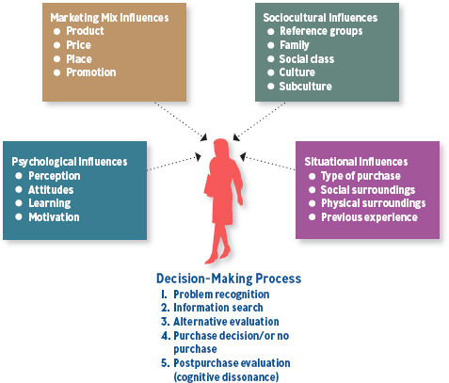
Cognitive Dissonance a type of psychological conflict that can occur after a purchase. Consumers who make major purchases (i.e. washing machines) may have doubts about whether they got the best product at the best price.
Marketers must reassure such customers after the sale that they made a good decision. An auto dealer, for example, may send the customer positive press articles about the particular car purchased, offer product guarantees, and provide certain free services.

Chapter 15 – Managing the Marketing Mix

THE PRODUCT LIFECYCLE

Product Lifecycle a theoretical model of what happens to the sales and profits for a product class over time; the four stages of the cycle are introduction, growth, maturity, and decline

Sales and profits during the products lifestyle
- Profit levels start to fall before sales reach their peak. This is due to increasing price competition. When profits and sales start to decline, it is time to come out with a new product or to remodel the old one to maintain interest and profits.
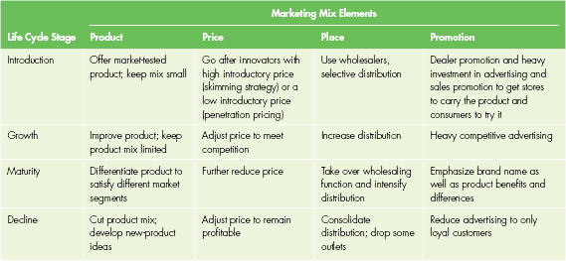

COMPETITIVE PRICING

What are the pricing objectives?
- Achieving a target return on investment or profit
- Building traffic
- Achieving greater market share
- Creating an image
- Furthering social objectives

There are three major approaches to pricing strategy: cost-based, demand-based (target costing), and competition-based

Cost-Based Pricing
- Producers often use cost as a primary basis for setting price. They develop cost accounting systems to measure production costs, add in margin or profit, and some up with a price.
- Pricing should take into account costs, but it should also include expected costs of product updates, the marketing objectives for each product, and competitor prices

Demand-Based Pricing
- Target Costing designing a product so that it satisfies customers and meets the profit margins desired by the firm

Competition-Based Pricing
- Competition-Based Pricing a pricing strategy based on what all other competitors are doing. The price can be set at, above, or below competitors’ prices.
- Pricing depends on customer loyalty, perceived differences, and the competitive climate
- Price Leadershipthe procedure by which one or more dominant firms set the pricing practices that all competitors in an industry follow

BREAK-EVEN ANALYSIS

Break-Even Analysis the process used to determine profitability at various levels of sales
Total Fixed Cost (FC)
(Price of 1 Unit (P) – Variable Cost (VC) of 1 unit)
Break-Even Point (BEP) =

Total Fixed Costs all expenses that remain the same no matter how many products are made or sold

Variable Costs costs that change according to the level of production

PRICING STRATEGIES FOR NEW PRODUCTS

Skimming Price Strategy a strategy in which a new project is priced high to make optimum profit while there’s little competition

Penetration Price Strategy a strategy in which the product is priced low to attract many customers and discourage competitors

RETAILER PRICING STRATEGIES

Everyday Low Pricing (EDLP) setting prices lower than competitors and then not having any special sales

High-Low Pricing Strategy set prices that are higher than EDLP stores, but have many special sales where the prices are lower than competitors

Psychological Pricing pricing goods and services at price points that make the product appear less expensive than it is

Chapter 16 – Understanding Accounting and Financial Information

UNDERSTANDING KEY FINANCIAL STATEMENENTS

Financial Statement a summary of all of the transactions that have occurred over a particular period

The key financial statements of a business are:
- Balance Sheet details what the company owns and owes on a certain day
- Income Statement shows the revenue a firm earned selling its products compared to its selling costs (profit or loss) over a specific period of time
- Cash Flow Statement highlights the difference between cash coming in and cash going out over a specific period of time

THE BALANCE SHEET

Balance Sheet the financial statement that reports a firms financial condition at a specific time and is composed of three major types of accounts: assets, liabilities, and owners’ equity.

Assets

Assets economic resources (things of value) owned by a firm

Liquidity how fast an asset can be converted into cash

Assets are divided into three categories according how quickly they can be turned into cash:
- Current Assets items that can or will be converted into cash within 1 year

- Capital Assets items that are relatively permanent, such as land, buildings, and equipment

- Intangible Assets long-term assets (e.g. patents, trademarks, copyrights) that have no real physical form but do have value.

Liabilities And Owners’ (Shareholders’) Equity Accounts

Liabilities what the business owes to others (debts)

Common liabilities accounts:
- Accounts Payable current liabilities are bills a company owes to others for merchandise or services purchased on credit but not yet paid for
- Notes payable short-term or long-term liabilities that a business promises to repay by a certain date
- Bonds Payable long-term liabilities that represent money lent to a firm that must be paid back
- Taxes payable sales tax and GST or HST collected, and income tax payable

Owners’ Equity the amount of the business that belongs to the owners minus any liabilities owed by the business

Retained Earnings the accumulated earnings from a firms’ profitable operations that remains in the business and not paid out to shareholders as dividends

THE INCOME STATEMENT

Income Statement the financial statement that shows a firms’ profit after costs, expenses, and taxes; it summarizes all of the resources (called revenue) that have been earned, all the resources that were used up, and the resulting net income.

Net Income or Net Loss revenue left over after all costs and expenses, including taxes, are paid

Cost of Goods Sold (COGS) a measure of the cost of merchandise sold or cost of raw materials and supplies used for producing items for resale

Gross Profit how much a firm earned by buying (or making) and selling merchandise

Operating Expenses costs involved in operating a business, such as rent, utilities, and salaries

THE CASH FLOW STATEMENT

Cash Flow Statement reports cash receipts and disbursements related to a firm’s three major activities:
- Operations cash transactions associated with running the business
- Investing cash used in or provided by the firm’s investing activities (normally included in capital assets)
- Financing cash raised from the issuance of new debt or equity capital or cash used to repay loans or company dividends

Cash Flow the difference between cash coming in and cash going out of a business

Chapter 17 – Financial Management

FINANCIAL PLANNING

Financial Planning means analyzing short-term and long-term money flows to and from a firm. Its overall objective is to optimize the firm’s profitability and make the best use of its money. It has three steps:
- Forecasting a firm’s short-term and long-term financial needs
- Developing budgets to meet those needs
- Establishing financial control to see whether the company is achieving its goals

1. Forecasting Financial Needs

Short-Term Forecast forecast that predicts revenues, costs, and expenses for a period of one year or less

Cash Flow Forecast forecast that predicts the cash inflows and outflows in future periods, usually months or quarters

Long-Term Forecast forecast that predicts revenues, costs, and expenses for a period longer than one year, and sometimes as far as five or ten years in the future.

2. Working With The Budget Process

Budget a financial plan that sets forth managements expectations, and, on the basis of those expectations, allocates the use of specific resources throughout the firm. There are usually several types of budgets established in a firm’s financial plan:
- An operating (master) budget
- A capital budget
- A cash budget

Operating (Master) Budget the budget that ties together all of a firm’s other budgets and summarizes the business’s proposed financial activities

Capital Budget a budget that highlights a firm’s spending plans for major asset purchases that often require large sums of money, like property, buildings, and equipment.

Cash Budget estimates cash inflows and outflows during a particular period (e.g. monthly, quarterly). It helps managers anticipate borrowing needs, debt repayment, operating expenses, and short-term investments.

3. Establishing Financial Controls

Financial Control a process in which a firm periodically compares its actual revenues, costs, and expenses with its projected ones.

THE NEED FOR FUNDS

Businesses need financing for four major tasks: (1) managing day-to-day needs of the business, (2) controlling credit operations, (3) acquiring needed inventory, and (4) making capital expenditures.

Managing Day-To-Day Needs Of A Business

The interest a firm gains on its investments is important in maximizing the profit it will gain. That is why financial managers often try to minimize cash expenditures to free up funds for interest-bearing accounts. They suggest the company pay its bills as late as possible (unless a cash discount is available for early payment) and collect what is owed to them as fast as possible.

Controlling Credit Operations

The problem with selling on account is that a large percentage of non-retailers business assets could be tied up in its credit accounts (account receivable). A convenient way to decrease time and expense of collecting A/R is to accept bank credit cards (MasterCard or VISA) which reduces companies risk.

Making Capital Expenditures

Capital Expenditures major investments in either tangible long-term assets such as land, buildings, and equipment, or intangible assets such as patents, trademarks, and copyrights.

Expanding into new markets can be extensive with no guarantee of success. Therefore, it is critical that companies weigh all possible options before committing a large portion of available resources.

Alternative Sources Of Funds

A firm can raise needed capital by borrowing money (debt), selling ownership (equity), or earning profits (retained earnings).

Equity Financing funds that are raised from operations within the firms through the sole ownership in the firm

Debt Financing funds raised through various forms of borrowing that must ne repaid

Short-Term Financing borrowed funds that are needed for one year or less

Long-Term Financing borrowed funds that are needed for a period more than one year.

Appendix A – Using Technology to Manage Information

THE ROLE OF INFORMATION TECHNOLOGY

Information Technology (IT) technology that helps companies change business by allowing them to use new methods.

Business Intelligence (BI) BI refers to a variety of software applications that analyze an organization’s raw data and take useful insights from it. BI activity includes data mining, online analytical process, querying, and reporting. Business people that use Business Intelligence can focus on what’s important: deciding how to react to problems and opportunities.

The chart below shows a few ways that information technology is changing businesses, their employees, suppliers, and customers.

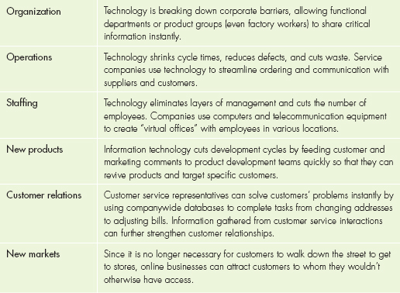

TYPES OF INFORMATION

The types of information that are available to businesses today include:
- Business Process Information includes all transaction data gathered at the point of sale as well as information gained through operations like enterprise resource planning, supply chain management, and customer relationship management skills
- Physical-World Observations these result from the use of radio frequency identification (RFID) devices, mini cameras, wireless access, GPS’s and sensory technology – all of which have to do with where people are located and what they’re doing.
- Biological Data forms of identification include fingerprinting technology that usually serves security purposes but may customize products and services in the future
- Data That Can Indicate Personal Preference Or Intentions Internet shoppers leave a trail of information that can reveal likes and dislikes

The usefulness of management information depends on four characteristics:
- Quality
- Completeness
- Timelessness
- Relevance

